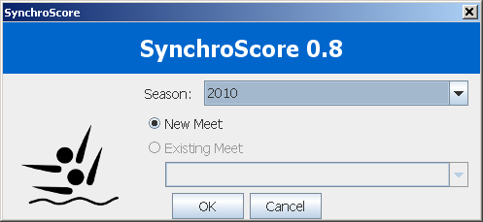
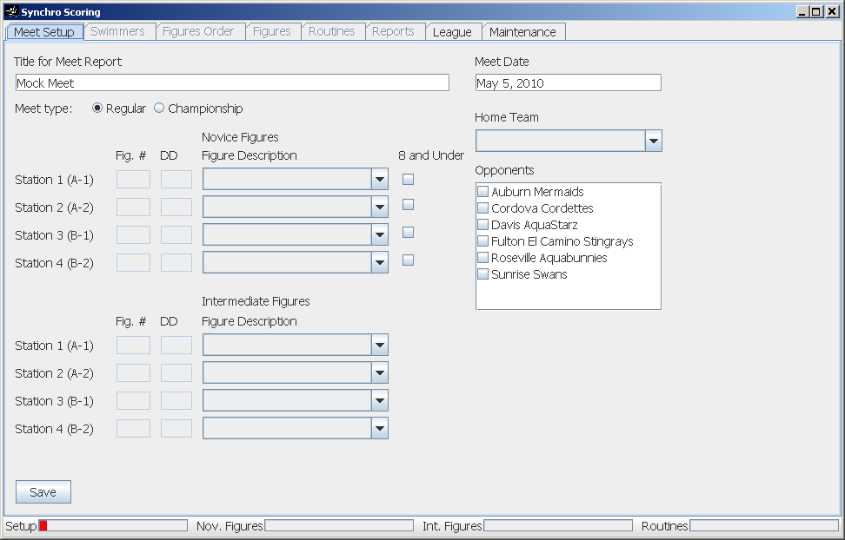
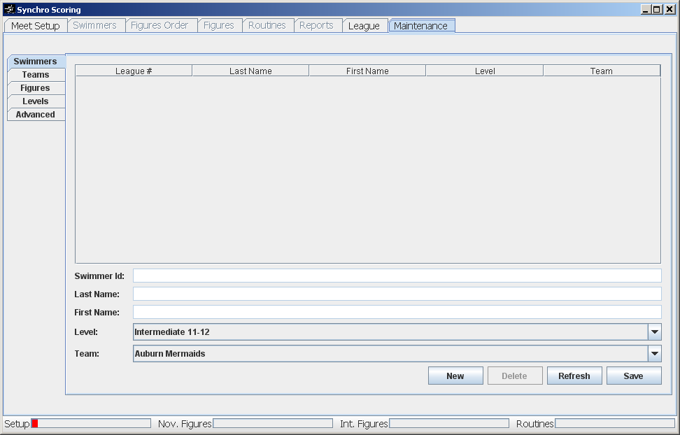
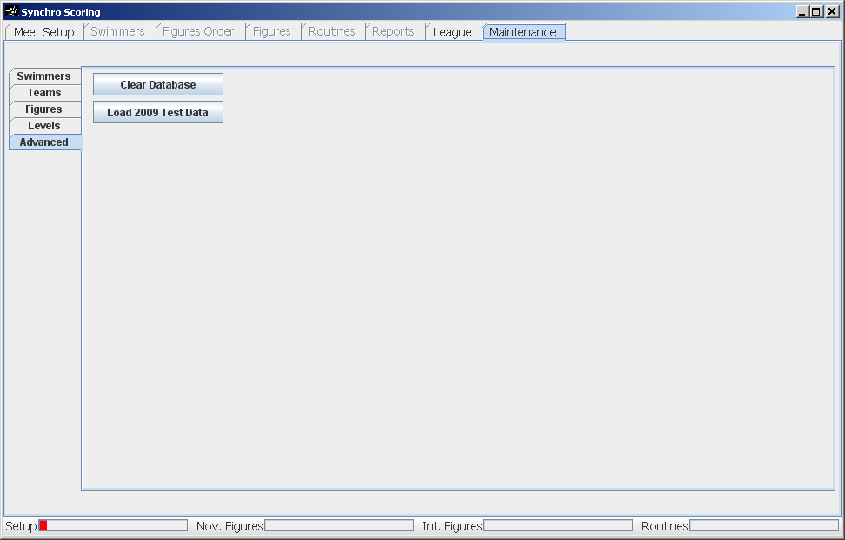
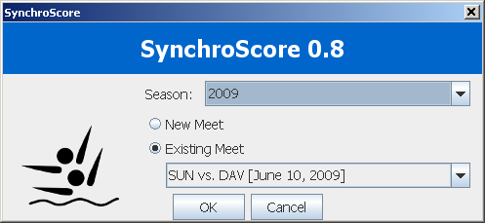
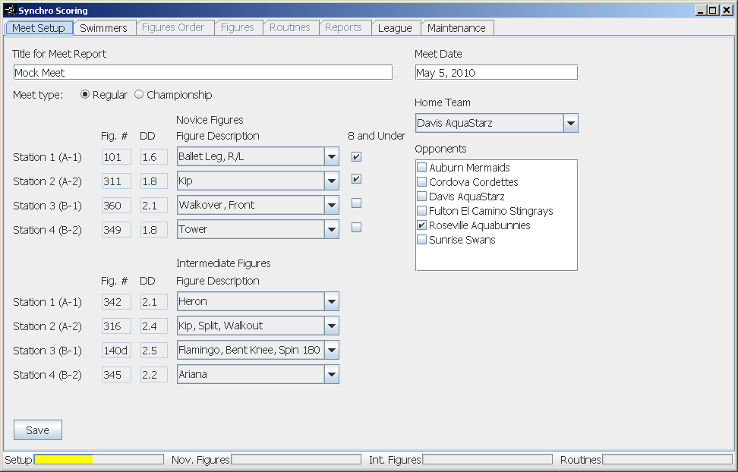
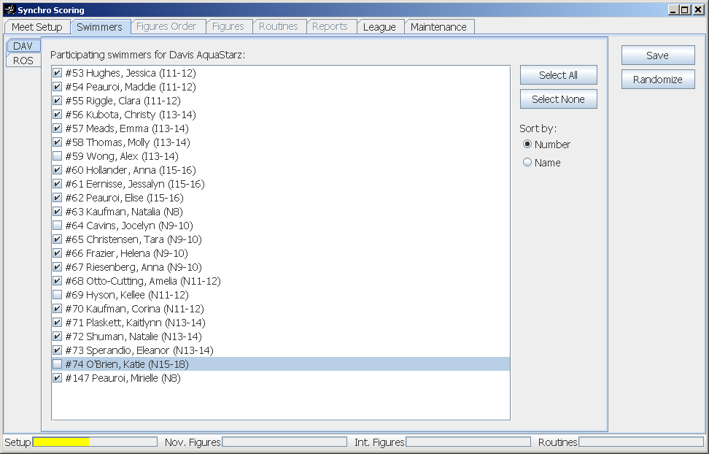
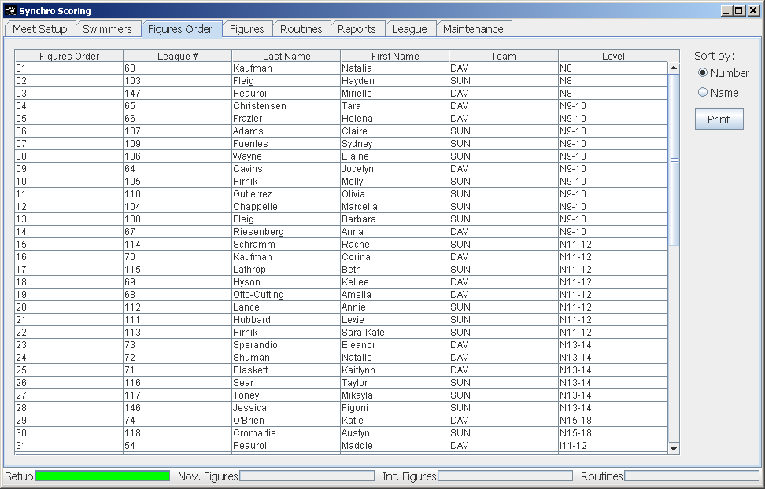
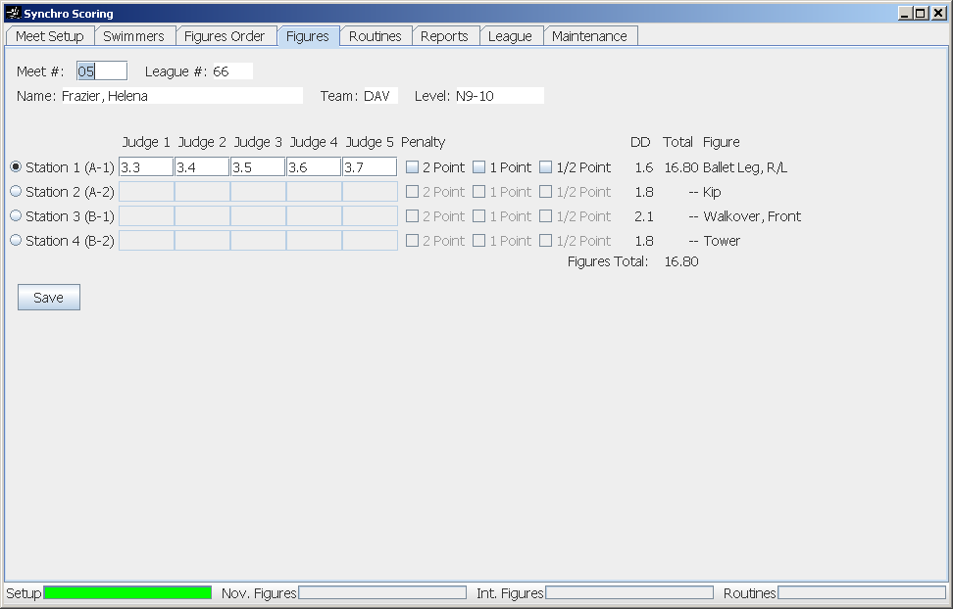
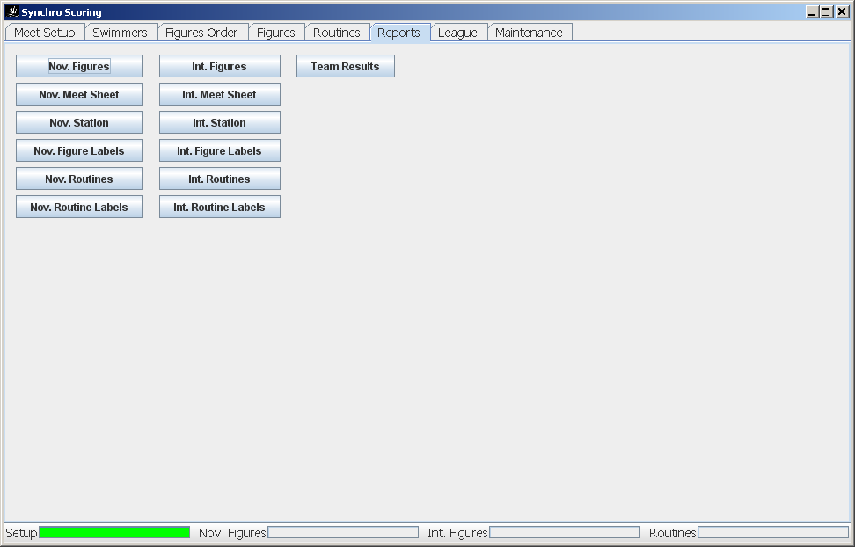
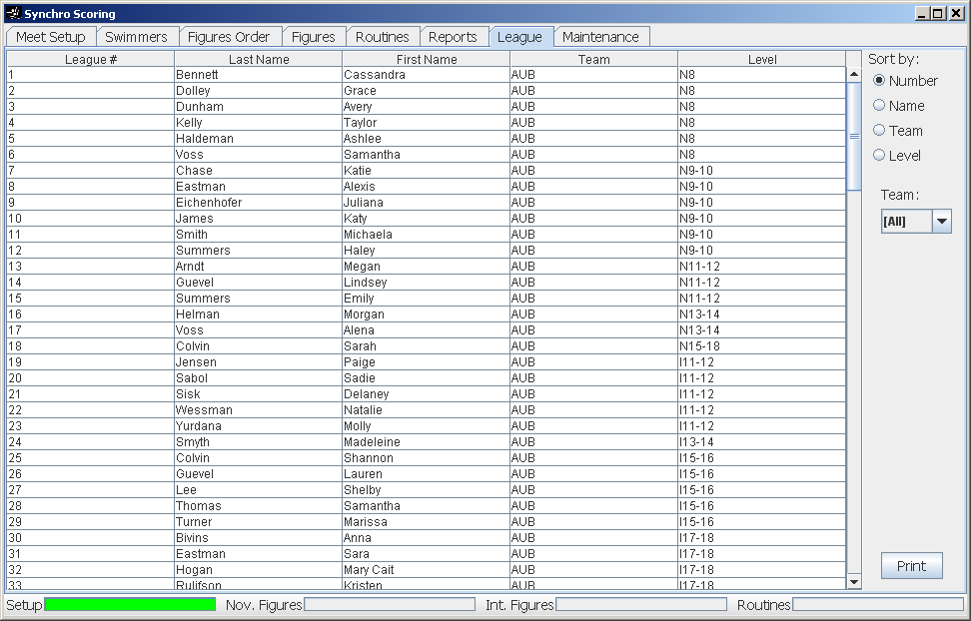
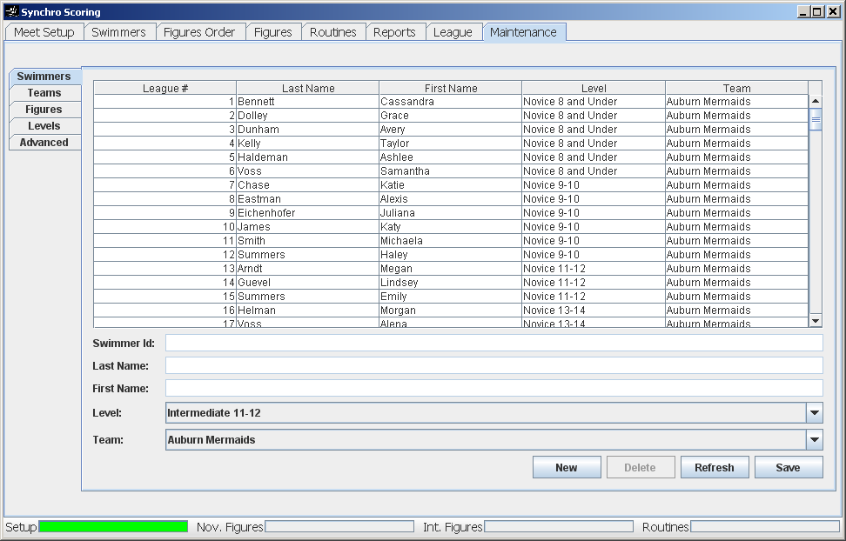
Testing SynchroScore
The program is downloaded as a ZIP file. Open this file and copy the SyncroScore program someplace where you can find it (the Desktop, if you like).
You need to have a recent Java runtime installed. If that is not available, the program will complain and direct you on where to download it.
When you start up the program it will create a database in a folder called .SynchroScore under your home folder. This is usually in C:\Documents And Settings\username\.SynchroScore. If at any time you want to clear out all the data in the program, this folder can be deleted or moved.
The first screen to appear is the meet selection screen. This will show Seasons including the current year and any prior years for which it has data. You can select to create a new meet or re-open an existing meet if one is available. To make it easy, this screen will default to New Meet if there isn’t a meet for today, and it will re-open today’s meet if it finds one.
For now, just press OK to make a new meet.

The next screen to appear is the main screen. There are several tabs along the top to get access to the various functions. Most of them are disabled to start and will become enabled as the meet setup process is done.

To save on typing and time, I have included data for the 2009 Season that you can load in to either experiment with a completed meet or create a new meet using the 2009 swimmer list. To do this, click on the Maintenance tab (this tab takes a second to load.)
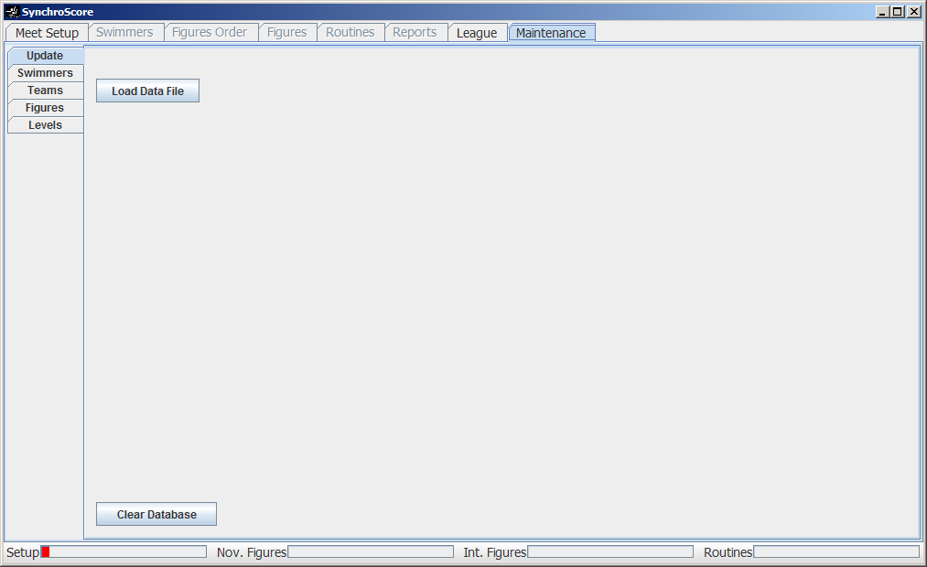

Click the Load Data File button, browse to the 2009.zip file, and click Open. By default, this will be located in C:\Program Files\SynchroScore. When it shows the message, “Done,” you can either load another file or close the program and start it up again.
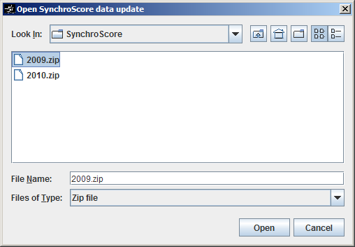
Now you will get a starting dialog that has both the 2009 season and the current season. Select the 2009 season and it will select the one existing meet. Press OK.

When the main window opens, you can explore the various tabs. Since this is a completed meet, you can go to the Reports tab and look at the results. Currently, only the three buttons in the top row work. I need to implement the rest of the reports.
If you close and restart the program, you can select the 2009 season and proceed to set up a new meet. The advantage of the 2009 season is that all the swimmers are in the database already.
Below is a screenshot of each of the tabs with some explanation of how to use.
This is the Meet Setup for a typical meet. Note that only Meet type = Regular and a single opponent have been tested, but Champs and Triple meets should work.
Figures are all selected from the drop down lists. If a new figure needs to be added, that can be done in the Maintenance tab. Currently, the program needs to be restarted for the dropdown boxes to show the new figure.
Once everything is completed, press the Save button. If all is well, the Swimmers tab will be enabled, and the Setup progress bar will move a bit and change from red to yellow. You should now click the Swimmers tab to make up the meet list.

This screen is a departure from the original program. The swimmers are listed and checkmarks are set next to the participating swimmers. There is a tab on the left for each team. When all the swimmers are selected for all the teams, press Save. The progress bar will more a little more. Then press Randomize to assign a random figure order. The progress bar will change to full and green, and the tab will automatically change to the Figures Order tab.
If you need to make changes to the meet list, you can come back to this screen, make the changes, and press Save. The new swimmers will be assigned appropriate numbers behind the last swimmer in their level.

On this screen you can review the figures order and use the Print button to print the meet list.

The Figures tab is where the figure scores are entered and reviewed. This screen works much like the original program, pressing period takes you to the meet # search field, figure scores are entered as two digit numbers, and enter moves to the next score field and on to the Save button. This should make using this screen easy for those accustomed to efficient use of the numeric keypad.
As figures scores are input, the progress bars on the bottom will show the percentage of completion. Green bars mean that all scores are entered.

The Routines tab is not implemented yet.

The Reports tab has all of the usual reports. There is no need to “Calculate” as this is done as needed. Currently only the three buttons on the top row are implemented.
Pressing a button will open a new window containing the report where it can be viewed and printed.

The League tab is where you review and print the team lists.

The Maintenance tab is used to edit the database of Swimmers, Teams, Figures, and Levels. Probably the Swimmers screen is the most likely to be used when a new swimmer is added or a name needs spelling corrected. Currently, changes here may need the program to be restarted before other parts of the program pick up the change.

