SynchroScore
Quick Start:
Download and install the Java Runtime (Windows only)
- For an install while connected to the internet, go to http://www.java.com and click the big red button.
- To install later on another computer, go to http://java.com/en/download/manual.jsp and click the link for “Windows 7, XP Offline.”
- Run this install program and accept all the defaults.

Download SynchroScore.exe (for Windows) and SynchroScore.jar (for non-Windows) from http://sourceforge.net/projects/synchroscore/files/

SynchoScore needs no install, just save it someplace convenient and run it from there. If all goes well, you should see the window below when it starts up:
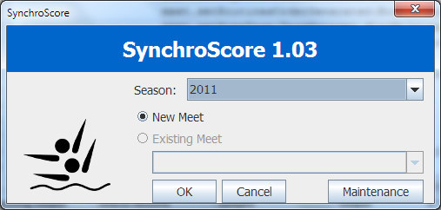

The program is almost ready to use, but it doesn't have the list of VFCAL swimmers. You should have a swimmers.csv file that you received via email. To load this, click the Maintenance button. After a few seconds (this takes too long, and I plan to fix) the window below will open:
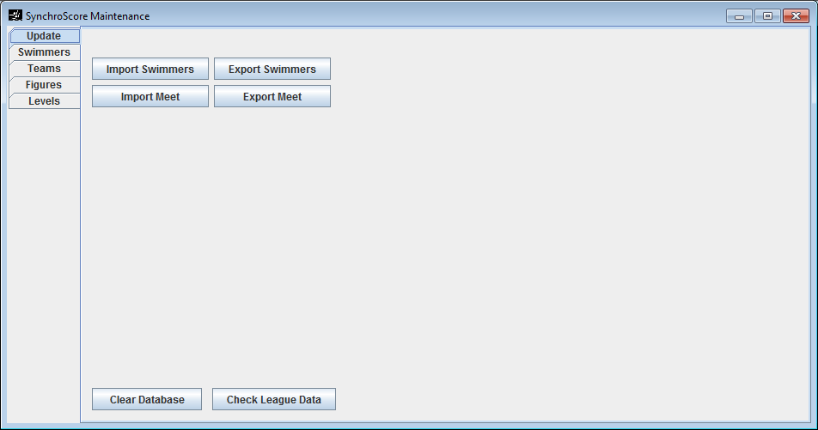
Press Import Swimmers, select the file, close and restart the program.

Scoring a Meet:

Start SynchroScore:

Select an existing meet or start a new one and press OK.

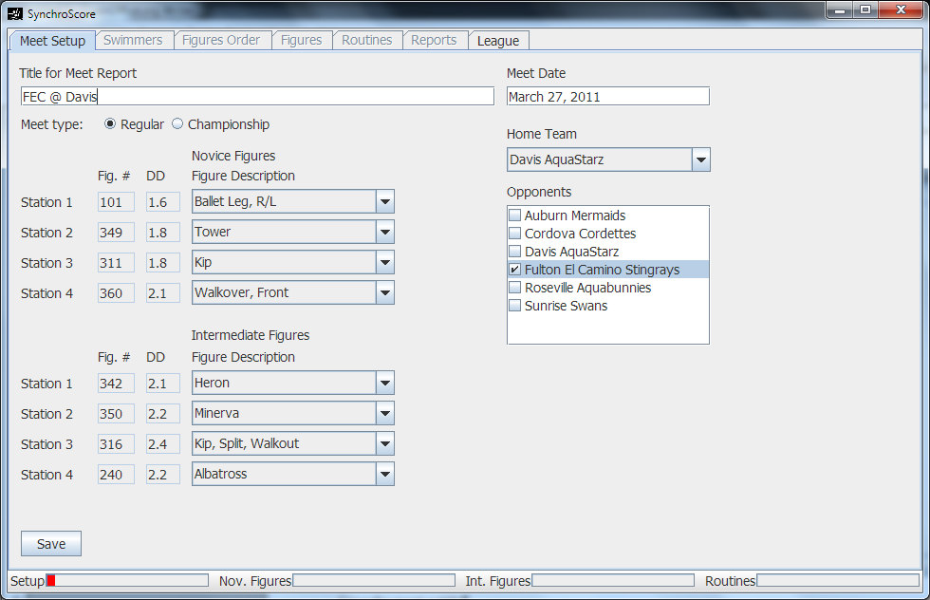
Give the meet a title. Select the home team, and put a check next to the opponent team. Set the figures being performed (station numbering is up to you for your convenience). Press Save, click Swimmers tab.

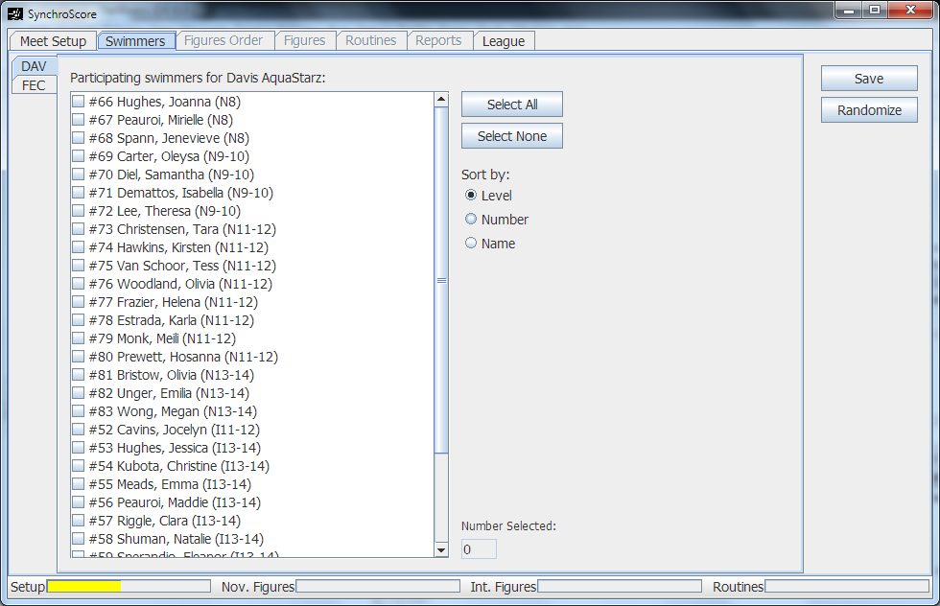

Click a check next to each participating swimmer for both teams. Each team has it's own tab to the left. When done, click Save. Then click Randomize, and you will automatically move to the Figures Order tab.
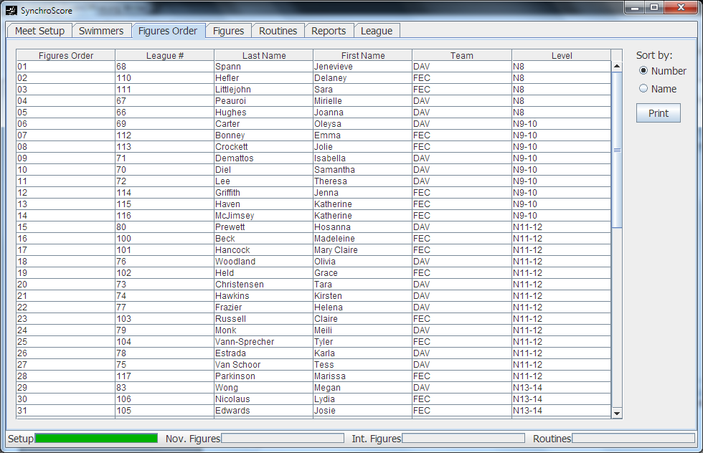

Here you can view the list of figures swimmers. Click the Print button to print the Meet List.
If there are any changes to swimmer names or level, you need to exit the program and restart to get to the Maintenance window where you can make the corrections, restart, and reopen the meet. A change in level will require that you either re-randomize or that you remove the swimmer from the meet, save, add the swimmer back, and save again. This process will give the swimmer a new number at the end of other swimmers of the same level.

Once the Meet List is done, you are ready to enter figures scores. Click on the Figures tab.
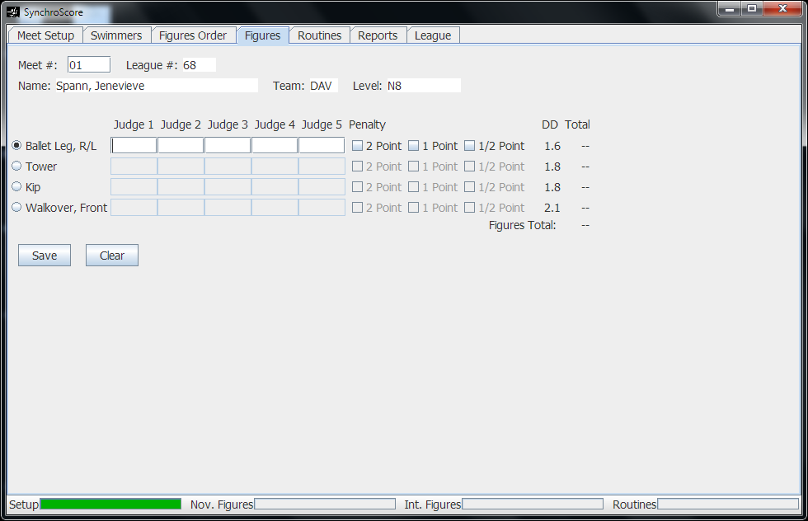

Enter the meet number of the swimmer at the top and press enter. Then click on the correct figure from the list. Now you can begin entering scores. Enter just the two numbers in each box pressing enter between each (I plan to change this to not require the enter). After the last one, the Save button will be highlighted, and pressing enter once more will save the score.

Hot keys:
Period will take you directly to the Meet # box to look up a new swimmer.
Slash “/” will move to the next figure.

Along the bottom of the window, there are progress meters. When Nov. Figures or Int. Figures are completely dark green, then you have entered all scores for that group, and it's time to print results (see below).

To enter routines, click on the Routines tab. Press Add for a new routine, enter all the information, and enter the scores similar to how they are entered for figures. The Penalty box will accept a decimal for penalties (e.g. “1.5”)
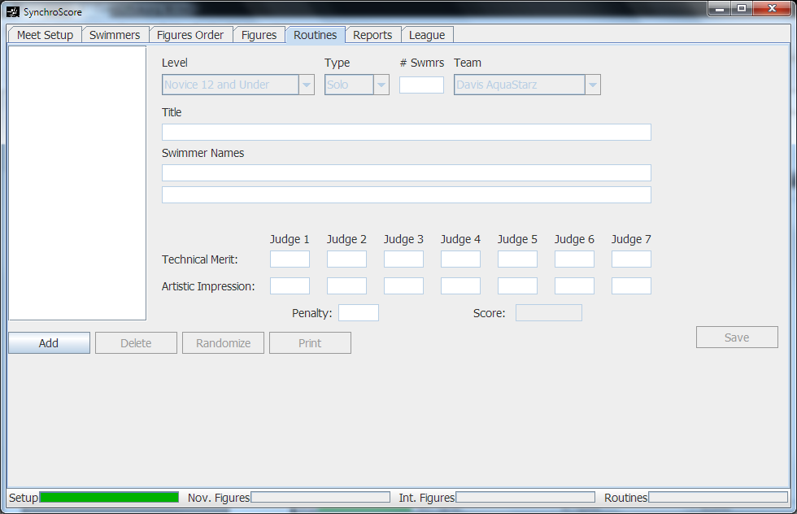
NOTE: the Routines progress meter currently does not work.

To print results, click on the Reports tab. This should be fairly self-explanatory...
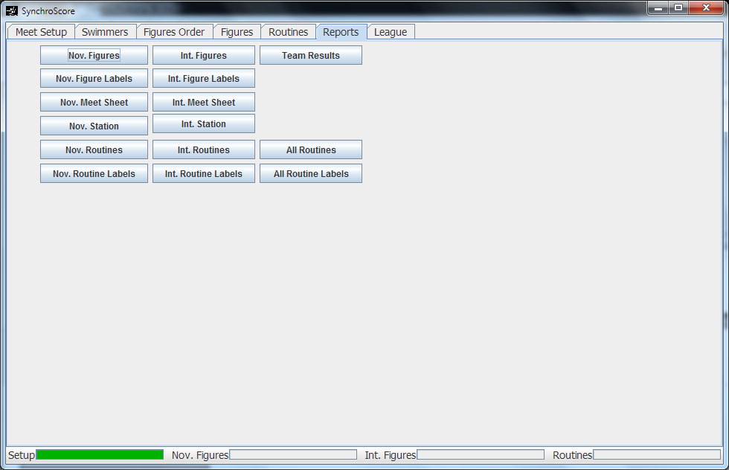

If you need to view or print a list of swimmers for the league or a team, you can do this on the League tab.
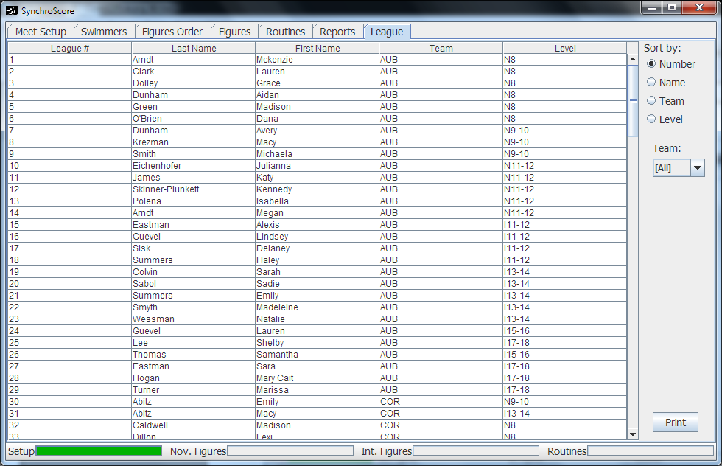

Maintenance

The only really useful parts of this window are the Update and Swimmers tabs.

On the Update tab, you have several buttons.
Import Swimmers – read a .csv file of all the swimmers in the league. This will update the current season's swimmers.

Export Swimmers – write a .csv file of all the swimmers in the league, asks for a season with the current season at the default. If you make changes to the swimmers, please export this file and email it to me.

Import Meet – read a .csv file of an exported meet for transferring all meet info from one computer to another or for archiving meet data.

Export Meet – write a .csv file of a meet (either complete or in-progress). You will be prompted for the season and meet.

Clear Database – completely erase all data for all meets, seasons, swimmers, etc. Only use this as a last resort to fix problems or when testing.

Check League Data – this will check and update certain fixed data like the list of figures, teams, levels, etc. It is safe to run this at anytime, but not necessary unless you have received a new version of the program and I have indicated that you need to do this.

The swimmers tab is where you can update names and levels for the swimmers in the league.
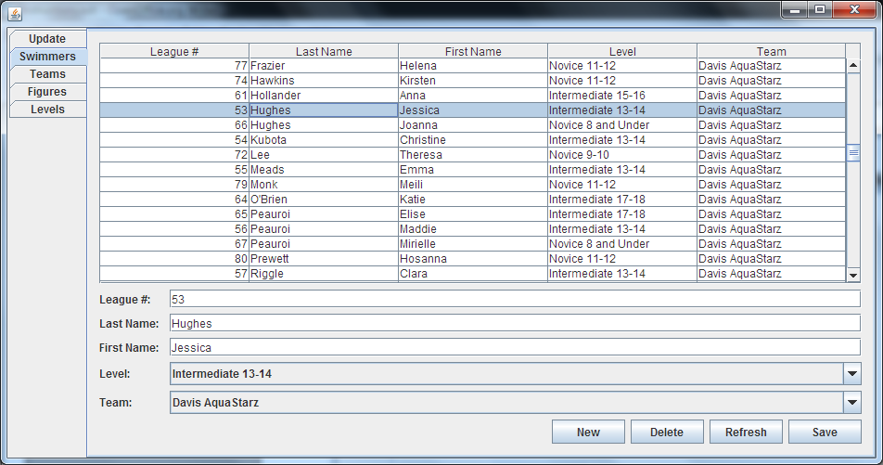
To Update: Click on a swimmer in the list, update the info below, and click the Save button.
To Add: Click New, add the info in the lower section, and click the Save button.

The League number must be typed in. It is not assigned automatically. However, it must be unique and is typically the next sequential number. To find the next league number, take a look at the League tab back in the main part of the program and sort the list by number.

