AMERICA 250 CHALLENGE COIN
Vendor Sourcing & Cost Sheet — 500 unit run
GPSInsight × ServiceBridge · v18 FINAL · May 2026
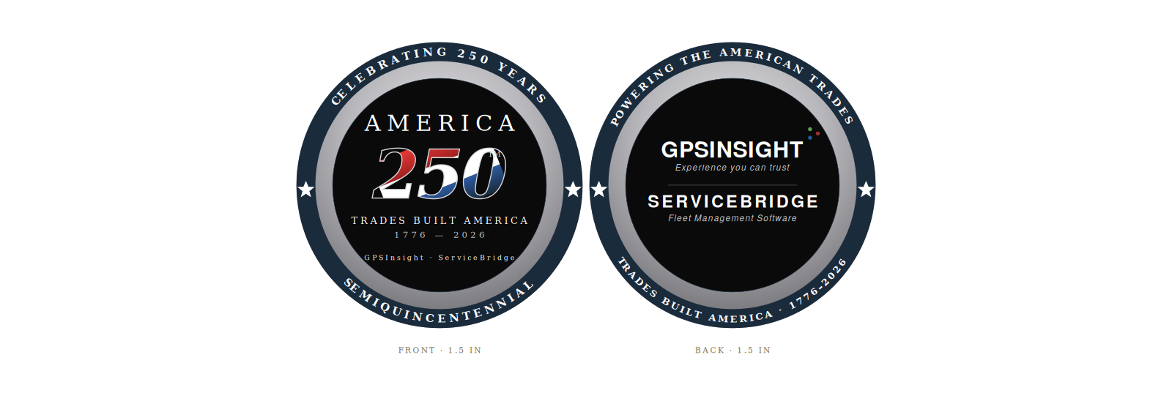
Design v18 FINAL · 1.5" diameter · Die-struck brass · Hard enamel · Antique silver rim with navy enamel band

1. Coin Specification
Diameter | 1.5 inch (38 mm)
Thickness | 3.0–3.5 mm
Base metal | Die-struck heavy brass (premium standard)
Color fill | Hard enamel, both sides (smooth jewelry finish)
Plating | Antique silver (rim) with navy and black enamel fields
Edge | Reeded (60 ticks)
Colors | 5–6 Pantone: Navy 295C, Red 187C, White, Antique Silver, GPS Blue 7691C, GPS Red 7621C, GPS Green 357C
Quantity | 500 coins
Packaging | Individual PVC pouch per coin (upgrade to velvet box optional for VIP/whale-hunt subset)

2. Vendor Comparison
Five qualified US-facing vendors with proven challenge coin production. All quotes are estimates for 500 units of the specified design. Final pricing requires submitted artwork and quote.
Vendor | Per-coin est. | 500 total est. | Mold fee | Lead time | Notes
All About Challenge Coins (preferred — prior relationship) | $3.50–$4.50 | $1,750–$2,250 | Waived at 300+ | 10–14 days (overseas) | ~2 wks (US-made die-struck) | Mike has used previously. Both overseas and American-made options. Proven track record.
ChallengeCoins4Less | $3.95–$4.75 | $1,975–$2,375 | Waived at 300+ | 14–17 days | Industry leader. Free design + revisions. Free US shipping. Mold kept 2 yrs.
MetalPromo | $3.75–$4.50 | $1,875–$2,250 | Waived at 300+ | 10–15 days | 15+ yrs experience. Quote within 24 hrs.

3. Cost Breakdown — 500 units
Typical all-in cost for 500 die-struck brass coins with two-sided hard enamel, antique silver plating, and reeded edge.
Line item | Low estimate | High estimate
Coins (500 × per-unit) | $1,750.00 | $2,375.00
Mold fee (typically waived at 300+) | $0.00 | $0.00
Setup / artwork | $0.00 | $0.00 (most vendors include free)
Standard PVC pouch packaging | $0.00 | $0.00 (typically included)
Upgrade: velvet box for 50 VIP coins ($3–$5/ea) | $150.00 | $250.00
Upgrade: acrylic capsule + desk display stand for ~120 VIP/leadership coins ($2–$5/ea) | $240.00 | $600.00
Domestic shipping (continental US) | $0.00 | $0.00 (typically free)
Rush fee (if needed, 15–30%) | $0.00 | Optional add
Subtotal (standard run) | $1,750.00 | $2,375.00
Subtotal w/ VIP velvet boxes + desk stands | $2,140.00 | $3,225.00

BOTTOM LINE — 500 coins, standard run: $1,750–$2,375
VIP velvet boxes (50): +$150–$250 · Desk display stands (120): +$240–$600 · All-in: $2,140–$3,225

4. Distribution Plan — 500 units
Recipient group | Count | Purpose
Existing GPS Insight / ServiceBridge clients | 200 | Customer recognition and loyalty
T1 franchisor leadership (9 targets × 3 coins each — Neighborly, Authority, Empower, ResiBrands, Five Star, PSB, HomeFront, BELFOR, Threshold) | 27 | Whale-hunt door-openers · CEO + 2 senior execs per franchisor
Track 2 sub-brands (85 brands × 1 coin each — across all 9 T1 franchisors) | 85 | Brand president recognition · day-in-the-life outreach
PE sponsors of T1 franchisors (8 firms × 2 coins each — KKR, Apax, MidOcean, Trivium/Contrarian, Princeton Equity, Roark, American Securities, Riverside) | 16 | PE relationship building · operating partner + senior partner per firm
Accel-KKR partners and operating team | 10 | PE sponsor relationship building
GPS Insight & ServiceBridge team (executive, board, and core team) | 50 | Internal alignment, team gift, morale
Reserve (re-orders, replacements, future opportunities) | 112 | Buffer
Total | 500

5. Action Items Before Order
- Mike and Becky agree on a formal campaign centered around the America 250 theme — with the challenge coin as the bond of the meaning and the campaign
- Confirm we are following the GPS Insight brand guidelines on logo use, 3-dot signature placement, and co-branding standards
- Andrea Rowan and Garrett Else sign-off on ServiceBridge wordmark, taglines, and the full coin design
- Lock the final SVG / vector art file for vendor handoff (artist will redraw in production format)
- Request final quotes from 3 vendors: All About Challenge Coins (preferred — prior relationship), ChallengeCoins4Less, and MetalPromo (competitive cross-quotes)
- Add a desk display stand option to both quotes — acrylic coin capsule + wood or metal base for desk presentation (typically $2–$5 per stand). Worth pricing as an upgrade for the VIP cohort (T1 franchisor CEOs, PE partners, Accel-KKR, GPS Insight & ServiceBridge leadership)

6. Recommendation
Lead vendor: All About Challenge Coins.
Mike has prior production experience with this vendor — a proven relationship outweighs marginal price differences at this volume. Estimated $3.50–$4.50 per coin for 500 units = $1,750–$2,250 total, plus optional VIP velvet box upgrade. They offer both overseas (10–14 day lead time) and American-made die-struck production for federal or PE-sensitive distribution.
Backup vendors: ChallengeCoins4Less and MetalPromo.
ChallengeCoins4Less is a strong industry leader with US-based service, free design with unlimited revisions, free US shipping, and 14–17 day lead time. MetalPromo brings 15+ years of experience with 24-hour quote turnaround. Both serve as competitive cross-checks on the All About Challenge Coins quote.
Recommended approach: Submit identical RFQ to all 3 vendors this week. Lead vendor (All About Challenge Coins) wins on existing relationship unless quote variance exceeds ~15%. Lock vendor by end of week with target delivery before July 4, 2026 (America 250 national event).

