--inner join ejercicios

--1. Obtener los nombres de los clientes y las fechas de sus pedidos.
SELECT Customers.CustomerName, Orders.OrderDate
FROM Customers
INNER JOIN Orders ON Customers.CustomerID = Orders.CustomerID;
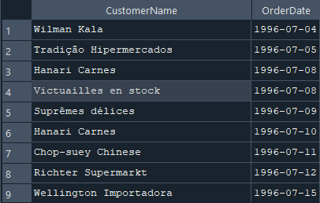
--2. Listar los productos y sus respectivas categorías.
SELECT Products.ProductName, Categories.CategoryName
FROM Products
INNER JOIN Categories ON Products.CategoryID = Categories.CategoryID;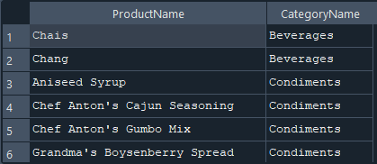

--3. Mostrar los nombres de los empleados y las órdenes que gestionaron.
SELECT Employees.FirstName, Employees.LastName AS EmployeeName, Orders.OrderID
FROM Employees
INNER JOIN Orders ON Employees.EmployeeID = Orders.EmployeeID;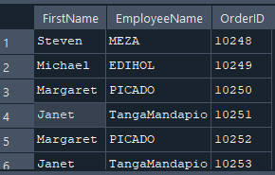
--4. Obtener los nombres de los productos y los nombres de sus proveedores.
SELECT Products.ProductName, Suppliers.SupplierName
FROM Products
INNER JOIN
Suppliers ON Products.SupplierID = Suppliers.SupplierID;
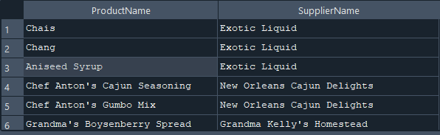

--5lista de pedidios y los metodos de envios utilizados
SELECT Orders.OrderID, Shippers.ShipperName
FROM Orders
INNER JOIN Shippers ON Orders.ShipperID = Shippers.ShipperID;
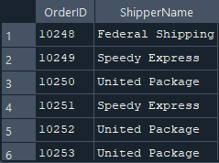
--6. Mostrar los detalles de cada pedido y los productos correspondientes.
SELECT OrderDetails.OrderID, Products.ProductName, OrderDetails.Quantity
FROM OrderDetails
INNER JOIN Products ON OrderDetails.ProductID = Products.ProductID;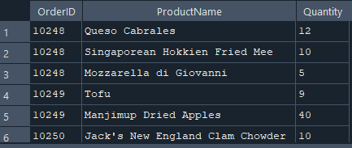
--7. Listar los nombres de los clientes junto con los empleados que atendieron sus pedidos.--
SELECT Customers.CustomerName, Employees.FirstName, Employees.LastName AS EmployeeName
FROM Orders
INNER JOIN Customers ON Orders.CustomerID = Customers.CustomerID
INNER JOIN Employees ON Orders.EmployeeID = Employees.EmployeeID
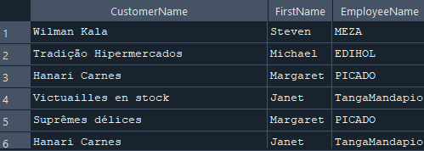
--8. Obtener el nombre de los empleados y las órdenes que han atendido.
SELECT Employees.FirstName, Employees.LastName AS EmployeeName, Orders.OrderID
FROM Employees
INNER JOIN Orders ON Employees.EmployeeID = Orders.EmployeeID;
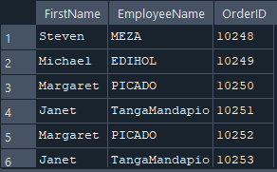
---9. Mostrar los productos y sus respectivas unidades de medida.
SELECT Products.ProductName, Products.Unit
FROM Products;
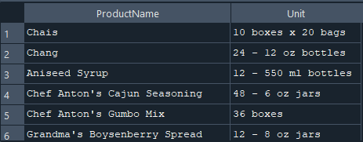

--10. Listar los proveedores y los productos que suministran.
SELECT Suppliers.SupplierName, Products.ProductName
FROM Suppliers
INNER JOIN Products ON Suppliers.SupplierID = Products.SupplierID;
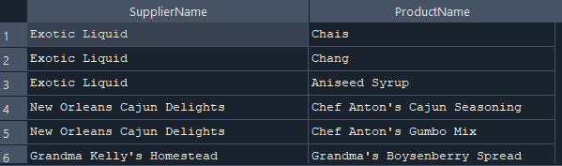
--INNER JOIN con 3 tablas
--1. Obtener los nombres de los clientes, los pedidos y las fechas en que se realizaron.
SELECT Customers.CustomerName, Orders.OrderID, Orders.OrderDate
FROM Customers
INNER JOIN Orders ON Customers.CustomerID = Orders.CustomerID;
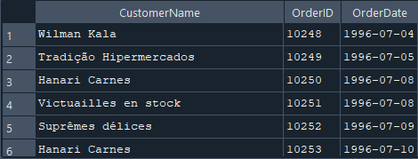
--2. Listar los productos, sus categorías y los proveedores.

SELECT Products.ProductName, Categories.CategoryName, Suppliers.SupplierName
FROM Products
INNER JOIN
Categories ON Products.CategoryID = Categories.CategoryID
INNER JOIN
Suppliers ON Products.SupplierID = Suppliers.SupplierID;
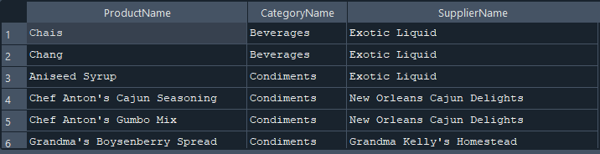
--3. Mostrar los empleados, los pedidos que gestionaron y los clientes correspondientes.
SELECT Employees.FirstName, Employees.LastName AS EmployeeName,
Orders.OrderID,
Customers.CustomerName
FROM Employees
INNER JOIN
Orders ON Employees.EmployeeID = Orders.EmployeeID
INNER JOIN
Customers ON Orders.CustomerID = Customers.CustomerID;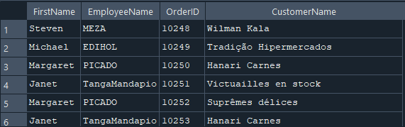
--4. Obtener los detalles de los pedidos junto con los productos y sus categorías.
SELECT OrderDetails.OrderID,
Products.ProductName,
Categories.CategoryName,
OrderDetails.Quantity
FROM OrderDetails
INNER JOIN
Products ON OrderDetails.ProductID = Products.ProductID
INNER JOIN
Categories ON Products.CategoryID = Categories.CategoryID;
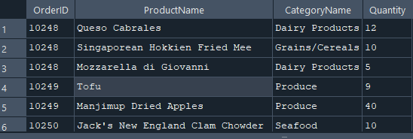
--5. Listar los pedidos, los clientes y los empleados involucrados.
SELECT Orders.OrderID,
Customers.CustomerName,
Employees.FirstName, Employees.LastName AS EmployeeName
FROM Orders
INNER JOIN
Customers ON Orders.CustomerID = Customers.CustomerID
INNER JOIN
Employees ON Orders.EmployeeID = Employees.EmployeeID;
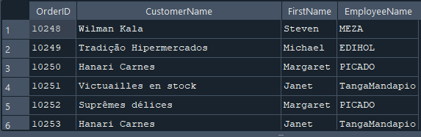
--6. Mostrar los productos, sus precios y los proveedores que los venden.
SELECT Products.ProductName,
Products.Price,
Suppliers.SupplierName
FROM Products
INNER JOIN Suppliers ON Products.SupplierID = Suppliers.SupplierID;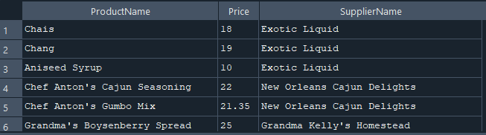
--7. Obtener los pedidos, los productos involucrados y sus cantidades.
SELECT Orders.OrderID,
Products.ProductName,
OrderDetails.Quantity
FROM Orders
INNER JOIN
OrderDetails ON Orders.OrderID = OrderDetails.OrderID
INNER JOIN
Products ON OrderDetails.ProductID = Products.ProductID;
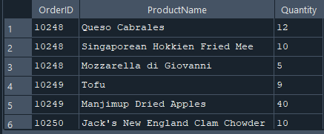
--8. Listar los empleados, los pedidos y los métodos de envío.
SELECT Employees.FirstName, Employees.LastName AS EmployeeName,
Orders.OrderID,
Shippers.ShipperName
FROM Orders
INNER JOIN Employees ON Orders.EmployeeID = Employees.EmployeeID
INNER JOIN Shippers ON Orders.ShipperID = Shippers.ShipperID;
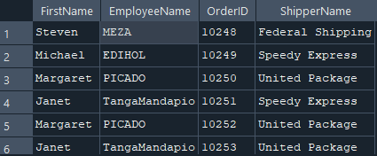
--9. Mostrar los clientes, sus pedidos y los productos que compraron.
SELECT Customers.CustomerName,
Orders.OrderID,
Products.ProductName
FROM Customers
INNER JOIN
Orders ON Customers.CustomerID = Orders.CustomerID
INNER JOIN
OrderDetails ON Orders.OrderID = OrderDetails.OrderID
INNER JOIN
Products ON OrderDetails.ProductID = Products.ProductID;
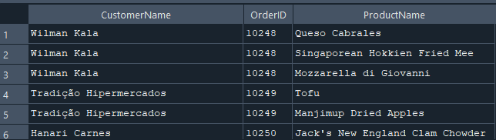
--10. Obtener los pedidos, los productos y las categorías de cada producto.
SELECT Orders.OrderID,
Products.ProductName,
Categories.CategoryName
FROM Orders
INNER JOIN
OrderDetails ON Orders.OrderID = OrderDetails.OrderID
INNER JOIN
Products ON OrderDetails.ProductID = Products.ProductID
INNER JOIN
Categories ON Products.CategoryID = Categories.CategoryID;
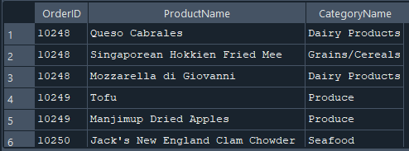

--INNER JOIN con 5 tablas

--1. Listar los pedidos con la información del cliente, empleado, productos y cantidades.
SELECT Orders.OrderID,
Customers.CustomerName,
Employees.FirstName, Employees.LastName AS EmployeeName,
Products.ProductName,
OrderDetails.Quantity
FROM Orders
INNER JOIN
Customers ON Orders.CustomerID = Customers.CustomerID
INNER JOIN
Employees ON Orders.EmployeeID = Employees.EmployeeID
INNER JOIN
OrderDetails ON Orders.OrderID = OrderDetails.OrderID
INNER JOIN
Products ON OrderDetails.ProductID = Products.ProductID;
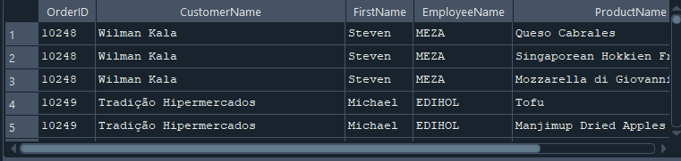
--2. Obtener los nombres de los productos, sus categorías, proveedores y pedidos en los que
--se incluyen.
SELECT Products.ProductName,
Categories.CategoryName,
Suppliers.SupplierName,
Orders.OrderID
FROM Products
INNER JOIN
Categories ON Products.CategoryID = Categories.CategoryID
INNER JOIN
Suppliers ON Products.SupplierID = Suppliers.SupplierID
INNER JOIN
OrderDetails ON Products.ProductID = OrderDetails.ProductID
INNER JOIN
Orders ON OrderDetails.OrderID = Orders.OrderID;
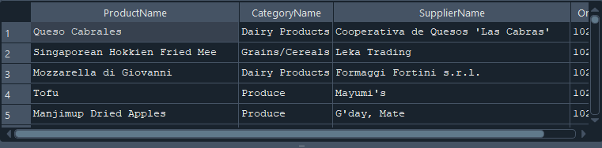
--3. Mostrar los pedidos con información del cliente, empleado, transportista y detalles del
--pedido.
SELECT Orders.OrderID,
Customers.CustomerName,
Employees.FirstName, Employees.LastName AS EmployeeName,
Shippers.ShipperName,
Products.ProductName,
OrderDetails.Quantity
FROM Orders
INNER JOIN
Customers ON Orders.CustomerID = Customers.CustomerID
INNER JOIN
Employees ON Orders.EmployeeID = Employees.EmployeeID
INNER JOIN
Shippers ON Orders.ShipperID = Shippers.ShipperID
INNER JOIN
OrderDetails ON Orders.OrderID = OrderDetails.OrderID
INNER JOIN
Products ON OrderDetails.ProductID = Products.ProductID;
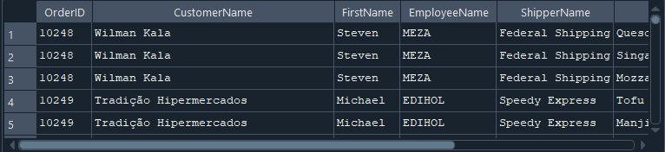
--4. Obtener una lista de pedidos con detalles completos de cliente, empleado y productos.
SELECT Orders.OrderID,
Customers.CustomerName,
Employees.FirstName, Employees.LastName AS EmployeeName,
Products.ProductName,
OrderDetails.Quantity
FROM Orders
INNER JOIN
Customers ON Orders.CustomerID = Customers.CustomerID
INNER JOIN
Employees ON Orders.EmployeeID = Employees.EmployeeID
INNER JOIN
OrderDetails ON Orders.OrderID = OrderDetails.OrderID
INNER JOIN
Products ON OrderDetails.ProductID = Products.ProductID;
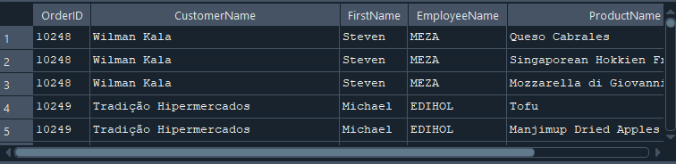
--5. Mostrar información de pedidos incluyendo datos del producto y la categoría.
SELECT Orders.OrderID,
Customers.CustomerName,
Products.ProductName,
Categories.CategoryName,
OrderDetails.Quantity
FROM Orders
INNER JOIN
Customers ON Orders.CustomerID = Customers.CustomerID
INNER JOIN
OrderDetails ON Orders.OrderID = OrderDetails.OrderID
INNER JOIN
Products ON OrderDetails.ProductID = Products.ProductID
INNER JOIN
Categories ON Products.CategoryID = Categories.CategoryID;
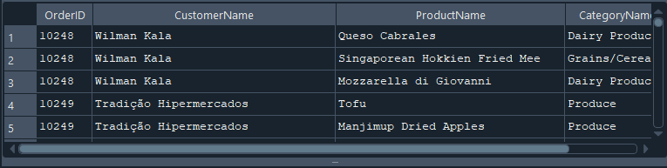
--6. Listar los clientes, los empleados que gestionaron su pedido, los productos comprados y
--sus proveedores.
SELECT Customers.CustomerName,
Employees.FirstName, Employees.LastName AS EmployeeName,
Products.ProductName,
Suppliers.SupplierName
FROM Orders
INNER JOIN
Customers ON Orders.CustomerID = Customers.CustomerID
INNER JOIN
Employees ON Orders.EmployeeID = Employees.EmployeeID
INNER JOIN
OrderDetails ON Orders.OrderID = OrderDetails.OrderID
INNER JOIN
Products ON OrderDetails.ProductID = Products.ProductID
INNER JOIN
Suppliers ON Products.SupplierID = Suppliers.SupplierID;
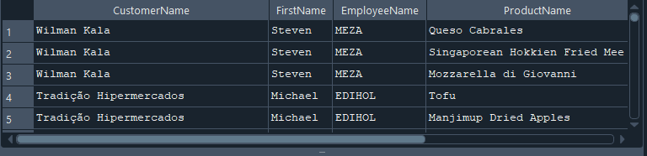
--7. Obtener información de los pedidos con los clientes y los productos vendidos.
SELECT Orders.OrderID,
Customers.CustomerName,
Products.ProductName,
OrderDetails.Quantity
FROM Orders
INNER JOIN
Customers ON Orders.CustomerID = Customers.CustomerID
INNER JOIN
OrderDetails ON Orders.OrderID = OrderDetails.OrderID
INNER JOIN
Products ON OrderDetails.ProductID = Products.ProductID;
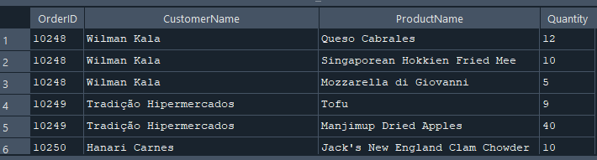
--8. Mostrar los pedidos, los clientes y los métodos de envío junto con los productos
--comprados.
SELECT Orders.OrderID,
Customers.CustomerName,
Shippers.ShipperName,
Products.ProductName,
OrderDetails.Quantity
FROM Orders
INNER JOIN
Customers ON Orders.CustomerID = Customers.CustomerID
INNER JOIN
Shippers ON Orders.ShipperID = Shippers.ShipperID
INNER JOIN
OrderDetails ON Orders.OrderID = OrderDetails.OrderID
INNER JOIN
Products ON OrderDetails.ProductID = Products.ProductID;
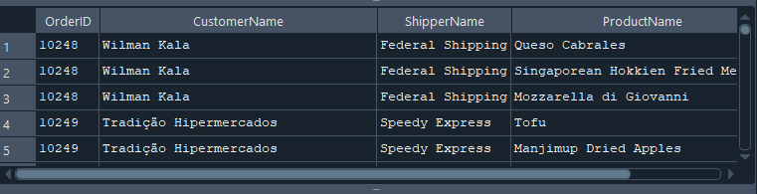
--9. Obtener una lista de productos con sus categorías, proveedores y detalles en los pedidos.
SELECT Products.ProductName,
Categories.CategoryName,
Suppliers.SupplierName,
Orders.OrderID,
OrderDetails.Quantity
FROM Products
INNER JOIN
Categories ON Products.CategoryID = Categories.CategoryID
INNER JOIN
Suppliers ON Products.SupplierID = Suppliers.SupplierID
INNER JOIN
OrderDetails ON Products.ProductID = OrderDetails.ProductID
INNER JOIN
Orders ON OrderDetails.OrderID = Orders.OrderID;
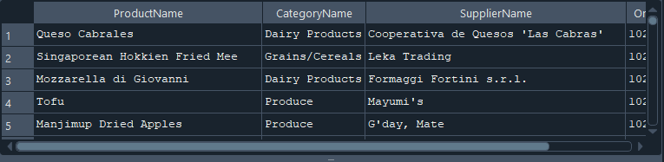
--10. Mostrar los empleados, los pedidos, los clientes, los productos y los métodos de envío.
SELECT Employees.FirstName, Employees.LastName AS EmployeeName,
Orders.OrderID,
Customers.CustomerName,
Products.ProductName,
Shippers.ShipperName
FROM Orders
INNER JOIN
Employees ON Orders.EmployeeID = Employees.EmployeeID
INNER JOIN
Customers ON Orders.CustomerID = Customers.CustomerID
INNER JOIN
OrderDetails ON Orders.OrderID = OrderDetails.OrderID
INNER JOIN
Products ON OrderDetails.ProductID = Products.ProductID
INNER JOIN
Shippers ON Orders.ShipperID = Shippers.ShipperID;
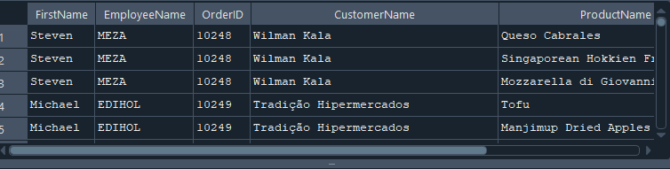
---INNER JOIN con 8 tablas

---1. Obtener una lista de pedidos con información completa del cliente, empleado,
--transportista y productos involucrados.

SELECT Orders.OrderID,
Customers.CustomerName,
Employees.FirstName, Employees.LastName AS EmployeeName,
Shippers.ShipperName,
Products.ProductName,
OrderDetails.Quantity
FROM Orders
INNER JOIN
Customers ON Orders.CustomerID = Customers.CustomerID
INNER JOIN
Employees ON Orders.EmployeeID = Employees.EmployeeID
INNER JOIN
Shippers ON Orders.ShipperID = Shippers.ShipperID
INNER JOIN
OrderDetails ON Orders.OrderID = OrderDetails.OrderID
INNER JOIN
Products ON OrderDetails.ProductID = Products.ProductID;
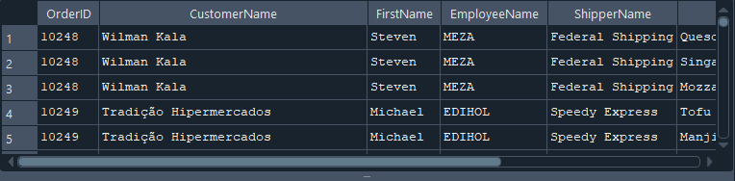
--2. Mostrar los clientes con detalles de sus pedidos y los productos adquiridos, junto con los
--proveedores.
SELECT Customers.CustomerName,
Orders.OrderID,
Products.ProductName,
Suppliers.SupplierName,
OrderDetails.Quantity
FROM Customers
INNER JOIN
Orders ON Customers.CustomerID = Orders.CustomerID
INNER JOIN
OrderDetails ON Orders.OrderID = OrderDetails.OrderID
INNER JOIN
Products ON OrderDetails.ProductID = Products.ProductID
INNER JOIN
Suppliers ON Products.SupplierID = Suppliers.SupplierID;
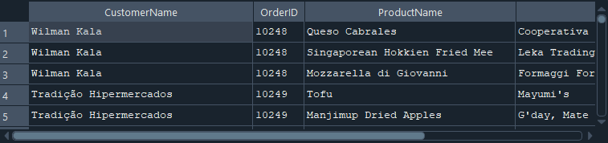
--3. Obtener una vista de los empleados y todos los pedidos que han atendido con detalles
--completos.
SELECT Employees.FirstName, Employees.LastName AS EmployeeName,
Orders.OrderID,
Customers.CustomerName,
Products.ProductName,
OrderDetails.Quantity,
Shippers.ShipperName
FROM Employees
INNER JOIN
Orders ON Employees.EmployeeID = Orders.EmployeeID
INNER JOIN
Customers ON Orders.CustomerID = Customers.CustomerID
INNER JOIN
OrderDetails ON Orders.OrderID = OrderDetails.OrderID
INNER JOIN
Products ON OrderDetails.ProductID = Products.ProductID
INNER JOIN
Shippers ON Orders.ShipperID = Shippers.ShipperID;
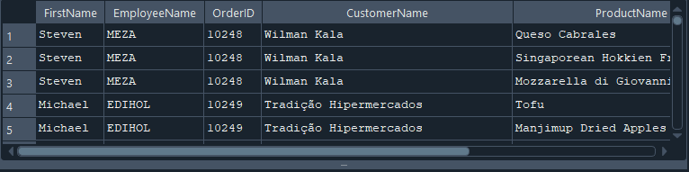
--4. Mostrar los detalles de pedidos incluyendo el cliente, empleado, productos y proveedores.
SELECT Orders.OrderID,
Customers.CustomerName,
Employees.FirstName, Employees.LastName AS EmployeeName,
Products.ProductName,
Suppliers.SupplierName,
OrderDetails.Quantity
FROM Orders
INNER JOIN Customers ON Orders.CustomerID = Customers.CustomerID
INNER JOIN Employees ON Orders.EmployeeID = Employees.EmployeeID
INNER JOIN OrderDetails ON Orders.OrderID = OrderDetails.OrderID
INNER JOIN Products ON OrderDetails.ProductID = Products.ProductID
INNER JOIN Suppliers ON Products.SupplierID = Suppliers.SupplierID;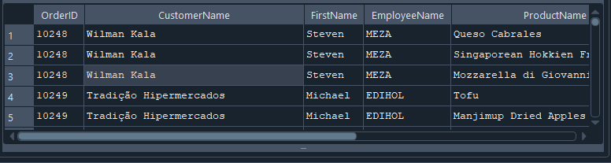

--5. Listar todos los pedidos con información detallada de clientes, empleados, productos y
--métodos de envío.
SELECT Orders.OrderID,
Customers.CustomerName,
Employees.FirstName, Employees.LastName AS EmployeeName,
Shippers.ShipperName,
Products.ProductName,
Categories.CategoryName,
Suppliers.SupplierName,
OrderDetails.Quantity
FROM Orders
INNER JOIN
Customers ON Orders.CustomerID = Customers.CustomerID
INNER JOIN
Employees ON Orders.EmployeeID = Employees.EmployeeID
INNER JOIN
Shippers ON Orders.ShipperID = Shippers.ShipperID
INNER JOIN
OrderDetails ON Orders.OrderID = OrderDetails.OrderID
INNER JOIN
Products ON OrderDetails.ProductID = Products.ProductID
INNER JOIN
Categories ON Products.CategoryID = Categories.CategoryID
INNER JOIN
Suppliers ON Products.SupplierID = Suppliers.SupplierID;
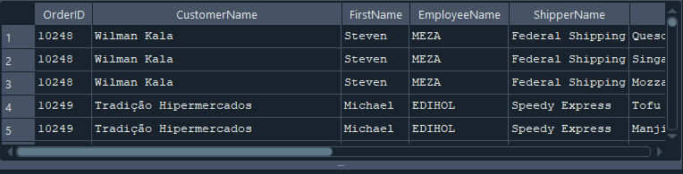
--6. Obtener los detalles de pedidos con los productos, proveedores, clientes y empleados
--involucrados.
SELECT Orders.OrderID,
Customers.CustomerName,
Employees.FirstName, Employees.LastName AS EmployeeName,
Products.ProductName,
Suppliers.SupplierName,
Categories.CategoryName,
OrderDetails.Quantity
FROM Orders
INNER JOIN
Customers ON Orders.CustomerID = Customers.CustomerID
INNER JOIN
Employees ON Orders.EmployeeID = Employees.EmployeeID
INNER JOIN
OrderDetails ON Orders.OrderID = OrderDetails.OrderID
INNER JOIN
Products ON OrderDetails.ProductID = Products.ProductID
INNER JOIN
Categories ON Products.CategoryID = Categories.CategoryID
INNER JOIN
Suppliers ON Products.SupplierID = Suppliers.SupplierID;
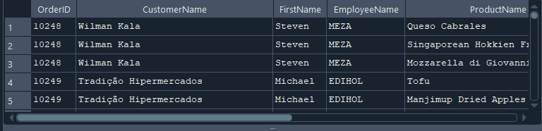
--7. Mostrar una lista completa de los pedidos con datos del cliente, empleado, producto,
--categoría y proveedor.
SELECT Orders.OrderID,
Customers.CustomerName,
Employees.FirstName, Employees.LastName AS EmployeeName,
Products.ProductName,
Categories.CategoryName,
Suppliers.SupplierName,
OrderDetails.Quantity
FROM Orders
INNER JOIN
Customers ON Orders.CustomerID = Customers.CustomerID
INNER JOIN
Employees ON Orders.EmployeeID = Employees.EmployeeID
INNER JOIN
OrderDetails ON Orders.OrderID = OrderDetails.OrderID
INNER JOIN
Products ON OrderDetails.ProductID = Products.ProductID
INNER JOIN
Categories ON Products.CategoryID = Categories.CategoryID
INNER JOIN
Suppliers ON Products.SupplierID = Suppliers.SupplierID;
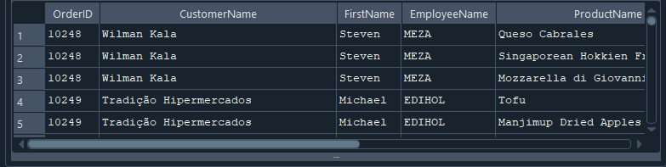
--8. Listar las órdenes con detalles completos de los clientes, empleados, transportistas,
--productos y sus categorías.
SELECT Orders.OrderID,
Customers.CustomerName,
Employees.FirstName, Employees.LastName AS EmployeeName,
Shippers.ShipperName,
Products.ProductName,
Categories.CategoryName,
OrderDetails.Quantity
FROM Orders
INNER JOIN
Customers ON Orders.CustomerID = Customers.CustomerID
INNER JOIN
Employees ON Orders.EmployeeID = Employees.EmployeeID
INNER JOIN
Shippers ON Orders.ShipperID = Shippers.ShipperID
INNER JOIN
OrderDetails ON Orders.OrderID = OrderDetails.OrderID
INNER JOIN
Products ON OrderDetails.ProductID = Products.ProductID
INNER JOIN
Categories ON Products.CategoryID = Categories.CategoryID;
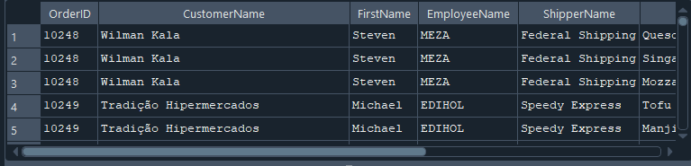
--9. Obtener una vista consolidada de la base de datos con pedidos, clientes, empleados,
--productos, proveedores y transportistas.
SELECT Orders.OrderID,
Customers.CustomerName,
Employees.FirstName, Employees.LastName AS EmployeeName,
Shippers.ShipperName,
Products.ProductName,
Categories.CategoryName,
Suppliers.SupplierName,
OrderDetails.Quantity
FROM Orders
INNER JOIN
Customers ON Orders.CustomerID = Customers.CustomerID
INNER JOIN
Employees ON Orders.EmployeeID = Employees.EmployeeID
INNER JOIN
Shippers ON Orders.ShipperID = Shippers.ShipperID
INNER JOIN
OrderDetails ON Orders.OrderID = OrderDetails.OrderID
INNER JOIN
Products ON OrderDetails.ProductID = Products.ProductID
INNER JOIN
Categories ON Products.CategoryID = Categories.CategoryID
INNER JOIN
Suppliers ON Products.SupplierID = Suppliers.SupplierID;
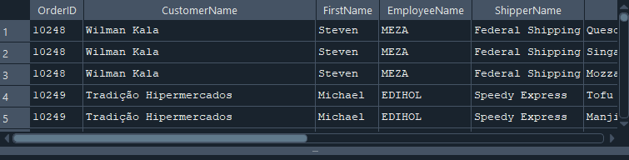
--10. Mostrar la relación completa entre órdenes, clientes, empleados, productos,
--proveedores, transportistas y detalles del pedido.
SELECT Orders.OrderID,
Customers.CustomerName,
Employees.FirstName, Employees.LastName AS EmployeeName,
Shippers.ShipperName,
Products.ProductName,
Categories.CategoryName,
Suppliers.SupplierName,
OrderDetails.Quantity
FROM Orders
INNER JOIN
Customers ON Orders.CustomerID = Customers.CustomerID
INNER JOIN
Employees ON Orders.EmployeeID = Employees.EmployeeID
INNER JOIN
Shippers ON Orders.ShipperID = Shippers.ShipperID
INNER JOIN
OrderDetails ON Orders.OrderID = OrderDetails.OrderID
INNER JOIN
Products ON OrderDetails.ProductID = Products.ProductID
INNER JOIN
Categories ON Products.CategoryID = Categories.CategoryID
INNER JOIN
Suppliers ON Products.SupplierID = Suppliers.SupplierID;
