-- Ejercicios de INNER JOIN en SQLite --

--INNER JOIN con 2 tablas
--1. Obtener los nombres de los clientes y las fechas de sus pedidos.
SELECT Customers.CustomerName, Orders.OrderDate
FROM Customers
INNER JOIN Orders ON Customers.CustomerID = Orders.CustomerID;
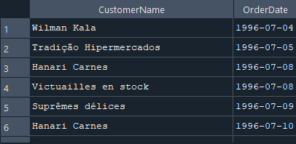

--2. Listar los productos y sus respectivas categorías.
SELECT Products.ProductName, Categories.CategoryName
FROM Products
INNER JOIN Categories ON Products.CategoryID = Categories.CategoryID;
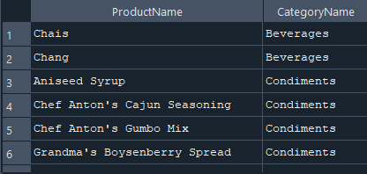

--3. Mostrar los nombres de los empleados y las órdenes que gestionaron.
SELECT Employees.FirstName, Employees.LastName, Orders.OrderID
FROM Employees
INNER JOIN Orders ON Employees.EmployeeID = Orders.EmployeeID;
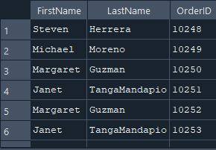

--4. Obtener los nombres de los productos y los nombres de sus proveedores.
SELECT Products.ProductName, Suppliers.SupplierName
FROM Products
INNER JOIN Suppliers ON Products.SupplierID = Suppliers.SupplierID;
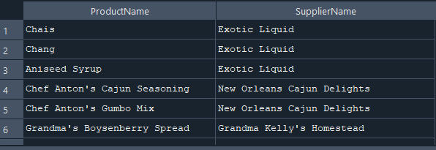

--5. Listar los pedidos y los métodos de envío utilizados.
SELECT Orders.OrderID, Shippers.ShipperName
FROM Orders
INNER JOIN Shippers ON Orders.ShipperID = Shippers.ShipperID;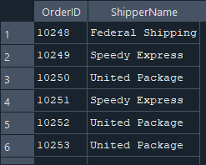

--6. Mostrar los detalles de cada pedido y los productos correspondientes.
SELECT OrderDetails.OrderID, Products.ProductName
FROM OrderDetails
INNER JOIN Products ON OrderDetails.ProductID = Products.ProductID;
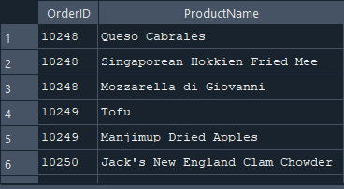

--7. Listar los nombres de los clientes junto con los empleados que atendieron sus pedidos.
SELECT Customers.CustomerName, Employees.FirstName, Employees.LastName
FROM Orders
INNER JOIN Customers ON Orders.CustomerID = Customers.CustomerID
INNER JOIN Employees ON Orders.EmployeeID = Employees.EmployeeID;
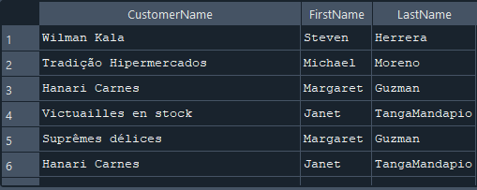

--8. Obtener el nombre de los empleados y las órdenes que han atendido.
SELECT Employees.FirstName, Employees.LastName, Orders.OrderID
FROM Employees
INNER JOIN Orders ON Employees.EmployeeID = Orders.EmployeeID;
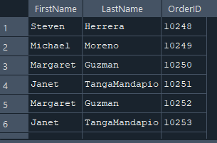

--9. Mostrar los productos y sus respectivas unidades de medida.
SELECT ProductName, Unit
FROM Products;
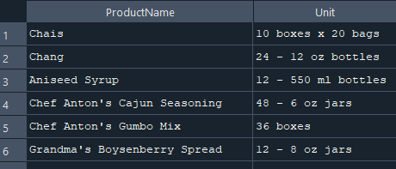

--10. Listar los proveedores y los productos que suministran.
SELECT
s.SupplierName,
p.ProductName
FROM
Suppliers s
INNER JOIN
Products p ON s.SupplierID = p.SupplierID;
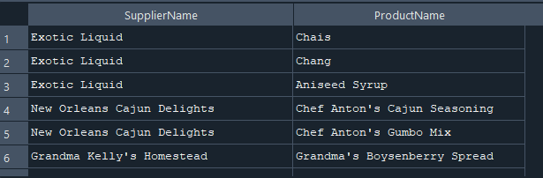

--INNER JOIN con 3 tablas
--1. Obtener los nombres de los clientes, los pedidos y las fechas en que se realizaron.
SELECT
c.CustomerName,
o.OrderID,
o.OrderDate
FROM
Customers c
INNER JOIN
Orders o ON c.CustomerID = o.CustomerID
INNER JOIN
OrderDetails od ON o.OrderID = od.OrderID;
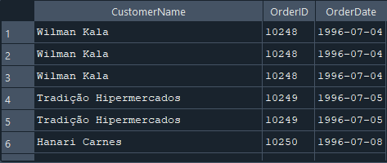

--2. Listar los productos, sus categorías y los proveedores.
SELECT p.ProductName,c.CategoryName,s.SupplierName
FROM Products p
INNER JOIN
Categories c ON p.CategoryID = c.CategoryID
INNER JOIN
Suppliers s ON p.SupplierID = s.SupplierID;
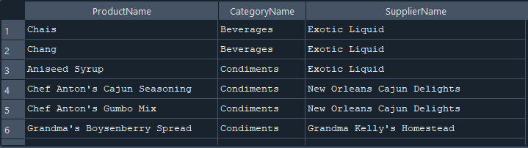

--3. Mostrar los empleados, los pedidos que gestionaron y los clientes correspondientes.
SELECT e.FirstName, e.LastName AS Empleado,o.OrderID AS Pedido,c.CustomerName AS Cliente
FROM Employees e
INNER JOIN
Orders o ON e.EmployeeID = o.EmployeeID
INNER JOIN
Customers c ON o.CustomerID = c.CustomerID;
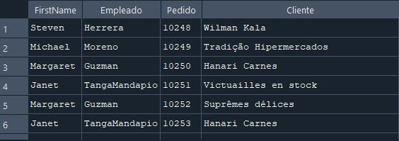

--4. Obtener los detalles de los pedidos junto con los productos y sus categorías.
SELECT od.OrderID AS Pedido,p.ProductName AS Producto,c.CategoryName AS Categoría
FROM OrderDetails od
INNER JOIN
Products p ON od.ProductID = p.ProductID
INNER JOIN
Categories c ON p.CategoryID = c.CategoryID;
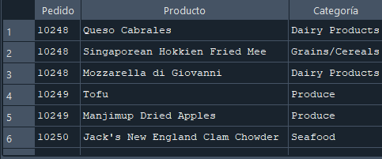

--5. Listar los pedidos, los clientes y los empleados involucrados.
SELECT o.OrderID AS Pedido,c.CustomerName AS Cliente,e.FirstName, e.LastName AS Empleado
FROM Orders o
INNER JOIN
Customers c ON o.CustomerID = c.CustomerID
INNER JOIN
Employees e ON o.EmployeeID = e.EmployeeID;
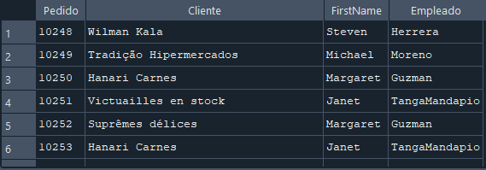

--6. Mostrar los productos, sus precios y los proveedores que los venden.
SELECT p.ProductName AS producto,p.price AS precio,s.SupplierName AS proveedor
FROM Products p
INNER JOIN
Suppliers s ON p.SupplierID=s.SupplierID
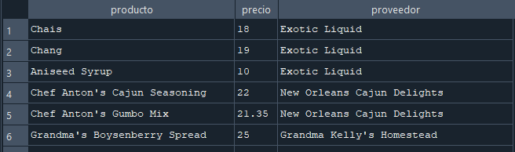

--7. Obtener los pedidos, los productos involucrados y sus cantidades.
SELECT o.OrderID AS Pedido,p.ProductName AS Producto,od.Quantity AS Cantidad
FROM Orders o
INNER JOIN
OrderDetails od ON o.OrderID = od.OrderID
INNER JOIN
Products p ON od.ProductID = p.ProductID;
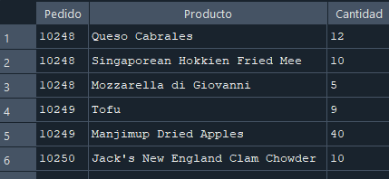

--8. Listar los empleados, los pedidos y los métodos de envío.
SELECT e.FirstName, e.LastName AS Empleado,o.OrderID AS Pedido,s.ShipperName AS "Método de Envío"
FROM Employees e
INNER JOIN
Orders o ON e.EmployeeID = o.EmployeeID
INNER JOIN
Shippers s ON o.ShipperID = s.ShipperID;
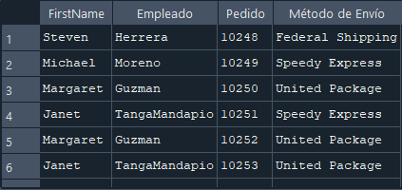

--9. Mostrar los clientes, sus pedidos y los productos que compraron.

SELECT c.CustomerName AS Cliente,o.OrderID AS Pedido,p.ProductName AS Producto
FROM Customers c
INNER JOIN Orders o ON c.CustomerID = o.CustomerID
INNER JOIN OrderDetails od ON o.OrderID = od.OrderID
INNER JOIN Products p ON od.ProductID = p.ProductID
WHERE c.CustomerID = 1;
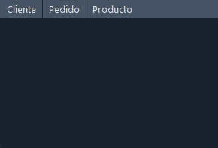

--10. Obtener los pedidos, los productos y las categorías de cada producto.
SELECT o.OrderID AS pedido, ProductName AS producto, c.CategoryID AS categoria
FROM Orders o
INNER JOIN
OrderDetails od ON o.OrderID= o.OrderID
INNER JOIN
Products p ON od.ProductID= od.ProductID
INNER JOIN
Categories c ON p.CategoryID= p.CategoryID
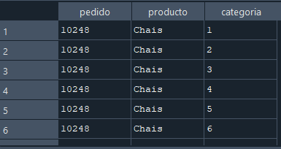

--INNER JOIN con 5 tablas
--1. Listar los pedidos con la información del cliente, empleado, productos y cantidades.
SELECT o.OrderID AS Pedido,c.CustomerName AS Cliente,e.FirstName, e.LastName AS Empleado,p.ProductName AS Producto,od.Quantity AS Cantidad
FROM Orders o
INNER JOIN
Customers c ON o.CustomerID = c.CustomerID
INNER JOIN
Employees e ON o.EmployeeID = e.EmployeeID
INNER JOIN
OrderDetails od ON o.OrderID = od.OrderID
INNER JOIN
Products p ON od.ProductID = p.ProductID;
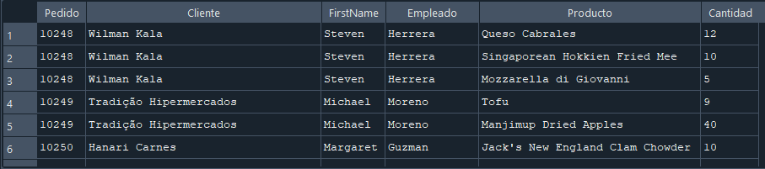

--2. Obtener los nombres de los productos, sus categorías, proveedores y pedidos en los que se incluyen.
SELECT p.ProductName AS Producto,c.CategoryName AS Categoría,s.SupplierName AS Proveedor,o.OrderID AS Pedido
FROM Products p
INNER JOIN
Categories c ON p.CategoryID = c.CategoryID
INNER JOIN
Suppliers s ON p.SupplierID = s.SupplierID
INNER JOIN
OrderDetails od ON p.ProductID = od.ProductID
INNER JOIN
Orders o ON od.OrderID = o.OrderID;
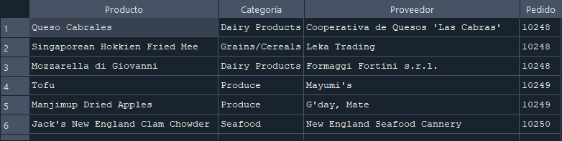

--3. Mostrar los pedidos con información del cliente, empleado, transportista y detalles del pedido.
SELECT o.OrderID AS Pedido,c.CustomerName AS Cliente,e.FirstName, e.LastName AS Empleado,s.ShipperName AS "Método de Envío",od.Quantity AS Cantidad,p.ProductName AS Producto
FROM Orders o
INNER JOIN
Customers c ON o.CustomerID = c.CustomerID
INNER JOIN
Employees e ON o.EmployeeID = e.EmployeeID
INNER JOIN
Shippers s ON o.ShipperID = s.ShipperID
INNER JOIN
OrderDetails od ON o.OrderID = od.OrderID
INNER JOIN
Products p ON od.ProductID = p.ProductID;
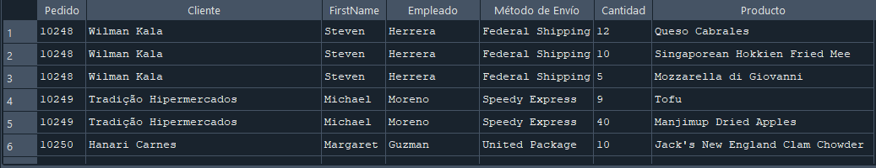

--4. Obtener una lista de pedidos con detalles completos de cliente, empleado y productos.
SELECT o.OrderID AS Pedido,c.CustomerName AS Cliente, e.FirstName, e.LastName AS Empleado,p.ProductName AS Producto,od.Quantity AS Cantidad,p.Price AS Precio,(od.Quantity * p.Price) AS "Total del Producto"
FROM Orders o
INNER JOIN
Customers c ON o.CustomerID = c.CustomerID
INNER JOIN
Employees e ON o.EmployeeID = e.EmployeeID
INNER JOIN
OrderDetails od ON o.OrderID = od.OrderID
INNER JOIN
Products p ON od.ProductID = p.ProductID;
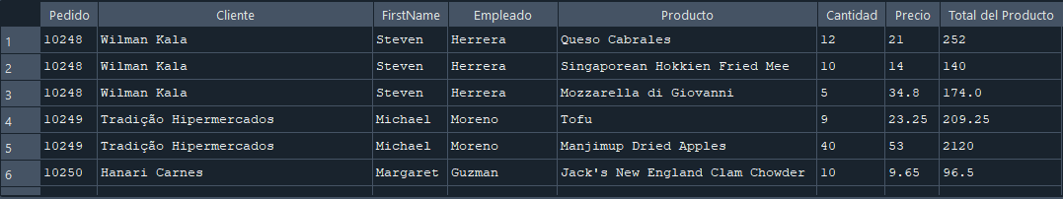

--5. Mostrar información de pedidos incluyendo datos del producto y la categoría.
SELECT o.OrderID AS Pedido,c.CustomerName AS Cliente,e.FirstName, e.LastName AS Empleado,p.ProductName AS Producto,c2.CategoryName AS Categoría,od.Quantity AS Cantidad
FROM Orders o
INNER JOIN
Customers c ON o.CustomerID = c.CustomerID
INNER JOIN
Employees e ON o.EmployeeID = e.EmployeeID
INNER JOIN
OrderDetails od ON o.OrderID = od.OrderID
INNER JOIN
Products p ON od.ProductID = p.ProductID
INNER JOIN
Categories c2 ON p.CategoryID = c2.CategoryID;
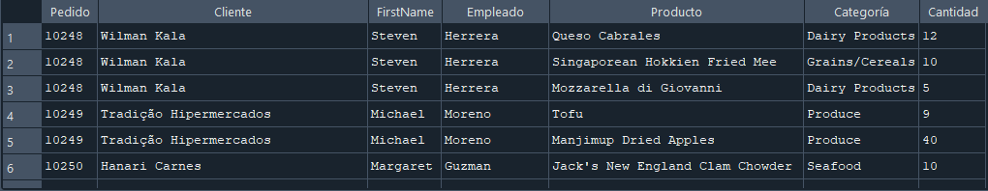
--6. Listar los clientes, los empleados que gestionaron su pedido, los productos comprados y sus proveedores.
SELECT c.CustomerName AS Cliente,e.FirstName, e.LastName AS Empleado,p.ProductName AS Producto,s.SupplierName AS Proveedor
FROM Customers c
INNER JOIN
Orders o ON c.CustomerID = o.CustomerID
INNER JOIN
Employees e ON o.EmployeeID = e.EmployeeID
INNER JOIN
OrderDetails od ON o.OrderID = od.OrderID
INNER JOIN
Products p ON od.ProductID = p.ProductID
INNER JOIN
Suppliers s ON p.SupplierID = s.SupplierID;
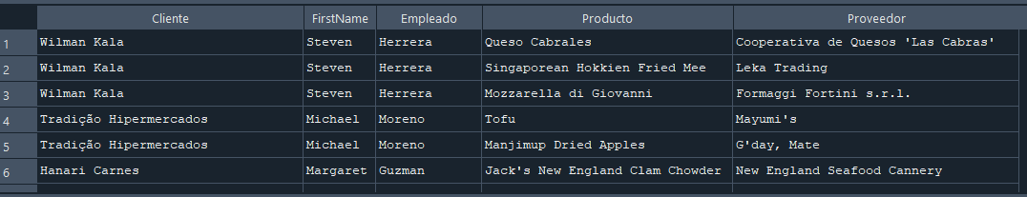

--7. Obtener información de los pedidos con los clientes y los productos vendidos.
SELECT o.OrderID AS Pedido,c.CustomerName AS Cliente,p.ProductName AS Producto,od.Quantity AS Cantidad,p.Price AS Precio,(od.Quantity * p.Price) AS "Total del Producto"
FROM Orders o
INNER JOIN
Customers c ON o.CustomerID = c.CustomerID
INNER JOIN
OrderDetails od ON o.OrderID = od.OrderID
INNER JOIN
Products p ON od.ProductID = p.ProductID;
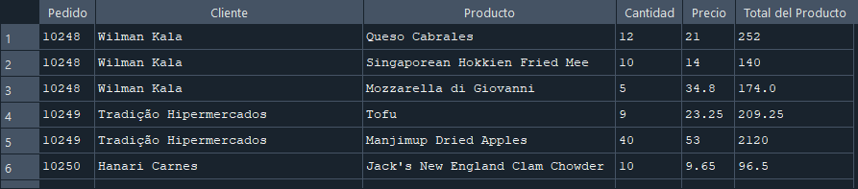

--8. Mostrar los pedidos, los clientes y los métodos de envío junto con los productos comprados.
SELECT o.OrderID AS Pedido,c.CustomerName AS Cliente,s.ShipperName AS "Método de Envío",p.ProductName AS Producto
FROM Orders o
INNER JOIN
Customers c ON o.CustomerID = c.CustomerID
INNER JOIN
Shippers s ON o.ShipperID = s.ShipperID
INNER JOIN
OrderDetails od ON o.OrderID = od.OrderID
INNER JOIN
Products p ON od.ProductID = p.ProductID;
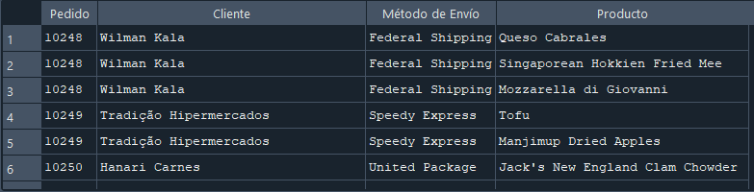

--9. Obtener una lista de productos con sus categorías, proveedores y detalles en los pedidos.
SELECT p.ProductName AS Producto,c.CategoryName AS Categoría,s.SupplierName AS Proveedor,o.OrderID AS Pedido,od.Quantity AS Cantidad,p.Price AS Precio,(od.Quantity * p.Price) AS "Total del Producto"
FROM Products p
INNER JOIN
Categories c ON p.CategoryID = c.CategoryID
INNER JOIN
Suppliers s ON p.SupplierID = s.SupplierID
INNER JOIN
OrderDetails od ON p.ProductID = od.ProductID
INNER JOIN
Orders o ON od.OrderID = o.OrderID;
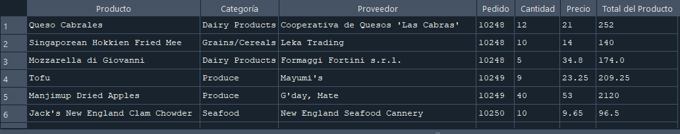

--10. Mostrar los empleados, los pedidos, los clientes, los productos y los métodos de envío.
SELECT e.FirstName, e.LastName AS Empleado,o.OrderID AS Pedido,c.CustomerName AS Cliente,p.ProductName AS Producto,s.ShipperName AS "Método de Envío"
FROM Employees e
INNER JOIN
Orders o ON e.EmployeeID = o.EmployeeID
INNER JOIN
Customers c ON o.CustomerID = c.CustomerID
INNER JOIN
OrderDetails od ON o.OrderID = od.OrderID
INNER JOIN
Products p ON od.ProductID = p.ProductID
INNER JOIN
Shippers s ON o.ShipperID = s.ShipperID;
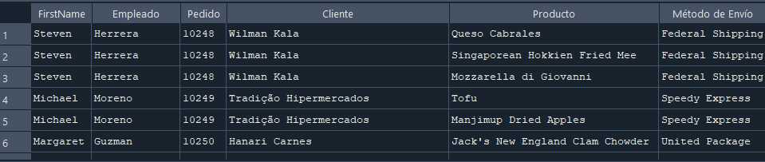

--INNER JOIN con 8 tablas
--1. Obtener una lista de pedidos con información completa del cliente, empleado,transportista y productos involucrados.
SELECT o.OrderID AS Pedido,c.CustomerName AS Cliente,e.FirstName, e.LastName AS Empleado,s.ShipperName AS "Método de Envío",p.ProductName AS Producto,od.Quantity AS Cantidad,
p.Price AS Precio,
(od.Quantity * p.Price) AS "Total del Producto",
c2.CategoryName AS Categoría,
s2.SupplierName AS Proveedor
FROM Orders o
INNER JOIN
Customers c ON o.CustomerID = c.CustomerID
INNER JOIN
Employees e ON o.EmployeeID = e.EmployeeID
INNER JOIN
Shippers s ON o.ShipperID = s.ShipperID
INNER JOIN
OrderDetails od ON o.OrderID = od.OrderID
INNER JOIN
Products p ON od.ProductID = p.ProductID
INNER JOIN
Categories c2 ON p.CategoryID = c2.CategoryID
INNER JOIN
Suppliers s2 ON p.SupplierID = s2.SupplierID;
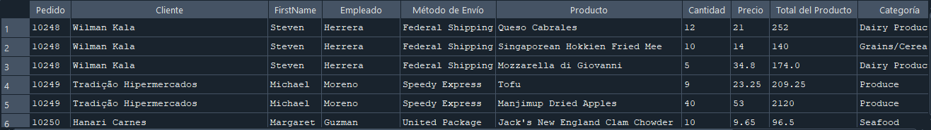

--2. Mostrar los clientes con detalles de sus pedidos y los productos adquiridos, junto con los proveedores.
SELECT c.CustomerName AS Cliente,o.OrderID AS Pedido,p.ProductName AS Producto,s.SupplierName AS Proveedor
FROM Customers c
INNER JOIN
Orders o ON c.CustomerID = o.CustomerID
INNER JOIN
OrderDetails od ON o.OrderID = od.OrderID
INNER JOIN
Products p ON od.ProductID = p.ProductID
INNER JOIN
Suppliers s ON p.SupplierID = s.SupplierID;
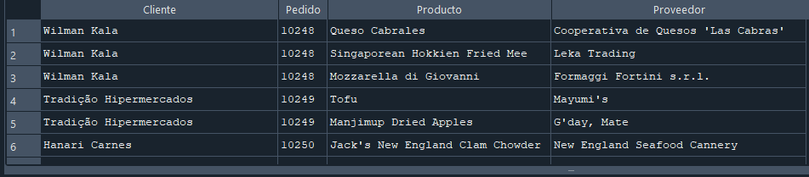

--3. Obtener una vista de los empleados y todos los pedidos que han atendido con detalles completos.
SELECT e.FirstName, e.LastName AS Empleado,o.OrderID AS Pedido,c.CustomerName AS Cliente,p.ProductName AS Producto,
od.Quantity AS Cantidad,
p.Price AS Precio,
(od.Quantity * p.Price) AS "Total del Producto"
FROM Employees e
INNER JOIN
Orders o ON e.EmployeeID = o.EmployeeID
INNER JOIN
Customers c ON o.CustomerID = c.CustomerID
INNER JOIN
OrderDetails od ON o.OrderID = od.OrderID
INNER JOIN
Products p ON od.ProductID = p.ProductID;
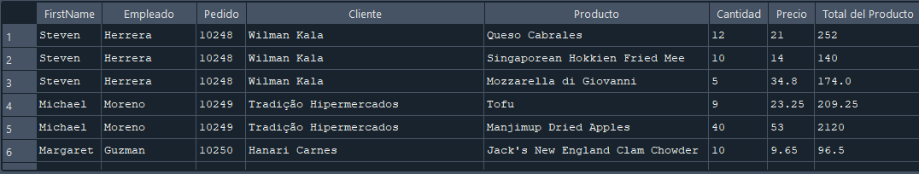

--4. Mostrar los detalles de pedidos incluyendo el cliente, empleado, productos y proveedores.
SELECT o.OrderID AS Pedido,c.CustomerName AS Cliente,e.FirstName, e.LastName AS Empleado,p.ProductName AS Producto,s.SupplierName AS Proveedor
FROM Orders o
INNER JOIN
Customers c ON o.CustomerID = c.CustomerID
INNER JOIN
Employees e ON o.EmployeeID = e.EmployeeID
INNER JOIN
OrderDetails od ON o.OrderID = od.OrderID
INNER JOIN
Products p ON od.ProductID = p.ProductID
INNER JOIN
Suppliers s ON p.SupplierID = s.SupplierID;
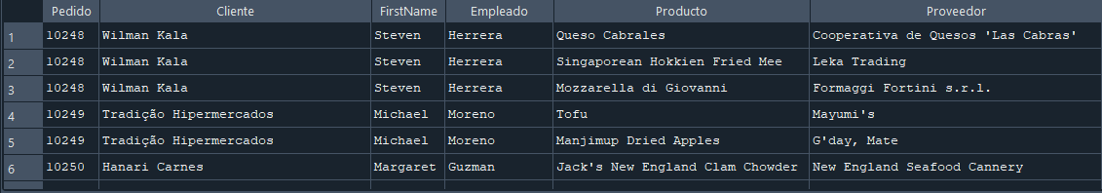

--5. Listar todos los pedidos con información detallada de clientes, empleados, productos y métodos de envio.
SELECT o.OrderID AS Pedido,c.CustomerName AS Cliente,e.FirstName, e.LastName AS Empleado,s.ShipperName AS "Método de Envío",p.ProductName AS Producto,
od.Quantity AS Cantidad,
p.Price AS Precio,
(od.Quantity * p.Price) AS "Total del Producto",
c2.CategoryName AS Categoría,
s2.SupplierName AS Proveedor
FROM Orders o
INNER JOIN
Customers c ON o.CustomerID = c.CustomerID
INNER JOIN
Employees e ON o.EmployeeID = e.EmployeeID
INNER JOIN
Shippers s ON o.ShipperID = s.ShipperID
INNER JOIN
OrderDetails od ON o.OrderID = od.OrderID
INNER JOIN
Products p ON od.ProductID = p.ProductID
INNER JOIN
Categories c2 ON p.CategoryID = c2.CategoryID
INNER JOIN
Suppliers s2 ON p.SupplierID = s2.SupplierID;
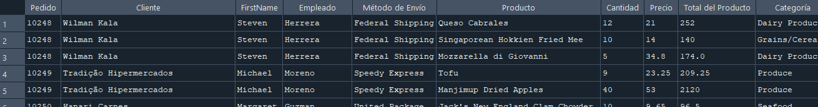

--6. Obtener los detalles de pedidos con los productos, proveedores, clientes y empleados involucrados.
SELECT o.OrderID AS Pedido,c.CustomerName AS Cliente,e.FirstName, e.LastName AS Empleado,p.ProductName AS Producto,s.SupplierName AS Proveedor
FROM Orders o
INNER JOIN
Customers c ON o.CustomerID = c.CustomerID
INNER JOIN
Employees e ON o.EmployeeID = e.EmployeeID
INNER JOIN
OrderDetails od ON o.OrderID = od.OrderID
INNER JOIN
Products p ON od.ProductID = p.ProductID
INNER JOIN
Suppliers s ON p.SupplierID = s.SupplierID;
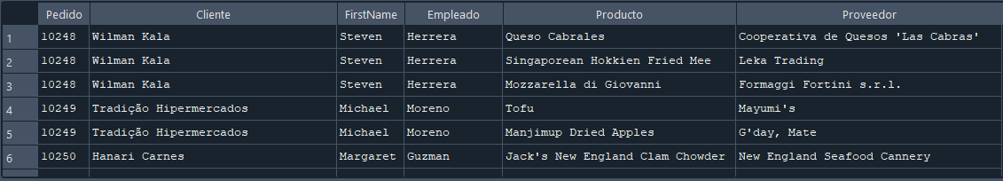

--7. Mostrar una lista completa de los pedidos con datos del cliente, empleado, producto,categoria y proveedor.
SELECT o.OrderID AS Pedido,c.CustomerName AS Cliente,e.FirstName, e.LastName AS Empleado,p.ProductName AS Producto,c2.CategoryName AS Categoría,s2.SupplierName AS Proveedor
FROM Orders o
INNER JOIN
Customers c ON o.CustomerID = c.CustomerID
INNER JOIN
Employees e ON o.EmployeeID = e.EmployeeID
INNER JOIN
OrderDetails od ON o.OrderID = od.OrderID
INNER JOIN
Products p ON od.ProductID = p.ProductID
INNER JOIN
Categories c2 ON p.CategoryID = c2.CategoryID
INNER JOIN
Suppliers s2 ON p.SupplierID = s2.SupplierID;
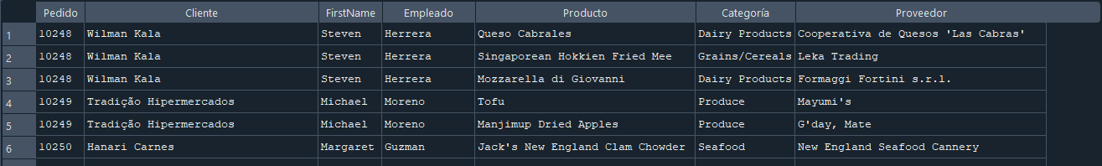

--8. Listar las órdenes con detalles completos de los clientes, empleados, transportistas,productos y sus categorías.
SELECT o.OrderID AS Pedido,c.CustomerName AS Cliente,e.FirstName, e.LastName AS Empleado,s.ShipperName AS "Método de Envío",p.ProductName AS Producto,c2.CategoryName AS Categoría
FROM Orders o
INNER JOIN
Customers c ON o.CustomerID = c.CustomerID
INNER JOIN
Employees e ON o.EmployeeID = e.EmployeeID
INNER JOIN
Shippers s ON o.ShipperID = s.ShipperID
INNER JOIN
OrderDetails od ON o.OrderID = od.OrderID
INNER JOIN
Products p ON od.ProductID = p.ProductID
INNER JOIN
Categories c2 ON p.CategoryID = c2.CategoryID;
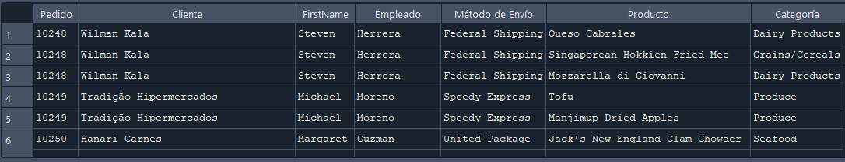

--9. Obtener una vista consolidada de la base de datos con pedidos, clientes, empleados,productos,proveedores y transportistas.
SELECT o.OrderID AS Pedido,c.CustomerName AS Cliente,e.FirstName, e.LastName AS Empleado,p.ProductName AS Producto,s2.SupplierName AS Proveedor,s.ShipperName AS "Método de Envío"
FROM Orders o
INNER JOIN
Customers c ON o.CustomerID = c.CustomerID
INNER JOIN
Employees e ON o.EmployeeID = e.EmployeeID
INNER JOIN
OrderDetails od ON o.OrderID = od.OrderID
INNER JOIN
Products p ON od.ProductID = p.ProductID
INNER JOIN
Suppliers s2 ON p.SupplierID = s2.SupplierID
INNER JOIN
Shippers s ON o.ShipperID = s.ShipperID;
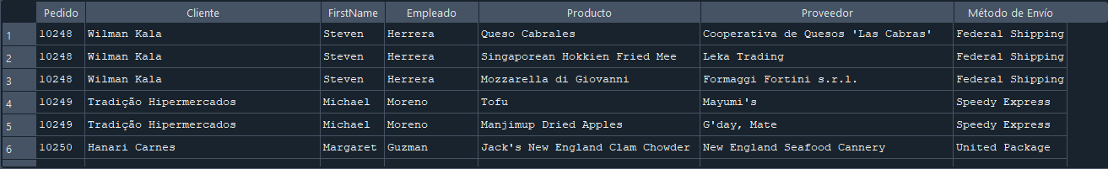

--10. Mostrar la relación completa entre órdenes, clientes, empleados, productos,proveedores,transportistas y detalles del pedido.
SELECT o.OrderID AS Pedido,c.CustomerName AS Cliente,e.FirstName, e.LastName AS Empleado,p.ProductName AS Producto,s2.SupplierName AS Proveedor,
s.ShipperName AS "Método de Envío",
od.Quantity AS Cantidad,
p.Price AS Precio,
(od.Quantity * p.Price) AS "Total del Producto"
FROM Orders o
INNER JOIN
Customers c ON o.CustomerID = c.CustomerID
INNER JOIN
Employees e ON o.EmployeeID = e.EmployeeID
INNER JOIN
OrderDetails od ON o.OrderID = od.OrderID
INNER JOIN
Products p ON od.ProductID = p.ProductID
INNER JOIN
Suppliers s2 ON p.SupplierID = s2.SupplierID
INNER JOIN
Shippers s ON o.ShipperID = s.ShipperID;
