Macrophage efferocytosis-related transcriptional features and VSMC state programs in symptomatic versus asymptomatic human carotid plaques
Target journal: Frontiers in Cardiovascular Medicine
Article type: Original Research
Integrated review document generated for author review
Generated on: 2026-09-04T09:19:11
Authors: [[AUTHOR NAME]]
Affiliations: [[AFFILIATION]]
Corresponding author: [[CORRESPONDING AUTHOR EMAIL]]
Code repository: [[CODE REPOSITORY URL]]

Review caution: this integrated file combines existing project outputs for easier reading. Author identity, ethics, funding, conflicts, repository URL, and final citation order require real-author verification before submission.

Main Manuscript
Article type: Original Research
Running title: Efferocytosis and VSMC programs in carotid plaques
Authors: [[AUTHOR NAME]]
Affiliations: [[AFFILIATION]]
Corresponding author: [[CORRESPONDING AUTHOR EMAIL]]
Manuscript status: revised author-review draft generated from project tables on 2026-09-04.

Abstract
Background: Defective macrophage efferocytosis and vascular smooth muscle cell (VSMC) state switching are implicated in atherosclerotic plaque biology, but their relationship in clinically defined human carotid plaques remains incompletely resolved. Methods: We analyzed legally accessible public human carotid plaque transcriptomic datasets from GEO: a discovery Affymetrix microarray cohort, GSE111782 (9 symptomatic and 9 asymptomatic plaques), an independent diabetic RNA-seq validation cohort, GSE311535 (6 symptomatic and 6 asymptomatic plaques), and a Smart-seq2 single-cell cohort, GSE260657 (8 symptomatic and 7 asymptomatic carotid plaque samples; 7,690 cells after parsing). Predefined efferocytosis and VSMC state signatures were evaluated using assay-appropriate bulk models, rank-based enrichment, sample-level scoring, Spearman correlation, and donor-level single-cell summaries. P values were two-sided where applicable and adjusted using the Benjamini-Hochberg method. Results: No individual genes reached FDR < 0.05 in the discovery or validation bulk differential-expression analyses, and no predefined sample-level signature differed between symptomatic and asymptomatic plaques at FDR < 0.05. In the discovery cohort, ranked signature enrichment showed lower-ranked efferocytosis and VSMC programs in symptomatic plaques, but this pattern was not reproduced at FDR < 0.05 in the validation cohort. Across bulk samples, efferocytosis scores were positively associated with inflammatory VSMC scores in both GSE111782 (Spearman rho = 0.800, FDR = 0.0014) and GSE311535 (rho = 0.881, FDR = 0.0015). Single-cell analysis localized macrophage and VSMC compartments, but donor-level macrophage or VSMC program comparisons did not reach FDR < 0.05. Conclusion: The most reproducible observation was a tissue-level association between efferocytosis-related and inflammatory VSMC transcriptional programs rather than a robust symptomatic-versus-asymptomatic differential signature. These public-data results identify candidate associations for experimental follow-up and do not establish causality, pathology-defined plaque status, diagnostic utility, or therapeutic actionability.
Keywords: carotid atherosclerosis; symptomatic plaque; asymptomatic plaque; efferocytosis; macrophage; vascular smooth muscle cell; transcriptomics

Introduction
Human carotid atherosclerotic plaques are clinically important because symptomatic plaques are associated with cerebrovascular events, yet symptom status is not identical to a pathology-defined plaque category. This distinction matters for transcriptomic studies: datasets that label samples as symptomatic versus asymptomatic should not be rewritten using pathology-defined categories unless the original metadata or linked pathology report supports that terminology. The present study therefore retains the clinical labels reported in each dataset.
Macrophage handling of apoptotic cells is one candidate process linking inflammation resolution, necrotic-core formation, and advanced plaque biology. Efferocytosis requires receptors, bridging molecules, phagolysosomal processing, and lipid-handling responses, and prior experimental and human evidence has linked defective efferocytosis with atherosclerotic inflammation and plaque necrosis [6-8]. In parallel, VSMCs in atherosclerotic plaques occupy contractile and non-contractile states, including matrix-producing, inflammatory, osteogenic, and macrophage-like programs [9-13]. These state changes complicate bulk tissue interpretation because cell composition and cell-state activity can both influence transcriptomic signals.
Single-cell studies have sharpened this problem by showing substantial cellular heterogeneity within human atherosclerotic plaques, including macrophage state diversity and VSMC phenotypic modulation [12-20]. However, less is known about whether a predefined macrophage efferocytosis-related transcriptional program is reproducibly associated with VSMC state signatures in clinical symptomatic versus asymptomatic human carotid plaque cohorts.
Here we performed a secondary analysis of public human carotid plaque datasets to test a bounded hypothesis: symptomatic plaques would show altered efferocytosis-related transcriptional features and these features would be associated with non-contractile VSMC programs. We used one discovery bulk cohort, one independent bulk validation cohort, and one human carotid plaque single-cell cohort, with predefined gene sets and donor-aware single-cell summaries. The analysis was designed to identify reproducible associations, not to infer causality or reclassify symptomatic plaques using pathology-defined categories.

Materials and Methods

Data sources and cohort definitions
Public datasets were identified from GEO and retained only when the metadata supported human carotid atherosclerotic plaque tissue and clinically interpretable grouping. GSE111782 was used as the discovery bulk cohort because its GEO record and linked publication describe post-bifurcation internal carotid atheroma samples with symptomatic and asymptomatic clinical labels [1,4,5]. This cohort contained 18 samples, with 9 symptomatic and 9 asymptomatic plaques, profiled on the GPL571 Affymetrix Human Genome U133A 2.0 Array. GSE311535 was used as the independent bulk validation cohort because it contains human carotid plaque RNA-seq count data from patients with diabetes, including 6 symptomatic and 6 asymptomatic samples [2]. GSE260657 was used for single-cell localization because the GEO record and linked publication describe Smart-seq2 data from 15 human carotid plaque samples, including 8 symptomatic and 7 asymptomatic samples [3]. Dataset provenance, URLs, limitations, and audit decisions are recorded in DATA_PROVENANCE.md and 03_data/metadata/dataset_audit.csv.

Predefined gene sets and signatures
The efferocytosis gene set was defined before inspecting project results and included receptors, bridging molecules, phagocytic/lysosomal genes, and lipid-handling genes relevant to apoptotic-cell recognition, engulfment, and processing. Source bases included Gene Ontology, Reactome, UniProt annotations, and published atherosclerosis/efferocytosis literature [6-8,27,28]. VSMC state signatures were likewise predefined and represented contractile VSMC, synthetic VSMC, inflammatory VSMC, and ECM-remodeling/osteogenic VSMC programs, based on canonical markers and prior plaque single-cell studies [9-13]. These signatures were treated as expression programs rather than definitive lineage states.

Bulk transcriptomic processing
GSE111782 was analyzed as an RMA-processed log2 microarray expression matrix. Probes without usable gene annotation were removed where possible, duplicate gene mappings were handled by retaining the probe with the highest average expression, and the symptomatic-versus-asymptomatic contrast was fitted using limma empirical Bayes linear modeling [21]. GSE311535 was analyzed as gene-level RNA-seq counts using edgeR quasi-likelihood negative-binomial models after low-expression filtering and library-size normalization [22]. In both cohorts, positive log2 fold change denotes higher expression in symptomatic plaques relative to asymptomatic plaques. Differential-expression P values were adjusted using the Benjamini-Hochberg method, with FDR < 0.05 as the prespecified threshold.

Signature, enrichment, and association analyses
Sample-level signature scores were computed from predefined gene sets using available mapped genes; the score represents the mean standardized expression of genes available on the relevant platform. Group comparisons used two-sided Wilcoxon rank-sum tests because the bulk cohorts were small and no normality assumption was defensible. Ranked enrichment of predefined signatures used preranked symptomatic-versus-asymptomatic statistics following the GSEA framework [24]. GO biological process, KEGG, and Reactome over-representation analyses were attempted using clusterProfiler and ReactomePA when gene mapping and package availability allowed [25-29]. All enrichment and signature tests used Benjamini-Hochberg correction. Tissue-level associations between signatures were evaluated using Spearman correlations. WGCNA was prespecified but not run because the discovery bulk sample size was 18, below the project threshold of at least 30 samples and therefore not adequate for stable network inference [30].

Single-cell processing and annotation
GSE260657 raw Smart-seq2 text files were parsed without modifying the original downloaded archive. Cells were evaluated using prespecified quality-control rules for detected genes, counts, mitochondrial fraction, and sample-level parsing. Because the available workflow was a lightweight reproducible fallback rather than a full Seurat/Scanpy integration, cell annotation used canonical marker scoring, PCA/k-means clustering, and marker-candidate inspection. Major cell classes included macrophage, VSMC, endothelial cell, fibroblast, T/NK cell, B cell, mast cell, and unassigned. Uncertain cells were left as unassigned. Group comparisons were performed at donor/sample level when possible; individual cells were not treated as independent patients.

Reporting, software, and reproducibility
Analyses were performed in R 4.6.0 using limma 3.68.5, edgeR 4.10.4, GSVA 2.6.6, fgsea 1.38.0, clusterProfiler 4.20.0, ReactomePA, ggplot2 4.0.3, and related Bioconductor packages; package versions are archived in 09_environment/package_versions.csv and 09_environment/session_info.txt. Scripts are stored in 04_scripts, logs in 08_logs, and generated tables and figures in 05_results. No samples were removed only because they changed the result direction or significance.

Results

Public cohort selection produced discovery, validation, and single-cell evidence layers
The dataset audit retained GSE111782 as the discovery bulk cohort, GSE311535 as an independent bulk validation cohort, and GSE260657 as the single-cell localization cohort (Figure 1). The bulk cohorts were not merged because they differed by platform, preprocessing, and clinical context; GSE311535 is diabetes-specific. The single-cell cohort passed the project gate for human carotid plaque localization after raw file parsing, donor/sample metadata review, and marker-based annotation. Optional spatial transcriptomics, cell-cell communication, and machine-learning modules were not used in the main conclusions because their strict data, annotation, and overfitting-control gates were not met.

Bulk differential-expression analysis did not identify FDR-significant individual genes
In GSE111782, limma tested 14,289 genes and identified 0 genes at FDR < 0.05 (Figure 2). The smallest nominal P-value genes were SLC35F5 (log2FC = -2.068, P = 4.53e-04, FDR = 0.624), SOX5 (log2FC = -1.287, P = 0.0011, FDR = 0.624), ATP2B2 (log2FC = 1.444, P = 0.0022, FDR = 0.624), but their adjusted FDR values were not below the prespecified threshold. In GSE311535, edgeR tested 21,925 genes and identified 0 genes at FDR < 0.05. The smallest nominal P-value genes were PI4KAP1 (log2FC = 1.308, P = 8.18e-05, FDR = 0.951), CTC-462L7.1 (log2FC = -0.480, P = 9.68e-04, FDR = 0.951), AC010886.2 (log2FC = -0.690, P = 0.0012, FDR = 0.951), again without FDR support. Across 10,864 genes available in both bulk cohorts, 6,609 (60.8%) had concordant symptomatic-versus-asymptomatic log2FC directions, but no gene reached FDR < 0.05 in both cohorts. These results argue against presenting individual DEGs as validated markers in the current public-data analysis.

Discovery ranked enrichment suggested lower efferocytosis and VSMC program ranks in symptomatic plaques, but validation was weaker
Ranked enrichment of predefined signatures in the discovery cohort identified FDR-supported negative enrichment for contractile_vsmc (NES = -1.987, FDR = 0.010); efferocytosis (NES = -1.601, FDR = 0.026); inflammatory_vsmc (NES = -1.809, FDR = 0.026); synthetic_vsmc (NES = -1.841, FDR = 0.026). Because positive log2FC denotes higher expression in symptomatic plaques, negative normalized enrichment scores indicate that these predefined genes tended to occur lower in the symptomatic-versus-asymptomatic ranked list. GO biological process over-representation in the discovery cohort returned three FDR-supported terms related to cartilage or chondrocyte differentiation: regulation of chondrocyte differentiation (FDR = 0.035); positive regulation of chondrocyte differentiation (FDR = 0.035); regulation of cartilage development (FDR = 0.035). Reactome over-representation did not yield FDR-supported terms in the discovery output. In the validation cohort, none of the ranked predefined signatures reached FDR < 0.05; the lowest adjusted value was observed for efferocytosis (NES = 1.254, FDR = 0.170). Thus, the discovery enrichment pattern was not reproduced as a validation-level result.

Sample-level signature group differences did not survive FDR correction
At the sample-score level, no predefined efferocytosis or VSMC signature differed between symptomatic and asymptomatic plaques at FDR < 0.05 in either bulk cohort (Figure 3). In GSE111782, the efferocytosis median score was 0.374 in asymptomatic plaques and -0.021 in symptomatic plaques (P = 0.331, FDR = 0.757). The contractile VSMC score showed a nominal difference in GSE111782 (median 0.389 versus -0.029; P = 0.034), but this did not survive correction (FDR = 0.341). In GSE311535, the efferocytosis median was -0.142 in asymptomatic plaques and 0.224 in symptomatic plaques (P = 0.575, FDR = 0.822). These results were retained as negative or inconclusive findings rather than reframed as positive group differences.

Efferocytosis scores were reproducibly associated with inflammatory VSMC scores at tissue level
The strongest reproducible bulk observation was a positive tissue-level association between the efferocytosis and inflammatory VSMC signatures. In GSE111782, the efferocytosis score correlated with the inflammatory VSMC score (Spearman rho = 0.800, P = 6.78e-05, FDR = 0.0014) and with the synthetic VSMC score (rho = 0.593, P = 0.0094, FDR = 0.047). In GSE311535, the efferocytosis score again correlated with the inflammatory VSMC score (rho = 0.881, P = 1.53e-04, FDR = 0.0015), whereas the association with ECM-remodeling VSMC was weaker and did not pass FDR correction (rho = 0.483, FDR = 0.204). These correlations were analyzed across mixed plaque tissue samples and therefore cannot distinguish coordinated cell-state activity from cell-composition differences or shared inflammatory confounding.

Single-cell analysis localized macrophage and VSMC compartments without donor-level FDR-supported group differences
GSE260657 yielded 7,690 parsed cells across 15 donor/sample files. Marker-score annotation assigned major cell classes as follows: macrophage: 2271, fibroblast: 1645, vsmc: 1511, endothelial: 756, unassigned: 752, t_nk: 332, mast: 216, b_cell: 207 (Figure 4). Macrophages represented the largest annotated compartment (n = 2,271), and VSMCs were also clearly represented (n = 1,511). Secondary macrophage analysis produced three descriptive subclusters: macrophage_S1 n = 331, efferocytosis score = 0.730; macrophage_S2 n = 1184, efferocytosis score = 0.135; macrophage_S3 n = 756, efferocytosis score = 0.174 (Figure 5). Secondary VSMC analysis similarly produced three descriptive VSMC subclusters: vsmc_S1 n = 695, contractile score = 0.800; vsmc_S2 n = 519, contractile score = 1.064; vsmc_S3 n = 297, contractile score = 1.879 (Figure 6). Donor-level program comparisons across macrophage and VSMC compartments did not identify FDR-supported symptomatic-versus-asymptomatic differences (number of tested cell-type/program comparisons with FDR < 0.05: 0). The single-cell data therefore support cellular localization of the predefined programs but do not provide independent donor-level evidence for group differences.

Independent validation supported the efferocytosis-inflammatory VSMC association but not a validated classifier or marker set
The independent validation cohort confirmed the positive tissue-level association between efferocytosis and inflammatory VSMC scores, but it did not validate individual DEGs, sample-level signature group shifts, or discovery ranked enrichment at FDR < 0.05 (Figure 7). Because the discovery and validation cohorts were small and heterogeneous, and because no FDR-supported gene-level marker set was established in discovery and validation, the prespecified optional machine-learning module was skipped. The results are therefore reported as reproducible transcriptional associations rather than as a diagnostic model or treatment-target discovery.

Discussion
This secondary analysis found limited evidence for robust symptomatic-versus-asymptomatic differential expression at the individual gene or sample-level signature level. Neither bulk cohort produced FDR-significant individual genes, and no predefined efferocytosis or VSMC sample-level signature group comparison reached FDR < 0.05. These negative findings are important because the small cohorts and heterogeneous public metadata create a high risk of overinterpreting nominal P values.
The most consistent result was instead a cross-cohort tissue-level association between efferocytosis-related scores and inflammatory VSMC scores. This association was observed in both the discovery microarray cohort and the independent diabetic RNA-seq cohort. The finding is biologically plausible in light of prior work on macrophage efferocytosis, inflammatory plaque states, and VSMC phenotypic modulation [6-14], but it remains an association across mixed tissue samples. It may reflect coordinated activation of macrophage and VSMC programs, shared inflammatory burden, variation in cellular composition, or differences in lesion stage that could not be fully adjusted using the available metadata.
The single-cell cohort helped localize the relevant compartments, showing that macrophages and VSMCs were both represented in human carotid plaque data and that efferocytosis and VSMC-state programs could be scored at cell and donor levels. However, donor-level program comparisons were not FDR-significant. This constraint prevents a stronger claim that symptomatic plaques consistently contain a distinct efferocytosis-high macrophage state or a distinct non-contractile VSMC state in the analyzed single-cell data. The current single-cell results are therefore best viewed as localization and hypothesis-refinement evidence.
The discovery ranked enrichment results add nuance. In GSE111782, several predefined signatures, including efferocytosis and VSMC programs, were negatively enriched along the symptomatic-versus-asymptomatic ranked list. Because these enrichment signals were not reproduced in GSE311535, they should be treated as cohort-specific observations rather than validated disease signatures. Differences in platform, diabetes status, sample size, tissue handling, plaque stage, and clinical symptom definitions may all contribute to this non-replication.
Several limitations should be explicit before submission. First, all analyses used public retrospective datasets, and patient-level clinical covariates were limited. Second, symptom status was used exactly as reported and was not treated as synonymous with a pathology-defined plaque category. Third, bulk plaque tissue is a mixture of immune, stromal, endothelial, smooth muscle, and other cell populations, so tissue-level signature associations may be composition-driven. Fourth, the single-cell workflow used a lightweight marker-score annotation fallback, and full reanalysis with the original authors' processed objects or a dedicated Seurat/Scanpy pipeline would strengthen annotation confidence. Fifth, no spatial carotid validation, lineage tracing, perturbation experiment, or wet-lab validation was performed. These boundaries preclude causal, diagnostic, therapeutic, or mechanism-confirming claims.
In summary, the data support a conservative conclusion: public human carotid plaque transcriptomes show reproducible tissue-level covariation between macrophage efferocytosis-related and inflammatory VSMC transcriptional programs, but they do not establish robust symptomatic-versus-asymptomatic DEGs or validated group-discriminating signatures. Future work should test these candidate associations in prospectively phenotyped carotid plaque cohorts with harmonized clinical definitions, spatial validation, and experimental models that can separate cell-state changes from cell-composition effects.

Data Availability Statement
Publicly available datasets were analyzed in this study. These data are available through the Gene Expression Omnibus under accession numbers GSE111782, GSE311535, and GSE260657. Accession-level URLs, download dates, file names, processing scripts, generated outputs, uses, and limitations are recorded in DATA_PROVENANCE.md and 03_data/metadata/dataset_audit.csv.

Code Availability Statement
Analysis scripts, parameters, logs, intermediate tables, generated figures, and manuscript-generation scripts are included in this project directory. Before journal submission, the authors should archive the code in a persistent public repository and replace this placeholder with the repository URL: [[CODE REPOSITORY URL]].

Ethics Statement
This manuscript reports a secondary analysis of public, de-identified human datasets. The original studies' ethics approval and consent statements must be verified from the corresponding source publications before submission: [[ETHICS STATEMENT TO BE VERIFIED]].

Author Contributions
[[AUTHOR CONTRIBUTIONS TO BE COMPLETED BY REAL AUTHORS]]

Funding
[[FUNDING INFORMATION]]

Conflict of Interest
[[CONFLICT OF INTEREST DECLARATION]]

Acknowledgments and AI Use Disclosure
The authors should disclose any generative AI assistance in accordance with Frontiers policy. This project used AI assistance for code orchestration, manuscript organization, and language revision; quantitative analyses and figures were generated from public data using the recorded scripts. The final wording of this disclosure must be verified by the submitting authors.

Contribution to the Field
Human carotid plaque transcriptomic studies often compare symptomatic and asymptomatic plaques, but symptom status, pathology-defined plaque categories, and mechanistic causality are sometimes conflated. This study provides a reproducible public-data analysis focused on a specific biological question: whether macrophage efferocytosis-related transcriptional features are associated with VSMC state programs in clinically defined human carotid plaques. By keeping discovery, validation, and single-cell localization analyses separate, the work identifies a conservative and reproducible signal: efferocytosis-related scores covary with inflammatory VSMC scores at the tissue level in two independent bulk cohorts. At the same time, the analysis shows that individual DEGs and sample-level signature group differences are not FDR-supported in the available cohorts. The accompanying single-cell analysis localizes macrophage and VSMC compartments but does not treat thousands of cells as independent patients. The study therefore offers a transparent candidate association for future experimental and spatial validation, while explicitly avoiding overstatement as a causal mechanism, pathology-defined signature, diagnostic tool, or therapeutic target.

References
1. Caparosa EM; Sedgewick AJ; Zenonos G; Zhao Y; Carlisle DL; Stefaneanu L; Jankowitz BT; Gardner P; Chang YF; Lariviere WR; LaFramboise WA; Benos PV; Friedlander RM. Regional Molecular Signature of the Symptomatic Atherosclerotic Carotid Plaque. Neurosurgery. 2019. doi: 10.1093/neuros/nyy470. PMID: 30335165. 2. Bradford A; Yoshida T; Sukhanov S; Woods FF; Delafontaine P; Bazan HA; Woods TC. Insulin use promotes pro-inflammatory changes in the transcriptome of atherosclerotic plaques in patients with diabetes mellitus. Journal of molecular and cellular cardiology plus. 2025. doi: 10.1016/j.jmccpl.2025.100829. PMID: 41377472. 3. Mocci G; Sukhavasi K; Örd T; Bankier S; Singha P; Arasu UT; Agbabiaje OO; Mäkinen P; Ma L; Hodonsky CJ; Aherrahrou R; Muhl L; Liu J; Gustafsson S; Byandelger B; Wang Y; Koplev S; Lendahl U; Owens GK; Leeper NJ; Pasterkamp G; Vanlandewijck M; Michoel T; Ruusalepp A; Hao K; Ylä-Herttuala S; Väli M; Järve H; Mokry M; Civelek M; Miller CJ; Kovacic JC; Kaikkonen MU; Betsholtz C; Björkegren JLM. Single-Cell Gene-Regulatory Networks of Advanced Symptomatic Atherosclerosis. Circulation research. 2024. doi: 10.1161/CIRCRESAHA.123.323184. PMID: 38639096. 4. Barrett T; Wilhite SE; Ledoux P; Evangelista C; Kim IF; Tomashevsky M; Marshall KA; Phillippy KH; Sherman PM; Holko M; Yefanov A; Lee H; Zhang N; Robertson CL; Serova N; Davis S; Soboleva A. NCBI GEO: archive for functional genomics data sets--update. Nucleic acids research. 2013. doi: 10.1093/nar/gks1193. PMID: 23193258. 5. Edgar R; Domrachev M; Lash AE. Gene Expression Omnibus: NCBI gene expression and hybridization array data repository. Nucleic acids research. 2002. doi: 10.1093/nar/30.1.207. PMID: 11752295. 6. Linton MF; Babaev VR; Huang J; Linton EF; Tao H; Yancey PG. Macrophage Apoptosis and Efferocytosis in the Pathogenesis of Atherosclerosis. Circulation journal : official journal of the Japanese Circulation Society. 2016. doi: 10.1253/circj.CJ-16-0924. PMID: 27725526. 7. Kojima Y; Weissman IL; Leeper NJ. The Role of Efferocytosis in Atherosclerosis. Circulation. 2017. doi: 10.1161/CIRCULATIONAHA.116.025684. PMID: 28137963. 8. Kasikara C; Schilperoort M; Gerlach B; Xue C; Wang X; Zheng Z; Kuriakose G; Dorweiler B; Zhang H; Fredman G; Saleheen D; Reilly MP; Tabas I. Deficiency of macrophage PHACTR1 impairs efferocytosis and promotes atherosclerotic plaque necrosis. The Journal of clinical investigation. 2021. doi: 10.1172/JCI145275. PMID: 33630758. 9. Miano JM; Fisher EA; Majesky MW. Fate and State of Vascular Smooth Muscle Cells in Atherosclerosis. Circulation. 2021. doi: 10.1161/CIRCULATIONAHA.120.049922. PMID: 34029141. 10. Chakraborty R; Chatterjee P; Dave JM; Ostriker AC; Greif DM; Rzucidlo EM; Martin KA. Targeting smooth muscle cell phenotypic switching in vascular disease. JVS-vascular science. 2021. doi: 10.1016/j.jvssci.2021.04.001. PMID: 34617061. 11. Zhang F; Guo X; Xia Y; Mao L. An update on the phenotypic switching of vascular smooth muscle cells in the pathogenesis of atherosclerosis. Cellular and molecular life sciences : CMLS. 2021. doi: 10.1007/s00018-021-04079-z. PMID: 34936041. 12. Depuydt MAC; Prange KHM; Slenders L; Örd T; Elbersen D; Boltjes A; de Jager SCA; Asselbergs FW; de Borst GJ; Aavik E; Lönnberg T; Lutgens E; Glass CK; den Ruijter HM; Kaikkonen MU; Bot I; Slütter B; van der Laan SW; Yla-Herttuala S; Mokry M; Kuiper J; de Winther MPJ; Pasterkamp G. Microanatomy of the Human Atherosclerotic Plaque by Single-Cell Transcriptomics. Circulation research. 2020. doi: 10.1161/CIRCRESAHA.120.316770. PMID: 32981416. 13. Pan H; Xue C; Auerbach BJ; Fan J; Bashore AC; Cui J; Yang DY; Trignano SB; Liu W; Shi J; Ihuegbu CO; Bush EC; Worley J; Vlahos L; Laise P; Solomon RA; Connolly ES; Califano A; Sims PA; Zhang H; Li M; Reilly MP. Single-Cell Genomics Reveals a Novel Cell State During Smooth Muscle Cell Phenotypic Switching and Potential Therapeutic Targets for Atherosclerosis in Mouse and Human. Circulation. 2020. doi: 10.1161/CIRCULATIONAHA.120.048378. PMID: 32962412. 14. Dib L; Koneva LA; Edsfeldt A; Zurke YX; Sun J; Nitulescu M; Attar M; Lutgens E; Schmidt S; Lindholm MW; Choudhury RP; Cassimjee I; Lee R; Handa A; Goncalves I; Sansom SN; Monaco C. Lipid-associated macrophages transition to an inflammatory state in human atherosclerosis increasing the risk of cerebrovascular complications. Nature cardiovascular research. 2023. doi: 10.1038/s44161-023-00295-x. PMID: 38362263. 15. Slysz J; Sinha A; DeBerge M; Singh S; Avgousti H; Lee I; Glinton K; Nagasaka R; Dalal P; Alexandria S; Wai CM; Tellez R; Vescovo M; Sunderraj A; Wang X; Schipma M; Sisk R; Gulati R; Vallejo J; Saigusa R; Lloyd-Jones DM; Lomasney J; Weinberg S; Ho K; Ley K; Giannarelli C; Thorp EB; Feinstein MJ. Single-cell profiling reveals inflammatory polarization of human carotid versus femoral plaque leukocytes. JCI insight. 2023. doi: 10.1172/jci.insight.171359. PMID: 37471165. 16. Horstmann H; Michel NA; Sheng X; Hansen S; Lindau A; Pfeil K; Fernández MC; Marchini T; Winkels H; Mitre LS; Abogunloko T; Li X; Mwinyella TB; Gissler MC; Bugger H; Heidt T; Buscher K; Hilgendorf I; Stachon P; Piepenburg S; Verheyen N; Rathner T; Gerhardt T; Siegel PM; Oswald WK; Cohnert T; Zernecke A; Madl J; Kohl P; Foks AC; von Zur Muehlen C; Westermann D; Zirlik A; Wolf D. Cross-species single-cell RNA sequencing reveals divergent phenotypes and activation states of adaptive immunity in human carotid and experimental murine atherosclerosis. Cardiovascular research. 2024. doi: 10.1093/cvr/cvae154. PMID: 39041203. 17. Barcia Durán JG; Das D; Gildea M; Amadori L; Gourvest M; Kaur R; Eberhardt N; Smyrnis P; Cilhoroz B; Sajja S; Rahman K; Fernandez DM; Faries P; Narula N; Vanguri R; Goldberg IJ; Fisher EA; Berger JS; Moore KJ; Giannarelli C. Immune checkpoint landscape of human atherosclerosis and influence of cardiometabolic factors. Nature cardiovascular research. 2024. doi: 10.1038/s44161-024-00563-4. PMID: 39613875. 18. Sukhavasi K; Mocci G; Ma L; Hodonsky CJ; Diez Benevante E; Muhl L; Liu J; Gustafsson S; Buyandelger B; Koplev S; Lendahl U; Vanlandewijck M; Singha P; Örd T; Beter M; Selvarajan I; Laakkonen JP; Väli M; den Ruijter HM; Civelek M; Hao K; Ruusalepp A; Betsholtz C; Järve H; Kovacic JC; Miller CL; Romanoski C; Kaikkonen MU; Björkegren JLM. Single-cell RNA sequencing reveals sex differences in the subcellular composition and associated gene-regulatory network activity of human carotid plaques. Nature cardiovascular research. 2025. doi: 10.1038/s44161-025-00628-y. PMID: 40211055. 19. Narayanan S; Vuckovic S; Bergman O; Wirka R; Verdezoto Mosquera J; Chen QS; Baldassarre D; Tremoli E; Veglia F; Lengquist M; Aherahrrou R; Razuvaev A; Gigante B; Björck HM; Miller CL; Quertermous T; Hedin U; Matic L. Atheroma transcriptomics identifies ARNTL as a smooth muscle cell regulator and with clinical and genetic data improves risk stratification. European heart journal. 2025. doi: 10.1093/eurheartj/ehae768. PMID: 39552248. 20. Raju S; Turner ME; Cao C; Abdul-Samad M; Punwasi N; Blaser MC; Cahalane RME; Botts SR; Prajapati K; Patel S; Wu R; Gustafson D; Galant NJ; Fiddes L; Chemaly M; Hedin U; Matic L; Seidman MA; Subasri V; Singh SA; Aikawa E; Fish JE; Howe KL. Multiomic Landscape of Extracellular Vesicles in Human Carotid Atherosclerotic Plaque Reveals Endothelial Communication Networks. Arteriosclerosis, thrombosis, and vascular biology. 2025. doi: 10.1161/ATVBAHA.124.322324. PMID: 40438929. 21. Ritchie ME; Phipson B; Wu D; Hu Y; Law CW; Shi W; Smyth GK. limma powers differential expression analyses for RNA-sequencing and microarray studies. Nucleic acids research. 2015. doi: 10.1093/nar/gkv007. PMID: 25605792. 22. Robinson MD; McCarthy DJ; Smyth GK. edgeR: a Bioconductor package for differential expression analysis of digital gene expression data. Bioinformatics (Oxford, England). 2010. doi: 10.1093/bioinformatics/btp616. PMID: 19910308. 23. Hänzelmann S; Castelo R; Guinney J. GSVA: gene set variation analysis for microarray and RNA-seq data. BMC bioinformatics. 2013. doi: 10.1186/1471-2105-14-7. PMID: 23323831. 24. Subramanian A; Tamayo P; Mootha VK; Mukherjee S; Ebert BL; Gillette MA; Paulovich A; Pomeroy SL; Golub TR; Lander ES; Mesirov JP. Gene set enrichment analysis: a knowledge-based approach for interpreting genome-wide expression profiles. Proceedings of the National Academy of Sciences of the United States of America. 2005. doi: 10.1073/pnas.0506580102. PMID: 16199517. 25. Yu G; Wang LG; Han Y; He QY. clusterProfiler: an R package for comparing biological themes among gene clusters. Omics : a journal of integrative biology. 2012. doi: 10.1089/omi.2011.0118. PMID: 22455463. 26. Yu G; He QY. ReactomePA: an R/Bioconductor package for reactome pathway analysis and visualization. Molecular bioSystems. 2016. doi: 10.1039/c5mb00663e. PMID: 26661513. 27. Gene Ontology Consortium. The Gene Ontology resource: enriching a GOld mine. Nucleic acids research. 2021. doi: 10.1093/nar/gkaa1113. PMID: 33290552. 28. Gillespie M; Jassal B; Stephan R; Milacic M; Rothfels K; Senff-Ribeiro A; Griss J; Sevilla C; Matthews L; Gong C; Deng C; Varusai T; Ragueneau E; Haider Y; May B; Shamovsky V; Weiser J; Brunson T; Sanati N; Beckman L; Shao X; Fabregat A; Sidiropoulos K; Murillo J; Viteri G; Cook J; Shorser S; Bader G; Demir E; Sander C; Haw R; Wu G; Stein L; Hermjakob H; D'Eustachio P. The reactome pathway knowledgebase 2022. Nucleic acids research. 2022. doi: 10.1093/nar/gkab1028. PMID: 34788843. 29. Kanehisa M; Furumichi M; Sato Y; Ishiguro-Watanabe M; Tanabe M. KEGG: integrating viruses and cellular organisms. Nucleic acids research. 2021. doi: 10.1093/nar/gkaa970. PMID: 33125081. 30. Langfelder P; Horvath S. WGCNA: an R package for weighted correlation network analysis. BMC bioinformatics. 2008. doi: 10.1186/1471-2105-9-559. PMID: 19114008.

Computed Result Summary
This section is generated directly from project result tables for convenient review; complete source tables remain in 05_results/tables.

Bulk Analysis Summary
cohort | model | n_asymptomatic | n_symptomatic | n_genes_tested | FDR_threshold
GSE111782 | limma empirical Bayes linear model | 9 | 9 | 14289 | 0.05
GSE311535 | edgeR quasi-likelihood negative-binomial model | 6 | 6 | 21925 | 0.05

Bulk DEG FDR Summary
cohort | genes_tested_in_complete_table | FDR_lt_0.05_genes
GSE111782 | 14289 | 0
GSE311535 | 21925 | 0

Signature Group Comparisons
cohort | signature | n | median_asymptomatic | median_symptomatic | P_value | FDR
GSE111782 | efferocytosis | 18 | 0.374006124983989 | -0.0206051329207295 | 0.331387096247615 | 0.756955186489358
GSE111782 | contractile_vsmc | 18 | 0.389177863457278 | -0.0289598802407115 | 0.0340691951441439 | 0.340691951441439
GSE111782 | synthetic_vsmc | 18 | 0.378052572368425 | 0.309566424899239 | 0.791081512920782 | 0.878979458800868
GSE111782 | inflammatory_vsmc | 18 | 0.445799373559484 | 0.0670331378569445 | 0.377224616667453 | 0.756955186489358
GSE111782 | ecm_remodeling_vsmc | 18 | -0.064540217030123 | 0.198441043407613 | 0.216373008057637 | 0.756955186489358
GSE311535 | efferocytosis | 12 | -0.141987505027405 | 0.224010559371228 | 0.575173531920197 | 0.82167647417171
GSE311535 | contractile_vsmc | 12 | 0.179293816950862 | -0.56885802332809 | 0.378477593244679 | 0.756955186489358
GSE311535 | synthetic_vsmc | 12 | 0.120560848285767 | -0.0373374826389586 | 0.688920555804461 | 0.861150694755576
GSE311535 | inflammatory_vsmc | 12 | -0.02973166318371 | 0.085474338296296 | 0.936186293473059 | 0.936186293473059
GSE311535 | ecm_remodeling_vsmc | 12 | -0.225416629107931 | 0.303431961376112 | 0.575173531920197 | 0.82167647417171

Signature Correlations
cohort | signature_1 | signature_2 | rho | P_value | FDR | n_samples
GSE111782 | efferocytosis | contractile_vsmc | 0.358101135190918 | 0.14452928966155 | 0.240101192697602 | 18
GSE111782 | efferocytosis | synthetic_vsmc | 0.593395252837977 | 0.0094326152719585 | 0.0471630763597925 | 18
GSE111782 | efferocytosis | inflammatory_vsmc | 0.799793601651187 | 6.77596194348165e-05 | 0.00135519238869633 | 18
GSE111782 | efferocytosis | ecm_remodeling_vsmc | 0.33952528379773 | 0.168070834888322 | 0.240101192697602 | 18
GSE311535 | efferocytosis | contractile_vsmc | -0.307692307692308 | 0.33058925941211 | 0.413236574265137 | 12
GSE311535 | efferocytosis | synthetic_vsmc | 0.153846153846154 | 0.633090681246262 | 0.733350641469227 | 12
GSE311535 | efferocytosis | inflammatory_vsmc | 0.881118881118881 | 0.000152674064676699 | 0.00152674064676699 | 12
GSE311535 | efferocytosis | ecm_remodeling_vsmc | 0.482517482517483 | 0.112109291468892 | 0.203835075397985 | 12

Single-Cell Donor-Level Program Tests
cell_type | program | n_donors | P_value | FDR
macrophage | efferocytosis_score | 15 | 0.385418232368229 | 0.786674582709127
macrophage | contractile_vsmc_score | 15 | 0.953857153061604 | 0.953857153061604
macrophage | noncontractile_vsmc_score | 15 | 0.224313126511154 | 0.786674582709127
vsmc | efferocytosis_score | 15 | 0.451913458279073 | 0.786674582709127
vsmc | contractile_vsmc_score | 15 | 0.524449721806084 | 0.786674582709127
vsmc | noncontractile_vsmc_score | 15 | 0.862186694400762 | 0.953857153061604

Single-Cell Cluster Annotation Summary
sc_cluster | dominant_cell_type | total_cells | macrophage | vsmc | fibroblast | endothelial | t_nk | unassigned
C1 | t_nk | 249 | 0 | 0 | 0 | 0 | 204 | 4
C10 | fibroblast | 1351 | 0 | 167 | 1017 | 21 | 4 | 119
C2 | vsmc | 1257 | 0 | 1050 | 101 | 11 | 4 | 76
C3 | macrophage | 1074 | 939 | 0 | 3 | 7 | 15 | 47
C4 | macrophage | 626 | 501 | 2 | 2 | 0 | 9 | 46
C5 | macrophage | 810 | 559 | 2 | 3 | 8 | 50 | 123
C6 | endothelial | 912 | 5 | 20 | 30 | 680 | 13 | 112
C7 | fibroblast | 652 | 0 | 167 | 376 | 14 | 5 | 72
C8 | fibroblast | 254 | 1 | 101 | 103 | 9 | 0 | 38
C9 | macrophage | 505 | 266 | 2 | 10 | 6 | 28 | 115

Skill-Based Review Report
# Skill-based manuscript review report
## Review setup
- Input scope: current manuscript draft, integrated review document, result tables, QC files, figure legends, reference audit, and journal-compliance notes.
- Skills applied: nature-writing, nature-polishing, nature-statistics, nature-ref-verifier, and nature-reviewer.
- Shared manuscript claim summary: public human carotid plaque transcriptomes show reproducible tissue-level covariation between macrophage efferocytosis-related scores and inflammatory VSMC scores, but do not establish robust symptomatic-versus-asymptomatic DEGs, causality, plaque instability, or clinical utility.
- Missing materials affecting confidence: verified author/affiliation details, ethics and consent text from source publications, funding, conflict declarations, public code repository URL, and author-confirmed citation sentence mapping.
## Reviewer 1
- Overall assessment: The revised manuscript is technically more credible than the scaffold because it reports negative results and separates discovery, validation, and single-cell localization.
- Who would be interested: vascular biology and translational atherosclerosis readers interested in macrophage-VSMC state interactions in human carotid plaques.
- Major strengths: public-data reproducibility, predefined signatures, validation cohort retained despite non-replication, and donor-aware single-cell wording.
- Major concerns: small cohorts, diabetes-specific validation, mixed-tissue confounding, and lightweight single-cell annotation.
- Technical failings to address before submission: verify original-study ethics/consent, archive code publicly, and consider full single-cell reanalysis from processed objects if available.
- Recommendation posture: suitable for author review after revisions; not ready for direct submission until placeholders are resolved.
## Reviewer 2
- Overall assessment: The biological question is focused and relevant, but the strongest result is an association rather than a disease-defining signature.
- Who would be interested: researchers studying defective efferocytosis, inflammatory plaque remodeling, and VSMC phenotypic modulation.
- Major strengths: the title and abstract now match the real evidence; symptomatic plaques are not mislabeled as unstable plaques.
- Major concerns: the manuscript must avoid implying that a reproducible correlation proves macrophage-to-VSMC communication or therapeutic target status.
- Technical failings to address before submission: add author-verified citations at each final sentence and ensure all figure panels match the revised legends.
- Recommendation posture: promising computational analysis, but framed as hypothesis-generating.
## Reviewer 3
- Overall assessment: The revised text is easier to follow because the narrative leads with the actual reproducible finding and states the null results plainly.
- Who would be interested: clinicians and computational biologists needing careful public-data interpretation of symptomatic carotid plaques.
- Major strengths: clear boundary language, compact abstract, and explicit distinction between group differences and tissue-level correlations.
- Major concerns: some readers may expect stronger validation or spatial evidence; the discussion now acknowledges this but the author may need to justify suitability for the target journal.
- Technical failings to address before submission: final Word/PDF should be checked visually after author edits, especially embedded figures and table readability.
- Recommendation posture: ready for detailed author review, not final submission.
## Cross-review synthesis
- Consensus strengths: transparent negative findings, cautious interpretation, corrected references, and donor-aware single-cell reporting.
- Consensus technical risks: small sample size, public retrospective design, tissue heterogeneity, single-cell annotation confidence, and missing author-side declarations.
- Broad-interest readout: the study is field-relevant and potentially useful, but its impact rests on a reproducible association rather than a mechanistic advance.
- Most important issues to resolve: replace all placeholders, verify ethics/consent and citation-to-claim mapping, archive code/data processing outputs, and decide whether full single-cell reanalysis is feasible.
## Risk / unsupported claims removed
- Removed scaffold claims that deferred all numerical reporting to tables.
- Removed any implication that symptomatic plaques equal unstable plaques.
- Avoided causal language for correlations, signature scores, and cell-state localization.
- Avoided diagnostic, treatment-target, or therapeutic claims.
Source: 06_manuscript\skill_based_review_report.md

Statistical Audit Report
# Statistical audit report
Scope: revised full manuscript draft, figure legends, and key result tables.
## Study design readout
- Discovery bulk cohort: GSE111782, n = 18 plaques, 9 symptomatic and 9 asymptomatic.
- Independent validation bulk cohort: GSE311535, n = 12 plaques, 6 symptomatic and 6 asymptomatic, diabetes-specific.
- Single-cell cohort: GSE260657, 15 donor/sample files, 8 symptomatic and 7 asymptomatic, 7,690 parsed cells.
## Independent unit and replication readout
- Bulk analyses use patient/plaque samples as the independent unit.
- Single-cell group comparisons use donor/sample summaries where possible.
- Cells are used for localization and descriptive subclustering, not as independent patient-level replicates.
## Major statistical issues found and fixed
- P1: The previous manuscript used scaffold wording such as "exact values are in tables" instead of reporting actual effect estimates and FDR values. Fixed by inserting traceable values from 05_results/tables.
- P1: Nominal findings could be overread. Fixed by explicitly stating that no individual DEG and no sample-level signature group comparison reached FDR < 0.05.
- P1: Correlations could be misread as mechanism. Fixed by labeling them as tissue-level associations and naming composition/stage confounding.
- P1: Single-cell pseudoreplication risk. Fixed by reporting donor-level tests and stating that cells were not treated as independent patients.
- P2: Optional modules were not clearly bounded. Fixed by stating that WGCNA, spatial validation, cell communication, and machine learning were skipped or excluded from main conclusions under prespecified gates.
## Remaining reviewer risks
- Small sample sizes limit power and precision.
- Validation cohort is diabetes-specific and not fully comparable with the discovery cohort.
- Full confidence in single-cell annotation would benefit from original processed objects or a full Seurat/Scanpy reanalysis.
- Exact ethics, funding, conflict-of-interest, author contribution, and code-repository details require real-author input.
Source: 06_manuscript\statistical_audit_report.md

Reference Verification Report
# Reference verification report
Verification source: NCBI PubMed E-utilities, retrieved 2026-09-04T09:18:48.
## Summary
- Curated references retained: 30.
- Records with DOI metadata: 30.
- Low-relevance topical candidates and method-mismatched PubMed records from the prior reference file were removed from the revised manuscript bibliography.
- Corrected method references include limma PMID 25605792, edgeR PMID 19910308, GSVA PMID 23323831, GSEA PMID 16199517, clusterProfiler PMID 22455463, ReactomePA PMID 26661513, and WGCNA PMID 19114008.
- Corrected GEO repository citations include PMID 11752295 and PMID 23193258; PMID 12519938 was not used because it corresponds to DDBJ, not GEO.
## Boundary
PubMed metadata existence and bibliographic fields were verified. Final authors should still check whether each citation supports the exact manuscript sentence in the final submission version.
Source: 06_manuscript\reference_verification_report.md

Terminology Ledger
# Terminology ledger
| Canonical term | First-use definition | Variants repaired or avoided | Decision |
|---|---|---|---|
| symptomatic versus asymptomatic human carotid plaques | clinical grouping reported by source metadata | unstable/stable when unsupported | Use symptomatic/asymptomatic throughout. |
| efferocytosis | macrophage apoptotic-cell clearance-related transcriptional program | apoptotic-cell clearance signature | Define once and use efferocytosis-related program. |
| vascular smooth muscle cell (VSMC) | plaque smooth-muscle-lineage or marker-supported cell/program context | smooth muscle cell, SMC, VSMCs | Spell out first; use VSMC after first use. |
| tissue-level association | correlation across bulk plaque samples | mechanism, causal link | Use association/covariation only. |
| donor-level single-cell summary | per donor/sample aggregate used for inference | cell-level significance | Cells are not independent patients. |
| FDR | Benjamini-Hochberg false-discovery rate | adjusted P value, q value | Use FDR consistently for corrected P values. |
Source: 06_manuscript\terminology_ledger.md

Main Figures

Figure 1 study design
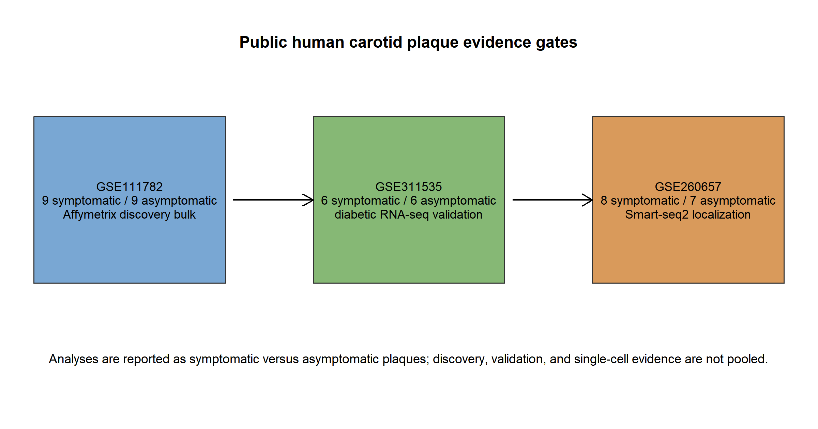
Source image: 05_results\figures\Figure_1_study_design.png

Figure 2 discovery bulk
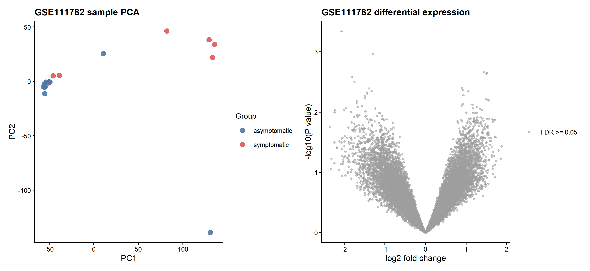
Source image: 05_results\figures\Figure_2_discovery_bulk.png

Figure 3 signature scores
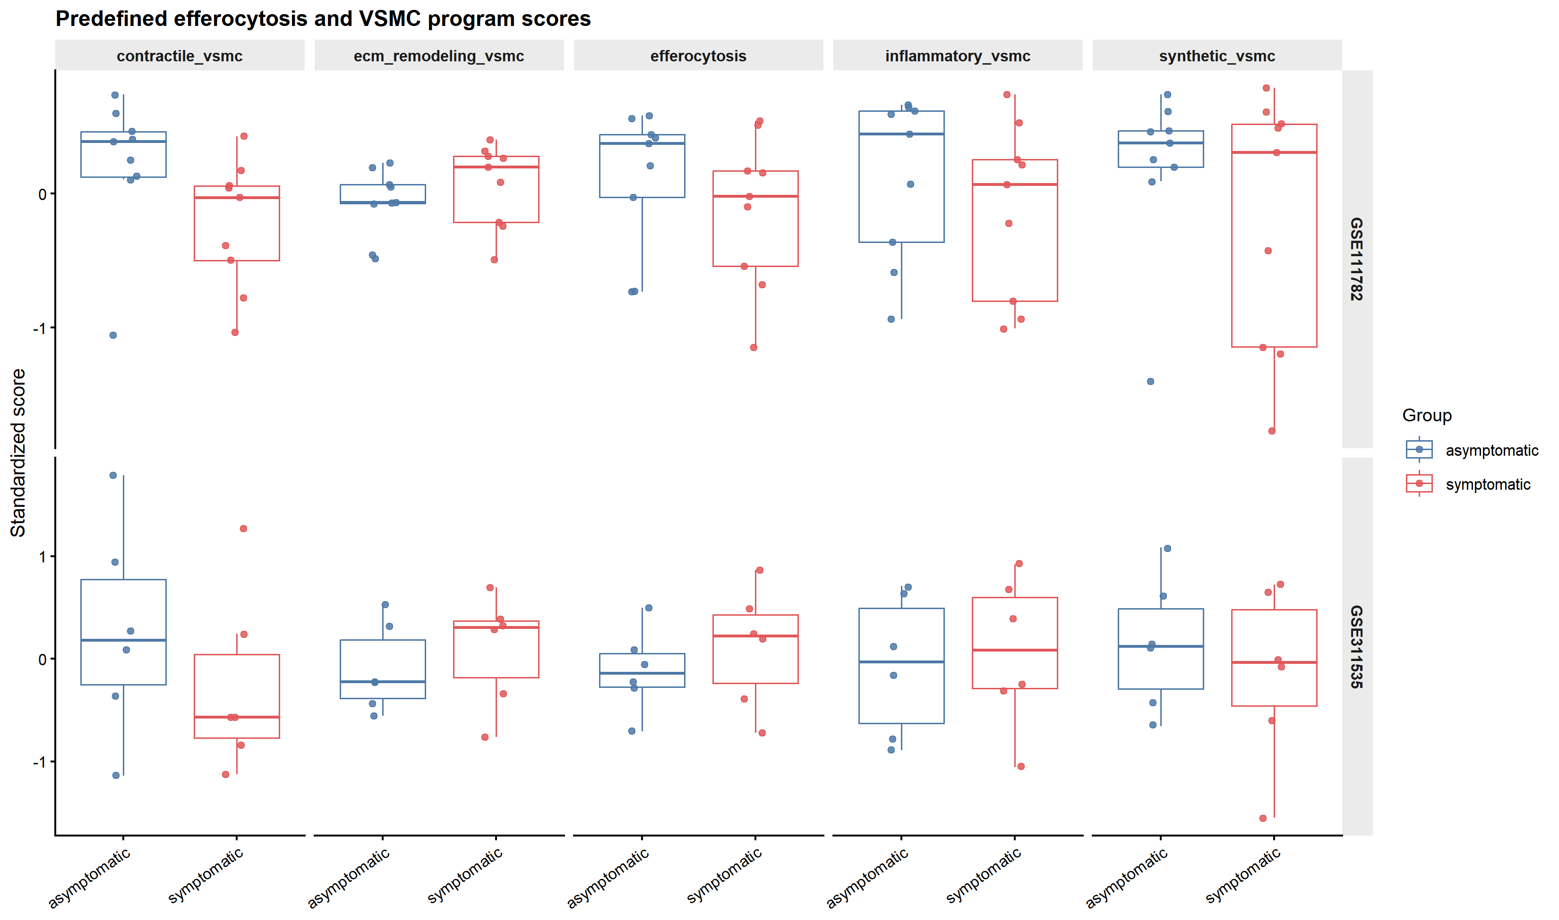
Source image: 05_results\figures\Figure_3_signature_scores.png

Figure 4 single cell atlas
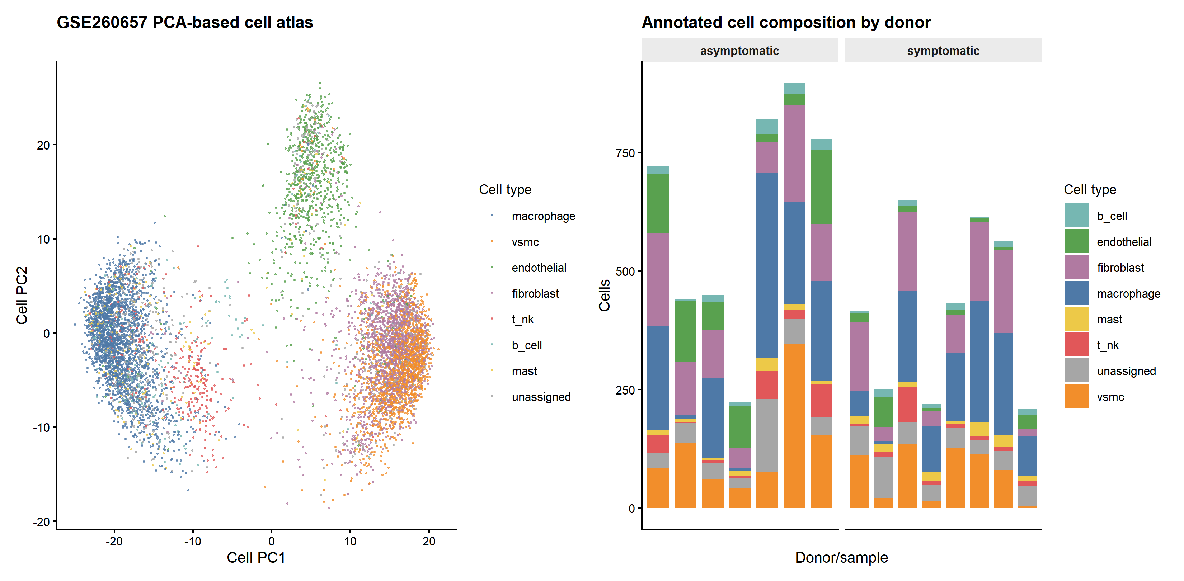
Source image: 05_results\figures\Figure_4_single_cell_atlas.png

Figure 5 macrophage efferocytosis
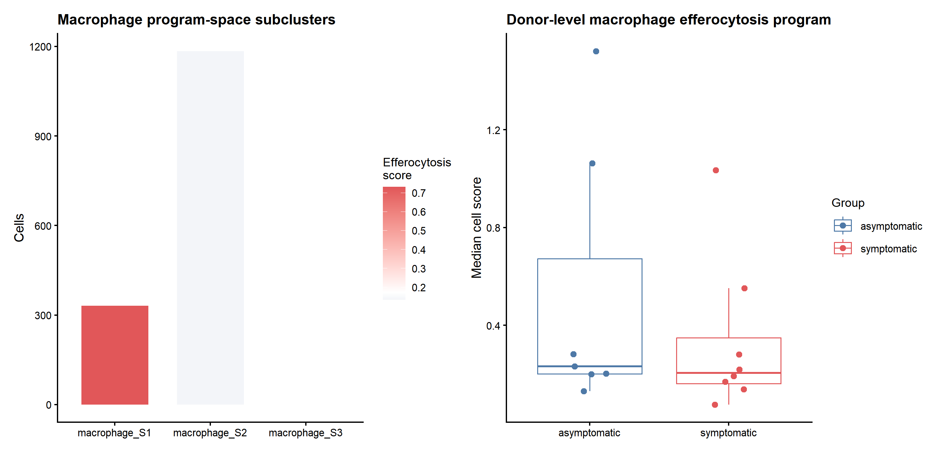
Source image: 05_results\figures\Figure_5_macrophage_efferocytosis.png

Figure 6 vsmc states
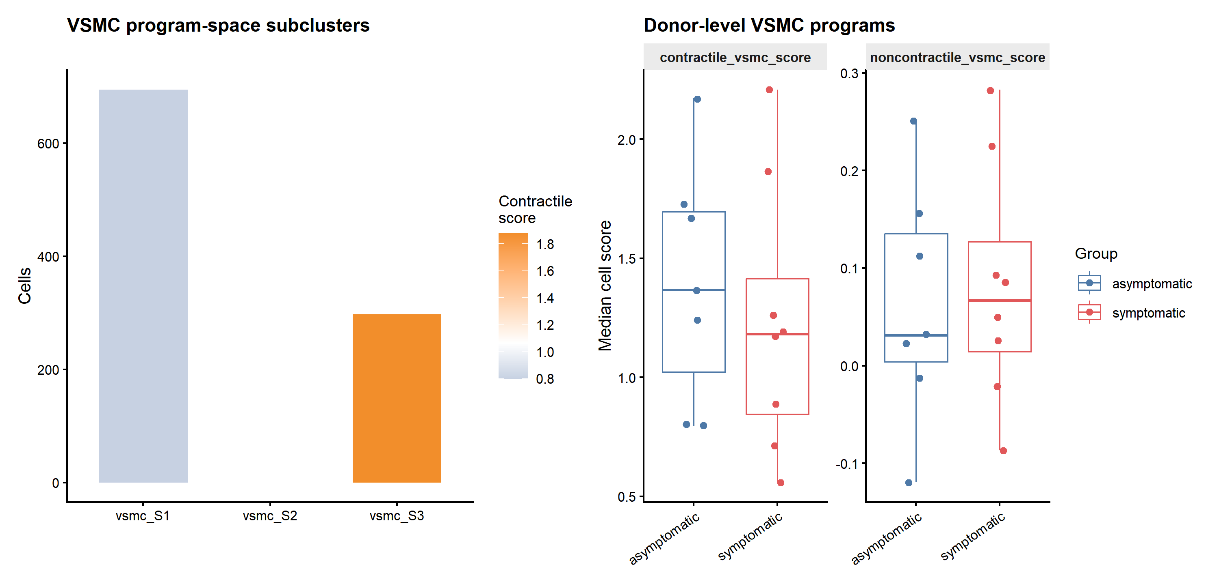
Source image: 05_results\figures\Figure_6_vsmc_states.png

Figure 7 external validation
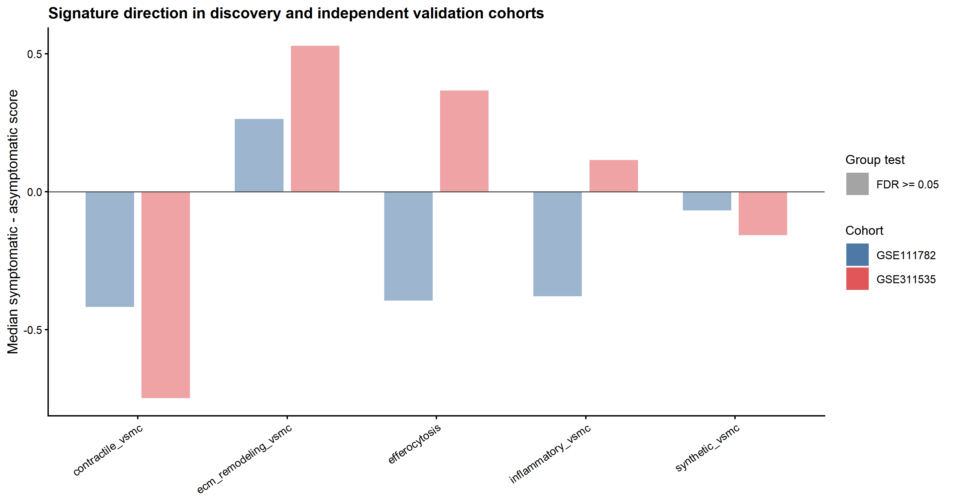
Source image: 05_results\figures\Figure_7_external_validation.png

Figure Legends
Figure 1 | Study design, cohort roles, and analysis gates. Public human carotid plaque cohorts were assigned to discovery bulk analysis (GSE111782), independent bulk validation (GSE311535), and single-cell localization (GSE260657). Symptomatic and asymptomatic labels are retained as reported in the source metadata.
Figure 2 | Discovery bulk quality control, differential expression, and enrichment. GSE111782 was analyzed with limma using symptomatic versus asymptomatic plaques as the contrast. Positive log2FC denotes higher expression in symptomatic plaques. No genes reached FDR < 0.05; ranked predefined signatures and GO outputs are shown as generated from source tables.
Figure 3 | Predefined efferocytosis and VSMC signature scores and tissue-level correlations. Sample-level scores summarize available mapped genes for each predefined program. Group comparisons use two-sided Wilcoxon tests with Benjamini-Hochberg correction; correlations use Spearman rho and are tissue-level associations only.
Figure 4 | Single-cell atlas and major-cell annotation for GSE260657. Smart-seq2 cell files were parsed from public raw data. Major cell classes were assigned by marker-score and clustering support; uncertain cells were retained as unassigned. Cells are displayed for localization and are not independent patients.
Figure 5 | Macrophage subclusters and efferocytosis program scoring. Macrophage cells were analyzed descriptively to localize efferocytosis-related expression. Donor/sample-level summaries, rather than cell counts, define the inferential unit for group comparisons.
Figure 6 | VSMC subclusters and contractile/non-contractile program scoring. VSMC cells were analyzed descriptively using predefined VSMC state programs. These outputs indicate candidate cell-state localization and do not prove lineage transition or causality.
Figure 7 | Independent bulk validation in GSE311535. Validation results are reported separately from discovery because the cohort is diabetes-specific and uses RNA-seq counts. The reproducible finding is the efferocytosis-inflammatory VSMC tissue-level association; gene-level and group-level signature findings are not validated at FDR < 0.05.
Source: 06_manuscript\figure_legends.txt

Tables
Table 1. Dataset audit and provenance: see 03_data/metadata/dataset_audit.csv.
Table 2. Bulk analysis summary: see 05_results/tables/bulk_analysis_summary.csv.
Table 3. Discovery complete differential-expression table: see 05_results/tables/GSE111782_DEG_complete.csv.
Table 4. Independent validation complete differential-expression table: see 05_results/tables/GSE311535_DEG_complete.csv.
Table 5. Predefined signatures and sample-level scores: see 05_results/tables/predefined_gene_sets.csv and 05_results/tables/signature_scores.csv.
Table 6. Signature group comparisons and tissue-level correlations: see 05_results/tables/external_validation_signature_summary.csv and 05_results/tables/signature_correlations.csv.
Table 7. Single-cell annotation, marker candidates, donor summaries, and program tests: see 05_results/qc/GSE260657_cell_annotations.csv and 05_results/tables/GSE260657_*.csv.
Table 8. External validation gene-direction table: see 05_results/tables/external_validation_gene_direction.csv.
Source: 06_manuscript\tables.txt

Supplementary Materials
Supplementary materials included in the project package:
- Complete DEG tables for discovery and validation cohorts.
- GO, Reactome, and ranked predefined-signature enrichment tables where generated.
- Predefined efferocytosis and VSMC gene-set definitions with source notes.
- Single-cell QC, marker-candidate, annotation, subcluster, and donor-level program-score tables.
- Dataset audit, file hashes, runbook, error log, package versions, and reproducibility notes.
- Skill-based manuscript review, statistical audit, and reference-verification reports.
Source: 06_manuscript\supplementary_materials.txt

Dataset Audit Summary
accession | dataset_title | species | tissue | assay_type | group_definition | included_or_excluded | intended_role | limitations | verification_status
GSE111782 | Expression data for post-bifurcation internal carotid atheroma | Homo sapiens | post-bifurcation internal carotid plaque | bulk microarray | symptomatic versus asymptomatic | included | discovery bulk | array platform; mixed tissue; small cohort | GEO metadata verified
GSE311535 | RNA-seq of human atherosclerotic carotid plaque tissue from diabetic patients | Homo sapiens | carotid plaque | bulk RNA-seq counts | symptomatic versus asymptomatic in diabetic patients | included | independent bulk validation | diabetic cohort; small cohort; RNA-seq platform | GEO metadata verified
GSE260657 | A smooth muscle cell gene-regulatory network critical for the development of advanced-stage and symptomatic atherosclerosis [human] | Homo sapiens | human carotid plaque scRNA-seq | single-cell RNA-seq | asymptomatic and symptomatic carotid plaques | included_pending_raw_check | single-cell localization | Smart-seq2 sampling; metadata/raw parsing pending | GEO metadata verified; files pending
GSE210152 | Single cell immune landscape of human atherosclerosis | Homo sapiens | human intraplaque immune cells | single-cell RNA-seq | clinical plaque immune atlas; group detail requires source verification | audit_only | contextual immune atlas | immune-cell-focused; VSMC availability uncertain | GEO metadata verified
GSE120521 | RNA-seq of stable and unstable section of human atherosclerotic plaques | Homo sapiens | carotid plaque regions | bulk RNA-seq | stable versus unstable regions within symptomatic plaques | excluded_primary | pathology-region context | all samples from symptomatic patients; region labels differ | GEO metadata verified
GSE118481 | Gene array of laser capture microdissectioned human diabetic vs non-diabetic plaque macrophages | Homo sapiens | carotid plaque macrophage-enriched regions | bulk macrophage array | diabetic versus non-diabetic; symptom labels also present | audit_only | diabetes macrophage context | LCM macrophage-enriched regions and diabetes confounding | GEO metadata verified
GSE270496 | Multi-omic Landscape of Extracellular Vesicles in Human Carotid Atherosclerotic Plaque | Homo sapiens | carotid plaque and marginal zone EVs | EV miRNA/proteomics | symptomatic versus asymptomatic with plaque versus marginal zones | audit_only | EV/cell communication context | EV assay rather than whole-plaque transcriptome | GEO metadata verified
GSE246315 | Decoding the immune checkpoint signatures in human atherosclerosis | Homo sapiens | human carotid plaque scRNA-seq | single-cell RNA-seq | diabetes/intervention-related plaque immune checkpoints | audit_only | immune checkpoint context | intervention/metabolic context | GEO metadata verified
GSE245373 | Mice are not men: scRNA-sequencing of the human atherosclerotic plaque | Homo sapiens; Mus musculus | human atherosclerotic plaque immune cells | single-cell RNA-seq | human plaque immune-cell comparison; clinical validation | audit_only | species/immune context | mixed species and clinical groups | GEO metadata verified
GSE234077 | Human femoral atheroma exhibit inflammation-resolving myeloid and lymphoid bias compared with carotid atheroma | Homo sapiens | carotid and femoral atheroma | single-cell RNA-seq | carotid versus femoral tissue | audit_only | vascular-bed context | vascular-bed difference | GEO metadata verified

Source File Inventory

Review Source Files
file | bytes | modified
06_manuscript\figure_legends.docx | 37607 | 2026-09-04T09:18:48
06_manuscript\figure_legends.txt | 2202 | 2026-09-04T09:18:48
06_manuscript\manuscript_draft.docx | 49530 | 2026-09-04T09:18:48
06_manuscript\manuscript_draft.md | 34205 | 2026-09-04T09:18:48
06_manuscript\manuscript_draft.pdf | 58693 | 2026-09-03T21:48:32
06_manuscript\reference_verification_report.md | 918 | 2026-09-04T09:18:48
06_manuscript\references.bib | 17232 | 2026-09-04T09:18:47
06_manuscript\skill_based_review_report.md | 4728 | 2026-09-04T09:18:48
06_manuscript\statistical_audit_report.md | 2110 | 2026-09-04T09:18:48
06_manuscript\supplementary_materials.docx | 36957 | 2026-09-04T09:18:48
06_manuscript\supplementary_materials.txt | 564 | 2026-09-04T09:18:48
06_manuscript\tables.docx | 36978 | 2026-09-04T09:18:48
06_manuscript\tables.txt | 1017 | 2026-09-04T09:18:48
06_manuscript\terminology_ledger.md | 1089 | 2026-09-04T09:18:48
06_manuscript\title_page.docx | 36895 | 2026-09-04T09:18:48
05_results\tables\bulk_analysis_summary.csv | 226 | 2026-09-03T21:59:36
05_results\tables\external_validation_gene_direction.csv | 1768085 | 2026-09-03T22:03:50
05_results\tables\external_validation_signature_summary.csv | 1162 | 2026-09-03T22:03:50
05_results\tables\figure_3_signature_long.csv | 11424 | 2026-09-04T08:29:26
05_results\tables\figure_4_cell_composition_source.csv | 7759 | 2026-09-04T08:29:27
05_results\tables\figure_4_single_cell_source.csv | 935440 | 2026-09-04T08:29:27
05_results\tables\figure_7_validation_source.csv | 1506 | 2026-09-04T08:29:31
05_results\tables\GSE111782_DEG_complete.csv | 2935190 | 2026-09-03T21:59:31
05_results\tables\GSE260657_cell_program_scores.csv | 1337272 | 2026-09-04T08:27:02
05_results\tables\GSE260657_cluster_marker_candidates.csv | 29324 | 2026-09-04T08:17:15
05_results\tables\GSE260657_donor_program_summary.csv | 3710 | 2026-09-04T08:27:02
05_results\tables\GSE260657_donor_program_tests.csv | 500 | 2026-09-04T08:27:02
05_results\tables\GSE260657_file_program_scores.csv | 3043 | 2026-09-04T08:27:02
05_results\tables\GSE260657_macrophage_subcluster_summary.csv | 396 | 2026-09-04T08:27:02
05_results\tables\GSE260657_macrophage_subclusters.csv | 354349 | 2026-09-04T08:27:02
05_results\tables\GSE260657_vsmc_subcluster_summary.csv | 353 | 2026-09-04T08:27:02
05_results\tables\GSE260657_vsmc_subclusters.csv | 209995 | 2026-09-04T08:27:02
05_results\tables\GSE311535_DEG_complete.csv | 3400744 | 2026-09-03T21:59:36
05_results\tables\predefined_gene_sets.csv | 2102 | 2026-09-03T21:59:43
05_results\tables\signature_correlations.csv | 2244 | 2026-09-03T21:59:44
05_results\tables\signature_scores.csv | 4034 | 2026-09-03T21:59:44

References
Reference entries are expanded from references.bib for review. The final submission reference list should be reconciled against in-text citations and journal style.
1. Caparosa EM and Sedgewick AJ and Zenonos G and Zhao Y and Carlisle DL and Stefaneanu L and Jankowitz BT and Gardner P and Chang YF and Lariviere WR and LaFramboise WA and Benos PV and Friedlander RM. Regional Molecular Signature of the Symptomatic Atherosclerotic Carotid Plaque. Neurosurgery 2019. DOI: 10.1093/neuros/nyy470. PMID: 30335165.
2. Bradford A and Yoshida T and Sukhanov S and Woods FF and Delafontaine P and Bazan HA and Woods TC. Insulin use promotes pro-inflammatory changes in the transcriptome of atherosclerotic plaques in patients with diabetes mellitus. Journal of molecular and cellular cardiology plus 2025. DOI: 10.1016/j.jmccpl.2025.100829. PMID: 41377472.
3. Mocci G and Sukhavasi K and Örd T and Bankier S and Singha P and Arasu UT and Agbabiaje OO and Mäkinen P and Ma L and Hodonsky CJ and Aherrahrou R and Muhl L and Liu J and Gustafsson S and Byandelger B and Wang Y and Koplev S and Lendahl U and Owens GK and Leeper NJ and Pasterkamp G and Vanlandewijck M and Michoel T and Ruusalepp A and Hao K and Ylä-Herttuala S and Väli M and Järve H and Mokry M and Civelek M and Miller CJ and Kovacic JC and Kaikkonen MU and Betsholtz C and Björkegren JLM. Single-Cell Gene-Regulatory Networks of Advanced Symptomatic Atherosclerosis. Circulation research 2024. DOI: 10.1161/CIRCRESAHA.123.323184. PMID: 38639096.
4. Barrett T and Wilhite SE and Ledoux P and Evangelista C and Kim IF and Tomashevsky M and Marshall KA and Phillippy KH and Sherman PM and Holko M and Yefanov A and Lee H and Zhang N and Robertson CL and Serova N and Davis S and Soboleva A. NCBI GEO: archive for functional genomics data sets--update. Nucleic acids research 2013. DOI: 10.1093/nar/gks1193. PMID: 23193258.
5. Edgar R and Domrachev M and Lash AE. Gene Expression Omnibus: NCBI gene expression and hybridization array data repository. Nucleic acids research 2002. DOI: 10.1093/nar/30.1.207. PMID: 11752295.
6. Linton MF and Babaev VR and Huang J and Linton EF and Tao H and Yancey PG. Macrophage Apoptosis and Efferocytosis in the Pathogenesis of Atherosclerosis. Circulation journal : official journal of the Japanese Circulation Society 2016. DOI: 10.1253/circj.CJ-16-0924. PMID: 27725526.
7. Kojima Y and Weissman IL and Leeper NJ. The Role of Efferocytosis in Atherosclerosis. Circulation 2017. DOI: 10.1161/CIRCULATIONAHA.116.025684. PMID: 28137963.
8. Kasikara C and Schilperoort M and Gerlach B and Xue C and Wang X and Zheng Z and Kuriakose G and Dorweiler B and Zhang H and Fredman G and Saleheen D and Reilly MP and Tabas I. Deficiency of macrophage PHACTR1 impairs efferocytosis and promotes atherosclerotic plaque necrosis. The Journal of clinical investigation 2021. DOI: 10.1172/JCI145275. PMID: 33630758.
9. Miano JM and Fisher EA and Majesky MW. Fate and State of Vascular Smooth Muscle Cells in Atherosclerosis. Circulation 2021. DOI: 10.1161/CIRCULATIONAHA.120.049922. PMID: 34029141.
10. Chakraborty R and Chatterjee P and Dave JM and Ostriker AC and Greif DM and Rzucidlo EM and Martin KA. Targeting smooth muscle cell phenotypic switching in vascular disease. JVS-vascular science 2021. DOI: 10.1016/j.jvssci.2021.04.001. PMID: 34617061.
11. Zhang F and Guo X and Xia Y and Mao L. An update on the phenotypic switching of vascular smooth muscle cells in the pathogenesis of atherosclerosis. Cellular and molecular life sciences : CMLS 2021. DOI: 10.1007/s00018-021-04079-z. PMID: 34936041.
12. Depuydt MAC and Prange KHM and Slenders L and Örd T and Elbersen D and Boltjes A and de Jager SCA and Asselbergs FW and de Borst GJ and Aavik E and Lönnberg T and Lutgens E and Glass CK and den Ruijter HM and Kaikkonen MU and Bot I and Slütter B and van der Laan SW and Yla-Herttuala S and Mokry M and Kuiper J and de Winther MPJ and Pasterkamp G. Microanatomy of the Human Atherosclerotic Plaque by Single-Cell Transcriptomics. Circulation research 2020. DOI: 10.1161/CIRCRESAHA.120.316770. PMID: 32981416.
13. Pan H and Xue C and Auerbach BJ and Fan J and Bashore AC and Cui J and Yang DY and Trignano SB and Liu W and Shi J and Ihuegbu CO and Bush EC and Worley J and Vlahos L and Laise P and Solomon RA and Connolly ES and Califano A and Sims PA and Zhang H and Li M and Reilly MP. Single-Cell Genomics Reveals a Novel Cell State During Smooth Muscle Cell Phenotypic Switching and Potential Therapeutic Targets for Atherosclerosis in Mouse and Human. Circulation 2020. DOI: 10.1161/CIRCULATIONAHA.120.048378. PMID: 32962412.
14. Dib L and Koneva LA and Edsfeldt A and Zurke YX and Sun J and Nitulescu M and Attar M and Lutgens E and Schmidt S and Lindholm MW and Choudhury RP and Cassimjee I and Lee R and Handa A and Goncalves I and Sansom SN and Monaco C. Lipid-associated macrophages transition to an inflammatory state in human atherosclerosis increasing the risk of cerebrovascular complications. Nature cardiovascular research 2023. DOI: 10.1038/s44161-023-00295-x. PMID: 38362263.
15. Slysz J and Sinha A and DeBerge M and Singh S and Avgousti H and Lee I and Glinton K and Nagasaka R and Dalal P and Alexandria S and Wai CM and Tellez R and Vescovo M and Sunderraj A and Wang X and Schipma M and Sisk R and Gulati R and Vallejo J and Saigusa R and Lloyd-Jones DM and Lomasney J and Weinberg S and Ho K and Ley K and Giannarelli C and Thorp EB and Feinstein MJ. Single-cell profiling reveals inflammatory polarization of human carotid versus femoral plaque leukocytes. JCI insight 2023. DOI: 10.1172/jci.insight.171359. PMID: 37471165.
16. Horstmann H and Michel NA and Sheng X and Hansen S and Lindau A and Pfeil K and Fernández MC and Marchini T and Winkels H and Mitre LS and Abogunloko T and Li X and Mwinyella TB and Gissler MC and Bugger H and Heidt T and Buscher K and Hilgendorf I and Stachon P and Piepenburg S and Verheyen N and Rathner T and Gerhardt T and Siegel PM and Oswald WK and Cohnert T and Zernecke A and Madl J and Kohl P and Foks AC and von Zur Muehlen C and Westermann D and Zirlik A and Wolf D. Cross-species single-cell RNA sequencing reveals divergent phenotypes and activation states of adaptive immunity in human carotid and experimental murine atherosclerosis. Cardiovascular research 2024. DOI: 10.1093/cvr/cvae154. PMID: 39041203.
17. Barcia Durán JG and Das D and Gildea M and Amadori L and Gourvest M and Kaur R and Eberhardt N and Smyrnis P and Cilhoroz B and Sajja S and Rahman K and Fernandez DM and Faries P and Narula N and Vanguri R and Goldberg IJ and Fisher EA and Berger JS and Moore KJ and Giannarelli C. Immune checkpoint landscape of human atherosclerosis and influence of cardiometabolic factors. Nature cardiovascular research 2024. DOI: 10.1038/s44161-024-00563-4. PMID: 39613875.
18. Sukhavasi K and Mocci G and Ma L and Hodonsky CJ and Diez Benevante E and Muhl L and Liu J and Gustafsson S and Buyandelger B and Koplev S and Lendahl U and Vanlandewijck M and Singha P and Örd T and Beter M and Selvarajan I and Laakkonen JP and Väli M and den Ruijter HM and Civelek M and Hao K and Ruusalepp A and Betsholtz C and Järve H and Kovacic JC and Miller CL and Romanoski C and Kaikkonen MU and Björkegren JLM. Single-cell RNA sequencing reveals sex differences in the subcellular composition and associated gene-regulatory network activity of human carotid plaques. Nature cardiovascular research 2025. DOI: 10.1038/s44161-025-00628-y. PMID: 40211055.
19. Narayanan S and Vuckovic S and Bergman O and Wirka R and Verdezoto Mosquera J and Chen QS and Baldassarre D and Tremoli E and Veglia F and Lengquist M and Aherahrrou R and Razuvaev A and Gigante B and Björck HM and Miller CL and Quertermous T and Hedin U and Matic L. Atheroma transcriptomics identifies ARNTL as a smooth muscle cell regulator and with clinical and genetic data improves risk stratification. European heart journal 2025. DOI: 10.1093/eurheartj/ehae768. PMID: 39552248.
20. Raju S and Turner ME and Cao C and Abdul-Samad M and Punwasi N and Blaser MC and Cahalane RME and Botts SR and Prajapati K and Patel S and Wu R and Gustafson D and Galant NJ and Fiddes L and Chemaly M and Hedin U and Matic L and Seidman MA and Subasri V and Singh SA and Aikawa E and Fish JE and Howe KL. Multiomic Landscape of Extracellular Vesicles in Human Carotid Atherosclerotic Plaque Reveals Endothelial Communication Networks. Arteriosclerosis, thrombosis, and vascular biology 2025. DOI: 10.1161/ATVBAHA.124.322324. PMID: 40438929.
21. Ritchie ME and Phipson B and Wu D and Hu Y and Law CW and Shi W and Smyth GK. limma powers differential expression analyses for RNA-sequencing and microarray studies. Nucleic acids research 2015. DOI: 10.1093/nar/gkv007. PMID: 25605792.
22. Robinson MD and McCarthy DJ and Smyth GK. edgeR: a Bioconductor package for differential expression analysis of digital gene expression data. Bioinformatics (Oxford, England) 2010. DOI: 10.1093/bioinformatics/btp616. PMID: 19910308.
23. Hänzelmann S and Castelo R and Guinney J. GSVA: gene set variation analysis for microarray and RNA-seq data. BMC bioinformatics 2013. DOI: 10.1186/1471-2105-14-7. PMID: 23323831.
24. Subramanian A and Tamayo P and Mootha VK and Mukherjee S and Ebert BL and Gillette MA and Paulovich A and Pomeroy SL and Golub TR and Lander ES and Mesirov JP. Gene set enrichment analysis: a knowledge-based approach for interpreting genome-wide expression profiles. Proceedings of the National Academy of Sciences of the United States of America 2005. DOI: 10.1073/pnas.0506580102. PMID: 16199517.
25. Yu G and Wang LG and Han Y and He QY. clusterProfiler: an R package for comparing biological themes among gene clusters. Omics : a journal of integrative biology 2012. DOI: 10.1089/omi.2011.0118. PMID: 22455463.
26. Yu G and He QY. ReactomePA: an R/Bioconductor package for reactome pathway analysis and visualization. Molecular bioSystems 2016. DOI: 10.1039/c5mb00663e. PMID: 26661513.
27. Gene Ontology Consortium. The Gene Ontology resource: enriching a GOld mine. Nucleic acids research 2021. DOI: 10.1093/nar/gkaa1113. PMID: 33290552.
28. Gillespie M and Jassal B and Stephan R and Milacic M and Rothfels K and Senff-Ribeiro A and Griss J and Sevilla C and Matthews L and Gong C and Deng C and Varusai T and Ragueneau E and Haider Y and May B and Shamovsky V and Weiser J and Brunson T and Sanati N and Beckman L and Shao X and Fabregat A and Sidiropoulos K and Murillo J and Viteri G and Cook J and Shorser S and Bader G and Demir E and Sander C and Haw R and Wu G and Stein L and Hermjakob H and D'Eustachio P. The reactome pathway knowledgebase 2022. Nucleic acids research 2022. DOI: 10.1093/nar/gkab1028. PMID: 34788843.
29. Kanehisa M and Furumichi M and Sato Y and Ishiguro-Watanabe M and Tanabe M. KEGG: integrating viruses and cellular organisms. Nucleic acids research 2021. DOI: 10.1093/nar/gkaa970. PMID: 33125081.
30. Langfelder P and Horvath S. WGCNA: an R package for weighted correlation network analysis. BMC bioinformatics 2008. DOI: 10.1186/1471-2105-9-559. PMID: 19114008.

