[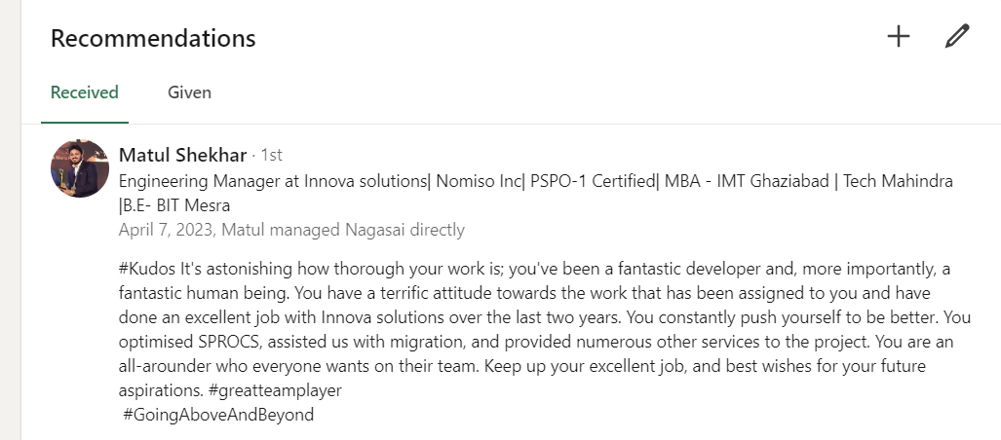](GitResumes1/AWS%20Certified%20Cloud%20Practitioner.pdf)

