Nagasai Velpuri

North York, ON, M3A 2R6

647-338-9549

velpurinagasai99@gmail.com

15-05, 2025

Hiring Manager,

Servus Credit Union,

Edmonton, Alberta.

Dear Hiring Manager,

Please accept my resume as a **Database Administrator** at Servus Credit Union as advertised on Indeed. I have gone through your company website and got very interested in working with a legacy company (since 1938) as yours. I have also gone through your net banking website which you might be redesigning it.

Coming to my skills I worked as Database Administrator for a client HALO for over 2 years. I have implemented search functionalities, Sprocs, optimized, migrated data which is all the stuff related to maintain a database. And the good part is I worked with Microsoft technologies like SSIS, SSRS, SSAS which you are using. I am also good at DevOps technologies, and a quick learner. I am doing Big Data certification which is giving me a good hands-on Experience on AWS tools. Given a chance I can be a potential candidate, please got through my profile once if possible.

<https://www.linkedin.com/in/mathlovernagasai/>

<https://github.com/velpurinagasai99>

<https://codeforces.com/profile/velpurinagasai>

<https://platform.torc.dev/#/profile/velpurinagasai99>

[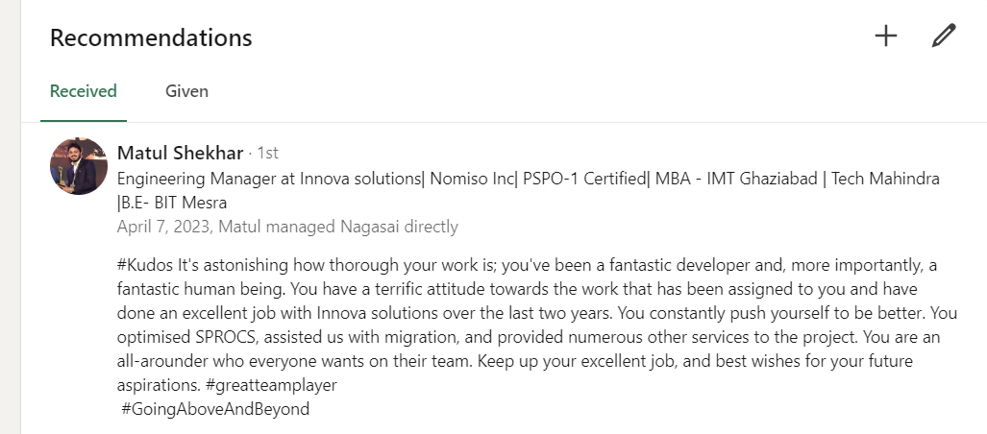](GitResumes1/AWS%20Certified%20Cloud%20Practitioner.pdf)

