CAMPUS INFORMATION ASSISTANT

Lenovo LEAP AI Capstone Project

Submitted By

Name: Velroy Fernandes
Roll No: 240842
Email:Velroydfernandes05@gmail.com

---

1. Selected SDG and Reason

SDG 4: Quality Education

Quality education aims to ensure inclusive and equitable learning opportunities for all students. In many colleges, students find it difficult to access important information regarding courses, facilities, departments, library services, and office contacts. A Campus Information Assistant can provide instant access to such information and improve the student experience.

---

2. Problem Statement

Students frequently have questions about courses, library locations, office contacts, admission procedures, and other campus-related services. Finding this information can be time-consuming, especially for new students. Lack of quick access to information may lead to confusion and reduced efficiency.

---

3. Proposed Solution

The Campus Information Assistant is an AI-powered chatbot designed to answer student queries related to the college. The chatbot provides instant responses about courses offered, library facilities, office contacts, campus locations, and other important information.

The assistant is available at any time and helps students obtain accurate information without needing to visit multiple offices.

---

4. Project Features

Course Information

Provides details about courses and programs available in the college.

Library Information

Helps students locate the library and access library-related information.

Office Contact Information

Provides contact details of the administration office.

Campus Assistance

Answers general questions regarding college facilities and services.

Instant Response System

Provides quick and user-friendly responses to student queries.

---

5. Technology Stack

- AI Chatbot Technology
- Natural Language Processing (NLP)
- Web-Based Interface
- Botpress / Conversational AI Platform
- GitHub Repository

---

6. Project Screenshots

Figure 1: Campus Assistant Interface

(Paste chatbot screenshot showing course information)

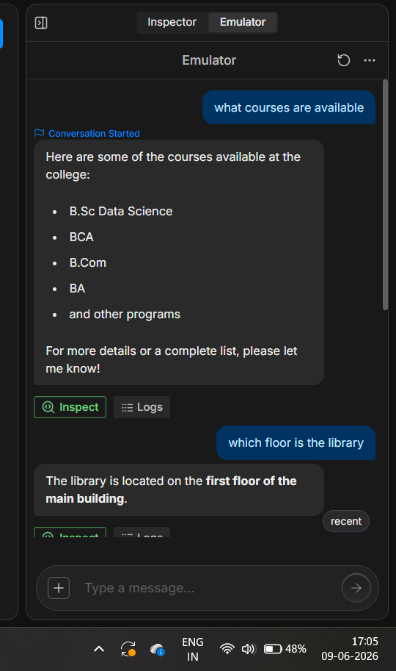

Figure 2: Library Information Response

(Paste screenshot showing library-related query)

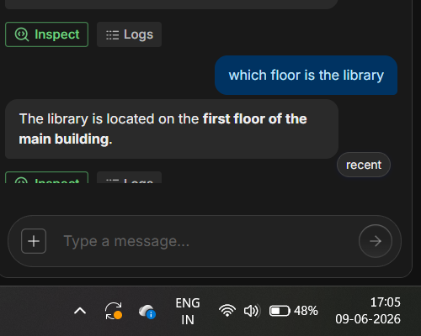

Figure 3: Office Contact Response

(Paste screenshot showing office contact query)
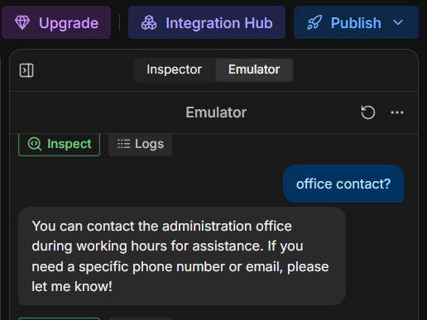

Figure 4: Chatbot Conversation Window

(Paste screenshot of chatbot interaction)

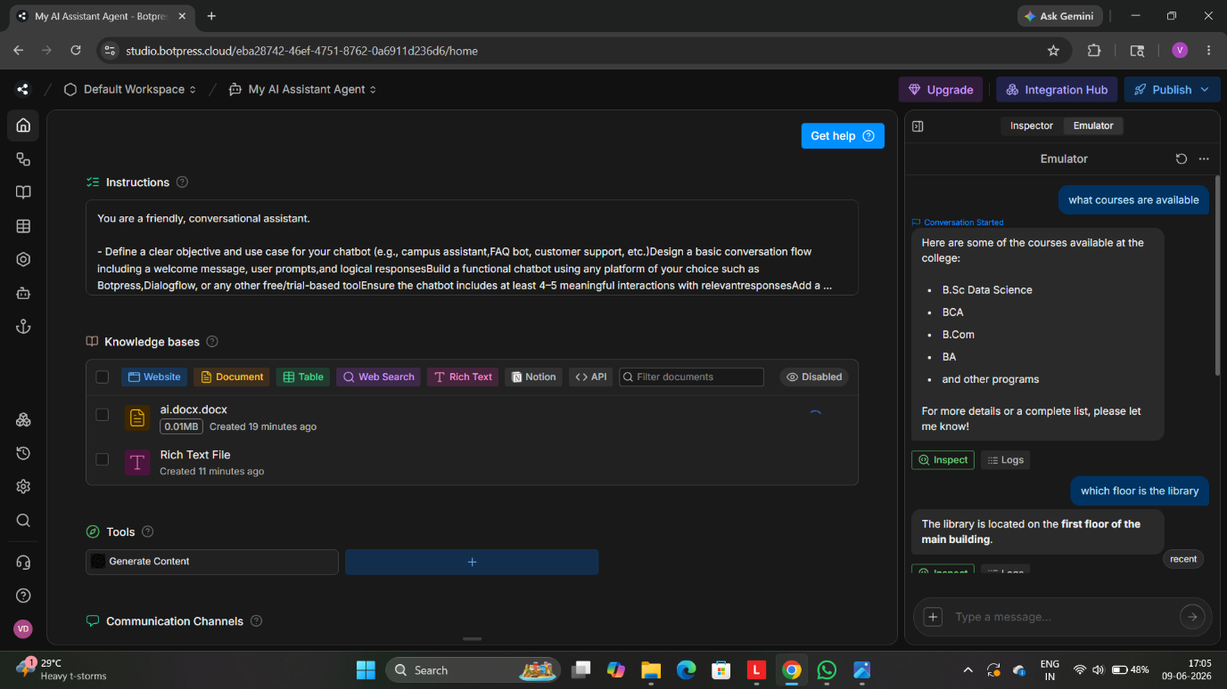

8. Future Scope

- Voice-enabled chatbot support
- Multi-language assistance
- Integration with college databases
- Student timetable and attendance support
- Event and notice notifications
- Mobile application integration

---

Conclusion

The Campus Information Assistant provides an efficient and user-friendly solution for accessing college-related information. By using Artificial Intelligence and Natural Language Processing, the chatbot helps students obtain accurate information instantly. This project supports SDG 4: Quality Education by improving access to educational resources and campus services.

