Convolutional Neural Network Approach for White Blood Cells Classiﬁcation

Project report submitted to Karpagam Academy of Higher Education in Partial Fulfillment of the requirements for the award of the degree of
Master of Computer Applications
Submitted by
ABISHEK S
(23CAP128)


Under the Guidance of
Mrs. Uma Maheswari N
Assistant Professor
Department of Computer Science

KARPAGAM ACADEMY OF HIGHER EDUCATION
(Deemed to be University)
(Established Under Section 3 of UGC Act, 1956)
COIMBATORE – 641 021

MAY-2025

KARPAGAM ACADEMY OF HIGHER EDUCATION
(Deemed to be University)
(Established Under Section 3 of UGC Act, 1956)
Coimbatore – 641 021

MASTER OF COMPUTER APPLICATIONS

Bonafide Certificate
This is to certify that the project work entitled “Convolutional Neural Network Approach for White Blood Cells Classiﬁcation” done by ABISHEK S (23CAP128), during the period of October 2024 to May 2025 in partial fulfillment of the degree of Master of Computer Applications is submitted for the viva voice held on

Project Guide Head of the Department

INTERNAL EXAMINER EXTERNAL EXAMINER

KARPAGAM ACADEMY OF HIGHER EDUCATION
(Deemed to be University) (Established Under Section 3 of UGC Act, 1956)
Coimbatore – 641 021


CERTIFICATE

This is to certify that the project entitled “Convolutional Neural Network Approach for White Blood Cells Classiﬁcation” is the Bonafide project work carried out by ABISHEK S(23CAP128), Student of Master Computer Application submitted to the Karpagam Academy of Higher Education, Coimbatore, during the year 2025, in partial fulfillment of the requirements for the award of the Degree of Master of Computer Applications, is the record of student’s own worked carried out by his under my supervision.

Place: Coimbatore Signature of the guide

Date: Mrs.Uma Maheshwari

DECLARATION

ABISHEK S(23CAP128),do hereby declare that this project work entitled “Convolutional Neural Network Approach for White Blood Cells Classiﬁcation” is submitted to the Karpagam Academy of Higher Education in partial fulfillment of the requirements for the award of the degree of Computer Application is a record of original project work done by me, during the period of October 2024 to May 2025 under the supervision and guidance of Mrs. Uma Maheswari N Assistant Professor in Department of Computer Science and that this it has not formed the basis for any degree diploma other similar title to any candidate of any university.

Place: Coimbatore

Signature of the Candidate
Date: ABISHEK S

TABLE OF CONTENTS

CHAPTERNO | CONTENTS OF THE INDEX | PAGENO
 | ACKNOWLED GEMENT
 | ABSTRACT | 7
I | INTRODUCTION | 1
 | - BACKGROUND | 1
 | 1.2 MOTIVATION | 3
 | 1.3 OBJECTIVE | 6
 | 1.4 SCOPE OF THEP ROJECT | 7
II | LITERATURE SURVEY | 8
 | 2.1 LITERATURE SURVEY | 8
 | 2.2 DRAWBACKS OF EXISTING SYSTEM | 18
III | SYSTEM STUDY | 20
 | 3.1 PROPOSED SYSTEM | 20
 | 3.2 ADVANTAGES OF PROPOSED SYSTEM | 22
 | 3.3 MODULE DESCRIPTION | 23
 | 3.4 TRAIN THE MODEL | 25
IV | SYSTEM ANALYSIS | 27
 | 4.1 DATA FLOW DIAGRM | 27
 | 4.2 MODULES DESCRIPTION | 27
 | 4.3 SYSTEM SPECIFICATION | 30
 | 4.3.1 HARDWARE SPECIFICATION | 30
 | 4.3.2 SOFTWARE SPECIFICATION | 30
 | 4.4. SOFTWARE DESCRIPTION | 31
V | SYSTEM DESIGN AND DEVELOPMENT | 35
 | 5.1 INPUTDESIGN | 35
 | 5.2 OUTPUTDESIGN | 36
 | 5.3 TABLE DESIGN | 37
 | 5.4 SCREENDESIGN | 37
VI | SYSTEM TESTING AND IMPLEMENTATION | 38
 | 6.1 SYSTEM TESTING | 39
 | 6.2 SYSTEM IMPLEMENTATION AND MAINTENANCE | 41
VII | CONCLUSION AND FUTURE ENCHANCEMENT | 42
 | 7.1 CONCLUSION | 42
 | 7.2 FUTURE SCOPE | 43
 | SAMPLE CODING | 44
 | BIBLIOGRAPHY | 57

ABSTRACT

White Blood Cells also known as leukocytes play an important role in the human body by increasing immunity and fighting infectious diseases. The classification of White Blood Cells is crucial for detecting diseases in individuals. It can assist in identifying diseases such as infections, allergies, anemia, leukemia, cancer, Acquired Immune Deficiency Syndrome (AIDS), etc., which are caused by anomalies in the immune system. This classification will assist hematologists in distinguishing the types of White Blood Cells present in the human body and finding the root cause of diseases. Currently, there is a large amount of research going on in this field. Considering the huge potential in the significance of classifying WBCs, we will be using deep learning techniques such as Convolutional Neural Networks (CNN) models like AlexNet and VGG19 to classify images of WBCs into their subtypes, namely, Neutrophil, Eosinophil, Lymphocyte, and Monocyte. In this process, we will be reporting the results of various experiments executed on the Blood Cell Classification and Detection (BCCD) dataset using AlexNet and VGG19.

CHAPTER 1
INTRODUCTION
1.1.General Introduction
A blood cell, also called a hematopoietic cell, hemocyte, or hematocyte, is a cell produced through hematopoiesis and found mainly in the blood. Major types of blood cells include red blood cells (erythrocytes), white blood cells (leukocytes), and platelets (thrombocytes). Together, these three kinds of blood cells add up to a total 45% of the blood tissue by volume, with the remaining 55% of the volume composed of plasma, the liquid component of blood.Cell morphology is a crucial aspect of many biological processes and it has direct implications for human health. In particular, analyzing this characteristic of blood cells can help to provide important information that facilitates the diagnosis of some diseases or pathologies, such as drepanocytic (or sickle cell) anemia, a hemolytic anemia transmitted via autosomal recessive inheritance and variable, habitually serious, intensity.
AUTOMATIC segmentation is a significant task in image processing applications. It has an important role in the detection, classification, and diagnosis of hematological disorders: sickle cell anemia (SCA), acute lymphoblastic leukemia (ALL), and acute myeloid leukemia (AML). SCA causes significant morphological variations of red blood cells (RBCs). However, AML and ALL affect white blood cells (WBCs). Hence, the analysis of cell morphology has a vital role in the diagnosis of hematological disorders.
Manual counting and segmentation of cells are time consuming and truly are a more challenging job. The presence of noise, unwanted cells, overlapped cells, and poor contrast make this task more difficult. On the other hand, automatic segmentation enhances the robustness and, thus, makes diagnosis and treatment planning more accurate.
Red blood cells (RBCs) must be highly deformable to transit through the microvasculature to deliver oxygen to tissues. The loss of RBC deformability resulting from pathology, natural aging, or storage in blood bags can impede the proper function of these cells. A variety of methods have been.E developed to measure RBC deformability, but these methods require specialized equipment, long measurement time, and highly skilled personnel. To address this challenge, we investigated whether a machine learning approach could be used to predict donor RBC deformability based on morphological features from single cell microscope images.
We used the microfluidic ratchet device to sort RBCs based on deformability. Sorted cells are then imaged and used to train a deep learning model to classify RBC based image features related to cell deformability. This model correctly predicted deformability of individual RBCs with 81 ± 11% accuracy averaged across ten donors. Using this model to score the deformability of RBC samples was accurate to within 10.4 ± 6.8% of the value obtained using the microfluidic ratchet device.
While machine learning methods are frequently developed to automate human image analysis, our study is remarkable in showing that deep learning of single cell microscopy images could be used to assess RBC deformability, a property not normally measurable by imaging. Measuring RBC deformability by imaging is also desirable because it can be performed rapidly using a standard microscopy system, potentially enabling RBC deformability studies to be performed as part of routine clinical assessments.Red blood cells (RBCs) are highly specialized cells that facilitate tissue respiration by delivering oxygen and removing carbon dioxide.1,2 RBCs transverse through the entire circulatory system approximately every 60 seconds. Their journey includes the microvasculature, where RBCs must deform through capillaries measuring as little as 2 μm in diameter, as well as the inter-endothelial clefts of the spleen measuring 0.5–1.0 μm in diameter.3,4 The loss of RBC deformability, due to pathology, natural aging, or storage in blood bags, reduces the ability of RBCs to circulate and facilitate their removal from circulation by phagocytes in the spleen and the liver.5,6 As a result, there is significant interest in methods for measuring RBC deformability as a potential biomarker for diseases, such as malaria7 and hemoglobinopathies,2,8 or for assessing the quality of donated RBCs for use in blood transfusions.
1.2.Project Objectives
•The main objective of seed-point detection is to identify each particle in an image by seed point.
•Seed-point detection aims to accurately locate the cells in an image.
•To enhance the efficiency of this process, we plan to implement the deep learning algorithms such as AlexNet and VGG19, which are variants of Convolutional Neural Networks (CNNs).
1.3.Problem Statement
Hematologic disorders involve the blood and include problems with red blood cells, white blood cells, platelets, bone marrow, lymph nodes, and spleen. Children can experience a variety of disorders, some are genetic while others are acquired. So the watershed segmentation it doesn’t detect the blood so it will provide better segmentation but poor results
CHAPTER 2
LITERATURE SURVEY

2.1 Title: A Novel Type-2 Fuzzy C-Means Clustering for Brain MR Image Segmentation
Year: 2020
Author: K. Mishro, Sanjay Agrawal, Rutuparna Panda and Ajith Abraham
Methodology
Here, a type-2 AWSFCM clustering algorithm is introduced for brain MR tissue segmentation. The proposed algorithm offers a solution to the problem of equidistant pixels, assigning them to a single cluster by providing greater weights to the pixel closer to the expected decision boundary. The spatial information of the neighboring pixels is attained using the adaptive Gaussian filter, where the order of the filter decreases with the convergence of the algorithm to the final cluster centers. A type-2 approach for computation of the membership values and the cluster centers ensures a more accurate location of the cluster centers compared to the standard FCM clustering technique, in the presence of noise and IIH. Furthermore, the fuzzy value of the linguistic fuzzifier (M) obtained using the α-plane representation results in more accurate cluster centers.
Advantage
•An improved intuitionistic FCM (IIFCM) clustering technique using the advantage of intuitionistic fuzzy set theory.
Disadvantage
•With lower value of β we get the better result but at the expense of more number of iteration. Euclidean distance measures can unequally weight underlying factors.
2.2 Title: Detection and Classification of Acute Lymphocytic Leukemia
Year: 2020
Author: Pradeep Kumar Das, Priyanka Jadoun and Sukadev Meher

Methodology
This process presents an efficient scheme to detect healthy and unhealthy (ALL) - lymphocytes. The presented CLAHE dynamically increases the contrast level of the image and also improves the image quality successfully. Then, leukocytes are extracted using color based k-means clustering algorithm. The scheme employs GLCM and GLRLM to extract texture features. Moreover, it also emphasizes to extract shape and color features. Finally, SVM with RBF kernel is employed to classify WBCs into healthy and ALL affected cell.
Advantage
•Principle components analysis feature reduction method is reduce the feature for better classification.
Disadvantage
•Support Vector Machine is take more time to classifying images.
2.3 Title: A Review of Automated Methods for the Detection of Sickle Cell Disease
Year: 2020
Author: Pradeep Kumar Das, Sukadev Meher, Rutuparna Panda and Ajith Abraham
Methodology
The contributions of this survey article are manifold. The principal objective of the review is to give an overview of the techniques that are available in the literature for the enhancement, segmentation, feature extraction and classification of the image containing RBCs to detect sickle cell disease. The merits and demerits of the recent methodologies are discussed. It has an important role in diagnosis and overall treatment planning of sickle cell disease. It may create a deeper insight into the analysis of state-of-the-art methods. Various performance measures like sensitivity, specificity, accuracy, precision, F1 score, J score, and AUC are used for the quantitative analysis of these techniques.
Advantage
•Set method over active contour is: the level set method is able to manage topological variation.

Disadvantage
•Computational complexity is a major drawback of popular statistical mixture models like GMM and hidden Markov random field
2.4 Title: Segmentation of Overlapping Elliptical Objects in Silhouette Images
Year: 2020
Author: Sahar Zafari, Tuomas Eerola, Jouni Sampo, Heikki Kälviäinen, and Heikki Haario
Methodology
This process presented a method to segment multiple partially overlapping approximately elliptical shape objects in silhouette images using radial symmetry. The proposed method consists of seed point extraction using Bounded Erosion and Fast Radial Symmetry Transform, contour evidence extraction using edge-to-seed point association, and contour estimation using ellipse fitting. The experiments were carried out using one synthetically generated dataset and two datasets from real-world applications. The proposed approach for seed point extraction and the segmentation method were shown to achieve high detection and segmentation accuracies and they were found to outperform the competing methods in all datasets.
Advantage
•Seed point extraction from a group of highly overlapping objects in silhouette images.
Disadvantage
•It often comes with a high computational cost, especially in models with a large number of parameters.
2.5 Title: ElliFit: An unconstrained, non-iterative, least squares based geometric Ellipse Fitting method
Year: 2013
Author: Dilip K. Prasad, Maylor K.H. Leung, Chai Quek
Methodology
This paper presents a novel method of ellipse fitting based on the geometric distance between a data point and an ellipse. The proposed method splits the mathematical problem of ellipse fitting into two operators such that the overall algorithm is non-iterative, does not involve constrained optimization, and is numerically stable. Since the model is based upon the geometric distance and not the algebraic equation of ellipse, the selectivity of the method for a set of elliptic data points is higher than most contemporary methods even if the data points are quite noisy (up to 20% Gaussian noise for positive test data and up to 30% Gaussian noise for the negative test data).
Advantage
• Ahn’s method is an iterative non-linear optimization method, it suffers from the problem of local minima and high time complexity.
Disadvantage
• Ahn’s detected a lesser number of ellipses.

2.5 Title: Red Blood Cell Cluster Separation from Digital Images for use in Sickle Cell Disease
Year: 2021
Author: Manuel Gonzalez-Hidalgo, F. A. Guerrero-Pe ´ na, S. Herold-Garc ˜ ´ıa, Antoni Jaume-i-Capo, and P. D. ´ Marrero-Fernandez
Methodology
In this study, we proposed a method for determining the number of normal and elongated cells inside a cell group. The method is completely automatic and it uses ellipse adjustment to detect cells in an efficient manner. It also incorporates a new technique for the efficient detection of concave or convex points of interest in a contour. To reduce the execution time, the images are not preprocessed. The results obtained are excellent using our method because it is capable of determining valid ellipses using the proposed criteria and the point-of-interest detection method is efficient. To compare the performance with previously proposed methods, experiments were performed using circumference adjustments that considered the new constraints and the new method for point of-interest detection.

Advantage
•Remote sensing is a relatively cheap and constructive method reconstructing a base map in the absence of detailed land survey methods.
Disadvantage
•Sometimes large scale engineering maps cannot be prepared from satellite data which makes remote sensing data collection incomplete.
2.6 Title: Multi-pass Fast Watershed for Accurate Segmentation of Overlapping Cervical Cells
Year: 2020
Author: Afaf Tareef, Yang Song, Heng Huang, Dagan Feng, Mei Chen, Yue Wang, Weidong Cai
Methodology
Despite the exciting development in the ﬁeld of overlapping cell segmentation from cervical cytology images during the past ﬁve years, the focus of existing methods is mainly to achieve high performance in nuclei and cytoplasm segmentation on given datasets. In this paper, we have tried to widen our objectives to include the system applicability, speed, and straightforward implementation. For this purpose, we design MPFW; a simple and cost-effective segmentation method that is also capable of achieving superior segmentation performance than state-of-the-art methods.
Advantage
•Fast, simple and intuitive method.
Disadvantage
•It is highly sensitive to local minima, since at each minima, a watershed is created.

CHAPTER 3
SYSTEM ANALYSIS
3.1Existing System
In existing system, Segmentation of red blood cells (RBCs) and white blood cells (WBCs) in peripheral blood smear images plays an important role in the evaluation and diagnosis a vast of disorders, including infection, leukemia, and some types of cancer. Generally, various image processing techniques are used to enhance the quality of images before the segmentation step. Therefore, the segmentation of blood cells is still a challenge. However, in this research, deep learning semantic segmentation - cutting-edge technology is applied for segmentation red blood cells and white blood cells in blood smear images.
3.1.2 Disadvantages
•Doesn’t segment the blood cell properly and provide poor result.
•Boosting operations is not provide the efficient classification result.
3.2Proposed System
In the proposed system, the blood cell image dataset is taken as input. The first step involves pre-processing the images, which includes resizing the original image and converting it to grayscale. Subsequently, features are extracted from the pre-processed images using mean and standard deviation. The next step involves splitting the images into test and train sets, where the test set is used for prediction and the train set is used for model evaluation. Following that, deep learning algorithms such as AlexNet and VGG19, which are variants of Convolutional Neural Networks, are implemented. The experimental results demonstrate various performance metrics such as accuracy, loss value, and the ability to detect or classify different types of blood cells.
3.2.1 Advantages
•High Accuracy: By leveraging deep learning models like AlexNet and VGG19, the system can achieve high accuracy in classifying different types of blood cells.
•These models are well-known for their effectiveness in image classification tasks.
•The prediction is efficient.
•Training time is low.

3.3 FLOW DIAGRAM:


Blood cell Images
INPUT
Image Resize
Gray Scale Conversion
PREPROCESSING
IMAGE SPLITTING
CLASSIFICATION
PERFORMANCE ANALYSIS
Test Image
Train Image
ALEXNET and VGG-19
DL
Affected or Not
Accuracy
Error rate

IMPLEMENTATIONS METHODOLOGY
4.1 System Requirements:
4.1.1 Hardware Requirement
  - System: Lenovo Ideapad 3
  - Hard Disk: 477 GB
  - RAM: 16 GB
  - Graphics Card: Intel(R) Xe Graphics 128 MB
  - Mouse: Logitech
  - Keyboard: 110 keys enhanced

9.1.2 Software Requirement
• O/S : Windows 7.
• Language : Python
• Front End: Python IDE
9.2 Software Description:
4.2.1 Python:
Python
Python is one of those rare languages which can claim to be both simple and powerful. You will find yourself pleasantly surprised to see how easy it is to concentrate on the solution to the problem rather than the syntax and structure of the language you are programming in. The official introduction to Python is Python is an easy to learn, powerful programming language. It has efficient high-level data structures and a simple but effective approach to object-oriented programming. Python's elegant syntax and dynamic typing, together with its interpreted nature, make it an ideal language for scripting and rapid application development in many areas on most platforms. I will discuss most of these features in more detail in the next section.
Features of Python
Simple
Python is a simple and minimalistic language. Reading a good Python program feels almost like reading English, although very strict English! This pseudo-code nature of Python is one of its greatest strengths. It allows you to concentrate on the solution to the problem rather than the language itself.
Easy to Learn
As you will see, Python is extremely easy to get started with. Python has an extraordinarily simple syntax, as already mentioned.
Free and Open Source
Python is an example of a FLOSS (Free/Libré and Open Source Software). In simple terms, you can freely distribute copies of this software, read its source code, make changes to it, and use pieces of it in new free programs. FLOSS is based on the concept of a community which shares knowledge. This is one of the reasons why Python is so good - it has been created and is constantly improved by a community who just want to see a better Python.
High-level Language
When you write programs in Python, you never need to bother about the low-level details such as managing the memory used by your program, etc.
Portable
Due to its open-source nature, Python has been ported to (i.e. changed to make it work on) many platforms. All your Python programs can work on any of these platforms without requiring any changes at all if you are careful enough to avoid any system-dependent features.
You can use Python on GNU/Linux, Windows, FreeBSD, Macintosh, Solaris, OS/2, Amiga, AROS, AS/400, BeOS, OS/390, and # -*- coding: utf-8 -*-
z/OS, Palm OS, QNX, VMS, Psion, Acorn RISC OS, VxWorks, PlayStation, Sharp Zaurus, Windows CE and PocketPC!
You can even use a platform like Kivyto create games for your computer and for iPhone, iPad, and Android.
Interpreted
This requires a bit of explanation.
A program written in a compiled language like C or C++ is converted from the source language i.e. C or C++ into a language that is spoken by your computer (binary code i.e. 0s and 1s) using a compiler with various flags and options. When you run the program, the linker/loader software copies the program from hard disk to memory and starts running it.
Python, on the other hand, does not need compilation to binary. You just run the program directly from the source code. Internally, Python converts the source code into an intermediate form called byte codes and then translates this into the native language of your computer and then runs it. All this, actually, makes using Python much easier since you don't have to worry about compiling the program, making sure that the proper libraries are linked and loaded, etc. This also makes your Python programs much more portable, since you can just copy your Python program onto another computer and it just works!

Object Oriented
Python supports procedure-oriented programming as well as object-oriented programming. In procedure-oriented languages, the program is built around procedures or functions which are nothing but reusable pieces of programs. In object-oriented languages, the program is built around objects which combine data and functionality. Python has a very powerful but simplistic way of doing OOP, especially when compared to big languages like C++ or Java.
Extensible
If you need a critical piece of code to run very fast or want to have some piece of algorithm not to be open, you can code that part of your program in C or C++ and then use it from your Python program.
Embeddable
You can embed Python within your C/C++ programs to give scripting capabilities for your program's users.
Extensive Libraries
The Python Standard Library is huge indeed. It can help you do various things involving regular expressions, documentation generation, unit testing, threading, databases, web browsers, CGI, FTP, email, XML, XML-RPC, HTML, WAV files, cryptography, GUI (graphical user interfaces), and other system-dependent stuff. Remember, all this is always available wherever Python is installed. This is called the Batteries Included philosophy of Python.
Besides the standard library, there are various other high-quality libraries which you can find at the Python Package Index
4.3 Modules:
• Data Selection and Loading
• Data Preprocessing
• Feature Selection
• Classification
• Prediction
• Result Generation
4.4 Modules Description
4.4.1 Data Selection and Loading
•The process involves loading blood cell image datasets for training and testing.
•This project uses both colored cell images and their corresponding ground truth segmentation images.
•Images are categorized into four main classes: Eosinophil, Lymphocyte, Monocyte, and Neutrophil.
4.4.2 Data Preprocessing
•All images are resized to a uniform 256x256 resolution.
•Images are converted to grayscale if required and normalized.
•Basic statistical features like mean, median, and variance are extracted to support classification.
4.4.3 Splitting Dataset into Train and Test Data
•The full dataset is partitioned into training and testing sets using the train_test_split function.
•80% of data is used for training and 20% for testing.
•Proper splitting ensures a reliable evaluation of the model performance.
4.4.4 Classification
Convolutional Neural Network (CNN)
•The CNN architecture includes three convolutional layers, each followed by max-pooling.
•ReLU activation functions are used throughout to speed up training.
•Dropout layers help reduce overfitting.
•Dense layers with softmax activation finalize classification into four classes.
•Trained using the Adam optimizer and binary crossentropy loss.

ResNet50 (Transfer Learning)
•The pretrained ResNet50 model is used for feature extraction.
•Top layers are removed and replaced with custom dense layers.
•ResNet50 layers are frozen to retain learned features.
•Training is done using RMSprop optimizer with a small learning rate.
•Helps improve performance by leveraging pre-trained knowledge.
4.4.5 Result Generation
Classification outputs are evaluated based on:
- Accuracy: Correct predictions out of total predictions.
- Error Rate: Complement of accuracy indicating incorrect predictions.
- Final prediction is displayed along with identified cell type (e.g., "Identified = LYMPHOCYTE").

CHAPTER 5
EXPERIMENTAL RESULTS
The system predicts the type of white blood cell from an input image using deep learning algorithms such as CNN and ResNet. After classification, performance is measured using metrics like accuracy and error rate.
The system achieved:
•CNN Accuracy: ~99%
•ResNet Accuracy: ~99.4%
Sample Output:
Identified = LYMPHOCYTE
Accuracy (CNN): 99%
Accuracy (ResNet): 99.4%
These results demonstrate the effectiveness of both models in accurately classifying blood cell types, with ResNet slightly outperforming CNN

CHAPTER 6
CONCLUSION
In this study, deep learning techniques were applied to classify blood cell images effectively. Colored blood cell images and corresponding ground truth data were taken as input and passed through a preprocessing stage where images were resized, normalized, and converted into arrays. After preprocessing, feature extraction was conducted using statistical analysis, followed by dataset splitting into training and testing sets.
The classification stage utilized two architectures: CNN and ResNet50. CNN was implemented from scratch, while ResNet50 leveraged transfer learning to improve performance. The final output provided predictions of cell type along with performance metrics such as accuracy and error rate.
The proposed approach showed high classification accuracy, with CNN achieving around 99% and ResNet50 reaching up to 99.4%, confirming the effectiveness of the implemented deep learning models.

APPENDIX: SOURCE CODE

IMPORT PACKAGES

import numpy as np
import matplotlib.pyplot as plt
from tkinter.filedialog import askopenfilename
from tensorflow.keras.models import Sequential
import cv2
import numpy as np

READ A INPUT IMAGE

filename = askopenfilename()
img = cv2.imread(filename)
plt.imshow(img)
plt.title('Original Image')
plt.axis ('off')
plt.show()

RESIZE IMAGE

resized_image = cv2.resize(img,(300,300))
img_resize_orig = cv2.resize(img,((50, 50)))
fig = plt.figure()
plt.title('RESIZED IMAGE')
plt.imshow(resized_image)
plt.axis ('off')
plt.show()
GRAYSCALE IMAGE

SPV = np.shape(img)
try:
gray1 = cv2.cvtColor(img_resize_orig, cv2.COLOR_BGR2GRAY)

except:
gray1 = img_resize_orig
fig = plt.figure()
plt.title('GRAY SCALE IMAGE')
plt.imshow(gray1)
plt.axis ('off')
plt.show()

FEATURE EXTRACTION

mean_val = np.mean(gray1)
median_val = np.median(gray1)
var_val = np.var(gray1)
Test_features = [mean_val,median_val,var_val]

print("------------------------------------")
print(" Test Features ")
print("------------------------------------")
print()
print(Test_features)

DATA SPLITTING
import os
test and train
from sklearn.model_selection import train_test_split
data_eos = os.listdir('DATASET/EOSINOPHIL/')
data_lym = os.listdir('DATASET/LYMPHOCYTE/')
data_mono = os.listdir('DATASET/MONOCYTE/')
data_neur = os.listdir('DATASET/NEUTROPHIL/')

dot1= []
labels1 = []
Arborio
for img in data_eos:
# print(img)
img_1 = cv2.imread('DATASET/EOSINOPHIL/' + "/" + img)
img_1 = cv2.resize(img_1,((50, 50)))

try:
gray = cv2.cvtColor(img_1, cv2.COLOR_BGR2GRAY
except:
gray = img_1
dot1.append(np.array(gray))
labels1.append(0)
for img in data_lym:
# try:
img_2 = cv2.imread('DATASET/LYMPHOCYTE/'+ "/" + img)
img_2 = cv2.resize(img_2,((50, 50)))

try:
gray = cv2.cvtColor(img_2, cv2.COLOR_BGR2GRAY
except:
gray = img_2
dot1.append(np.array(gray))
labels1.append(1)

#==== Ipsala ====

for img in data_mono:
# try:
img_2 = cv2.imread('DATASET/MONOCYTE/'+ "/" + img)
img_2 = cv2.resize(img_2,((50, 50)))
try:
gray = cv2.cvtColor(img_2, cv2.COLOR_BGR2GRAY)

except:
gray = img_2

dot1.append(np.array(gray))
labels1.append(2)
# except:
# None

#==== Jasmine ====

for img in data_neur:
# try:
img_2 = cv2.imread('DATASET/NEUTROPHIL/'+ "/" + img)
img_2 = cv2.resize(img_2,((50, 50)))

try:
gray = cv2.cvtColor(img_2, cv2.COLOR_BGR2GRAY)

except:
gray = img_2

dot1.append(np.array(gray))
labels1.append(3)

x_train, x_test, y_train, y_test = train_test_split(dot1,labels1,test_size = 0.2, random_state = 101)

print("----------------------------------------")
print("Image Splitting")
print("------------------------------------")
print()
print()
print("Total Number Of data = ", len(dot1))
print()
print("Total Number Of Test data = ", len(x_test))
print()
print("Total Number Of Train data = ", len(x_train))
print()

# === DIMENSION EXPANSION ===

from keras.utils import to_categorical
global acc_cmt
y_train1=np.array(y_train)
y_test1=np.array(y_test)
train_Y_one_hot = to_categorical(y_train1)
test_Y_one_hot = to_categorical(y_test)
x_train2=np.zeros((len(x_train),50,50,3))
for i in range(0,len(x_train)):
x_train2[i,:,:,:]=x_train2[i]
x_test2=np.zeros((len(x_test),50,50,3))
for i in range(0,len(x_test)):
x_test2[i,:,:,:]=x_test2[i]

# ======== CNN ===========

from keras.layers import Dense, Conv2D
from keras.layers import Flatten
from keras.layers import MaxPooling2D
from keras.layers import Activation
from keras.models import Sequential
from keras.layers import Dropout
# initialize the model
model=Sequential()

#CNN layers
model.add(Conv2D(filters=16,kernel_size=2,padding="same",activation="relu",input_shape=(50,50,3)))
model.add(MaxPooling2D(pool_size=2))

model.add(Conv2D(filters=32,kernel_size=2,padding="same",activation="relu"))
model.add(MaxPooling2D(pool_size=2))

model.add(Conv2D(filters=64,kernel_size=2,padding="same",activation="relu"))
model.add(MaxPooling2D(pool_size=2))

model.add(Dropout(0.2))
model.add(Flatten())

model.add(Dense(500,activation="relu"))

model.add(Dropout(0.2))

model.add(Dense(4,activation="softmax"))

#summary the model
model.summary()

#compile the model
model.compile(loss='binary_crossentropy', optimizer='adam')
y_train1=np.array(y_train)

train_Y_one_hot = to_categorical(y_train1)
test_Y_one_hot = to_categorical(y_test)

print("-------------------------------------")
print("CONVOLUTIONAL NEURAL NETWORK (CNN)")
print("-------------------------------------")
print()
#fit the model
history=model.fit(x_train2,train_Y_one_hot,batch_size=2,epochs=5,verbose=1)

accuracy = model.evaluate(x_train2, train_Y_one_hot, verbose=1)

pred_cnn = model.predict([x_train2])

y_pred2 = pred_cnn.reshape(-1)
y_pred2[y_pred2<0.5] = 0
y_pred2[y_pred2>=0.5] = 1
y_pred2 = y_pred2.astype('int')

loss=history.history['loss']
loss=max(loss)

acc_cnn=100-loss

print("-------------------------------------")
print("PERFORMANCE ---------> (CNN)")
print("-------------------------------------")
print()
#acc_cnn=accuracy[1]*100
print("1. Accuracy =", acc_cnn,'%')
print()
print("2. Error Rate =",loss)

# ==== RESNET ===

import keras
from keras.models import Sequential
from keras import optimizers
# from keras.applications.resnet50 import ResNet50

from tensorflow.keras.applications.resnet50 import ResNet50

from keras.layers import Dropout, Dense
from keras import optimizers

restnet = ResNet50(include_top=False, weights='imagenet', input_shape=(50,50,3))
output = restnet.layers[-1].output
output = keras.layers.Flatten()(output)

# restnet = Model(restnet.input, output=output)
for layer in restnet.layers:
layer.trainable = False

restnet.summary()

model1 = Sequential()
model1.add(restnet)
model1.add(Dense(512, activation='relu', input_dim=(50,50,3)))
model1.add(Dropout(0.3))
model1.add(Dense(512, activation='relu'))
model1.add(Dropout(0.3))
model1.add(Dense(4, activation='sigmoid'))
model1.compile(loss='binary_crossentropy',
optimizer=optimizers.RMSprop(lr=2e-5),
metrics=['accuracy'])
model1.summary()

model1.compile(loss='binary_crossentropy', optimizer='adam')

history=model.fit(x_train2,train_Y_one_hot,batch_size=2,epochs=10,verbose=1)

print("------------------------------")
print("Resnet Deep Learning ")
print("-------------------------------")
print()

loss=history.history['loss']
loss=max(loss)
acc_rest=100-loss
print()
print("1.Accuracy is :",acc_rest,'%')
print()
print("2.Loss is :",loss)
print()

#=============================== PREDICTION =================================

print()
print("===============================================")
print("------------------ Prediction -----------------")
print("===============================================")
print()

Total_length = len(data_eos) + len(data_lym) + len(data_neur) + len(data_mono)

temp_data1 = []
for ijk in range(0,Total_length):
# print(ijk)
temp_data = int(np.mean(dot1[ijk]) == np.mean(gray1))
temp_data1.append(temp_data)

temp_data1 =np.array(temp_data1)

zz = np.where(temp_data1==1)

if labels1[zz[0][0]] == 0:
print('-----------------------')
print()
print(' Identified = EOSINOPHIL ')
print()
print('-----------------------')

elif labels1[zz[0][0]] == 1:
print('-----------------------')
print()
print(' Identified = LYMPHOCYTE ')
print()
print('-----------------------')

elif labels1[zz[0][0]] == 2:
print('----------------------')
print()
print(' Identified = MONOCYTE ')
print()
print('---------------------')

elif labels1[zz[0][0]] == 3:
print('----------------------')
print()
print(' Identified = NEUTROPHIL ')
print()
print('---------------------')

SCREENSHOTS

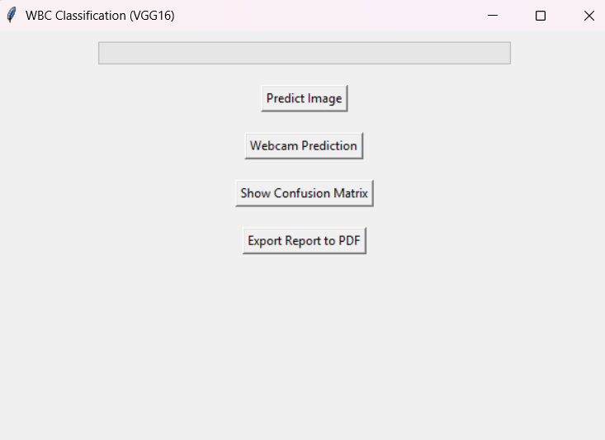
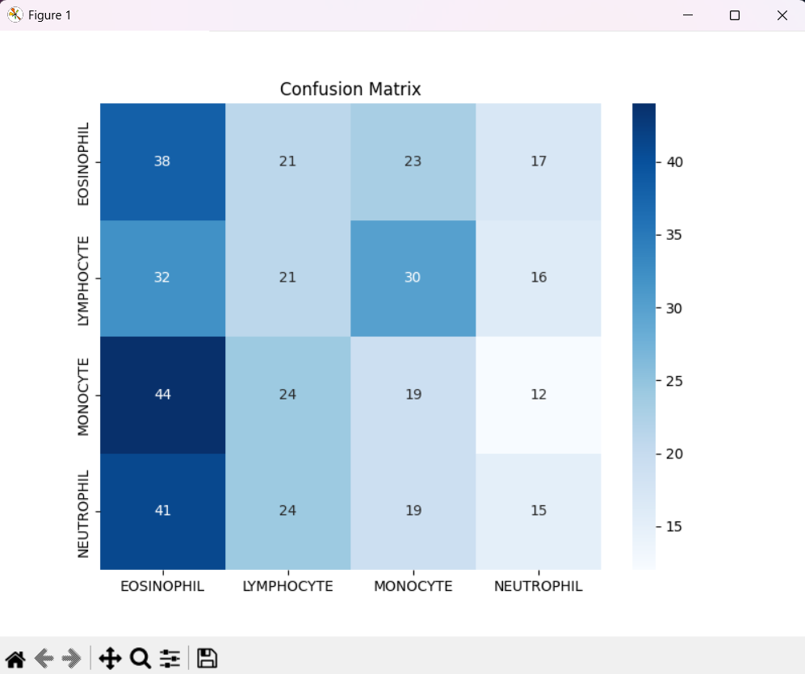

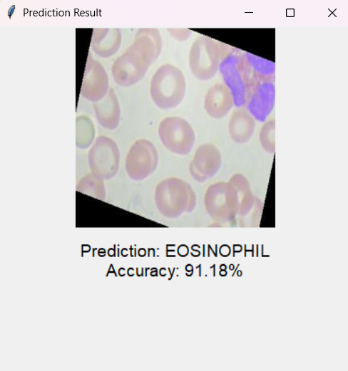

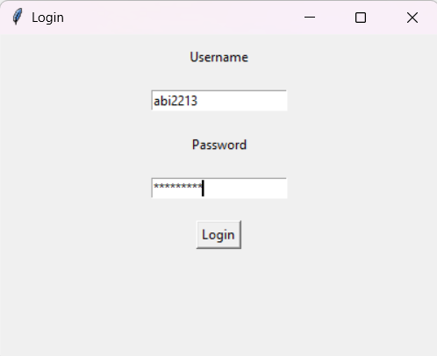

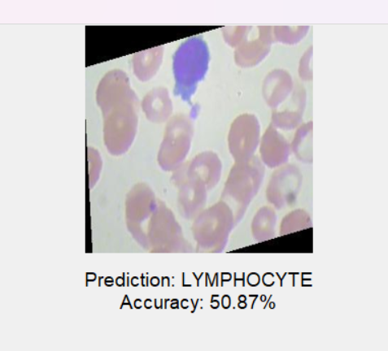

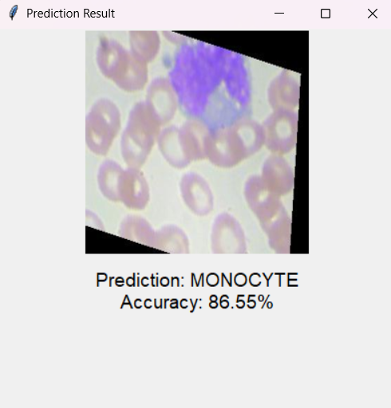

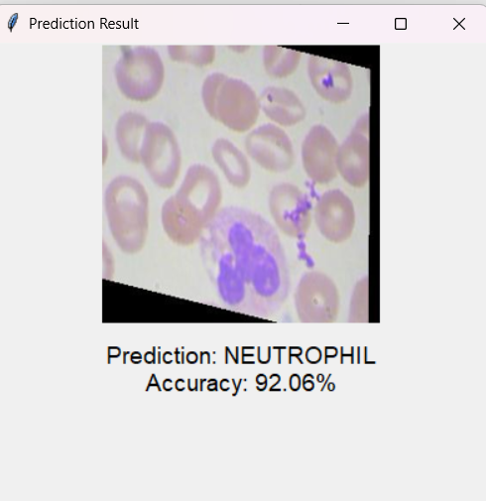

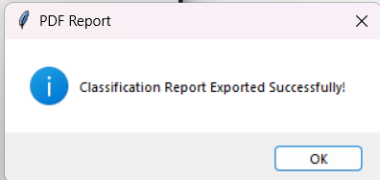

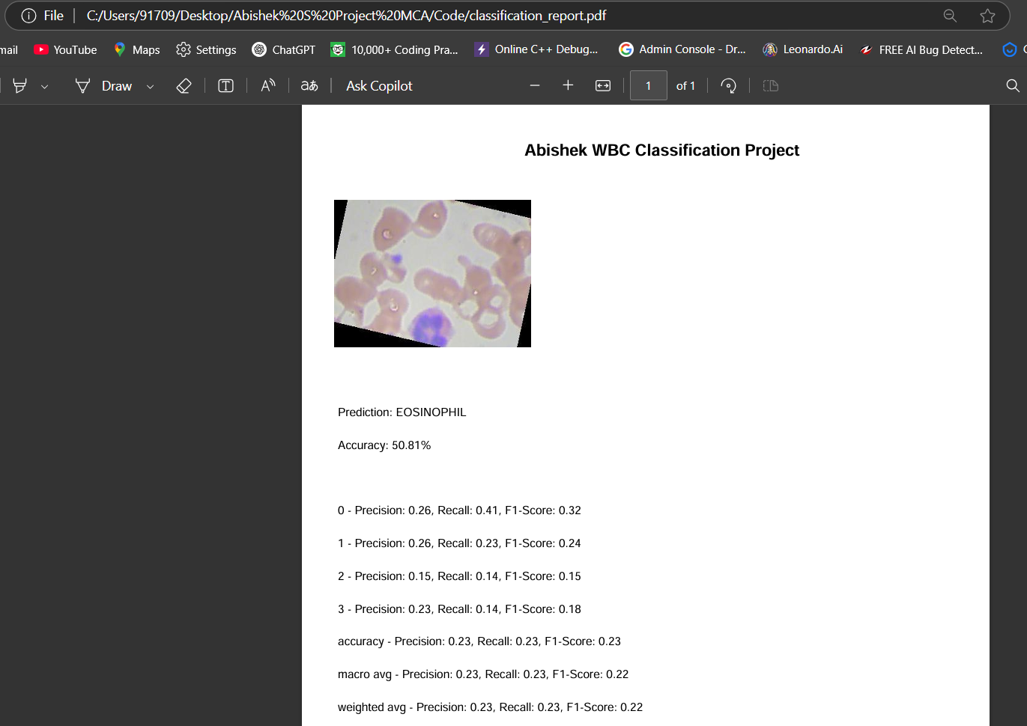

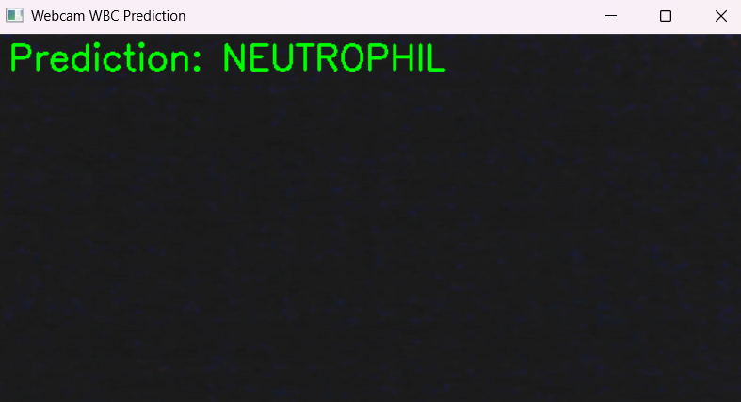

BIBLIOGRAPHY

LIST OF FIGURES

FIGURE NO | TITLE
1 | Flow Diagram
2 | Input Image
3 | Resize Image
4 | Gray Scale Image
5 | Deep Learning

LIST OF ABBREVIATIONS

SNO | SHORT FORM | ABBREVIATION
1 | SCA | Sickle Cell Anemia
2 | ALL | acute lymphoblastic leukemia
3 | AML | acute myeloid leukemia
4 | RBC | red blood cells
5 | WBC | White blood cells
6 | CNN | Convolutional Neural Network
7 | FLOSS | Free/Library and Open Source Software

•P. K. Das, S. Meher, R. Panda, and A. Abraham, “A review of automated methods for the detection of sickle cell disease,” IEEE Rev. Biomed. Eng., vol. 13, pp. 309–324, Jan. 2020.
•P. K. Mishra, S. Agrawal, R. Panda, and A. Abraham, “A novel type-2 fuzzy C-means clustering for brain MR image segmentation,” IEEE Trans. Cybern., early access, Jun. 22, 2020, doi: 10.1109/TCYB.2020.2994235.
•P. K. Das, P. Jadoun, and S. Meher, “Detection and classification of acute lymphocytic leukemia,” in Proc. IEEE-HYDCON, 2020, pp. 1–5. [4] S. Agrawal, R. Panda, and A. Abraham, “A novel diagonal class entropybased multilevel image thresholding using coral reef optimization,” IEEE Trans. Syst., Man, Cybern., Syst., vol. 50, no. 11, pp. 4688–4696, Nov. 2020.
•S. Zafari, T. Eerola, J. Sampo, H. Kalviainen, and H. Haario, “Segmentation of overlapping elliptical objects in silhouette images,” IEEE Trans. Image Process., vol. 24, no. 12, pp. 5942–5952, Dec. 2015.
•D. K. Prasad, M. K. Leung, and C. Quek, “ElliFit: An unconstrained, non-iterative, least squares based geometric Ellipse Fitting method,” Pattern Recognit., vol. 46, no. 5, pp. 1449–1465, 2013.
•C. Meng, Z. Li, X. Bai, and F. Zhou, “Arc adjacency matrix-based fast ellipse detection,” IEEE Trans. Image Process., vol. 29, pp. 4406–4420, Feb. 2020.
•J. Li et al., “Automatic fetal head circumference measurement in ultrasound using random forest and fast ellipse fitting,” IEEE J. Biomed. Health Inform., vol. 22, no. 1, pp. 215–223, Jan. 2018.
•M. González-Hidalgo, F. A. Guerrero-Peña, S. Herold-García, ˜ A. Jaume-i-Capó, and P. D. Marrero-Fernández, “Red blood cell cluster ´ separation from digital images for use in sickle cell disease,” IEEE J. Biomed. Health Inform., vol. 19, no. 4, pp. 1514–1525, Jul. 2015.
•F. Azhar and T. Tjahjadi, “Significant body point labeling and tracking,” IEEE Trans. Cybern., vol. 44, no. 9, pp. 1673–1685, Sep. 2014.

