**IKI10100I: Data Structures & Algorithms • 2015-16**

**Faculty of Computer Science, Universitas Indonesia**

**Tutorial 1 (Week 1): *Rendering a 2D gameworld* Deadline: Monday, 15th February 2016, 17:00**

In this worksheet you are asked to read a file that contains a definition for a 2D gameworld, which consists of a 30 × 30 grid, where each cell represents a location in the gameworld. Each location will have a code that defines the environment or static object at that location. There are 5 codes:

0 is free area: , 1 is a wall: , 2 is a tree: , 3 is water: , and 4 is a collectible coin: .

The gameworld can be represented as a two-dimensional array of integers, where the integer stored at cell position [*y*][*x*] represents the code of the location at that coordinate, i.e. at row *y* and column *x*.

Gameworld maps are stored in *map files*, which are simply text files with a **.map** extension. A map file contains 30 lines, where each line contains exactly 30 integers separated by a comma (‘**,**’) character.

Here is an example of a 20x20 map file called **test.map** and to the right is a screenshot of how the gameworld should appear once it is correctly rendered:

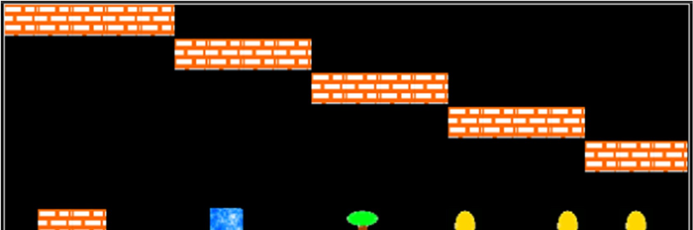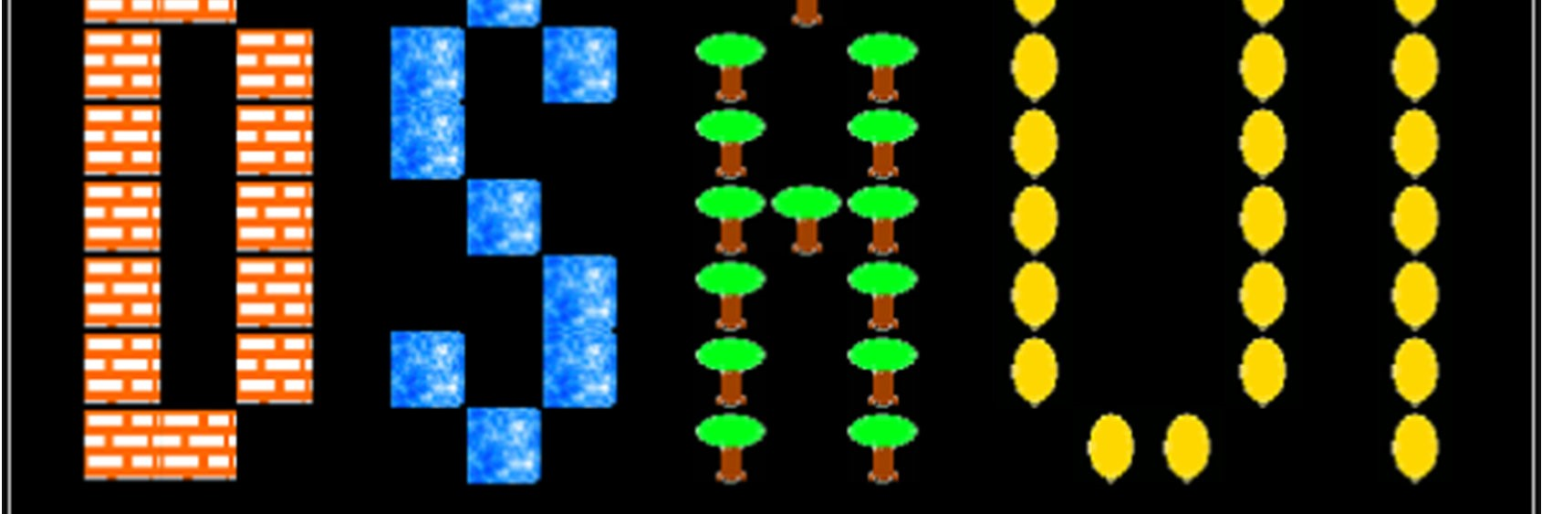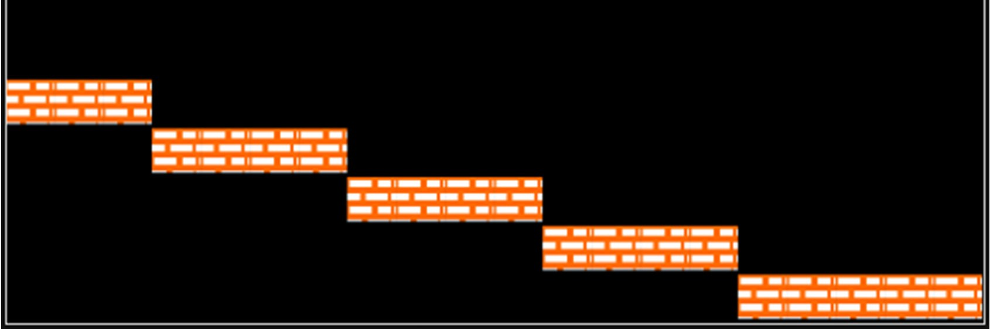

**1,1,1,1,1,0,0,0,0,0,0,0,0,0,0,0,0,0,0,0**

**0,0,0,0,0,1,1,1,1,0,0,0,0,0,0,0,0,0,0,0**

**0,0,0,0,0,0,0,0,0,1,1,1,1,0,0,0,0,0,0,0**

**0,0,0,0,0,0,0,0,0,0,0,0,0,1,1,1,1,0,0,0**

**0,0,0,0,0,0,0,0,0,0,0,0,0,0,0,0,0,1,1,1**

**0,0,0,0,0,0,0,0,0,0,0,0,0,0,0,0,0,0,0,0**

**0,1,1,0,0,0,2,0,0,0,3,0,0,4,0,0,4,0,4,0**

**0,1,0,1,0,2,0,2,0,3,0,3,0,4,0,0,4,0,4,0**

**0,1,0,1,0,2,0,0,0,3,0,3,0,4,0,0,4,0,4,0**

**0,1,0,1,0,0,2,0,0,3,3,3,0,4,0,0,4,0,4,0**

**0,1,0,1,0,0,0,2,0,3,0,3,0,4,0,0,4,0,4,0**

**0,1,0,1,0,2,0,2,0,3,0,3,0,4,0,0,4,0,4,0**

**0,1,1,0,0,0,2,0,0,3,0,3,0,0,4,4,0,0,4,0**

**0,0,0,0,0,0,0,0,0,0,0,0,0,0,0,0,0,0,0,0**

**0,0,0,0,0,0,0,0,0,0,0,0,0,0,0,0,0,0,0,0**

**1,1,1,0,0,0,0,0,0,0,0,0,0,0,0,0,0,0,0,0**

**0,0,0,1,1,1,1,0,0,0,0,0,0,0,0,0,0,0,0,0**

**0,0,0,0,0,0,0,1,1,1,1,0,0,0,0,0,0,0,0,0**

**0,0,0,0,0,0,0,0,0,0,0,1,1,1,1,0,0,0,0,0**

**0,0,0,0,0,0,0,0,0,0,0,0,0,0,0,1,1,1,1,1**

You need to write a function with the following definition: **def loadMap(filename)**

When this function is called with a parameter containing the name of a map file, it will read the contents of that file and return a “2D list”, i.e. a list-of-lists, that contains the representation of the gameworld.

Once you have obtained such a gameworld representation, the second task is to *render* this gameworld on a Tkinter object known as a **Canvas**. On the canvas, each cell is represented by an icon/image with a size of 20 × 20 pixels. Since the gameworld is a 30 × 30 grid, the canvas size should be 600 × 600 pixels. You can use the provided image files (**0.gif**,

**1.gif**, **2.gif**, **3.gif**, and **4.gif** in the directories **sprite** and **sprite/emoji**), or you can create your own.

The function that carries out this rendering should have the following definition: **def renderMap(map)**

This function should first create the Tk root object and the **Canvas** object. Once you have created your **Canvas** object, you may use its **create_image** method to render an image at a specific location on the canvas. See the documentation[1] for details, and make sure you understand the necessary options!

1. http://infohost.nmt.edu/tcc/help/pubs/tkinter/web/create_image.html