Homework 4 - CSS422 - Vu Dinh

# Question 1

1. MOVE.W D1, $0000A000

MOVE’s first 2 bits are 00. Data size = W → 11.

Destination: (xxx).L → Mode: 111, Reg: 001

Source: D1 → Mode: 000, Reg: 001

Followed by additional data words

|  |  |  |  |  |  |
| --- | --- | --- | --- | --- | --- |
| 00 | 11 | 001 | 111 | 000 | 001 |

|  |
| --- |
| 0000000000000000 |

|  |
| --- |
| 1010000000000000 |

1. MOVE.B $42A3, D1

MOVE’s first 2 bits are 00, data size = B → 01

Destination: D1 → Mode: 000, Reg: 001

Source: (xxx).W → Mode: 111, Reg: 000

Followed by one additional data word

|  |  |  |  |  |  |
| --- | --- | --- | --- | --- | --- |
| 00 | 01 | 001 | 000 | 111 | 000 |

|  |
| --- |
| 0100001010100011 |

1. ADD.L D7, D0

ADD’s first 4 bits are 1101, Opmode is 010 because:

--- data type: L

--- form: <ea> + D0 → D0

Source <ea>: D7 → mode: 000, reg: 111

|  |  |  |  |  |
| --- | --- | --- | --- | --- |
| 1101 | 000 | 010 | 000 | 111 |

# Question 2

1. MOVE.B $A000, A3

Moving data into Address Registers can only be done via MOVEA commands.

1. ADD.B #$1000, D2

#$1000 has 4 hex bits, it does not fit as a byte.

1. MOVEA.W $1234, D0

MOVEA is used for moving data into Address Registers. If normal data is needed to be moved, use MOVE instead

1. ANDI.B #23, #$100

There seem to be multiple things wrong with this operation:

* ~~#$100 has 3 hex bits, it does not fit as a byte.~~ Actually this is not a problem because the specified data size (Byte) only needs to match the first operand, which it does.
* ANDI needs an <ea> as destination operand (so that the result can be stored)

# Question 3

1. Represent -99 and -39

99 in binary = %01100011

-99 in binary = %10011101

-99 in hex = $9D

39 in binary = %00100111

-39 in binary = %11011001

-39 in hex = $D9

1. Add

$9D + $D9 = $76 (truncated the carry bit)

1. The sign bit of the sum is 0 (which doesn’t make sense when adding 2 negative numbers)
2. An overflow definitely occurred.
3. Assembly program

*-----------------------------------------------------------

* Title : Homework 4

* Written by : Vu Dinh

* Date : October 31 2014

* Description: I'm late I'm late I'm lateeeee

*-----------------------------------------------------------

ORG $1000

START: ; first instruction of program

* Put program code here

MOVE.B #$9D, D2 * test conversion

MOVE.B #$D9, $6000 * specified address for result

ADD.B D2, $6000 * Addition

BVS OVERFLOW

BVC NOOVERFLOW

OVERFLOW LEA BADMSG, A1

MOVE.B #14, D0

TRAP #15

BRA PRINTRESULT

NOOVERFLOW LEA GOODMSG, A1

MOVE.B #14, D0

TRAP #15

BRA PRINTRESULT

PRINTRESULT MOVE.B $6000, D1 * prime for output

MOVE.B #3, D0 * load trap task #3

TRAP #15

SIMHALT ; halt simulator

* Put variables and constants here

GOODMSG DC.B 'There were no overflows, the sum is: ',0

BADMSG DC.B 'Overflow happened, the sum is not reliable: ',0

END START ; last line of source

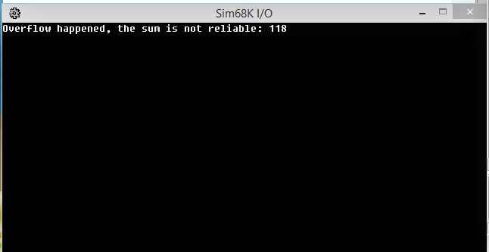

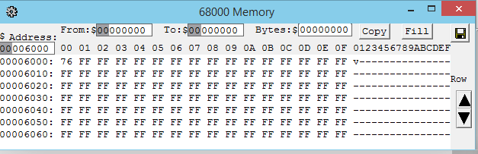

# Question 4

I’m just not going to show the multiplication steps because it’s quicker to do it in my head and write down 0 or 1

1. Convert into IEEE single-precision format
2. -69/32 = -2.15625

-2.15625 in binary is -10.00101 = -1.000101 * 2^1

|  |  |  |
| --- | --- | --- |
| 1 | 10000000 | 00010100000000000000000 |

in hex: C00A0000

1. 13.625

13.625 in binary is 1101.101 = 1.101101 * 2^3

|  |  |  |
| --- | --- | --- |
| 0 | 10000010 | 10110100000000000000000 |

in hex: 415A0000

1. Convert into decimal
2. 42E48000

|  |  |  |
| --- | --- | --- |
| 0 | 10000101 | 11001001000000000000000 |

=> 42E48000 = + 1.11001001 * 2^(133-127) = 1.11001001 * 2^6 = 1110010.01 = 114.25

1. C6F00040

|  |  |  |
| --- | --- | --- |
| 1 | 10001101 | 11100000000000001000000 |

=> C6F00040 = - 1.11100000000000001 * 2^14 = - 111100000000000.001 = -30720.125