Homework 5

Vu Dinh

# Part 1. Bit Shifting, Bit Rotating, and CCR bits

1. ASL.B #2, #$C1A8D372:  
   Result: C1A8D3**C8**  
   CCR: 11011
2. ASL.L #5, #$C1A8D372:  
   Result: **351A6E40**  
   CCR: 00010
3. LSR.B #4, #$C1A8D372:  
   Result: C1A8D3**07**  
   CCR: 00000
4. ROR.W #2, #$C1A8D372:  
   Result: C1A8**B4DC**  
   CCR: 01001
5. ROL.L #7, #$C1A8D372:  
   Result: **D469B960**  
   CCR: 01000

# Part 2. Pattern matching and cumulative sum

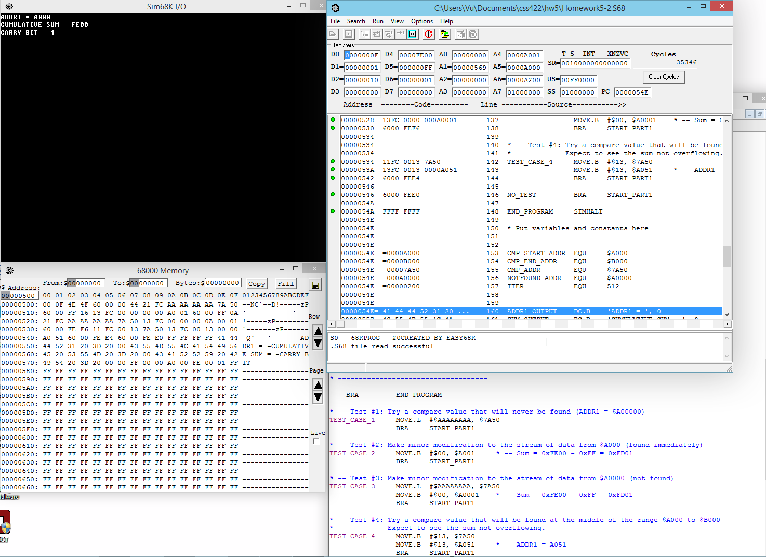

See source (full resolution) at: <http://i.imgur.com/zHAiin5.png>

Source code:

#### *--------------------------------------------------------------------------

#### * Title : Homework 5 part 2 // Pattern finding and Cumulative sum

#### * Written by : Vu Dinh

#### * Date : Nov 28 2014

#### * Comment : There are a lot of vague specifications of the program.

#### * I've created some test cases and stated expected results.

#### *--------------------------------------------------------------------------

#### 

#### 

#### ORG $400

#### START: ; first instruction of program

#### 

#### * ------------------------------------

#### * --------- PART 3: TESTING ----------

#### * ------------------------------------

#### 

#### TEST_CASE MOVE.B #$0, D7 * -- test case number

#### CMP.B #$1, D7

#### BEQ TEST_CASE_1

#### CMP.B #$2, D7

#### BEQ TEST_CASE_2

#### CMP.B #$3, D7

#### BEQ TEST_CASE_3

#### CMP.B #$4, D7

#### BEQ TEST_CASE_4

#### DEFAULT BRA NO_TEST

#### 

#### 

#### 

#### * ------------------------------------

#### * --- PART 1: PATTERN MATCHING -------

#### * ------------------------------------

#### * | Tested for the following cases: |

#### * | >> Pattern found immediately at |

#### * | $A000 |

#### * | >> Pattern not found |

#### * | >> Pattern found between $A000 |

#### * | and $B000 |

#### * ------------------------------------

#### 

#### 

#### START_PART1 CLR D1

#### 

#### MOVEA.L #CMP_START_ADDR, A4 * -- starting search location

#### LOOP CMPA.L #CMP_END_ADDR, A4 * -- ending search location

#### BEQ NOT_FOUND

#### MOVEA.L A4, A5 * -- keep a copy before incrementing A4

#### 

#### COMPARE MOVE.B (A4)+, D4 * -- currently processed data

#### CMP.B CMP_ADDR, D4

#### BEQ FOUND

#### ENDLOOP BRA LOOP

#### 

#### FOUND MOVE.L A5, ADDR1 * -- match is found addr1 = matched location

#### BRA CSUM

#### 

#### NOT_FOUND MOVE.L #NOTFOUND_ADDR, ADDR1 * -- match not found, addr1 = special value

#### BRA CSUM

#### 

#### 

#### * ------------------------------------

#### * --- PART 2: CUMULATIVE SUM ---------

#### * ------------------------------------

#### * | Tested for the following cases: |

#### * | >> Change one summand to $00 |

#### * ------------------------------------

#### 

#### CSUM CLR D4

#### MOVEA.L #$0, A3 * -- resetting A3

#### MOVE.W #ITER, D2 * -- D2 = loop counter

#### MOVEA.L ADDR1, A6

#### 

#### SUM_LOOP CMP.L #0, D2

#### BEQ SUM_FINISH

#### MOVE.B (A6)+, D5 * -- data is extracted as BYTE

#### ADD.W D5, D4 * -- but summed as WORD

#### BCS SET_CARRY * -- if the carry bit is set, record it

#### LOOPBACK SUB.L #1, D2

#### BRA SUM_LOOP

#### 

#### SET_CARRY MOVE.B #1, D6 * -- record carry bit

#### BRA LOOPBACK * -- going back into loop

#### 

#### SUM_FINISH MOVE.W D4, ADDSUM * -- move the sum to requested location

#### MOVE.B D6, CARRYBIT * -- move the carry bit to the requested location

#### BRA PRINTRESULT

#### 

#### PRINTRESULT LEA ADDR1_OUTPUT, A1

#### MOVE.B #14, D0

#### TRAP #15

#### MOVE.L ADDR1, D1 * -- printing ADDR1

#### MOVE.B #16,D2

#### MOVE.B #15,D0

#### TRAP #15

#### 

#### LEA EMPTY_LINE, A1 * -- printing empty line

#### MOVE.B #13,D0

#### TRAP #15

#### 

#### LEA SUM_OUTPUT, A1

#### MOVE.B #14, D0

#### TRAP #15

#### MOVE.L D4, D1 * -- printing the sum (stored temporarily in D4)

#### MOVE.B #16,D2 * -- the sum is printed in hex format

#### MOVE.B #15,D0

#### TRAP #15

#### 

#### LEA EMPTY_LINE, A1 * -- empty line

#### MOVE.B #13,D0

#### TRAP #15

#### 

#### LEA CARRY_OUTPUT, A1

#### MOVE.B #14, D0

#### TRAP #15

#### MOVE.L D6, D1 * -- the carry bit information (overwrites D1)

#### MOVE.B #16,D2

#### MOVE.B #15,D0

#### TRAP #15

#### 

#### 

#### * ------------------------------------

#### * --------- PART 3: TESTING ----------

#### * ------------------------------------

#### 

#### BRA END_PROGRAM

#### 

#### * -- Test #1: Try a compare value that will never be found (ADDR1 = $A00000)

#### TEST_CASE_1 MOVE.L #$AAAAAAAA, $7A50

#### BRA START_PART1

#### 

#### * -- Test #2: Make minor modification to the stream of data from $A000 (found immediately)

#### TEST_CASE_2 MOVE.B #$00, $A001 * -- Sum = 0xFE00 - 0xFF = 0xFD01

#### BRA START_PART1

#### 

#### * -- Test #3: Make minor modification to the stream of data from $A0000 (not found)

#### TEST_CASE_3 MOVE.L #$AAAAAAAA, $7A50

#### MOVE.B #$00, $A0001 * -- Sum = 0xFE00 - 0xFF = 0xFD01

#### BRA START_PART1

#### 

#### * -- Test #4: Try a compare value that will be found at the middle of the range $A000 to $B000

#### * Expect to see the sum not overflowing.

#### TEST_CASE_4 MOVE.B #$13, $7A50

#### MOVE.B #$13, $A051 * -- ADDR1 = A051

#### BRA START_PART1

#### 

#### NO_TEST BRA START_PART1

#### 

#### END_PROGRAM SIMHALT

#### 

#### * Put variables and constants here

#### 

#### 

#### CMP_START_ADDR EQU $A000

#### CMP_END_ADDR EQU $B000

#### CMP_ADDR EQU $7A50

#### NOTFOUND_ADDR EQU $A0000

#### ITER EQU 512

#### 

#### 

#### ADDR1_OUTPUT DC.B 'ADDR1 = ', 0

#### SUM_OUTPUT DC.B 'CUMULATIVE SUM = ', 0

#### CARRY_OUTPUT DC.B 'CARRY BIT = ', 0

#### EMPTY_LINE DC.B '', 0

#### 

#### ADDR1 DS.L $1

#### ADDSUM DS.W $1

#### CARRYBIT DS.B $1

#### 

#### END START ; last line of source

#### 

#### 

#### 

#### 

#### 

# Part 3. Floating point number decoding

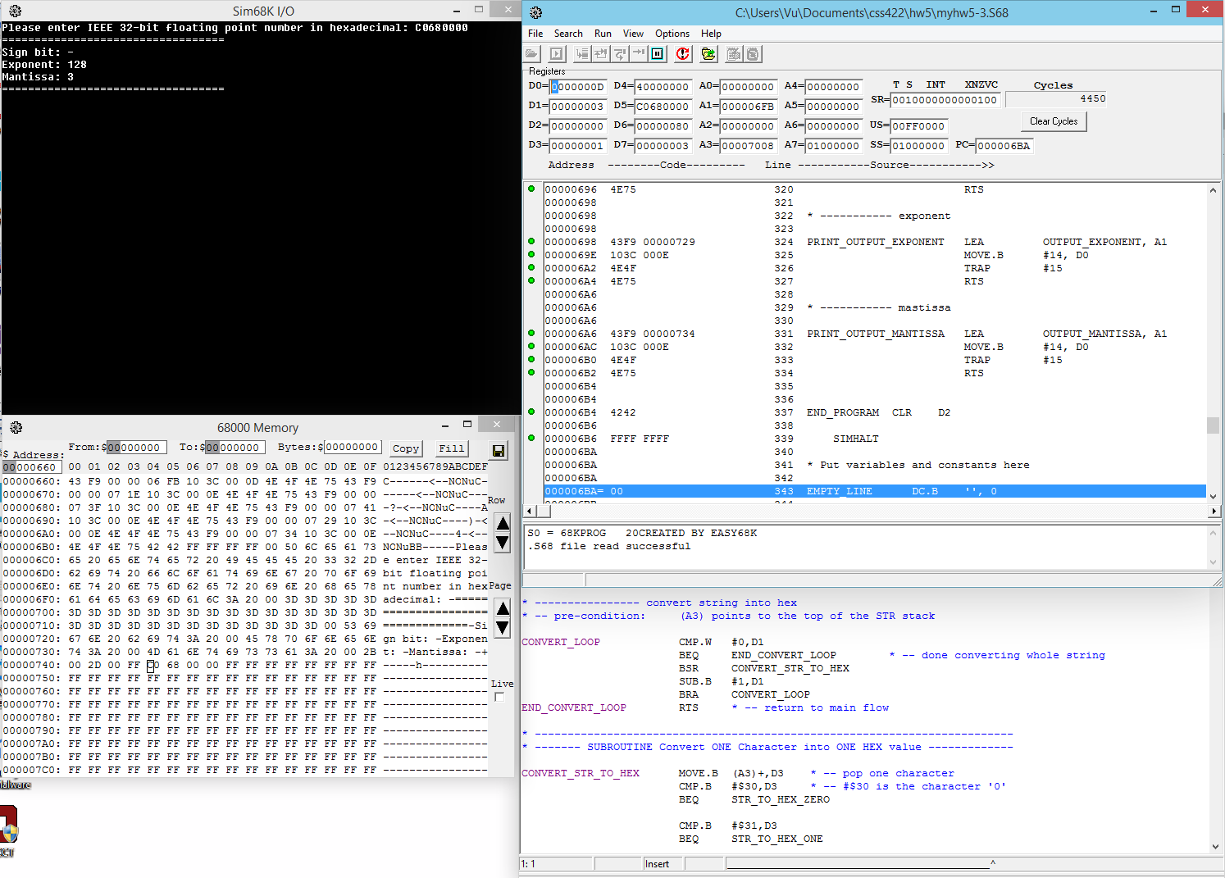

See source (full resolution) at: <http://i.imgur.com/RVTitg4.png>

Source code:

#### *----------------------------------------------------------------------------

#### * Title : Homework 5 part 2 // Pattern finding and Cumulative sum

#### * Written by : Vu Dinh

#### * Date : Nov 28 2014

#### * Comment : Not thoroughly tested.

#### *----------------------------------------------------------------------------

#### ORG $400

#### START: ; first instruction of program

#### 

#### 

#### BSR PRINT_INPUT_PROMPT

#### 

#### ************************************************************************************

#### 

#### * --------------------------------------------------------

#### * ----------------------- SUBROUTINE ---------------------

#### * --------------------------------------------------------

#### * | I borrowed this String --> Hex conversion subroutine |

#### * | from the disassembler project. |

#### * | post-condition: The converted hex location is |

#### * | stored in D4. |

#### * --------------------------------------------------------

#### 

#### 

#### CONVERT_START_LOCATION CLR D1

#### MOVEA.L #$7000,A1

#### MOVE.B #2,D0 * --- read NULL-terminated string

#### TRAP #15 * --- read string into (A1)

#### MOVEA.L A1,A3 * --- make a copy to preserve original input

#### END_CONVERT_START_LOCATION BSR CONVERT_LOOP

#### BRA CONVERT_DONE

#### 

#### * ---------------- convert string into hex

#### * -- pre-condition: (A3) points to the top of the STR stack

#### 

#### CONVERT_LOOP CMP.W #0,D1

#### BEQ END_CONVERT_LOOP * -- done converting whole string

#### BSR CONVERT_STR_TO_HEX

#### SUB.B #1,D1

#### BRA CONVERT_LOOP

#### END_CONVERT_LOOP RTS * -- return to main flow

#### 

#### * -------------------------------------------------------------------------

#### * ------- SUBROUTINE Convert ONE Character into ONE HEX value -------------

#### 

#### CONVERT_STR_TO_HEX MOVE.B (A3)+,D3 * -- pop one character

#### CMP.B #$30,D3 * -- #$30 is the character '0'

#### BEQ STR_TO_HEX_ZERO

#### 

#### CMP.B #$31,D3

#### BEQ STR_TO_HEX_ONE

#### 

#### CMP.B #$32,D3

#### BEQ STR_TO_HEX_TWO

#### 

#### CMP.B #$33,D3

#### BEQ STR_TO_HEX_THREE

#### 

#### CMP.B #$34,D3

#### BEQ STR_TO_HEX_FOUR

#### 

#### CMP.B #$35,D3

#### BEQ STR_TO_HEX_FIVE

#### 

#### CMP.B #$36,D3

#### BEQ STR_TO_HEX_SIX

#### 

#### CMP.B #$37,D3

#### BEQ STR_TO_HEX_SEVEN

#### 

#### CMP.B #$38,D3

#### BEQ STR_TO_HEX_EIGHT

#### 

#### CMP.B #$39,D3 * -- #$39 is the character '9'

#### BEQ STR_TO_HEX_NINE

#### 

#### CMP.B #$41,D3 * -- #$41 is the character 'A'

#### BEQ STR_TO_HEX_A

#### CMP.B #$61,D3 * -- #$61 is the character 'a'

#### BEQ STR_TO_HEX_A

#### 

#### CMP.B #$42,D3

#### BEQ STR_TO_HEX_B

#### CMP.B #$62,D3

#### BEQ STR_TO_HEX_B

#### 

#### CMP.B #$43,D3

#### BEQ STR_TO_HEX_C

#### CMP.B #$63,D3

#### BEQ STR_TO_HEX_C

#### 

#### CMP.B #$44,D3

#### BEQ STR_TO_HEX_D

#### CMP.B #$64,D3

#### BEQ STR_TO_HEX_D

#### 

#### CMP.B #$45,D3

#### BEQ STR_TO_HEX_E

#### CMP.B #$65,D3

#### BEQ STR_TO_HEX_E

#### 

#### CMP.B #$46,D3

#### BEQ STR_TO_HEX_F

#### CMP.B #$66,D3

#### BEQ STR_TO_HEX_F

#### 

#### BRA INVALID_CHARACTER

#### 

#### * --------------- Conversion definitions ------------

#### 

#### INVALID_CHARACTER NOP * -- skip invalid character

#### RTS

#### STR_TO_HEX_ZERO MOVE.L #$0,D3 * -- push HEX 0 into HEX stack

#### BSR SHIFT_START_ADDR

#### ADD.L D3,D4

#### RTS

#### STR_TO_HEX_ONE MOVE.L #$1,D3 * -- push HEX 1 into HEX stack

#### BSR SHIFT_START_ADDR

#### ADD.L D3,D4

#### RTS

#### STR_TO_HEX_TWO MOVE.L #$2,D3 * -- push HEX 2 into HEX stack

#### BSR SHIFT_START_ADDR

#### ADD.L D3,D4

#### RTS

#### STR_TO_HEX_THREE MOVE.L #$3,D3 * -- push HEX 3 into HEX stack

#### BSR SHIFT_START_ADDR

#### ADD.L D3,D4

#### RTS

#### STR_TO_HEX_FOUR MOVE.L #$4,D3 * -- push HEX 4 into HEX stack

#### BSR SHIFT_START_ADDR

#### ADD.L D3,D4

#### RTS

#### STR_TO_HEX_FIVE MOVE.L #$5,D3 * -- push HEX 5 into HEX stack

#### BSR SHIFT_START_ADDR

#### ADD.L D3,D4

#### RTS

#### STR_TO_HEX_SIX MOVE.L #$6,D3 * -- push HEX 6 into HEX stack

#### BSR SHIFT_START_ADDR

#### ADD.L D3,D4

#### RTS

#### STR_TO_HEX_SEVEN MOVE.L #$7,D3 * -- push HEX 7 into HEX stack

#### BSR SHIFT_START_ADDR

#### ADD.L D3,D4

#### RTS

#### STR_TO_HEX_EIGHT MOVE.L #$8,D3 * -- push HEX 8 into HEX stack

#### BSR SHIFT_START_ADDR

#### ADD.L D3,D4

#### RTS

#### STR_TO_HEX_NINE MOVE.L #$9,D3 * -- push HEX 9 into HEX stack

#### BSR SHIFT_START_ADDR

#### ADD.L D3,D4

#### RTS

#### STR_TO_HEX_A MOVE.L #$A,D3 * -- push HEX A into HEX stack

#### BSR SHIFT_START_ADDR

#### ADD.L D3,D4

#### RTS

#### STR_TO_HEX_B MOVE.L #$B,D3 * -- push HEX B into HEX stack

#### BSR SHIFT_START_ADDR

#### ADD.L D3,D4

#### RTS

#### STR_TO_HEX_C MOVE.L #$C,D3 * -- push HEX C into HEX stack

#### BSR SHIFT_START_ADDR

#### ADD.L D3,D4

#### RTS

#### STR_TO_HEX_D MOVE.L #$D,D3 * -- push HEX D into HEX stack

#### BSR SHIFT_START_ADDR

#### ADD.L D3,D4

#### RTS

#### STR_TO_HEX_E MOVE.L #$E,D3 * -- push HEX E into HEX stack

#### BSR SHIFT_START_ADDR

#### ADD.L D3,D4

#### RTS

#### STR_TO_HEX_F MOVE.L #$F,D3 * -- push HEX F into HEX stack

#### BSR SHIFT_START_ADDR

#### ADD.L D3,D4

#### RTS

#### 

#### SHIFT_START_ADDR CLR D7

#### MOVE.W D1,D7

#### SUB.W #1,D7

#### ASL #2,D7 * -- D7 = (D1 - 1) * 4

#### ASL.L D7,D3

#### END_SHIFT_START_ADDR RTS

#### 

#### 

#### * --------------------------------------------------------

#### * ----------------- END OF SUBROUTINE --------------------

#### * --------------------------------------------------------

#### * | I borrowed this String --> Hex conversion subroutine |

#### * | from the project. |

#### * | post-condition: The converted hex location is |

#### * | stored in D4. |

#### * --------------------------------------------------------

#### 

#### 

#### ***********************************************************************************

#### 

#### CONVERT_DONE MOVE.L D4, INPUT_ADDRESS * -- store the addr at the end of the program

#### MOVE.L D4, D5 * -- make a copy

#### CMP.L #$0, D4

#### BLT NEGATIVE

#### BRA EXTRACT_EXP

#### 

#### NEGATIVE MOVE.B #1, D3 * -- Store the sign bit in D3

#### SUB.L #$80000000, D4

#### BRA EXTRACT_EXP

#### 

#### * --------------------------- Finished processing the sign bit

#### 

#### EXTRACT_EXP MOVE.B #23, D0 * -- shifting the IEEE number by 23 bits

#### * -- to the right will expose the exponent

#### * -- Sign-extension is a problem, but it is

#### * -- taken care of in the NEGATIVE branch if

#### * -- the number IS negative.

#### ASR.L D0, D4

#### STORE_EXP MOVE.L D4, D6 * -- Store the exponent in D6

#### BRA EXTRACT_MANT

#### 

#### * --------------------------- Finished processing the exponent

#### 

#### EXTRACT_MANT MOVE.L D5, D7 * -- Move the copy to D7

#### ASL.L D0, D4 * -- Shift the exponent 23-bits to the left

#### SUB.L D4, D7 * -- Original value - exponent value = mantissa

#### 

#### COUNT_MASTISSA CLR D1

#### ROTATE_LOOP CMP.B #0, D0

#### BEQ ROTATE_DONE

#### ROR.L #1,D7

#### BCS INCREMENT_MANT * -- if the bit 1 is rotated out, C = 1

#### CONT_ROTATE SUB.B #1, D0

#### BRA ROTATE_LOOP

#### 

#### INCREMENT_MANT ADD.B #1, D1 * -- D1 (later D7) stores the count of the 1's in the mantissa

#### BRA CONT_ROTATE

#### 

#### ROTATE_DONE BRA PRINT_RESULT

#### 

#### * --------------------------- Finished processing the mantissa

#### 

#### 

#### 

#### ************************************************************************

#### ************************* OUTPUT OUTPUT OUTPUT *************************

#### ************************************************************************

#### ************************* OUTPUT OUTPUT OUTPUT *************************

#### ************************************************************************

#### ************************* OUTPUT OUTPUT OUTPUT *************************

#### ************************************************************************

#### 

#### PRINT_RESULT BSR PRINT_OUTPUT_SEPARATOR

#### MOVE.L D1, D7 * -- make a copy of the mantissa results

#### 

#### * ------------------------------------------- sign bit

#### PRIME_SIGNBIT BSR PRINT_OUTPUT_SIGNBIT

#### CMP.B #1, D3

#### BEQ SIGNBIT_NEG

#### BRA SIGNBIT_POS

#### 

#### SIGNBIT_NEG BSR PRINT_SIGNBIT_NEGATIVE

#### BRA PRIME_EXPONENT

#### SIGNBIT_POS BSR PRINT_SIGNBIT_POSITIVE

#### BRA PRIME_EXPONENT

#### 

#### * ------------------------------------------- exponent

#### PRIME_EXPONENT BSR PRINT_EMPTY_LINE

#### BSR PRINT_OUTPUT_EXPONENT

#### MOVE.L D6, D1 * -- the exponent to be printed

#### MOVE.B #10, D2 * -- print in base 10

#### MOVE.B #15, D0 * -- trap task #15

#### TRAP #15

#### BRA PRIME_MANTISSA

#### 

#### * ------------------------------------------- mantissa (now stored in D7)

#### PRIME_MANTISSA BSR PRINT_EMPTY_LINE

#### BSR PRINT_OUTPUT_MANTISSA

#### MOVE.L D7, D1 * -- the exponent to be printed

#### MOVE.B #10, D2 * -- print in base 10

#### MOVE.B #15, D0 * -- trap task #15

#### TRAP #15

#### 

#### CLEANING_UP BSR PRINT_EMPTY_LINE

#### BSR PRINT_OUTPUT_SEPARATOR

#### BRA END_PROGRAM

#### 

#### 

#### * -----------------------------------------------------

#### * ----------- PROGRAM FLOW SUBROUTINES ----------------

#### * -----------------------------------------------------

#### 

#### PRINT_EMPTY_LINE LEA EMPTY_LINE, A1

#### MOVE.B #13, D0

#### TRAP #15

#### RTS

#### 

#### PRINT_INPUT_PROMPT LEA INPUT_PROMPT, A1 * -- displaying input message

#### MOVE.B #14, D0

#### TRAP #15

#### RTS

#### 

#### PRINT_OUTPUT_SEPARATOR LEA OUTPUT_SEPARATOR, A1

#### MOVE.B #13, D0

#### TRAP #15

#### RTS

#### 

#### * ----------- sign bit

#### 

#### PRINT_OUTPUT_SIGNBIT LEA OUTPUT_SIGNBIT, A1

#### MOVE.B #14, D0

#### TRAP #15

#### RTS

#### 

#### PRINT_SIGNBIT_POSITIVE LEA OUTPUT_SIGNBIT_POSITIVE, A1

#### MOVE.B #14, D0

#### TRAP #15

#### RTS

#### 

#### PRINT_SIGNBIT_NEGATIVE LEA OUTPUT_SIGNBIT_NEGATIVE, A1

#### MOVE.B #14, D0

#### TRAP #15

#### RTS

#### 

#### * ----------- exponent

#### 

#### PRINT_OUTPUT_EXPONENT LEA OUTPUT_EXPONENT, A1

#### MOVE.B #14, D0

#### TRAP #15

#### RTS

#### 

#### * ----------- mastissa

#### 

#### PRINT_OUTPUT_MANTISSA LEA OUTPUT_MANTISSA, A1

#### MOVE.B #14, D0

#### TRAP #15

#### RTS

#### 

#### 

#### END_PROGRAM CLR D2

#### 

#### SIMHALT

#### 

#### * Put variables and constants here

#### 

#### EMPTY_LINE DC.B '', 0

#### 

#### INPUT_PROMPT DC.B 'Please enter IEEE 32-bit floating point number in hexadecimal: ', 0

#### 

#### OUTPUT_SEPARATOR DC.B '==================================', 0

#### OUTPUT_SIGNBIT DC.B 'Sign bit: ', 0

#### OUTPUT_EXPONENT DC.B 'Exponent: ', 0

#### OUTPUT_MANTISSA DC.B 'Mantissa: ', 0

#### 

#### OUTPUT_SIGNBIT_POSITIVE DC.B '+', 0

#### OUTPUT_SIGNBIT_NEGATIVE DC.B '-', 0

#### 

#### INPUT_ADDRESS DS.L $1

#### 

#### END START ; last line of source

#### 

#### 