Testing Report
07-02-2026

- Chat
- Still not using ajax or background requests for chats

- Notification Page:
  - Notification page should have a button to “mark as read” for each notification and the user have the ability to select which notifications to mark as read.
  - Please follow the previous system and implement the same techniques.
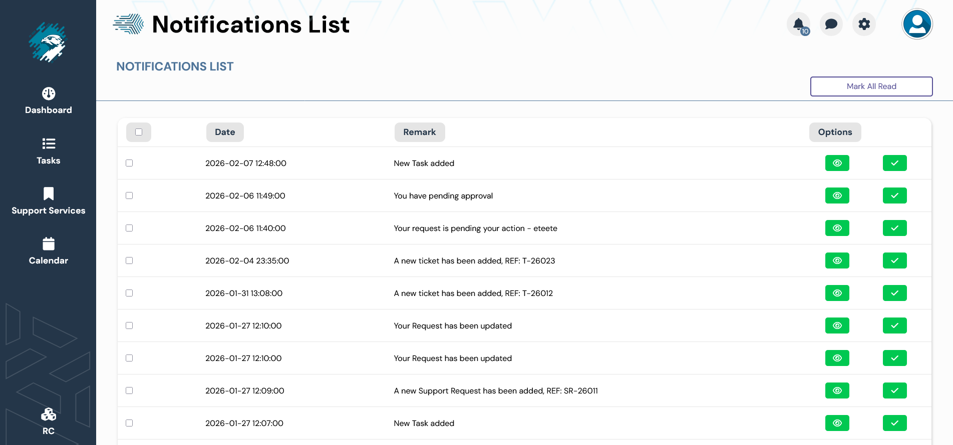

- Org chart:
  - Please use full name: Organization chart
  - Pagination does not use ajax, page refresh on every change
  - CSS for pagination is missing:
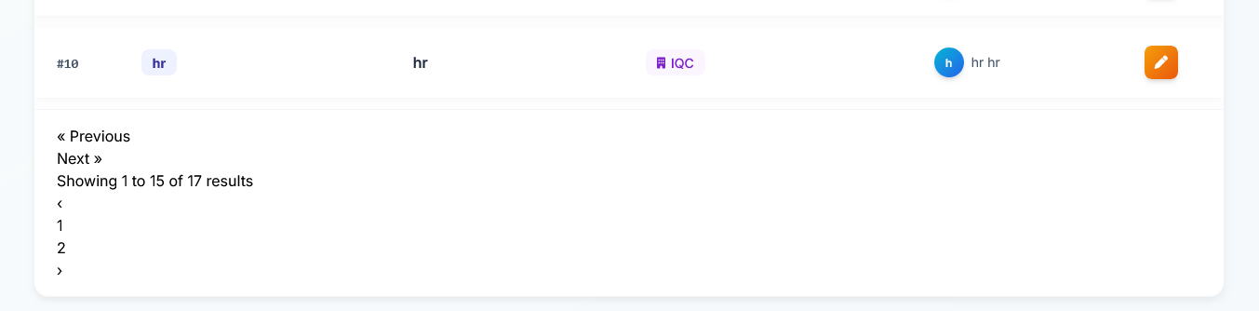
  - Please clear all database and only keep one department called IQC
  - Add pagination to designation page
- Org chart page:
  - Add “Export to PDF” Functionality.
  - Rename “Lead” to “line manager”
  - Remove “Company Hierarchy” and the sub text below it

- Tickets Page:
  - Add pagination to tickets pages
  - When adding a new ticket, add a preview to the attachment before uploading it, THIS POINT APPLIES TO ALL SYSTEM
  - At the ticket View page, attachment not working


  - Technical Note:
    - For all attachments at all parts of the system, you must change the attachment name into a 64 letter GUID.
    - All file sizes must be 8 mb maximum and it should be shown to the user, also server admin can change this size.
    - Allowed file types: Excel, Word, PDF, all images
  - At Ticket View page: Admin can assign to, change status, and reopen any ticket, please check the previous system

- Assets Page:
  - Add pagination
  - Admin can change assets status, please check the previous system

- Users Page:
  - Any error in form should not reload the page and erase all inserted information, show the error and DO NOT USE REQUESTS THAT MAKES ANY PAGE REFRESH
  - Add new user can accept email or login ID, it not working
  - Add new user is not working:
    - 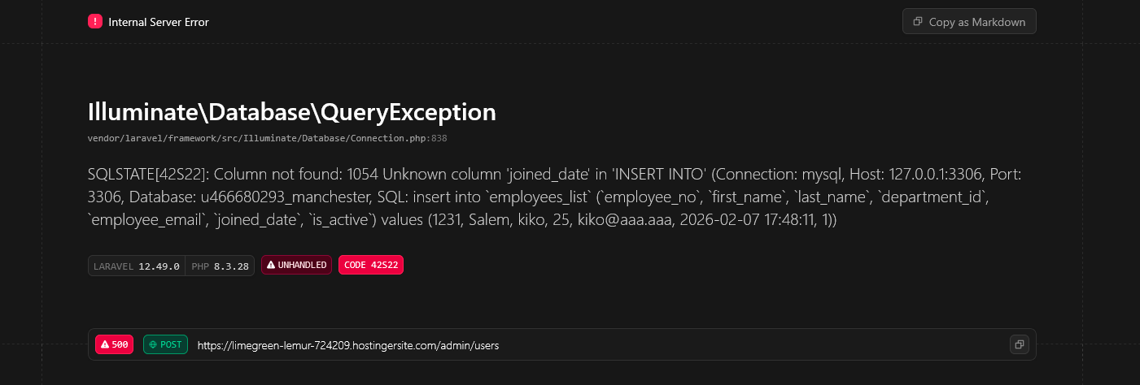

- Settings:
  - Add Pagination
  - DO NOT USE PAGE REFRESH

- Feedback page:
  - Remove understanding ratings element
  - Add pagination

