Exercise 1 – JSF Hello World
Exercise Description:
Set up a JSF-based application, as demonstrated by the teacher. Create a simple "Hello World" page using the <h:outputText> tag.

Exercise directory:
<exercises>\ JSF-Hello\

Files to use:
myfaces-core-1.1.3-bin.zip

Exercise 2 – JSF Calculator Screen
Exercise Description:
Create a JSF calculator. The application's screen should look like this:

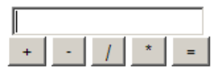

In other words, an input box and five buttons. Make sure all components have proper IDs, including the form itself.

Exercise directory:
<exercises>\ JSF-Calculator\

Exercise 3 – JSF Calculator Content
Exercise Description:
Now, update the calculator to work properly:

- Define a Backing Bean that will allow you to retrieve the value typed by the user.
- Define action listener methods, and wire them to the five different buttons.
- The backing bean should maintain the original value, so it can perform the calculation based on the previously-remembered value and the previously-entered operation.
- The calculation result should be stored as the display value.

For example, if the user types in "13" and clicks "+", the backing bean should remember the "13" and the "+". Now, if the user types "16" and clicks "+", the display (input box) will be updated to "29".

Ignore operator precedence issues; i.e., if the user types "13", "+", "16" and clicks "*", the displayed result will be "29", and this will be multiplied by whatever the user types next.

Exercise directory:
<exercises>\ JSF-Calculator\

Exercise 4 – JSF Calculator, Continued
Exercise Description:
Add a link to the calculator; the link text should be "Scientific mode".

When clicked, a set of new buttons will appear, for square-root and power-of-two. These are image buttons. In scientific mode, the link itself will change to "Standard mode" (see image). When "Standard mode" is clicked, the new buttons will disappear.

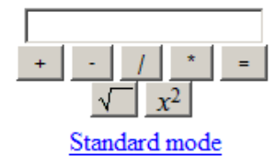

There are several possible ways to add or remove the two buttons:

- Define them in the JSP file, with the rendered property set to false. Toggle the rendered property when the link is clicked.
- Define them in the JSP file, with the style property set to "display:none". Change the style property when the link is clicked.
- Do not define them in the JSP at all; add them to the component tree in the Java code which handles the link.
- Define them in the JSP inside a container, such as <h:panelGroup>. Toggle the rendered or style attributes of the panel group rather than of each individual button.

The link itself should change its text when clicked, but it should not be replaced with a different link object (i.e., do not define two link objects, one visible and the other invisible at any given time. Use a single link that changes its caption).

If you have sufficiently mastered the ideas behind JSF, you should be able to complete this without changing the component tree at all in the Java code; just export properties that the JSP will be able to use.

Exercise directory:
<exercises>\ JSF-Calculator\

Files to use:
sqrt.gif
p2.gif

Exercise 5 – Birthday Cake
Exercise Description:
In this exercise, you will directly manipulate the component tree.

The main page should contain an input field for the user's age, and a button captioned "It's my birthday!".

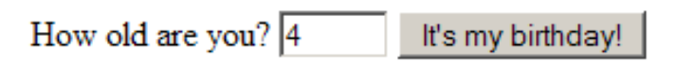
After the button is pressed, a birthday cake appears, with one candle per year of the user's age.
Hint: Use <h:panelGroup> as a container for images.

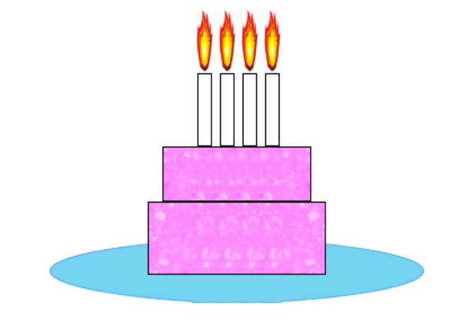
Exercise directory:
<exercises>\ Birthday\

Files to use:
candle_on.gif
cake_left.gif
cake_right.gif

Exercise 6 – JSF Validation
Exercise Description:
In this exercise, we will use both a simple validator and a validation method.

(a) Add a validator object to the birthday cake "age" input box. Use the integer range validator, and specify a 1-to-120 range. Also make sure that the field is marked as "required".

(b) Note that if a valid value is entered at first, and then an invalid value, the error message appear, but the cake (for the last valid value) remains.

Replace the validator object with a validation method. The method should pose the same requirement but also clear the cake if validation fails.

Note how using a validator method also allows you to specify a different error message for too low and too high values (e.g., "too young" and "too old", respectively).

Exercise directory:
<exercises>\ Birthday\

Exercise 7 – Internationalization
Exercise Description:
We will now internationalize the birthday application. We will see how even extreme measures, such as replacing the screen with right-to-left writing direction (for Hebrew, Arabic or Farsi) can be achieved using resource bundles.

Externalize all strings in the application to a resource bundle, named "birthday.properties". Then, create an alternative resource bundle, in some other language.

Change the list of supported languages in JSF's setup, and add links on the top of the page for all the supported languages, that change the language the application is currently viewed.
Use the UIViewRoot.setLocale() method.

If the list of supported languages includes a right-to-left language, how will you go about supporting this change of direction?

Hebrew support note (advanced):
Hebrew (and any non-latin encoded language) is a bit more complicated. To use Hebrew you must follow these additional steps:
- Create a properties file that will hold the Hebrew strings, save it in UTF-8 format.
- Use the native2ascii utility to convert this properties file to ascii. Notice that all the Hebrew letters change to the escaping form (\uXXXX). E.g.
native2ascii –encoding UTF-8 resource_iw_native.properties resource_iw.properties
- Make sure the converted properties file is saved with the iw language code.
- Update the JSP page to use UTF8 as the character encoding.

Exercise directory:
<exercises>\ Birthday\

Files to use:
properties_en.html

Exercise 8 – JSF Navigation
Exercise Description:
In this exercise, a navigation and login system will be added to our birthday application.

We will create 3 new screens; the links from one screen to the other must all be based on the navigation system.

1. The homepage will contain some simple "welcome" text.
2. The help page will contain a brief help text.
3. The login page will ask the user for a login name and a password.

The fourth screen remains the birthday-cake screen developed in the previous steps (this is the main page).

The login page will include the usual username/password pair of fields. For simplicity, the program should accept any password that is identical to the login name. If the login is successful, the main page will be displayed; otherwise, the login page will re-display itself, with an error message, prompting the user to retry.

The help page will contain a link titled "Enter", which should lead to the main page if the user is logged in, or to the login page if the user is not logged in.

Advanced:
If the user tries to access the birthday application screen directly without logging in, he should be transferred immediately to the login page.
Hint: Use a PhaseListener

Exercise directory:
<exercises>\ Birthday\

Files to use:
homepage.html – contains the text that should appear in the homepage (without the links, etc.)
help.html – contains the text for the help page (again, without the required links).

