Module 3 Demo 9: Examining VisualGC Capabilities
This exercise demonstrates the monitoring capabilities of the VisualGC plugin.
Slide id: 113

Required Software
- Any OS
- JDK 1.6 or higher
Note: Although you can launch VisualVM using JDK 1.4.2, the use of a later version of the JDK will enable the use of additional VisualVM features. (For additional information, eee the feature matrix on https://visualvm.dev.java.net).
- VisualVM
VisualVM is included in Java SE 6 update 7 (jdk 1.6.0_u7). If you are running an earlier version of Java SE you can download VisualVM from: http://visualvm.dev.java.net.
- VisualGC
Visual GC is available as a plugin for VisualVM.
- Java2Demo
Located in: <JDK install dir>/demo/jfc/Java2D/Java2Demo.jar

Objective
- Examine the monitoring capabilities of the VisualGC plugin for VisualVM.

Preparations
Verify and if required download and install VisualVM.
- Verify if you are running Java SE 6 update 7 or later. To check enter the following command on a terminal window:
java -version
If the response is: java version "1.6.0_07" or later you can bypass the following VisualVM installation step.
- Down load and install VisualVM from http://visualvm.dev.java.net.
- Add the bin subdirectory of the VisualVM install directory to the OS PATH variable.

Instructions
- Open a command line window and and change directory to the Java2D demo directory:
cd <JDK install dir>/demo/jfc/Java2D
- In a different command line window, run the Java2Demo. It is located in the <JDK install dir>/demo/jfc/Java2D/ directory.
java -client-Xmx12m -Xms3m -Xmn1m -XX:MaxPermSize=3m -XX:PermSize=1m
-jar Java2Demo.jar
- Click the Transforms tab of the Java2Demo application to increase object allocation. This step is optional, but it will increase the frequency full GC events.

- Launch VisualVM
- If you are using Java SE 6 update 7 or later run the following command in a command line window:
jvisualvm
- If you had installed VisualVM in step 1, run the following command in a command line window:
visualvm
Examine the resulting VisualVM GUI. You should notice the following tabs: Start Page; Application.
- Perform the following step if you have not already installed the VisualGC plugin into VisualVM.
Within Java VisualVM, download and install the VisualGC plug-in by selecting Tools > Plugins menu option.
- Note the process id of the Java2Demo on Applications panel and select that as the process to monitor in the VisualGC panel on the right.
- Observe the VisualGC panel.

An Overview of the VisualGC Display
VisualGC will display two or three windows in the right panel of VisualVM depending the garbage collector being used by the monitored JVM. When the throughput collector is used, VisualGC will show only two windows; the VisualGC window and the Graph window. Otherwise, when the serial collector or concurrent collector is being used a third window, the Survivor Age Histogram window is also shown. The upper leftmost window of VisualGC is called the VisualGC window. It is comprised of the following two panels.

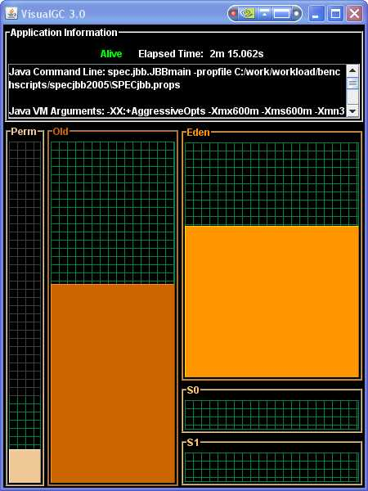
The top panel, labeled Application Information contains a live-ness indicator and the elapsed time since the start of the target Java application. It also contains a scrollable text area that lists miscellaneous information about the configuration of the Java application being run and the JVM being monitored. This section includes the target application's main class name (or jar file if the application was started with the -jar option), and the arguments to the class's main method. It also includes the arguments passed to the JVM being monitored and the values of certain Java properties exported as instrumentation objects. The bottom panel provides a graphical view of the garbage collection spaces. This panel is divided into three vertical sections, one for each of the of the spaces: Perm (Permanent) space, Old (or Tenured) space, and the young generation section, (the right most vertical slice of this panel). The young generation section is comprised of three spaces; an Eden space and two Survivor spaces, S0 and S1. The screen areas representing all these spaces are sized proportionately to the maximum capacities of the spaces as they are allocated by the JVM. The screen area real estate representing the spaces in the window are of fixed size and do not vary over time. Each space is filled with a unique color indicating the current utilization of the space relative to its maximum capacity. A unique color for each space is used consistently among this window, the Graph window and Survivor Age Histogram window. The memory management system within the JVM is capable of growing and shrinking the garbage collected heap. This is accomplished by reserving memory for the requested maximum Java heap size but committing real memory to only the amount currently needed. The relationship between committed and reserved memory is represented by the color of the background grid in each space. Uncommitted memory is represented by the dark gray colored portion of the grid whereas committed memory is represented by the green colored portion of the grid. In many cases, the utilization of a space may be nearly identical to the committed amount of memory making it difficult to determine the exact transition point of the green portion of the grid to the gray portion of the grid. The relationship between the sizes of the Eden and Survivor spaces in the young generation portion of the VisualGC frame are usually fixed in size. The two survivor spaces are usually identical in size and fully committed. The Eden space may be only partially committed, with the uncommitted portion of the space represented by dark gray portion of the grid. When the throughput collector (-XX:+UseParallelGC or -XX:+UseParallelOldGC) is used along with the adaptive size policy feature (-XX:+UseAdaptiveSizePolicy), which is enabled by default, the relationship or ratio between the sizes of the young generation spaces can vary over time. When the adaptive size policy is in effect, the sizes of the of the survivor spaces are may not be identical and the space in young generation can be dynamically redistributed among the three spaces. In this configuration, the screen areas representing the Survivor spaces and the colored region representing the utilization of the space are sized relative to the current size of the space, not the maximum size of the space. When adaptive resizing occurs, the screen area associated with the young generation spaces will update accordingly.

The Graph window, shown below, which is to the right of the VisualGC window, plots performance statistics as a function of time for a historical view. This window displays garbage collection statistics along with dynamic (JIT) compiler and class loader statistics. The latter two statistics will be discussed later in this chapter. The resolution of the horizontal axis in each display is determined by the interval command line argument. Each sample occupies 2 pixels of screen real estate. The height of each display depends on the statistic being plotted.

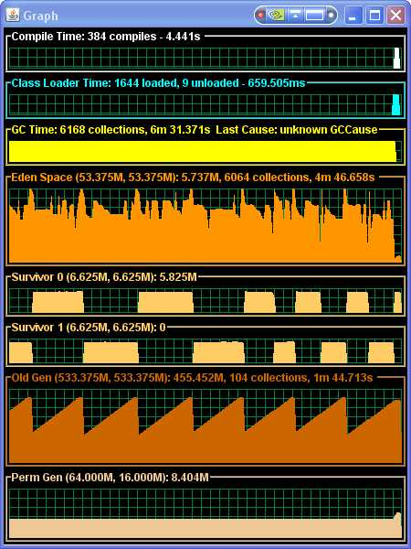
The Graph window has the following displays:
- Compile Time – discussed a later in this chapter
- Class Loader Time – discussed a little later in this chapter
- GC Time – Displays the amount of time spent in garbage collection activities. The height of this display is not scaled to any particular value. A non zero value in this graph indicates that garbage collection activity occurred during the last interval. A narrow pulse indicates a relatively short duration and a wide pulse indicates a long duration. The title bar indicates the total number of GC events and the accumulated GC time since the start of the application. If the JVM being monitored maintains the hotspot.gc.cause and hotspot.gc.last_cause statistics, the cause of the most recent GC event will also be displayed in the title bar.
- Eden Space – Displays the utilization of the Eden Space over time. The Eden Space is one of three spaces that make up the young generation space. The height of this display is fixed and, by default, the data is scaled according to the current capacity of the space. The current capacity of the space can change depending on the collector being used as the space shrinks and grows over time. The title bar displays the name of the space and its maximum and current capacity in parenthesis followed by the current utilization of the space. In addition, the title also contains the number and accumulated time of minor garbage collections.
- Survivor 0 and Survivor 1 – Displays the utilization of the two survivor spaces over time. The Survivor Spaces are the remaining two spaces which comprise the Young Generation space. The height of each of these two displays is fixed and, by default, the data is scaled according to the current capacity of the corresponding space. The current capacity of these spaces can change depending on the collector being used as a space shrinks and grows over time. The title bar displays the name of the space and its maximum and current capacity in parenthesis followed by the current utilization of the space.
- Old Gen – Displays the utilization of the Old Generation space over time. The height of the display is fixed and, by default, the data is scaled according to the current capacity of the space. The current capacity of this space can change depending on the collector being used as the space shrinks and grows over time. The title bar displays the name of the space and its maximum and current capacity in parenthesis followed by the current utilization of the space. In addition, the title also contains the number and accumulated time of full garbage collections.
- Perm Gen – Displays the utilization of the Permanent Generation space over time. The height of the display is fixed and, by default, the data is scaled according to the current capacity of the space. The current capacity of this space can change depending on the collector being used as the space shrinks and grows over time. The title bar displays the name of the space and its maximum and current capacity in parenthesis followed by the current utilization of the space.
The Eden Space, Survivor 0, Survivor 1, Old Gen and Perm Gen displays can be updated to show reserved memory utilization by right clicking the mouse over any of these spaces in the Graph window and checking the “Show Reserved Space” box. The default is to show committed memory utilization and can be switched back by right-clicking and unchecking the “Show Reserved Space” box. In reserved mode the data is scaled according to the maximum capacity of the space while in committed mode the data is scaled according to the current capacity of the space. In reserved mode, the background grid is painted in dark gray to represent that portion of the reserved memory that is uncommitted memory and in green to represent the portion that is committed.
The Survivor Age Histogram Window, shown below, which is displayed below the VisualGC window and Graph window when the low pause collector or serial collector is being used by the monitored JVM shows object survivor statistics. The throughput collector does not maintain a survivor age since it uses a different mechanism for maintaining objects in the survivor spaces. Hence, the Survivor Age Histogram Window is of no value and is not displayed when monitoring a JVM which is using the throughput collector.
