Securing LLM & MCP Access for AI Agents
Okta JWT vs Virtual Access Tokens — best practice and a hands-on guide for TrueFoundry AI Gateway

Audience: Engineering team members new to AI gateways, JWTs and agent identity
Format: The questions we asked, the answers, and step-by-step labs to try
Prepared: October 2026
Product names, menu paths and config fields reflect vendor documentation as of October 2026. Check the linked docs before production rollout.

Contents

1. Summary for busy readers
- Use both, in layers. Okta proves who is calling (a short-lived JWT). The gateway's Virtual Account / virtual key decides what they may do (models, budgets, rate limits) and who pays.
- Okta is on the control path, not the data path. The gateway validates JWTs locally using Okta's cached public keys (JWKS). There is no call to Okta on every LLM request.
- Agent → LLM: the agent sends an Okta JWT; TrueFoundry maps it to a Virtual Account. The agent never holds a static key.
- Agent → MCP tools: use a token exchange (on-behalf-of) to get a down-scoped, audience-bound token per tool. Never pass the user's token through.
- Plain script, no agent: a scoped, auto-rotated Virtual Account Token (VAT) is fine. Move to JWT when your platform has workload identity or policy bans static secrets.
- Local experiments: use a Personal Access Token (PAT). Never in production.

Glossary
Term | Plain-English meaning
JWT (JSON Web Token) | A signed, self-contained "passport" issued by Okta. Contains who you are, what you may do and when it expires. Anyone with Okta's public key can verify it.
Virtual key / VAT | A random string issued by the gateway (TrueFoundry calls it a Virtual Account Token). Meaningless on its own; the gateway looks it up in its database.
Virtual Account | TrueFoundry's non-human identity for an app/agent/script. Holds model access, budgets and rate limits.
PAT | Personal Access Token. Tied to a human user. For local development only.
JWKS | The public keys Okta publishes so gateways can check JWT signatures without calling Okta each time.
Client credentials | OAuth flow where an app (no human) gets a token using its own ID and credential.
Token exchange / OBO | Swapping one token for another that is narrower and meant for a specific downstream service (RFC 8693, "on-behalf-of").
Claim | A field inside a JWT, e.g. sub, client_id, aud, exp, email.
Data path | Everything that carries the actual request/response payload on every call.
Control path | Systems that issue, configure or observe (Okta, policy store, vault, logs) — not touched per request.

2. Okta or Virtual Access Tokens — which is best practice?
Question: Should all model invocations from agents be routed via Okta from the AI gateway, or should they use Virtual Access Tokens?
Answer: use both, layered. They solve different problems:
- Okta (identity): answers "who is calling?" — the agent, and optionally the user it acts for.
- Virtual key / Virtual Account (policy): answers "what may they do, and who pays?" — model allowlist, budgets, rate limits, guardrails.
- Provider keys (OpenAI, Bedrock, etc.) stay inside the gateway's vault and never reach agents.

Why not virtual keys alone for agents?
- They are long-lived unless you build rotation, and get copied into env files, CI variables and even prompts.
- They identify a key, not a principal — you lose "which agent, acting for which user, did this".
- Revocation is per key, not tied to your Okta joiner/mover/leaver process.
- They cannot express delegation (an agent acting with a specific user's permissions).

Why not "route every call through Okta"?
Okta should not sit in the path of every model call. It issues tokens. The gateway validates them locally using cached public keys, so there is no per-request round trip, no added latency and no new availability dependency beyond token refresh.

Recommended pattern
- Autonomous agents: OAuth client credentials, one Okta client per agent. Prefer private_key_jwt over shared client secrets, or use workload identity (Kubernetes / cloud IAM) so no secret is stored.
- Agents acting for a user: token exchange (RFC 8693). The token records both the user (sub) and the agent (act / client_id).
- At the gateway: validate the JWT, then map its claims to a Virtual Account / policy. Provider keys stay in the vault.
- Short lifetimes: minutes to an hour, audience restricted to the gateway, refreshed automatically.
- End-to-end logging: user, agent, model, tokens and cost tied to the same identity your SIEM already knows from Okta.
When plain virtual keys are acceptable: local development, third-party tools that only accept an API_KEY field (scope, budget and rotate them tightly), and as a transition step while moving runtimes to OAuth.

3. User → Agent → MCP / LLM: what is the data path?
Question: User to Agent → Agent to MCP or Agent to LLM. Recommend what is best, and what do you call the data path in this case?
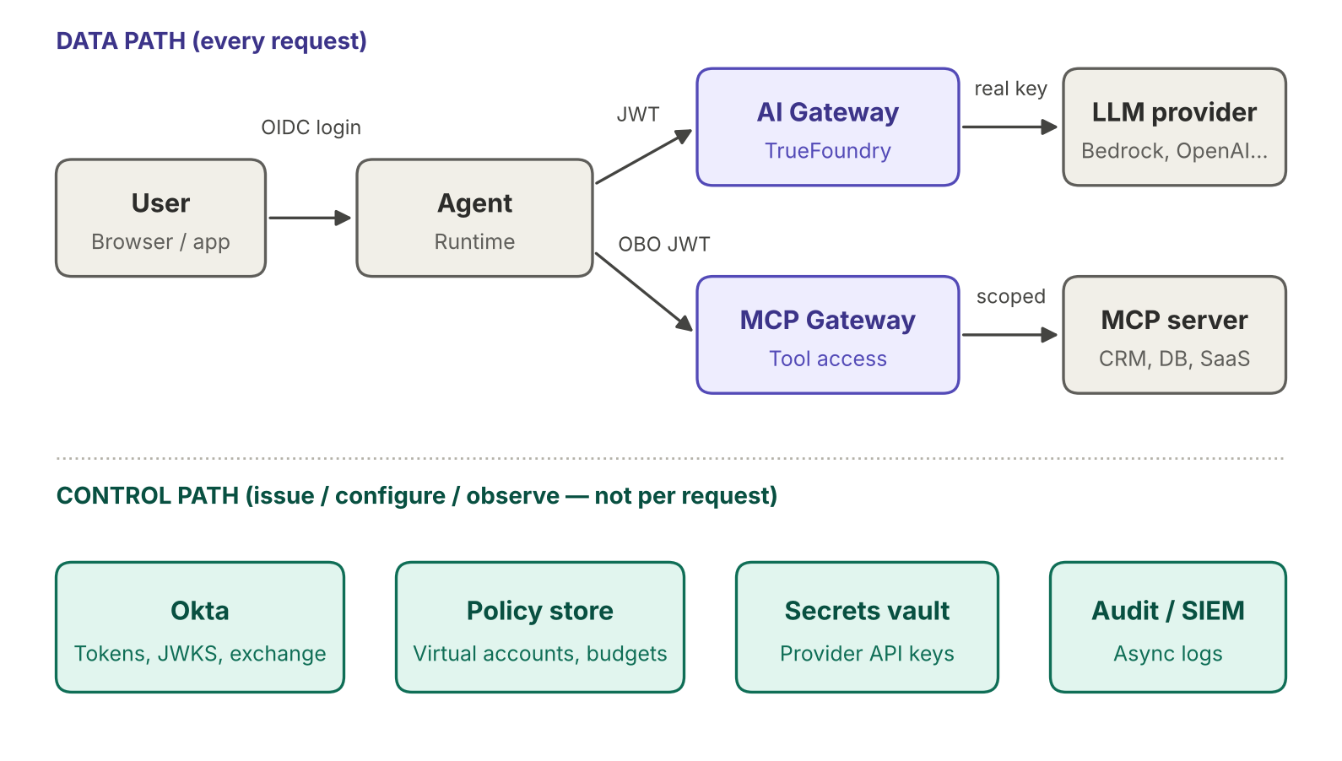
Figure 1 — Data path (top) vs control path (bottom)
Data path: every hop that carries prompts, completions, tool calls and tool results — User → Agent → AI Gateway → LLM, and Agent → MCP Gateway → MCP server → backend. These must be fast, highly available, and authenticate/authorize every request.
Control path: Okta (login, token issuance, token exchange, JWKS), the gateway policy store (virtual accounts, budgets, allowlists), the secrets vault and the audit pipeline. Okta is only contacted at login, token refresh and token exchange.

Recommendation per hop
Hop | Auth mechanism | Whose authority | Where virtual keys fit
User → Agent | OIDC Authorization Code + PKCE (Okta), with MFA / conditional access | User | —
Agent → LLM | Client credentials or workload identity JWT; user claim for attribution | Agent (user for attribution) | Inside the AI gateway, mapped from JWT claims
Agent → MCP | Token exchange → audience-bound, down-scoped OBO token per MCP server | User AND agent (intersection) | Generally not used; OAuth scopes do this job

Why the MCP hop is the sensitive one
- Tools read and write real business data on the user's behalf.
- Never pass the user's token through. The MCP authorization spec forbids token passthrough; an MCP server must reject tokens not issued for it.
- Exchange for a token with the MCP server as audience (RFC 8707 resource indicators), only the needed scopes, and a lifetime of minutes.
- For enterprise SaaS, evaluate Okta Cross App Access (identity assertion grant) so IT approves which agents reach which apps. Confirm GA status for your tenant.

Guardrails across all hops
- Short token lifetimes, automatic refresh, no static secrets in agent code.
- One Okta client per agent so a single agent can be revoked.
- Human-in-the-loop approval for high-risk tool actions (writes, payments, deletes), enforced at the MCP gateway.
- One trace ID across user, agent, LLM call and tool call.

4. Are virtual keys used on the Agent → LLM hop?
Question: For Agent → LLM the table says "inside AI gateway, mapped from claims". So virtual tokens will be used here?
Yes — but by the gateway internally, not held by the agent. The agent presents an Okta JWT; the gateway resolves it to a virtual key / Virtual Account, which carries the policy.
- Validate the JWT (signature, aud, exp) using cached Okta JWKS.
- Read claims: client_id (agent), sub / email (user), groups.
- Map claims → Virtual Account: allowed models, budgets, rate limits, guardrails, cost attribution.
- Call the provider with the real key from the vault.
Thing | Its job
JWT | Who is calling
Virtual key / Virtual Account | What they are allowed to do, and who pays
Provider key | Never leaves the gateway

Fallback if a gateway cannot validate JWTs: the agent holds a virtual key fetched at runtime from a secrets manager (never hard-coded), scoped to one agent, rotated often, with user attribution in a header. Treat this as a stepping stone.

5. JWT vs virtual token — explained simply
Question: What is the difference between a JWT and a virtual token issued by the gateway? How frequently can they be updated? AWS AgentCore supports JWT — how does it fit?
Think of a JWT as a passport and a virtual key as a gym membership card. A passport is issued by a trusted authority (Okta); anyone can verify the official stamp without phoning the passport office, and it has an expiry date printed on it. A gym card is just a number the gym (the gateway) made up; each swipe, the front desk looks you up in its own system.
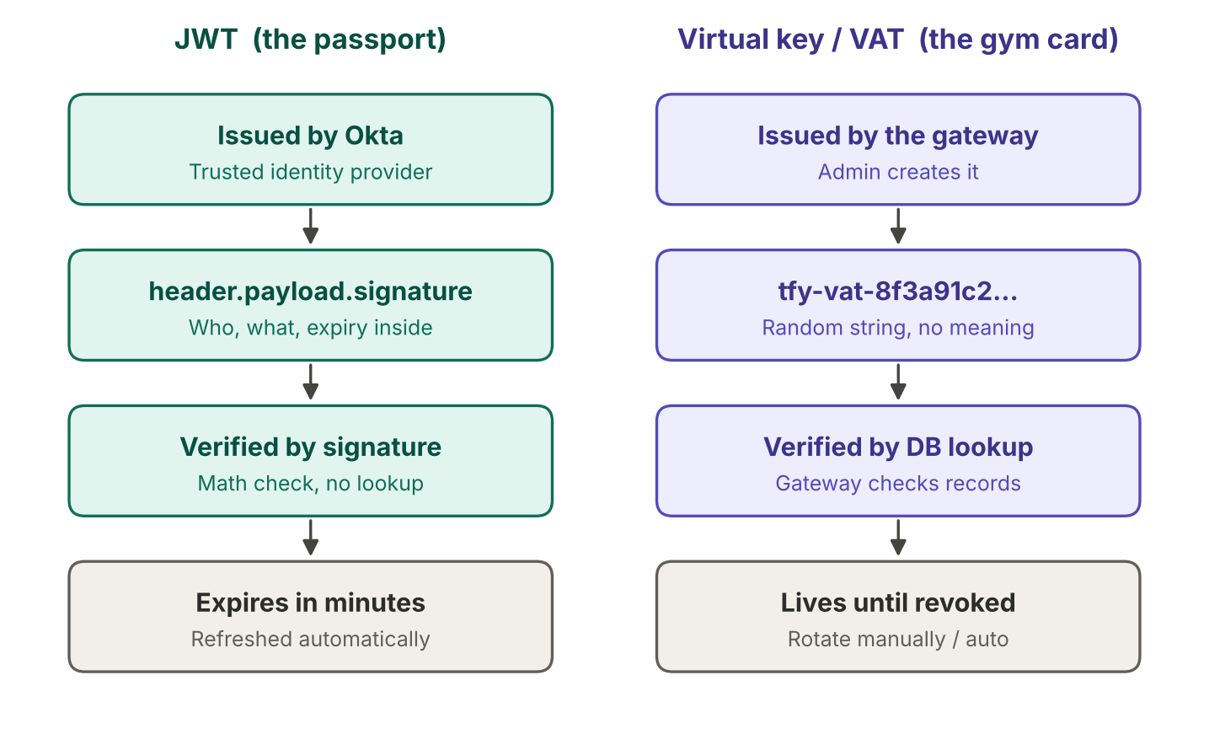
Figure 2 — JWT vs virtual key

What is inside a JWT
A JWT looks like gibberish (eyJhbGci...) but is three Base64 parts joined by dots: header, payload, signature. Decoded, the payload is plain JSON:
{
"iss": "https://acme.okta.com/oauth2/default", // who issued it
"sub": "priya@acme.com", // the user
"client_id": "agent-sales-assistant", // the agent
"aud": "api://truefoundry", // who it is meant for
"scp": ["llm.invoke"], // what it may do
"exp": 1760800000 // expiry time
}

The signature is Okta's stamp over all of that. If even one character is tampered with, the check fails. A virtual key carries nothing inside — all meaning lives in the gateway's database.

The key differences
 | JWT | Virtual key / VAT
Answers | Who is calling | What they may do, and who pays
Information lives | Inside the token | In the gateway's database
If stolen | Useless after expiry (minutes) | Works until someone revokes it
Change permissions | Takes effect at next token | Takes effect on the next request

How often can each be updated?
 | JWT (access token) | Virtual key / VAT
Lifetime | Typically 5–60 minutes, configurable in Okta per authorization server | No expiry by default unless set
Renewal | Agent's OAuth library refreshes automatically before expiry | Rotate every 30–90 days, immediately if leaked; TrueFoundry supports auto-rotation
Signing / underlying keys | Okta rotates signing keys; gateways re-fetch JWKS automatically | —
Policy changes | Claims are frozen until the token expires | Edit any time; applies on the next request
Revocation lag | At most the token lifetime | Immediate once revoked

Where AWS Bedrock AgentCore fits
AgentCore Runtime and AgentCore Gateway have an inbound JWT authorizer. You configure an OIDC discovery URL from your IdP (e.g. Okta), allowed audiences (checked against aud), allowed clients (checked against client_id) and optionally required scopes. It is IdP-agnostic and Okta is documented for both inbound auth and outbound credentials via AgentCore Identity.
- User → Agent (AgentCore Runtime): user's Okta JWT checked by the inbound authorizer.
- Agent → MCP tools (AgentCore Gateway): JWT checked by the same kind of authorizer; AgentCore Identity's outbound side fetches downstream credentials.
- Agent → LLM: calling Bedrock directly typically uses the runtime's IAM execution role. Routing through TrueFoundry instead uses the JWT → Virtual Account mapping in Section 6.

6. Mapping JWT → Virtual Account in TrueFoundry
Question: How do we map a JWT to virtual keys when invoking an LLM from inside the agent, using TrueFoundry as the AI gateway? Is it possible?
Yes, natively. In TrueFoundry the "virtual key" is a Virtual Account (its static key is the Virtual Account Token, VAT). The Identity Providers feature validates your Okta JWT and resolves it to a Virtual Account (or a user), then applies RBAC — so the agent never holds a VAT.
Analogy: the Virtual Account is a pre-paid company account at a shop. Normally you pay with the account's card (the VAT). With an Identity Provider configured, the shop accepts your Okta passport, reads the name on it, and charges the matching company account.
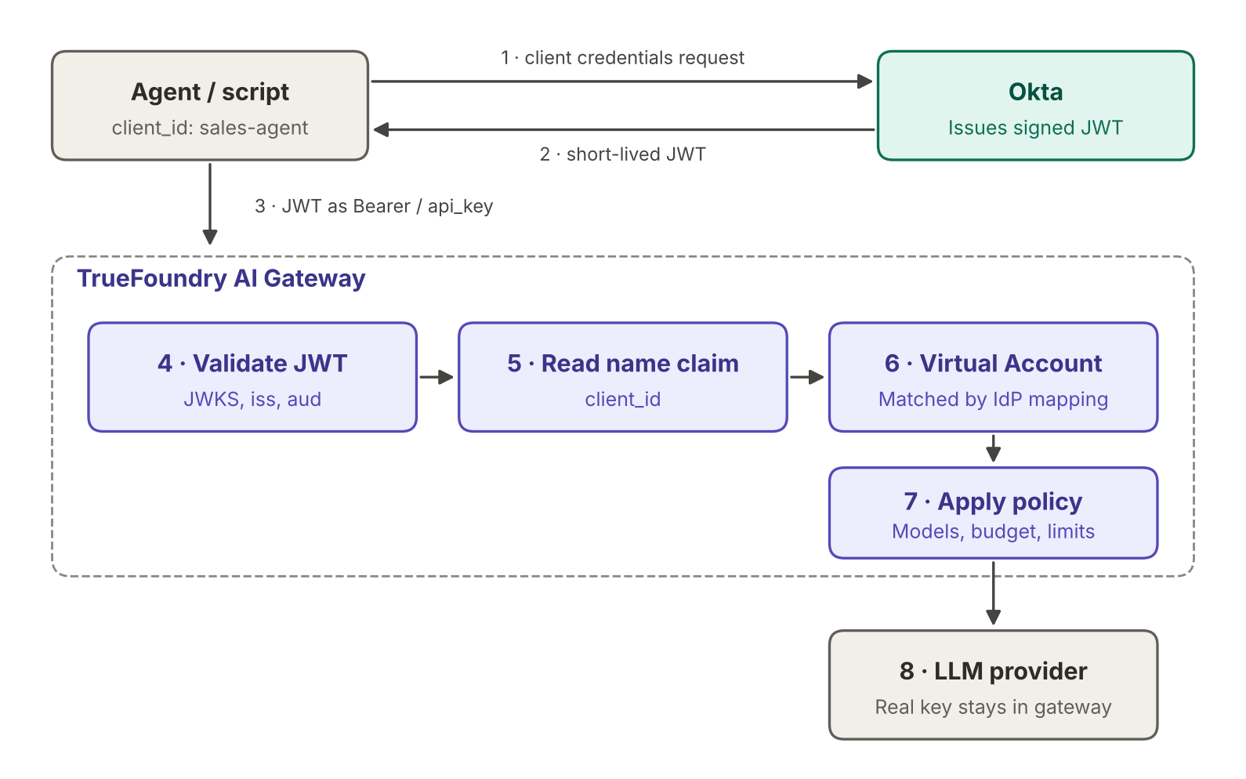
Figure 3 — Okta JWT resolved to a TrueFoundry Virtual Account

How TrueFoundry resolves a token
- The caller sends the IdP-issued JWT as a Bearer token.
- TrueFoundry verifies the signature using the configured JWKS URI.
- It checks issuer (iss) and allowed audiences (aud).
- It resolves the token to a Virtual Account (Name Claim must match an IdP mapping on the account) or to a user (Email Claim must match an existing user).
- RBAC is evaluated using the resolved identity.
Precedence: if both Virtual Account and user resolution are configured, Virtual Account resolution wins. TrueFoundry does not auto-create users or teams — provision via SCIM, JIT or invites.

Setup steps

Step 1 — Okta
- Create an API Services app per agent (e.g. sales-agent) with the client credentials grant.
- Create / use a custom authorization server with audience api://truefoundry and a scope such as llm.invoke.
- Note the issuer URL and the JWKS URI (<issuer>/v1/keys).

Step 2 — TrueFoundry Identity Provider
Settings → Security & Access → Identity Providers → Add (+). Example based on the TrueFoundry docs:
name: my-okta-provider
config:
type: jwt
issuer: https://<your-org>.okta.com/oauth2/<auth-server-id>
audiences:
- api://truefoundry
jwks_uri: https://<your-org>.okta.com/oauth2/<auth-server-id>/v1/keys
resolve_to:
virtual_account:
enabled: true
name_claim: client_id # JWT field that identifies the agent
# user_slug_claim: sub # optional: per-user attribution

Check: the issuer must exactly match the iss claim in your tokens (custom authorization servers include /oauth2/<id>). Decode a real token to confirm before saving.

Step 3 — Virtual Account per agent
- Access → Virtual Accounts → create e.g. va-sales-agent.
- Grant access only to the provider accounts / models it needs; set budget and rate limits.

Step 4 — Identity Provider mapping on the Virtual Account
- On va-sales-agent, add mapping: provider my-okta-provider, value = the agent's Okta client_id. This links the JWT to the account.

Step 5 — Agent code
import os, time, requests
from openai import OpenAI

OKTA_TOKEN_URL = "https://<your-org>.okta.com/oauth2/<auth-server-id>/v1/token"
_cache = {"token": None, "exp": 0}

def get_okta_token():
# Reuse token until ~60s before expiry
if _cache["token"] and time.time() < _cache["exp"] - 60:
return _cache["token"]
r = requests.post(
OKTA_TOKEN_URL,
data={"grant_type": "client_credentials", "scope": "llm.invoke"},
auth=(os.environ["OKTA_CLIENT_ID"], os.environ["OKTA_CLIENT_SECRET"]),
timeout=10,
)
r.raise_for_status()
body = r.json()
_cache.update(token=body["access_token"], exp=time.time() + body["expires_in"])
return _cache["token"]

client = OpenAI(api_key=get_okta_token(), base_url="https://<your-gateway-url>")
resp = client.chat.completions.create(
model="<provider-account>/<model-name>",
messages=[{"role": "user", "content": "Summarise this account"}],
)
print(resp.choices[0].message.content)

In production prefer private_key_jwt client authentication (or workload identity) over a client secret, and create a fresh client (or set api_key) after refresh.

What about the human behind the agent?
- Recommended — User Slug Claim: keep the agent's Virtual Account policy and add a user slug claim (e.g. sub) so each token resolves to a distinct user for attribution.
- Alternative — resolve to user: map email to an existing TrueFoundry user and groups to a team. The user's permissions apply instead of the agent's.

7. No agent — just a script calling LLMs
Question: What if there is no agent and I just need a VAT to invoke LLMs directly from a script? Should I still use JWT?
No, you don't have to. A VAT is TrueFoundry's recommended credential for production applications and services. What matters is where the script runs, who owns it, and the impact of a leaked key — not "agent vs script".
Situation | Use
Personal experimentation on your laptop | PAT
Production script / cron / pipeline, one owner, secret in a vault | VAT — scoped and auto-rotated
Runs on a platform with workload identity (K8s, AWS IAM, GCP, Azure MI) | JWT mapped to a Virtual Account
Security policy forbids long-lived static secrets | JWT mapped to a Virtual Account
Copied/run by many teams or machines, or need to know which human triggered it | JWT mapped to a Virtual Account

VAT hygiene checklist
- One Virtual Account per script / job.
- Grant only the models it needs; set budget and rate limits.
- Never hard-code. Load from a secret manager or injected environment variable; keep out of git.
- Enable auto-rotation in TrueFoundry and sync the token to your secret store.
import os
from openai import OpenAI

client = OpenAI(
api_key=os.environ["TFY_VAT"], # injected from secret manager
base_url="https://<your-gateway-url>",
)
print(client.chat.completions.create(
model="<provider-account>/<model-name>",
messages=[{"role": "user", "content": "Hello"}],
).choices[0].message.content)

Switching to JWT later only changes what goes into api_key.

8. Hands-on labs to try
Work through these in a non-production TrueFoundry tenant and Okta developer org.

Lab A — Script with a VAT (30 min)
- Create Virtual Account va-lab-script with access to one cheap model and a small budget.
- Store the VAT in your secret manager; export as TFY_VAT.
- Run the Section 7 script. Confirm the request appears in gateway logs under va-lab-script.
- Revoke / rotate the token and confirm the old one fails.

Lab B — Agent with Okta JWT → Virtual Account (60–90 min)
- Okta: create API Services app lab-agent (client credentials), audience api://truefoundry, scope llm.invoke.
- Get a token with curl and decode it (e.g. jwt.io in a safe/offline tool) — note iss, aud, client_id, exp.
- TrueFoundry: add Identity Provider (Section 6, Step 2) using those values.
- Create va-lab-agent and add the IdP mapping with the client_id value.
- Run the Section 6 Python code. Confirm logs show va-lab-agent.

Negative tests (prove the controls work)
Test | Expected result
Change one character in the token | 401 — signature invalid
Token issued for a different audience | Rejected — aud mismatch
Wait past exp and reuse the token | Rejected — expired
Valid token from an Okta client with no VA mapping | Authenticated but not resolved → access denied
Request a model not granted to the VA | Forbidden
Exceed the VA budget / rate limit | Throttled or blocked

Lab C — Per-user attribution (optional)
- Add user_slug_claim: sub to the Identity Provider.
- Issue tokens representing two different users (e.g. via token exchange) and call the gateway.
- Confirm logs attribute each call to the right user under the same Virtual Account.

Lab D — AgentCore inbound JWT (optional)
- Deploy a sample agent to AgentCore Runtime with a custom JWT authorizer: Okta discovery URL, allowed audience, allowed client.
- Invoke with and without a valid Okta token; confirm only valid tokens are accepted.
- Have the agent call TrueFoundry using its own client-credentials token (Lab B).

9. Troubleshooting
Symptom | Likely cause and fix
Token rejected | JWKS URI unreachable from the TrueFoundry control plane; iss not an exact match; aud not in allowed list.
Token valid but no Virtual Account found | Name Claim value in the JWT does not match the mapping on the Virtual Account.
User token resolves as a Virtual Account | Both resolutions configured — VA takes precedence. Disable VA resolution for that provider if users should resolve directly.
Token valid but wrong / no team | Team claim value does not match a team-level IdP mapping; team must exist first.
Calls stop after ~1 hour | Agent not refreshing tokens. Cache with expiry and fetch a new token before exp.
Older guides mention "External Identity" | Legacy flow; TrueFoundry docs say Identity Providers replace it. Use Identity Providers for new setups.

10. References
- TrueFoundry — Identity Providers
- TrueFoundry — AI Gateway Authentication
- TrueFoundry — Gateway Access Control
- TrueFoundry — Setup AI Gateway in Your Organization
- TrueFoundry — MCP Gateway Auth & Security
- AWS — AgentCore inbound JWT authorizer
- AWS — AgentCore with Okta
- RFC 8693 — OAuth 2.0 Token Exchange
- RFC 8707 — Resource Indicators for OAuth 2.0

