LLM Inference Infrastructure
An architect's field guide: model types, number formats, architectures, attention, KV cache, FLOPs, VRAM, Claude tiers, and two reference serving stacks
October 2026 · Facts about current models and services were checked on 27 Oct 2026; re-check prices, IDs and quotas before committing budgets.
Diagrams are animated GIFs. They play in Word for Microsoft 365 / Word 2021 (desktop and web). Printouts and PDFs show the first frame, which is a complete static diagram.

The short version
- What you serve decides everything else. Generative models (chat, reasoning) spend most GPU time in decode; embedding and decision models run one pass and need far less.
- Bytes per parameter set your GPU count. BF16 = 2 bytes, FP8 = 1, FP4 ≈ 0.5. A 70B model needs 140 GB in BF16 but 70 GB in FP8, which fits on one H200 with room left for KV cache.
- Attention design sets your KV cache bill. GQA stores ~164 KB per token for a 70B-class model at FP8; MLA stores ~35 KB; hybrids store even less. KV cache, not weights, limits concurrency at long context.
- Prefill is compute-bound (FLOPs) and sets time-to-first-token; decode is bandwidth-bound (HBM) and sets per-token latency. Splitting them onto separate GPU pools lets you size each.
- On Bedrock you don't run GPUs. You build the gateway: identity, quotas, model routing, prompt caching, logging and cost allocation. For 1,000 users that is a small multi-AZ container service in front of Bedrock.

1. Model classes: what kind of model is it?
This is the first classification to make, because it decides what the model returns and how it loads your hardware. A class says what the model is for; the architecture (section 3) says how it is built. The two are independent: DeepSeek-R1 is a reasoning model built as an MoE.
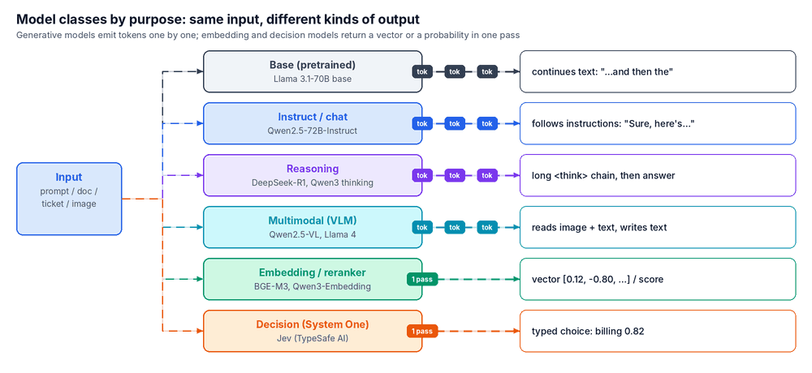
Figure 1: The same input produces different outputs. Generative classes stream tokens; embedding and decision models answer in one pass.
Table 1: Model classes
Class | What it is | Output | Examples | Serving note
Base (pretrained) | Trained only to predict the next token on a large text corpus. | Continuation of the text | Llama 3.1-70B base, Qwen2.5-72B base | Starting point for fine-tuning; rarely shown to end users.
Instruct / chat | Base model + supervised fine-tuning + preference training (RLHF/RLAIF) to follow instructions. | Conversational text, tool calls | Llama 3.3-70B-Instruct, Qwen2.5-72B-Instruct, Claude, GPT | Default for apps; balanced prefill/decode load.
Reasoning | Trained with reinforcement learning to work through a long chain of thought before answering. | Thinking tokens + final answer | DeepSeek-R1, QwQ-32B, Qwen3 thinking mode, Claude with adaptive thinking | Decode-heavy: thousands of output tokens. Size the decode pool larger; watch cost per request.
Multimodal (VLM / omni) | A vision or audio encoder feeds the language model. | Text (some also speech) | Qwen2.5-VL, Llama 4, Gemma 3, Claude | Images become hundreds of tokens and inflate prefill; the encoder can run on its own pool.
Code-specialised | Extra training on code, often with fill-in-the-middle. | Code, diffs | Qwen2.5-Coder, DeepSeek-Coder-V2, Codestral | Long repository context; prefix caching pays off.
Embedding | Encoder that maps text to a fixed-length vector for search. | Vector (e.g. 1,024 numbers) | BGE-M3, Qwen3-Embedding, Titan Text Embeddings, Cohere Embed | One forward pass, no decode; batch heavily on small GPUs or CPU.
Reranker | Cross-encoder that scores how well a document answers a query. | Relevance score | BGE-reranker, Qwen3-Reranker, Cohere Rerank | Sits between vector search and the LLM in RAG.
Decision model (System One) | Chooses among answers you define and returns calibrated probabilities. Cannot write text. | Typed choice, score or yes/no + probability | Jev (TypeSafe AI, launched 15 Sep 2026) | Hosted API only; architecture not published. For routing, intent, guardrail checks, tool choice.
Small / edge (SLM) | 0.5–8B models, often distilled and quantised. | Text | Llama 3.2-3B, Phi-4-mini, Gemma 3-4B, Qwen3-4B | Runs on one small GPU, CPU or phone; also used as a draft model for speculative decoding.
Jev's speed and cost figures (20–200× faster, $0.042 per million input tokens, free output) are vendor claims. An independent study found it weak on maths (17.7 points below the frontier median on MathQA).

2. Number formats and quantization
A weight is a number. The format decides how many bits store it: the sign, the exponent (range: how big or small it can be) and the mantissa (precision: how many significant digits). Fewer bits means less memory and faster decode, at some cost in accuracy. 4-bit formats only work well with block scaling: a small group of values shares one scale factor.
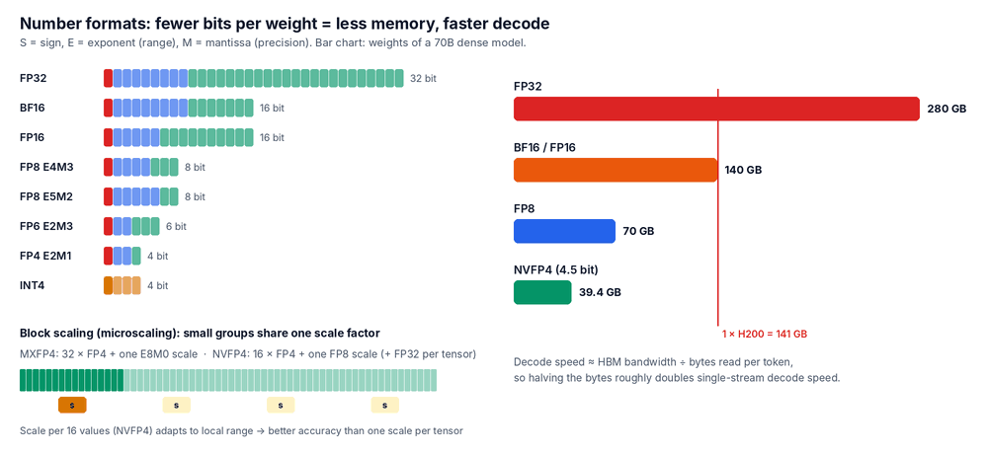
Figure 2: Bit layouts (left), how microscaling groups share a scale (bottom left), and weight memory for a 70B dense model (right).
Table 2a: Floating-point and integer formats
Format | Bits (S-E-M) | Bytes / weight | Scaling | Native tensor-core support | Typical use | Quality vs BF16
FP32 | 32 (1-8-23) | 4 | none | All GPUs (slow path for matmul) | Master weights and optimiser state in training | Reference
TF32 | 19 used of 32 (1-8-10) | 4 | none | A100 and later | FP32 matmuls in training | ≈ same
FP16 | 16 (1-5-10) | 2 | none (loss scaling in training) | V100 and later | Older inference | ≈ lossless; can overflow
BF16 | 16 (1-8-7) | 2 | none | A100+, TPUs, Trainium | Default for training and serving | Baseline
FP8 E4M3 | 8 (1-4-3) | 1 | per tensor, channel or 128×128 block | H100/H200, B200/B300, MI300 | Weights + activations + KV in inference; FP8 training | Near-lossless (<1%)
FP8 E5M2 | 8 (1-5-2) | 1 | per tensor | Same as E4M3 | Gradients (more range, less precision) | Not used for weights
MXFP8 | 8 + shared E8M0 per 32 | ≈1.03 | per 32-value block | Blackwell, MI355 | Training and inference on Blackwell | Near-lossless
INT8 | 8 integer | 1 | per channel / per token | A100+ and CPUs | W8A8 via SmoothQuant; older GPUs | Near-lossless with calibration
FP6 / MXFP6 | 6 (1-2-3 or 1-3-2) | ≈0.78 | per 32 block | Blackwell, MI355 | Niche middle ground | Small loss
MXFP4 | 4 (1-2-1) + E8M0 per 32 | ≈0.53 (4.25 bit) | per 32 block | Blackwell native; Hopper via kernels | gpt-oss MoE experts (trained for it) | Small loss; best with QAT
NVFP4 | 4 (1-2-1) + FP8 per 16 + FP32 per tensor | ≈0.56 (4.5 bit) | two-level, per 16 block | Blackwell only | Blackwell inference (TensorRT-LLM, vLLM, SGLang) | ≈1% loss on large models
INT4 (W4A16) | 4 integer + group scale | ≈0.53 | per group of 128 | Any GPU via Marlin/Machete kernels | GPTQ / AWQ weight-only | 1–3% loss; worse on small models
NF4 | 4 (normal-float lookup) | ≈0.53 | per 64 block + double quant | Any (bitsandbytes) | QLoRA fine-tuning | Similar to INT4
GGUF k-quants | 2.6–8.5 bits mixed | varies | super-blocks | CPU, Apple, consumer GPU (llama.cpp) | Local / edge | Q4_K_M small loss; Q2 noticeable
Ternary (1.58-bit) | {-1, 0, +1} | ≈0.2 | per tensor | Research kernels | BitNet b1.58 | Only works if trained that way
"BP4" is not a standard format name. It usually means 4-bit block floating point, which is what MXFP4 and NVFP4 implement. BF16 (brain float 16) is the 16-bit format above.
Table 2b: Weight memory by model size and format (GB, weights only)
Model | Parameters | FP32 | BF16 | FP8 | NVFP4 (4.5 bit) | INT4 g128 (4.25 bit) | H200s for FP8 weights*
Llama 3.1-8B | 8B  dense | 32.0 | 16.0 | 8.0 | 4.5 | 4.3 | 1
Gemma 3-27B | 27B  dense | 108 | 54.0 | 27.0 | 15.2 | 14.3 | 1
Llama 3.1-70B | 70.6B  dense | 282 | 141 | 70.6 | 39.7 | 37.5 | 1
gpt-oss-120b | 117B  MoE, 5.1B active | 468 | 234 | 117 | 65.8 | 62.2 | 2
Llama 3.1-405B | 405B  dense | 1620 | 810 | 405 | 228 | 215 | 4
DeepSeek-V3 / R1 | 671B  MoE, 37B active | 2684 | 1342 | 671 | 377 | 356 | 8
Kimi K2 | 1.04T  MoE, 32B active | 4160 | 2080 | 1040 | 585 | 553 | 16
*Smallest power-of-two H200 count (141 GB each) where FP8 weights use ≤80% of memory, leaving the rest for KV cache. Real checkpoints keep embeddings, norms and routers in higher precision, so files are slightly larger. gpt-oss-120b ships in MXFP4 (~61 GB) and fits one H100/H200.

How the format changes performance vs memory
- Memory: weights = parameters × bytes per weight. Halving the bytes frees memory for KV cache, which means more concurrent users or longer contexts on the same GPUs.
- Decode speed: decode reads every active weight once per step, so it scales with bytes read. Going BF16 → FP8 typically gives 1.5–2× decode throughput; FP8 → FP4 on Blackwell gives more.
- Prefill speed: improves only when the tensor cores compute natively in that format. FP8 on Hopper has 2× the peak FLOP/s of BF16; FP4 on Blackwell has 2× FP8. Weight-only INT4 (W4A16) speeds up decode but not prefill, because weights are unpacked to BF16 before the multiply.
- Quality: FP8 is close to lossless. 4-bit loses a little, more on small models and on maths, code, long reasoning and non-English text. Below 4 bits, quality drops unless the model was trained for it (QAT).
- KV cache precision is a separate dial. FP8 KV halves KV memory versus BF16 with little quality loss.
Table 2c: Quantization techniques
Technique | When applied | What gets quantised | How it works | Tools / users
Round-to-nearest (RTN) | After training (PTQ) | Weights, optionally activations | Compute a scale, round each value. No calibration data. | FP8 dynamic in vLLM / SGLang
GPTQ | PTQ | Weights (INT4 / INT3) | Quantises layer by layer and corrects the error using second-order (Hessian) information from calibration data. | GPTQModel, llm-compressor
AWQ | PTQ | Weights (INT4) | Finds the ~1% of channels that matter most from activation sizes and scales them to protect them. | AutoAWQ, vLLM, TensorRT-LLM
SmoothQuant | PTQ | Weights + activations (INT8) | Moves activation outliers into the weights with per-channel scaling so both quantise well. | TensorRT-LLM, llm-compressor
FP8 static / dynamic | PTQ | Weights, activations, KV | Per-tensor, per-channel or per-block scales; static uses calibration, dynamic computes at runtime. | TensorRT Model Optimizer, vLLM
Rotation-based (QuaRot, SpinQuant) | PTQ | W4A4, 4-bit KV | Applies Hadamard rotations to spread outliers before quantising. | Research, early production
Quantization-aware training (QAT) | During training | Any | Simulates low precision while training so the weights adapt. | gpt-oss (MXFP4), Gemma 3 QAT, Kimi K2 Thinking (INT4)
Low-precision training | Pretraining | Weights, activations, gradients | Trains directly in FP8, MXFP8 or NVFP4. | DeepSeek-V3 (FP8), Blackwell recipes
KV cache quantisation | Inference | K and V tensors | FP8, or INT4/INT2 with per-channel keys and per-token values (KIVI). | vLLM --kv-cache-dtype fp8
bitsandbytes (NF4, LLM.int8()) | PTQ | Weights | 4-bit lookup table; 8-bit with outlier columns kept in FP16. | QLoRA, Hugging Face
GGUF k-quants / i-quants | PTQ | Weights | Block quantisation guided by an importance matrix. | llama.cpp, Ollama, LM Studio
2:4 structured sparsity | Compression | Weights | Two of every four weights set to zero; sparse tensor cores run 2× faster. | Supported on NVIDIA; rarely used for LLMs (quality loss)
Distillation / pruning | Compression | Whole model | Train a smaller student, or remove layers, heads or channels. | Llama 3.2 1B/3B, NVIDIA Minitron

3. Model types by architecture
Architecture decides where weights sit, how they are split across GPUs, and how memory grows with context. The main split is dense (every weight works on every token) versus Mixture-of-Experts (a router sends each token to a few experts). Hybrid models replace most attention layers with a fixed-size state.
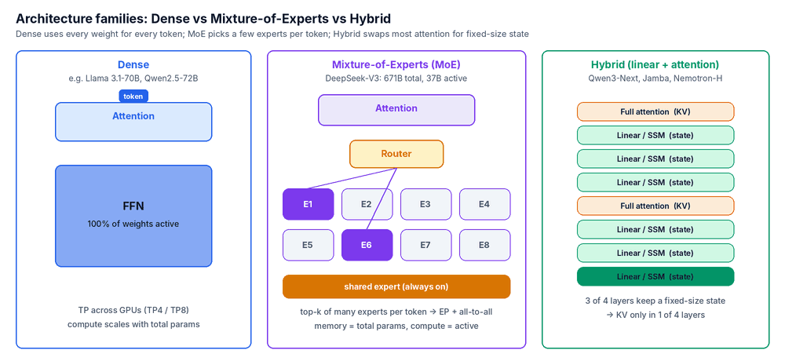
Figure 3: Dense lights the whole FFN for every token; MoE lights two experts plus a shared one; Hybrid keeps KV in only one layer in four.
Table 3: Architecture types
Type | How it works | Examples | Memory / compute profile | How it is served
Decoder-only dense | Stack of attention + FFN blocks; all weights used for every token. | Llama 3.1-8B/70B/405B, Qwen2.5-72B, Gemma 3-27B | Memory and compute both scale with total parameters. | Tensor parallel (TP) inside one node; pipeline parallel across nodes if needed.
Sparse MoE (coarse) | FFN replaced by a few large experts; router picks top-2. | Mixtral 8×7B (47B total / 13B active) | Memory = total params; compute = active params. | TP or expert parallel (EP).
Fine-grained MoE + shared experts | Hundreds of small experts, top-8 routing, plus always-on shared experts. | DeepSeek-V3 (671B / 37B), Qwen3-235B-A22B, Kimi K2 (~1T / 32B), gpt-oss-120b, Llama 4 Maverick | Huge memory, low FLOPs per token, heavy all-to-all traffic. | Wide EP (EP32–EP72) with DeepEP; attention data-parallel; NVL72 racks suit it.
Hybrid (linear / SSM + attention) | Most layers keep a fixed-size recurrent state; a minority keep full attention. | Qwen3-Next (3:1 Gated DeltaNet), Kimi Linear, Jamba, MiniMax-01 (7:1), Nemotron-H | KV only in attention layers, so long context is cheap. | Like dense/MoE plus a per-sequence state cache; newer engine support.
Pure SSM / RNN | No attention; constant-size state. | Mamba, RWKV | Constant memory per sequence; weaker exact recall. | Simple; mostly research or edge.
Encoder-only | Bidirectional attention over the whole input; no generation. | BERT, ModernBERT, most embedding / reranker models | Small; single pass. | Batch on small GPUs or CPU.
Encoder–decoder | Encoder reads input; decoder generates with cross-attention. | T5, Flan-T5, Whisper (speech) | Two stacks; cross-attention KV. | Translation, speech-to-text.
Multimodal | Vision / audio encoder + projector + LLM, or early fusion of image tokens. | Qwen2.5-VL, Llama 4, Gemma 3 | Encoder FLOPs + many image tokens in prefill. | Encoder can be disaggregated (E/P/D).
Diffusion LM | Generates by denoising many tokens in parallel instead of one at a time. | Gemini Diffusion, Inception Mercury, LLaDA | Fewer sequential steps; different KV story. | Emerging; limited engine support.
Draft / MTP heads | Small extra heads or models that guess several next tokens for the main model to verify. | EAGLE-3, Medusa, DeepSeek-V3 MTP | Small extra memory. | Speculative decoding: 1.5–3× faster decode at low batch.

4. Kinds of attention
Attention lets each token look at earlier tokens. The variants differ in how much they store per token (the KV cache) and how far back they look. KV size per token = 2 (K and V) × layers × KV heads × head dimension × bytes per value.
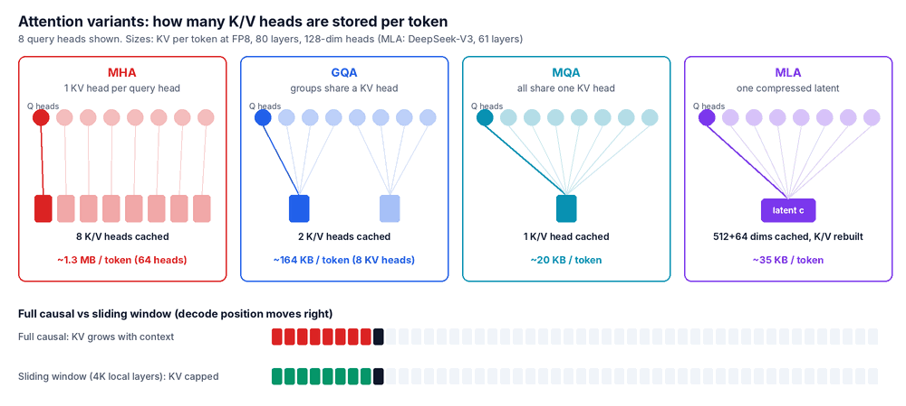
Figure 4: The highlighted query head and the K/V head it reads. Fewer cached heads means a smaller KV cache. Bottom: full causal vs sliding window.
Table 4a: Attention variants (change what is computed and stored)
Variant | Idea | KV per token (FP8) | Examples | Trade-off
MHA (multi-head) | Every query head has its own K and V head. | ~1.3 MB (80 layers × 64 heads × 128) | GPT-3, Llama 2-7B | Best quality per head, largest cache; mostly legacy.
MQA (multi-query) | All query heads share one K/V head. | ~20 KB | Falcon-7B, PaLM | Tiny cache, some quality loss.
GQA (grouped-query) | Groups of query heads share K/V heads (e.g. 64 Q : 8 KV). | ~164 KB (Llama 3.1-70B) | Llama 3, Qwen2.5, Mistral, gpt-oss | Today's default balance.
MLA (multi-head latent) | Compresses K/V into one small latent vector per layer, expanded on the fly. | ~35 KB (DeepSeek-V3: 61 × 576) | DeepSeek-V2/V3/R1, Kimi K2 | ~4–5× smaller than GQA; needs MLA kernels (FlashMLA).
Sliding window / local | Each token sees only the last W tokens. | Capped at W tokens per layer | Mistral 7B, Gemma 2/3 local layers | Cheap, but cannot see far back alone.
Interleaved local–global | Mostly local layers with periodic full-attention layers. | Mostly capped | Gemma 3 (5:1), gpt-oss (alternating), Llama 4 (chunked + global) | Long context at a fraction of full cost.
Sparse attention | Selects the top-k most relevant earlier tokens per query. | Full cache kept, less compute | DeepSeek V3.2 (DSA), NSA | Cuts long-context compute; cache size unchanged.
Linear attention / SSM | Replaces the softmax over all tokens with a running fixed-size state. | Constant | Gated DeltaNet (Qwen3-Next), Lightning (MiniMax), Mamba | Very cheap; weaker exact recall, so used in hybrids.
Cross-attention | Decoder attends to another sequence (encoder output, image features). | Per source sequence | T5, Whisper, Llama 3.2 Vision | Separate cache for the source.
Attention sinks | Keep the first few tokens (or learned sink logits) so windowed attention stays stable. | Few extra tokens | StreamingLLM, gpt-oss | Enables endless streaming with a window.
Table 4b: Attention kernels and systems (same maths, faster or leaner)
Technique | What it does | Where
FlashAttention 2 / 3 / 4 | Fused, tiled attention that never writes the full attention matrix to HBM. FA3 targets Hopper, FA4 Blackwell. | All major engines
FlashInfer, FlashMLA | Kernel libraries for paged, ragged and MLA attention in serving. | vLLM, SGLang
PagedAttention | Stores KV in fixed-size blocks like OS memory pages. | vLLM (origin), all engines now
RadixAttention | Radix tree of cached prefixes for automatic reuse. | SGLang
Chunked prefill | Splits long prompts into chunks interleaved with decode steps. | vLLM, SGLang, TensorRT-LLM
Ring attention / context parallelism | Splits one very long sequence across GPUs and passes KV blocks around a ring. | Million-token prefill

5. Feed-forward network (FFN) and related building blocks
Each transformer block has two halves. Attention mixes information across tokens. The feed-forward network (FFN, also called MLP) then processes each token on its own: it widens the vector (e.g. 8,192 → 28,672), applies a non-linearity, and narrows it back. The FFN holds most of the model's stored knowledge and about two-thirds of a dense model's weights. In MoE models, the FFN is the part replaced by experts.
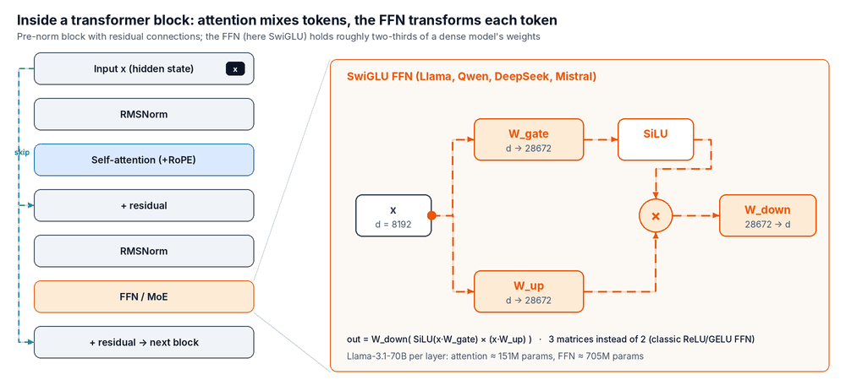
Figure 5: A pre-norm transformer block (left) and the SwiGLU FFN used by most current models (right).
Table 5: FFN and other building blocks
Component | What it does | Variants | Used in
FFN / MLP | Per-token two-layer network: expand, activate, project back. | Classic 4× width with ReLU or GELU | GPT-2, BERT, GPT-3
Gated FFN (GLU family) | Two parallel projections; one gates the other. Three matrices; better quality per parameter. | SwiGLU (SiLU gate), GeGLU (GELU gate) | Llama, Qwen, Mistral, DeepSeek (SwiGLU); Gemma (GeGLU)
MoE FFN | Many expert FFNs; a router sends each token to the top-k. | Softmax or sigmoid gates; load-balance loss or DeepSeek's bias-based balancing | Mixtral, DeepSeek-V3, Qwen3 MoE, Kimi K2, gpt-oss
Shared expert | One or more experts every token always uses, holding common knowledge. | 1–2 shared + many routed | DeepSeek-V3, Qwen2-MoE, Llama 4
Activation function | The non-linearity inside the FFN. | ReLU, GELU, SiLU / Swish | SiLU in most current LLMs
Normalisation | Keeps activations in a stable range. | LayerNorm, RMSNorm; pre-norm vs post-norm; QK-norm | RMSNorm pre-norm is standard; QK-norm in Qwen3, Gemma 3
Residual connection | Adds a block's input to its output so signals and gradients flow through deep stacks. | Standard skip | All transformers
Positional encoding | Tells attention where each token sits. | Learned absolute, RoPE, ALiBi, NoPE layers; extension via YaRN / NTK scaling | RoPE in most models; Llama 4 mixes in NoPE
Embedding / LM head | Maps token IDs to vectors and final vectors back to vocabulary scores. | Tied or untied; vocabularies of 128K–256K | Large share of parameters in small models
Multi-token prediction (MTP) | Extra heads predict tokens further ahead; reused as a built-in draft model. | 1–n extra heads | DeepSeek-V3, Qwen3-Next

6. Infrastructure components: interconnect, RDMA and KV cache design
These are the parts between the model and the user. Fast links decide how cheaply KV cache and expert traffic can move. KV cache techniques decide how many users fit in GPU memory.
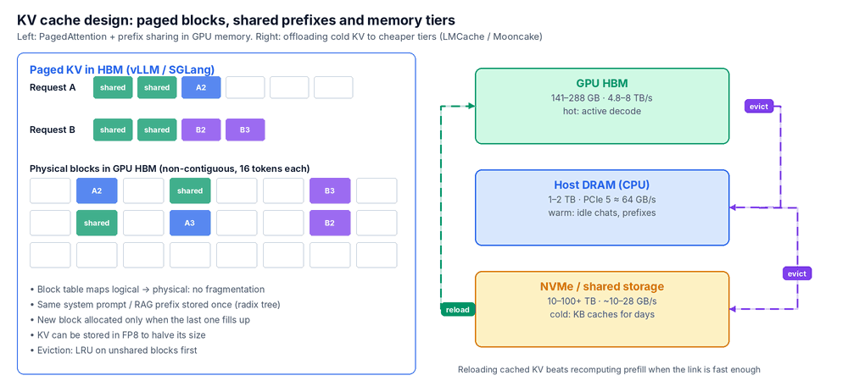
Figure 6: Paged KV blocks with a shared prefix (left) and offloading cold KV down the memory hierarchy (right).
Table 6a: Hardware, network and software components
Component | Layer | What it does | Typical numbers / products
HBM (GPU memory) | GPU | Holds weights, KV cache, activations; its bandwidth sets decode speed. | H200 141 GB at 4.8 TB/s; B200 ~180 GB at 8 TB/s; B300 / MI355X 288 GB
NVLink + NVSwitch | Scale-up | GPU-to-GPU links inside a node or rack; carries TP all-reduce and EP all-to-all. | Hopper 900 GB/s per GPU; Blackwell 1.8 TB/s; GB200 NVL72 joins 72 GPUs
NVLink-C2C | CPU–GPU | Coherent link between Grace CPU and GPU; makes CPU memory a fast KV tier. | 900 GB/s total (Grace Hopper / Grace Blackwell only)
PCIe Gen5 / Gen6 | Host | Standard GPU / NIC / NVMe link on x86 servers. | x16 ≈ 64 GB/s (Gen5) or 128 GB/s (Gen6) per direction
RDMA (InfiniBand, RoCE v2, AWS EFA) | Scale-out | Network that writes directly into remote memory without the remote CPU; low latency, high bandwidth. | 400–800 Gb/s per GPU (NDR / XDR, Spectrum-X)
GPUDirect RDMA | Scale-out | The NIC reads and writes GPU memory directly, with no copy through host RAM. | Used for KV transfer and multi-node TP/EP
GPUDirect Storage (GDS) | Storage | DMA from NVMe or network storage straight into GPU memory. | Model loading, cold KV tier
NCCL | Library | Collective operations (all-reduce, all-gather) for TP / PP / DP. | NVIDIA; RCCL on AMD
DeepEP | Library | Optimised all-to-all dispatch and combine for MoE expert parallelism. | DeepSeek; used by SGLang, vLLM
NIXL | Library | Point-to-point transfer library that moves KV between prefill and decode GPUs or storage tiers. | NVIDIA Dynamo; plugs into vLLM, SGLang, TensorRT-LLM
Serving engine | Runtime | Batches requests, manages the KV cache, runs kernels. | vLLM, SGLang, TensorRT-LLM
Orchestrator / router | Control plane | Schedules P/D pools, KV-aware routing, autoscaling. | NVIDIA Dynamo, llm-d (Kubernetes), KServe, Ray Serve
KV store | Memory tiering | Shares and offloads KV across GPUs, CPU RAM, NVMe and remote stores. | LMCache, Mooncake, Dynamo KV block manager
Model loader | Startup | Streams safetensors into GPUs in parallel to cut cold-start time. | Run:ai Model Streamer, fastsafetensors
Table 6b: KV cache design techniques
Technique | Problem it solves | How | Where
Paged KV (block tables) | Fragmentation and over-reservation | Fixed-size blocks allocated on demand and mapped by a block table. | All modern engines
Prefix caching | Repeated system prompts, RAG documents, chat history | Hash or radix tree of token blocks; reuse matching prefixes instead of recomputing. | vLLM APC, SGLang RadixAttention
KV-aware routing | Cache hits lost when requests land on the wrong GPU | Router sends each request to the worker that already holds its prefix. | Dynamo, llm-d, SGLang router
Architectural compression | KV grows with layers × heads | GQA, MLA, sliding window, hybrid layers. | Chosen at model-selection time
KV quantisation | KV memory at long context | Store K/V in FP8 (or INT4). | Engine flag
Tiered offload | HBM too small for idle sessions | Evict cold blocks to CPU DRAM, NVMe or a remote store; reload on hit. | LMCache, Mooncake, Dynamo KVBM
P/D disaggregation + transfer | Prefill stalls decode | Prefill GPUs compute KV and ship it to decode GPUs over RDMA. | Dynamo + NIXL, Mooncake, SGLang PD
Layer-wise streaming | Transfer time adds to TTFT | Send each layer's KV as soon as it is computed, overlapping transfer with compute. | LMCache, Mooncake, Dynamo
CacheBlend | RAG chunks that are not a shared prefix | Reuse cached chunks and recompute only a few tokens to fix cross-attention. | LMCache
Token eviction / sparse KV | Context longer than memory | Drop low-importance tokens; keep sinks + recent window. | H2O, SnapKV, StreamingLLM (research)
Provider prompt caching | Same as prefix caching, for managed APIs | Mark cache breakpoints (cache_control); cached reads cost a fraction of normal input. | Claude API, Amazon Bedrock
Table 6c: Parallelism strategies
Strategy | What is split | Traffic | Use when
Data parallel (DP) | Requests; each replica holds the full model | None between replicas | Model fits on one GPU or node; scale throughput
Tensor parallel (TP) | Each layer's matrices across GPUs | All-reduce every layer (needs NVLink) | Dense model too big for one GPU; lowers latency
Pipeline parallel (PP) | Layers in stages across GPUs or nodes | Activations between stages | Model spans nodes
Expert parallel (EP) | MoE experts across GPUs | All-to-all per MoE layer | Large MoE models
Context / sequence parallel | One long sequence across GPUs | KV blocks passed around | Very long prefill

7. FLOPs and their effect on prefill
FLOP stands for floating-point operation: one add or multiply on real numbers. FLOPs counts how many a job needs. FLOP/s (often written FLOPS) is how many a chip does per second; GPUs are rated in TFLOP/s (10¹²) or PFLOP/s (10¹⁵). A transformer needs about 2 FLOPs per active parameter per token (one multiply and one add), plus attention, which grows with context length.
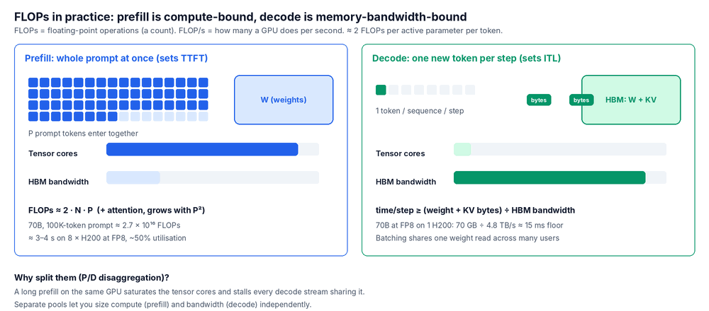
Figure 7: Prefill keeps the tensor cores busy; decode keeps HBM busy. That is why they are sized and scaled separately.
Table 7a: Terms
Term | Meaning
FLOPs (count) | Work needed. Forward pass ≈ 2 × active parameters × tokens + attention (∝ context²).
FLOP/s (rate) | Chip speed. Vendor figures are peak; real jobs reach 40–70% of dense peak.
MFU | Model FLOPs utilisation: achieved FLOP/s ÷ peak FLOP/s.
Arithmetic intensity | FLOPs per byte moved from memory. High = compute-bound (prefill); low = memory-bound (decode at small batch).
Roofline | Achieved speed = min(peak FLOP/s, bandwidth × arithmetic intensity). Explains why batching helps decode.
TTFT / ITL | Time to first token (set by prefill) / inter-token latency (set by decode).

Effect on prefill (worked example)
- Prefill processes all P prompt tokens in parallel, so it is compute-bound: TTFT ≈ prefill FLOPs ÷ achieved FLOP/s.
- Llama 3.1-70B, 100K-token prompt: 2 × 70.6B × 100K ≈ 1.4 × 10¹⁶ FLOPs for the weights, plus ≈ 1.3 × 10¹⁶ for attention (80 layers × 2 × P² × 8,192) ≈ 2.7 × 10¹⁶ FLOPs.
- On 8 × H200 in FP8 (8 × 1,979 TFLOP/s peak, ~50% achieved ≈ 7.9 PFLOP/s): ≈ 3.4 s TTFT. In BF16 it takes twice as long.
- Levers: prefix caching (skip FLOPs entirely), FP8 / FP4 (more FLOP/s), more GPUs per prefill (TP), chunked prefill (protects decode), MLA or sparse attention (less attention work).
- Decode is the opposite: each step needs only 2 × N FLOPs per sequence but must read all the weights. 70 GB ÷ 4.8 TB/s ≈ 15 ms per step on one H200, whatever the FLOP rating. Batching many users shares that one read.
Table 7b: Accelerator reference (per GPU, vendor peak dense figures)
GPU | Memory | Bandwidth | BF16 TFLOP/s | FP8 TFLOP/s | FP4 TFLOP/s
NVIDIA H100 SXM | 80 GB HBM3 | 3.35 TB/s | ≈ 989 | ≈ 1,979 | —
NVIDIA H200 | 141 GB HBM3e | 4.8 TB/s | ≈ 989 | ≈ 1,979 | —
NVIDIA B200 | ~180 GB HBM3e | 8 TB/s | ≈ 2,250 | ≈ 4,500 | ≈ 9,000
AMD MI300X | 192 GB HBM3 | 5.3 TB/s | ≈ 1,307 | ≈ 2,615 | —
Sparsity-enabled figures are 2× these; check the exact SKU and power configuration.

8. GPU VRAM and where the weights get loaded
VRAM stands for Video Random Access Memory, the memory on the graphics card. On data-centre GPUs it is HBM (High Bandwidth Memory): stacked DRAM next to the GPU die, with terabytes per second of bandwidth. Everything the GPU computes on must be in HBM.
Memory budget: HBM ≥ weights + KV cache (users × context × bytes per token) + activations + runtime overhead (CUDA graphs, communication buffers, a few GB per GPU).
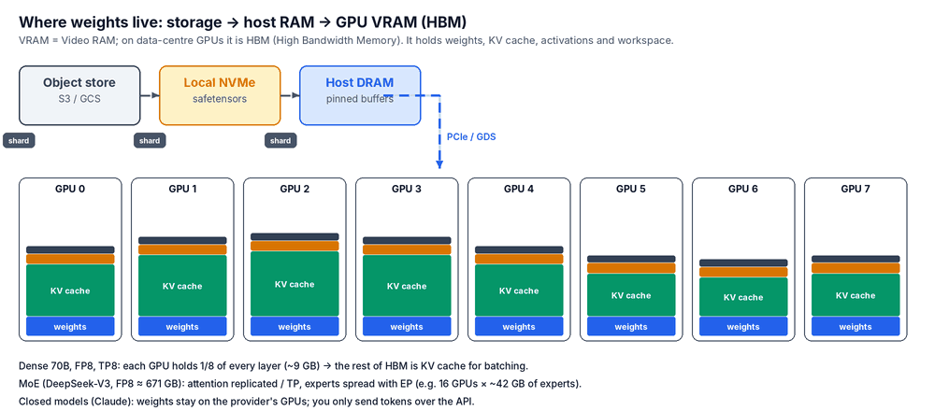
Figure 8: Weights stream from storage through host memory into each GPU's HBM. Whatever the weights don't use becomes KV cache.
Example: Llama 3.1-70B in FP8 on 4 × H200 (564 GB). Weights take 70 GB and overhead ~25 GB, leaving ~420 GB of usable KV space. At 164 KB per token that is ~2.5 million tokens: about 25 concurrent 100K-token sessions, or about 600 sessions at 4K tokens.
Table 8: Where weights are loaded, by model type
Model type | Weights live in | How they are split | Example
Small dense (≤ ~30B in FP8) | One GPU's HBM | Not split; add data-parallel replicas for throughput | Llama 3.1-8B on one L40S or H100
Large dense | HBM across GPUs in one node | TP inside the NVLink domain; PP across nodes if still too big | 70B on TP4 / TP8; 405B FP8 on 8 × H200
MoE | HBM across many GPUs | Attention by TP or DP; experts spread with EP; all-to-all every MoE layer | DeepSeek-V3 on 16 × H200, or a GB200 NVL72 slice
Hybrid | HBM, like dense / MoE | Same as above, plus a fixed-size state per sequence | Qwen3-Next-80B-A3B
Quantised local | CPU RAM, Apple unified memory or a consumer GPU | Layers split between CPU and GPU | GGUF Q4 models in llama.cpp / Ollama
Offloaded (memory-poor) | CPU DRAM or NVMe, streamed to the GPU layer by layer | Very slow; batch jobs only | ZeRO-Inference, Accelerate offload
Embedding / reranker | Small GPU or CPU | Replicas | BGE-M3 on an L4
Closed models (Claude) | The provider's accelerators (Anthropic uses NVIDIA GPUs, Google TPUs and AWS Trainium) | Not visible to you | Claude API, Amazon Bedrock, Google Cloud, Microsoft Foundry

Loading path and cold starts
- Object store (S3) → local NVMe cache → host DRAM (pinned) → GPU HBM over PCIe, or straight from NVMe with GDS.
- From local NVMe RAID at ~25 GB/s, 140 GB of BF16 weights load in ~6 s. From S3 the network dominates, so use a parallel model streamer, pre-pull images and weights, and keep a warm pool for autoscaling.

9. Claude model variants: Haiku vs Sonnet vs Opus
Claude models are closed-weight: Anthropic doesn't publish parameter counts or attention design, so they can't be placed on the dense/MoE or GQA/MLA axes. You choose them by capability, speed and price. The current family is 5.5: all three share a 1M-token context window and up to 128K output tokens, with adaptive thinking.
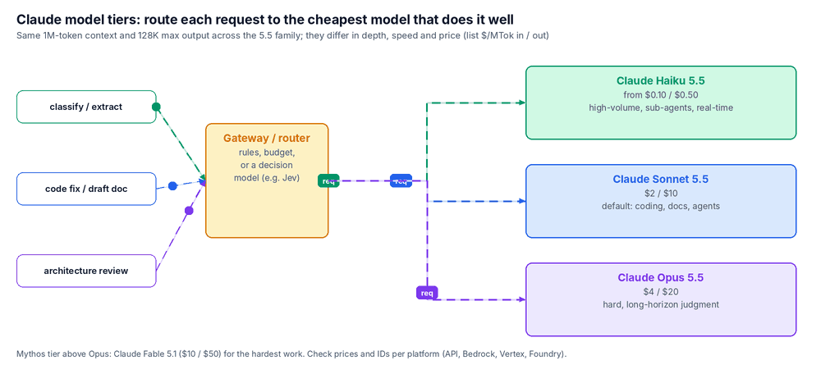
Figure 9: Route each request to the cheapest tier that handles it well. Haiku packets move fastest; Opus takes longer and costs more.
Table 9: Claude family (Anthropic list prices, $ per million tokens, input / output)
Model | Role | Context / max output | Price (in / out) | Thinking (default effort) | Best for | Not ideal for
Claude Haiku 5.5 | Fast, low-cost tier | 1M / 128K | from $0.10 / $0.50 | Adaptive (medium) | Classification, extraction, routing, real-time chat, sub-agents under a bigger model | Long, open-ended design or judgment work
Claude Sonnet 5.5 | Default workhorse | 1M / 128K | $2 / $10 | Adaptive (high) | Coding, agents, documents, analysis; most production traffic | The hardest multi-day agentic tasks
Claude Opus 5.5 | Flagship of the main family | 1M / 128K | $4 / $20 | Adaptive, always on (medium) | Complex, long-horizon coding and knowledge work needing sustained judgment | High-volume simple calls (cost)
Claude Fable 5.1 | Mythos tier, above Opus | 1M / 128K | $10 / $50 | Adaptive, always on (high) | The hardest problems; has extra safeguards for biology, cybersecurity and LLM R&D | Routine work (cost)
- Shared features: text and image input, tool use, streaming, prompt caching and batch processing. Availability and model IDs vary by platform (Claude API, Amazon Bedrock, Google Cloud, Microsoft Foundry).
- Typical routing for an enterprise: about 60% of calls to Haiku (classify, extract, summarise short text), about 35% to Sonnet (coding, drafting, agents) and about 5% to Opus (architecture reviews, hard debugging, long research). Adjust from your own evaluations.
- Older models (Sonnet 5, Opus 5, 4.x) are still listed but marked legacy; plan migrations using Anthropic's model deprecation page.

10. Reference stack A: self-hosted open-weight serving
Use this when you must run open-weight models on your own GPUs, for data control, custom fine-tunes or cost at very high volume. It is the corrected version of the original diagram.
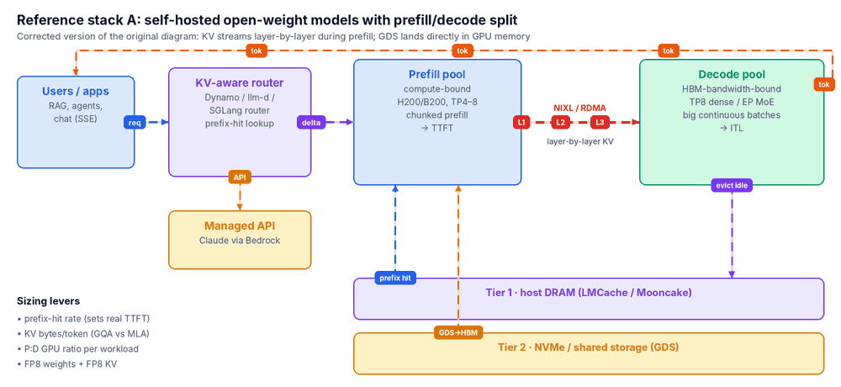
Figure 10: Router → prefill → layer-wise KV transfer → decode → streamed tokens, with LMCache tiers underneath and a managed-API side path.
Table 10: Stack choices
Layer | Choice | Why
Hardware | 8-GPU H200 / B200 nodes; GB200 NVL72 for large MoE | NVLink domain for TP / EP; HBM size for KV
Network | 400–800 Gb/s InfiniBand or RoCE per GPU, GPUDirect RDMA | KV transfer and multi-node EP
Storage | Local NVMe RAID + shared parallel file system or object store; GDS | Fast model loads and a cold KV tier
Platform | Kubernetes + NVIDIA GPU Operator; Dynamo or llm-d | P/D pools, autoscaling, KV-aware routing
Engine | vLLM, SGLang or TensorRT-LLM | Paged KV, continuous batching, FP8 / FP4 kernels
KV | LMCache or Mooncake over NIXL | Prefix reuse across sessions; offload tiers
Precision | FP8 weights + FP8 KV on Hopper; NVFP4 on Blackwell | Halve memory and bandwidth at near-zero quality cost
Observability | DCGM exporter, Prometheus, Grafana, OpenTelemetry | SLOs: p95 TTFT, p95 ITL, goodput, cache-hit rate

Corrections to the original diagram
- GPUDirect Storage should land in GPU memory, not host DRAM.
- "Reloads 3.5 GB in ~4 ms" needs Grace + NVLink-C2C and uses the bidirectional figure. On PCIe Gen5 x86 servers (H200 / B200 HGX) expect ~55 ms.
- KV transfer is not instant: 3.5 GB over one 400 Gb/s link takes ~70 ms. Layer-wise streaming hides most of it.
- A TTFT under 0.5 s at 100K tokens only holds on prefix-cache hits; a cold prefill takes seconds (section 7).
- "4.7× more users" compares a 671B MoE with a 72B dense model; GPU counts differ, so it doesn't translate directly into concurrency.

11. Reference stack B: Claude on Amazon Bedrock for 1,000+ users
With Bedrock, AWS runs the GPUs and the model. Your job is the gateway in front of it, plus identity, quotas, cost control and observability. For 1,000 users this is a small multi-AZ container service and a few managed AWS services.
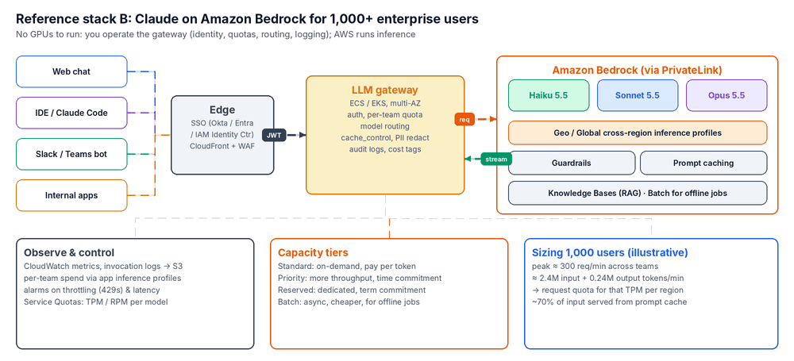
Figure 11: Clients → SSO and edge → LLM gateway → Bedrock over PrivateLink, with observability, capacity tiers and sizing underneath.
Table 11a: Components
Layer | AWS service / component | Notes
Identity | IAM Identity Center federated with Okta or Entra ID | Users get a token; the gateway maps it to a team and quota.
Edge | CloudFront + AWS WAF; ALB (or API Gateway) | Prefer ALB for long streaming responses; API Gateway has integration time limits.
LLM gateway | Containers on ECS Fargate or EKS across 3 AZs (LiteLLM or in-house) | Authentication, per-team rate and budget limits, model routing, cache_control markers, PII redaction, audit logging.
Private network | VPC interface endpoint (PrivateLink) for bedrock-runtime | Traffic never crosses the public internet.
Models | Claude Haiku / Sonnet / Opus 5.5 through inference profiles | Geo cross-region profiles (us., eu. …) raise throughput while keeping data in a geography; Global when residency doesn't matter.
Capacity | Standard (on-demand), Priority, Reserved; Batch inference | Priority: more throughput with a time commitment. Reserved: dedicated throughput with a term commitment. Batch for offline jobs.
Caching | Bedrock prompt caching | Cache system prompts, tool definitions and shared documents; see each model card for minimum tokens and TTL.
RAG | Bedrock Knowledge Bases (S3 → embeddings → vector store) | OpenSearch Serverless, Aurora pgvector or S3 Vectors.
Safety | Bedrock Guardrails | PII filters, denied topics, prompt-attack detection.
Agents (optional) | Bedrock AgentCore | Hosted agent runtime, tool gateway and memory.
Observability & FinOps | CloudWatch, model invocation logging → S3, application inference profiles with cost tags, AWS Budgets | Track invocations, latency, throttles and tokens per team.
Security | IAM least privilege on specific profile ARNs, SCPs to restrict models and regions, KMS, CloudTrail | Block unapproved models organisation-wide.
Resilience | Retries with exponential backoff and jitter; fallback model or region | Handle ThrottlingException (429) gracefully.
Table 11b: Sizing for 1,000 users (illustrative assumptions)
Item | Assumption / result
Usage | 40 requests per user per working day × 22 days = 880,000 requests / month
Request shape | 8K input tokens (6K of them cacheable: system prompt, tools, shared docs) + 800 output tokens
Peak load | Busiest hour = 15% of daily volume (6,000 requests); bursts at 3× → ~300 requests/min
Throughput to request | ≈ 2.4M input + 0.24M output tokens per minute at peak → raise Service Quotas (TPM / RPM) per model and region accordingly
Cost, all Sonnet 5.5 | ≈ $11,616 / month (≈ $12 per user)
Cost, routed mix (60% Haiku / 35% Sonnet / 5% Opus) | ≈ $5,576 / month (≈ $6 per user)
Costs use Anthropic list prices ($ per million tokens: Haiku from 0.10 / 0.50, Sonnet 2 / 10, Opus 4 / 20) and assume cached input is billed at 10% of the input price, ignoring cache-write premiums. Bedrock prices can differ by region and tier; confirm on the Amazon Bedrock pricing page.

Rollout checklist
- Request quota increases early; they are the most common launch blocker.
- Put every shared system prompt and tool list behind a cache breakpoint from day one.
- Start with Sonnet as the default, then move traffic to Haiku as evaluations prove it out.
- Give each team an application inference profile so cost is tagged automatically.
- Load-test the gateway with streaming at 2× expected peak, and alarm on throttles and p95 latency.

Glossary
Term | Meaning
TTFT | Time to first token: user-visible wait, set by prefill
ITL / TPOT | Inter-token latency / time per output token, set by decode
P/D disaggregation | Prefill and decode on separate GPU pools
KV cache | Stored keys and values of earlier tokens, so they are not recomputed each step
HBM | High Bandwidth Memory, the GPU's VRAM on data-centre cards
RDMA | Remote Direct Memory Access: network writes straight into another machine's (or GPU's) memory
TP / PP / EP / DP | Tensor, pipeline, expert and data parallelism
PTQ / QAT | Post-training quantisation / quantisation-aware training
MFU | Model FLOPs utilisation

Sources
- Anthropic model docs and comparison table: platform.claude.com/docs/en/models
- Amazon Bedrock model cards (inference profiles, service tiers, prompt caching): docs.aws.amazon.com/bedrock/latest/userguide
- TypeSafe AI Jev launch coverage: gigazine.net/news/20260916-system-one-jev; Jev benchmark study: arxiv.org/pdf/2610.11978
- Model configs (layer and head counts) from each model's published config files on Hugging Face

