NETWORK ARCHITECTURE – 1

Project-part-1

Name :Sai Srinivas Reddy Velugoti

Student ID:16301758

Email ID :sv6by@mail.umkc.edu

Department of Computer Science

University of Missouri ,Kansas City

1. Client- Server Communication ( Client and server are two different machines in this code)

Client side code to communicate with server using socket programming in python.

Server side IP is used in client code to communicate with server.

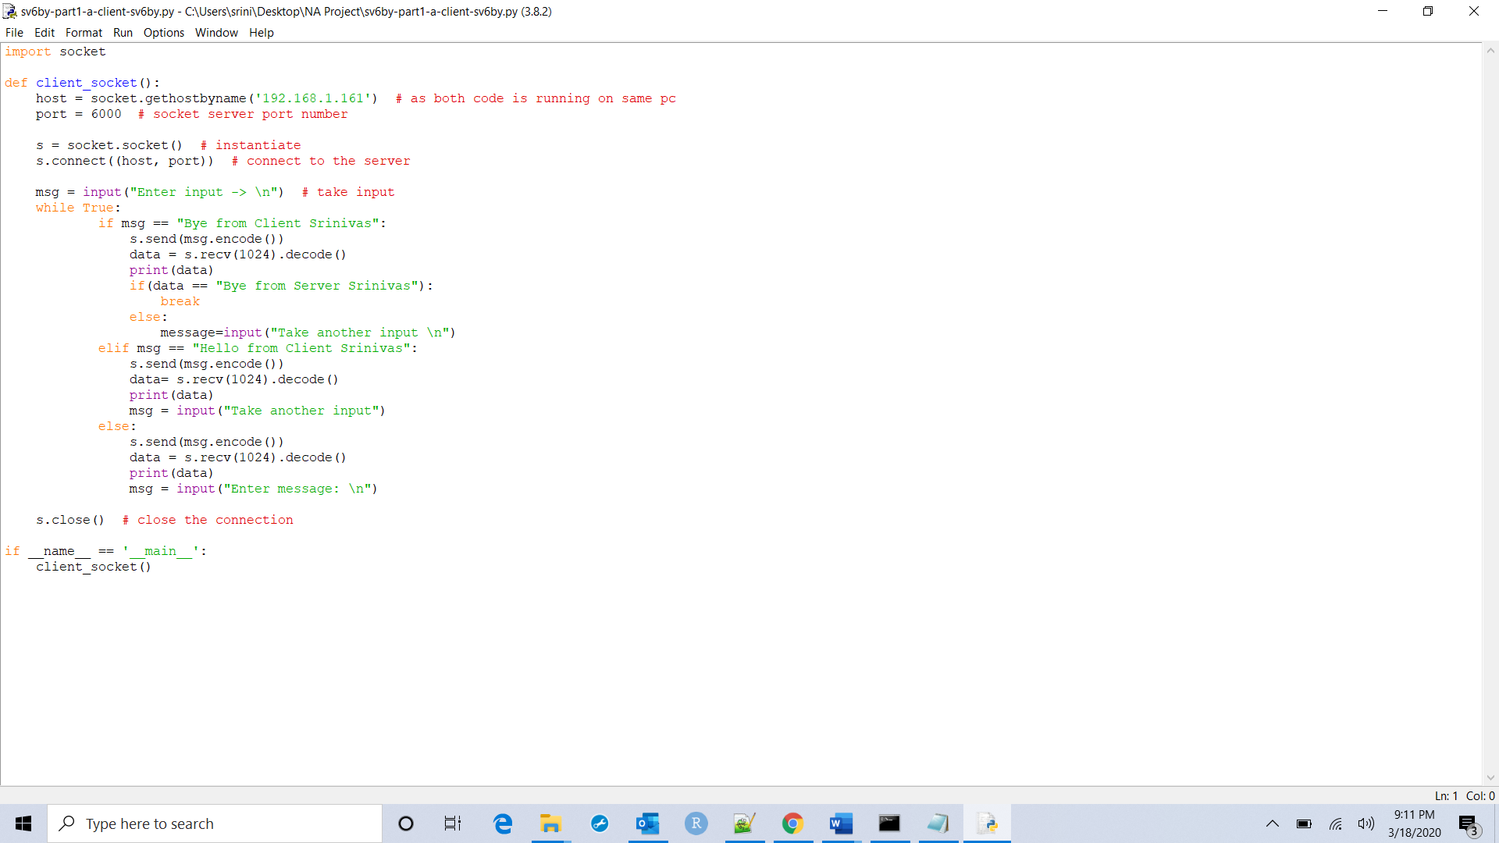

Server code to communicate with client using socket programming in python.

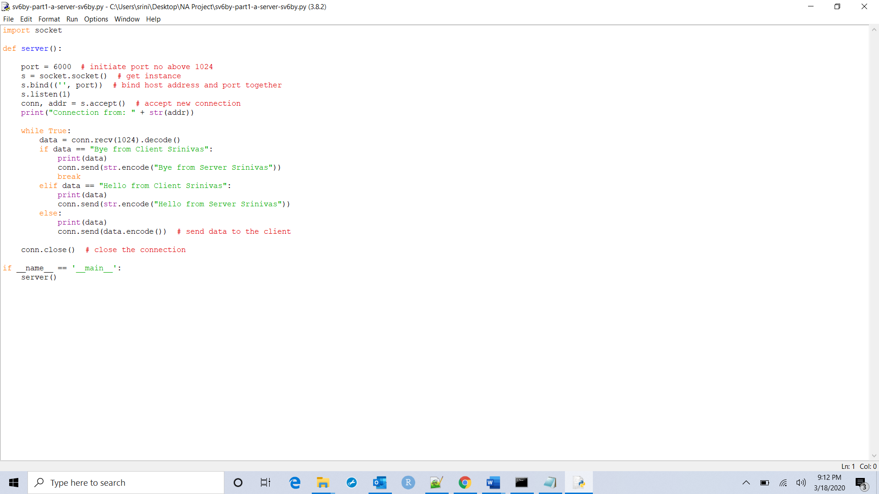

Output: Client side

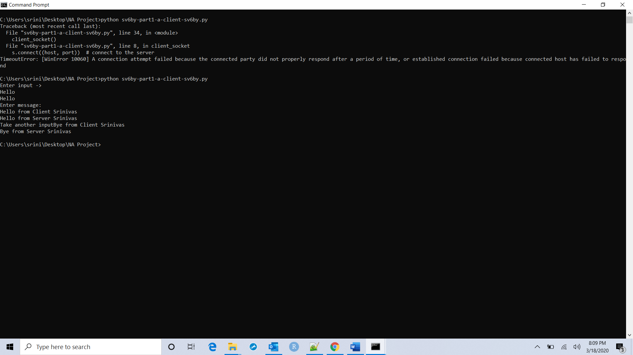

Server side

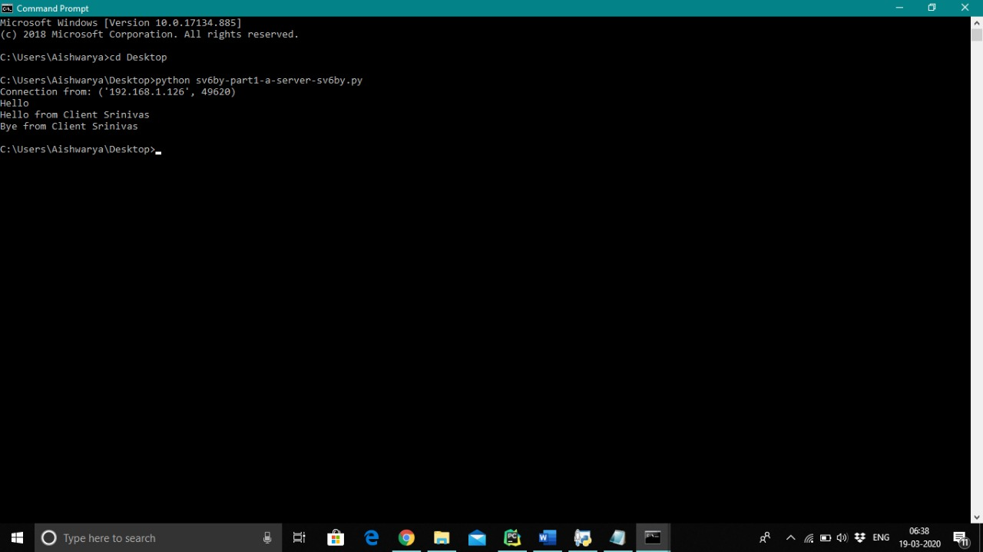

(b)Client Side : Code to transfer large file from client to server and back from server to client.

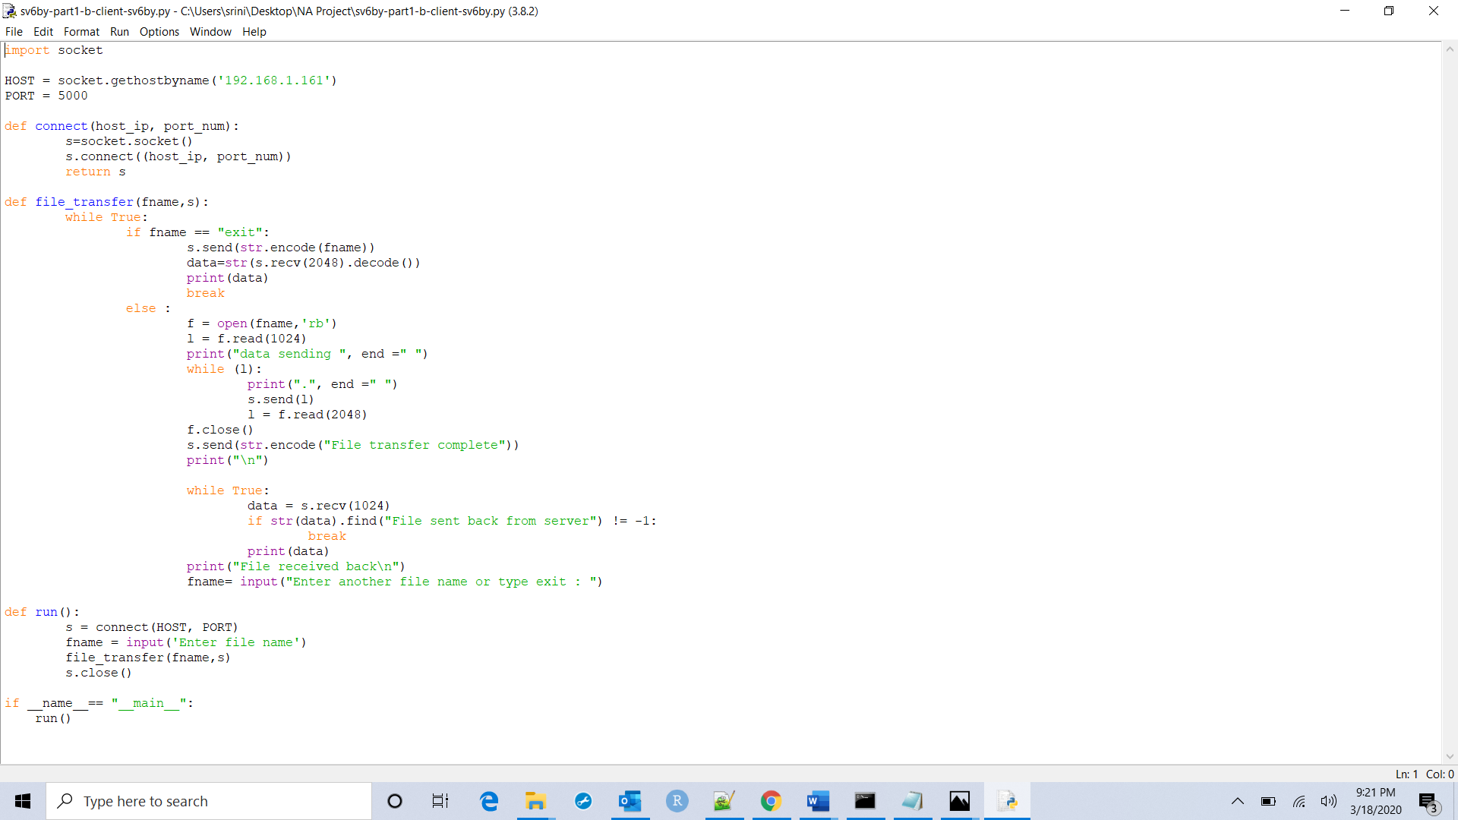

Server side : code

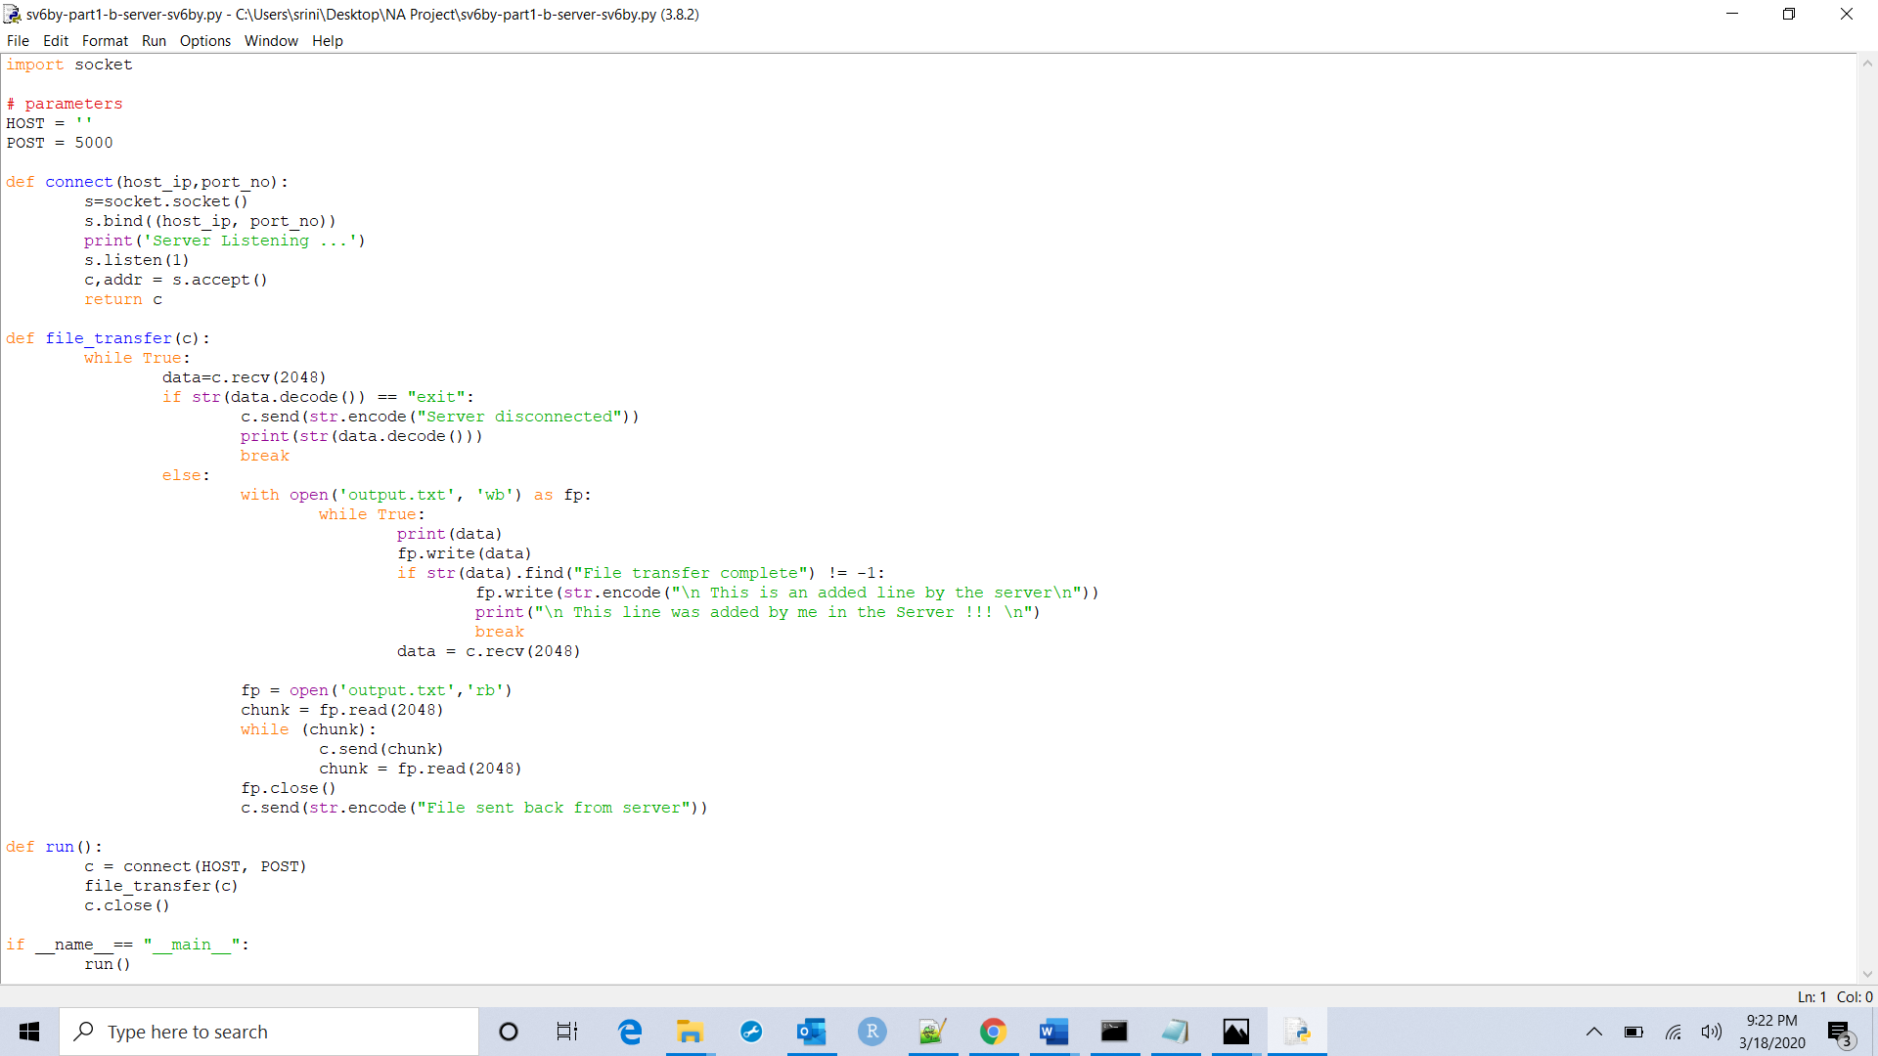

Output :Client side

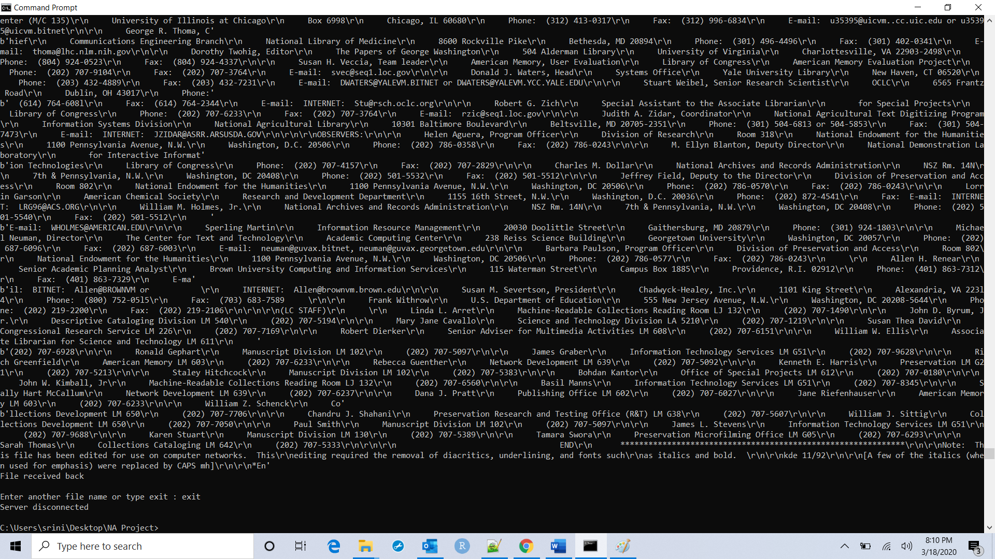

Server side

