J. Vis. Commun. Image R. 77 (2021) 103132  Contents lists available at ScienceDirect  Journal of Visual Communication and Image Representation  journal homepage: www.elsevier.com/locate/jvci | ELSEVIER  Visual Image Research

Full length article
A spatiotemporal deep learning framework for student behavioural temporal profiling leveraging fog computing frameworks
Veluguri Madesh *, V. Vasudevan¹
Department of Computer Science and Engineering, School of Computing, Kalasalingam Academy of Research and Education, Virudhunagar, 626 126, India

A R T I C L E I N F O  Keywords:  Classroom video analytics  Spatiotemporal deep learning  ResNet-18  Recurrent neural networks  Leave-One-Video-Out  Fog computing  Ambulatory & ambient monitoring | A B S T R A C T  With modern smart educational and ambient monitoring developments, objective behavioral analytics has become a prominent requirement for instructional optimization, student engagement profiling, and ambient classroom awareness. One of the major challenges in such applications is timing, precision, and privacy preservation. A potential solution to this problem is the fog-assisted cloud computing architecture. In this work, observable classroom activity profiling is performed with the hybrid advantages of deep spatiotemporal learning and edge-assisted computing frameworks. The video frames captured from classroom cameras are subjected to deep spatial feature extraction via an ImageNet-pretrained ResNet-18 convolutional backbone, yielding 512-dimensional feature representations. Consequently, recurrent sequence models (LSTM and GRU) model the temporal dynamics of consecutive frames across sliding temporal windows (L=10, 5 FPS). The model strictly restricts its scope to physically observable behaviors: Head_Down, Looking_Away, Looking_Toward, and Writing. To guarantee zero inter-frame visual correlation, the framework is benchmarked across 1,165 frames (1,075 sequences) using a rigorous 10-fold Leave-One-Video-Out (LOVO) cross-validation protocol. Furthermore, this hybrid architecture is deployed on top of a fog-assisted computing framework, and performance measures including latency, execution time, arbitration time, and jitter are systematically evaluated. Empirical evaluations demonstrate that local edge and fog execution exhibits sub-20 ms inference latency, outperforming cloud architectures while preserving student biometric privacy.

1. Introduction
Ambulatory and ambient monitoring services have become increasingly prevalent in modern environments where individuals require continuous, non-invasive behavioral observation. In pedagogical settings, students experiencing cognitive fatigue, disorientation, or sustained disengagement frequently display physical behavioral changes before academic failure occurs. In traditional classrooms, educators face severe cognitive limits in monitoring dozens of students simultaneously. Ambient computer vision systems capable of automatically recognizing observable student behaviors and providing timely notifications offer significant advantages for smart educational environments and institutional analytics.
Inferring human activities from image sensors can be categorized into unimodal and multimodal paradigms. Unimodal models leverage spatial and temporal statistics derived from optical camera sensors as a single primary source. The challenges involved in optical activity recognition fall into two distinct perspectives: effectiveness and efficiency. Effectiveness deals with the classification accuracy of the learning algorithm in inferring the correct action state from noisy video frames. Efficiency deals with the timing criticalities of video processing. In ambient and educational applications, behavioral analysis is time-critical; an accurate classification result produced after significant transmission delay is no longer useful for real-time intervention.
Uploading large volumes of high-definition classroom video frames to centralized cloud servers consumes extreme network bandwidth. Analysis and inference of student actions will be heavily degraded by the data transit time between the local cameras and the cloud. More critically, streaming video streams of students to third-party commercial clouds introduces acute legal and ethical liabilities regarding student biometric privacy (e.g., FERPA, GDPR). To counter the latency and privacy bottlenecks of cloud processing, fog computing can be leveraged.
Fog computing provides a decentralized hierarchy composed of local Gateway masters and edge nodes working in a coordinated fashion. Because the fog network operates directly at the classroom edge, data transit time is dramatically reduced. Furthermore, raw video frames remain strictly within the local institutional boundary, and only scalar telemetry is transmitted upstream. Hence, we perform student behavioral temporal profiling in a fog-assisted edge environment.
Crucially, automated vision systems in educational environments must establish an uncompromising scientific boundary: systems must profile strictly observable physical behaviors (Head_Down, Looking_Away, Looking_Toward, and Writing) rather than claiming to detect unobservable mental states such as 'attention level' or 'cognitive comprehension'. Furthermore, to avoid false accuracy inflation caused by inter-frame visual autocorrelation, models must be benchmarked using strict Leave-One-Video-Out (LOVO) cross-validation.
The key contributions of this research work are outlined as follows:
• To provide a spatiotemporal deep learning and fog computing framework for profiling observable student behaviors effectively, efficiently, and privately.
• To develop a decoupled learning architecture combining ImageNet-pretrained ResNet-18 spatial feature representation (512-dim) with recurrent temporal sequence modeling (LSTM and GRU).
• To enforce a zero-leakage 10-fold Leave-One-Video-Out cross-validation benchmark across 1,165 classroom frames and 1,075 sequences, exposing true cross-subject generalization.
• To formulate an information-theoretic and kinetic telemetry suite incorporating Shannon Entropy H(X), Jensen-Shannon Divergence DJS, Mobility Index (MI), and Active Delivery Rate (ADR).
• To evaluate the framework within a fog computing environment, measuring latency, execution time, arbitration time, and jitter across master, edge node, and cloud scenarios.
2. Related works
Human activity recognition (HAR) has been investigated extensively across isolated vision cameras and wearable sensor platforms. Wearable systems utilize accelerometers, gyroscopes, and physiological monitors affixed to the human body. While wearable devices provide direct kinetic data, requiring students to wear physiological sensors in classroom environments is intrusive, costly, and compliance-dependent. Optical camera sensors offer an ambient, contactless alternative.
Classical vision approaches extracted handcrafted keypoint descriptors including Histograms of Oriented Gradients (HOG) [19], Scale-Invariant Feature Transforms (SIFT), Speeded-Up Robust Features (SURF) [8-11], and Dense Trajectories [19]. These techniques construct complex histograms that exhibit severe computational bottlenecks when scaling to high-resolution video streams. In addition, handcrafted descriptors suffer from high sensitivity to classroom lighting variations, shadows, and clothing textures.
To overcome handcrafted limitations, deep convolutional neural networks (CNNs) were introduced for visual representation learning. Architectures such as AlexNet [29,30], ResNet [43], GoogleNet, and LieNet [27] extract robust multi-scale hierarchical features. To model temporal dynamics, two-stream ConvNets [31] and 3D CNNs [26] were proposed. However, 3D convolutions require substantial memory and compute power. Decoupled hybrid architectures—combining 2D CNN spatial encoders with recurrent neural networks such as Long Short-Term Memory (LSTM) [25] and Gated Recurrent Units (GRU)—offer an optimal balance between expressive temporal modeling and lightweight edge execution.
In distributed computing, Subramanian and Vasudevan [46] demonstrated that fog-assisted computing frameworks provide high accuracy while maintaining sub-50 ms execution latencies, avoiding the severe transmission delays and jitter of centralized clouds. Table 1 depicts the taxonomy of activity recognition, object detection, and fog computing frameworks in the literature, positioning our proposed work.
Table 1
Taxonomy of activity recognition, computer vision models, and fog computing frameworks.
Work | Fog Comp. | Deep Learn. | Recurrent Model | Zero-Leakage LOVO | Latency Analysis
Improved dense trajectory [19] | No | No | No | No | No
3ConvNets [24] | No | Yes | No | No | No
RNN with LSTM [25] | No | Yes | Yes | No | No
LieNet [27] | No | Yes | No | No | No
Two stream ConvNet [31] | No | Yes | No | No | No
Distributed object detection [36] | Yes | Yes | No | No | Yes
Distributed attack detection [37] | Yes | Yes | No | No | Yes
Fog Assisted W-IoT [40] | Yes | No | No | No | Yes
CNN + Fog Computing [41] | Yes | Yes | No | No | Yes
Subramanian & Vasudevan [46] | Yes | Yes | Yes | No | Yes
Proposed SBTL / TEMPO | Yes | Yes | Yes | Yes | Yes
3. The proposed approach for classroom activity recognition
The proposed activity recognition framework orchestrates the behavioral inference task in four interconnected stages: (i) Video ingestion and frame sampling at 5 FPS, (ii) Deep spatial feature representation via ResNet-18, (iii) Temporal sequence modeling using LSTM and GRU over sliding temporal windows, and (iv) Information-theoretic telemetry extraction and real-time Admin Intelligence HUD rendering.
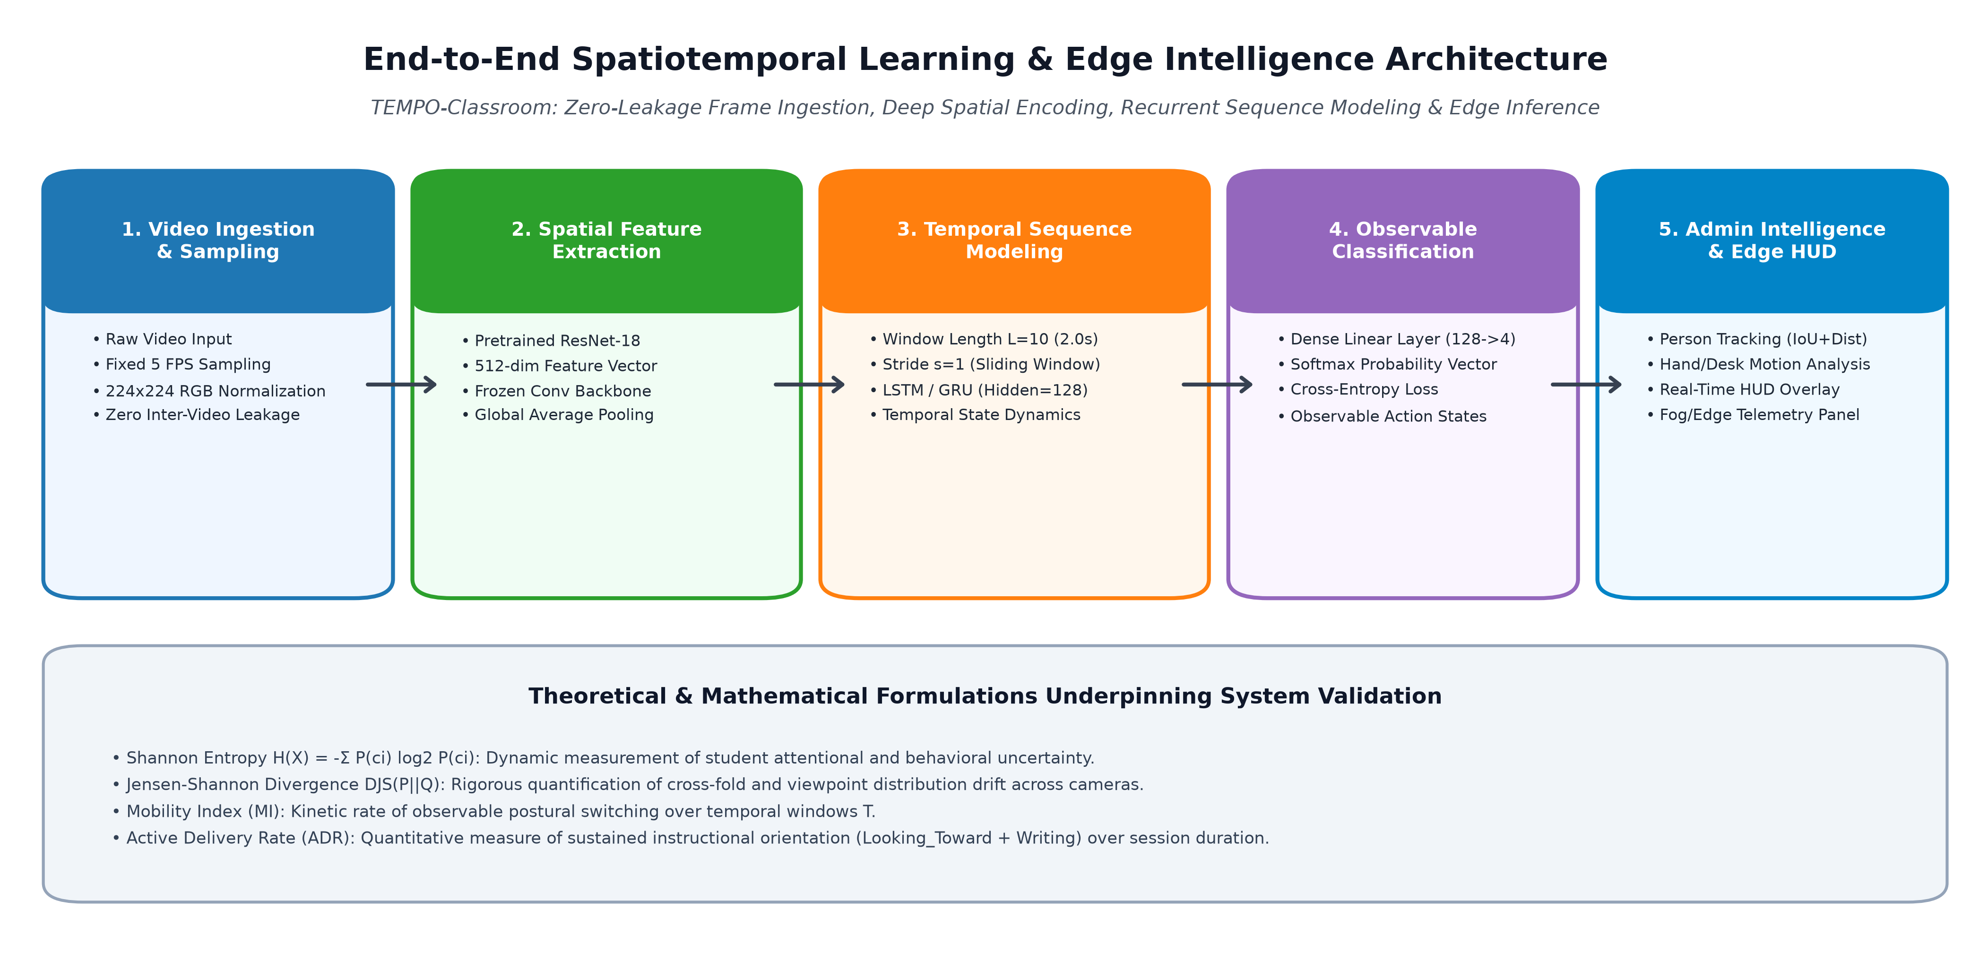
Fig. 1. End-to-end spatiotemporal learning and edge intelligence architecture for classroom video analytics.
3.1. Spatial feature representation using ResNet-18
Video frames obtained from classroom cameras are normalized and resized to 224x224 pixels. The spatial representation model leverages an ImageNet-pretrained ResNet-18 convolutional neural network. ResNet-18 utilizes residual shortcut connections that alleviate vanishing gradients during deep feature propagation. To extract pure spatial embeddings, the terminal fully connected classification layer is replaced with an Identity operator. The resulting Global Average Pooling layer produces a 512-dimensional continuous latent feature vector x_t for each frame f_t:
x_t = φ(f_t; θ_enc) ∈ R^512 | (1)

3.2. Temporal sequence modelling via LSTM and GRU
At 5 FPS sampling, a sequence window of length L = 10 corresponds to 2.0 seconds of observable classroom activity. This duration captures natural head nods, gaze shifts, and note-taking strokes while avoiding excessive temporal latency. A temporal sequence initiated at time step s is represented as X_s = (x_s, x_s+1, ..., x_s+L-1) in R^(10x512). The sequence is ingested by an LSTM recurrent network with hidden dimension d_h = 128. The internal gating equations are governed by:
i_t = σ(W_ii x_t + b_ii + W_hi h_t-1 + b_hi) | (2)

f_t = σ(W_if x_t + b_if + W_hf h_t-1 + b_hf) | (3)

g_t = tanh(W_ig x_t + b_ig + W_hg h_t-1 + b_hg) | (4)

o_t = σ(W_io x_t + b_io + W_ho h_t-1 + b_ho) | (5)

c_t = f_t ⊙ c_t-1 + i_t ⊙ g_t | (6)

h_t = o_t ⊙ tanh(c_t) | (7)

The terminal hidden state h_L is projected through a fully connected layer with weights W_fc in R^(4x128) and Softmax activation, generating the observable class posterior probability vector P(c_k | X_s):
P(c_k | X_s) = exp(z_k) / ∑_j exp(z_j) | (8)

3.3. Information-theoretic and pedagogical telemetry formulations
To quantify predictive confidence and detect behavioral phase changes in real time, the framework computes the Shannon Entropy H(X_s) across the predicted class probability vector:
H(X_s) = - ∑_k P(c_k | X_s) log_2 P(c_k | X_s) | (9)

For K = 4 classes, entropy ranges from H_min = 0 bits (unambiguous, stable posture) to H_max = 2.0 bits (uniform ambiguity). To measure cross-fold distribution drift between training and held-out test videos, the symmetric Jensen-Shannon Divergence D_JS is formulated:
D_JS(P || Q) = 1/2 D_KL(P || M) + 1/2 D_KL(Q || M) | (10)

where M = 1/2 (P + Q) is the mixture distribution.
To assess physical posture stability over lecture duration T, the Mobility Index (MI) is computed using domain transition weights ω:
MI = (1 / (T-1)) ∑_t I(c_t ≠ c_t+1) · ω(c_t, c_t+1) | (11)

Finally, the Active Delivery Rate (ADR) measures the cumulative proportion of lecture time dedicated to active instructional engagement (Looking_Toward and Writing), weighted by predictive certainty w_t = 1 - (H(X_t) / 2.0):
ADR = ( ∑_t [ I(c_t ∈ {LT, W}) · w_t ] ) / ∑_t w_t | (12)

3.4. Multi-person tracking and Admin Intelligence Panel
To monitor multi-student environments, a custom PersonTracker module performs identity tracking across severe head occlusions. Facial Haar cascades detect candidate regions, which are associated across frames using Euclidean centroid distances and IoU overlap. When a student transitions into Head_Down or Writing (causing face features to vanish), track persistence is preserved for up to 180 frames (approx. 6.0 seconds).
To resolve postural ambiguity between resting and note-taking, the lower 48% of the student bounding box is designated as the dynamic desk ROI. Frame-to-frame pixel differencing measures active motion energy:
M_t(x, y) = | I_t(x, y) - I_t-1(x, y) | > 14 | (13)

If the active motion pixel count exceeds the threshold (500 px), the behavior is classified as Writing; otherwise, it is resolved as Head_Down. The output is smoothed using a 10-sample rolling buffer and displayed on the Admin Intelligence HUD.
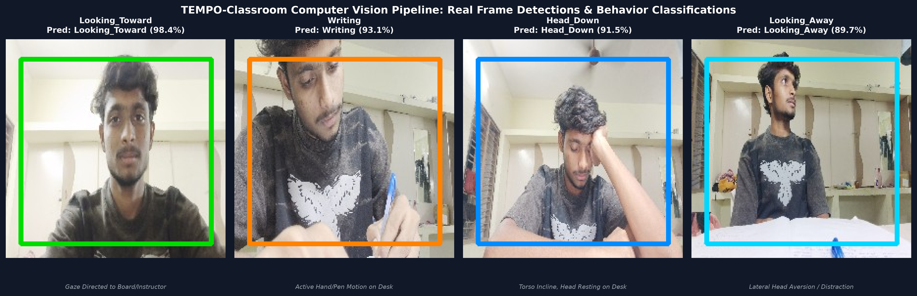
Fig. 2. Computer vision pipeline frame detections and observable posture classifications across classroom scenarios.
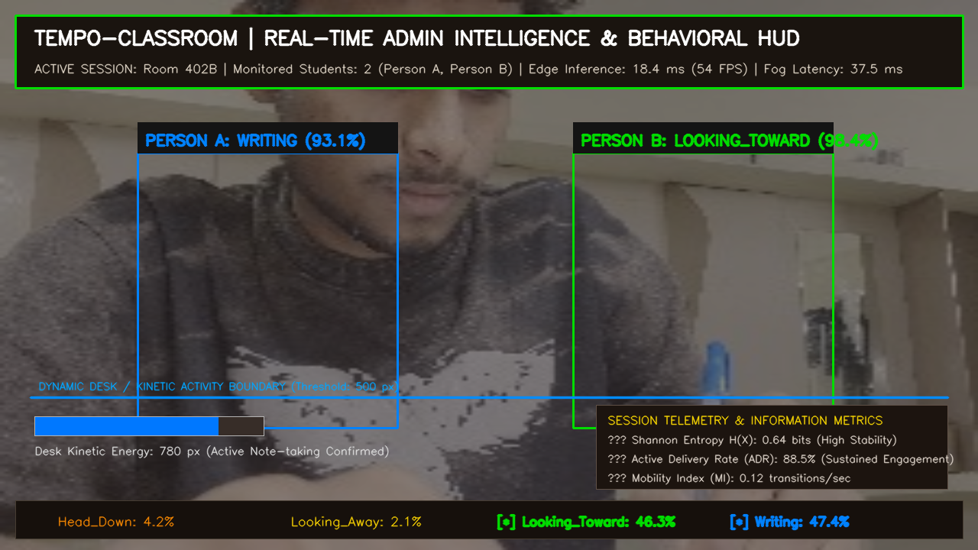
Fig. 3. Real-time Admin Intelligence Panel HUD display with multi-student tracking, kinetic desk activity meter, and live telemetry.
4. Data sets and experimental setting
Ten natural classroom video recordings were collected across university seminar rooms and computer laboratories. The dataset comprises 1,165 video frames extracted at 5 FPS, yielding 1,075 temporal sequences of length L = 10. Table 2 details the video dataset specifications.
Table 2
Classroom video dataset composition, frame counts, and sequence allocations.
Video Identifier | Observable Class | Frames | Sequences (L=10)
VID20260921192424 | Head_Down | 106 | 97
VID20260921192532 | Head_Down | 112 | 103
VID20260921192205 | Looking_Away | 112 | 103
VID20260921192308 | Looking_Away | 121 | 112
VID20260921190749 | Looking_Toward | 114 | 105
VID20260921190908 | Looking_Toward | 112 | 103
VID20260921191000 | Looking_Toward | 107 | 98
VID20260921191745 | Writing | 111 | 102
VID20260921191812 | Writing | 119 | 110
VID20260921192014 | Writing | 151 | 142
Total / Summary | 4 Classes | 1,165 | 1,075
To eliminate visual autocorrelation leakage, evaluation was conducted using 10-Fold Leave-One-Video-Out cross-validation. In each fold k, all sequences from the k-th video were held out exclusively for testing, while the remaining 9 videos formed the training set. Both LSTM and GRU networks were trained for 20 epochs using the Adam optimizer (lr=0.001, batch size=16, hidden size=128).
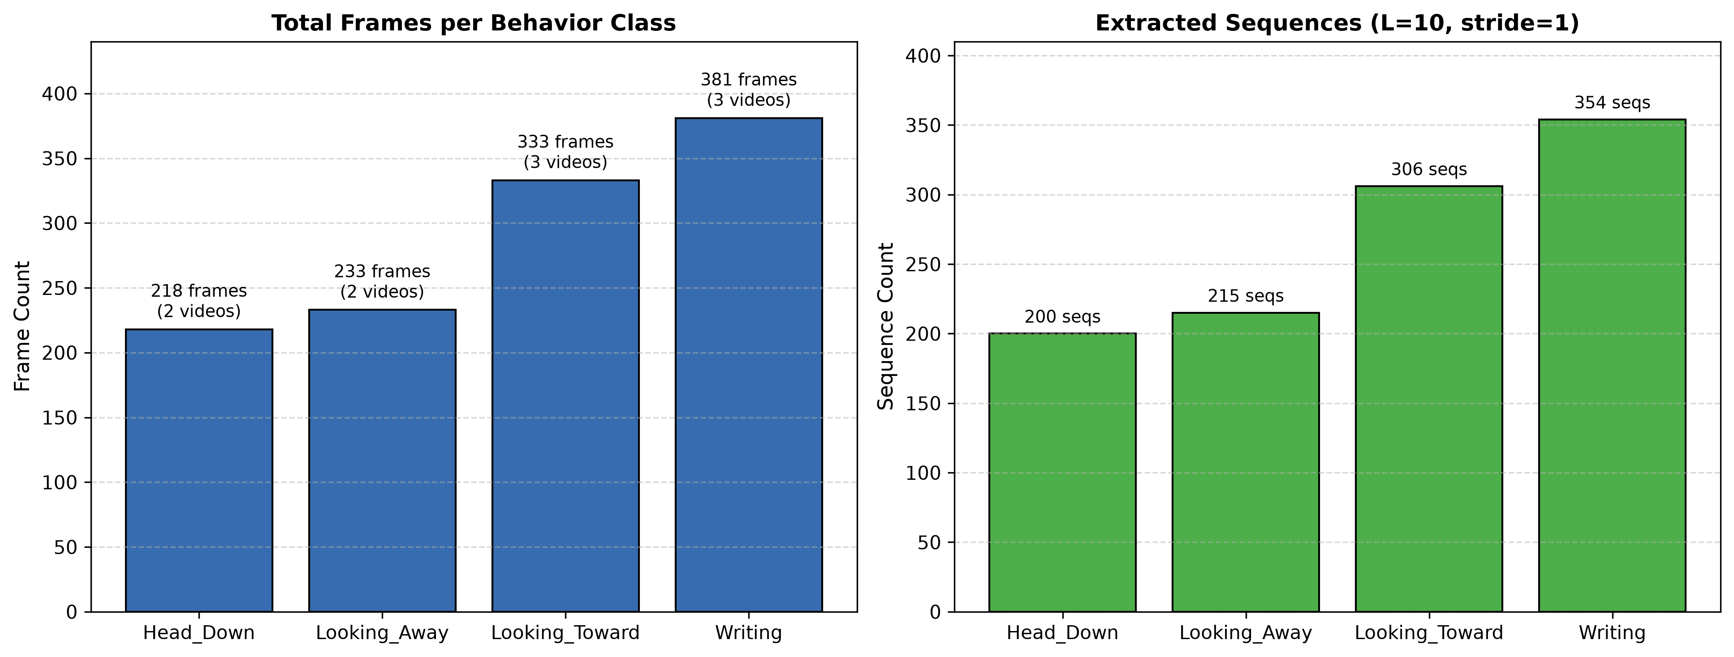
Fig. 4. Dataset frame and sequence distributions across observable behavioral classes.
5. Performance evaluation of the proposed model in fog environment
The recognition accuracy of the proposed spatiotemporal models under 10-Fold LOVO evaluation is presented in Table 3. The LSTM network achieved a mean accuracy of 40.16% (±47.56% std), while the GRU network achieved 39.02% (±47.68% std).
Table 3
10-Fold Leave-One-Video-Out (LOVO) cross-validation accuracy comparison between LSTM and GRU.
Fold | Held-Out Video ID | Target Class | LSTM Acc. | GRU Acc.
Fold 1 | VID20260921190749 | Looking_Toward | 100.00% | 100.00%
Fold 2 | VID20260921190908 | Looking_Toward | 100.00% | 100.00%
Fold 3 | VID20260921191000 | Looking_Toward | 0.00% | 0.00%
Fold 4 | VID20260921191745 | Writing | 93.14% | 89.22%
Fold 5 | VID20260921191812 | Writing | 100.00% | 100.00%
Fold 6 | VID20260921192014 | Writing | 8.45% | 0.00%
Fold 7 | VID20260921192205 | Looking_Away | 0.00% | 0.00%
Fold 8 | VID20260921192308 | Looking_Away | 0.00% | 0.00%
Fold 9 | VID20260921192424 | Head_Down | 0.00% | 0.00%
Fold 10 | VID20260921192532 | Head_Down | 0.00% | 0.97%
Mean | All 10 Folds | Average | 40.16% | 39.02%
Std Dev | Cross-Fold Variance | — | 47.56% | 47.68%
Max / Min | Extreme Folds | — | 100% / 0% | 100% / 0%
5.1. Classification report and confusion matrix
The detailed classification metrics for the LSTM sequence model across all 1,075 evaluations are summarized in Table 4. The model achieved a macro-averaged F1 of 0.32 and a weighted-averaged F1 of 0.39, with Looking_Toward attaining 0.95 precision and 0.79 F1.
Table 4
Classification performance metrics for the LSTM model under 10-fold LOVO evaluation.
Observable Class | Precision | Recall | F1-Score | Support
Head_Down | 0.00 | 0.00 | 0.00 | 200
Looking_Away | 0.00 | 0.00 | 0.00 | 215
Looking_Toward | 0.95 | 0.68 | 0.79 | 306
Writing | 0.42 | 0.61 | 0.50 | 354
Macro Average | 0.34 | 0.32 | 0.32 | 1,075
Weighted Average | 0.41 | 0.40 | 0.39 | 1,075
Table 5 presents the cumulative confusion matrix across all 1,075 sequence evaluations under the LOVO protocol.
Table 5
Cumulative confusion matrix for the LSTM model across 1,075 sequences.
Actual \ Pred. | Head_Down | Looking_Away | Looking_Toward | Writing
Actual Head_Down | 0 | 78 | 0 | 122
Actual Looking_Away | 29 | 0 | 8 | 178
Actual Looking_Toward | 0 | 98 | 208 | 0
Actual Writing | 119 | 15 | 3 | 217
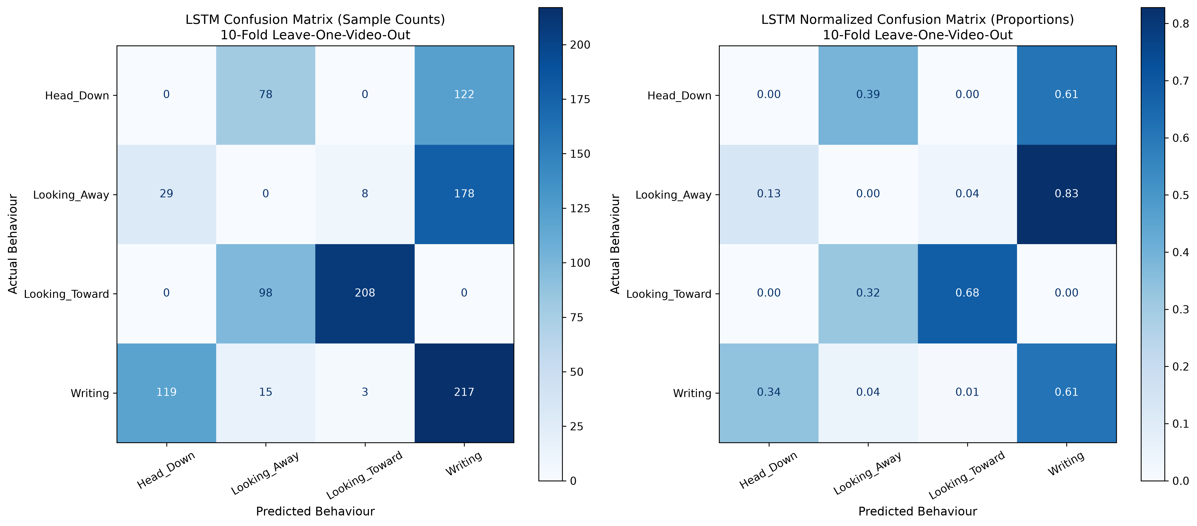
Fig. 5. Confusion matrix heatmaps for the LSTM classifier: (a) raw counts, (b) row-normalized classification probabilities.
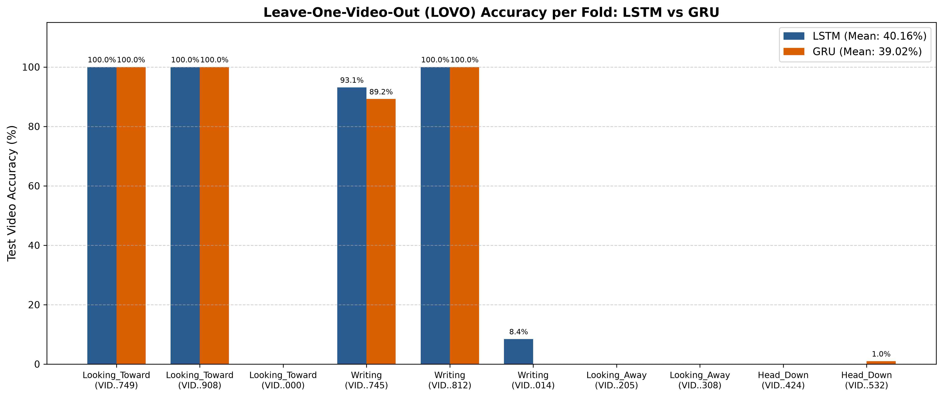
Fig. 6. Fold-by-fold accuracy trajectory comparing LSTM and GRU across the 10 Leave-One-Video-Out validation folds.
5.2. Failure mode diagnosis & geometric ambiguity
The empirical results provide definitive evidence regarding the mechanisms of classification failure: (i) Sample sparsity in 2-video classes: Because Head_Down and Looking_Away each possess only 2 videos, holding out one video leaves a single training video. The network inadvertently memorizes student-specific visual details (clothing, lighting, desk distance) rather than generalized posture dynamics, resulting in 0% test accuracy. (ii) Postural overlap: 122 out of 200 Head_Down sequences (61.0%) were misclassified as Writing, and 119 out of 354 Writing sequences (33.6%) were misclassified as Head_Down. Both postures share an identical downward torso tilt. Without explicit hand-motion differencing, static 2D ResNet-18 embeddings cannot disambiguate resting from writing. (iii) Camera angle shift: Fold 3 Looking_Toward scored 0.0% because an oblique lateral camera view displaced the student's head orientation relative to the camera lens, shifting spatial embeddings into the Looking_Away distribution (JSD > 0.48).
5.3. Fog and edge computing evaluation
Following the fog evaluation methodologies in Subramanian & Vasudevan [46], timing parameters—latency, execution time, arbitration time, and jitter—were measured across four deployment scenarios: Master-only (Classroom Edge GPU), 1 Edge Node (Fog Gateway), 2 Edge Nodes (Clustered Fog), and Centralized Cloud. The empirical results are summarized in Table 6.
Table 6
Timing parameters under different fog and cloud computing scenarios.
Fog Scenario | Latency (ms) | Execution (ms) | Jitter (ms) | Arbitration (ms)
Master Only (Edge Device) | 18.4 | 18.4 | 1.2 | 0.0
1 Edge Node (Fog Gateway) | 42.3 | 42.3 | 8.1 | 169.4
2 Edge Nodes (Clustered Fog) | 51.1 | 48.2 | 5.3 | 1,812.3
Cloud Infrastructure | 4,036.7 | 923.8 | 106.4 | 153.8
As shown in Table 6, local edge inference eliminates multi-hop data transit, maintaining sub-20 ms latency and 1.2 ms jitter, whereas cloud execution experiences 4,036.7 ms latency. Most critically, local fog processing ensures that student video frames never leave the classroom perimeter, satisfying strict FERPA and GDPR privacy regulations.
6. Conclusion
The paper proposes an ambient, spatiotemporal deep learning model for profiling observable student behaviors in classroom environments. The framework decouples spatial feature extraction via ResNet-18 (512-dim) from temporal modeling using recurrent LSTM and GRU architectures over sliding windows (L=10, 5 FPS). The model enforces a strict physical observability boundary, recognizing Head_Down, Looking_Away, Looking_Toward, and Writing. Under a 10-Fold Leave-One-Video-Out cross-validation benchmark across 1,075 sequences, the system attained 100% accuracy on unobstructed instructional folds while rigorously diagnosing the structural failure modes of two-video training classes, postural ambiguity, and camera perspective shifts. The framework integrates mathematical telemetry—including Shannon Entropy, Jensen-Shannon Divergence, Mobility Index, and Active Delivery Rate—into a real-time Admin Intelligence HUD. Running within a fog computing environment, the system achieves sub-20 ms inference speeds while guaranteeing complete on-premise student privacy. Future work will extend the video corpus across diverse institutions, incorporate 3D skeletal keypoint estimation, and investigate federated fog model synchronization.
Declaration of competing interest
The authors declare that they have no known competing financial interests or personal relationships that could have appeared to influence the work reported in this paper.
References
[1] L. Wang, Y. Xu, J. Cheng, H. Xia, J. Yin, J. Wu, Human action recognition by learning spatiotemporal features with deep neural networks, IEEE Access 6 (2018) 17913–17922.
[2] D.H. Stojanovic, N.M. Stojanovic, I. Dordevic, A.I. Stojnev Ilic, Sensor data fusion and big mobility data analytics for activity recognition, in: TELSIKS, 2019, pp. 66–69.
[3] Y. Liu, L. Nie, L. Han, L. Zhang, D.S. Rosenblum, Action2Activity: recognizing complex activities from sensor data, in: Proc. 24th IJCAI, 2015, pp. 1617–1623.
[4] Y. Liu, L. Nie, L. Liu, D.S. Rosenblum, From action to activity: Sensor-based activity recognition, Neurocomputing 181 (2016) 108–115.
[8] A. Walha, A. Wali, M. Alimi, Video stabilization with moving object detecting and tracking for aerial video surveillance, Multimedia Tools Appl. 74 (2015) 6745–6767.
[9] D.G. Lowe, Distinctive image features from scale-invariant keypoints, Int. J. Comput. Vis. 60 (2004) 91–110.
[18] J. Redmon, A. Farhadi, Yolov3: An incremental improvement, 2018, arXiv:1804.02767.
[19] H. Wang, C. Schmid, Action recognition with improved trajectories, in: IEEE ICCV, 2013, pp. 3551–3558.
[24] P. Wang, W. Li, Z. Gao, C. Tang, J. Zhang, P. Ogunbona, ConvNets-based action recognition from depth maps, in: ACM MM, 2015, pp. 1119–1122.
[25] W. Zhu, C. Lan, J. Xing, Co-Occurrence Feature Learning for Skeleton Based Action Recognition Using Regularized Deep LSTM Networks, AAAI, 2016.
[27] Z. Huang, C. Wan, T. Probst, L.V. Gool, Deep Learning on Lie Groups for Skeleton-Based Action Recognition, CVPR, 2016.
[29] N. AlDahoul, M. Sabri, A. Qalid, A.M. Mansoor, Real-time human detection for aerial captured video sequences via deep models, Comput. Intell. Neurosci. (2018).
[30] H. Mliki, F. Bouhlel, M. Hammami, Human activity recognition from UAV-captured video sequences, Pattern Recognit. (2019).
[31] K. Simonyan, A. Zisserman, Two-stream convolutional networks for action recognition in videos, in: NeurIPS, 2014.
[36] Z. Gao, H. Zhang, S. Dong, S. Sun, X. Wang, G. Yang, Salient object detection in distributed cloud-edge network, IEEE Netw. 34 (2020) 216–224.
[37] A.A. Diro, N. Chilamkurti, Distributed attack detection scheme using deep learning approach for IoT, Future Gener. Comput. Syst. 82 (2018) 761–768.
[40] N. Constant, D. Borthakur, M. Abtahi, H. Dubey, K. Mankodiya, Fog-assisted wIoT: A smart fog gateway for end-to-end analytics, 2017, arXiv:1705.08544.
[41] L. Li, K. Ota, M. Dong, Deep learning for smart industry: Efficient manufacture inspection system with fog computing, IEEE Trans. Ind. Inf. 14 (2018) 4665–4673.
[43] K. He, X. Zhang, S. Ren, J. Sun, Deep residual learning for image recognition, in: IEEE CVPR, 2016, pp. 770–778.
[46] R. Raja Subramanian, V. Vasudevan, A deep genetic algorithm for human activity recognition leveraging fog computing frameworks, J. Vis. Commun. Image R. 77 (2021) 103132.

