GIT-GITHUB-Assignments

Task-1:
Git Practice Assignment (Local Repository & Version Rollback)
Please complete the following Git practice task to understand version control and rollback using local repository.
👉 Tasks to complete:
1️⃣ Create a folder named git-assignment and initialize Git repository
2️⃣ Create file notes.txt and add:
This is version 1
→ Commit it

3️⃣ Add new line in same file:
This is version 2
→ Commit it

4️⃣ Add new line again:
This is version 3
→ Commit it

5️⃣ Check commit history using:
git log --oneline

6️⃣ Rollback to Version 1 temporarily using checkout command and verify file content
For rolling back to particular commit we need to do with commit id (unique for each commit)
git checkout commitid
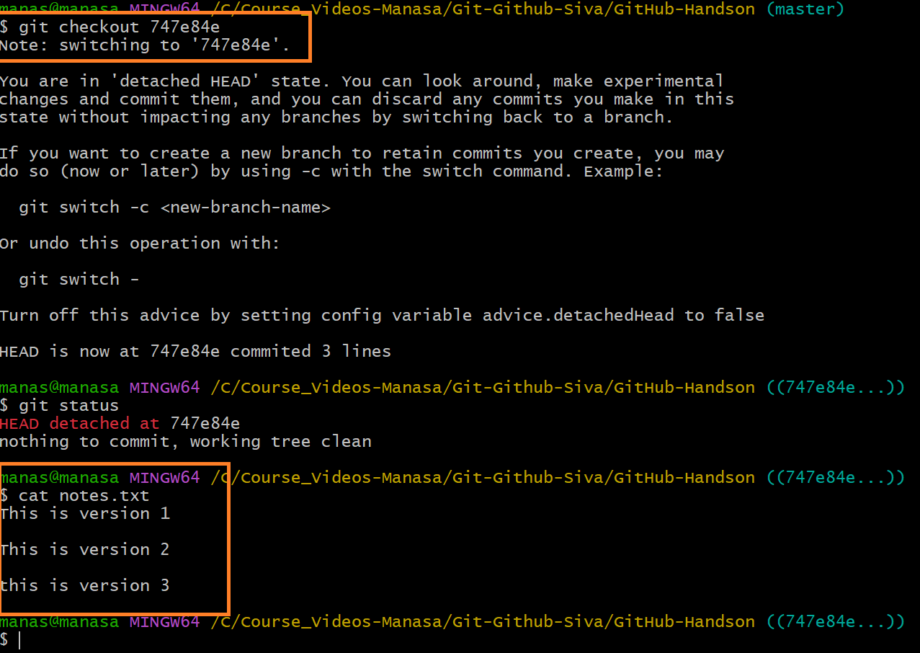
7️⃣ Switch back to main branch
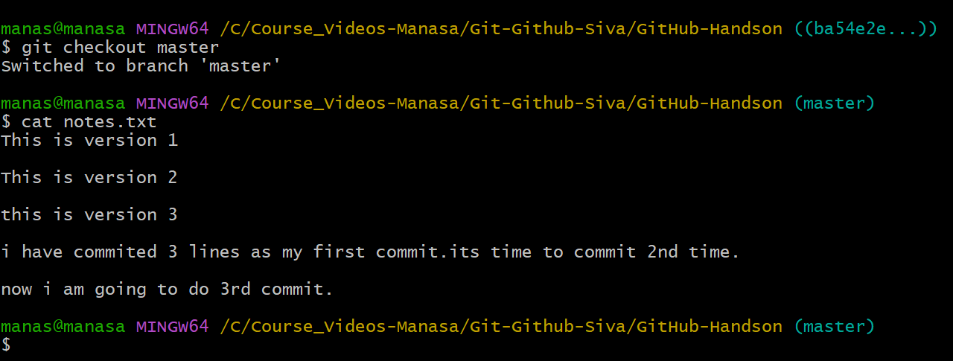

👉 Expected Output:
When you checkout Version 1, notes.txt should show only:
This is version 1

📸 Submit screenshots of:

Commit history
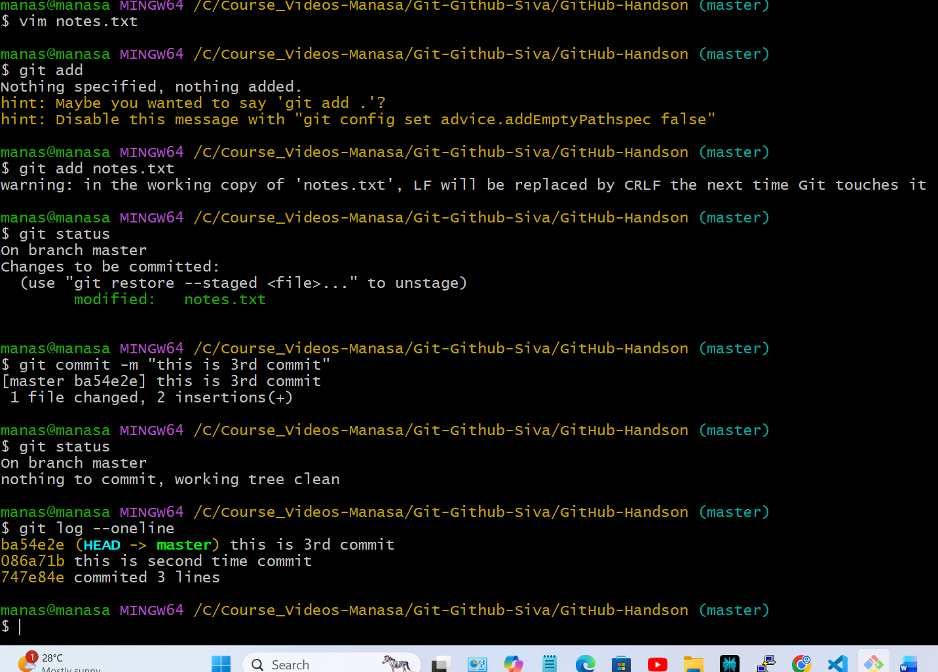

File content after rollback
Switching back to main branch

Refer the notes If you got blocked some where

Trying o push one folder to github getting this error.
https://github.com/siva9800/techenth-assignments.git
I don’t have access to make any changes for this main branch.
Task-2: Create one folder in siva9800/techenth-assignments in this repo and add Assignment details.
Send an PR to review and merge in the main Repo.
Fork the repo cloned the repo in my local created branch Added the folder and file inside it git add git commitgit push open CLI compare and pull requestadd comment click on pull request.
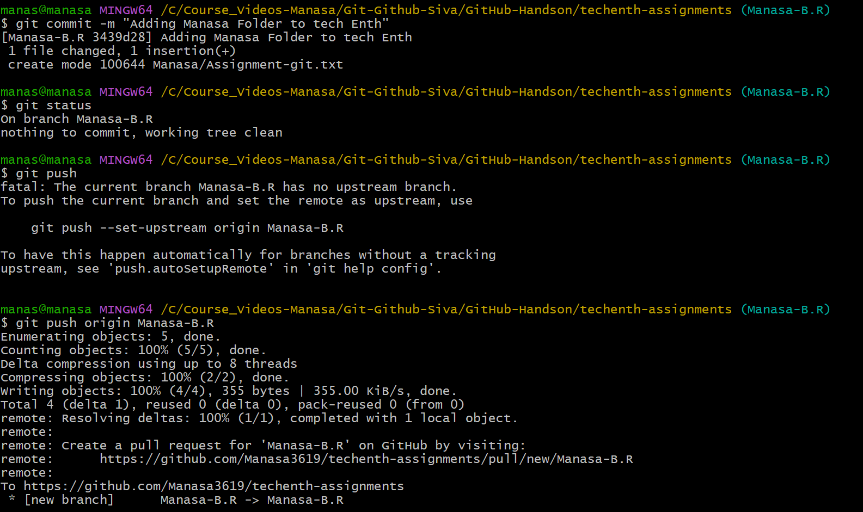
Adding Manasa Folder to techenth-Assignment by Manasa3619 · Pull Request #12 · siva9800/techenth-assignments

