PHASE 1
Brainstorming & Ideation
Script-Controlled ACL – Restrict Record Access Based on Field Value
Field | Details
Date | 30.9.2026
Team ID | 6ab4dcafa238dc999eb5d928
Project Name | Script-Controlled ACL – Restrict Record Access Based on Field Value
Platform | ServiceNow (Global scope)
Purpose
This phase defines the problem, objectives, proposed solution, project flow, and supporting implementation evidence for implementing a script-controlled Access Control List (ACL) in ServiceNow. The project restricts record access based on roles and the Branch field, while administrators retain full access.

PHASE 1 – Brainstorming & Ideation
Script-Controlled ACL – Restrict Record Access Based on Field Value

Project Name
Script-Controlled ACL – Restrict Record Access Based on Field Value

Purpose
This phase defines the problem, objectives, proposed solution, project flow, and supporting implementation evidence for implementing a script-controlled Access Control List (ACL) in ServiceNow. The project restricts record access based on roles and the Branch field, while administrators retain full access.

1. Problem Statement
In enterprise environments, sensitive institution and student records should not be available to every user. Without proper access control, unauthorized users may view, create, modify, or delete records. This project addresses the need for record-level security using ServiceNow ACLs, custom roles, and script-controlled conditions.

2. Objectives
- Create a test user and custom roles required for access control.
- Create the Institution Details table and required student fields.
- Create student records with different branch values such as ECE, EEE, and CSE.
- Configure a script-controlled READ ACL.
- Configure CREATE, WRITE, and DELETE ACLs using separate roles.
- Verify the permissions for authorized users, unauthorized users, and administrators.

PHASE 1 – Brainstorming & Ideation

3. Proposed Solution
The proposed solution uses ServiceNow Access Control Lists to enforce record-level security. A custom table named u_institution_details stores the records. The roles bb1, bb2, bb3, and bb4 are assigned for different access operations. The READ ACL uses script logic to allow administrators full access and control access for the required role. CREATE, WRITE, and DELETE ACLs provide additional operation-level security.

4. Project Flow
Users & Roles → Institution Details Table → Student Records → READ ACL → CREATE ACL → WRITE ACL → DELETE ACL → Verification

5. Access Control Plan
Operation | Role | Control | Expected Result
READ | bb1 | Script / branch-based control | Authorized records can be viewed
CREATE | bb2 | Role-based ACL | Authorized user can create
WRITE | bb3 | Role-based ACL | Authorized user can edit
DELETE | bb4 | Role-based ACL | Authorized user can delete
Admin | admin | Administrator access | Full access

6. Expected Outcome
By completing the project, learners demonstrate how script-controlled READ, WRITE, CREATE, and DELETE ACLs enforce record-level security and how user roles and record field values are used in access decisions.

7. Implementation Evidence
The following screenshots are arranged in workflow order and are taken from the supplied ACL project PDF.

IMPLEMENTATION SCREENSHOTS
Screenshot – Project scenario and user creation
Source: Script-Controlled ACL project PDF, page 1.
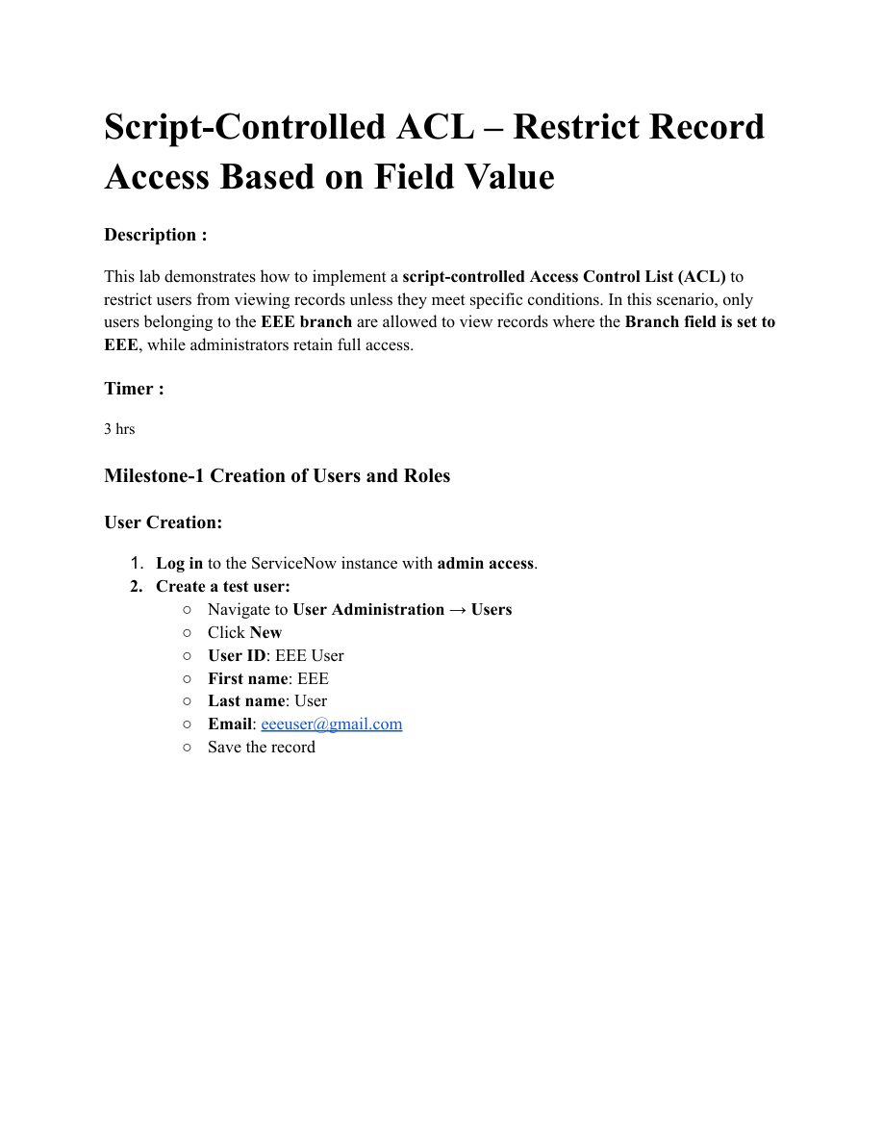

Screenshot – Role creation
Source: Script-Controlled ACL project PDF, page 2.
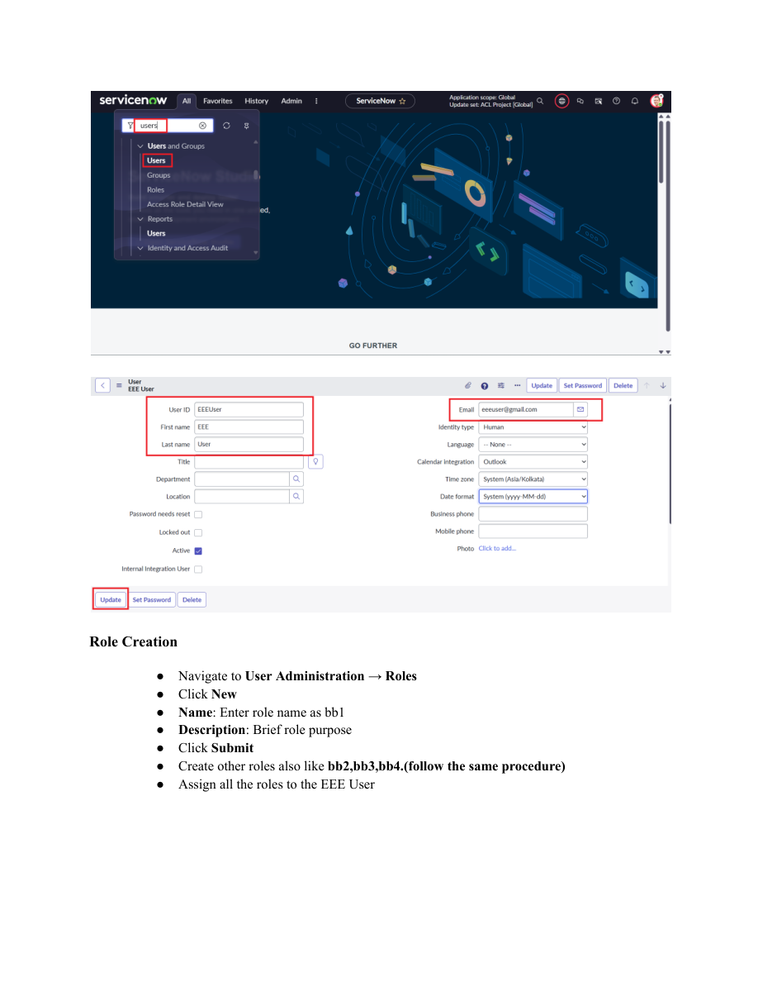

Screenshot – Institution Details table creation
Source: Script-Controlled ACL project PDF, page 3.
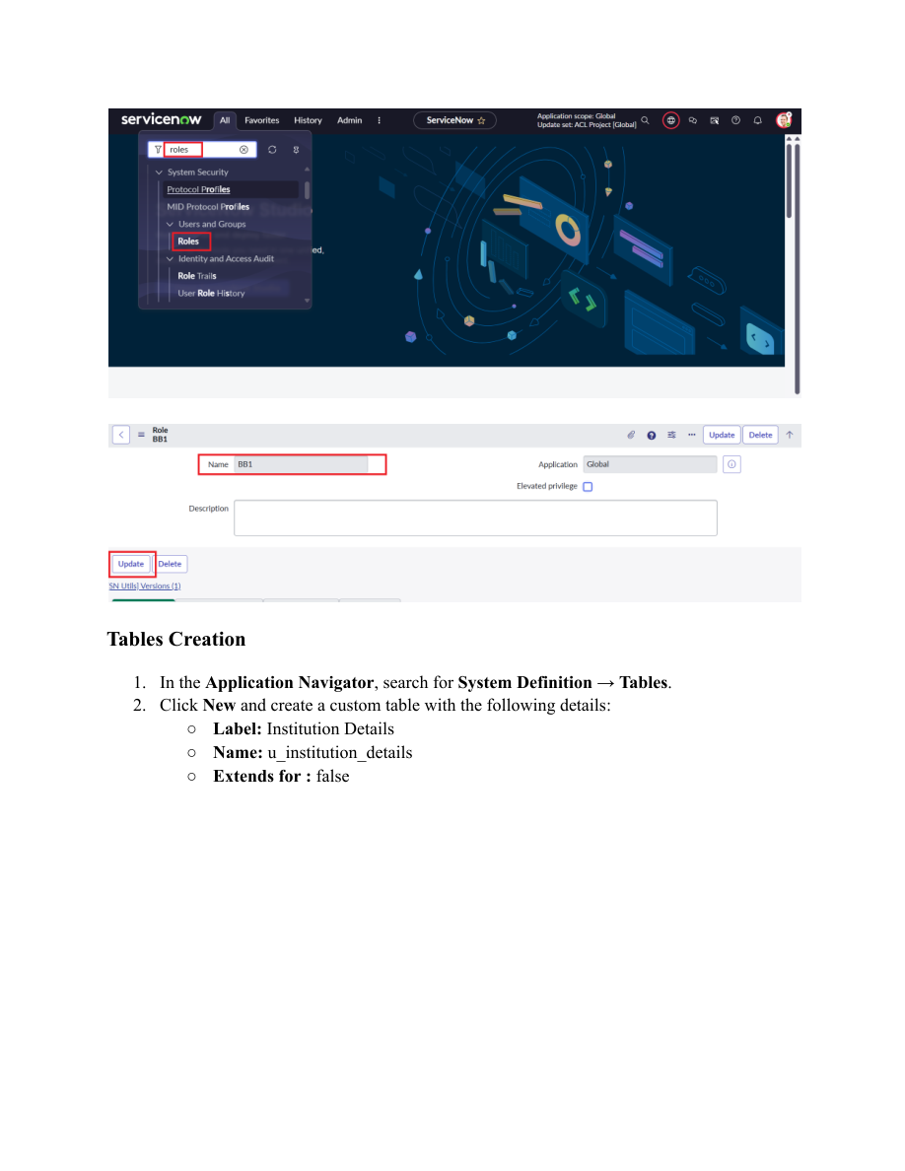

Screenshot – Institution Details field configuration
Source: Script-Controlled ACL project PDF, page 4.
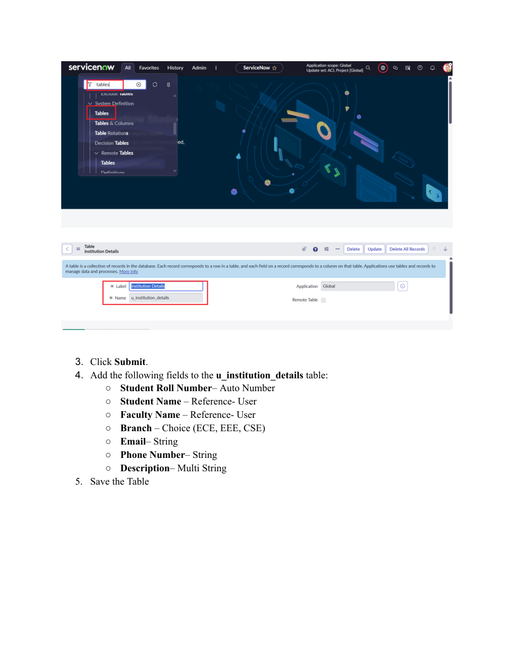

Screenshot – Student records and READ ACL setup
Source: Script-Controlled ACL project PDF, page 5.
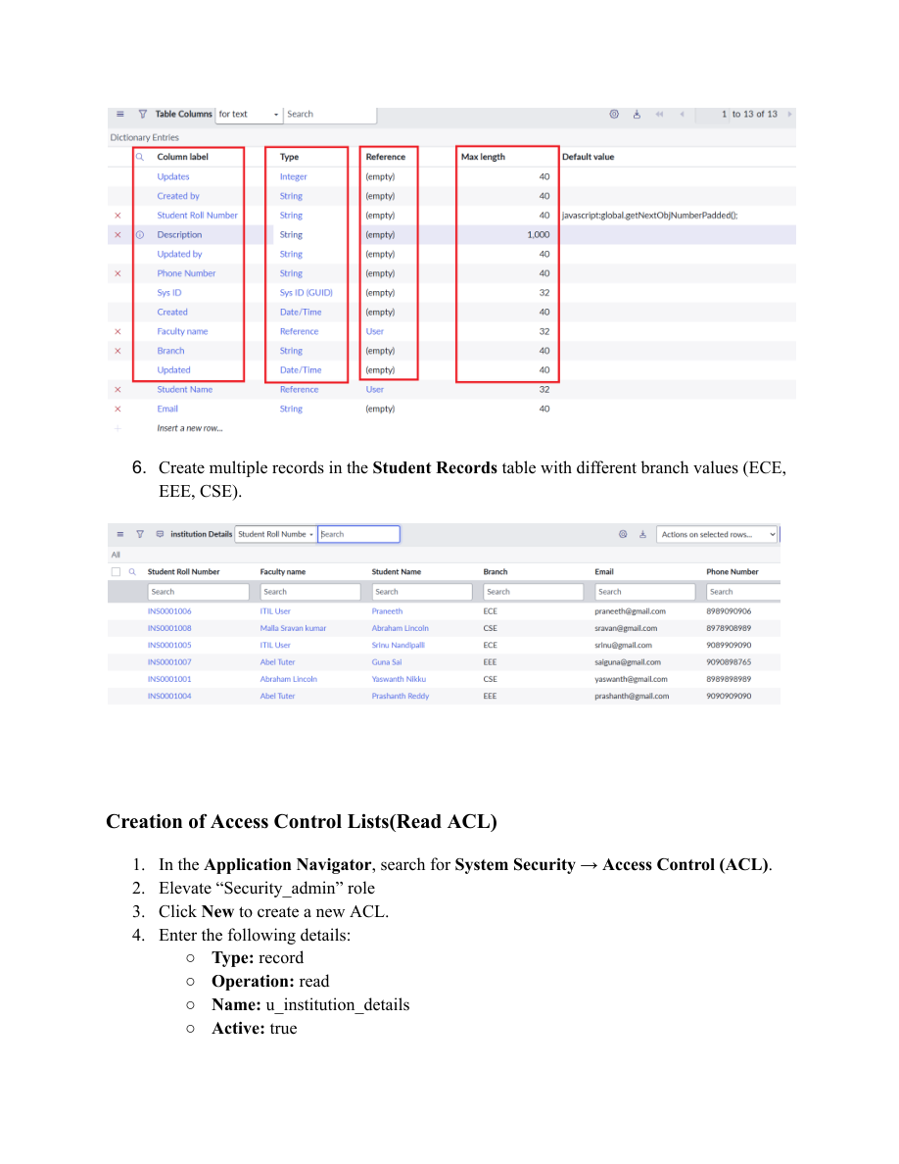

Screenshot – READ ACL script and configuration
Source: Script-Controlled ACL project PDF, page 6.
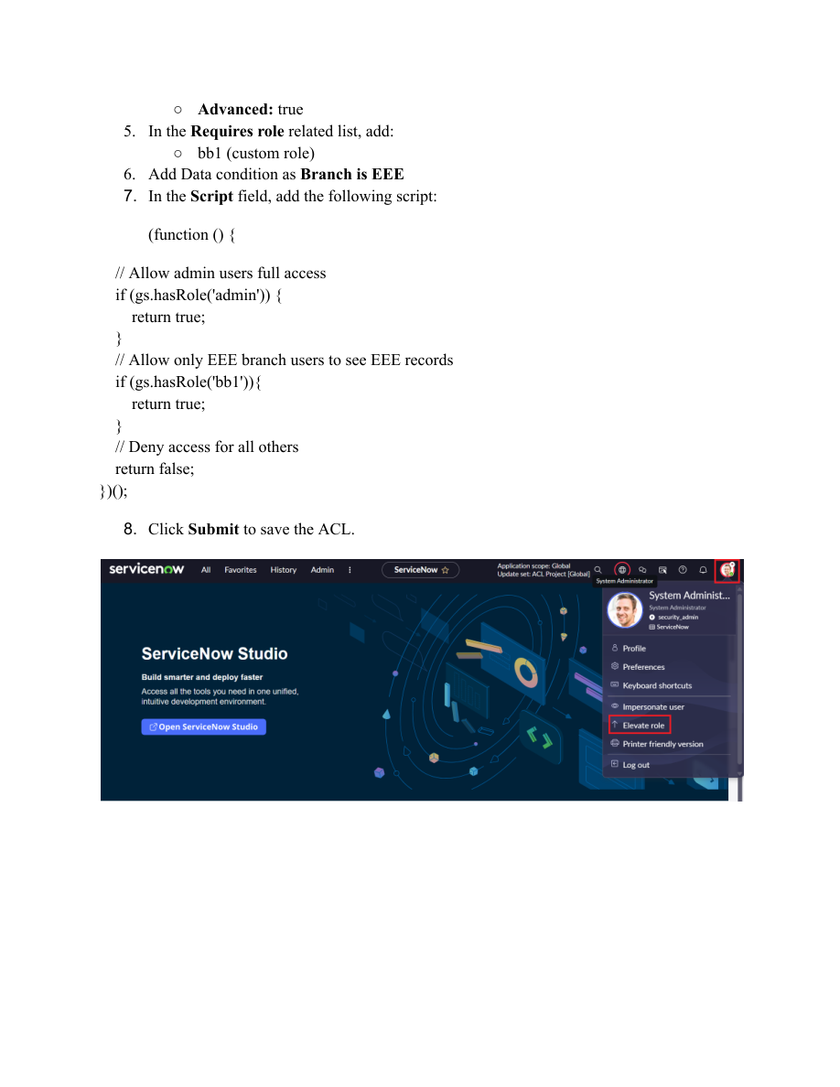

Screenshot – READ ACL verification
Source: Script-Controlled ACL project PDF, page 9.
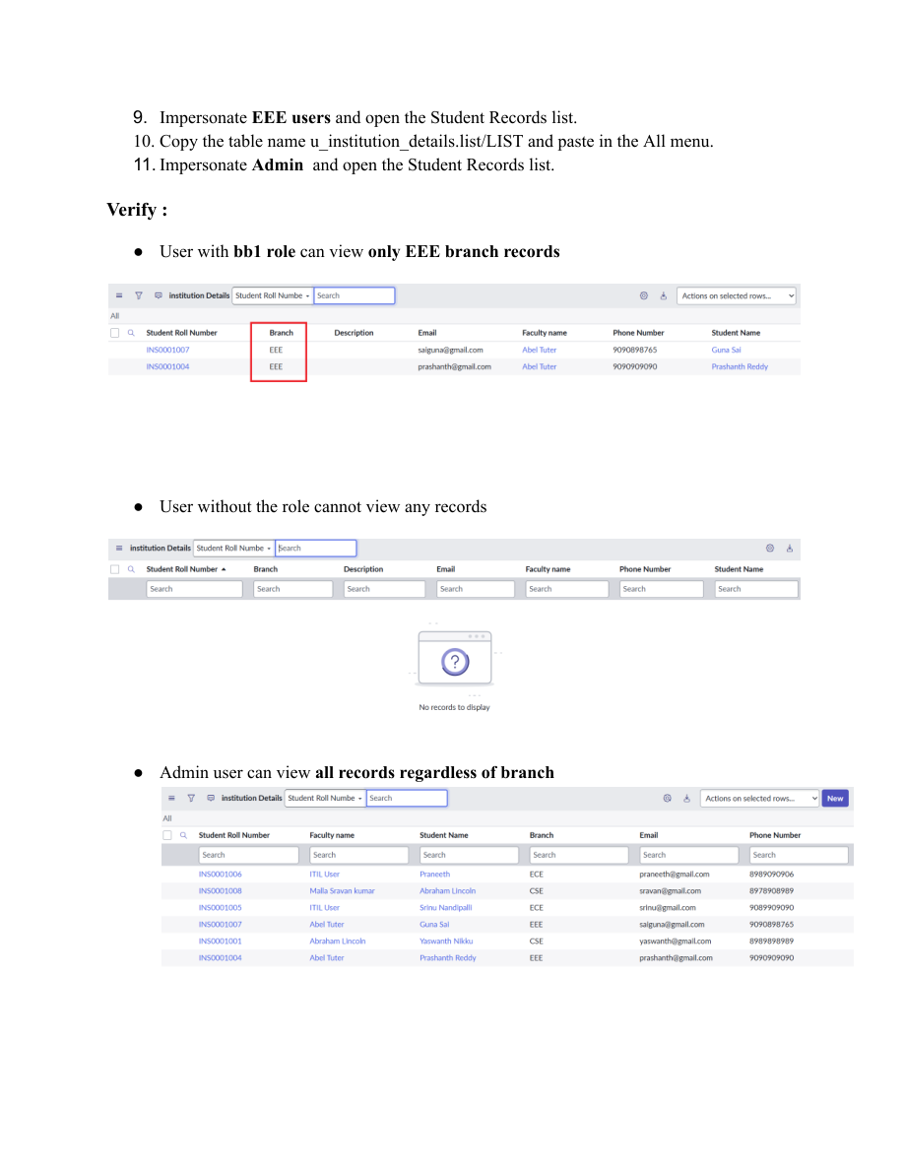

Screenshot – CREATE ACL configuration
Source: Script-Controlled ACL project PDF, page 10.
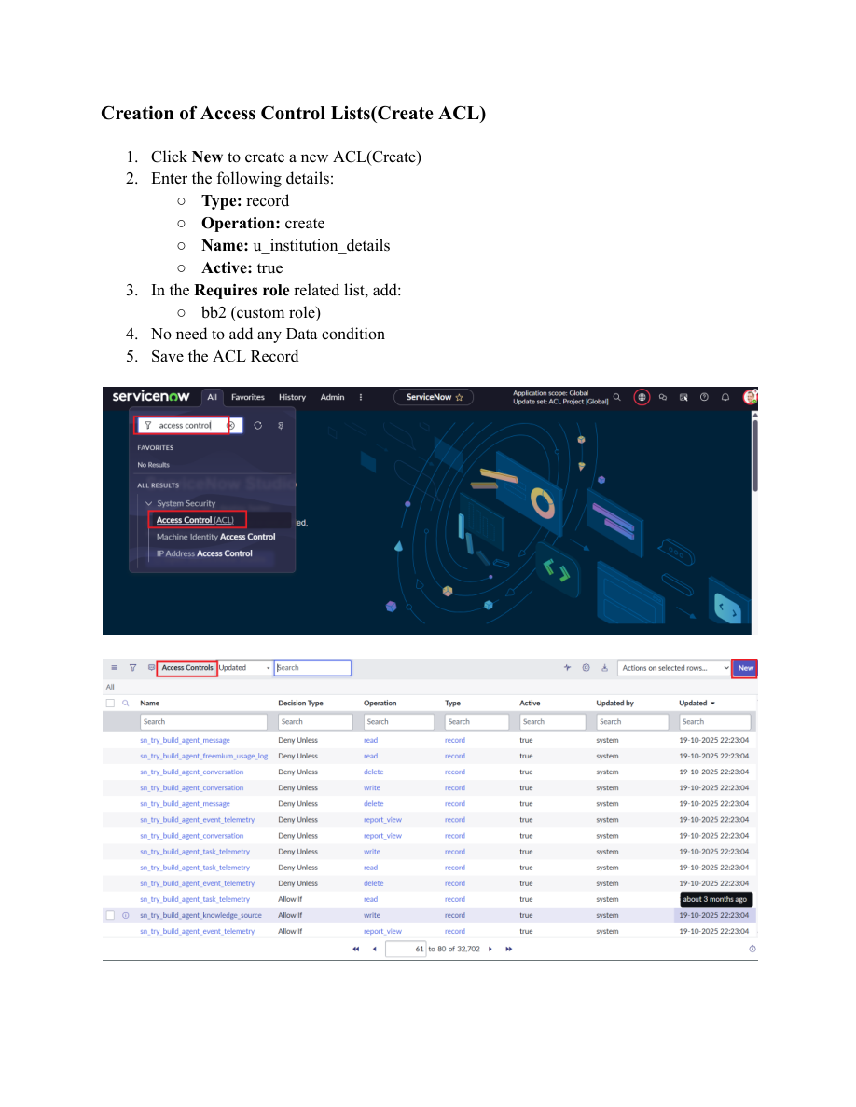

Screenshot – WRITE ACL configuration
Source: Script-Controlled ACL project PDF, page 11.
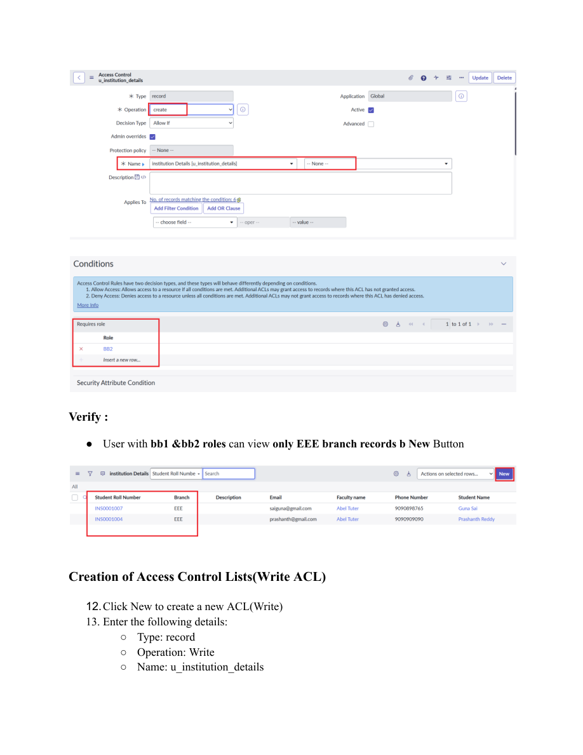

Screenshot – WRITE ACL role configuration
Source: Script-Controlled ACL project PDF, page 12.
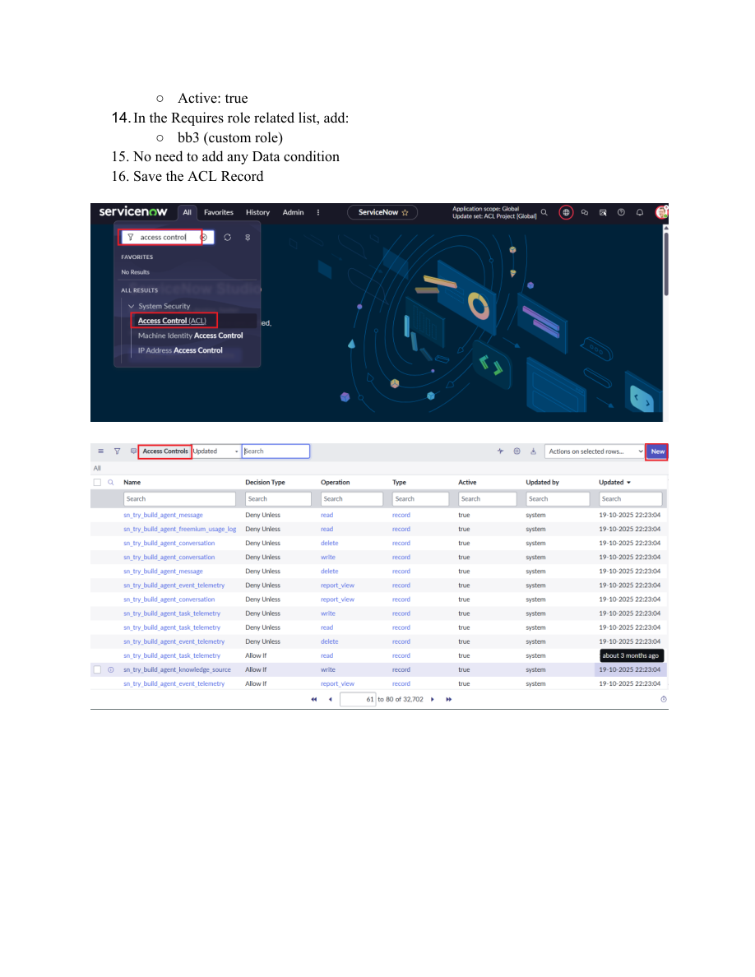

Screenshot – DELETE ACL configuration
Source: Script-Controlled ACL project PDF, page 14.
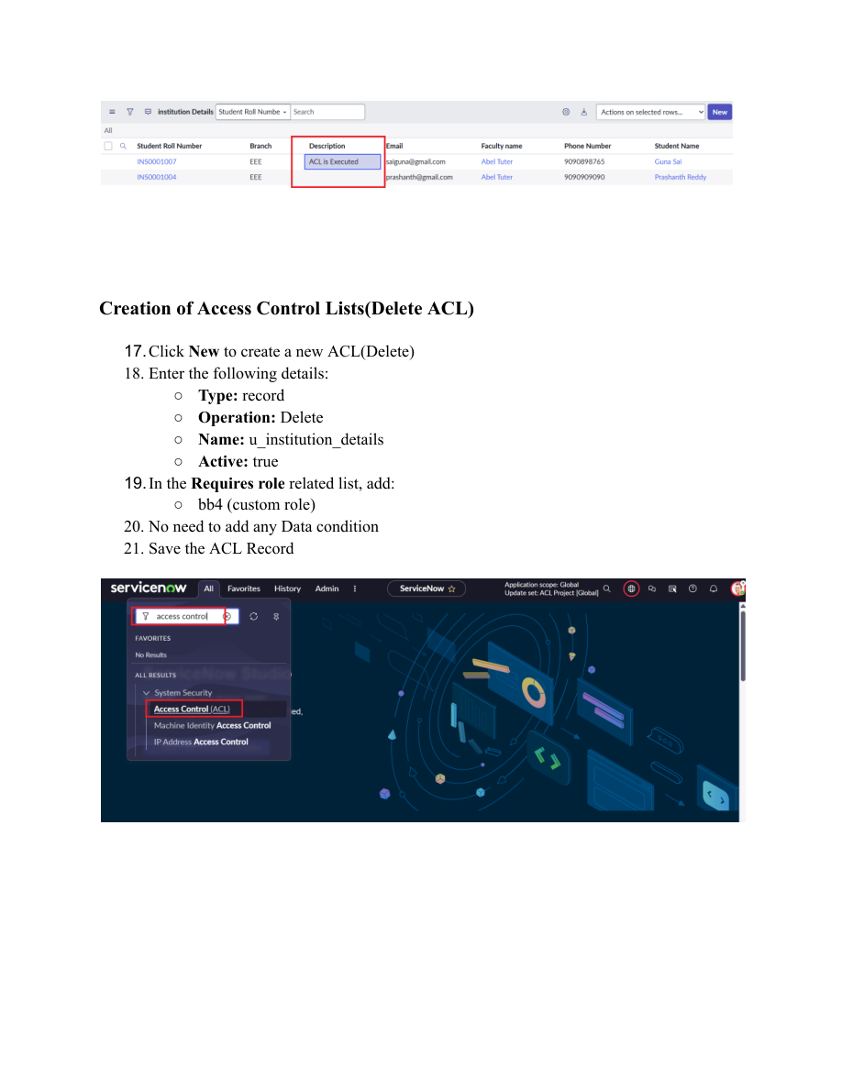

Screenshot – DELETE ACL verification
Source: Script-Controlled ACL project PDF, page 15.
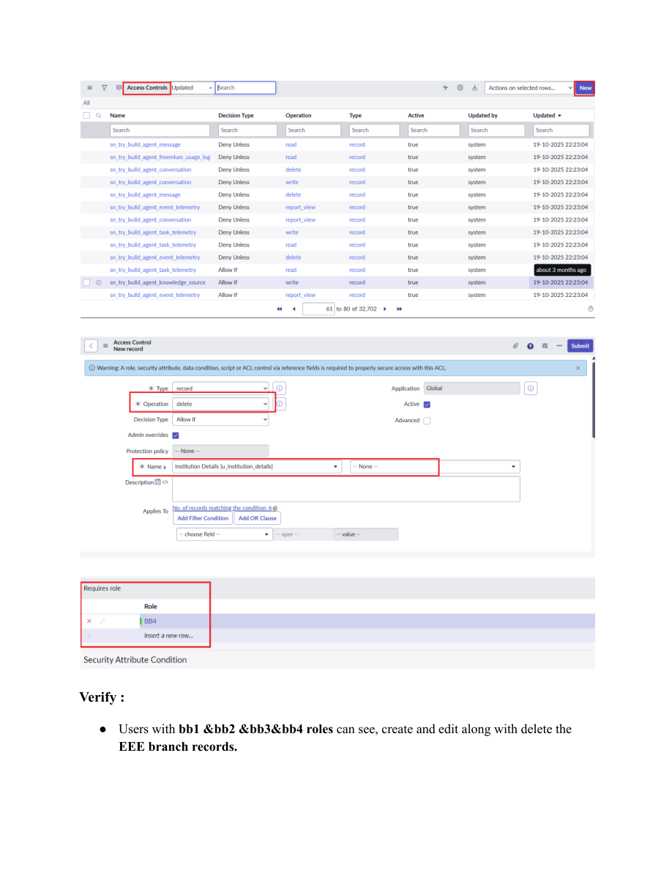

Final Outcome
By completing this lab, learners gain an understanding of script-controlled READ, WRITE, CREATE, and DELETE ACLs, record-level security, role-based permissions, and field-based access decisions across ServiceNow records.

