PHASE 5
Project Development
Script-Controlled ACL – Restrict Record Access Based on Field Value
Field | Details
Date | 30.9.2026
Team ID | 6ab4dcafa238dc999eb5d928
Project Name | Script-Controlled ACL – Restrict Record Access Based on Field Value
Platform | ServiceNow (Global scope)
Custom Table | Institution Details (u_institution_details)
Development Approach | Milestone-wise configuration (6 milestones)

Purpose
This phase documents how the solution was built in ServiceNow: the users and roles, the custom table and records, and the Read, Create, Write and Delete ACLs, with screenshots and verification results for every milestone.

1. Development Overview
The solution was developed in six milestones, following the plan from Phase 4. Each milestone was configured in the ServiceNow instance and verified by impersonating users with different role combinations.
Milestone | What was developed | Result
M1 | Test user EEE User and roles bb1, bb2, bb3, bb4 | User holds all four roles
M2 | Custom table u_institution_details with sample records | Records for ECE, EEE and CSE
M3 | Script-controlled Read ACL (bb1 + Branch is EEE) | Only EEE records visible
M4 | Create ACL (bb2) | New button available
M5 | Write ACL (bb3) | Records editable
M6 | Delete ACL (bb4) | Records deletable

Development flow
Admin Login → Users & Roles → Table u_institution_details → Sample Records → Elevate security_admin → Read ACL → Create ACL → Write ACL → Delete ACL → Impersonate &amp; Verify

2. Platform and Components Used
Component | Navigation / Module | Used For
Users | User Administration → Users | Create the EEE User test account
Roles | User Administration → Roles | Create custom roles bb1 to bb4
Tables | System Definition → Tables | Create u_institution_details
Elevate role | Profile menu → Elevate role | Enable security_admin for ACL changes
Access Control (ACL) | System Security → Access Control (ACL) | Create Read, Create, Write, Delete ACLs
Impersonate User | Profile menu → Impersonate user | Test access as different users

3. Milestone 1 – Users and Roles
- Log in to the ServiceNow instance with admin access.
- Go to User Administration → Users and click New.
- Enter User ID EEEUser, First name EEE, Last name User and Email eeeuser@gmail.com, then save.
- Go to User Administration → Roles, click New, enter Name bb1 and submit.
- Repeat for roles bb2, bb3 and bb4.
- Assign all four roles to the EEE User.

Screenshot 1 — User creation
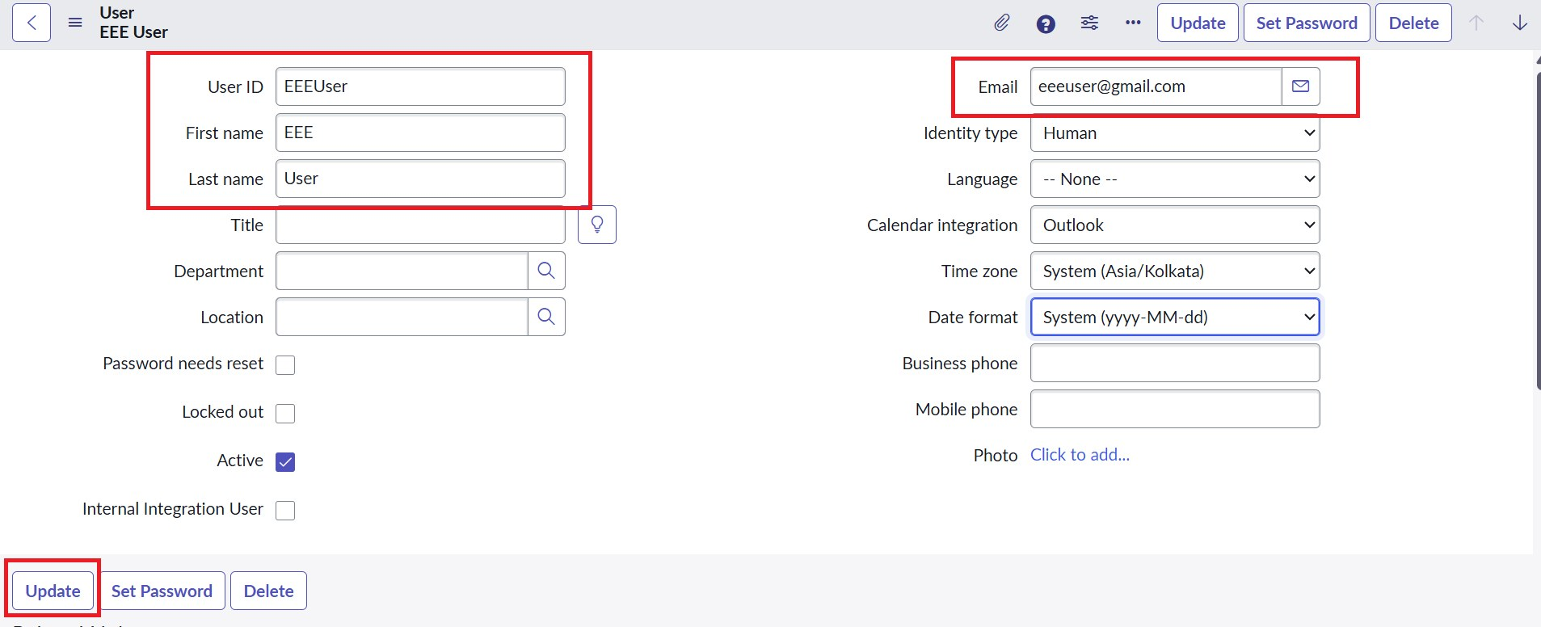
EEE User created with email eeeuser@gmail.com

Screenshot 2 — Role creation
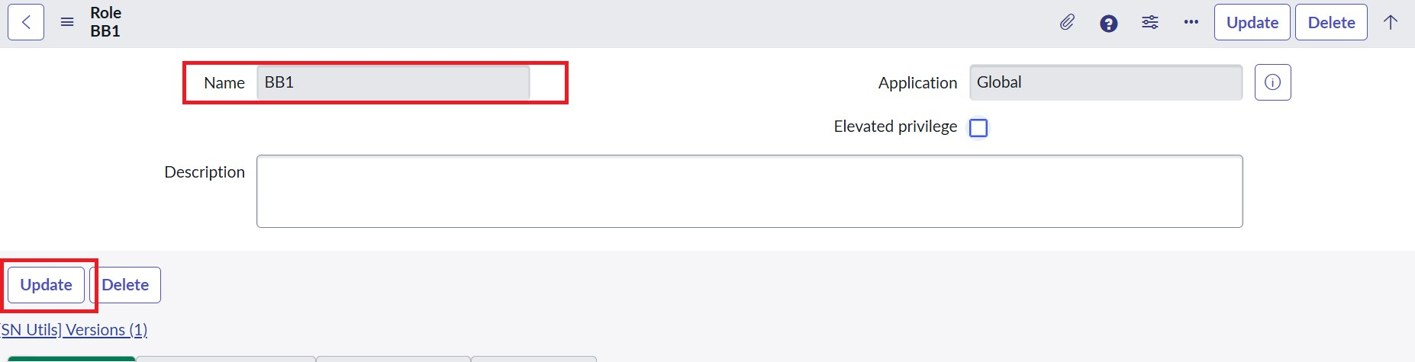
Custom role BB1 (BB2, BB3 and BB4 are created the same way)

4. Milestone 2 – Table and Records
- Go to System Definition → Tables and click New.
- Enter Label Institution Details, Name u_institution_details, Extends table None, then submit.
- Add the required fields to the table (see the table below).
- Insert multiple records with different Branch values (ECE, EEE, CSE).

Field | Type | Purpose
Student Roll Number | Auto Number | Unique record number (INS0001001 format)
Student Name | Reference – User | Student linked to a user record
Faculty Name | Reference – User | Faculty member linked to a user record
Branch | Choice (ECE, EEE, CSE) | Field evaluated by the ACL data condition
Email | String | Contact email
Phone Number | String | Contact phone number
Description | Multi-line String | Notes; used to test the Write ACL

Screenshot 3 — Create Institution Details table
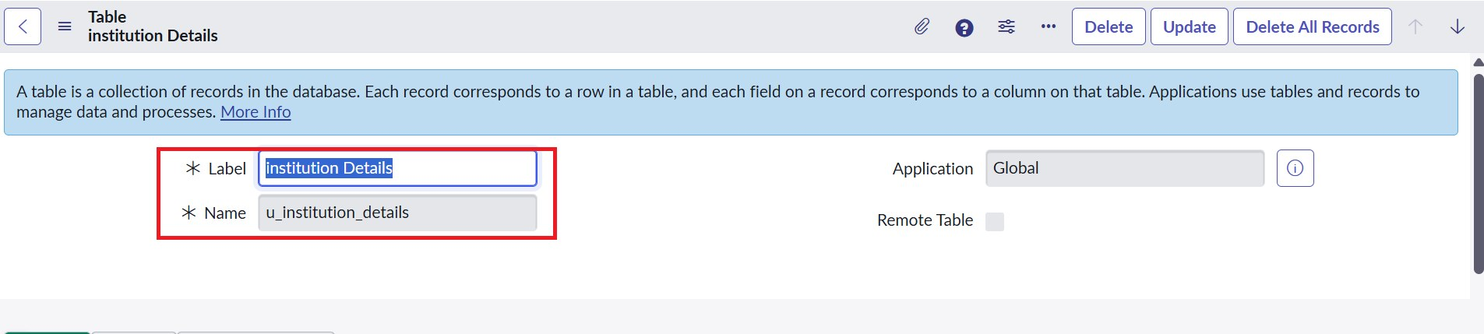
Custom table u_institution_details

Screenshot 4 — Table columns
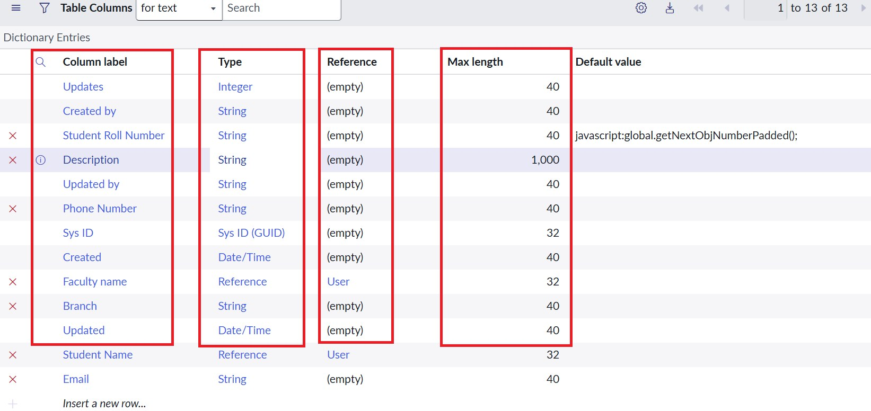
Fields added to the table

Screenshot 5 — Sample records
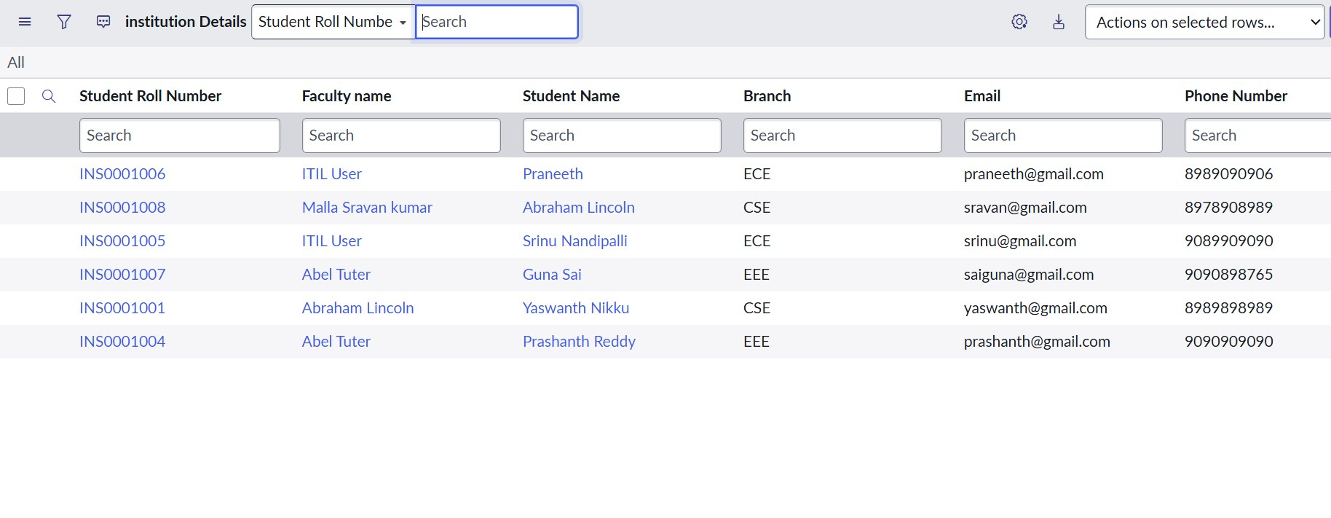
Records with different Branch values (ECE, EEE, CSE)

5. Milestone 3 – Read ACL (Script-Controlled)
- Open the profile menu, click Elevate role, select security_admin and click Update.
- Go to System Security → Access Control (ACL) and click New.
- Set Type record, Operation read, Name u_institution_details, Active true, Advanced true.
- In the Requires role related list, add bb1.
- Add the Data Condition Branch is EEE.
- Add the script shown below in the Script field and click Submit.
- Impersonate the EEE User and open u_institution_details.list, then impersonate the Admin and open the list again.

Read ACL script
(function () {
if (gs.hasRole('bb1')) {
return true;
} else {
return false;
}
})();

The script confirms the role, while the Branch is EEE data condition limits the records. Admins are not blocked because Admin overrides is enabled on the ACL.

Screenshot 6 — Elevate role option
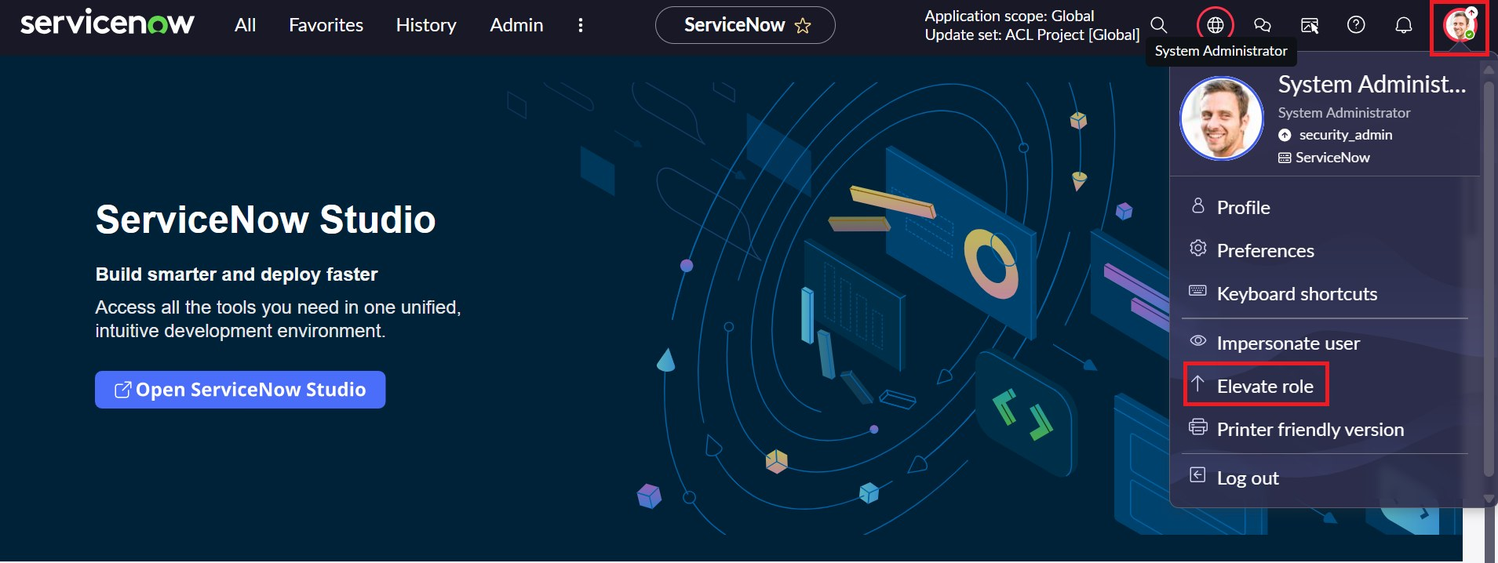
Profile menu with the Elevate role option

Screenshot 7 — Elevate security_admin
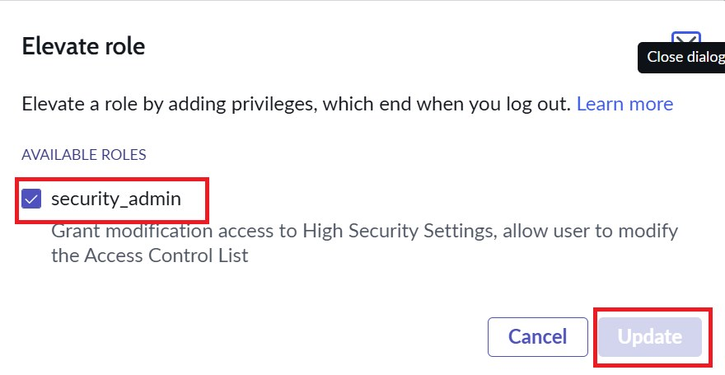
security_admin role elevated to create ACLs

Screenshot 8 — Read ACL configuration
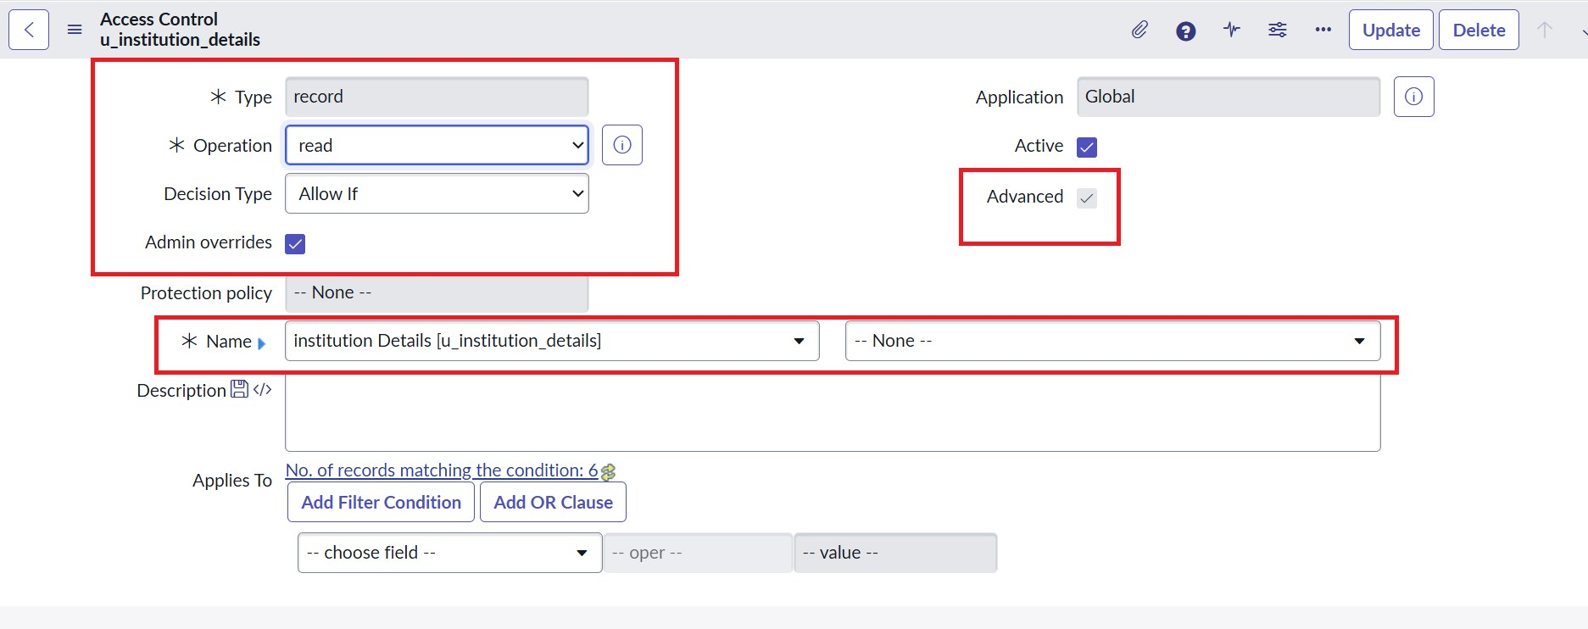
Type: record, Operation: read, Advanced: true

Screenshot 9 — Data condition and script
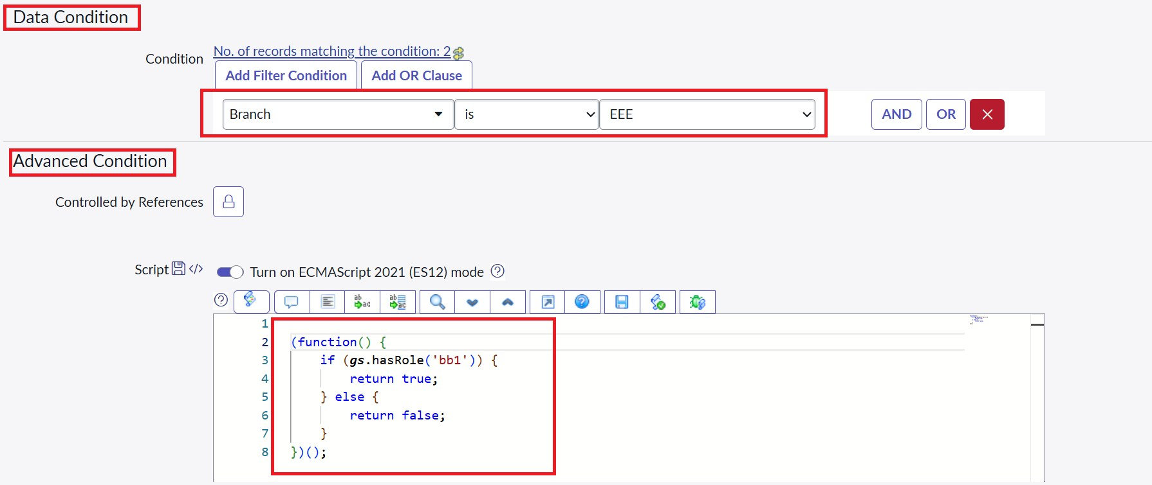
Branch is EEE with the advanced role-check script

Verification
User | Result observed
User with bb1 role | Only EEE branch records are visible
User without the role | No records to display
Admin | All records visible regardless of branch

Screenshot 10 — Read ACL result – bb1 user
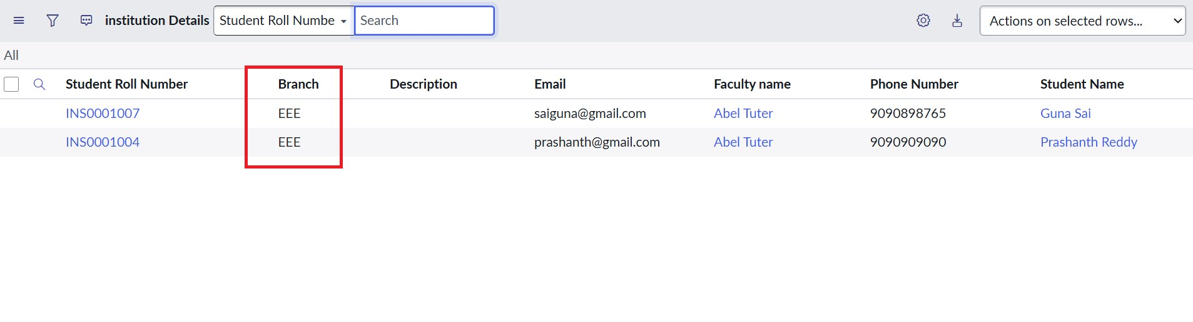
User with the bb1 role sees only EEE branch records

Screenshot 11 — Read ACL result – user without role
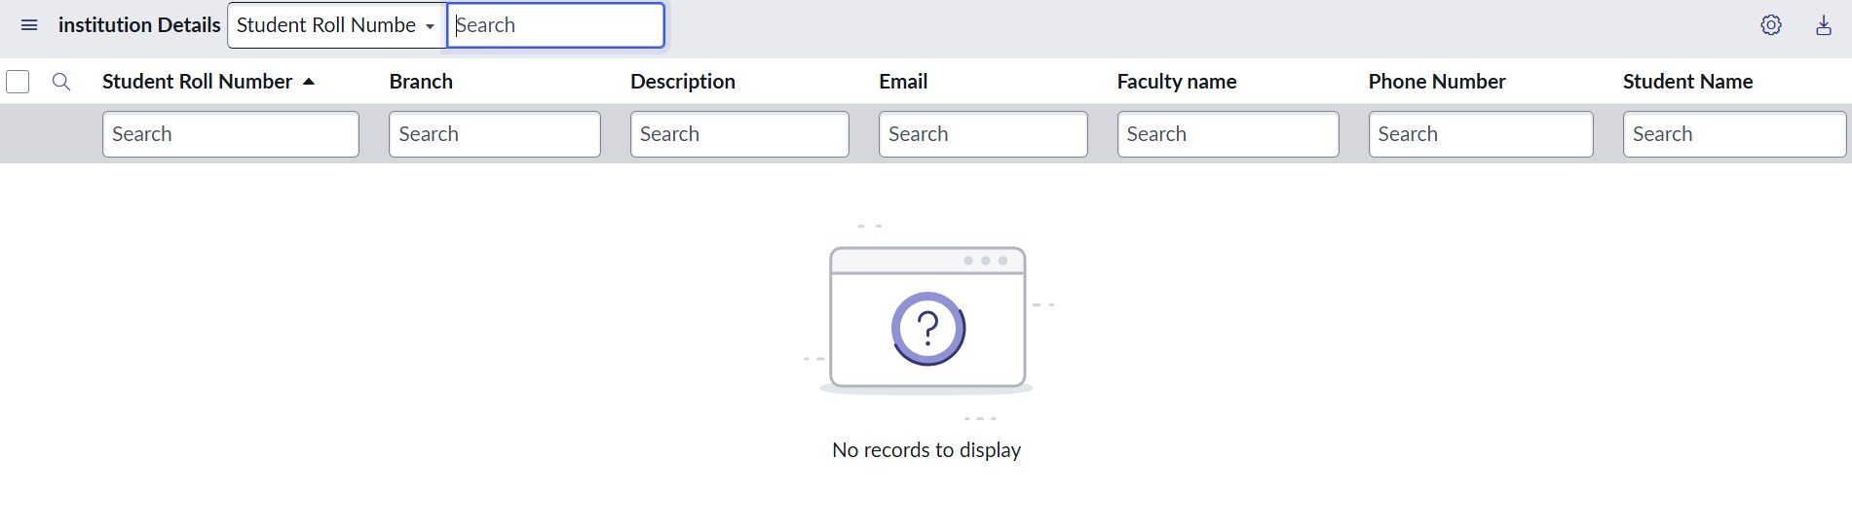
No records to display

Screenshot 12 — Read ACL result – admin
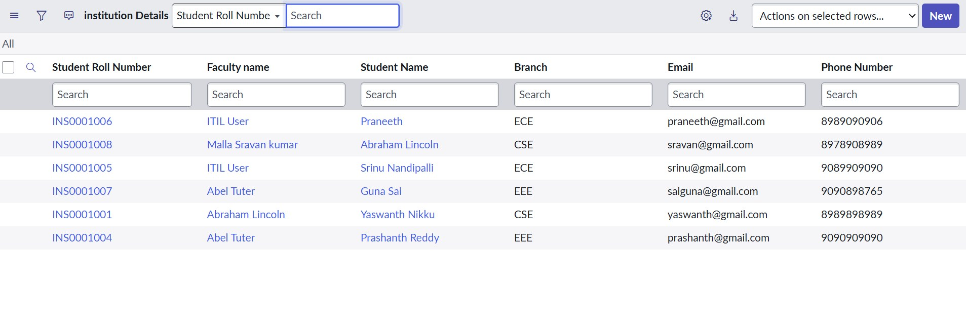
Admin sees all records regardless of branch

6. Milestone 4 – Create ACL
- Go to System Security → Access Control (ACL) and click New.
- Set Type record, Operation create, Name u_institution_details, Active true.
- In the Requires role related list, add bb2.
- No data condition is needed. Save the ACL.
- Impersonate a user with bb1 and bb2 and confirm that the New button appears.

Screenshot 13 — Create ACL configuration
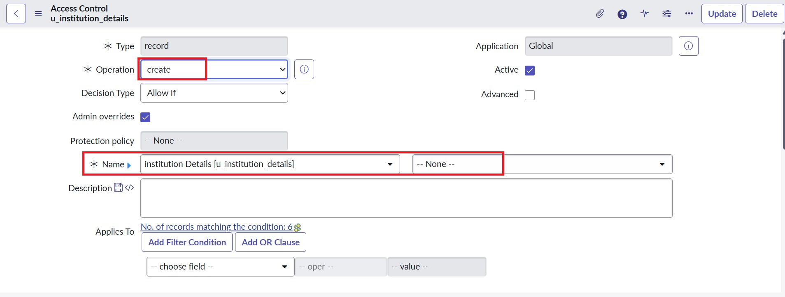
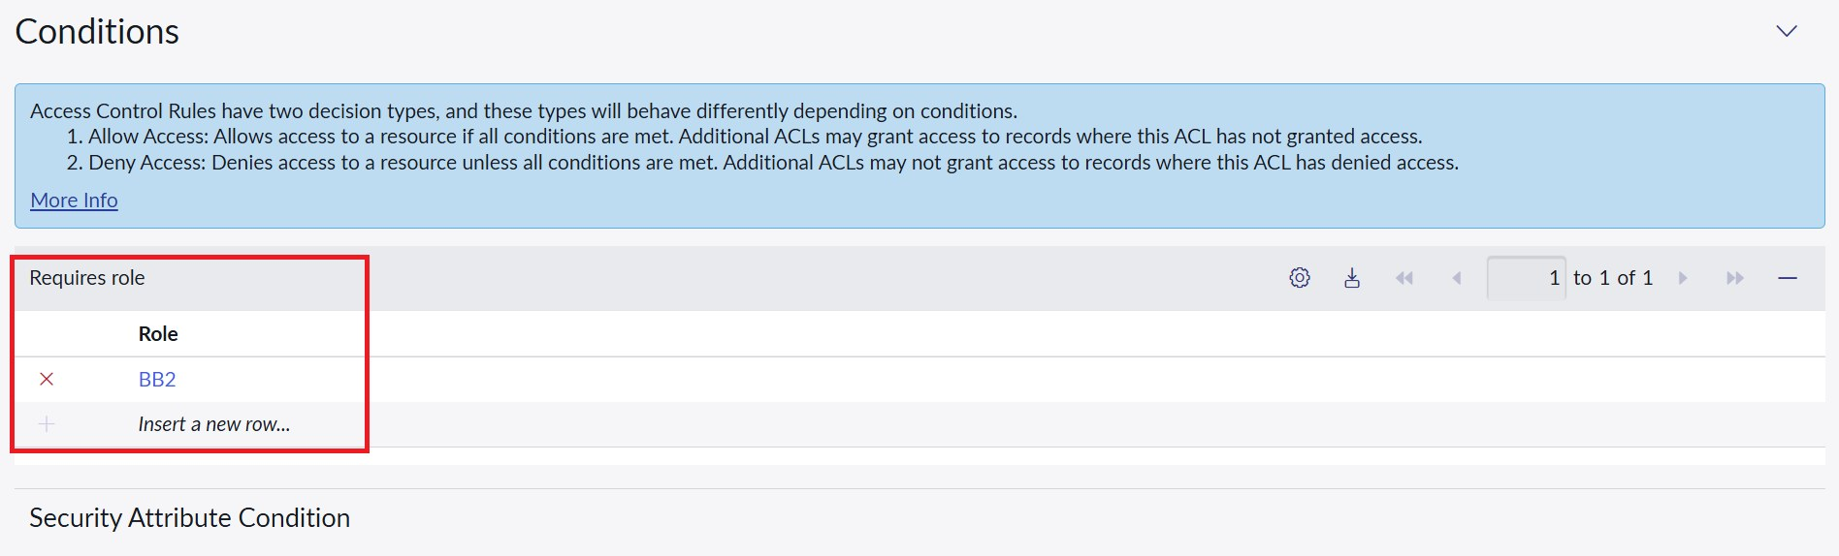
Operation: create, Requires role: BB2

Screenshot 14 — Create ACL result
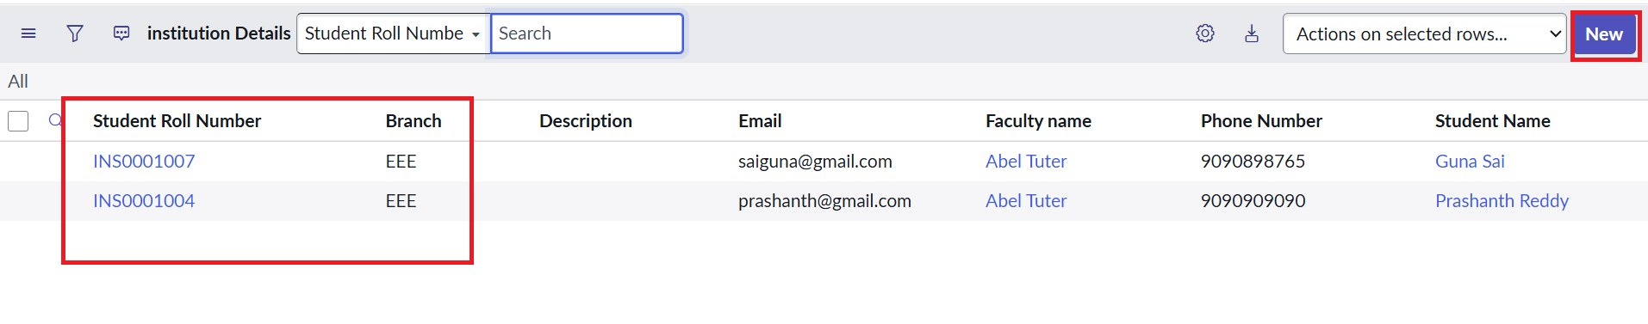
With bb1 and bb2, the New button appears

7. Milestone 5 – Write ACL
- Click New in Access Controls to create another ACL.
- Set Type record, Operation write, Name u_institution_details, Active true.
- In the Requires role related list, add bb3.
- No data condition is needed. Save the ACL.
- Impersonate a user with bb1, bb2 and bb3 and edit the Description of an EEE record.

Screenshot 15 — Write ACL configuration
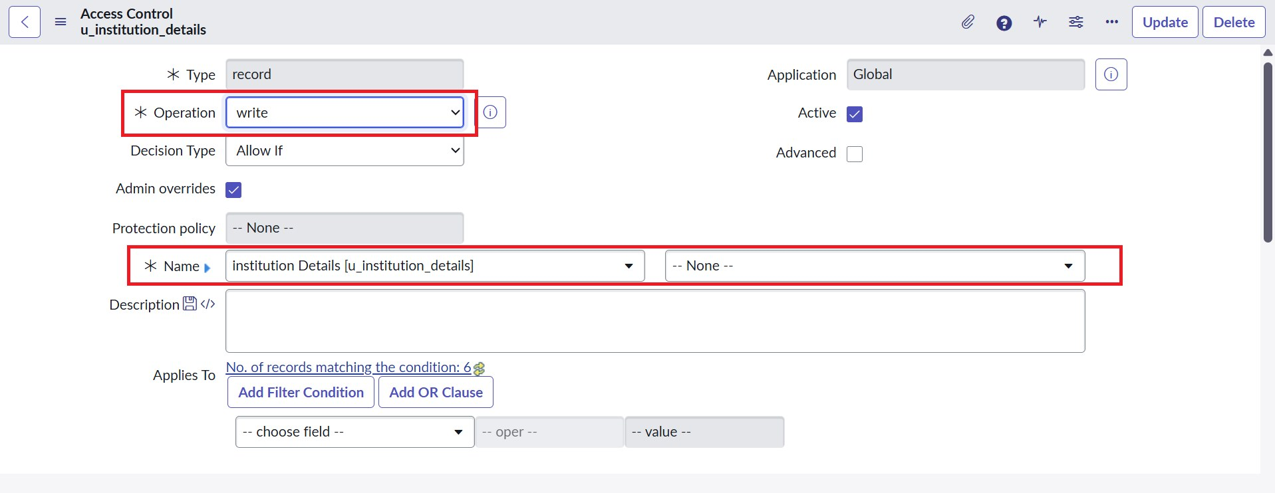
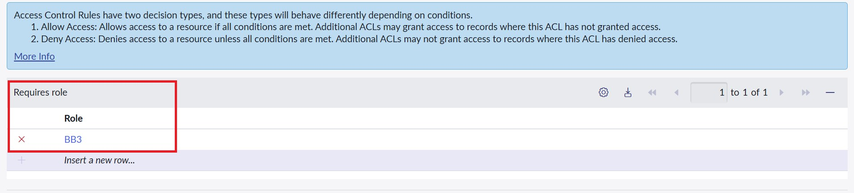
Operation: write, Requires role: BB3

Screenshot 16 — Write ACL result
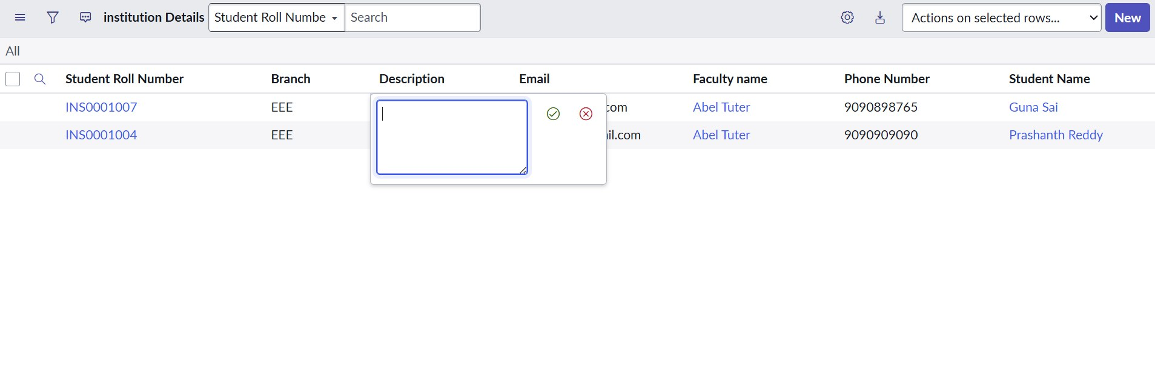
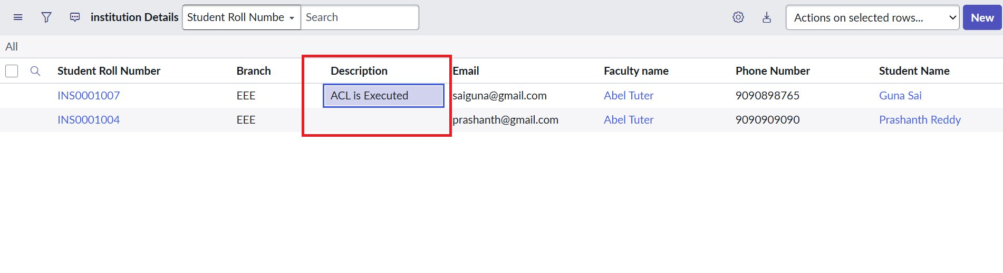
With bb1, bb2 and bb3, the Description field can be edited

8. Milestone 6 – Delete ACL
- Click New in Access Controls to create the last ACL.
- Set Type record, Operation delete, Name u_institution_details, Active true.
- In the Requires role related list, add bb4.
- No data condition is needed. Save the ACL.
- Impersonate a user with bb1 to bb4, select an EEE record, choose Delete from Actions on selected rows and confirm.

Screenshot 17 — Delete ACL configuration
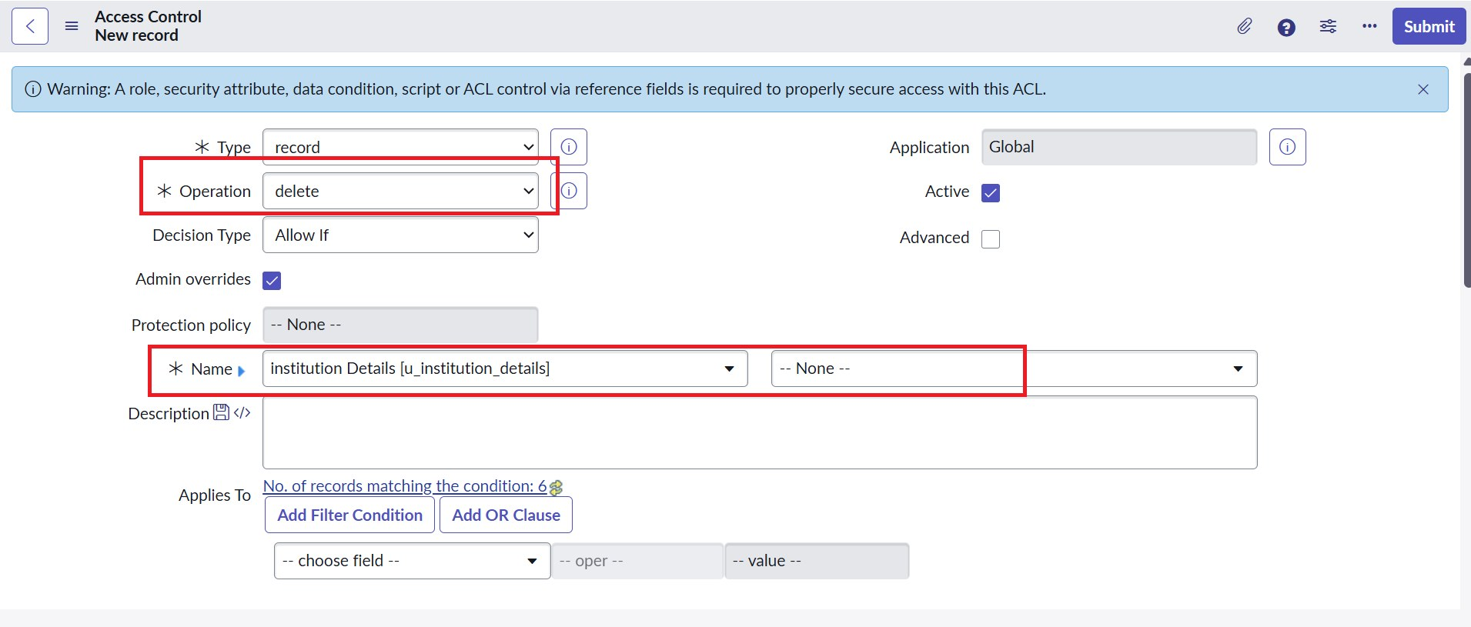
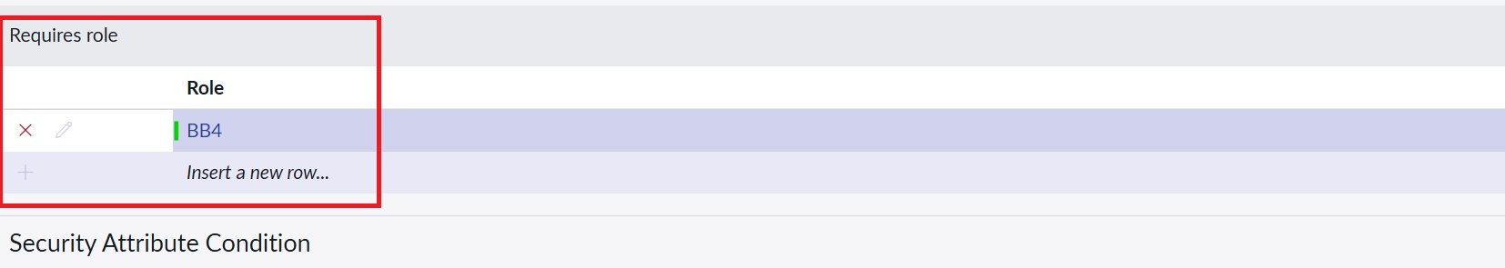
Operation: delete, Requires role: BB4

Screenshot 18 — Delete ACL result
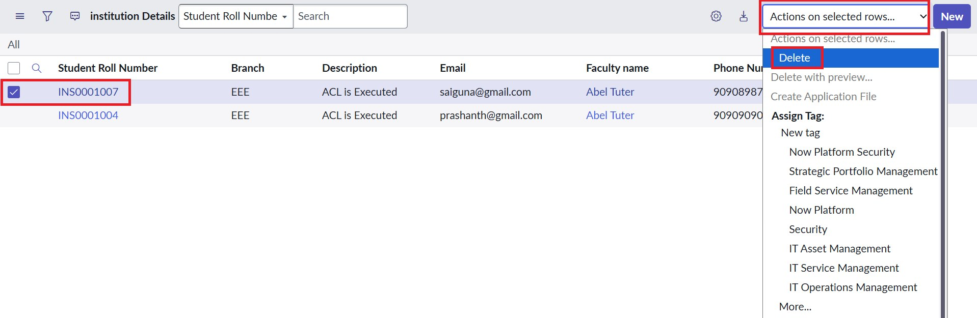
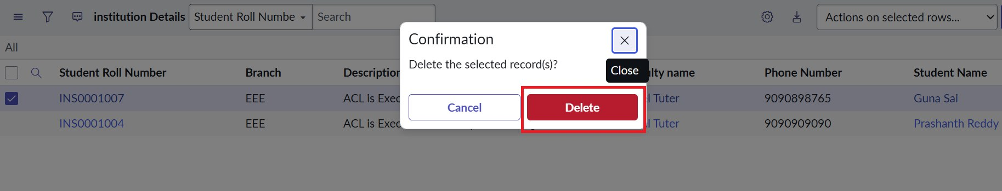
With bb1 to bb4, selected EEE records can be deleted

9. ACL Configuration Summary
Operation | Requires role | Data condition | Advanced script | Effect
read | bb1 | Branch is EEE | Yes | Only EEE records are visible
create | bb2 | None | No | New button available
write | bb3 | None | No | Records can be edited
delete | bb4 | None | No | Records can be deleted

10. Development Notes
- Elevate first: the security_admin role must be elevated before ACLs can be created or saved.
- Assign roles: the EEE User must hold bb1 to bb4, otherwise records or buttons will not appear during testing.
- Advanced flag: Advanced must be enabled on the Read ACL, otherwise the script is ignored.
- Branch field: create Branch as a Choice field (ECE, EEE, CSE) so the data condition shows a dropdown.
- Order of testing: the Read ACL must work first, because Create, Write and Delete are verified on visible records.

11. Expected Outcome
The development delivers record-level security for the Institution Details table. Users with bb1 see only EEE branch records, users without the role see nothing, and admins see everything. The Create, Write and Delete ACLs add separate control over adding, editing and removing records, showing how roles, field values and scripts work together to protect data from unauthorized access.

