PHASE 6
Project Testing
Script-Controlled ACL – Restrict Record Access Based on Field Value
Field | Details
Date | 30.9.2026
Team ID | 6ab4dcafa238dc999eb5d928
Project Name | Script-Controlled ACL – Restrict Record Access Based on Field Value
Platform | ServiceNow (Global scope)
Testing Type | Functional testing using user impersonation

Purpose
This phase verifies that the Read, Create, Write and Delete ACLs on the Institution Details table behave as designed. Each test case lists the user role combination, the expected result, the actual result and the screenshot evidence.

1. Testing Overview
Testing was carried out in the ServiceNow instance by impersonating users with different role combinations and opening the list u_institution_details.list. The aim is to confirm that record visibility and the create, edit and delete actions follow the ACL design.

Testing objectives
- Confirm that users with the bb1 role see only records where Branch is EEE.
- Confirm that users without the role see no records.
- Confirm that admins see all records regardless of branch.
- Confirm that the New button, inline editing and Delete action depend on bb2, bb3 and bb4 respectively.

2. Test Environment
Item | Details
Platform | ServiceNow instance (Global scope)
Table under test | Institution Details (u_institution_details)
Test user | EEE User (eeeuser@gmail.com) with roles bb1, bb2, bb3, bb4
Admin user | System Administrator (full access through Admin overrides)
ACLs under test | Read (bb1 + Branch is EEE + script), Create (bb2), Write (bb3), Delete (bb4)
Test method | Impersonate User, then open u_institution_details.list

3. Test Data
Six records with different Branch values were used. Two of them belong to the EEE branch.
Student Roll Number | Student Name | Branch
INS0001001 | Yaswanth Nikku | CSE
INS0001004 | Prashanth Reddy | EEE
INS0001005 | Srinu Nandipalli | ECE
INS0001006 | Praneeth | ECE
INS0001007 | Guna Sai | EEE
INS0001008 | Abraham Lincoln | CSE

4. Test Cases and Results
ID | Scenario | User / Roles | Expected result | Actual result | Status
TC1 | Read as EEE role user | bb1 | Only EEE records are listed | 2 records listed (INS0001007, INS0001004), both EEE | Pass
TC2 | Read without role | No bb1 role | No records displayed | No records to display | Pass
TC3 | Read as admin | Admin | All records listed | All 6 records listed (ECE, EEE, CSE) | Pass
TC4 | Create without bb2 | bb1 only | New button not shown | No New button in the list | Pass
TC5 | Create with bb2 | bb1 + bb2 | New button is shown | New button appears | Pass
TC6 | Write with bb3 | bb1 + bb2 + bb3 | Description can be edited | Description edited and saved as "ACL Is Executed" | Pass
TC7 | Delete with bb4 | bb1 + bb2 + bb3 + bb4 | Delete action available for selected record | Delete option shown and confirmation dialog displayed | Pass

Result summary
Total test cases | Passed | Failed | Pass rate
7 | 7 | 0 | 100%

5. Test Evidence
The screenshots below are arranged in test case order.

Screenshot 1 — TC1 and TC4 – bb1 user
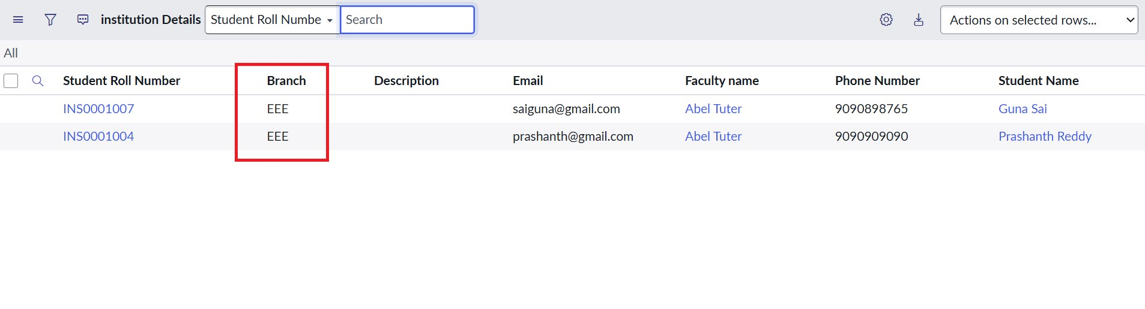
Only EEE records are visible and there is no New button (bb1 only)

Screenshot 2 — TC2 – User without role
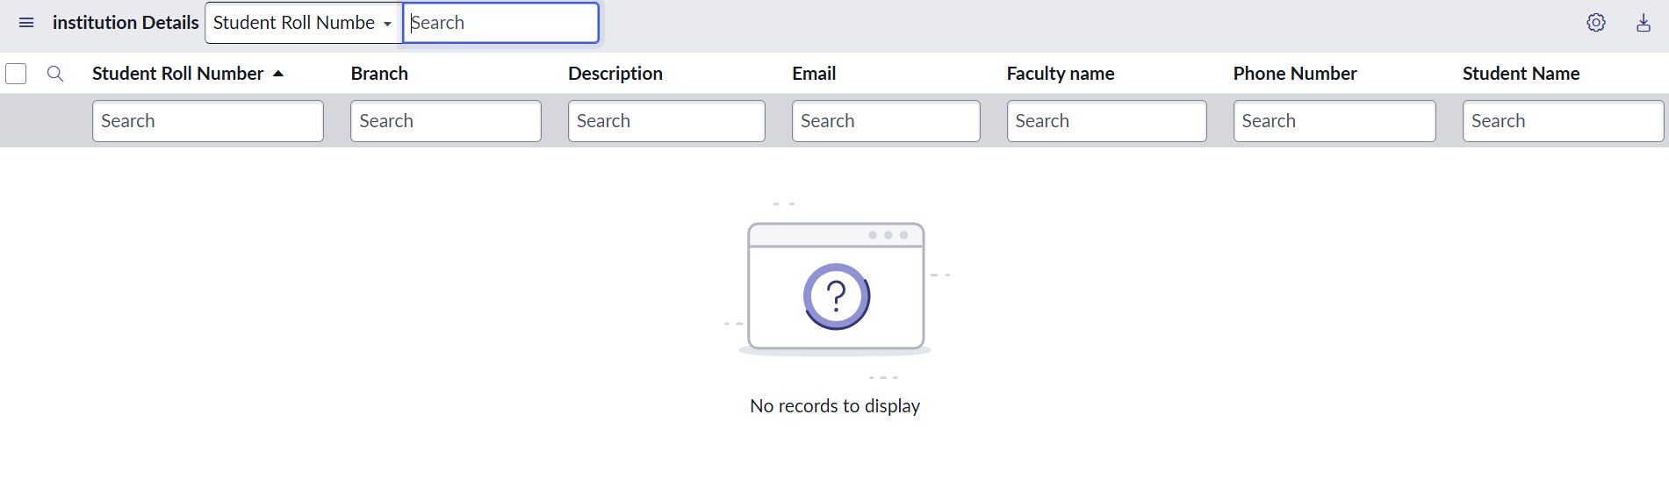
No records to display

Screenshot 3 — TC3 – Admin
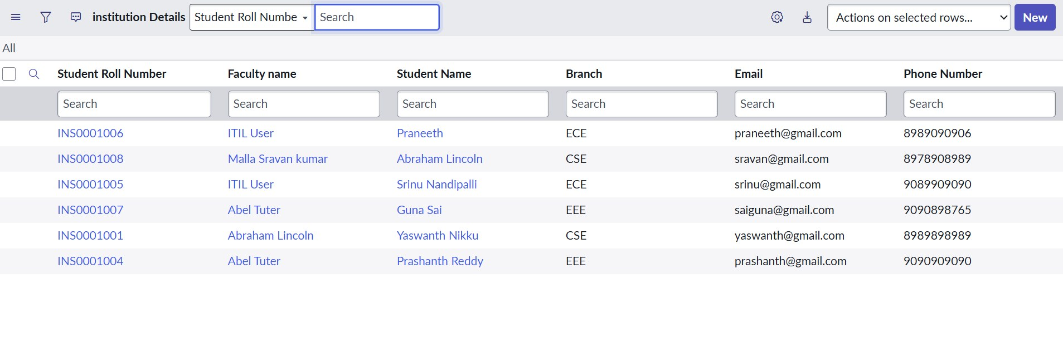
Admin sees all records regardless of branch

Screenshot 4 — TC5 – Create ACL (bb1 + bb2)
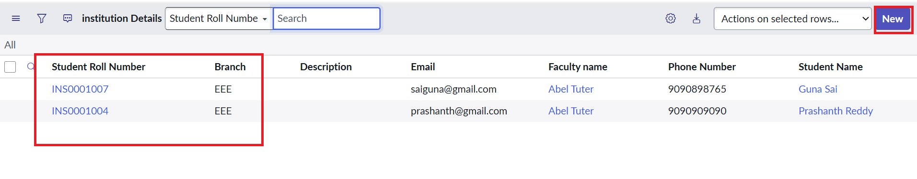
The New button appears for users with bb1 and bb2

Screenshot 5 — TC6 – Write ACL (bb1 + bb2 + bb3)
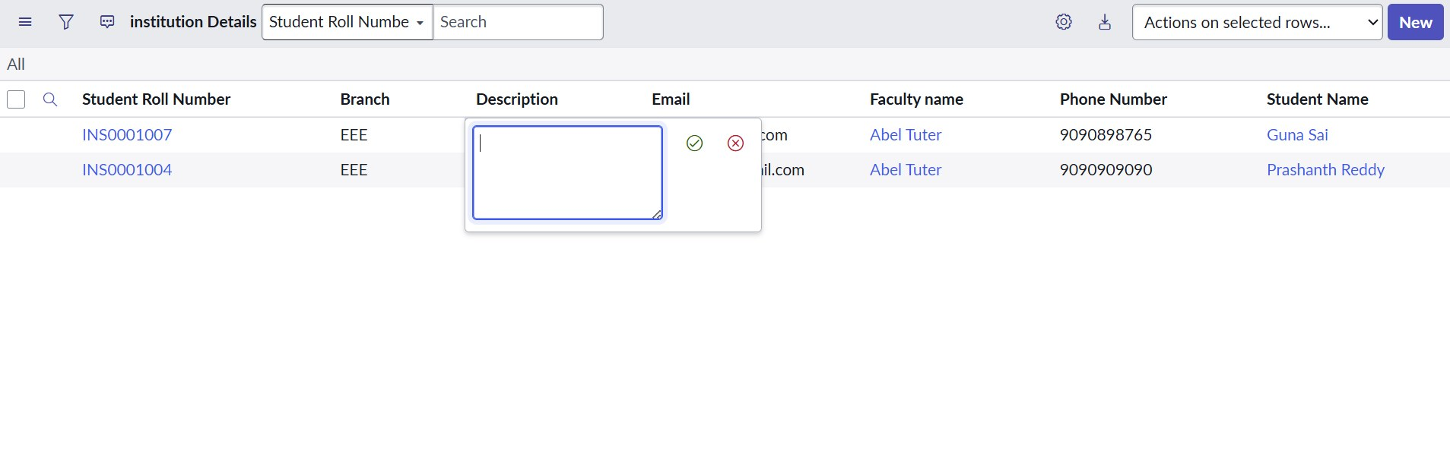
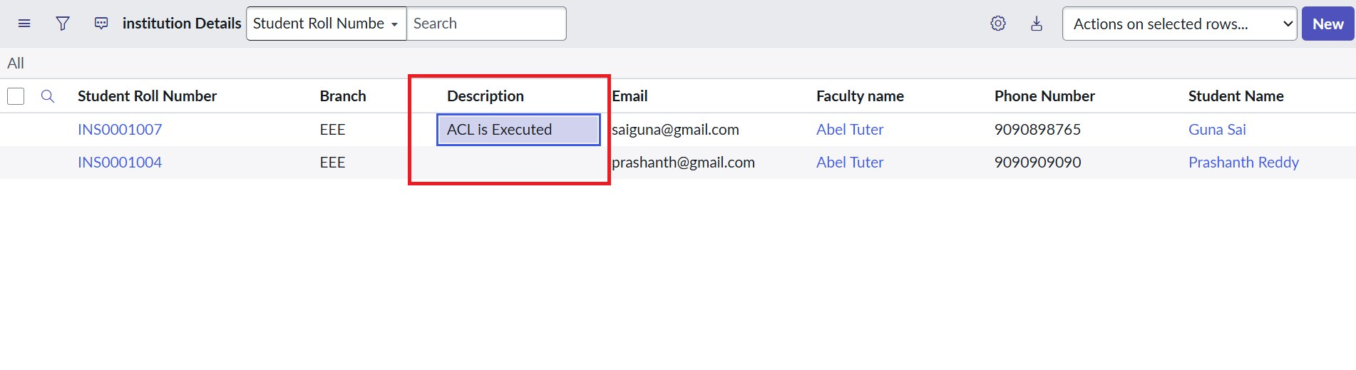
Description field edited by a user with bb1, bb2 and bb3

Screenshot 6 — TC7 – Delete ACL (bb1 to bb4)
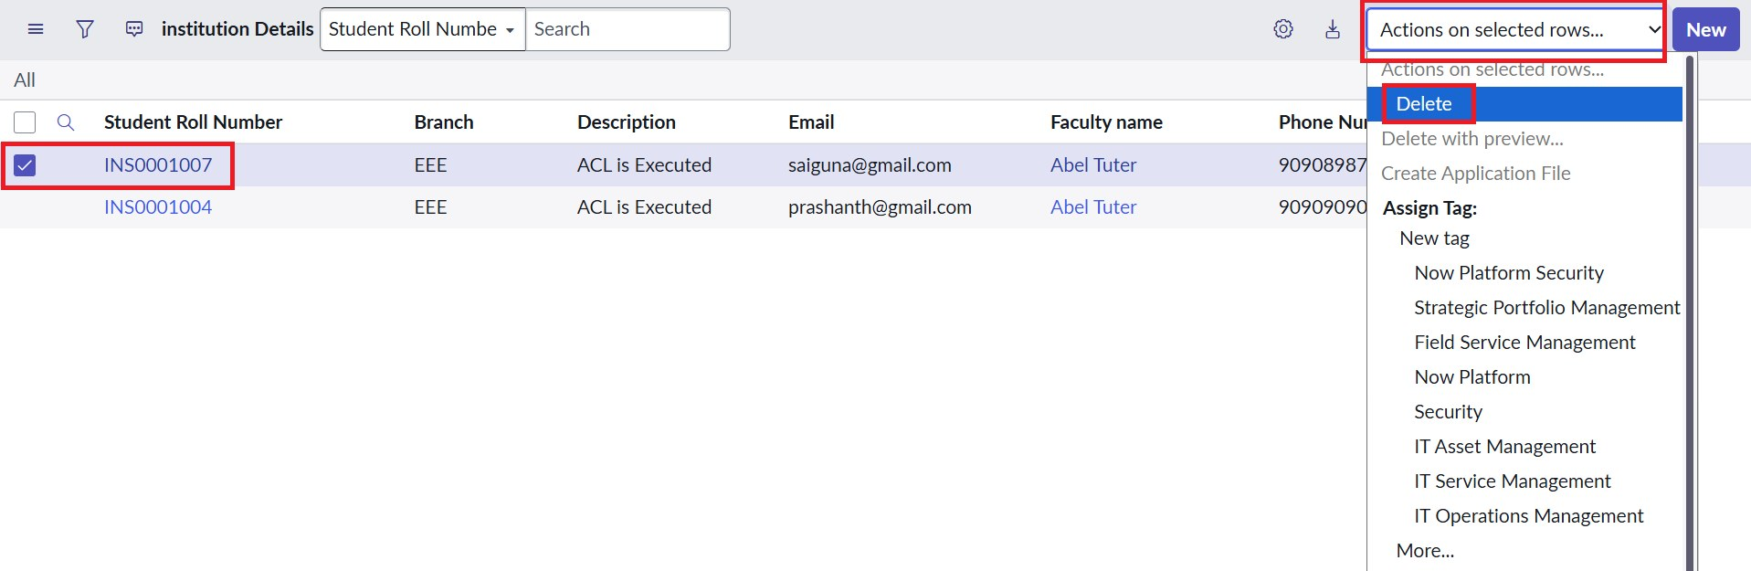
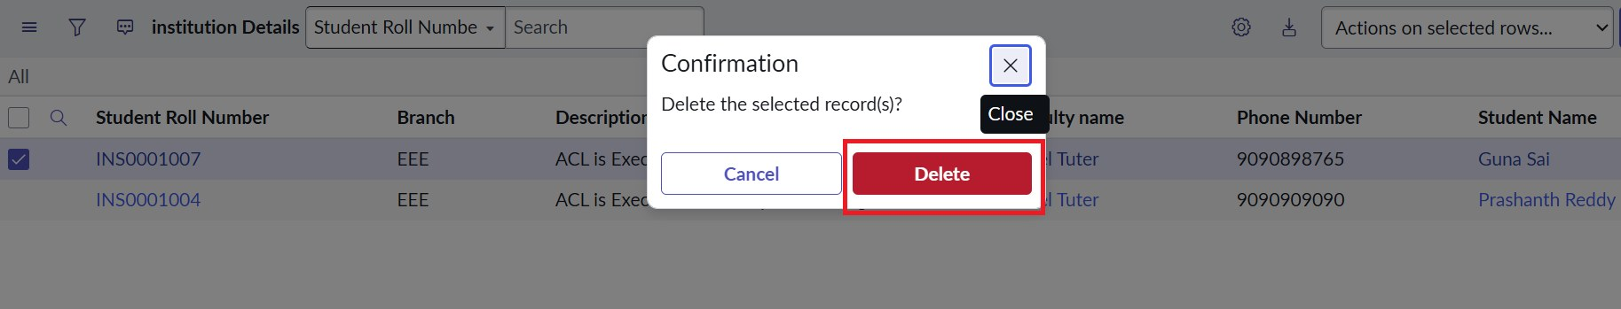
Delete action and confirmation for a selected EEE record

6. Performance Considerations
No load or response-time test was run in this lab, so no performance figures are reported. Design-wise, the Read ACL is lightweight: the record filter is applied through the data condition, and the script only performs a single role check with gs.hasRole.

7. Observations and Recommendations
No functional defects were found. The points below are minor observations that improve quality.
No. | Observation | Severity | Recommendation
1 | Branch field appears as String in the table columns view, while the design specifies Choice. | Low | Create Branch as a Choice field (ECE, EEE, CSE).
2 | Script comments mention "EEE branch users", but the script only checks the bb1 role. | Low | Update the comment: the Branch filter comes from the data condition.
3 | Admin check in the script is redundant because Admin overrides is enabled. | Low | Keep the script simple or retain the check for readability.

8. Conclusion
All seven test cases passed. The ACLs correctly restrict record visibility to EEE records for bb1 users, hide all records from users without the role, give admins full access, and control creating, editing and deleting through bb2, bb3 and bb4. The project meets its objective of script-controlled, field-value-based record access.

