PHASE 7
Project Documentation
Script-Controlled ACL – Restrict Record Access Based on Field Value
Field | Details
Date | 30.9.2026
Team ID | 6ab4dcafa238dc999eb5d928
Project Name | Script-Controlled ACL – Restrict Record Access Based on Field Value
Platform | ServiceNow (Global scope)
Custom Table | Institution Details (u_institution_details)

Purpose
This document is the final project record. It summarises the problem, solution, design, implementation, testing results and learnings of the script-controlled ACL project, with key screenshots as evidence.

1. Project Overview

Problem statement
Institution records such as student, faculty, branch and contact details are sensitive. If every user can open the table, people can view, change or delete records that do not concern them. The project needs record-level security so that access depends on both the user’s role and the value stored in the record.

Objectives
- Restrict record viewing so that only users with the bb1 role can see records where Branch is EEE.
- Keep full access for administrators.
- Control creating, editing and deleting records separately through the roles bb2, bb3 and bb4.
- Verify the behaviour by impersonating users with different role combinations.

2. Proposed Solution
The solution uses a script-controlled Read ACL combined with a data condition on the Branch field, plus one role-based ACL each for Create, Write and Delete on the custom table u_institution_details.

Solution flow
Admin Login → Users & Roles → Table u_institution_details → Sample Records → Elevate security_admin → Read ACL → Create ACL → Write ACL → Delete ACL → Impersonate & Verify

3. Data Model
Table: Institution Details (u_institution_details), Extends table: None.
Field | Type | Purpose
Student Roll Number | Auto Number | Unique record number (INS0001001 format)
Student Name | Reference – User | Student linked to a user record
Faculty Name | Reference – User | Faculty member linked to a user record
Branch | Choice (ECE, EEE, CSE) | Field evaluated by the ACL data condition
Email | String | Contact email
Phone Number | String | Contact phone number
Description | Multi-line String | Notes; used to test the Write ACL

4. Users and Roles
The test user EEE User (eeeuser@gmail.com) holds all four custom roles. Each role controls one operation.
Role | Controls | Used by ACL
bb1 | View records (Read) | Read ACL
bb2 | Add new records (Create) | Create ACL
bb3 | Edit records (Write) | Write ACL
bb4 | Remove records (Delete) | Delete ACL
admin | Full access to all records | Admin overrides enabled on every ACL

5. ACL Design and Script
All ACLs are of Type record, Decision Type Allow If, Active true, on table u_institution_details. The security_admin role must be elevated before creating them.
Operation | Requires role | Data condition | Advanced script | Effect
read | bb1 | Branch is EEE | Yes | Only EEE records are visible
create | bb2 | None | No | New button available
write | bb3 | None | No | Records can be edited
delete | bb4 | None | No | Records can be deleted

Read ACL script
(function () {
if (gs.hasRole('bb1')) {
return true;
} else {
return false;
}
})();

The script confirms the role; the Branch is EEE data condition limits the records. Admins are not blocked because Admin overrides is enabled.

6. Project Phases Summary
Phase | Name | What was covered
1 | Brainstorming and Ideation | Problem statement, objectives, proposed solution and flow
2 | Project Design | Data model, roles, ACL matrix, access logic, script design, test design
4 | Project Planning | Scope, 6 milestones, task backlog, 3-hour schedule, risks
5 | Project Development | Step-by-step configuration of users, roles, table and ACLs with screenshots
6 | Project Testing | 7 test cases, all passed, with screenshot evidence
7 | Project Documentation | Final consolidated project record (this document)

7. Testing Summary
ID | Scenario | User / Roles | Result
TC1 | Read as EEE role user | bb1 | Only EEE records visible – Pass
TC2 | Read without role | No bb1 role | No records displayed – Pass
TC3 | Read as admin | Admin | All 6 records visible – Pass
TC4 | Create without bb2 | bb1 only | No New button – Pass
TC5 | Create with bb2 | bb1 + bb2 | New button appears – Pass
TC6 | Write with bb3 | bb1 + bb2 + bb3 | Description edited – Pass
TC7 | Delete with bb4 | bb1 to bb4 | Delete option and confirmation shown – Pass
Result: 7 of 7 test cases passed, 0 failed.

8. Key Screenshots

Screenshot 1 — Read ACL configuration
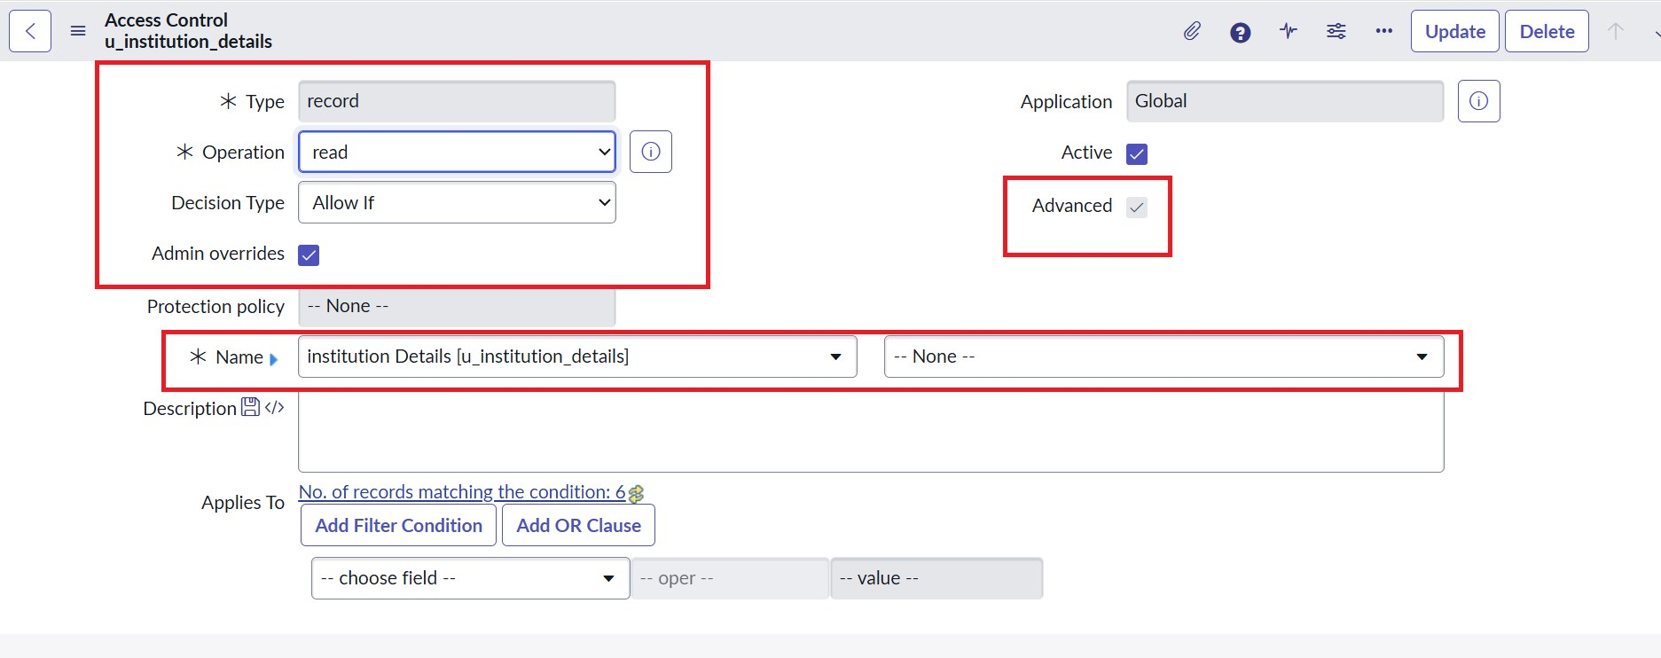
Type: record, Operation: read, Advanced: true

Screenshot 2 — Data condition and script
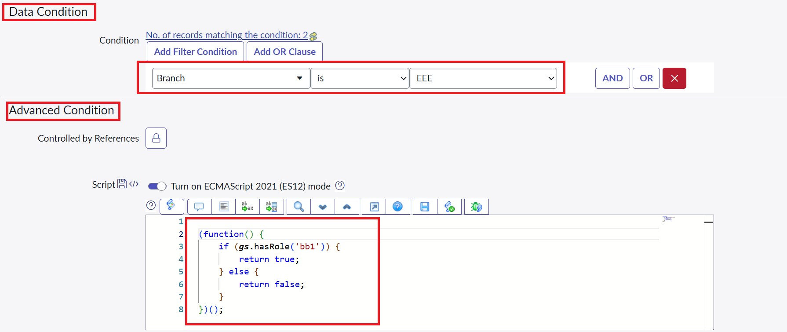
Branch is EEE with the advanced role-check script

Screenshot 3 — bb1 user – only EEE records
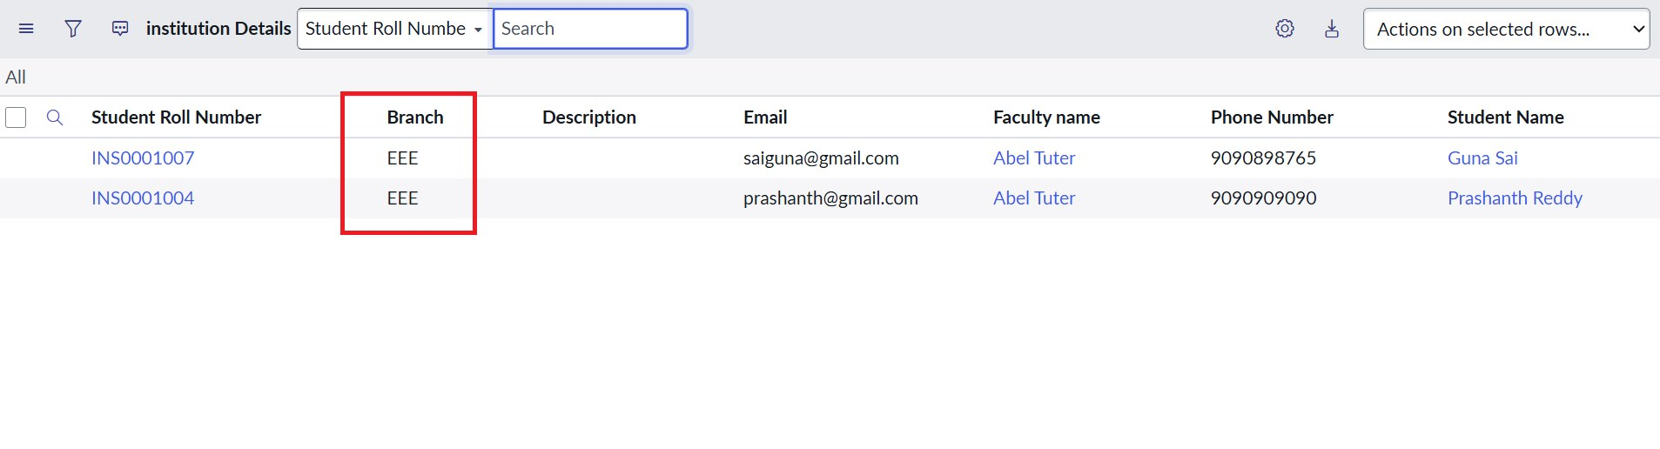
User with the bb1 role sees only EEE branch records

Screenshot 4 — User without role – no records
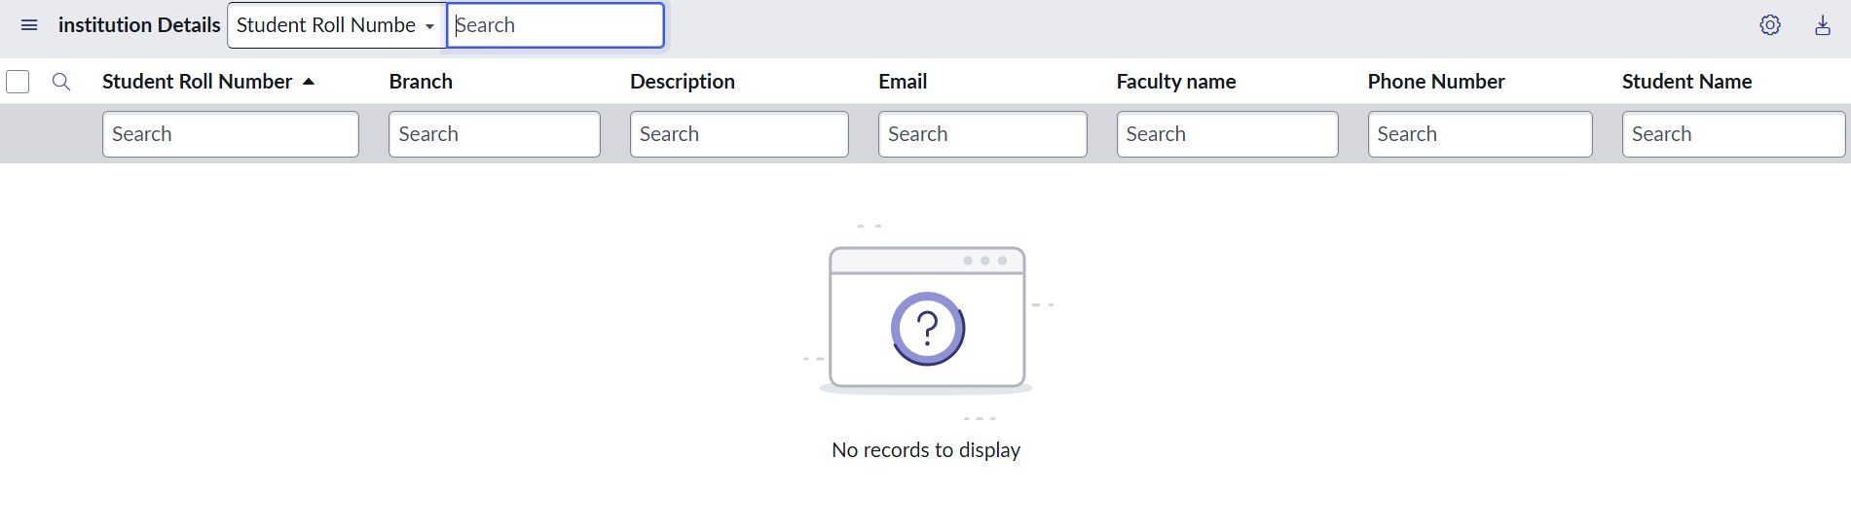
No records to display

Screenshot 5 — Admin – all records
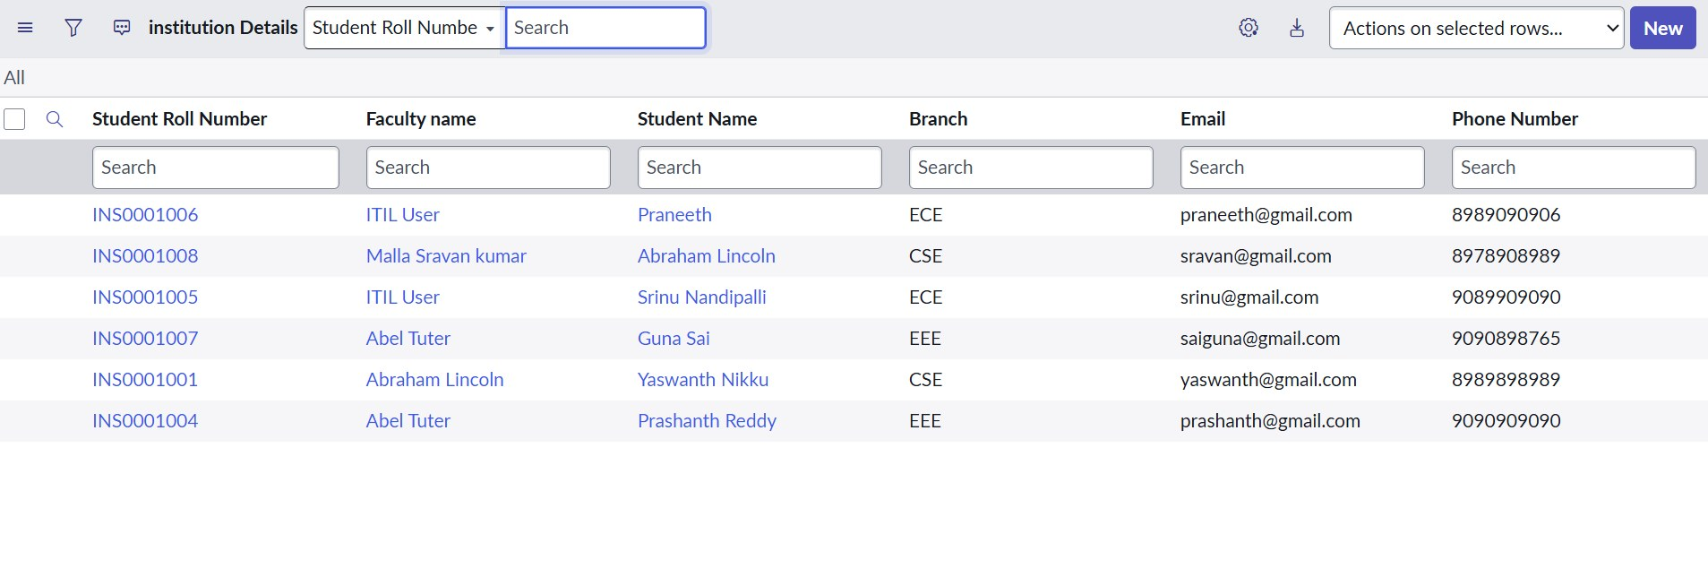
Admin sees all records regardless of branch

Screenshot 6 — Create ACL result
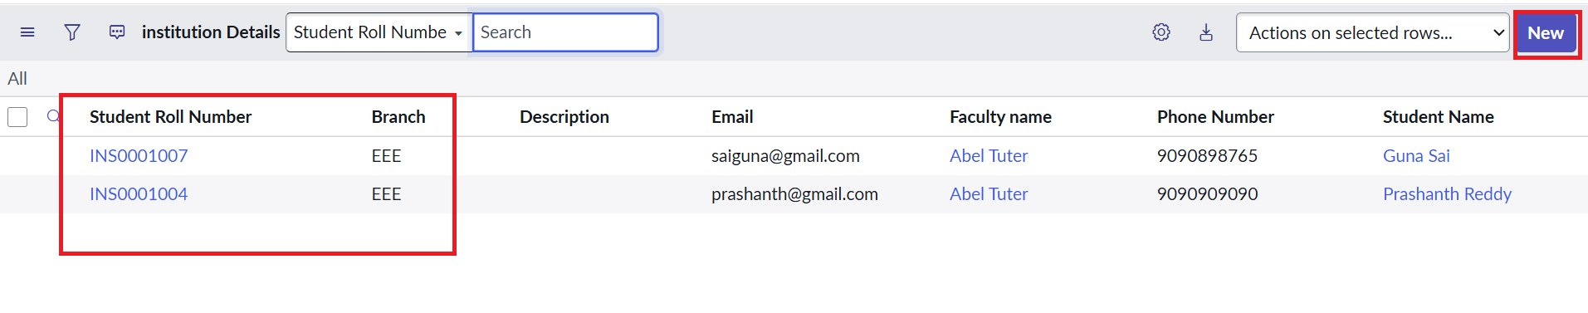
The New button appears for users with bb1 and bb2

Screenshot 7 — Write ACL result
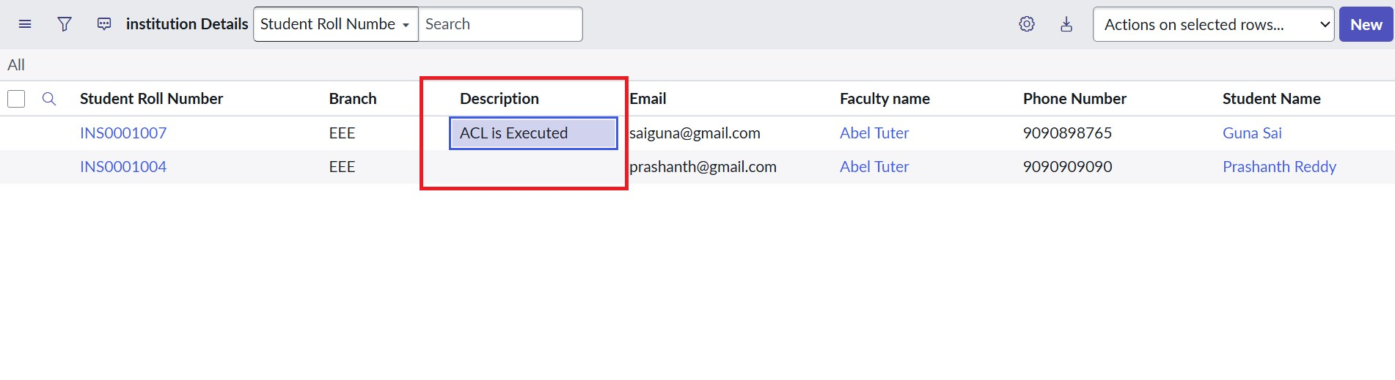
Description edited by a user with bb1, bb2 and bb3

Screenshot 8 — Delete ACL result
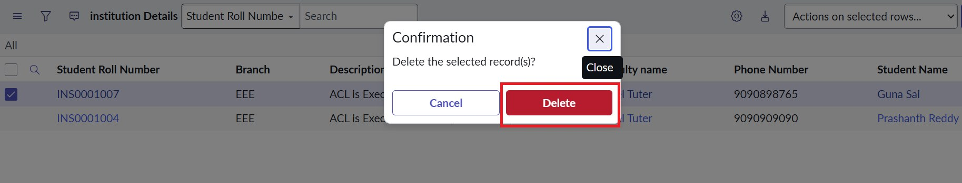
Delete confirmation for a selected EEE record

9. Challenges and Learnings
- Elevate first: ACLs can be created only after elevating the security_admin role.
- Roles must be assigned: without bb1 to bb4 on the test user, records or buttons do not appear.
- Advanced flag: the Read ACL script works only when Advanced is enabled.
- Data condition vs script: the field-value filter is done by the data condition, while the script checks the role.
- Field type: Branch should be a Choice field so the condition offers a dropdown.

10. Future Enhancements
- Assign ACL roles to groups instead of individual users for easier maintenance.
- Add field-level ACLs to hide sensitive fields such as phone number and email.
- Extend the branch-based rule to ECE and CSE with separate roles.
- Automate the test cases with the ServiceNow Automated Test Framework.
- Expose the records through a Service Portal page and confirm the ACLs apply there too.

11. Conclusion
The project shows how roles, field values and a script can work together to give record-level security in ServiceNow. Users with bb1 see only EEE branch records, users without the role see nothing, and admins see everything, while creating, editing and deleting are controlled through bb2, bb3 and bb4. All test cases passed, so the project meets its objective.

