PHASE 8
Demonstration
Script-Controlled ACL – Restrict Record Access Based on Field Value
Field | Details
Date | 30.9.2026
Team ID | 6ab4dcafa238dc999eb5d928
Project Name | Script-Controlled ACL – Restrict Record Access Based on Field Value
Platform | ServiceNow (Global scope)
Demo Duration | About 10 minutes
Demo Video Link | https://drive.google.com/file/d/1XL-zInBaSgZcZE5kp5v4o3hNAWqN7851/view?usp=drivesdk

Purpose
This phase presents the demonstration of the project: what will be shown, the step-by-step demo flow with talking points, the expected result at each step, screenshot evidence, and answers to likely questions.

1. Demo Overview
The demo shows how a script-controlled ACL restricts access to the Institution Details table. The same list is opened by three kinds of users, and the audience sees that each one gets a different result.

What the audience will see
- An admin sees all records (ECE, EEE and CSE).
- A user with the bb1 role sees only the EEE records.
- A user without the role sees no records.
- The New button, inline editing and Delete action appear only when the user has bb2, bb3 and bb4.

2. Demo Preparation Checklist
Item | Check
Table u_institution_details has records for ECE, EEE and CSE | Ready before the demo
EEE User has roles bb1, bb2, bb3, bb4 | Ready before the demo
Read, Create, Write and Delete ACLs are active | Ready before the demo
Admin account is logged in; Impersonate user is available | Ready before the demo
Browser tabs: u_institution_details.list and Access Control (ACL) | Open before the demo
Screen recording tool is running (if recording the demo) | Start before the demo

3. Demo Flow and Script
Step | Time | Action | What to say | Expected result
1 | 1 min | Introduce the project | Institution records are sensitive; access must depend on role and Branch value. | Audience understands the goal
2 | 1 min | Open u_institution_details.list as Admin | Admin has full access, so all branches are visible. | All 6 records shown
3 | 2 min | Open the Read ACL | Requires bb1, data condition Branch is EEE, and an advanced script. | ACL settings displayed
4 | 1 min | Impersonate EEE User (bb1) | Only EEE records pass the ACL. | 2 EEE records; no New button
5 | 1 min | Impersonate a user without bb1 | No role means no access. | No records to display
6 | 1 min | Show Create ACL (bb2) | With bb2 the user can add records. | New button appears
7 | 1 min | Show Write ACL (bb3) | With bb3 the user can edit fields. | Description edited
8 | 1 min | Show Delete ACL (bb4) | With bb4 the user can delete records. | Delete option and confirmation
9 | 1 min | Conclude | Roles, field values and a script protect the data. | Summary given

4. Demo Screenshots
The screenshots below follow the demo steps.

Screenshot 1 — Step 2 – Admin sees all records
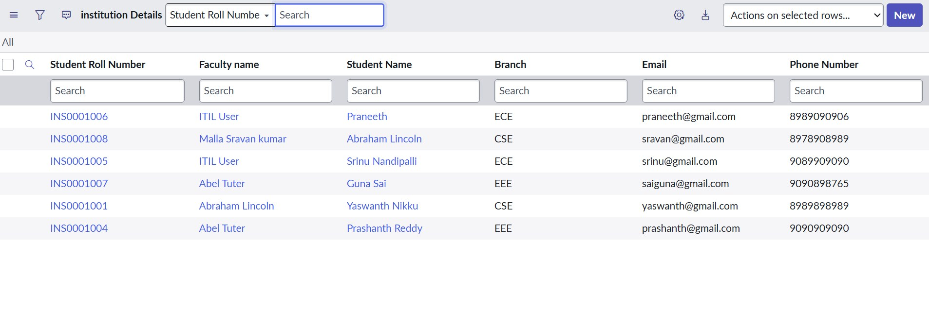
Admin sees all records regardless of branch

Screenshot 2 — Step 3 – Read ACL configuration
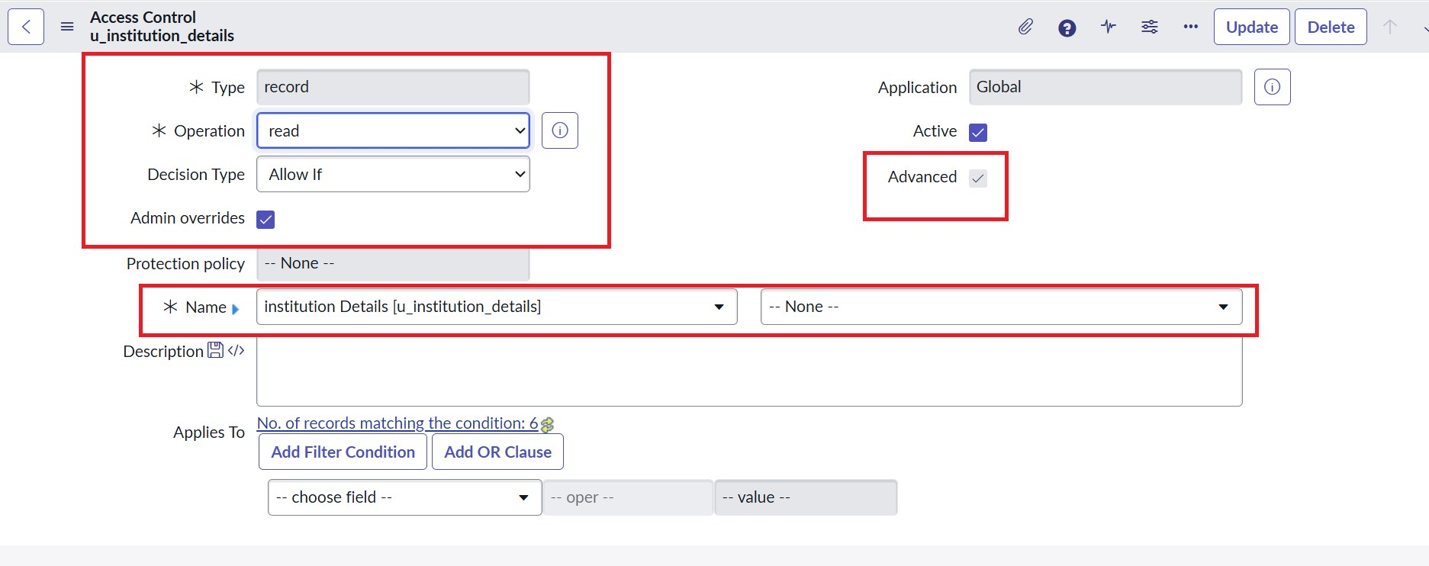
Type: record, Operation: read, Advanced: true

Screenshot 3 — Step 3 – Data condition and script
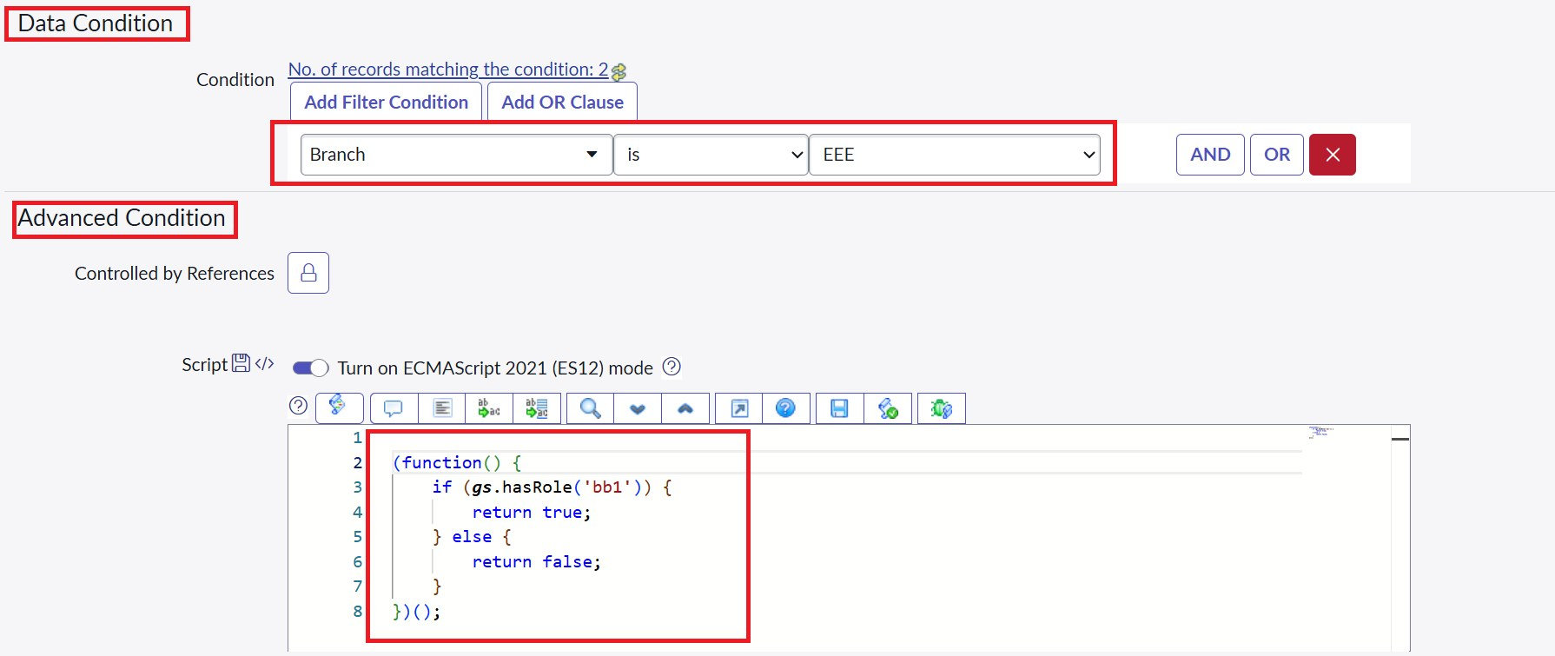
Branch is EEE with the advanced role-check script

Screenshot 4 — Step 4 – bb1 user
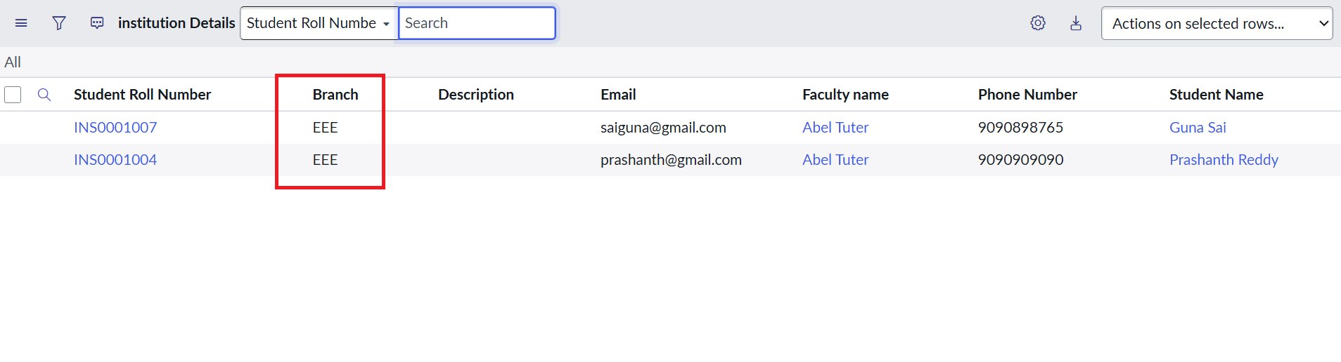
User with the bb1 role sees only EEE branch records

Screenshot 5 — Step 5 – User without role
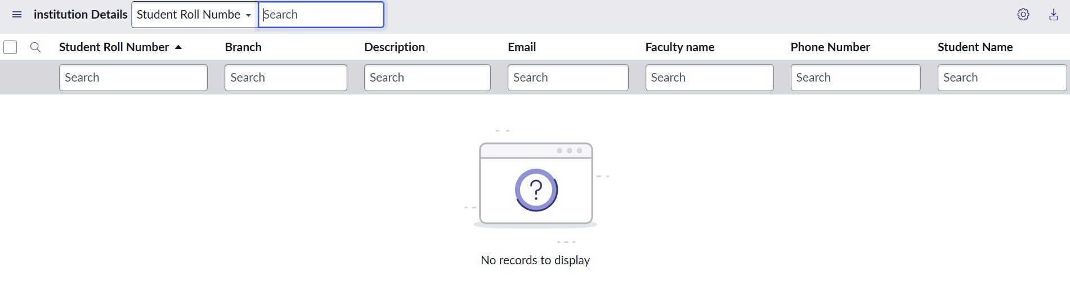
No records to display

Screenshot 6 — Step 6 – Create ACL
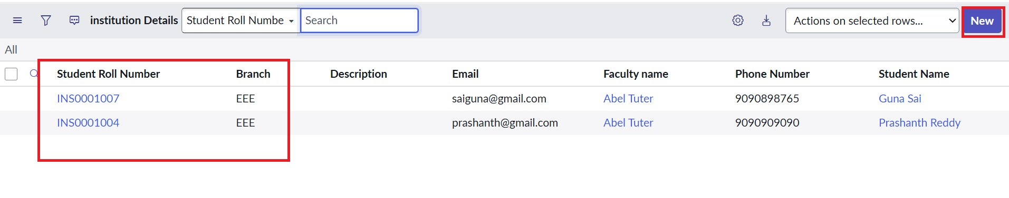
The New button appears for users with bb1 and bb2

Screenshot 7 — Step 7 – Write ACL
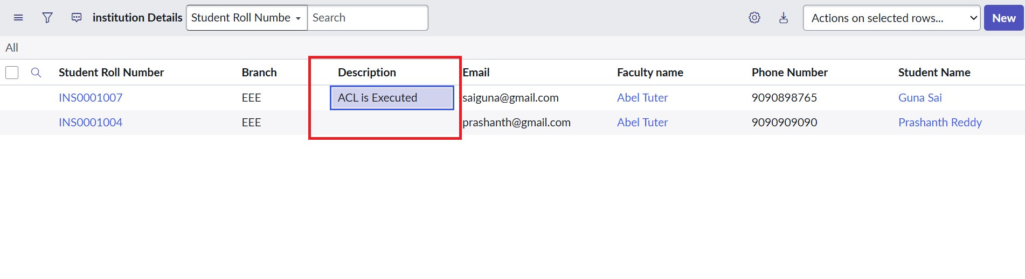
Description edited by a user with bb1, bb2 and bb3

Screenshot 8 — Step 8 – Delete ACL
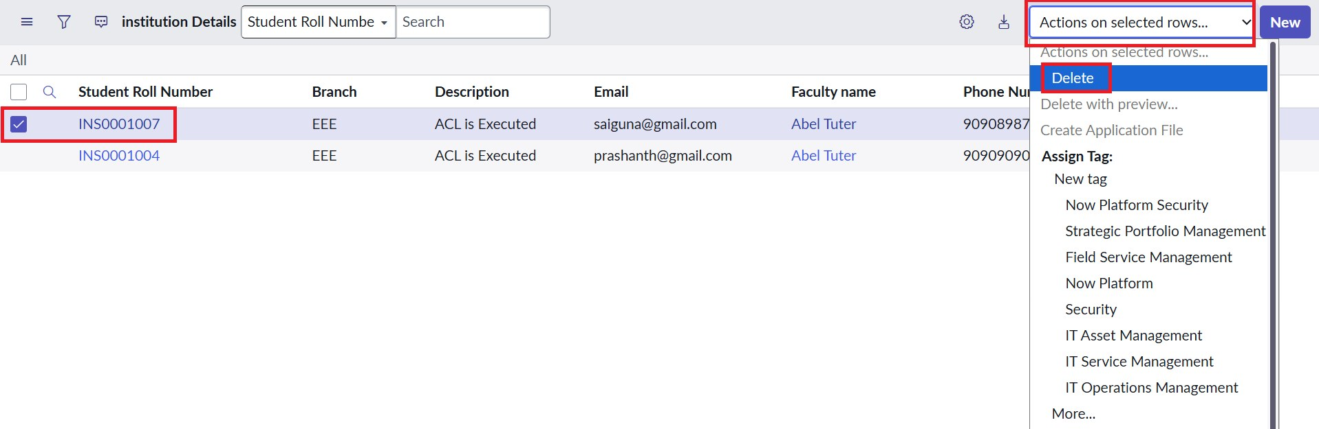
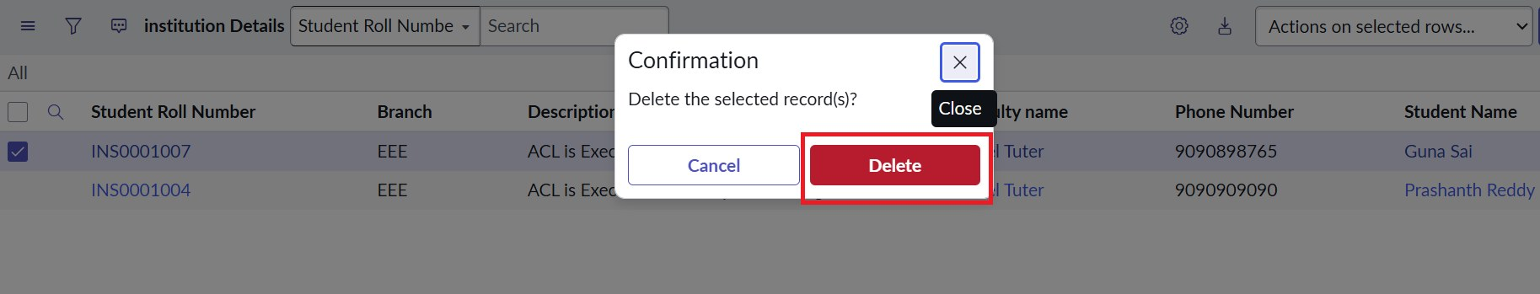
Delete action and confirmation for a selected EEE record

5. Questions and Answers
Question | Answer
Why use both a data condition and a script? | The data condition filters records by Branch; the script checks the role. Access is granted only when all conditions pass.
Can a bb1 user see ECE or CSE records? | No. Those records fail the Branch is EEE condition, so they are hidden.
Why can the admin see everything? | Admin overrides is enabled on the ACLs, so the admin role is not blocked.
Why separate roles for create, edit and delete? | It follows least privilege: each user gets only the permissions needed.
Why is security_admin elevation needed? | Only an elevated security_admin can create or change ACLs.
What if the Advanced box is not checked? | The script is ignored, so the script logic does not run.

6. Key Takeaways
- Record-level security can combine role, field value and script logic.
- ACLs give separate control over read, create, write and delete.
- Impersonation makes it easy to prove the behaviour for different users.

7. Conclusion
The demonstration proves that the ACLs work as designed: EEE records for bb1 users, no records without the role, full access for admins, and controlled create, edit and delete actions through bb2, bb3 and bb4.

