
Санкт-Петербургское государственное бюджетное
профессиональное образовательное учреждение
«Радиотехнический колледж»
ОТЧЕТ
по лабораторной работе № 3
«Построение диаграммы компонентов»
по дисциплине МДК.05.02
Разработка кода информационных систем.
специальность 09.02.07
Информационные системы и программирование.
Выполнил: студент группы № ИВ2-22
Гребенников Дмитрий

Проверил: преподаватель
Харин Е.Н.

abstract
The report is made in 1 part and contains: pages— 7, words— 199, images— 1
Aim: to consolidate the practical skills of constructing a component diagram.

Contents
abstract 1
introduction 3
Body of the report 4
conclusion 6

introduction

Body of the report

Image 1 — Diagram

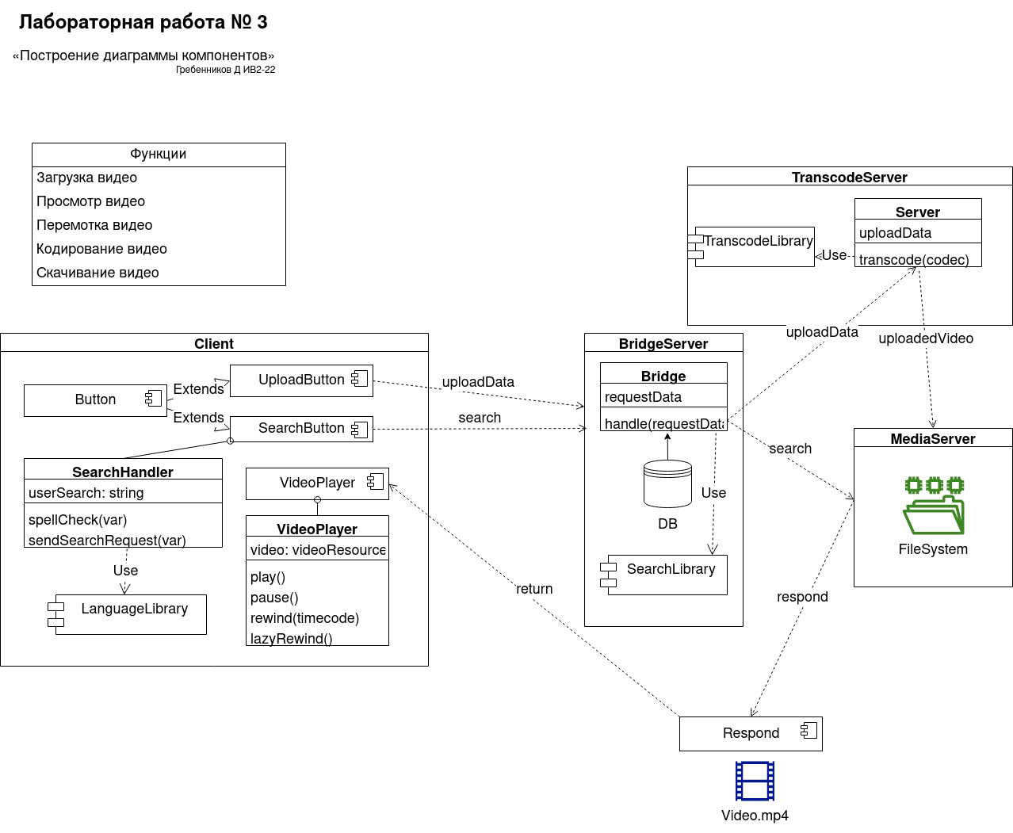
Components Description
UploadButton: View
Upload: Controller
Sends ‘upload’ request with video data to BridgeServer

SearchButton: View
SearchHandler: Controller
Contains a ‘search’ request. Processes the request by correcting grammatical errors using a third-party module. Makes a quick request to ServerBridge to generate hints for the user. After processing, sends the main request to ServerBridge

VideoPlayer: View
VideoPlayer: Controller
Implements video player functional

BridgeServer: Model
Provides a connection between client and required server.
In our case, depending on request type redirects to TranscodeServer or directly to MediaServer.

TranscodeServer: Model
Transcodes video data to supported format using a third-party module, upload output to available MediaServer

MediaServer: Model
Contains uploaded videos

conclusion

