EXPERIMENT – 6

AIM
To implement modules in Node.js by creating, exporting, importing, and using functions from separate JavaScript files.

DESCRIPTION
This experiment demonstrates the module concept in Node.js. A separate module is created to contain reusable functions, which are exported from the module file and imported into the main JavaScript file. The imported functions are then executed to produce the required output.

PROGRAM
Client.js
const os = require('os'); const path = require('path'); const dns = require('dns'); const net = require('net');
const readline = require('readline'); const rl = readline.createInterface({
input: process.stdin, output: process.stdout
});
function osFunction(){ console.log('platform : '+os.platform());
console.log('CPU architecture : '+os.arch()); console.log('CPU information: ',os.cpus()); console.log('Total memory: '+os.totalmem() +"bytes."); console.log('Free memory: '+os.freemem() +"bytes."); showMenu();
}

function pathFunction() {
rl.question("Enter a file path: ", (filePath) => { console.log("Directory: " + path.dirname(filePath)); console.log("File name: " + path.basename(filePath)); console.log("Extension: " + path.extname(filePath)); console.log("Normalized path: " + path.normalize(filePath)); showMenu();
});
}
function dnsFunction(){
rl.question("Enter a domain name: " ,(domainname) =>{ dns.lookup(domainname,(err,address) => {
if (err){
console.log("Error: "+err.message); return;
}
console.log("IP address: "+ address); showMenu();
});
});
}
function netFunction(){
const server = net.createServer((socket) => { console.log("Client Connected");

socket.write("Welcome to the Node.js TCP Server!"); socket.on("data", (data) => {

console.log("Message from Client:", data.toString());
});
socket.on("end", () => { console.log("Client disconnected");
});
});
server.listen(5000, () => {
console.log("Server is running on port 5000");
});
}
function showMenu() { console.log("\n========================================");
console.log(" Node.js System and Network Information"); console.log("========================================");
console.log("1. Operating System Information"); console.log("2. File Path Information"); console.log("3. DNS Lookup");
console.log("4. TCP Server"); console.log("5. Exit");
rl.question("Enter your choice: ", (choice) => { if (choice === "1") {
osFunction();
}
else if (choice === "2") { pathFunction();
}
else if (choice === "3") {

dnsFunction();
}
else if (choice === "4") { netFunction();
}
else if (choice === "5") { console.log("Exiting..."); rl.close();
}
else {
console.log("Invalid choice."); showMenu();
}
});
}
showMenu();

Server.js
const net = require('net');
const client = net.createConnection(5000, 'localhost', () => { console.log('Connected to server');
});
client.on('data', (data) => {
console.log('Message from server:', data.toString()); client.end();
});
client.on('close', () => { console.log('Connection closed');

});

DETAILS ABOUT PROGRAM
Folder structure:
FullStack/
└── Week-6/
├── Client.js
└── Server.js
The program is executed using Node.js in the VS Code Terminal. Execution steps:
- Open the Node-Modules folder in VS Code.
- Open the VS Code Terminal.
- Run the main JavaScript file using Node.js.
- The module is imported into the main program.
- The functions from the module are executed.
- The required output is displayed in the terminal.

OUTPUT
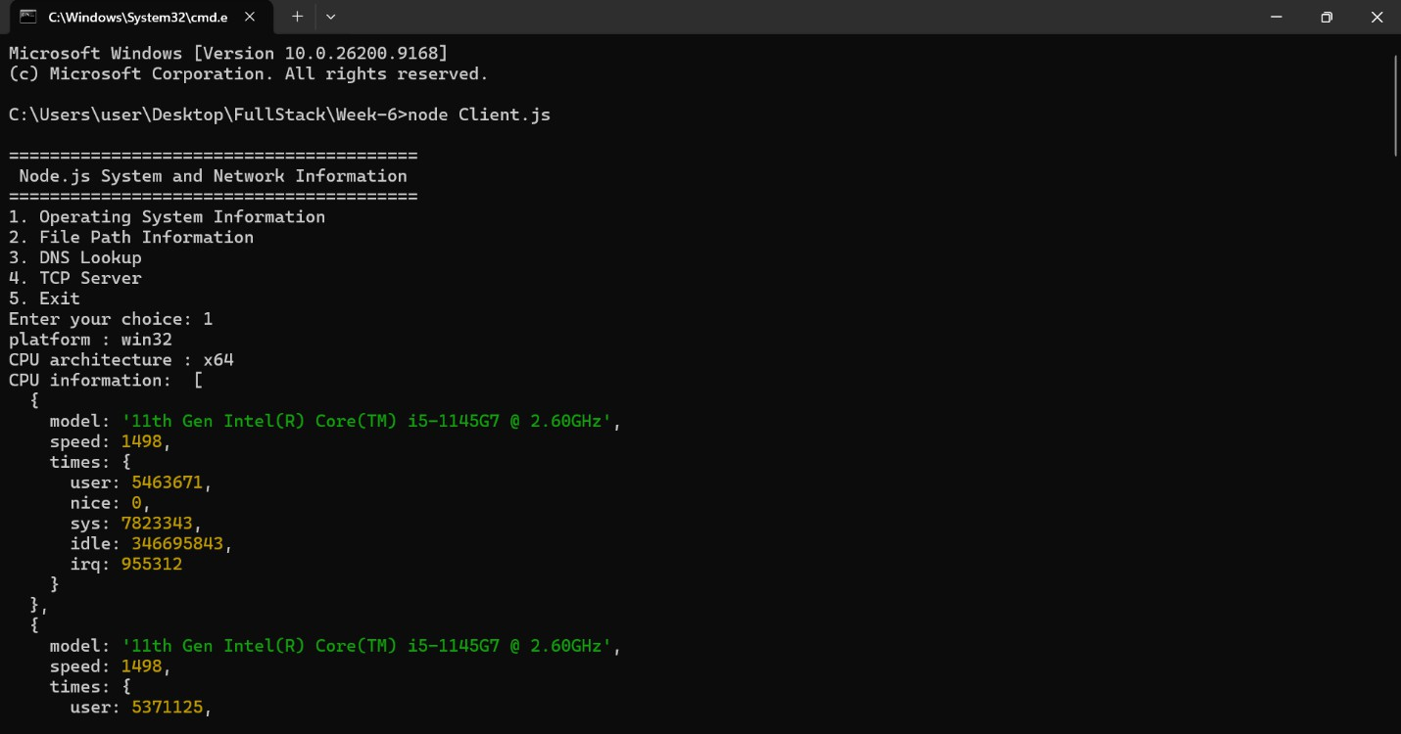
The Node.js module is successfully created, exported, imported, and executed, and the required output is displayed in the terminal.

