**ASSIGNMENT 1**

**PS ID: 10828639**

**Q) Can we convert the existing master detail relationship into lookup relationship, if yes then how?**

ANS:

Yes we can convert existing master detail relationship into lookup

When there are records present in child (i.e Student) it will show error,so we need to delete all records

We consider Trainer as a parent and Student as a child

We select student from object manager,then we click on the existing master detail relationship and click on edit then

Here we click on change field type,and change datatype into lookup and save it

Here Student got changed into lookup relationship

**Q)Can we convert the existing lookup relationship into master detail relationship, if yes then how?**

ANS:

Yes we can convert existing lookup relationship into master detail relationship

We consider Trainer as a parent and Student as a child

We select student from object manager,then we click on the existing lookup relationship and click on edit then

Here we click on change field type,and change datatype into lookup and save it

Here Student got changed into Master Detail relationship

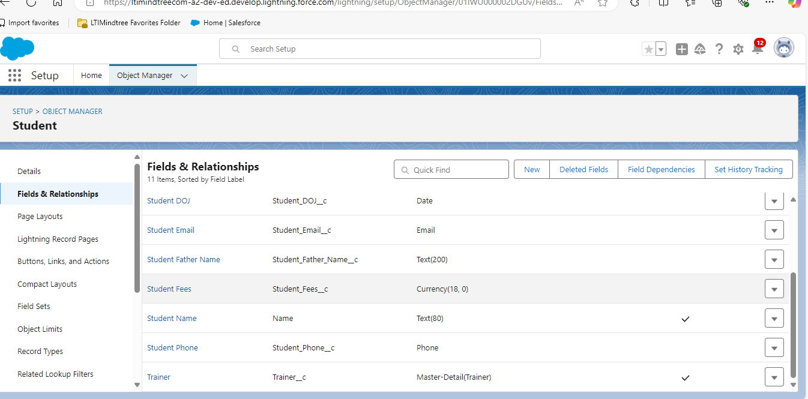

**Q) Whenever we are going to close invoice status as “Closed”, please make sure your invoice Closed Date should not be blank.**

Here first we go to Invoice object and we create a validation rule

We use “ISpickval” function return true if the invoice status field is selected to closed

We use “ISBlank” function to check whether the closed date is left blank or not.If it is blank it returns true

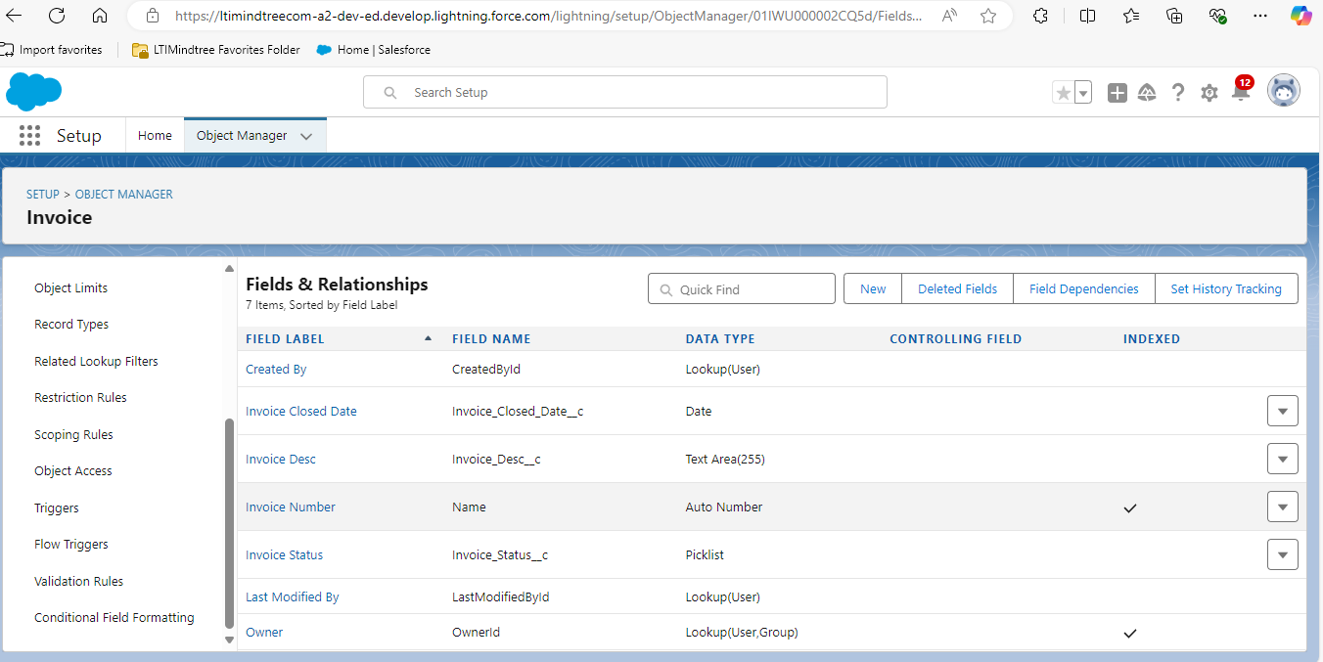

We check both the conditions using AND ,if both satisfy it returns true and shows error to add closed date mandatorily

Add an error message to enter date

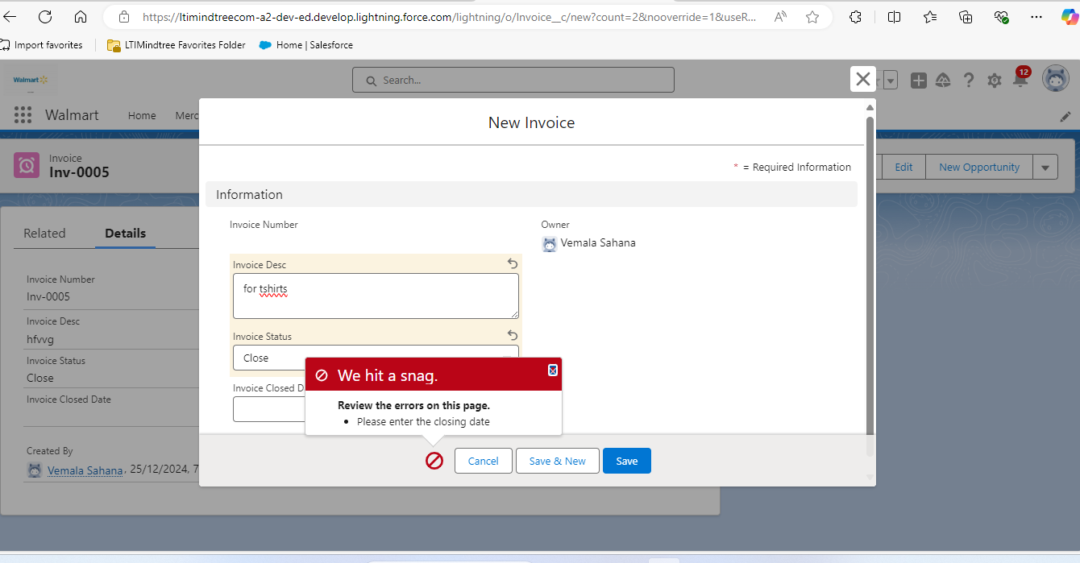

**Q) Whenever we are selling a product/item from SellItem Object then Selling stock mut also be reduced from Merchandise Object too.**

Here we go to APP manager and click Workflow rules

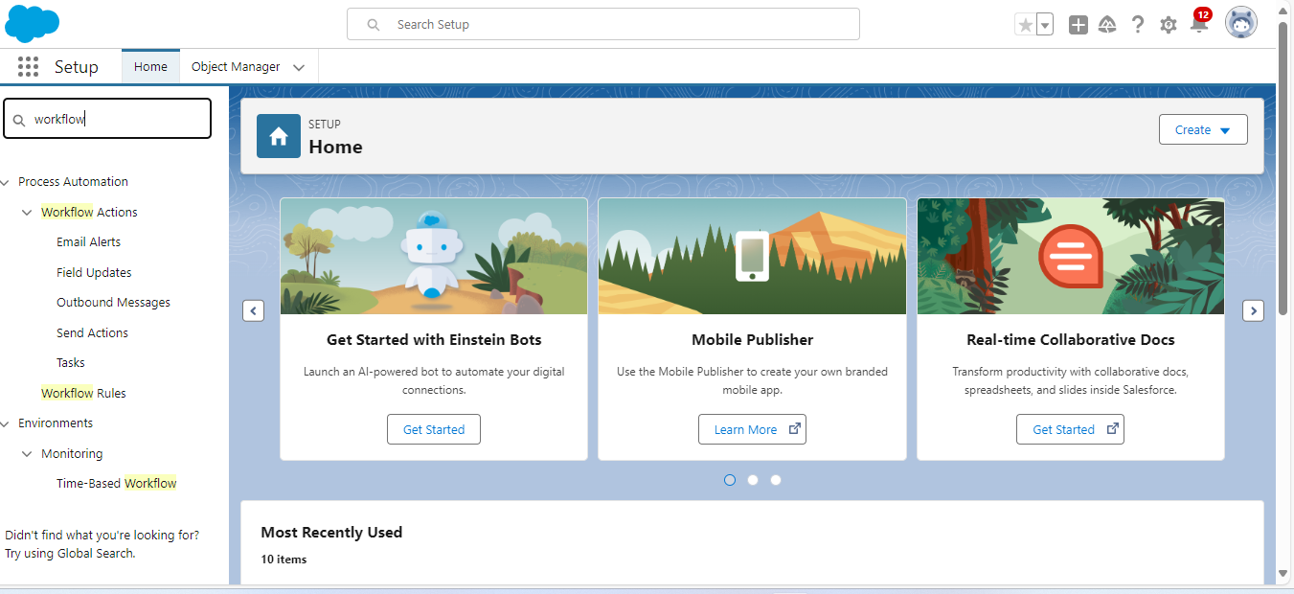

Give the rule name and select “created,and every time its edited” so it will be edited everytime we modify

Give rule criteria as “formula evaluates to true” and give formula as True

Then click save and next and add action as New Field Update

Then write the formula we already select merchandise stock so we just write formula(merchandise stock-sellitem stock)

Here we have 34,000 stock now lets sell item and check whether it is updated or not

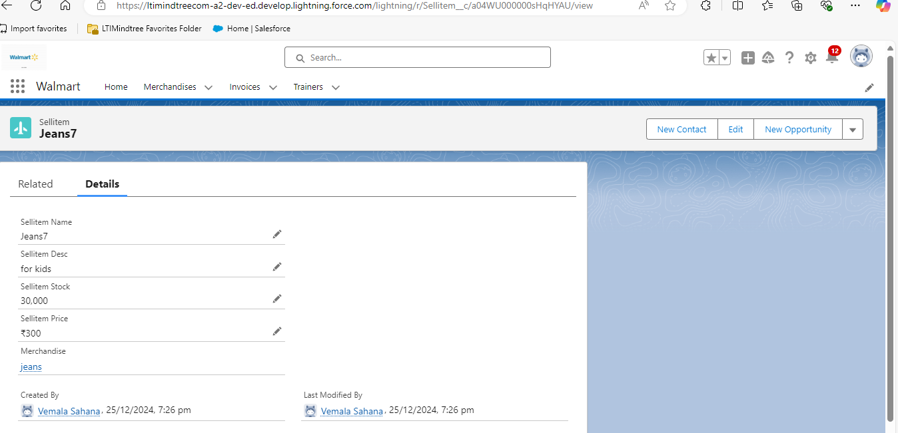

We sold 30000 stock and see the updated value

So finally the stock got reduced