Iranian Journal of Electrical and Electronic Engineering No. (YEAR) pp-pp
Implementation of an Electrical Facility Control and Prohibited Activity Detection System at Bahrul Ulum Mosque Using YOLOv8
Vemas Ardiyan Syah*(C.A.), Noorman Rinanto** and Muhammad Lukman Arif**
Abstract: This study presents a smart-mosque system that combines YOLOv8m-based computer vision with Internet of Things (IoT) control for occupancy-aware electrical-facility management and prohibited-activity monitoring in the second-floor women's prayer area of Bahrul Ulum Mosque, Politeknik Perkapalan Negeri Surabaya (PPNS). A TP-Link Tapo C212 camera supplies real-time video to an edge laptop, while an ESP32, a Light Dependent Resistor (LDR), a DS3231 Real-Time Clock (RTC), relay modules, HiveMQ, Supabase, Cloudflare Tunnel, and a web dashboard provide sensing, communication, actuation, logging, and supervision. The final dataset contained 8,948 labeled images divided into 8,040 training, 613 validation, and 295 test images. The model achieved validation precision of approximately 0.85, recall of 0.81-0.82, mAP@0.5 of 0.83-0.84, and mAP@0.5:0.95 of 0.51-0.52. Mean field confidence was 0.80 for worshippers, 0.85 for sleeping/overnight activity, and 0.79 for littering. The controlled phase load decreased from 1.4025 kW to 0.9537 kW, corresponding to a 448.8 W or approximately 32% reduction. The results demonstrate the feasibility of integrating visual activity detection directly with electrical control in an operational mosque environment.
Keywords: Computer vision, Energy efficiency, Internet of Things, Smart mosque, YOLOv8

1 Introduction
1.1 Background and Research Motivation
Vision-based automation has progressed from conventional surveillance toward systems that interpret occupancy and human activity as control inputs. Alzahrani, Bchir, and Ben Ismail introduced a spatiotemporal YOLO framework for action detection across multiple frames [1]. Challa, AlHmoud, Jaiswal, Gokaraju, and Tesireo demonstrated that real-time video can be combined with environmental sensing for occupancy estimation [2], while Chaudhari, Xiao, Cheng, and Li reviewed the fundamental algorithms and Internet of Things (IoT) technologies used for occupancy detection in smart buildings [3]. These studies support the use of visual sensing when the state of a room must be inferred more directly than is possible with schedule-based operation alone.
Recent activity-detection research has also expanded the YOLO family beyond ordinary person localization. Chen, Liu, Zhang, and Cai investigated joint human-location and action recognition [4]. Gawande, Hajari, and Golhar combined enhanced YOLOv5 with motion information for suspicious-activity recognition [5], whereas Gaya-Morey, Manresa-Yee, and Buades-Rubio summarized the challenges of vision-based activity recognition and fall detection [6]. Behavior-specific YOLOv8 models have been applied to classroom activity detection [7], and Hermens evaluated YOLOv8 for automated behavioral research [8]. Huang and Abisado further showed that lightweight YOLOv8 variants can support safety-behavior detection [9].
Occupancy information is particularly relevant to energy-aware building operation. Khan, Zedadra, Guerrieri, and Spezzano reviewed occupancy prediction for IoT-enabled smart buildings [10]. Improved YOLOv8 has been applied to high-precision human fall detection [11], while dense-crowd abnormal-behavior detection has been studied using YOLOv8 [12]. Occlusion remains a recognized challenge in smart video surveillance [13], and comparative analyses of the YOLO family emphasize the trade-off between detector complexity, accuracy, and speed [14]. Data augmentation can materially influence robustness [15], and attention-enhanced one-stage models have been proposed for real-time human fall detection [16].
At the building-control level, precise occupancy detection has been linked to energy efficiency using convolutional neural networks [17]. Reviews of human activity/action recognition emphasize the importance of representative data and temporal context [18], while occupancy behavior has been identified as a central variable in building energy performance [19]. High-accuracy occupancy counting has been demonstrated at crowded smart-building entrances [20], and computer vision has been reviewed as an enabling technology for occupant-centric sensing and control [21]. Non-visual alternatives using passive infrared sensors and smart-meter data remain attractive for low-cost occupancy estimation [22], but they provide limited semantic information about activity classes.
Improved YOLO networks have been designed for human detection in complex indoor scenes [23], including lightweight YOLOv8 models for fast indoor occupancy detection [24]. Vision-based occupancy studies have compared deep-learning detectors in highly occupied buildings [25] and standard RGB with thermal cameras [26]. Consumer network cameras have also been used for abnormal-behavior detection [27], whereas direct comparisons between single-shot and two-stage occupancy detectors highlight the computational advantage of one-stage inference for continuous applications [28]. These developments are consistent with the broader evolution of modern object detection summarized by Zou, Chen, Shi, Guo, and Ye [29].
Bahrul Ulum Mosque at PPNS presents a practical setting in which these research directions intersect. The second-floor women's prayer area requires lighting and ventilation control that follows actual room use, but continuous direct supervision is constrained by access and privacy considerations. Field observation also identified the need to support detection of littering and potential sleeping/overnight activity outside the intended operating period. Therefore, the research problem is not only object recognition; it is the integration of computer vision, embedded control, communication, and electrical actuation in one operational facility.
1.2 Objectives and Contributions
The objective is to design and evaluate an integrated system that (1) detects worshipper presence and two prohibited-activity classes using a custom YOLOv8m model, (2) translates the visual results and sensor states into automatic lamp and fan commands, (3) provides local and web-based monitoring with bidirectional control, and (4) quantifies detector performance, system response, and electrical-load reduction under field conditions. The principal contribution is the end-to-end deployment of a single three-class visual detector as an actionable input to electrical-facility control in a mosque rather than as a stand-alone monitoring module.
The work also contributes a complete implementation chain consisting of a day/night IP camera, edge inference, ESP32 control, ambient-light and time sensing, relay-based actuation, MQTT communication, cloud database logging, a web interface, and field-installed electrical protection. Unlike studies that evaluate only the detector or only occupancy sensing, this study evaluates model convergence, class-wise detection behavior, actuator responses, communication delay, and before-after controlled-load power in the same system.
2 Literature Review
2.1 Vision-Based Occupancy Detection
Vision-based occupancy systems estimate presence, location, or count directly from images, which can provide richer spatial information than binary sensors. Smart-building research has used convolutional networks, one-stage detectors, two-stage detectors, and multimodal combinations for this purpose [3], [10], [17], [20], [21], [23], [24], [25], [26], [28]. The principal benefit for control is that the same camera can provide both occupancy count and spatial context; the principal limitation is sensitivity to viewpoint, occlusion, object scale, lighting, and clothing variation.
2.2 Human Activity and Prohibited-Behavior Detection
Activity detection introduces a more difficult recognition problem because visually similar poses can correspond to different behaviors. Multi-frame and motion-assisted approaches improve temporal understanding [1], [5], whereas behavior-specific YOLO models demonstrate that one-stage detectors can be adapted to specialized classes [7], [9], [11], [12], [16]. Reviews also emphasize that pose variation, temporal cues, and dataset coverage affect generalization [6], [18]. In the present application, sleeping and littering may both contain lowered or horizontal body configurations, making false association between the classes a foreseeable risk.
2.3 IoT-Based Building Control and Energy Efficiency
Occupancy becomes operationally valuable when detection results are connected to control. IoT-enabled occupancy systems have used cameras, environmental sensors, passive infrared sensing, smart meters, and networked controllers to reduce unnecessary operation of building services [2], [3], [10], [17], [19], [21], [22]. However, many studies focus on prediction or monitoring and do not combine activity-specific vision with direct actuation. The proposed system therefore couples visual occupancy and behavior information to physical relays controlling lighting and fan-speed circuits.
2.4 Research Gap and Novelty
The literature indicates three partially separate research streams: vision-based occupancy, activity recognition, and IoT energy control. The gap addressed here is their deployment as one integrated smart-mosque system. The novelty is not a new YOLO backbone; it is the application-level integration of a custom YOLOv8m detector with electrical-facility control, environmental/time sensing, persistent monitoring, and an installed panel in a real religious facility. This emphasis on system integration and field validation is summarized in Table 1.
Table 1. Position of the proposed work relative to representative approaches.
Approach | Representative sources | Relevance / limitation
Sensor-based occupancy | [2], [3], [10], [17], [22] | Low visual-processing cost; limited semantic distinction among worshipper, sleeping, and littering classes.
Vision-based occupancy | [20], [21], [23], [24], [25], [26], [28] | Provides location/count information; many studies stop at sensing or monitoring.
Activity-oriented YOLO | [1], [4], [5], [6], [7], [9], [11], [12], [16], [18], [27] | Provides richer behavior evidence; temporal/pose-aware methods may increase implementation complexity.
Proposed system | YOLOv8m + IoT electrical control | One three-class detector is integrated with lamp/fan control, sensors, MQTT, database logging, and web monitoring in an operational mosque.
3 System Architecture and Design
3.1 Overall System Architecture
Fig. 1 presents the implemented architecture. A TP-Link Tapo C212 Internet Protocol (IP) camera provides a Real-Time Streaming Protocol (RTSP) stream to an edge laptop running Python, OpenCV, the YOLOv8m model, and a Flask backend. Visual inference remains on the edge computer, while the ESP32 performs low-level sensing and actuation. Message Queuing Telemetry Transport (MQTT) through HiveMQ Cloud provides bidirectional communication, Supabase stores operational information, and Cloudflare Tunnel exposes the local web application without conventional public-port forwarding.
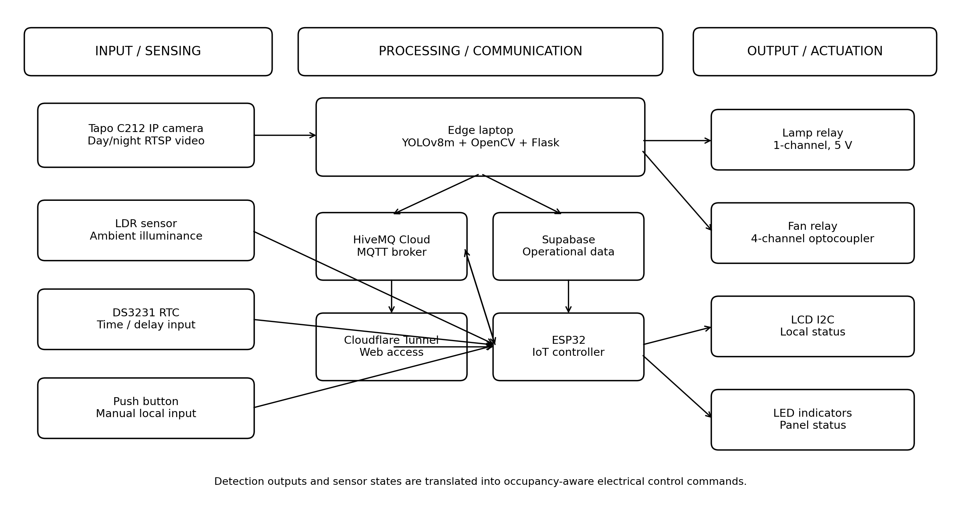
Fig. 1. Implemented smart-mosque sensing, processing, communication, and actuation architecture.
3.2 Hardware and Electrical Panel Design
The prototype was designed as an installed control panel rather than a bench-only circuit. The 220 V ac supply passes through a 4 A miniature circuit breaker (MCB), a 2 A fuse, and terminal blocks before entering a 12 V, 10 A switching power supply. A 5 V, 3 A dc-dc step-down module supplies the ESP32 and low-voltage control electronics. The panel also contains relay modules, an LCD I2C, indicator lamps, and distribution wiring. The arrangement separates low-voltage control wiring from the ac load path and provides accessible protection and maintenance points.
The four-channel optocoupler relay is used for the fan circuit, with tested control channels connected to ESP32 GPIO 25, 26, and 27. The one-channel lamp relay is driven from GPIO 33. The LCD I2C uses GPIO 21 for SCL and GPIO 22 for SDA. The camera, router, panel, wall fan, and lamp were positioned in the second-floor prayer area so that visual coverage, wireless connectivity, cable routing, and maintenance access could be maintained without interfering with normal worship activities.
Table 2. Principal hardware and implementation roles.
Component | Function in the system
Tapo C212 IP camera | Day/night RTSP video source for YOLOv8m inference.
Edge laptop | YOLOv8m, OpenCV, Flask backend, RTSP acquisition, and web services.
ESP32 | Sensor acquisition, MQTT communication, local state logic, and relay control.
Protection / power | 220 V ac -> MCB 4 A -> fuse 2 A -> terminal block -> 12 V/10 A supply -> 5 V/3 A step-down.
LDR + DS3231 RTC | Ambient illuminance and time/delay information.
Fan relay | Four-channel optocoupler module; tested fan outputs on GPIO 25-27.
Lamp relay | One-channel 5 V relay controlled from GPIO 33.
LCD I2C | Local status display; SCL GPIO 21 and SDA GPIO 22.
HiveMQ / Supabase / Cloudflare | MQTT messaging, data storage, and remote web access.
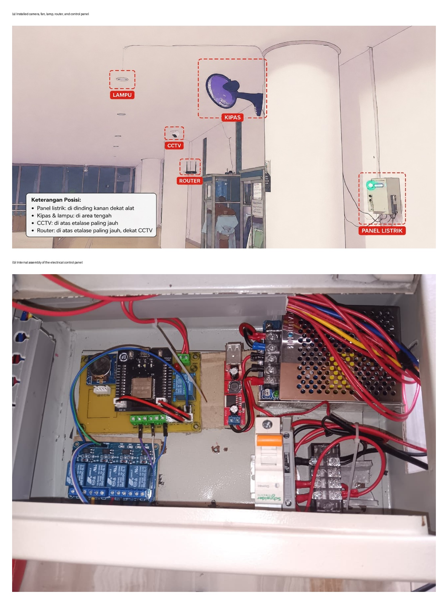
Fig. 2. Field implementation: (a) installed devices and (b) internal control-panel assembly.
3.3 Software, Communication, and Web Monitoring
The software stack is centered on a Python/Flask backend that acquires RTSP frames, executes YOLOv8m inference, handles device states, and serves the web interface. MQTT publish-subscribe messaging decouples the edge computer from the ESP32 and permits two-way updates for detection results, sensor values, actuator commands, and actuator feedback. Supabase records operational information, while the web interface displays worshipper count, fan speed, lamp status, ambient-light information, and camera status. Manual controls provide a supervisory override for lamp, fan-speed, camera pan-tilt-zoom (PTZ), and system reset functions.
A system log records initialization, MQTT connection state, camera availability, mode changes, actuator transitions, and communication events with timestamps. This logging layer is important for troubleshooting because a field failure may originate from the camera stream, local Wi-Fi, MQTT, backend logic, or ESP32 connectivity rather than from the detector itself. Fig. 3 shows the implemented monitoring interface together with an example of a field detection event.
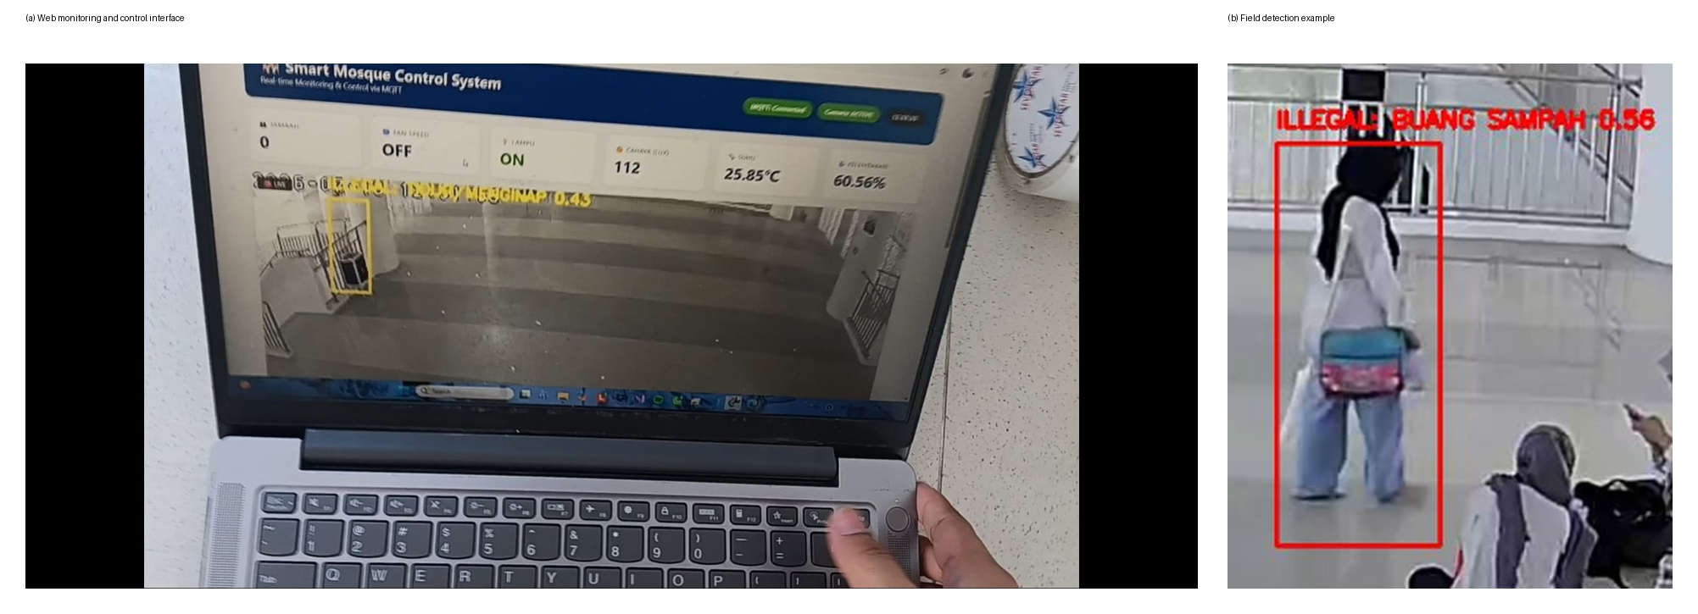
Fig. 3. Implemented web monitoring interface and representative field detection output.
3.4 Detection and Control Strategy
Each acquired frame is resized/letterboxed to 640 x 640 pixels and forwarded to YOLOv8m. The detector extracts multi-scale features and produces bounding boxes, class labels, and confidence scores for three target classes: worshipper, sleeping/overnight activity, and littering activity. Unlike an image-level classifier, the model retains object localization, allowing multiple people or activities to be represented in a single camera frame.
The primary facility-control variable is the detected worshipper count. With zero detected worshippers, the tested fan outputs remain off; increasing occupancy produces progressively higher fan-speed states. Lighting decisions combine worshipper detection with the LDR, so the lamp is not energized when the room has sufficient natural illumination. The RTC provides time information and supports delayed switching. For prohibited-activity monitoring, the detector supplies class evidence, while operational interpretation can also consider event persistence and time-of-day. This distinction is important because the trained detector itself is fundamentally a visual object detector rather than a complete temporal behavior-recognition model.
For a convolutional feature extractor, a feature value can be expressed generally by Eq. (1), followed by the Rectified Linear Unit (ReLU) nonlinearity in Eq. (2). These equations summarize the local feature extraction used by convolutional neural networks; the implemented YOLOv8m architecture internally applies its own configured convolutional, C2f, SPPF, feature-fusion, and detection-head modules.
Y(i,j,k) = Σ_m Σ_u Σ_v W(u,v,m,k) X(i+u,j+v,m) + b(k) | (1)
ReLU(z) = max(0, z) | (2)
4 Dataset, Training, and Evaluation Method
4.1 Dataset Preparation
The final dataset contained 8,948 labeled images representing worshipper presence, sleeping/overnight activity, and littering activity. The images included standing, sitting, moving, grouped worshippers, varying object scale, and different indoor-lighting conditions. Annotation was performed using Roboflow with bounding boxes. Preprocessing included resizing and normalization, while augmentation included rotation, flipping, and lighting variation to improve generalization to realistic mosque conditions.
The dataset was partitioned into 8,040 training images (90%), 613 validation images (7%), and 295 test images (3%). The large training portion was used to update model weights, the validation set monitored generalization and early stopping, and the held-out test set supported final evaluation. Fig. 4 illustrates the split.
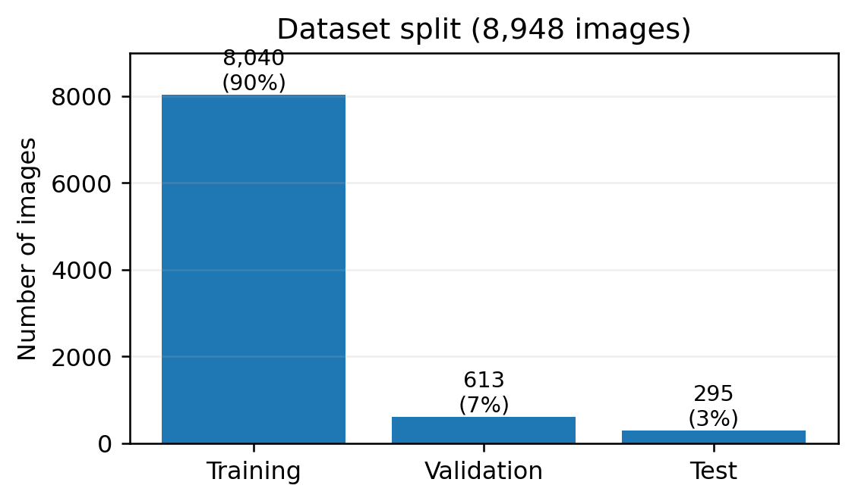
Fig. 4. Dataset allocation used for YOLOv8m development.
4.2 Training Configuration
Training was conducted in Kaggle Notebooks using an NVIDIA Tesla T4 GPU and the Ultralytics YOLOv8 framework. The input image size was 640 x 640 pixels, batch size was 16, and optimizer selection was automatic. A maximum of 220 epochs was configured with early-stopping patience of 45 epochs. The best validation fitness occurred at approximately epoch 64; training stopped automatically at approximately epoch 109, and the corresponding best.pt weights were selected for integration.
Table 3. Dataset split and YOLOv8m training configuration.
Item | Value
Model | YOLOv8m
Training platform | Kaggle Notebooks
GPU | NVIDIA Tesla T4
Image size | 640 x 640 pixels
Batch size | 16
Optimizer | Automatic (Ultralytics)
Maximum epochs | 220
Early-stopping patience | 45 epochs
Best validation epoch | approximately 64
Stopped epoch | approximately 109
Training / validation / test | 8,040 / 613 / 295
4.3 Evaluation Metrics and Equations
Detector performance was evaluated with precision, recall, mean Average Precision (mAP), loss curves, a confusion matrix, and a normalized confusion matrix. Precision and recall are given by Eqs. (3) and (4). Intersection over Union (IoU), defined in Eq. (5), measures the overlap between a predicted bounding box and its corresponding ground-truth box. Average Precision (AP) and mAP can be summarized by Eqs. (6) and (7).
Precision = TP / (TP + FP) | (3)
Recall = TP / (TP + FN) | (4)
IoU = Area(Bpred ∩ Bgt) / Area(Bpred ∪ Bgt) | (5)
AP_c = ∫_0^1 p_c(r) dr | (6)
mAP = (1 / C) Σ_c AP_c | (7)
In Eqs. (3)-(7), TP, FP, and FN are true positives, false positives, and false negatives; B_pred and B_gt denote predicted and ground-truth boxes; p_c(r) is the class-c precision as a function of recall; and C is the number of classes. mAP@0.5 uses an IoU threshold of 0.5, whereas mAP@0.5:0.95 averages AP over multiple IoU thresholds from 0.5 through 0.95.
Electrical analysis used the mean measured current and the active-power equation. The arithmetic mean current is given by Eq. (8), active power by Eq. (9), percentage reduction by Eq. (10), and an operating-time energy estimate by Eq. (11).
I_mean = (1 / n) Σ_k I_k | (8)
P = V I_mean cos(φ) | (9)
η_P = ((P_before - P_after) / P_before) × 100% | (10)
E_saved = (P_before - P_after) t | (11)
For the reported controlled-load calculation, V = 220 V ac and cos(phi) = 0.85. P is expressed in watts (W) or kilowatts (kW), current in amperes (A), energy in kilowatt-hours (kWh), illuminance in lux (lx), and communication time in seconds (sec). The energy estimate in Eq. (11) is scenario-based unless the operating duration t is measured continuously by an energy meter.
4.4 Abbreviations and Reporting Conventions
Abbreviations are defined at first use in the main text, consistent with the journal instructions. For clarity, the most frequently used technical abbreviations are summarized in Table 4. Citation numbers are written in separate square brackets (for example, [3], [10], [21]) and are mapped to the A-Z reference list at the end of the manuscript.
Table 4. Frequently used abbreviations.
Abbreviation | Definition
IoT | Internet of Things
IP | Internet Protocol
RTSP | Real-Time Streaming Protocol
LDR | Light Dependent Resistor
RTC | Real-Time Clock
MQTT | Message Queuing Telemetry Transport
PTZ | Pan-Tilt-Zoom
IoU | Intersection over Union
mAP | mean Average Precision
MCB | Miniature Circuit Breaker
5 Experimental Results
5.1 YOLOv8m Training Performance
The training curves show consistent convergence. Train box loss decreased from approximately 1.68 to 0.75, train classification loss from 1.52 to 0.40, and train distribution focal loss from 1.62 to 1.02. Validation box loss stabilized around 1.33-1.35 and validation classification loss around 0.71-0.73. Validation distribution focal loss decreased initially to approximately 1.46-1.48 and then increased gradually toward approximately 1.58-1.59, indicating mild late-stage localization overfitting. Early stopping therefore prevented unnecessary continuation after validation fitness ceased to improve.
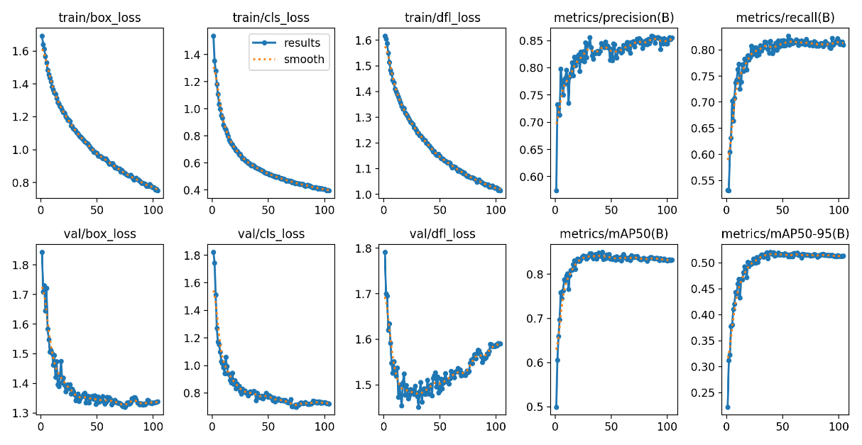
Fig. 5. YOLOv8m training and validation losses and detection metrics.
At convergence, validation precision was approximately 0.85, recall was 0.81-0.82, mAP@0.5 was 0.83-0.84, and mAP@0.5:0.95 was 0.51-0.52. The lower mAP@0.5:0.95 relative to mAP@0.5 indicates that performance becomes more demanding when stricter bounding-box overlap thresholds are imposed.
5.2 Confusion Matrix and Class-Wise Performance
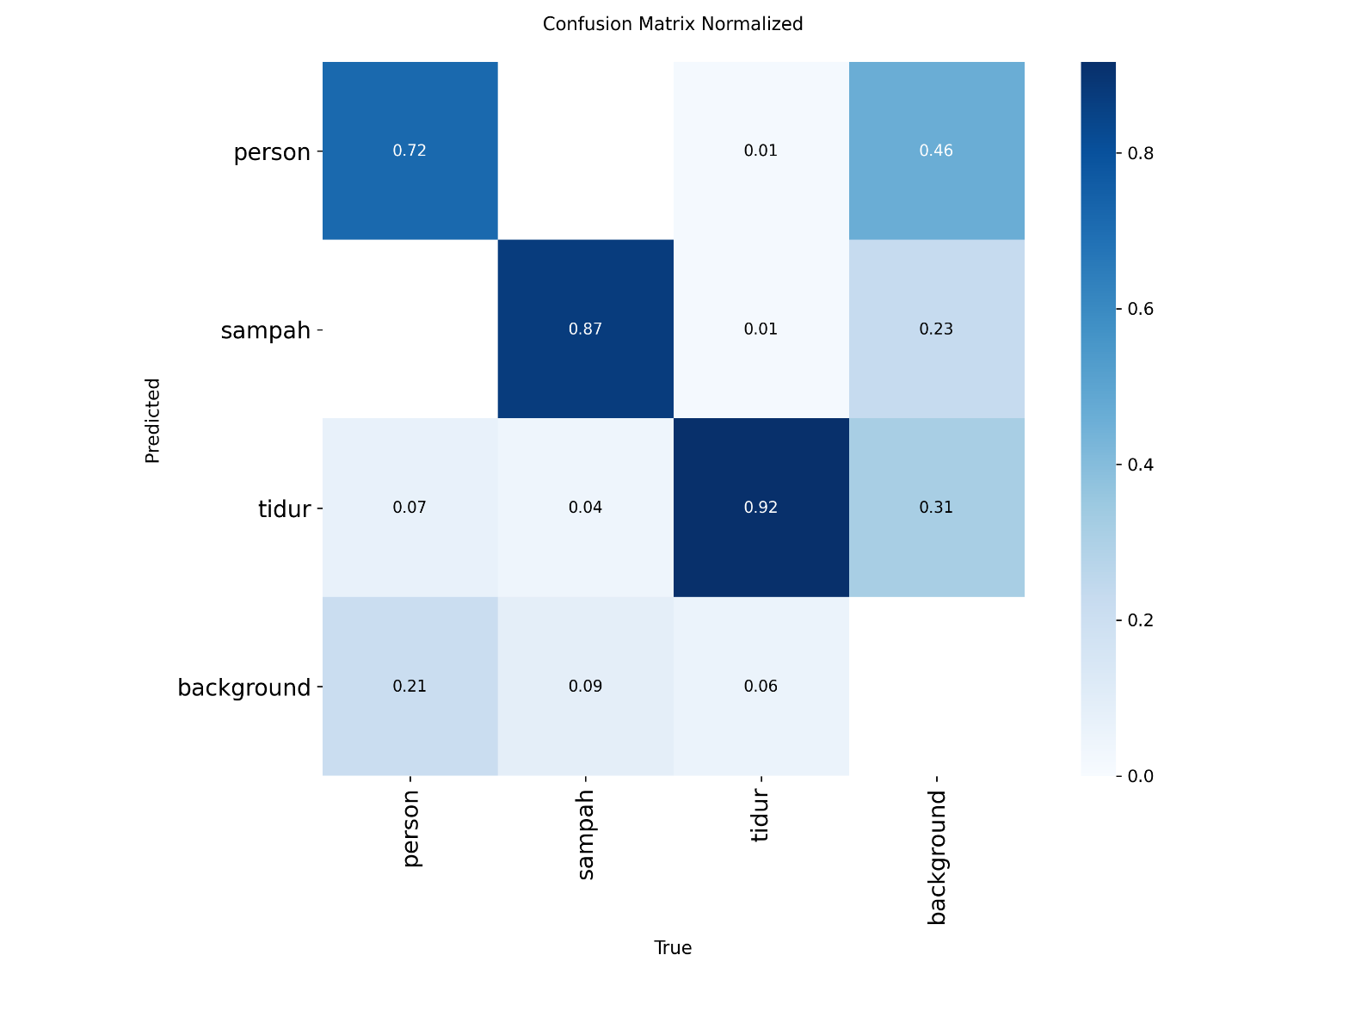
Fig. 6. Normalized confusion matrix for the three target classes and background.
The normalized confusion matrix produced correct-class diagonal rates of approximately 72% for worshipper/person, 87% for littering, and 92% for sleeping. Worshipper detection was the most difficult class: about 7% of worshipper ground-truth instances were associated with sleeping and approximately 21% were unmatched/background. This behavior is consistent with distant or small occupants, partial occlusion, sitting, bending, prayer postures, and clothing such as mukena. Littering retained approximately 4% confusion with sleeping, while sleeping showed approximately 1% confusion with each of the other two classes.
The non-normalized confusion matrix contained 2,105 ground-truth instances across the 613 validation images. It included 391 correctly predicted person instances, 423 correctly predicted littering instances, and 985 correctly predicted sleeping instances. The results confirm that the sleeping class was visually the most separable, whereas worshipper presentation varied more strongly with pose and image scale.
5.3 Field Detection Tests
Ten representative field images were evaluated for each class. Worshipper confidence ranged from 0.74 to 0.88 with a mean of 0.80. Sleeping/overnight confidence ranged from 0.83 to 0.87 with a mean of 0.85, while littering confidence ranged from 0.66 to 0.90 with a mean of 0.79. In this controlled 30-image field subset, all samples were assigned to the intended class. The subset is therefore useful as a deployment check but should not replace the larger validation-set metrics.
Table 5. Field-image confidence and validation diagonal rates.
Class | Mean confidence | Observed range | Validation diagonal
Worshipper | 0.80 | 0.74-0.88 | 72%
Sleeping / overnight | 0.85 | 0.83-0.87 | 92%
Littering | 0.79 | 0.66-0.90 | 87%
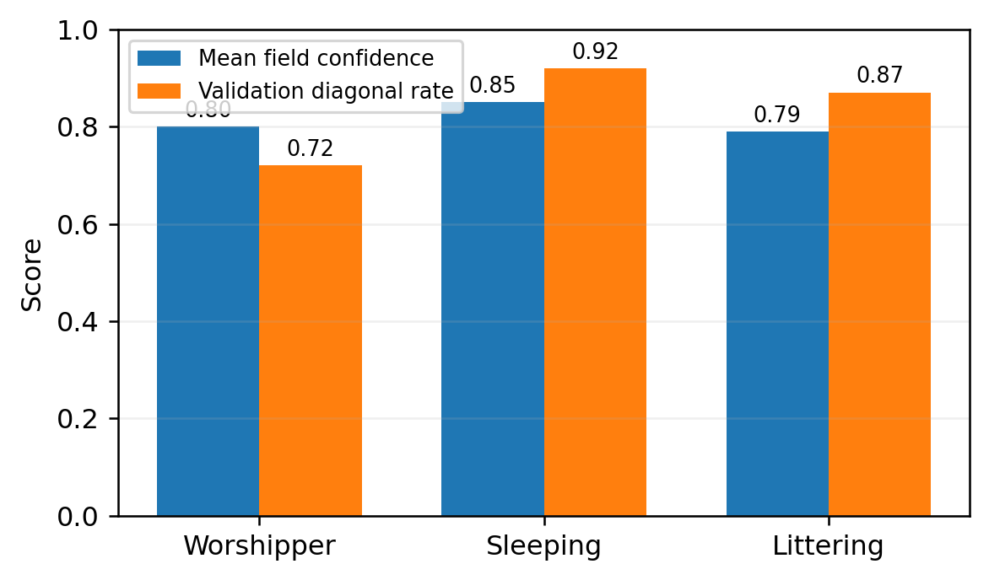
Fig. 7. Comparison of mean field confidence and validation correct-class rate.
5.4 Facility-Control, Sensor, and Display Tests
Control tests confirmed that detector outputs were translated into physical device states. With no worshipper detected, the fan remained off. Tested occupancies of 1-3 worshippers corresponded to fan speed 1, occupancies of 5-6 to fan speed 2, and an occupancy of 8 to fan speed 3 in the integrated LCD test. Separate fan-relay trials also produced speed 1 for three worshippers, speed 2 for five worshippers, and speed 3 for seven and nine worshippers. These tests demonstrate progressive fan control based on occupancy rather than a single on/off threshold.
Lamp relay testing produced approximately 221.4 V ac and 220.9 V ac at the output when the relay was commanded on, while off-state measurements were approximately 0.9 V ac or lower residual values. LDR testing covered 45 to 1000 lx. With worshipper presence detected, the lamp was commanded on at 45, 120, and 285 lx, and off at 470, 650, 820, and 1000 lx. The LDR therefore acts as a supporting input; occupancy remains necessary to prevent lighting an empty room.
The RTC was compared with reference time in seven tests. The maximum observed deviation was 2 sec, several tests had zero deviation, and the reported mean error was 0.85 sec. The LCD I2C correctly reflected worshipper count, lamp status, and fan-speed state in all reported integrated test conditions, providing a local diagnostic display independent of the web interface.
Table 6. Summary of facility-control and sensor validation.
Subsystem | Test condition | Observed response
Fan | 0 worshippers | Off
Fan | 1-3 worshippers | Speed 1
Fan | 5-6 worshippers | Speed 2
Fan | 7-9 worshippers / tested high occupancy | Speed 3
Lamp + LDR | 45, 120, 285 lx + worshipper detected | On
Lamp + LDR | 470, 650, 820, 1000 lx + worshipper detected | Off
RTC | 7 time comparisons | Mean error 0.85 sec; maximum 2 sec
LCD I2C | Integrated occupancy/actuator states | Displayed states matched reported system output
5.5 Communication and Web Response
Wireless/web testing was conducted at 1-12 m from the access point with three response measurements at each distance. Average delay varied from approximately 1.6 to 7 sec. The lowest average delay occurred at 2 m, while a 7 sec average was observed at 3 m. This non-monotonic pattern indicates that local Wi-Fi conditions, network traffic, and internet-service variability were more influential than geometric distance alone. During the reported tests, data were received successfully, but web updates and actuator-state feedback could be delayed by several seconds.
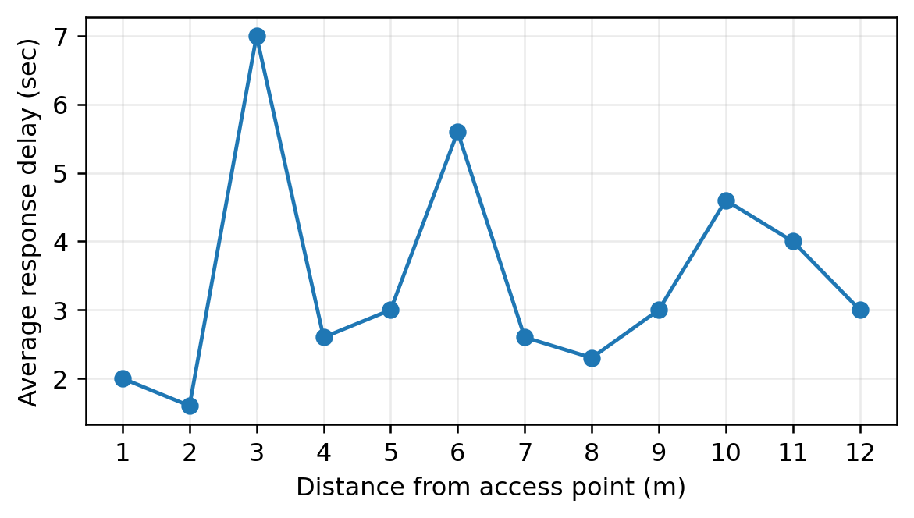
Fig. 8. Average web/communication response delay versus test distance.
Because the web-layer response can reach several seconds, the deployed system is more accurately described as near-real-time at the remote monitoring layer rather than hard real-time. This limitation does not prevent local ESP32 actuation, but stable Wi-Fi and internet connectivity are important for MQTT synchronization, database updates, camera streaming, and responsive remote supervision.
5.6 Electrical-Power Reduction
Before implementation, the study reports mean currents of approximately 7.50 A on phase R, 0.88 A on phase S, and 3.05 A on phase T. After implementation, the reported values were 5.10 A, 1.29 A, and 3.04 A, respectively. The controlled lighting and fan loads were principally associated with phase R, which exhibited the largest reduction. Using Eq. (9) with 220 V ac and a power factor of 0.85, the reported controlled-phase active power decreased from 1.4025 kW to 0.9537 kW.
The difference is 448.8 W, corresponding to approximately 32% according to the reported study calculation. If this reduction were maintained for 12 h per day, Eq. (11) gives an estimated saving of approximately 5.39 kWh/day and 161.7 kWh over a 30-day month. This monthly figure is an operating-scenario extrapolation and not a direct 30-day energy-meter measurement.
Table 7. Reported electrical measurements before and after implementation.
Condition | Phase R (A) | Phase S (A) | Phase T (A) | Controlled active power
Before | 7.50 | 0.88 | 3.05 | 1.4025 kW
After | 5.10 | 1.29 | 3.04 | 0.9537 kW
Difference | -2.40 | +0.41 | -0.01 | -448.8 W (~32%)
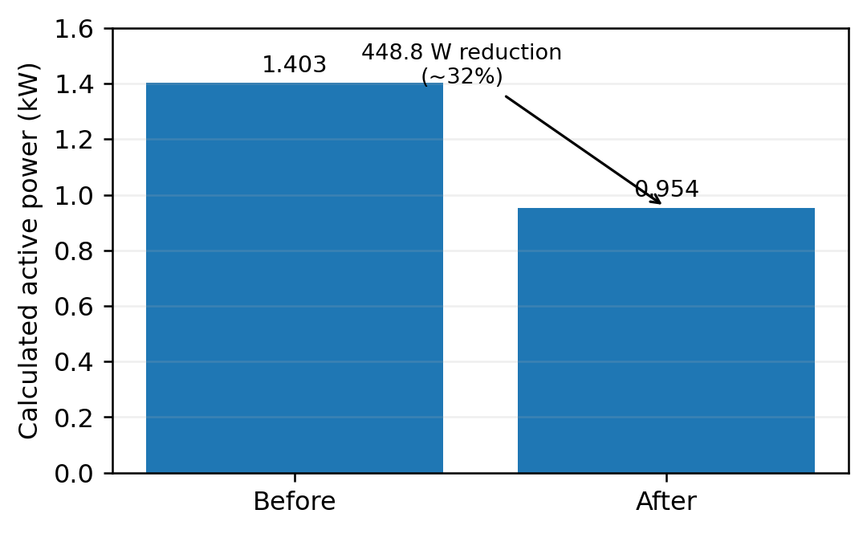
Fig. 9. Calculated active-power comparison for the controlled phase.
6 Discussion
6.1 Comparison with Prior Work
The proposed system differs from sensor-only occupancy approaches because it provides semantic visual classes in addition to presence information. PIR- and smart-meter-based approaches can reduce sensing cost [22], but they cannot directly distinguish littering or sleeping. Vision-based occupancy systems provide richer information [20], [23], [24], [25], [26], [28], while activity-aware models add behavior evidence [1], [5], [7], [11], [12], [16], [27]. The present implementation combines these advantages with direct electrical actuation, but it intentionally avoids a heavier temporal network to preserve deployability on the available edge computer.
The model-level results are consistent with the broader literature in showing that the difficult cases are not necessarily the classes with the lowest field confidence; they are classes with high visual variability and unmatched objects. In this work, worshipper detection is affected by scale, occlusion, sitting, bending, prayer postures, and mukena. Conversely, sleeping is visually more consistent because a horizontal body orientation is distinctive. The remaining littering-to-sleeping confusion supports the recommendation from activity-recognition research that temporal or pose-aware cues can improve behavior discrimination [1], [6], [18].
6.2 Practical Implications
The engineering value of the system lies in closing the loop from perception to action. The camera is not used only for observation; its detections alter fan and lamp states. The LDR prevents unnecessary lighting under sufficient ambient illumination, the RTC supports time-based logic, and the local LCD provides immediate state feedback. MQTT and the web layer give the mosque administrator remote visibility and manual override, while the installed protection chain supports maintainability and electrical safety. This architecture is applicable to other small public facilities where occupancy changes rapidly and full-time manual supervision is impractical.
6.3 Limitations and Future Work
Four limitations should be considered. First, the worshipper validation diagonal rate of 72% indicates that difficult poses and distant objects require broader training data. Second, the detector produces single-frame evidence, so short actions such as littering can be visually similar to bending or resting; future work should evaluate pose estimation, tracking, or temporal action modeling. Third, remote response time varied up to approximately 7 sec under the available network, motivating a stronger local-first control architecture and more stable networking. Fourth, the energy result is based on before-after current measurements and a stated power-factor assumption; future work should use a calibrated energy meter over matched operating periods to measure kWh directly and to separate occupancy variation from control-system effects.
A further methodological point concerns reproducibility. The field subset consisted of only ten images per class and therefore cannot be interpreted as a statistically comprehensive deployment benchmark. Future evaluation should increase the number of independent test scenes, report class-wise precision and recall on a strictly held-out test set, and document inference latency on the actual deployment computer. These additions would make the model comparison and deployment claims more directly reproducible across sites.
7 Conclusion
This study implemented an operational smart-mosque prototype that combines a custom YOLOv8m detector, edge computing, ESP32 control, LDR and RTC sensing, relay-based electrical actuation, MQTT communication, database logging, and web monitoring. The 8,948-image dataset produced a best model at approximately epoch 64, with training stopped at approximately epoch 109. Validation precision was about 0.85, recall 0.81-0.82, mAP@0.5 0.83-0.84, and mAP@0.5:0.95 0.51-0.52. Field confidence averaged 0.80, 0.85, and 0.79 for worshipper, sleeping/overnight, and littering classes, respectively.
The system successfully converted visual occupancy into progressive fan-speed control and combined worshipper detection with ambient illuminance for lamp control. RTC, LCD, MQTT, database, and web functions were also validated in the reported tests. The controlled phase load decreased from 1.4025 kW to 0.9537 kW, corresponding to a reported reduction of 448.8 W or approximately 32%. The study therefore demonstrates the practical feasibility of coupling computer vision with smart-facility control in a religious building. Future work should strengthen temporal activity recognition, dataset diversity, network robustness, and long-duration metered energy evaluation.
Conflict of Interest
The authors declare no conflict of interest.
Author Contributions
V.A.S.: conceptualization, methodology, software, hardware implementation, data curation, investigation, analysis, visualization, and writing-original draft. N.R.: supervision, validation, and writing-review and editing. M.L.A.: supervision, site coordination, validation, and writing-review and editing. All authors reviewed the manuscript and take responsibility for its content.
Funding
Not applicable.
Informed Consent Statement
Not applicable. The study evaluates an engineering monitoring and control system and does not report personally identifying participant information.
Declaration of Generative AI and AI-Assisted Technologies
During preparation of this manuscript, OpenAI ChatGPT was used to assist with English-language editing and manuscript formatting. The authors reviewed and edited all content and take full responsibility for the manuscript.
Acknowledgment
The authors thank Politeknik Perkapalan Negeri Surabaya (PPNS) and the management of Bahrul Ulum Mosque for supporting system implementation and field testing.
Appendix
Table 8 provides a compact implementation map for the principal ESP32 interfaces reported in the study. The appendix is included to improve reproducibility without interrupting the main results discussion.
Table 8. Selected ESP32 interface and control mapping.
Interface | ESP32 pin | Function
Fan relay channel 1 | GPIO 25 | Fan speed state 1
Fan relay channel 2 | GPIO 26 | Fan speed state 2
Fan relay channel 3 | GPIO 27 | Fan speed state 3
Lamp relay | GPIO 33 | Lighting circuit on/off
LCD I2C SCL | GPIO 21 | Display clock line
LCD I2C SDA | GPIO 22 | Display data line
References
[1] Alzahrani N., Bchir O. and Ben Ismail M. M., "YOLO-Act: Unified spatiotemporal detection of human actions across multi-frame sequences," Sensors, Vol. 25, No. 10, Art. No. 3013, 2025, doi: 10.3390/s25103013.
[2] Challa K., AlHmoud I. W., Jaiswal C., Gokaraju B. and Tesireo R., "Gas sensors and real-time video for accurate classroom occupancy detection," MethodsX, Vol. 14, Art. No. 103386, 2025, doi: 10.1016/j.mex.2025.103386.
[3] Chaudhari P., Xiao Y., Cheng M. M.-C. and Li T., "Fundamentals, algorithms, and technologies of occupancy detection for smart buildings using IoT sensors," Sensors, Vol. 24, No. 7, Art. No. 2123, 2024, doi: 10.3390/s24072123.
[4] Chen S., Liu Y., Zhang H. and Cai Y., "A human location and action recognition method based on improved YOLOv11 model," Discover Artificial Intelligence, Vol. 5, Art. No. 232, 2025, doi: 10.1007/s44163-025-00492-6.
[5] Gawande U., Hajari K. and Golhar Y., "Novel person detection and suspicious activity recognition using enhanced YOLOv5 and motion feature map," Artificial Intelligence Review, Vol. 57, Art. No. 16, 2024, doi: 10.1007/s10462-023-10630-0.
[6] Gaya-Morey F. X., Manresa-Yee C. and Buades-Rubio J. M., "Deep learning for computer vision based activity recognition and fall detection of the elderly: A systematic review," Applied Intelligence, Vol. 54, pp. 8982-9007, 2024, doi: 10.1007/s10489-024-05645-1.
[7] Han L., Ma X., Dai M. and Bai L., "A WAD-YOLOv8-based method for classroom student behavior detection," Scientific Reports, Vol. 15, Art. No. 9655, 2025, doi: 10.1038/s41598-025-87661-w.
[8] Hermens F., "Automatic object detection for behavioural research using YOLOv8," Behavior Research Methods, Vol. 56, No. 7, pp. 7307-7330, 2024, doi: 10.3758/s13428-024-02420-5.
[9] Huang K. and Abisado M. B., "Lightweight construction safety behavior detection model based on improved YOLOv8," Discover Applied Sciences, Vol. 7, Art. No. 326, 2025, doi: 10.1007/s42452-025-06766-z.
[10] Khan I., Zedadra O., Guerrieri A. and Spezzano G., "Occupancy prediction in IoT-enabled smart buildings: Technologies, methods, and future directions," Sensors, Vol. 24, No. 11, Art. No. 3276, 2024, doi: 10.3390/s24113276.
[11] Khekan A. R., Aghdasi H. S. and Salehpour P., "Fast and high-precision human fall detection using improved YOLOv8 model," IEEE Access, Vol. 13, pp. 5271-5283, 2025, doi: 10.1109/ACCESS.2024.3470319.
[12] Nasir R., Jalil Z., Nasir M., Alsubait T., Ashraf M. and Saleem S., "An enhanced framework for real-time dense crowd abnormal behavior detection using YOLOv8," Artificial Intelligence Review, Vol. 58, Art. No. 202, 2025, doi: 10.1007/s10462-025-11206-w.
[13] Ouardirhi Z., Mahmoudi S. A. and Zbakh M., "Enhancing object detection in smart video surveillance: A survey of occlusion-handling approaches," Electronics, Vol. 13, No. 3, Art. No. 541, 2024, doi: 10.3390/electronics13030541.
[14] Parambil M. M. A., Ali L., Swavaf M., Bouktif S., Gochoo M., Aljassmi H. and Alnajjar F., "Navigating the YOLO landscape: A comparative study of object detection models for emotion recognition," IEEE Access, Vol. 12, pp. 109427-109442, 2024, doi: 10.1109/ACCESS.2024.3439346.
[15] Park S., Kim J., Wang S. and Kim J., "Effectiveness of image augmentation techniques on non-protective personal equipment detection using YOLOv8," Applied Sciences, Vol. 15, No. 5, Art. No. 2631, 2025, doi: 10.3390/app15052631.
[16] Priadana A., Nguyen D.-L., Vo X.-T., Choi J., Ashraf R. and Jo K., "HFD-YOLO: Improved YOLO network using efficient attention modules for real-time one-stage human fall detection," IEEE Access, Vol. 13, pp. 41248-41258, 2025, doi: 10.1109/ACCESS.2025.3547360.
[17] Sayed A. N., Mahmud S., Bensaali F., Chowdhury M. E. H. and Himeur Y., "Optimizing energy efficiency through precise occupancy detection: A tailored CNN architecture for smart buildings and beyond," Neural Computing and Applications, Vol. 37, pp. 16487-16503, 2025, doi: 10.1007/s00521-025-11348-6.
[18] Sedaghati N., Ardebili S. and Ghaffari A., "Application of human activity/action recognition: A review," Multimedia Tools and Applications, Vol. 84, pp. 33475-33504, 2025, doi: 10.1007/s11042-024-20576-2.
[19] Song W. and Calautit J., "Impact of occupancy behavior on building energy efficiency: What is next in detection and monitoring technologies?," Next Energy, Vol. 8, Art. No. 100350, 2025, doi: 10.1016/j.nxener.2025.100350.
[20] Sun K., Wang X., Xing T., Liu S. and Zhao Q., "High-accuracy occupancy counting at crowded entrances for smart buildings," Energy and Buildings, Vol. 319, Art. No. 114509, 2024, doi: 10.1016/j.enbuild.2024.114509.
[21] Wang J., Jiang L., Yu H., Feng Z., Castaño-Rosa R. and Cao S.-J., "Computer vision to advance the sensing and control of built environment towards occupant-centric sustainable development: A critical review," Renewable and Sustainable Energy Reviews, Vol. 192, Art. No. 114165, 2024, doi: 10.1016/j.rser.2023.114165.
[22] Wu Y., Chen S., Jin Y., Xu H., Zhou X., Wang X., Chong A., Li J. and Yan D., "Novel occupancy detection method based on convolutional neural network model using PIR sensor and smart meter data," Advanced Engineering Informatics, Vol. 62, Art. No. 102589, 2024, doi: 10.1016/j.aei.2024.102589.
[23] Xu Y. and Fu Y., "Complex indoor human detection with You Only Look Once: An improved network designed for human detection in complex indoor scenes," Applied Sciences, Vol. 14, No. 22, Art. No. 10713, 2024, doi: 10.3390/app142210713.
[24] Zhang H., Liu L., Bi J., Liu H. and Wen Z., "Modified lightweight YOLOv8 model for fast and precise indoor occupancy detection," Applied Sciences, Vol. 16, No. 1, Art. No. 335, 2026, doi: 10.3390/app16010335.
[25] Zhang W., Calautit J., Tien P. W., Wu Y. and Wei S., "Deep learning models for vision-based occupancy detection in high occupancy buildings," Journal of Building Engineering, Vol. 98, Art. No. 111355, 2024, doi: 10.1016/j.jobe.2024.111355.
[26] Zhang W., Li J., Tien P. W. and Calautit J. K. S., "Vision-based occupancy detection in indoor environments: A comparison of standard RGB and thermal cameras," Journal of Building Engineering, Vol. 114, Art. No. 114215, 2025, doi: 10.1016/j.jobe.2025.114215.
[27] Zhang Y., Liang W., Yuan X., Zhang S., Yang G. and Zeng Z., "Deep learning-based abnormal behavior detection for elderly healthcare using consumer network cameras," IEEE Transactions on Consumer Electronics, Vol. 70, No. 1, pp. 2414-2422, 2024, doi: 10.1109/TCE.2023.3309852.
[28] Zhou S., Zhang W., Tien P. W. and Calautit J. K. S., "Evaluating single-shot and two-stage vision-based detection of occupancy activity in energy-efficient buildings," Energy and Buildings, Vol. 345, Art. No. 116017, 2025, doi: 10.1016/j.enbuild.2025.116017.
[29] Zou Z., Chen K., Shi Z., Guo Y. and Ye J., "Object detection in 20 years: A survey," Proceedings of the IEEE, Vol. 111, No. 3, pp. 257-276, 2023, doi: 10.1109/JPROC.2023.3238524.
Biographies
Vemas Ardiyan Syah is a student in the D4 Automation Engineering Study Program, Department of Marine Electrical Engineering, Politeknik Perkapalan Negeri Surabaya (PPNS), Indonesia. His final-project research focuses on IoT-based automation, computer vision, YOLO object detection, and smart-facility control.
Noorman Rinanto, S.T., M.T., Ph.D., is a lecturer at Politeknik Perkapalan Negeri Surabaya (PPNS), Indonesia, and served as the principal supervisor of this study.
Muhammad Lukman Arif, S.Pd.I., M.Pd.I., is a lecturer at Politeknik Perkapalan Negeri Surabaya (PPNS), Indonesia, and served as the co-supervisor of this study, including support for implementation access at Bahrul Ulum Mosque.

Iranian Journal of Electrical & Electronic Engineering, YYYY. Paper first received DD MONTH YYYY and accepted DD MONTH YYYY. * The author is with the Department of XXX, YYY University, Address. E-mail: xxx@xxx.xxx.xxx. ** The authors are with the Department of XXX, YYY University, Address. E-mails: yyy@yyy.yyy.yyy, zzz@zzz.zzz.zzz. Corresponding Author: Second B. Author.

