**Edu Tutor AI**

(Personalized Learning with Generative AI and LMS Integration)



Team Leader: G. Meena   
Team Members: S. Hemalatha, B. Kaviya, R. Lalitha, P. Vembu

**Introduction**

EduTutor AI is an AI-powered personalized education platform that uses IBM Granite Models (via Hugging Face) to deliver interactive learning experiences. The platform generates concept explanations, quizzes, and study aids for students. It is deployed using Google Colab and Gradio framework, making it lightweight, flexible, and easy to use for both students and educators.

# Project Description

Edu Tutor AI is an AI-powered personalized education platform designed to revolutionize learning. It integrates Generative AI with LMS platforms such as Google Classroom to:  
- Generate quizzes automatically for students  
- Provide clear and detailed explanations of concepts  
- Create personalized learning paths based on student performance  
- Track progress and suggest improvements  
- Enhance classroom management and engagement

# Objectives

- Improve the learning experience using AI  
- Provide personalized learning for each student  
- Automate assessment and feedback generation  
- Integrate seamlessly with existing LMS systems

# Problem Statement

Traditional education often lacks personalized attention and timely feedback. Edu Tutor AI addresses these gaps by:  
- Customizing learning for each student  
- Automating assessments and explanations  
- Reducing teacher workload while improving student engagement

# Tools & Technologies

- IBM Cloud – For hosting AI models and backend services  
- Generative AI Models – For question generation, explanations, and content creation  
- Google Classroom Integration – To synchronize assignments, quizzes, and student progress

# System Architecture / Flow

1. Student logs into Edu Tutor AI via LMS

2. AI evaluates student progress and learning style  
3. Generates personalized quizzes and explanations  
4. Updates LMS with results and progress  
5. Provides recommendations for improvement

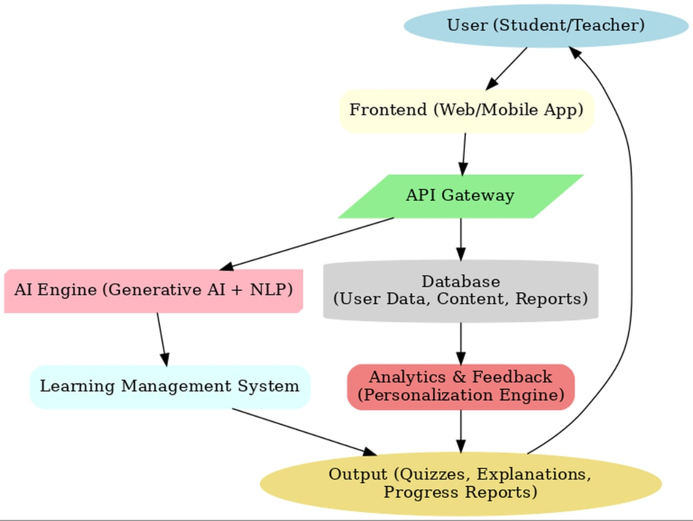

**Features & Functionality**

- Personalized quizzes and assessments  
- Concept explanation with AI-powered clarity  
- Progress tracking and analytics  
- Integration with Google Classroom  
- Adaptive learning paths

# Implementation Details

- IBM Cloud setup for AI services  
- Generative AI model integration  
- Google Classroom API integration

- Frontend and backend connection and Testing and deployment

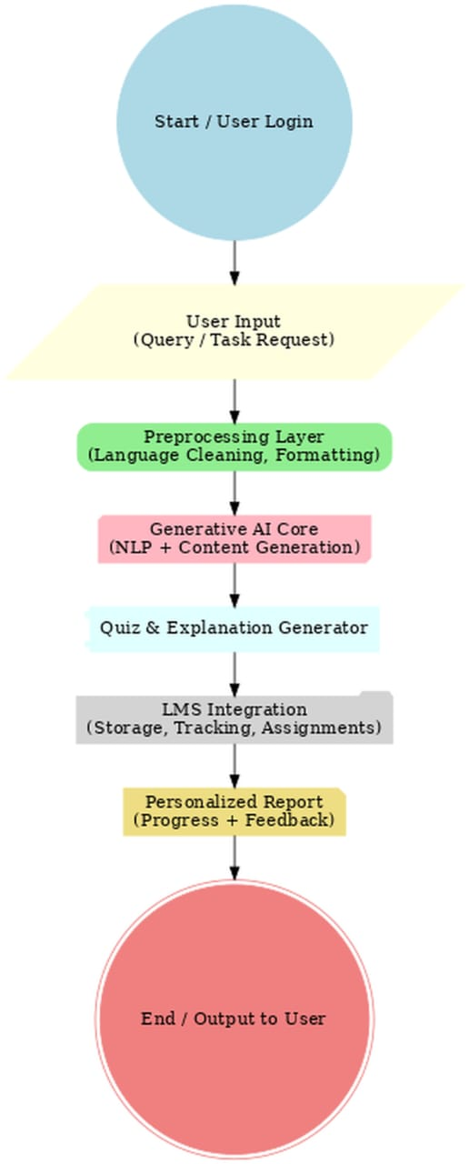

**Module Description**

The system is divided into the following modules:

User Module – Manages student/teacher login, profiles, and dashboards for easy access to learning resources.

Input & Preprocessing Module – Accepts queries or topics, cleans and validates input for smooth AI processing.

AI Processing Module – Uses Generative AI (LLM + NLP) to produce explanations, notes, and personalized quizzes.

Quiz & Assessment Module – Generates dynamic quizzes, evaluates responses, and provides instant feedback.

LMS Integration Module – Stores learning materials, tracks student progress, and assigns tasks as per AI suggestions.

Report & Feedback Module – Creates personalized progress reports, collects user feedback, and provides teachers with performance insights.

# Screenshot

Code:

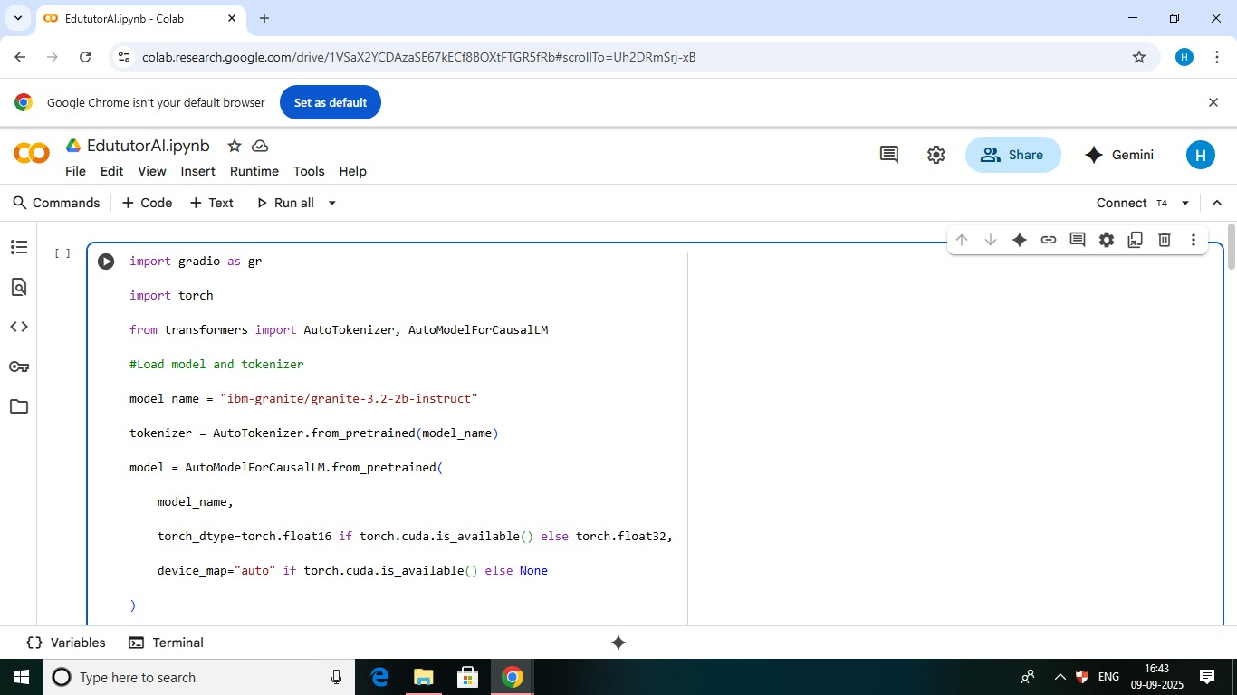

Output: (Quiz Generation)

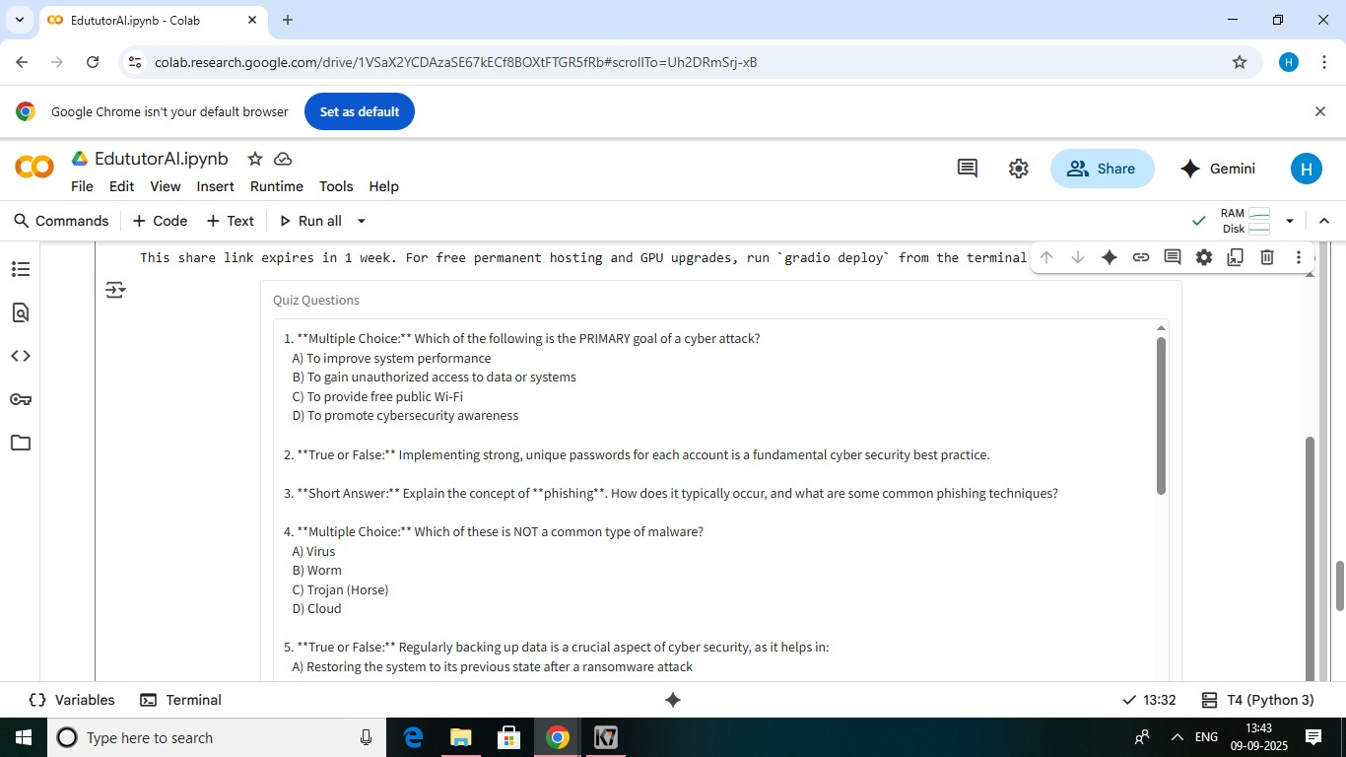

Output: ( Generating Explanation)

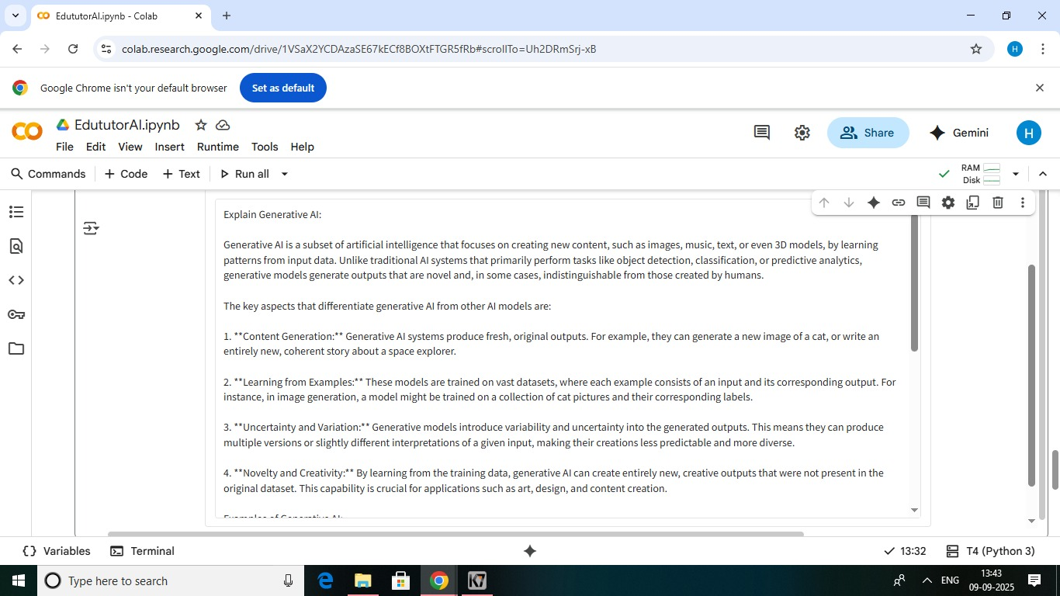

# Conclusion

Edu Tutor AI enhances the learning process by providing personalized content, automating assessments, and supporting teachers with AI-driven insights. It combines technology and education to make learning smarter, engaging, and effective.

# References

- IBM Cloud Documentation  
- Google Classroom API Documentation  
- Generative AI Tutorials and Research Papers