Balancing Robot

Wheel Encoders

Sensors
For each wheel a pair of Hamamatsu-P5587 photo reflectors.

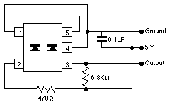
Instead of the 470 Ohm resistor I used 680 Ohm, for the 6.8k resistor I used 10k.

Hookup with Arduino Mega
The Arduino Mega has six external interrupts. Excerpt from http://arduino.cc/en/Main/ArduinoBoardMega:
External Interrupts: 2 (interrupt 0), 3 (interrupt 1), 18 (interrupt 5), 19 (interrupt 4), 20 (interrupt 3), and 21 (interrupt 2). These pins can be configured to trigger an interrupt on a low value, a rising or falling edge, or a change in value. See the attachInterrupt() function for details.
I am using pins 2,3,18,19 (interrupts 0,1,4,5)

Measurements
Signal for the motor on the right (motor 1):
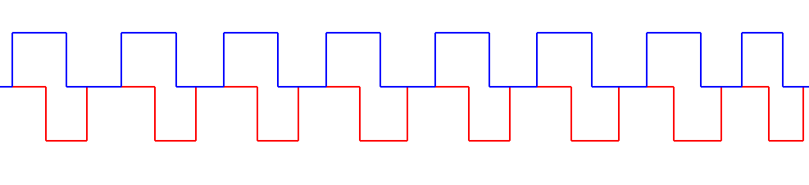
Covered time is 100 milliseconds.
The motor turns extremely slowly and due to the low power output the speed varies slightly.

