Dr.P.NARAYANA

Founder

Page

3



…………………………………..

A Mini Project Report on

**PORTFOLIO**

Submitted to

**Department of**

**MASTER OF COMPUTER APPLICATIONS**

In partial fulfillment of requirement for the a ward of the degree of

MASTER OF COMPUTER APPLICATIONS

by

**P.SIVA KUMAR---24F11F0089**

**SK.SHAKEER---24F11F0094**

**V.NAGARJUNA---24F11F00A0**

**V.SRIYA---24F11F00A1**

Under the esteemed guidance of

**Mrs.K.LEELAVATHI, MCA, Assistant Professor**

**MASTER OF COMPUTER APPLICATIONS**

**NARAYANA ENGINEERING COLLEGE::GUDUR**

**(**

**An Autonomous College Under JNTUA)**

**2024 - 2026**

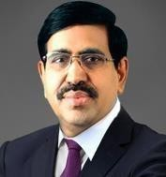

Dr.P.NARAYANA

Founder

Page

4

**Department of**

**MASTER OF COMPUTER APPLICATIONS**

**BONAFIDE CERTIFICATE**

This is to certify that the Project report entitled

“

**PORTFOLIO”**

being submitted by

**Regd.No.24F11F0094)**

**(**

**SK.SHAKEER**

**Regd.No.24F11F0089),**

**(**

**KUMAR**

**P.SIVA**

**,V.NAGARJUNA (Regd.No.24F11F00A0) ,V.SRIYA (Regd.No.24F11F00A1)**

in partial

fulfillment for the award of the Degree of Master Of Computer Applications Department to the

Narayana Engineering College Gudur, is a record to be bonafide work carried out undermy

guidance and supervision.

**Project Guide**

**Head of the Department**

Dr.V.Sucharita,Ph.D

Mrs. K.LEELAVATHI, MCA

Assistant Professor

Professor

Submitted for Viva-voice Examination held on.

**INTERNALEXAMINER**

**EXTERNALEXAMINER**

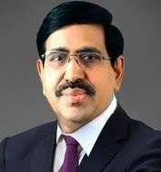

**ACKNOWLEDGEMENT**

We am extremely thankful to **Dr.P.Narayana**, the **Founder Chairman** of **Narayana Group** for his good initiation starting technical institution in Gudur like rural area for helping economically poor students.

We also thankful to **Mr.K.Puneeth**, the **Chairman** of **Narayana Group** for providing the infrastructural facilities to work in, without this the work would not have been possible.

We would like to express our deep sense of gratitude to **Dr.V.Ravi Prasad, Principal, Narayana Engineering College, Gudur** for his continuous effort in creating a competitive environment in our college and encouraging throughout this course.

We would like to express our deep sense of gratitude to **Dr. P. Srinivasulu, Vice- Principal, Narayana Engineering College, Gudur** for his continuous effort in creating a competitive environment in our college and encouraging throughout this course.

We would like to convey our heartfelt thanks to **Dr.V.Sucharita, Professor&HOD** of MCA and for giving the opportunity to embark up on this topic and for her continues encouragement throughout the preparation of the project.

We would like to thank our project coordinator **Mrs.K.Leelavathi, Assistant Professor** Department of MCA for his valuable guidance, constant assistance, support endurance and constructive suggestions for the betterment of the project.

We would like to thank our guide **Mr.K.Venkateswarlu, Assistant professor** Department of MCA for her valuable guidance, constant assistance, support endurance and constructive suggestions for the betterment of the project.

We also wish to thank all the **staff members** of the Department of Master of Computer Applications for helping us directly or indirectly in completing this project successfully.

Finally, weare thankful to my **parents and friends** for their continued moral and material support throughout the course and in helping us to finalize the report.

**P.SIVA KUMAR---24F11F0089**

**SK.SHAKEER---24F11F0094**

**V.NAGARJUNA---24F11F00A0**

**V.SRIYA---24F11F00A1**

**CONTENTS OF INDEX**

# ABSTRACT

**1. INTRODUCTION** 1-2

## 2. SYSTEM REQUIREMENTS 3-5

Introduction 3

Existing System 3

Disadvantages 3-4

Proposed System 4-5 Advantages 5

## 3. SYSTEM ANALYSIS 6

Hardware Components 6

Software Requirements 6

Hardware Requirements 6

## 4. SYSTEMDESIGN 7-11

Introduction 7

UML Basics 7-8

Use Case Diagram 9

Class Diagram 10

Activity Diagram 11

## 5. IMPLEMENTATION&RESULTS 12-18

Coding Introduction 12-16

Main page 17 Sub main page 17

Output screens 18

Final output 18

## 6. SYSTEM TESTING 19

Types of Testing 19

Functional Testing 19

Responsive Testing 19

Usability T esting 19

**7. CONCLUSION** 19

# ABSTRACT

This project focuses on the development of a fully responsive portfolio website using only frontend technologies—HTML, CSS, and JavaScript. The portfolio is designed to showcase a user's professional background, skills, and projects in a visually appealing and user-friendly format. It ensures cross-device compatibility and offers interactive elements to improve user engagement. The absence of a backend component emphasizes static site deployment and simplicity in design and functionality**.**

This project involves the design and development of a fully responsive personal portfolio website using only front-end web technologies—HTML, CSS, and JavaScript—without relying on any backend frameworks or databases. The primary aim of the portfolio is to serve as a digital resume and showcase platform for an individual, highlighting their skills, educational background, completed projects, certifications, and contact information.

The website is structured using HTML5 to create a semantic and accessible layout, which includes sections such as Home, About, Projects, Skills, and Contact. CSS3 is utilized for styling, layout management, and responsive design. Advanced CSS techniques, including Flexbox and CSS Grid, are implemented to ensure a fluid and adaptive layout across devices of various screen sizes. Media queries are strategically applied to fine-tune the user experience on desktops, tablets, and mobile phones.

JavaScript plays a critical role in enhancing user interaction and engagement. It is used to implement interactive elements such as a responsive navigation menu, animated typing effects, image sliders or carousels, theme switching (e.g., dark mode), scroll animations, and clientside form validation. While the contact form does not send data to a server due to the absence of backend processing, it is fully functional in terms of user interface and form handling logic. The overall design focuses on clean aesthetics, modern UI/UX principles, and smooth transitions to maintain professional appeal. This type of static portfolio website is ideal for individuals such as web developers, graphic designers, or freelancers who wish to present their work and credentials online effectively without the need for complex backend infrastructure. This project demonstrates proficiency in front-end web development and reflects the importance of responsive and accessible design in creating personal branding tools in the digital era.

## 1.INTRODUCTION

### 1.1 project overview

The responsive portfolio website is a static web application developed to represent an individual's professional identity online. It includes sections like an introduction, skillset, projects, education, and contact information. The project focuses on clean UI design, smooth navigation, and responsiveness for optimal viewing on all devices.

### 1.2 Objectives

To create a responsive and interactive portfolio using only frontend technologies.

To provide a structured platform for users to display their professional achievements and skills.

To enhance user experience with animations, transitions, and interactivity without relying on backend logic.

To deploy a fast, lightweight, and easily maintainable website.

### 1.3 Scopes

Implementation using only HTML, CSS, and JavaScript.

Responsive design that adapts to different screen sizes and orientations.

Inclusion of sections such as About Me, Projects, Skills, Contact, and Resume download.

Use of client-side validation for contact forms (no data storage).

## 2.SYSTEM REQUIRMENTS

### Introduction

In today's digital age, having a strong online presence is crucial for individuals, especially professionals, students, and freelancers. A personal portfolio website serves as a centralized platform to showcase skills, achievements, projects, and contact details in a visually appealing and organized manner. Unlike traditional resumes, portfolio websites offer interactive and real time insights into a person’s capabilities and experiences.

This project aims to develop a responsive portfolio website using only frontend technologies HTML, CSS, and JavaScript. The website is designed to be user-friendly, aesthetically pleasing, and functional across all devices—desktop, tablet, and mobile. With no backend dependency, it ensures simplicity, fast loading times, and ease of deployment on static hosting services.

### Existing system

In the current scenario, many individuals use platforms like LinkedIn, GitHub, or CMSbased templates (e.g., WordPress) to present their professional profiles and projects. While functional, these systems often lack customization, require backend integration, and may not offer full control over layout and content presentation. Additionally, many templates are not fully responsive, leading to inconsistent user experiences across devices.

### Disadvantages

While a frontend-only portfolio website offers simplicity and ease of deployment, there are certain limitations:

1. **No Backend Functionality:**

The website cannot handle dynamic content, data storage, or server-side processing (e.g., storing contact form submissions or user interactions).

1. **Limited Interactivity:**

Features like user login, comments, or admin panel are not possible without backend integration.

1. **Security Limitations:**

Since everything is on the client-side, sensitive data cannot be handled securely.

1. **No Real-Time Updates:**

Content updates require manual code changes and re-deployment instead of dynamic content management.

1. **Scalability Constraints:**

The design is best suited for personal use. For large-scale or enterprise use, backend and database support would be necessary.

1. **SEO Limitations:**

Although basic SEO can be achieved, the absence of dynamic content and structured backend support can reduce search engine performance for complex needs.

### Proposed System

The proposed system is a custom-built, fully responsive portfolio website created using only HTML, CSS, and JavaScript. It allows users to showcase their skills, experience, and projects in a modern and interactive format. The system ensures:

**Responsiveness:** Adapts seamlessly to mobile, tablet, and desktop screens.

**Customization:** Full control over layout, colors, fonts, and animations.

**No Backend Dependency:** The entire site is static, eliminating the need for server-side scripting or databases.

**Easy Deployment:** Can be hosted on platforms like GitHub Pages, Netlify, or Vercel for free.

**Fast Load Time:** Lightweight structure ensures quick access and performance.

### Advantages

Here’s the Advantages section for your responsive portfolio project using HTML, CSS, and JavaScript:

**Advantages**

1. **Simplicity and Ease of Use:**

The project uses only frontend technologies, making it simple to develop, understand, and maintain—ideal for beginners and students.

1. **Fast Loading Speed:**

Without server-side processing or database queries, the site loads quickly, improving user experience and performance.

1. **Responsive Design:**

The layout adapts seamlessly to various devices (mobiles, tablets, desktops), enhancing accessibility and usability.

1. **Customizable and Flexible:**

Full control over design and layout allows users to personalize their site without the constraints of third-party platforms.

1. **No Hosting Cost:**The static nature of the site enables free deployment on platforms like GitHub Pages, Netlify, or Vercel.
2. **Offline Development and Preview:**

Since there’s no server dependency, the website can be built and tested entirely offline before deployment.

1. **No Backend Vulnerabilities:**

Eliminating backend components reduces risks related to server-side security vulnerabilities.

## 3. SYSTEM ANALYSIS

### Introduction

System analysis is a crucial phase in the development process, where the current systems are studied, and the proposed solution is examined for feasibility, efficiency, and functionality. For this portfolio project, the system analysis identifies the limitations of existing solutions and highlights the advantages of creating a lightweight, responsive, and customizable website using only frontend technologies.

The analysis covers the existing systems used for online portfolios, proposes an alternative with improved design and usability, and assesses the technical, operational, and economic feasibility of the new system. This ensures that the final product aligns with the user’s goals and delivers a smooth and engaging experience across all devices without relying on complex backend infrastructure.

**Hardware Requirements:**

* Processor : intel i3 or higher

|  |  |  |
| --- | --- | --- |
| ✓ | RAM | : 4GB. |
| ✓ | HDD | : 500 GB |

**Software Requirements:**

* Operating System : Window7 or above
* Front End : HTML, CSS, JAVASCRIPT
* Tools : Visual Studio

## 4. SYSTEM DESIGN

### INTRODUCTION

System design is a fundamental step in the development process, where the overall structure and components of the system are outlined. For this project, the focus of the system design is to create a responsive, aesthetically pleasing, and user-friendly portfolio website using only HTML, CSS, and JavaScript.

The system design defines how the portfolio will be structured, the flow of user interaction, and the technologies that will be used to implement the site. The design ensures that the website is not only functional but also accessible and engaging across various devices and screen sizes.

System design is the process of defining the architecture, components, modules, interfaces, and data flow of a software or hardware system to satisfy specified requirements. It is a crucial phase in the development lifecycle that transforms high-level requirements into a detailed blueprint for implementation. The primary goal of system design is to create a system structure that is robust, scalable, maintainable, and efficient.

In software development, system design is typically divided into two major phases:

1. **High-Level Design (HLD):** Also known as architectural design, this phase focuses on the overall structure of the system. It outlines system components, their interactions, data flow, technologies used, and the integration strategy. Key outputs include architecture diagrams, module overviews, and system flowcharts.
2. **Low-Level Design (LLD):** This phase delves into the internal workings of each module or component defined during HLD. It provides detailed logic, algorithms, database schema, class diagrams, and interface specifications.

Effective system design considers several important aspects, including performance, reliability, security, scalability, and usability. It also takes into account the constraints of available resources and technologies.

.

### UML BASICS

UML (Unified Modeling Language) is a standardized visual modeling language used to describe, design, and document the structure and behavior of software systems. It helps developers, designers, and stakeholders understand and communicate complex system designs clearly and effectively.

UML provides a set of diagrams that illustrate different aspects of a system, such as how users interact with it (use case diagrams), how components are structured (class diagrams), and how processes flow (activity diagrams). It is platform-independent and can be used throughout the software development lifecycle—from analysis and design to implementation and maintenance.

In this project, UML is used to model the static and dynamic behavior of the responsive portfolio website, even though it is a frontend-only application. UML diagrams like Use Case and Class diagrams help visualize how different parts of the portfolio interact and how users engage with the system. ✓ Structural Diagrams

* Behavioral Diagrams **Structural Diagrams:**

Thestructuraldiagramsrepresentthestaticfacetofthesystem.Thesestaticaspects represent those components of a diagram that forms the most structure and so stable.

These static components are represents by categories, interfaces, objects, parts and nodes.

The four structural diagrams are:

* Class diagram
* Object diagram
* Component diagram
* Deployment diagram

**Behavioural Diagrams:**

Behavioural diagrams essentially capture the dynamic side of a system. Dynamic side are often any delineated because the changing/moving components of a system.

UML has the subsequent 5forms of activity diagrams:

* Use case diagram
* Sequence diagram
* Collaboration diagram
* State chart diagram
* Activity diagram

**Use case Diagram**

Use case diagrams are a group of use cases, actors and their relationships. They represent the employment case read of a system.

So use case diagram is employed to explain the relationships among the functionalities and their internal/external controllers. These controllers are called actors.

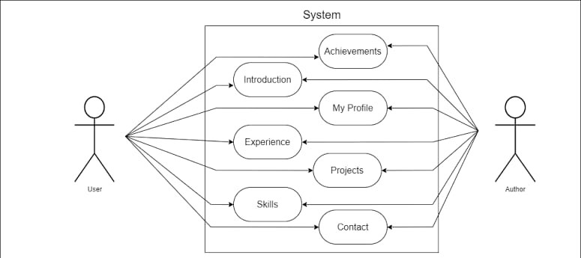

**Class Diagram**

Class diagrams area unit the foremost common diagrams employed in UML.

category diagram consists of categories, interfaces, associations and collaboration. Category diagrams primarily represent the thing directed read of a system that is static in nature. Active category is employed in a very category diagram to represent the concurrency of the system.

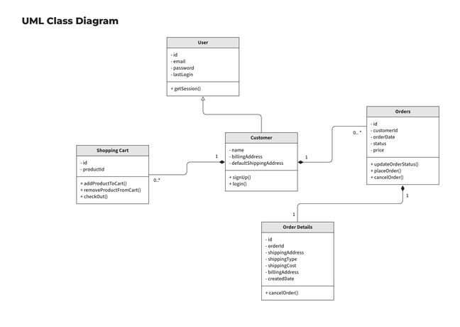

Class diagram represents the thing orientation of a system. Therefore it's usually used fordevelopment purpose. This can betheforemost wideused diagram at thetimeof system construction.

**Activity Diagram**

Activity diagram is another vital diagram in UML to explain dynamic aspects of the system. Activity diagram is largely a flowchart to represent the flow kind one activity to a different activity. The activity may be eating as associate operation of the system.

So the management low is drawn from one operation to a different. This flow may be serial, branched or coinciding. Activity diagrams deals with all style of flow management by victimization completely different parts like fork, join etc.

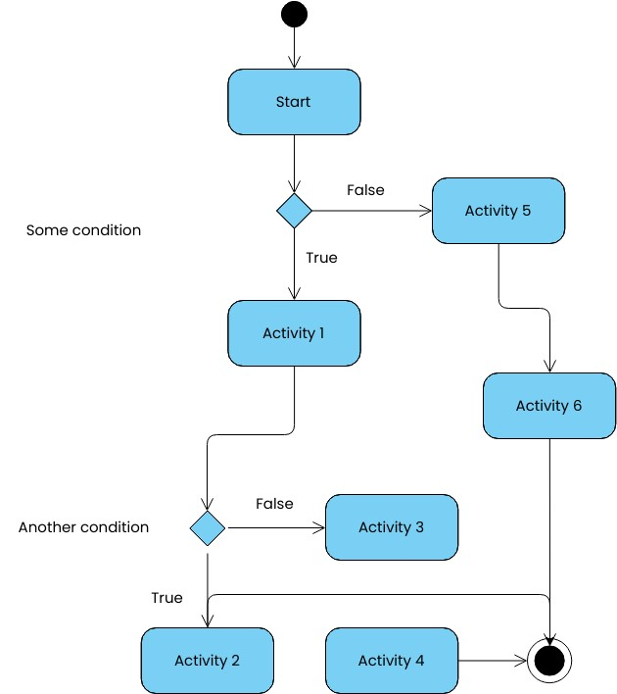

## 5.IMPLEMENTATION & RESULTS

### Introduction

In this section, we describe the all the major functions of the system and we provide brief description about key functions. Finally we show the input forms and output forms of this mini project.

### Coding

<!DOCTYPE html>

<html lang="en">

<head>

<meta charset="UTF-8">

<meta name="viewport" content="width=device-width, initial-scale=1.0">

<title>Portfolio - Ariana</title>

<link rel="stylesheet" href="styles.css">

<link rel="stylesheet" href="https://cdnjs.cloudflare.com/ajax/libs/fontawesome/6.0.0/css/all.min.css">

<style> body { font-family: Arial, sans-serif; margin: 0; padding: 0; background-color: #000; color: white;

} header { display: flex; justify-content: space-between; align-items: center; padding: 20px; background: #333;

} nav ul { list-style: none; display: flex;

} nav ul li { margin: 0 15px; } nav ul li a { color: white; text-decoration: none; cursor: pointer;

}

.hero { display: flex; justify-content: space-between; align-items: center; padding: 50px; background: #111;

}

.hero .content { max-width: 50%;

}

.hero .image img { max-width: 300px; border-radius: 10px;

}

.highlight { color: orange;

}

.social-links { display: flex; gap: 15px; margin-top: 10px;

}

.social-links a { color: white; font-size: 24px;

}

.about-content, .skills-content, .projects { padding: 50px; text-align: center;

}

.about-content h1, .skills-content h1, .projects h2 { color: #ff9800;

}

.about-content p, .skills-content p { color: #f5f5f5;

}

.skills-list { display: flex; justify-content: center; gap: 20px; flex-wrap: wrap;

}

.skill { background: #333; padding: 15px; border-radius: 5px;

}

.project { background: #222; padding: 20px; margin: 10px 0; border-radius: 5px; color: #ffcc00;

}

.project h3 { color: #ff5733;

}

.project p { color: #ffffff;

}

</style>

</head>

<body>

<header>

<div class="logo">

<img src="C:\Users\HP\OneDrive\Pictures\port folio image.jpg" alt="Logo" style="height: 150px;">

</div>

<nav>

<ul>

<li><a href="#home">Home</a></li>

<li><a href="#about">About</a></li>

<li><a href="#skills">Skills</a></li>

<li><a href="#projects">Projects</a></li>

<li><a href="#contact">Contact</a></li>

</ul>

</nav>

</header>

<section id="home" class="hero">

<div class="content">

<h2>Hi, WE'RE <span class="highlight">SSSN</span>.</h2>

<h1><span class="highlight">WEB DESIGNERS</span></h1>

<p>Web designer and developer from California, USA. I create websites to help businesses do better online.</p> <button>Hire Me</button>

<div class="social-links">

<a href="https://www.facebook.com" target="_blank"><i class="fa-brands fafacebook"></i></a>

<a

href="https://www.instagram.com/new_comers_2k24?utm_source=qr&igsh=MW9rcnRnbnI wdWQ1bA==" target="_blank">

<i class="fa-brands fa-instagram"></i>

</a>

<a href="https://youtube.com/@nagarjunavemineni2131?si=Kh9WMv6sBHe4yTh" target="_blank">

<i class="fa-brands fa-youtube"></i>

</a>

<a href="https://chat.whatsapp.com/FiiEv89poOg1rANbrCBdgZ" target="_blank">

<i class="fa-brands fa-whatsapp"></i>

</a>

</div>

</div>

<div class="image">

<img src="C:\Users\HP\OneDrive\Pictures\jpg pic.jpg" alt="Hero Image">

</div>

</section>

<section id="about" class="about-content">

<h1>About Us</h1>

<p>We are a team of passionate web designers and developers dedicated to creating visually stunning and highly functional websites. We specialize in crafting user-friendly experiences that drive engagement and growth. Whether you need a sleek landing page or a dynamic web application, we've got you covered.</p>

</section>

<section id="skills" class="skills-content">

<h1>Our Skills</h1>

<div class="skills-list">

<div class="skill">HTML</div>

<div class="skill">CSS</div>

<div class="skill">JavaScript</div>

<div class="skill">Python</div>

<div class="skill">Advanced Java</div>

</div>

</section>

<section class="projects" id="projects">

<h2>Projects</h2>

<div class="project">

<h3>Project 1</h3>

<p>COMMUNITY SERVICE PROJECT</p>

</div>

<div class="project">

<h3>Project 2</h3>

<p>DRDA PROJECT</p>

</div>

</section>

<!-- Contact Section -->

<section id="contact" class="about-content">

<h1>Contact</h1>

<p>Connect with us on Instagram:</p>

<a

href="https://www.instagram.com/new_comers_2k24?utm_source=qr&igsh=MW9rcnRnbnI wdWQ1bA=="

target="_blank" style="color: #ff9800; font-size: 18px; text-decoration: underline;">

@new_comers_2k24

</a>

</section>

</body>

</html>

**Output Screens Main page:**

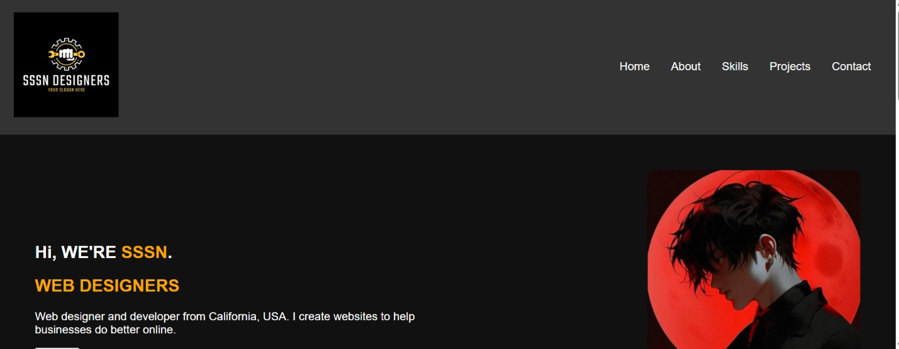

**Home page:**

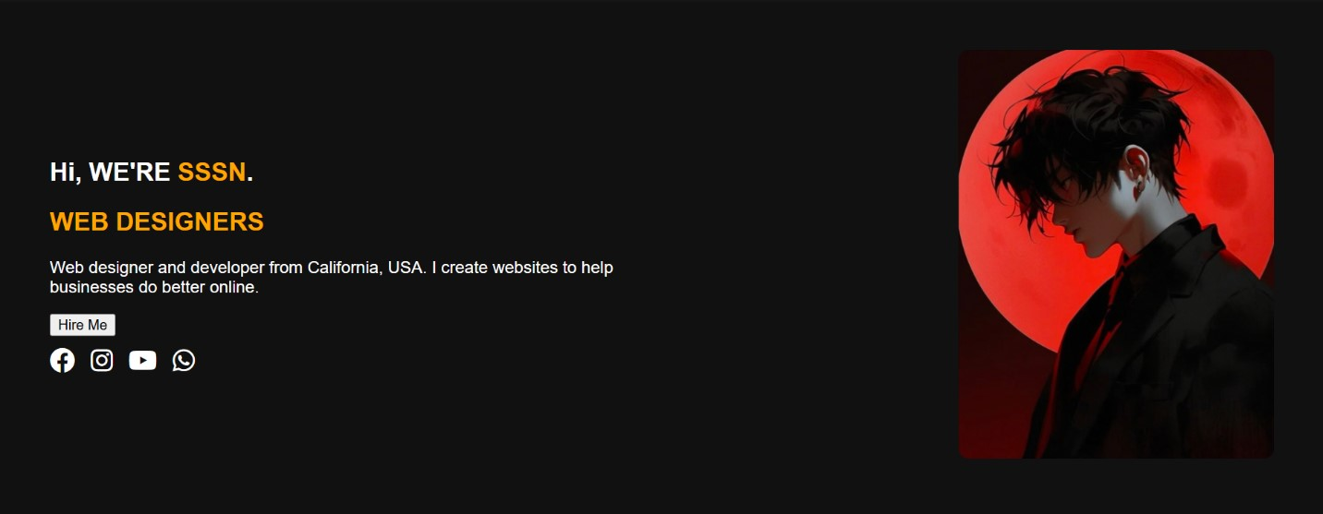

**Final output screens:**



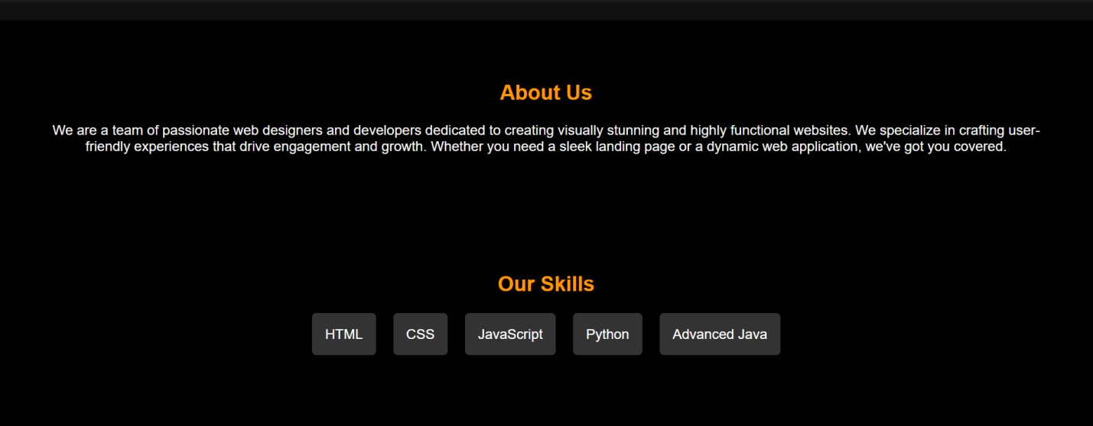

## 6.SYSTEM TESTING

### INTRODUCTION

System testing is a critical phase in the software development lifecycle where a complete and integrated software application is tested to verify that it meets the specified requirements. It involves testing the system as a whole to ensure that all components—such as UI, functionality, responsiveness, and interactions—work together seamlessly in the intended environment.

For this **responsive front-end portfolio**, system testing focuses on validating the performance, appearance, and behavior of the website across different devices, screen sizes, and browsers. Since the project uses only front-end technologies (HTML, CSS, and JavaScript), the testing ensures that:

* The layout adapts correctly on mobile, tablet, and desktop screens.
* All navigation and interactive elements function as expected.
* Styles, animations, and responsiveness behave consistently across browsers (Chrome, Firefox, Edge, etc.).
* There are no broken links, rendering issues, or JavaScript errors.

**TYPES OF TESTING**

1. **Functional Testing**

**Purpose:** Ensure all features work as expected.

**Examples:**

* + Navigation links scroll to correct sections.
  + Buttons and interactive elements respond correctly.
  + Contact form (if present) validates input (e.g., required fields).

1. **Responsive Testing**

**Purpose:** Verify the website adapts to various screen sizes.

**Examples:**

* + Layout adjusts on mobile, tablet, and desktop.
  + Hamburger menu appears on small screens.
  + Images and text scale appropriately.

1. **Usability Testing**

**Purpose:** Assess how intuitive and user-friendly the website is.

**Examples:**

* + Users can easily find projects or contact info.
  + Navigation is clear and easy to use.
  + No confusing labels or unclear buttons.

## 7.CONCLUSION

The responsive portfolio website project successfully demonstrates the effective use of frontend web technologies—HTML, CSS, and JavaScript—to build a clean, interactive, and userfriendly personal website without the need for a backend. Through the implementation of modern design principles and responsive layouts, the site adapts well to different screen sizes and devices, ensuring a consistent user experience. Features such as smooth navigation, project showcases, and a contact section help highlight skills and personal branding in a professional manner. The project also provided valuable hands-on experience in front-end development, responsiveness, browser compatibility, and UI/UX design. It serves not only as a technical accomplishment but also as a practical tool for career development and online presence.

The development of this responsive portfolio website marks a significant step in applying and demonstrating practical front-end web development skills. Utilizing HTML for content structure, CSS for layout and styling, and JavaScript for interactivity, the project fulfills the core objectives of showcasing personal information, skills, and completed projects in a modern, accessible, and responsive format.

One of the key achievements of this project is its device-independent design, ensuring that users across smartphones, tablets, and desktops can access and interact with the portfolio seamlessly. Extensive testing was conducted to validate functionality, responsiveness, and browser compatibility, which further enhanced the reliability and polish of the final product.