Multi-round conversation module (D)

D你好

DI am sad

DI do not know how to learn math

D真的嘛

D但我晚上还是睡不着

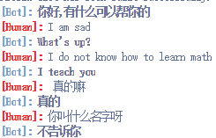

Medical Q&A(Q)

Q fever



Q失眠



Q手和脚出汗，晚上失眠多梦是不是肾虚



Q I am very tired and I have a heat with sore-throat



Emotion(E)

E我今天去买了块蛋糕结果丢了



EI bought a cake today, it is so delicious!



Mental Health(M)

Input:

M我担心我和同学和舍友的关系



MI can not sleep at night

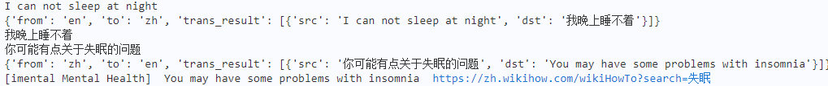

MEstoy super feliz hoy tengo un regalo

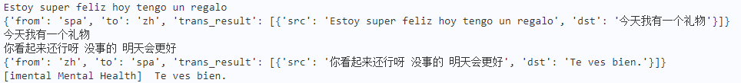

MJe suis super content aujourd'hui j'ai eu un cadeau

