CSDA 6010 : Analytics Practicum
Prof: Dr. Willie Rivers

Vemula Anil
Student Id : 4253247

Table of Contents
Case 1 : Voter Engagement Analytics……………………………………………………..
  - Project Introduction…………………………………………………………… 3
  - Business Problem……………………………………………………………... 3
  - Business Goal…………………………………………………………………. 3
  - Analytics Goal………………………………………………………………… 4
  - Data Preprocessing……………………………………………………………. 4
Attributes Definations…………………………………………………………. 4
Data Structure………………………………………………………………….. 5
Data Exploration……..………………………………………………………… 7
Handling missing values……………………………………………………….. 9
  - Predictor Analysis & Variable Relevance……………………………………… 10
  - Dimension reduction…………….……………………………………………... 10
  - Data engineering & Transformation……………………………………………. 11
  - Data Partitioning method……………………………………………………… 11
  - Model selection & Justification…………………………………………… 12
  - Model fitting & Performance evaluation………………………………….. 12
  - Model Performance………………………………………………………… 14
  - Comparision & model evaluation………………………………………….. 16
  - Observations & Conclusions………………………………………………. 17

  - Project Introduction

Civisight Analytics is a consulting firm that uses data analytics on voter-level information to assist civic and political organizations during election cycles. A statewide political organization that is getting ready for an election has hired Civisight for this project. The organization maintains a large voter database compiled from demographic sources, public records, and historical voting activity, but currently lacks an internal analytics capability to systematically evaluate this information.The dataset used in this project contains Individual voter records that describe demographics, household composition, geographic context, political affiliation, voting history, consumer behavior indicators, and experimental campaign treatments are included in the dataset used for this study. While some variables are modeled estimates or indications at the local level, others are explicitly observed behaviors, such past election participation. This is representative of real-world political data situations where it is not possible to measure every voter trait.
The campaign leadership with limited time and resources, campaign leadership must decide which voters should receive priority outreach as the election draws near. This decision is currently driven by broad assumptions and prior experience, creating risk that campaign efforts are directed toward voters who are unlikely to respond. Without suggesting finalized modeling results, this project focuses on analyzing and preparing voter-level data to clearly frame this outreach prioritization problem and establish an analytical foundation through data understanding and exploration.
  - Business Problem
The statewide political group that collaborated with Civisight Analytics is having trouble converting its sizable voter database into useful advice for campaign choices. Despite having access to comprehensive voter-level data, the organization lacks the analytical skills and resources necessary to convert this data into useful insights. As a result, rather than systematic, data-driven evaluation, many outreach and planning decisions throughout the campaign have been made on the basis of experience and intuition.
The challenge of the problem is how the voter data can be used to improve outreach planning and the allocation of campaign resources. To determine which voter segments should be given priority and how voters differ from one another, campaign leadership needs a methodical approach. Outreach initiatives run the risk of being dispersed equally among all voters, regardless of their propensity to reply, in the absence of a systematic analytical strategy. This may result in the wasteful use of scarce campaign resources, such as staff time, funds, and fieldwork, which would lower the campaign's overall efficacy.
  - Business Goals

The main business objective of this engagement is enhancing the effectiveness of campaign outreach through improved voter contact prioritization. Due to time, staffing, and financial constraints, campaign leadership aims to cut down on wasteful outreach and concentrate resources on voters who are more likely to react to engagement initiatives. Reaching this objective would enable the campaign to more strategically organize outreach initiatives and use resources in a way that optimizes their impact.

Giving campaign leadership a better understanding of the variations among voter segments is a secondary business objective. The campaign hopes to enhance outreach planning, messaging coordination, and performance evaluation throughout the election cycle by better understanding the differences in response and involvement among voter categories. These objectives place more emphasis on operational effectiveness and better decision-making than on particular analytical techniques.

  - Analytical Goals
The analytical goal at this point in the project is examining, preparing, and exploring the voter dataset in order to assist the campaign's outreach priority decisions. This entails comprehending attribute definitions, evaluating the quality of the data, resolving missing or inconsistent values, and investigating correlations between voter attributes that might be pertinent to responsiveness.
Evaluating the significance of voter characteristics such as demographics, voting history, party identification, home setting, and campaign exposure indicators in distinguishing voter behavior is one of the main goals. Rather than producing finalized predictive models or performance outcomes, the analysis is restricted to providing a solid data foundation and elucidating the analytical problem.
  - Data Pre processing
The data Preprocessing since the quality and structure of the input data have a significant impact on the analytical outcomes, data preparation is an essential step in this project. Public voter records, past election participation, demographic indicators, regional context, and modeled estimations are all included in the voter-level dataset that Civisight Analytics was given. Preprocessing is necessary to guarantee consistency, accuracy, and suitability for supervised modeling because the structure and completeness of these data sources vary. This step's goal is to provide a clear, comprehensible dataset that allows for accurate voter persuasion outcome prediction while preserving openness for non-technical stakeholders.
Attribute definations
The initial preprocessing stage involves looking over and documenting attribute definitions for every variable in the dataset. Each attribute in the analysis has its meaning, scale, type of data, and function examined. Variables that are logically organized include identification fields, household composition, neighborhood environment, political affiliation, voting history, consumer and lifestyle indicators, modeled political propensities, experimental treatments, and persuasive outcomes.
Voter_id: A unique number assigned to each voter record. This variable is just used for identification; it does not directly enable predictive modeling.
age: The voters age expressed in years. Age commonly influences political engagement and receptivity to campaign language, and different age groups exhibit different patterns of persuasion.
Gender_f and Gender_m : The binary indicators gender_f and gender_m indicate the voter's gender. Gender-related differences may affect how voters respond to specific campaign messaging or candidates.
Kids: Indicates if the voter's home has children. Political objectives and message receptivity can be influenced by the makeup of a household. indicates whether there are children in the voter's family. The composition of a home can have an impact on political goals and communication receptivity.
Ed_4col: determines whether the voter has completed a four-year college degree. Political engagement and information consumption are usually linked to educational attainment.
party_d, party_i, and party_r : are party registration indicators (Republican, Democrat, or Independent). Party identity has a considerable impact on both persuasion and basic political alignment.
VPR_08, VPR_10, and VPR_12 : are indicators of previous general election participation. Voter engagement and consistency can be deduced from previous voting behavior.
Med_hh_inc : is the voter's local median household income. Income levels can impact political objectives and opinions.
g_pelig and e_pelig: Modeled probabilities describe the likelihood of casting a ballot in general elections. These parameters give an overview of demographic and historical changes in political participation.
Message_a and message_a_rev : are indicators of exposure to specific campaign message tactics.
moved_a and moved_ad: These variables aid in determining how well different message strategies perform. Outcome variables indicate whether exposure to a campaign message or advertising changed a voter's attitude or preference. These variables are used as target variables in supervised analyses.
Data Structure
The dataset with 10,000 observations and 79 variables, the dataset offers a thorough voter-level perspective that incorporates behavioral, political, socioeconomic, and demographic data. Identifiers, household characteristics, racial and ethnic makeup, income and education metrics, party identification, past voting patterns, political involvement ratings, and campaign message indicators are all included in the dataset. The dataset's voters had a median education level of roughly 12.6 years, an average household income of roughly $70,000, and a mean age of roughly 51. With roughly 47% Democrats, 29% Republicans, and 23% Independents, party affiliation is fairly balanced. Primary participation is significantly lower than general election turnout, especially during presidential election years. All things considered, the dataset provides a solid basis for voter segmentation and predictive modeling, allowing data-driven study of political participation, turnout behavior, and the efficacy of campaign message tactics.
Variable | Count | Mean | Std Dev | Min | 25% | 50% | 75% | Max
AGE | 10000 | 50.87 | 18.15 | 18 | 36 | 51 | 64 | 100
MED_HH_INC | 10000 | 70160.67 | 25682.92 | 22381 | 51797 | 59802 | 84476 | 200227
G_PELIG | 10000 | 64.95 | 38.91 | 0 | 33 | 80 | 100 | 100
E_PELIG | 10000 | 40.54 | 28.58 | 0 | 20 | 40 | 60 | 100
Table 1 : Statistics of numerical variables

Variable | Level | Count | Proportion | Variable | Level | Count | Proportion
GENDER_F | 1 | 5704 | 0.5704 | PARTY_R | 1 | 2363 | 0.2363
GENDER_F | 0 | 4296 | 0.4296 | VPR_08 | 0 | 6115 | 0.6115
GENDER_M | 1 | 4296 | 0.4296 | VPR_08 | 1 | 3885 | 0.3885
GENDER_M | 0 | 5704 | 0.5704 | VPR_10 | 0 | 7168 | 0.7168
KIDS | 0 | 4477 | 0.4477 | VPR_10 | 1 | 2832 | 0.2832
KIDS | 7 | 1987 | 0.1987 | VPR_12 | 0 | 5947 | 0.5947
KIDS | 14 | 1784 | 0.1784 | VPR_12 | 1 | 4053 | 0.4053
KIDS | 20 | 1752 | 0.1752 | MESSAGE_A | 1 | 10000 | 1
ED_4COL | 0 | 5349 | 0.5349 | MESSAGE_A_REV | 0 | 8805 | 0.8805
ED_4COL | 1 | 4651 | 0.4651 | MESSAGE_A_REV | 1 | 1195 | 0.1195
PARTY_D | 0 | 5406 | 0.5406 | MOVED_A | N | 8691 | 0.8691
PARTY_D | 1 | 4594 | 0.4594 | MOVED_A | Y | 1309 | 0.1309
PARTY_I | 0 | 8602 | 0.8602 | MOVED_AD | N | 8814 | 0.8814
Table 2 : Statistics of categorical Variables
Data Exploration
The VoterPersuasion dataset, which includes voter-level data gathered from public records, past election participation, demographic sources, and modeled political indicators, was utilized in this project. Each column in the dataset corresponds to a particular voter attribute, and each row in the dataset represents a single voter. Voter demographics, household composition, political affiliation, voting history, neighborhood environment, consumer behavior indicators, experimental treatments, and persuasion outcomes are all described by a combination of category, binary, and numerical variables in the dataset.
The dataset contains a number of binary indicators, including party registration variables (e.g., Democratic, Republican, Independent), gender indicators, voter participation indicators for previous elections, and campaign treatment flags. During analysis, these variables are handled as categorical inputs and represent yes/no conditions. Descriptive statistics can be used to examine other numerical qualities, such as age, modelled voting probabilities, neighborhood demographic percentages, and household-level statistics, in order to find patterns and trends.
Additionally, the dataset contains outcome variables that indicate whether exposure to campaign message altered a voter's attitude or preference. The target variables for supervised modeling are these persuasion indicators. Knowing the dataset's structure is a crucial first step since it helps with preprocessing choices and indicates which variables need to be transformed before further investigation.

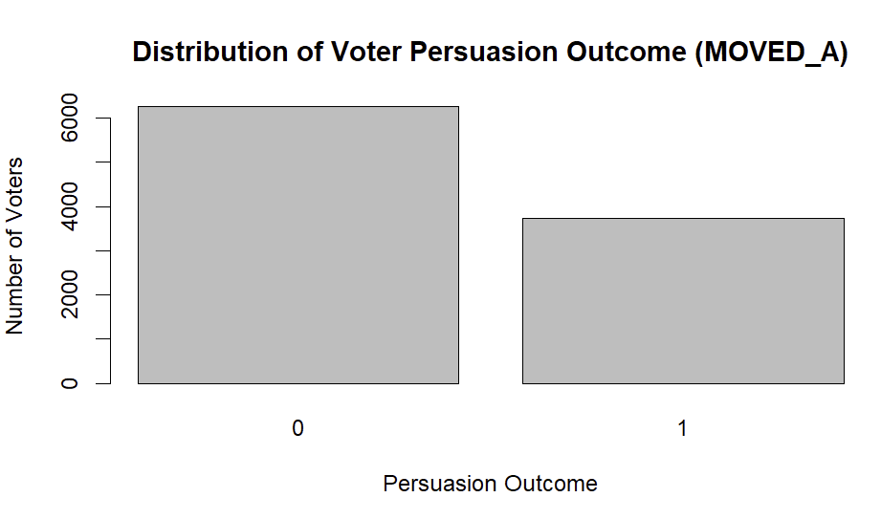
Fig 1 : Distribution of voter persuasion outcome
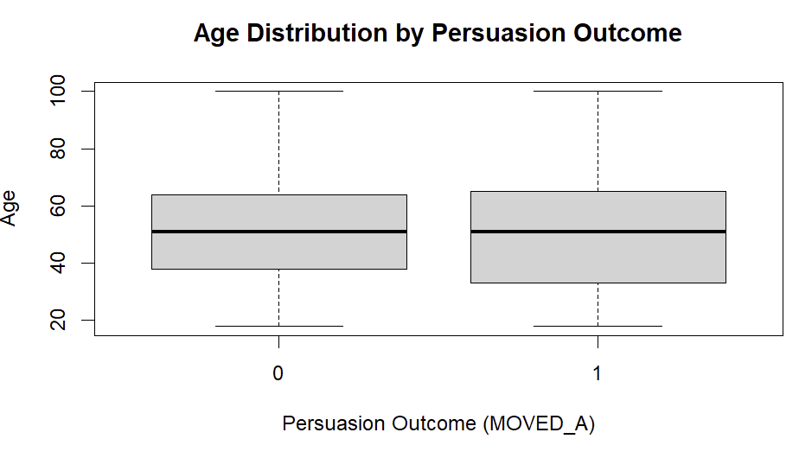
Fig 2 : Age distribution by Persuasion outcome
The association between voter attributes and the persuasion outcome was evaluated by exploratory visual analysis prior to model creation. In order to determine the percentage of voters that showed preference movement, the distribution of the target variable (MOVED_A) was examined. This provided context for the model's subsequent evaluation. In order to identify trends related to persuasion results and validate the applicability of these variables for supervised modeling, visual comparisons across age, party membership, and voting participation likelihood were employed.
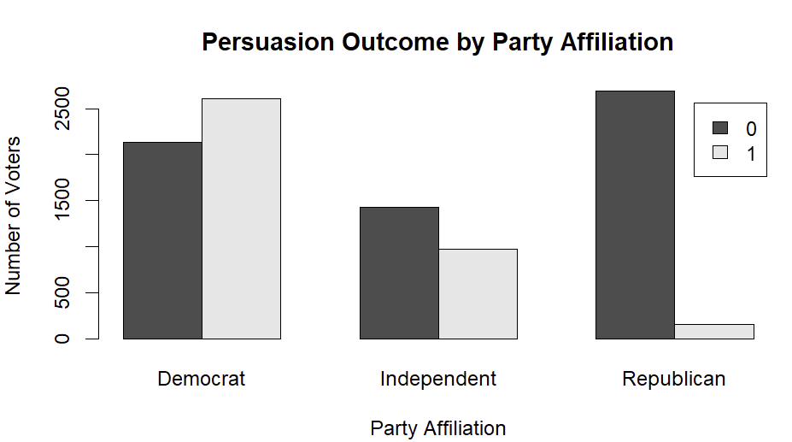
Fig 3 : Party outcome by Party affilation

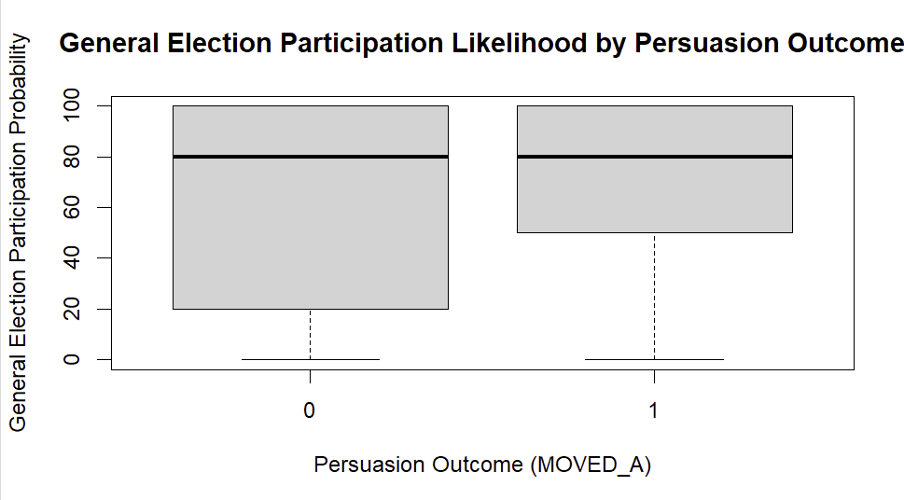
Fig 4 : General election participation likelihood by persuasion outcome

Handling missing values
The number and percentage of missing observations for each variable in the Voter Persuasion dataset were examined in order to assess missing values. According to this evaluation, there was no substantial missing data in the dataset that required to be imputed, and no entries had to be eliminated because of incomplete information.
After being determined to be non-informative, two columns were removed from further investigation.
Voter_id : a special number given to every voter record. This variable is exclusively used for record identification and has 10,000 distinct values (one for each observation). It is eliminated prior to modeling since it has no variance and no significant connection to voter behavior or persuasion results.
Unnamed 0 : An index column that is automatically generated when data is imported. This column offers no analytical value; it just sequentially counts data from 1 to 10,000. The analysis does not include it.
1.6 Predictor Analysis & Variable relevance
Voter characteristics that directly supported outreach prioritization decisions and demonstrated distinct associations with preference change were given priority by predictor analysis. The most significant predictors were historical voting behavior factors, such as modeled participation probability (G_PELIG, E_PELIG) and general and primary election participation indicators (VG_04–VG_12, VPR_08, VPR_10, VPR_12, VPP_08, VPP_12) those with irregular or moderate participation patterns were more likely to show preference shift than those with consistently high participation rates, according to exploratory comparisons. Because persuasion outcomes differed by partisan alignment, especially among independent and mixed-party families, party registration and household political composition variables (PARTY_D, PARTY_R, PARTY_I, HH_ND, HH_NR, HH_NI) were shown to be the next most relevant category. The campaign's requirement to concentrate its efforts on voters who are most likely to respond is closely correlated with these factors.
The demographic variables were kept as supporting predictors (AGE, GENDER_F, GENDER_M, ED_4COL, KIDS, and MED_AGE). These variables offer contextual information but do not directly influence persuasion outcomes. To evaluate the relationship between campaign actions and observed voter movement, experimental treatment indicators (MESSAGE_A, MESSAGE_A_REV, OPP_SEX, and I3) were incorporated. Due to their lesser direct associations with persuasion, lifestyle, consumer behavior, and neighborhood-level characteristics (including RELIGIOUSM, FINANCIALM, POLITICALC, MED_HH_INC, and NL5G) were given lower priority but kept in order to improve voter segmentation and environmental context. To avoid knowledge leakage and maintain the validity of the supervised modeling approach, identifier variables (VOTER_ID) and post-outcome measures (MOVED_AD) were eliminated.
  - Dimension reduction
In the area of voter engagement analytics, PCA aids in condensing recurring behavioral signals into concise engagement or context metrics, such as voting history or neighborhood traits. As a result, there is less chance of multicollinearity, predictor redundancy, and model stability can be increased without sacrificing important information. For my business problem , there is no chance to need of PCA. In sort of data PCA excluded. But instead of reduction , the drop() function has been used. The variables like voter_Id , unnamed_0 also been removed.
To address redundancy among predictors that capture comparable voter behaviors and contextual information, dimension reduction was used. Voters who regularly participated in one election tended to participate in others, according to an exploratory assessment of historical voting factors that revealed a substantial association across election-year indicators. To summarize overall participation patterns, representative measures of voter involvement were kept instead of all year-specific variables (VG_04,VG_12, VPR_08, VPR_10, and VPR_12). By minimizing redundant variables that would compromise model stability, this method maintained significant variance in voter behavior.
Party affiliation, predicted participation probability, and local context data were all similarly consolidated. Measures of household party composition and party registration were examined jointly, and representative variables were kept to show partisan alignment without repeating data at different levels. Only the modeled participation probabilities (G_PELIG, E_PELIG) that added unique information were kept after being compared to the observed voting history. By choosing more comprehensive contextual measurements instead of several highly connected percentages, neighborhood demographic and political indicators were diminished. Since the client needs precise explanations connecting particular voter traits to outreach decisions, advanced dimension reduction techniques like principal component analysis were purposefully avoided in order to preserve interpretability.
1.8 Data engineering & Transformation
The training dataset was examined to find predictors with almost zero variance before the model was fitted. To lower noise and avoid convergence problems during model estimation, variables that showed little to no variation across observations were eliminated from both the training and testing datasets. By keeping variables that provide important information about the persuasion outcome, this phase helped increase the stability of the model. The nearzerovar() function used to identify which are near zero variance variables. And the correlated variables find using function cor().
Predictors that caused target leakage were found and eliminated during data engineering before the model was fitted. It was discovered that variables like opposite(variable) and MOVED_AD successfully encoded post-outcome information and had a strong correlation with the target variable (MOVED_A). The model performed unrealistically well when these factors were kept. Prior to model creation, these variables were removed from the training and testing datasets in order to guarantee a correct evaluation and stop information leakage. To increase model stability and dependability, extra data preparation procedures were used prior to fitting the supervised models. Predictors with correlated variables were discovered and deleted from the training dataset by finding with the function cor().
This transformation stage made sure that there was enough variability in the remaining predictors to enable efficient categorization. To keep training and evaluation data consistent, the same variables were eliminated from the testing dataset. By using these steps, the feature set was streamlined while the analytical solution's interpretability and integrity were maintained.
1.9 Data Partitioning method
To enable objective assessment of model performance, the voter dataset was divided into training and testing subsets. Stratified sampling based on the target variable (MOVED_A) was used to apply an 80 percent training and 20 percent testing split. The relative distribution of voters who were persuaded and those who were not was maintained in both subsets by this method.
The training dataset was used entirely for model estimation and parameter learning, while the testing dataset was held out to measure predictive accuracy on unseen data. By lowering the possibility of overfitting and promoting trustworthy comparison of model findings, this partitioning technique makes sure that inferences made from the analysis represent generalizable patterns rather than sample-specific behavior.
1.10 Model selection & Justification
The outcome as based on the decision making of the problem in the business here there are three supervised classification models were selected to satisfy the voter persuasion objective. Because the goal variable reflects a binary outcome and the model generates probability estimates that are directly applicable to campaign decision making, logistic regression was selected as the main model. The logistic regression model's structure enables findings to be interpreted in terms of how voter traits relate to the likelihood of persuasion, which satisfies the client's need for analytics that are clear and convincing.
In order to assess if non-linear correlations and interaction effects among voter traits could enhance classification performance, a decision tree model was incorporated as a secondary model. By enabling various combinations of variables to affect persuasion outcomes in various voter demographics, the decision tree offers an alternative viewpoint on the data. By incorporating this model, it was possible to compare a more adaptable classification method with a stable, comprehensible baseline approach, facilitating a fair assessment of the model's usability and performance.
A random forest model, an ensemble technique that combines several decision trees to increase classification accuracy and decrease overfitting, was presented to further improve prediction capability. In order to determine whether integrating multiple tree-based models could result in more robust discrimination between persuaded and non-persuaded voters while preserving robustness on unseen data, the random forest model was chosen. Ensemble approaches have better prediction performance, which is useful for finding high-priority voter segments when resources are limited, but being less interpretable than logistic regression and single decision trees.
Instead of optimizing predictive complexity, interpretability, stability, and alignment with campaign planning requirements were prioritized in the model selection process. This method guarantees that the analytical solution can be utilized consistently in operational outreach planning and effectively explained to non-technical stakeholders.
1.11 Model fitting & Performance evaluation
The outcome with MOVED_A as the dependent variable and the other predictors as independent variables, the logistic regression model was fitted using the training dataset. Stable parameter estimation was ensured by controlling model convergence. In order to ensure that model performance was assessed on unseen data, the dataset was split using a 80% train and 20% test split. A confusion matrix was used to evaluate the model's performance in terms of both accurate and inaccurate classifications.The other model has taken for comparing which model is best among two models , Classification based splitting rules were used to train the decision tree model on the same training dataset. The testing dataset was used to produce predictions, and a confusion matrix in line with the logistic regression assessment method was used to assess the classification results.
To give a thorough evaluation, the model's performance was assessed using a variety of categorization indicators. These criteria comprised specificity to determine the right classification of non-convinced voters, sensitivity to test the model's capacity to accurately identify persuaded voters, and accuracy to gauge overall prediction correctness. For every model, confusion matrices were created in order to analyze the distribution of accurate and inaccurate classifications.
This evaluation framework aligned the analytical approach with the voter persuasion prediction target and guaranteed a fair and consistent comparison amongst models.
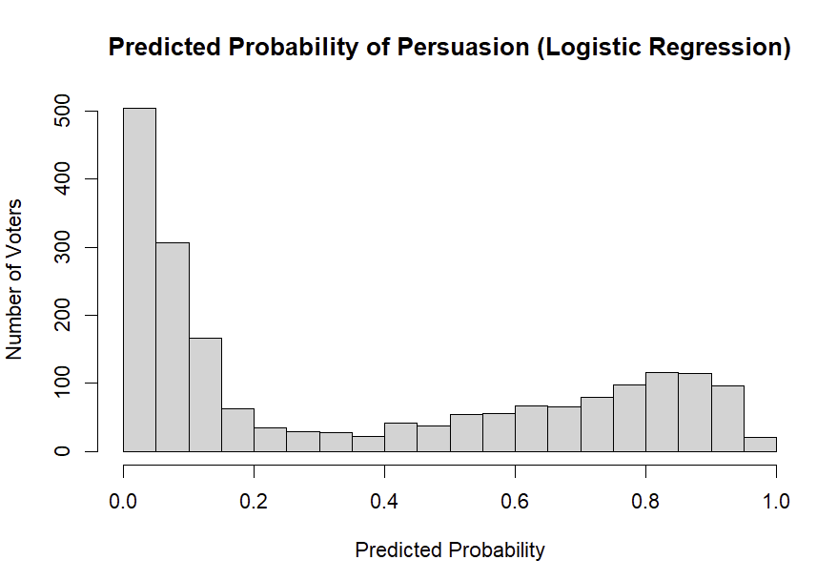
Fig 5 : Predicted probabilities of Logistic Regression
The distribution of anticipated persuasion probabilities produced by the logistic regression model on the test dataset is depicted by the histogram. The number of voters assigned a specific likelihood of being persuaded is represented by each bar. According to the distribution, voters who are more likely to respond to campaign outreach are given greater probability by the model, while voters who are unlikely to modify their preferences are given lower probabilities.

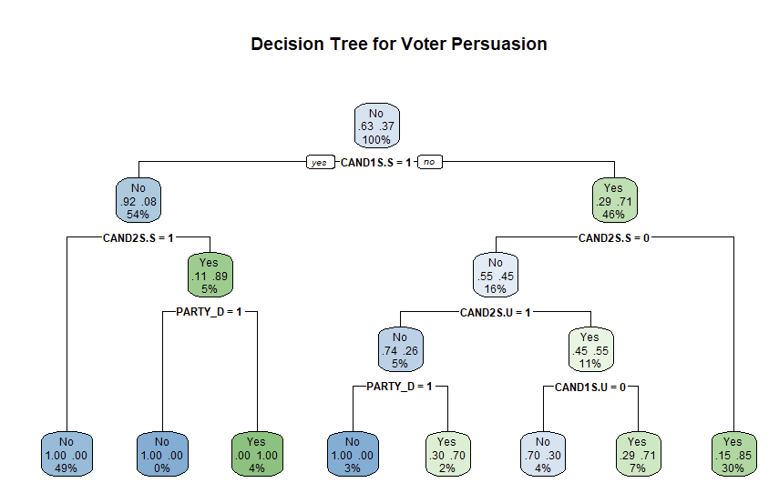
Fig 6 : Decision Tree Structure for Voter Persuasion Classification

1.12 Model Performance
The hold-out testing dataset was used to assess the logistic regression model, which showed a notable improvement above baseline categorization. The model had significant predictive power with an overall accuracy of 0.8604, surpassing the no-information rate of 0.6268. With sensitivity of 0.8803, specificity of 0.8271, and balanced accuracy of 0.8537, performance was balanced across outcome categories. With a Kappa value of 0.7034, there is no indication of systematic categorization bias and a high degree of agreement between the expected and observed results. These findings imply that logistic regression maintains interpretability while offering consistent and dependable classification.
On the testing dataset, the decision tree model performed better overall. Both convinced and non-persuaded voters showed improved classification, as evidenced by its 0.9165 accuracy and 0.9255 balanced accuracy. Both result groups were successfully identified by the model, which showed excellent specificity (0.9611) and good sensitivity (0.8899). The robustness of the model is confirmed by a Kappa value of 0.8266, which denotes excellent agreement beyond chance. The decision tree improved overall categorization and decreased misclassification errors in comparison to logistic regression.
Out of the three methods, the random forest model had the best prediction performance. The model obtained an accuracy of roughly 0.9625, with sensitivity of 0.9593, specificity of 0.9678, and balanced accuracy of 0.9636, according to the testing findings. The confusion matrix, which specifically enhances the detection of persuaded voters, displays the fewest misclassifications. These findings show great generalization to unknown data and excellent discrimination between outcome categories. The random forest's performance indicates that ensemble approaches are quite good at identifying intricate patterns in voter behavior.

 | Actual
Predicted | No | Yes
No | 1103 | 129
Yes | 150 | 617

Table 3: Cofusion matrix of Logistic regression

 | Actual
Predicted | No | Yes
No | 1115 | 29
Yes | 138 | 717

Table 4 : Confusion matrix of Decision tree

 | Actual
Prediction | No | Yes
No | 1202 | 24
Yes | 51 | 722

Table 5 : Confusion matrix of Random forest
On the testing dataset, the confusion matrices display how each model categorized voters as either persuaded or not. Although a sizable portion of voters were misclassified in either direction, the logistic regression model accurately classified the majority of voters in both outcome categories. According to a stable and interpretable model, this shows a strong but imperfect division between those who are persuaded and those who are not.
1.13 Comparision & model evaluation
Performance on the hold-out testing dataset was used to compare the logistic regression, decision tree, and random forest models. Significant variations in prediction strength were noted, despite the fact that all three models significantly outperformed the baseline categorization.
Model | Accuracy | Sensitivity | Specificity
Logistic Regression | 0.86043 | 0.880287 | 0.8270777
Decision Tree | 0.916458 | 0.889864 | 0.961126
Random Forest | 0.962481 | 0.959298 | 0.9678284

Table 6 : Comparision of three models by metrices
The same hold-out testing dataset was used to assess a random forest model in addition to logistic regression and decision tree models. Out of the three models, the random forest model had the best classification performance, according to the confusion matrix results. Very few votes were misclassified by the model; most voters, both convinced and non-persuaded, were correctly classified. Specifically, there were significantly fewer false negatives than with the other models, suggesting better identification of voters who were persuaded.
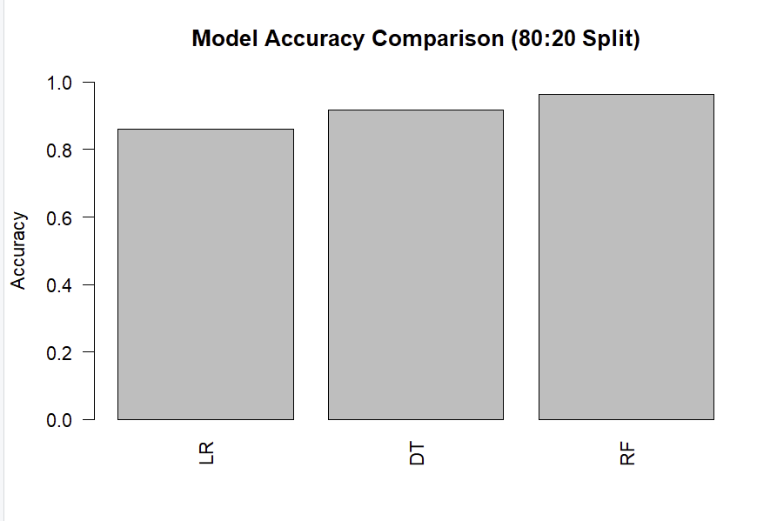
LR – Linear Regression , DT – Decision Tree , RF – Random Forest
Fig 6 : Models comparision based on accuracy

Additionally, there was an increase in agreement above chance across models, with the random forest findings showing the most consistency. The evolution from logistic regression to decision trees to random forests illustrates how increasingly adaptable models are able to identify intricate trends in voter behavior. However, because ensemble approaches offer less direct insight into the impacts of individual predictors, this improvement comes at the expense of diminished interpretability. Overall, the analysis shows that interpretability and predictive performance are traded off. While tree-based algorithms, especially random forest, provide better classification accuracy for identifying high-priority voter segments, logistic regression provides clarity for explaining outreach decisions.
1.14 Observations & Conclusions
The analysis shows that, even with limited campaign resources, voter-level data can be used to enhance outreach priority. Voters with less consistent voting records and lower party alignment are more likely to react to campaign outreach attempts, according to exploratory data and model results. The campaign's goal of concentrating resources on voters where persuasion impact is most likely is directly supported by this understanding.
The random forest model demonstrated the highest predictive capacity for finding persuadable voters among the models studied, yielding the most accurate classification results and the fewest misclassifications. While logistic regression offered the most lucid explanation of predictor effects, despite its somewhat lower accuracy, decision trees also demonstrated great performance while maintaining some interpretability.
Practically speaking, the campaign can make better use of outreach resources by utilizing these insights. While resources allocated to regularly non-responsive voters should be reduced, efforts should be focused on voter segments that have been identified as moderately engaged and less strongly aligned. Geographic prioritizing and customized messaging tactics can also be supported by model results. All things considered, this project creates a solid, data-driven foundation for outreach and voter targeting. Campaign leadership may increase the efficacy of voter engagement tactics and make better judgments by fusing the predictive power of tree-based models with the interpretable insights from logistic regression.

