VISVESVARAYA TECHNOLOGICAL UNIVERSITY
“JnanaSangama”, Belgaum -590014, Karnataka.


LAB REPORT
on

OPERATING SYSTEMS

Submitted by
VEMULA VENKATA JAIDHEER(1BF24CS333)

in partial fulfilment for the award of the degree of
BACHELOR OF ENGINEERING
in
COMPUTER SCIENCE AND ENGINEERING


B.M.S. COLLEGE OF ENGINEERING
(Autonomous Institution under VTU)
BENGALURU-560019
Feb-2026 to June-2026

B. M. S. College of Engineering,
Bull Temple Road, Bangalore 560019
(Affiliated To Visvesvaraya Technological University, Belgaum)
Department of Computer Science and Engineering


CERTIFICATE

This is to certify that the Lab work entitled “OPERATING SYSTEMS – 23CS4PCOPS” carried out by Vemula Venkata Jaidheer(1BF24CS333), who is bonafide student of B. M. S. College of Engineering. It is in partial fulfilment for the award of Bachelor of Engineering in Computer Science and Engineering of the Visvesvaraya Technological University, Belgaum during the year 2024. The Lab report has been approved as it satisfies the academic requirements in respect of a
OPERATING SYSTEMS - (23CS4PCOPS) work prescribed for the said degree.

Dr. Seema Patil Dr. Kavitha Sooda
Associate Professor Professor and Head
Department of CSE Department of CSE
BMSCE, Bengaluru BMSCE, Bengaluru

Sl.  No. | Experiment Title | Page No.
1. | Write a C program to simulate the following CPU scheduling algorithm to find turnaround time and waiting time.  - FCFS  - SJF  - Priority  - Round Robin (Experiment with different quantum sizes for RR algorithm) | 3
2. | Write a C program to simulate multi-level queue scheduling algorithm considering the following scenario. All the processes in the system are divided into two categories – system processes and user processes. System processes are to be given higher priority than user processes. Use FCFS scheduling for the processes in each queue. | 20
3. | Write a C program to simulate Real-Time CPU Scheduling algorithms:  - Rate- Monotonic  - Earliest-deadline First  - Proportional scheduling | 23
4. | Write a C program to simulate:  - Producer-Consumer problem using semaphores.  - Dining-Philosopher’s problem | 32
5. | Write a C program to simulate:  - Bankers’ algorithm for the purpose of deadlock avoidance.  - Deadlock Detection | 38
6. | Write a C program to simulate the following contiguous memory allocation techniques.  - Worst-fit  - Best-fit  - First-fit | 46
7. | Write a C program to simulate page replacement algorithms.  - FIFO  - LRU  - Optimal | 50

- Write a C program to simulate the following CPU scheduling algorithm to find turnaround time and waiting time.

  - FCFS
#include <stdio.h> int main()
{
int n, i;

printf("Enter the number of processes:"); scanf("%d", &n);

int at[n], bt[n], ct[n], wt[n], tat[n];

for(i = 0; i < n; i++)
{
printf("Enter Arrival Time for Process %d:", i + 1); scanf("%d", &at[i]);

printf("Enter Burst Time for Process %d:", i + 1); scanf("%d", &bt[i]);
}
ct[0] = at[0] + bt[0]; for(i = 1; i < n; i++)
{
if(ct[i - 1] < at[i])
ct[i] = at[i] + bt[i]; else
ct[i] = ct[i - 1] + bt[i];
}
float totalWT = 0, totalTAT = 0; for(i = 0; i < n; i++)
{
tat[i] = ct[i] - at[i];
wt[i] = tat[i] - bt[i];

totalWT += wt[i]; totalTAT += tat[i];
}

printf("\nPROCESS\tAT\tBT\tCT\tWT\tTAT\n"); for(i = 0; i < n; i++)
{
printf("P%d\t%d\t%d\t%d\t%d\t%d\n", i + 1, at[i], bt[i], ct[i], wt[i], tat[i]);
}

printf("\nAverage Waiting Time = %.2f", totalWT / n); printf("\nAverage Turnaround Time = %.2f\n", totalTAT / n);

return 0;
}

OUTPUT:
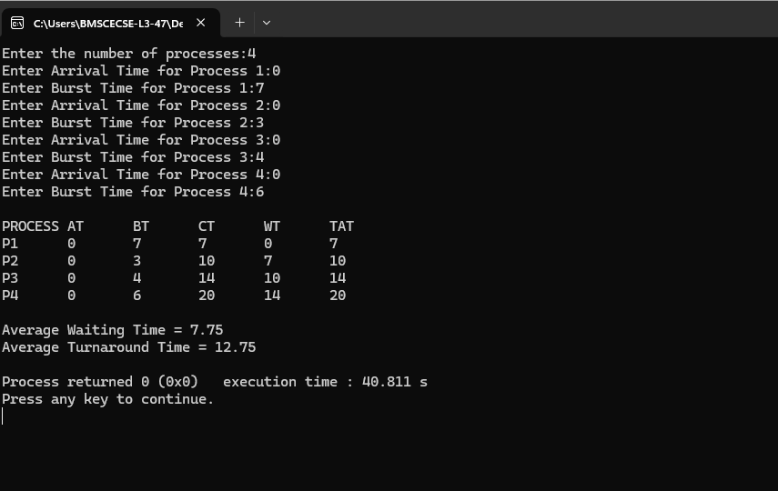

SJF (pre-emptive)
#include<stdio.h> struct process{
int pid, bt, at, wt, tat, ct;
};

int main(){
struct process p[10], temp; int n,i,j;

printf("Enter number of processes: "); scanf("%d",&n);

for(i=0;i<n;i++){
printf("Process %d Arrival Time: ",i+1); scanf("%d",&p[i].at);
printf("Process %d Burst Time: ",i+1); scanf("%d",&p[i].bt);
p[i].pid=i+1;
}

for(i=0;i<n-1;i++){ for(j=i+1;j<n;j++){
if(p[i].bt > p[j].bt){ temp=p[i]; p[i]=p[j]; p[j]=temp;
}
}
}

int time=0; for(i=0;i<n;i++){
time += p[i].bt; p[i].ct=time; p[i].tat=p[i].ct-p[i].at;
p[i].wt=p[i].tat-p[i].bt;
}

float avgwt=0,avgtat=0; printf("\nPID\tAT\tBT\tWT\tTAT\n");

for(i=0;i<n;i++){ printf("%d\t%d\t%d\t%d\t%d\n",p[i].pid,p[i].at,p[i].bt,p[i].wt,p[i].tat); avgwt+=p[i].wt;
avgtat+=p[i].tat;
}

printf("\nAverage Waiting Time = %.2f",avgwt/n); printf("\nAverage Turnaround Time = %.2f",avgtat/n);
}

OUTPUT:
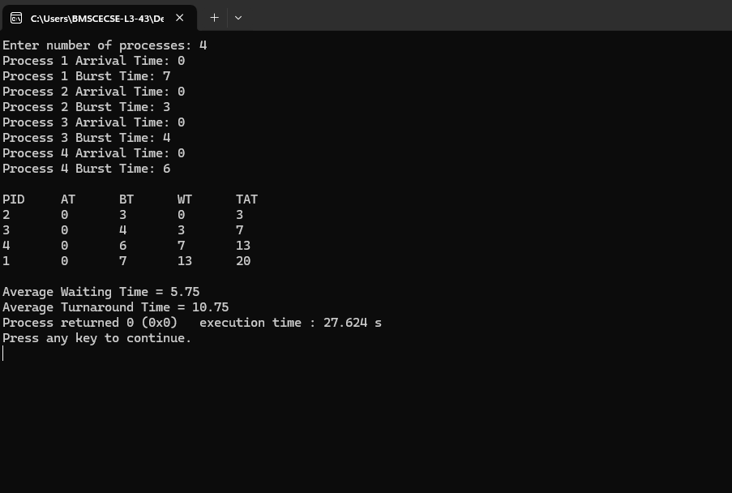

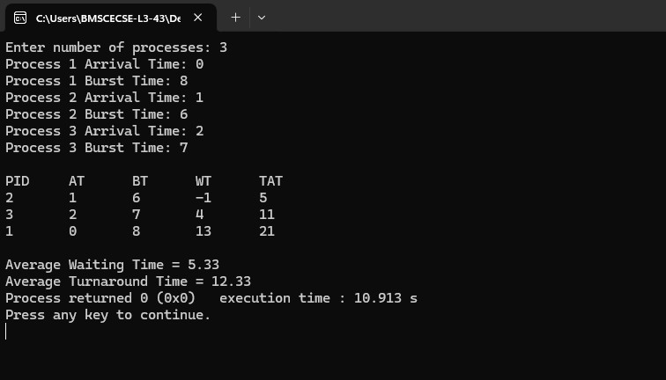

SJF (non pre-emptive)
#include<stdio.h> int main(){
int bt[10],at[10],rt[10],ct[10],tat[10],wt[10]; int n,i,time=0,remain,smallest;
float avgwt=0,avgtat=0;

printf("Enter number of processes: "); scanf("%d",&n);

for(i=0;i<n;i++){ printf("Arrival Time: "); scanf("%d",&at[i]); printf("Burst Time: "); scanf("%d",&bt[i]); rt[i]=bt[i];

remain=n;

}
while(remain!=0){ smallest=-1;

for(i=0;i<n;i++){ if(at[i]<=time && rt[i]>0){
if(smallest==-1 || rt[i]<rt[smallest]) smallest=i;
}
}

if(smallest==-1){ time++; continue;
}

rt[smallest]--; time++;

if(rt[smallest]==0){ remain--; ct[smallest]=time;
tat[smallest]=ct[smallest]-at[smallest];

wt[smallest]=tat[smallest]-bt[smallest];
}
}
printf("\nPID\tAT\tBT\tWT\tTAT\n"); for(i=0;i<n;i++){
printf("%d\t%d\t%d\t%d\t%d\n",i+1,at[i],bt[i],wt[i],tat[i]); avgwt+=wt[i];
avgtat+=tat[i];
}

printf("\nAverage WT=%.2f",avgwt/n); printf("\nAverage TAT=%.2f",avgtat/n);
}

OUTPUT:
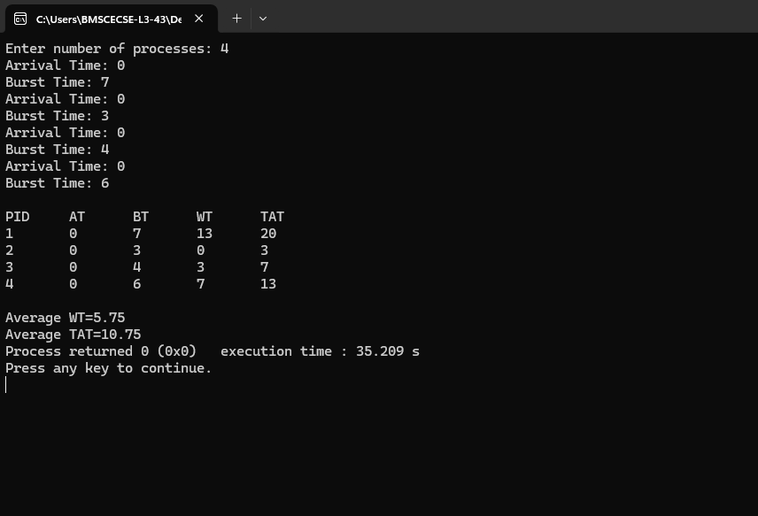

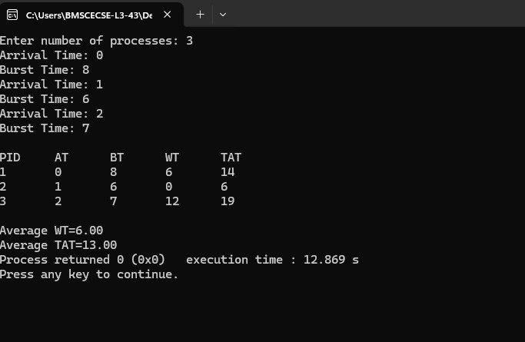

Priority (pre emptive)
#include<stdio.h> struct process{
int pid,bt,at,pr,wt,tat,ct;
};

int main(){
struct process p[10],temp; int n,i,j;

printf("Enter number of processes: "); scanf("%d",&n);

for(i=0;i<n;i++){ printf("Arrival Time: "); scanf("%d",&p[i].at);

printf("Burst Time: "); scanf("%d",&p[i].bt);

printf("Priority: "); scanf("%d",&p[i].pr);

p[i].pid=i+1;
}

for(i=0;i<n-1;i++){ for(j=i+1;j<n;j++){
if(p[i].pr > p[j].pr){ temp=p[i]; p[i]=p[j]; p[j]=temp;
}
}
}

int time=0;
float avgwt=0,avgtat=0;

for(i=0;i<n;i++){ time+=p[i].bt; p[i].ct=time;

p[i].tat=p[i].ct-p[i].at;
p[i].wt=p[i].tat-p[i].bt;
}
printf("\nPID\tPR\tWT\tTAT\n"); for(i=0;i<n;i++){
printf("%d\t%d\t%d\t%d\n",p[i].pid,p[i].pr,p[i].wt,p[i].tat); avgwt+=p[i].wt;
avgtat+=p[i].tat;
}

printf("\nAverage WT=%.2f",avgwt/n); printf("\nAverage TAT=%.2f",avgtat/n);
}

OUTPUT:
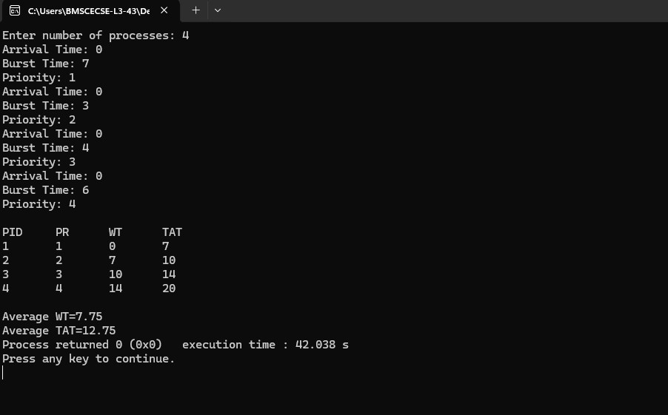

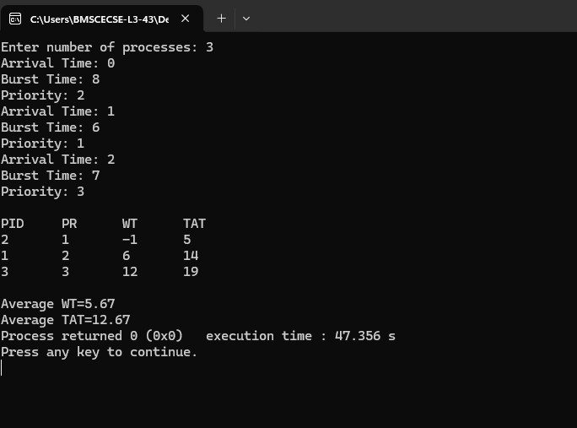

Priority (Non pre-emptive)
#include<stdio.h> int main(){
int bt[10],at[10],pr[10],rt[10];
int wt[10],tat[10],ct[10];
int n,time=0,remain,highest,i; float avgwt=0,avgtat=0;
printf("Enter number of processes: "); scanf("%d",&n);

for(i=0;i<n;i++){ printf("Arrival Time: "); scanf("%d",&at[i]);

printf("Burst Time: "); scanf("%d",&bt[i]);

printf("Priority: "); scanf("%d",&pr[i]);

rt[i]=bt[i];
}
remain=n; while(remain!=0){
highest=-1;

for(i=0;i<n;i++){ if(at[i]<=time && rt[i]>0){
if(highest==-1 || pr[i]<pr[highest]) highest=i;
}
}

if(highest==-1){ time++; continue;
}

rt[highest]--; time++;

if(rt[highest]==0){ remain--; ct[highest]=time;
tat[highest]=ct[highest]-at[highest]; wt[highest]=tat[highest]-bt[highest];
}
}
printf("\nPID\tWT\tTAT\n"); for(i=0;i<n;i++){
printf("%d\t%d\t%d\n",i+1,wt[i],tat[i]); avgwt+=wt[i];
avgtat+=tat[i];
}

printf("\nAverage WT=%.2f",avgwt/n); printf("\nAverage TAT=%.2f",avgtat/n);
}

OUTPUT:
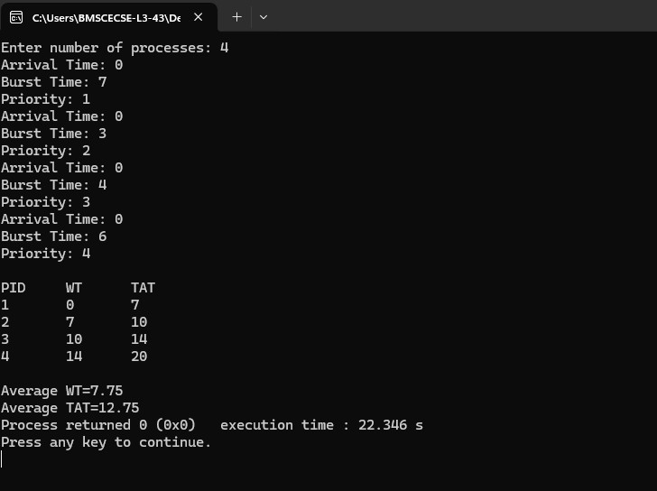

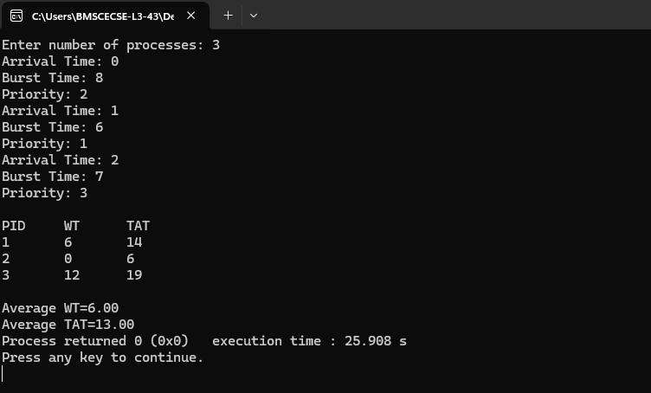

Round Robin
#include <stdio.h> int main()
{
int n, i, tq;
int at[20], bt[20], rem_bt[20];
int ct[20], wt[20], tat[20]; int time = 0, done;

printf("Enter number of processes: "); scanf("%d", &n);
printf("Enter Arrival Time and Burst Time for each process:\n"); for(i = 0; i < n; i++)
{
printf("P%d Arrival Time: ", i+1); scanf("%d", &at[i]);

printf("P%d Burst Time: ", i+1); scanf("%d", &bt[i]);

rem_bt[i] = bt[i];
}

printf("Enter Time Quantum: "); scanf("%d", &tq);

do
{
done = 1;

for(i = 0; i < n; i++)
{
if(at[i] <= time && rem_bt[i] > 0)
{
done = 0;

if(rem_bt[i] > tq)
{
time += tq; rem_bt[i] -= tq;

}
else
{
time += rem_bt[i]; ct[i] = time; rem_bt[i] = 0;
}
}
}

if(done == 1) time++;
} while(done == 0); for(i = 0; i < n; i++)
{
tat[i] = ct[i] - at[i];
wt[i] = tat[i] - bt[i];
}
float avg_wt = 0, avg_tat = 0; printf("\nProcess\tAT\tBT\tCT\tWT\tTAT\n"); for(i = 0; i < n; i++)
{
printf("P%d\t%d\t%d\t%d\t%d\t%d\n", i+1, at[i], bt[i], ct[i], wt[i], tat[i]);

avg_wt += wt[i]; avg_tat += tat[i];
}

printf("\nAverage Waiting Time = %.2f", avg_wt/n); printf("\nAverage Turnaround Time = %.2f\n", avg_tat/n);

return 0;
}

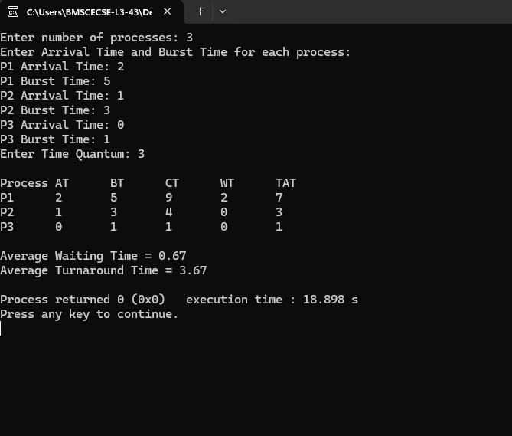
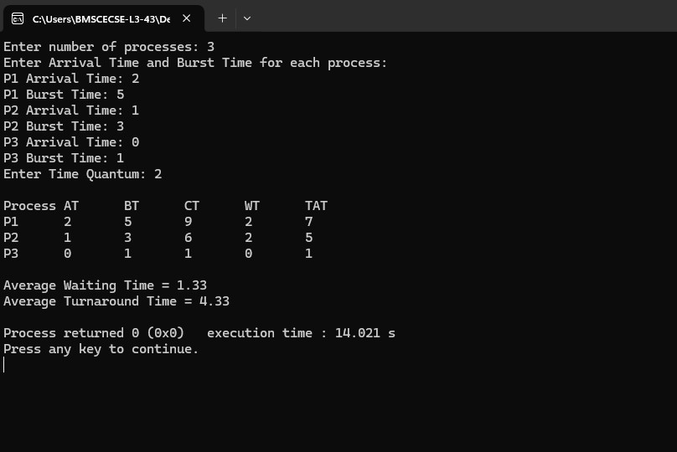

- Write a C program to simulate multi-level queue scheduling algorithm considering the following scenario. All the processes in the system are divided into two categories – system processes and user processes. System processes are to be given higher priority than user processes. Use FCFS scheduling for the processes in each queue.
#include <stdio.h> #define MAX 100 int main() {
int n, i, j;

int PID[MAX], AT[MAX], BT[MAX], TYPE[MAX];
int CT[MAX], TAT[MAX], WT[MAX], Start[MAX];

int sys[MAX], user[MAX];
int sysCount = 0, userCount = 0; int time = 0;
printf("Enter number of processes: "); scanf("%d", &n);

for(i = 0; i < n; i++) { printf("\nProcess %d\n", i + 1); printf("PID: ");
scanf("%d", &PID[i]); printf("Arrival Time: "); scanf("%d", &AT[i]); printf("Burst Time: "); scanf("%d", &BT[i]);
printf("Type (0 = System, 1 = User): "); scanf("%d", &TYPE[i]);
}

for(i = 0; i < n; i++) { if(TYPE[i] == 0)
sys[sysCount++] = i; else
user[userCount++] = i;
}

for(i = 0; i < sysCount - 1; i++) { for(j = i + 1; j < sysCount; j++) {
if(AT[sys[i]] > AT[sys[j]]) { int temp = sys[i];

sys[i] = sys[j]; sys[j] = temp;
}
}
}

for(i = 0; i < userCount - 1; i++) { for(j = i + 1; j < userCount; j++) {
if(AT[user[i]] > AT[user[j]]) { int temp = user[i];
user[i] = user[j]; user[j] = temp;
}
}
}

for(i = 0; i < sysCount; i++) { int p = sys[i];

if(time < AT[p]) time = AT[p];

Start[p] = time; time += BT[p]; CT[p] = time;

TAT[p] = CT[p] - AT[p];
WT[p] = TAT[p] - BT[p];
}

for(i = 0; i < userCount; i++) { int p = user[i];

if(time < AT[p]) time = AT[p];

Start[p] = time; time += BT[p]; CT[p] = time;

TAT[p] = CT[p] - AT[p];
WT[p] = TAT[p] - BT[p];
}

printf("\nPID\tAT\tBT\tTYPE\tCT\tTAT\tWT\n"); for(i = 0; i < n; i++) {

printf("%d\t%d\t%d\t%d\t%d\t%d\t%d\n", PID[i], AT[i], BT[i], TYPE[i],
CT[i], TAT[i], WT[i]);
}

return 0;
}

OUTPUT:
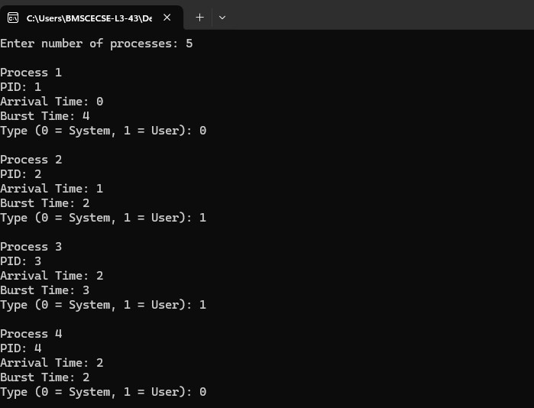
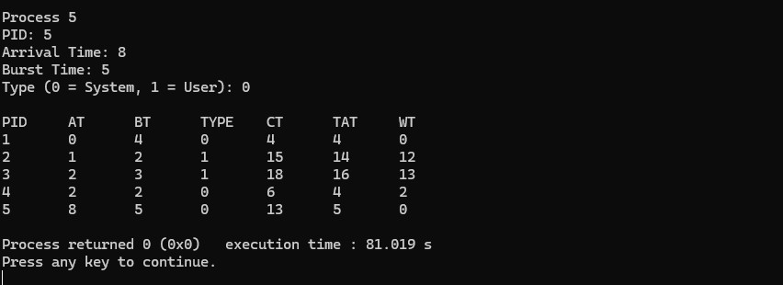

- Write a C program to simulate Real-Time CPU Scheduling algorithms:

  - Rate- Monotonic

#include <stdio.h> #include <math.h>
#define MAX 10 struct Task {
int id;
int Ci; int Ti;
int remaining;
};

int gcd(int a, int b) { while (b != 0) {
int temp = b; b = a % b;
a = temp;
}
return a;
}

int lcm(int a, int b) { return (a * b) / gcd(a, b);
}

void sortTasks(struct Task tasks[], int n) { struct Task temp;

for (int i = 0; i < n - 1; i++) { for (int j = i + 1; j < n; j++) {
if (tasks[i].Ti > tasks[j].Ti) { temp = tasks[i];
tasks[i] = tasks[j]; tasks[j] = temp;
}
}
}
}

int main() {

int n, time;
int hyperperiod = 1; float U = 0.0, bound;

struct Task tasks[MAX];

printf("Enter number of tasks: "); scanf("%d", &n);

if (n > MAX) {
printf("Maximum %d tasks allowed.\n", MAX); return 0;
}
for (int i = 0; i < n; i++) { tasks[i].id = i + 1;

printf("\nTask %d\n", i + 1);

printf("Enter Execution Time (Ci): "); scanf("%d", &tasks[i].Ci);

printf("Enter Period (Ti): "); scanf("%d", &tasks[i].Ti);

tasks[i].remaining = 0;

U += (float)tasks[i].Ci / tasks[i].Ti;
}
printf("\nCPU Utilization = %.4f\n", U); bound = n * (pow(2.0, 1.0 / n) - 1);
printf("RMS Utilization Bound = %.4f\n", bound);

if (U <= bound)
printf("System is Schedulable using RMS\n"); else
printf("System is NOT Guaranteed Schedulable using RMS\n"); sortTasks(tasks, n);
printf("\nPriority Order:\n"); for (int i = 0; i < n; i++) {
printf("Priority %d -> Task %d (Period = %d)\n",

i + 1, tasks[i].id, tasks[i].Ti);
}

hyperperiod = tasks[0].Ti; for (int i = 1; i < n; i++) {
hyperperiod = lcm(hyperperiod, tasks[i].Ti);
}

printf("\nHyperperiod = %d\n", hyperperiod); printf("\nScheduling Timeline:\n");
for (time = 0; time < hyperperiod; time++) {

for (int i = 0; i < n; i++) {
if (time % tasks[i].Ti == 0) { tasks[i].remaining = tasks[i].Ci;
}
}

int selected = -1;

for (int i = 0; i < n; i++) {
if (tasks[i].remaining > 0) { selected = i;
break;
}
}

if (selected != -1) {
printf("Time %2d -> Task %d\n", time, tasks[selected].id); tasks[selected].remaining--;
} else {
printf("Time %2d -> Idle\n", time);
}
}

return 0;
}

OUTPUT:
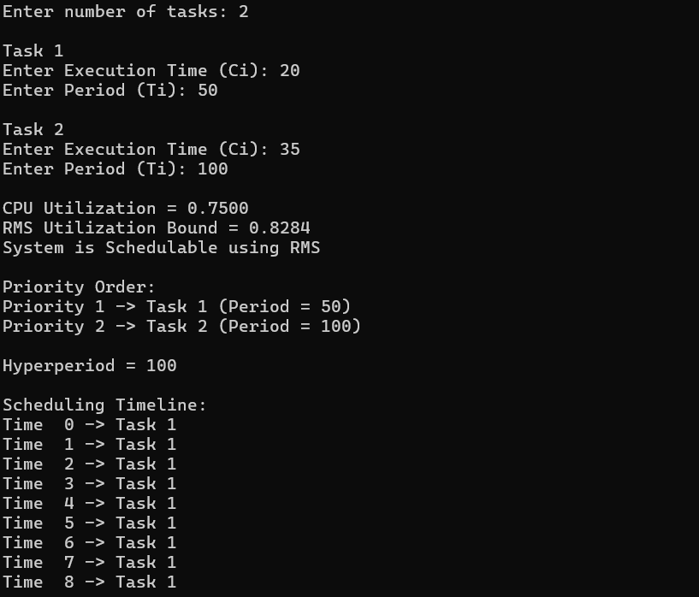
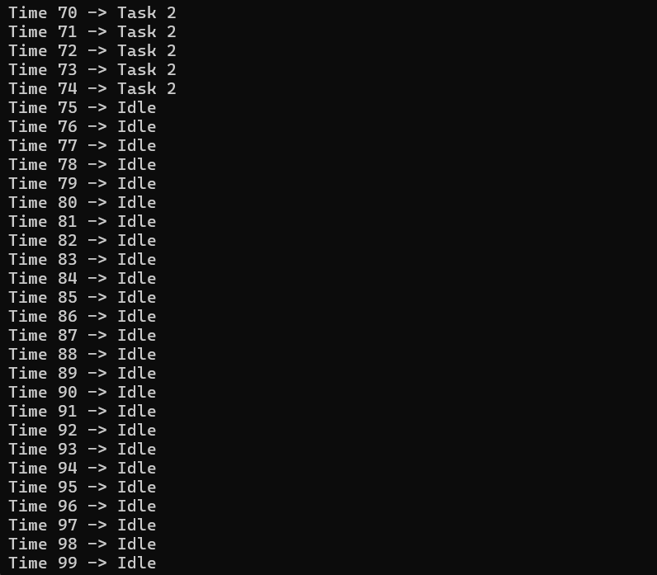

- Earliest-deadline First #include <stdio.h> #define MAX 10
typedef struct { int id;
int Ci; int Ti; int Di;
int remaining; int next_release;
} Task;

int gcd(int a, int b) { if (b == 0) return a;
return gcd(b, a % b);
}

int lcm(int a, int b) { return (a * b) / gcd(a, b);
}

int main() { int n;
Task t[MAX];
int hyperperiod = 1;

printf("Enter number of tasks: "); scanf("%d", &n);

for (int i = 0; i < n; i++) { printf("\nTask %d\n", i + 1); t[i].id = i + 1;

printf("Execution Time (Ci): "); scanf("%d", &t[i].Ci);

printf("Period (Ti): ");
scanf("%d", &t[i].Ti);

printf("Deadline (Di): ");
scanf("%d", &t[i].Di);

t[i].remaining = 0;
t[i].next_release = 0;

hyperperiod = lcm(hyperperiod, t[i].Ti);
}

printf("\nHyperperiod (LCM) = %d\n\n", hyperperiod); for (int time = 0; time < hyperperiod; time++) {
for (int i = 0; i < n; i++) {
if (time == t[i].next_release) { t[i].remaining += t[i].Ci; t[i].next_release += t[i].Ti;
}
}

int selected = -1;
int min_deadline = 1e9;

for (int i = 0; i < n; i++) { if (t[i].remaining > 0) {
if (t[i].Di < min_deadline) { min_deadline = t[i].Di; selected = i;
}
}
}

if (selected == -1) {
printf("Time %d: Idle\n", time);
} else {
printf("Time %d: Task %d running (Deadline=%d)\n", time, t[selected].id, t[selected].Di);

t[selected].remaining--;
}
}

return 0;
}

OUTPUT:
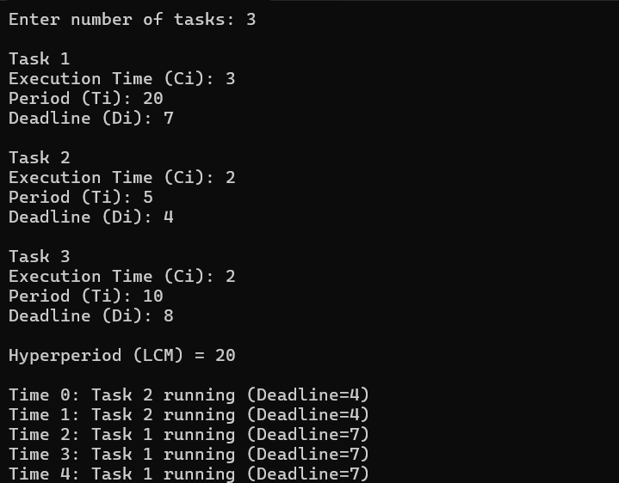
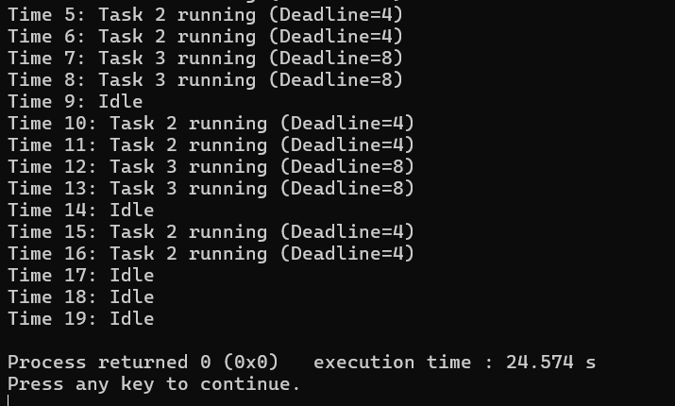

- Proportional-sharing
#include <stdio.h> struct Task {
int id, execution, period; float share;
};

int main() { int n, i;
struct Task t[10];

printf("Enter number of tasks: "); scanf("%d", &n);

for(i = 0; i < n; i++) { t[i].id = i + 1;
printf("Enter execution time and period for Task %d: ", i+1); scanf("%d %d", &t[i].execution, &t[i].period);

t[i].share = (float)t[i].execution / t[i].period;
}

printf("\nProportional Scheduling:\n"); for(i = 0; i < n; i++) {
printf("Task %d gets %.2f CPU share\n", t[i].id, t[i].share);
}

return 0;
}

OUTPUT:
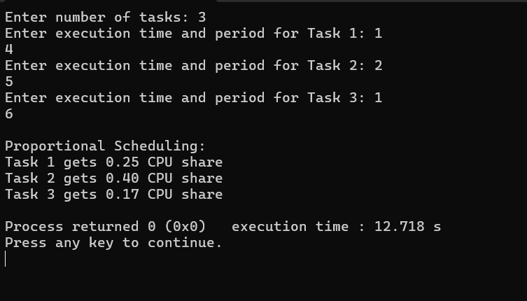

- Write a C program to simulate:
  - Producer-Consumer problem using semaphores. #include <stdio.h>
#include <stdlib.h>

int mutex = 1; int full = 0; int empty = 3; int x = 0;

void wait() { mutex--;
}

void signal() { mutex++;
}

void producer() {
if ((mutex == 1) && (empty != 0)) { wait();
full++; empty--; x++;
printf("Producer has produced: Item %d\n", x); signal();
} else {
printf("Buffer is full!\n");
}
}

void consumer() {
if ((mutex == 1) && (full != 0)) { wait();
full--; empty++;
printf("Consumer has consumed: Item %d\n", x); x--;
signal();
} else {
printf("Buffer is empty!\n");
}

}

int main() { int choice;

while (1) {
printf("\nEnter 1.Producer 2.Consumer 3.Exit\n"); printf("Enter your choice:\n");
scanf("%d", &choice);

switch (choice) { case 1:
producer(); break;
case 2:
consumer(); break;
case 3:
exit(0); break;
default:
printf("Invalid choice!\n");
}
}

return 0;
}

OUTPUT:

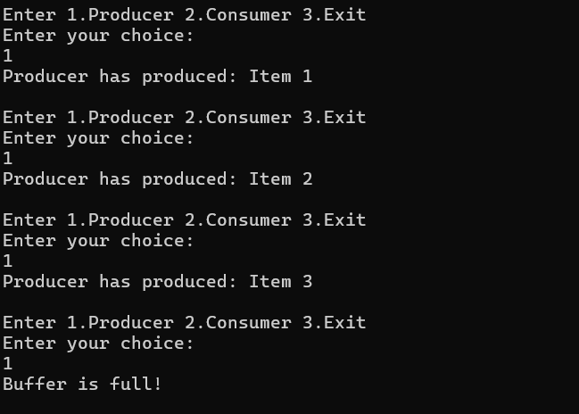
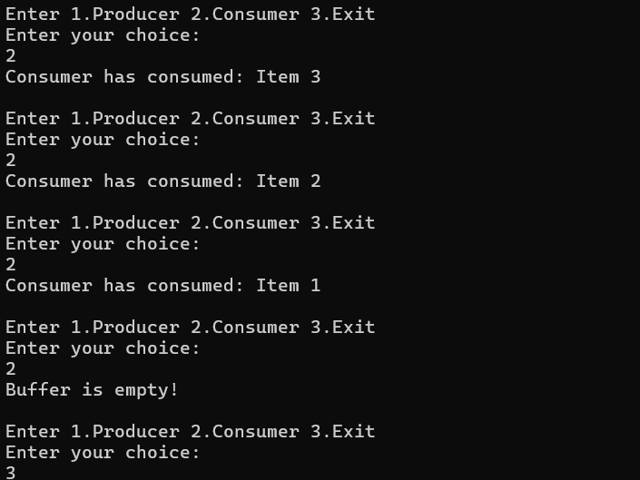

  - Dining-Philosopher’s problem #include <stdio.h>
#define MAX 10

int n;
int hungry;
int pos[MAX];

int canEat(int p, int eating[]) { int left = (p + n - 1) % n; int right = (p + 1) % n;

if (eating[left] == 0 && eating[right] == 0) return 1;
return 0;
}

void oneAtATime() {
int eating[MAX] = {0};
printf("Allow one philosopher to eat at any time\n"); for (int i = 0; i < hungry; i++) {
int p = pos[i];

for (int j = 0; j < hungry; j++) { printf("P %d is waiting\n", pos[j]);
}

if (canEat(p, eating)) { eating[p] = 1;
printf("P %d is granted to eat\n", p); printf("P %d has finished eating\n", p); eating[p] = 0;
}
}
}
void twoAtATime() {
int eating[MAX] = {0};

printf("Allow two philosophers to eat at any time\n");

for (int i = 0; i < hungry; i++) { int p = pos[i];

if (canEat(p, eating)) { eating[p] = 1;
printf("P %d is granted to eat\n", p);
} else {
printf("P %d is waiting\n", p);
}
}

for (int i = 0; i < hungry; i++) { int p = pos[i];
if (eating[p]) {
printf("P %d has finished eating\n", p); eating[p] = 0;
}
}
}

int main() { int choice;

printf("Enter the total number of philosophers: "); scanf("%d", &n);

printf("How many are hungry: "); scanf("%d", &hungry);

for (int i = 0; i < hungry; i++) {
printf("Enter philosopher %d position (1 to %d): ", i + 1, n); scanf("%d", &pos[i]);
pos[i]--;
}

while (1) {
printf("\n1. One can eat at a time\n"); printf("2. Two can eat at a time\n"); printf("3. Exit\n");
printf("Enter your choice: "); scanf("%d", &choice);

switch (choice) { case 1:

oneAtATime(); break;
case 2:
twoAtATime(); break;
case 3:
return 0; default:
printf("Invalid choice\n");
}
}

return 0;
}

OUTPUT:
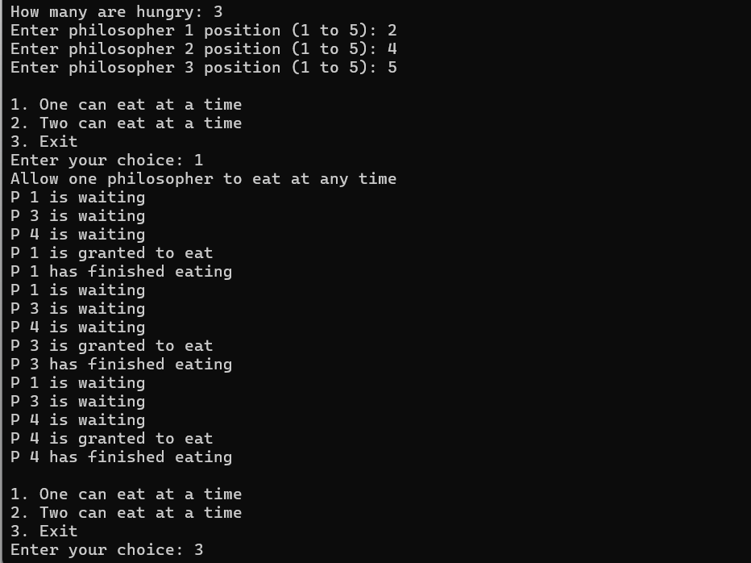

- Write a C program to simulate:

  - Bankers’ algorithm for the purpose of deadlock avoidance. #include <stdio.h>
int main()
{
int n, m;

printf("Enter number of processes -- "); scanf("%d", &n);

printf("Enter number of resources -- "); scanf("%d", &m);

int alloc[n][m], max[n][m], need[n][m]; int avail[m];
int finish[n], safe[n];

for (int i = 0; i < n; i++)
{
printf("\nEnter details for P%d\n", i);

printf("Enter allocation -- "); for (int j = 0; j < m; j++)
{
scanf("%d", &alloc[i][j]);
}

printf("Enter Max -- "); for (int j = 0; j < m; j++)
{
scanf("%d", &max[i][j]);
}
}
printf("\nEnter Available Resources -- "); for (int i = 0; i < m; i++)
{
scanf("%d", &avail[i]);
}
for (int i = 0; i < n; i++)
{
for (int j = 0; j < m; j++)

{
need[i][j] = max[i][j] - alloc[i][j];
}
}

int pid;
int request[m];
printf("\nEnter New Request Details --\n"); printf("Enter pid -- ");
scanf("%d", &pid);

printf("Enter Request for Resources -- "); for (int i = 0; i < m; i++)
{
scanf("%d", &request[i]);
}

int possible = 1;

for (int i = 0; i < m; i++)
{
if (request[i] > need[pid][i] || request[i] > avail[i])
{
possible = 0; break;
}
}

if (!possible)
{
printf("\nRequest cannot be granted.\n"); return 0;
}

for (int i = 0; i < m; i++)
{
avail[i] -= request[i]; alloc[pid][i] += request[i]; need[pid][i] -= request[i];
}

for (int i = 0; i < n; i++)

{
finish[i] = 0;
}
int count = 0; while (count < n)
{
int found = 0;

for (int i = 0; i < n; i++)
{
if (finish[i] == 0)
{
int flag = 1;

for (int j = 0; j < m; j++)
{
if (need[i][j] > avail[j])
{
flag = 0; break;
}
}

if (flag)
{
for (int j = 0; j < m; j++)
{
avail[j] += alloc[i][j];
}
printf("\nP%d is visited(", i); for (int j = 0; j < m; j++)
{
printf("%d", avail[j]);

if (j != m - 1)
printf(" ");
}

printf(")");

safe[count] = i; count++;

finish[i] = 1;
found = 1;
}
}
}

if (found == 0)
{
printf("\nSYSTEM IS NOT SAFE STATE\n");
return 0;
}
}

printf("\n\nSYSTEM IS IN SAFE STATE\n"); printf("The Safe Sequence is -- (");
for (int i = 0; i < n; i++)
{
printf("P%d", safe[i]);

if (i != n - 1)
printf(" ");
}

printf(")\n");

return 0;
}

OUTPUT:
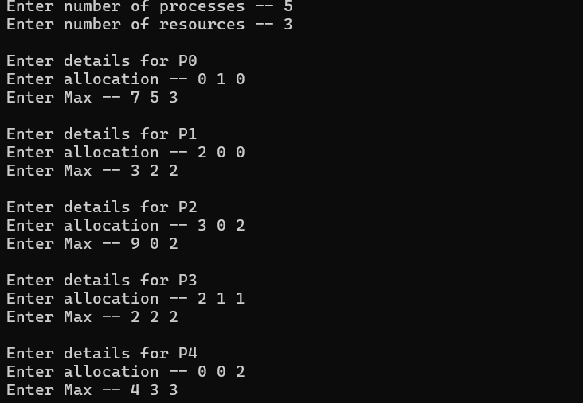
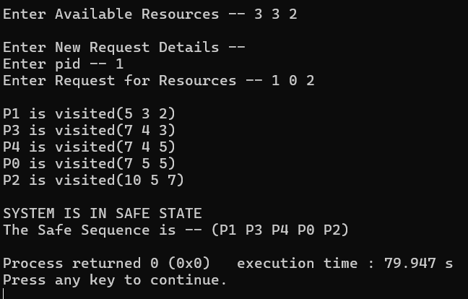

  - Deadlock Detection #include <stdio.h>
int main()
{
int n, m;

printf("Enter no of processes: "); scanf("%d", &n);

printf("Enter no of resources: "); scanf("%d", &m);

int alloc[n][m], req[n][m], avail[m], work[m]; int finish[n], seq[n];

for (int i = 0; i < n; i++)
{
printf("\nP%d Allocation: ", i); for (int j = 0; j < m; j++)
scanf("%d", &alloc[i][j]);

printf("P%d Request: ", i); for (int j = 0; j < m; j++)
scanf("%d", &req[i][j]);
}

printf("\nAvailable Resources: "); for (int i = 0; i < m; i++)
{
scanf("%d", &avail[i]); work[i] = avail[i];
}

for (int i = 0; i < n; i++)
{
int sum = 0; finish[i] = 0;

for (int j = 0; j < m; j++) sum += alloc[i][j];

if (sum == 0)

finish[i] = 1;
}
int k = 0, found; do
{
found = 0;

for (int i = 0; i < n; i++)
{
if (!finish[i])
{
int flag = 1;

for (int j = 0; j < m; j++)
{
if (req[i][j] > work[j])
{
flag = 0; break;
}
}

if (flag)
{
for (int j = 0; j < m; j++) work[j] += alloc[i][j];

finish[i] = 1; seq[k++] = i; found = 1;

printf("P%d visited\n", i);
}
}
}

} while (found); int deadlock = 0;
for (int i = 0; i < n; i++)
{

if (!finish[i])
{
deadlock = 1; break;
}
}

if (deadlock)
{
printf("\nSystem is in Deadlock\n");

printf("Deadlocked Processes: "); for (int i = 0; i < n; i++)
if (!finish[i])
printf("P%d ", i);
}
else
{
printf("\nSystem is not in Deadlock\n");

printf("Sequence: "); for (int i = 0; i < k; i++)
printf("P%d ", seq[i]);
}

return 0;
}

OUTPUT:
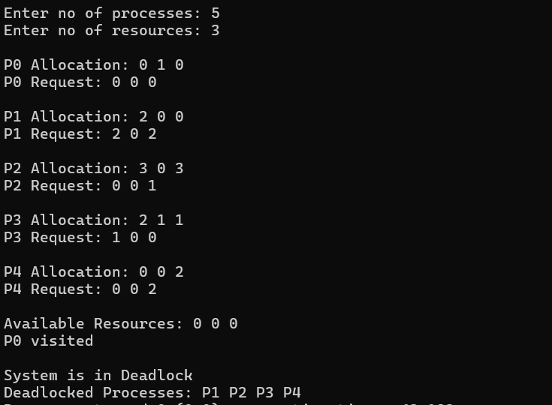

- Write a C program to simulate the following contiguous memory allocation techniques. (Any one) a) Worst-fit b) Best-fit c) First-fit

#include <stdio.h>

void firstFit(int blockSize[], int m, int processSize[], int n) { int allocation[n];

for (int i = 0; i < n; i++) allocation[i] = -1;

for (int i = 0; i < n; i++) { for (int j = 0; j < m; j++) {

if (blockSize[j] >= processSize[i]) { allocation[i] = j;

blockSize[j] = -1; break;
}
}
}

printf("\nFIRST FIT Allocation\n"); printf("Process No.\tProcess Size\tBlock No.\n");

for (int i = 0; i < n; i++) { printf("%d\t\t%d\t\t", i + 1, processSize[i]);

if (allocation[i] != -1) printf("%d\n", allocation[i] + 1);
else
printf("Not Allocated\n");
}
}

void bestFit(int blockSize[], int m, int processSize[], int n) { int allocation[n];

for (int i = 0; i < n; i++) allocation[i] = -1;

for (int i = 0; i < n; i++) { int bestIdx = -1;

for (int j = 0; j < m; j++) {

if (blockSize[j] >= processSize[i]) {

if (bestIdx == -1 || blockSize[j] < blockSize[bestIdx]) { bestIdx = j;
}
}
}

if (bestIdx != -1) { allocation[i] = bestIdx;

blockSize[bestIdx] = -1;
}
}

printf("\nBEST FIT Allocation\n"); printf("Process No.\tProcess Size\tBlock No.\n");

for (int i = 0; i < n; i++) { printf("%d\t\t%d\t\t", i + 1, processSize[i]);

if (allocation[i] != -1) printf("%d\n", allocation[i] + 1);
else
printf("Not Allocated\n");
}
}

void worstFit(int blockSize[], int m, int processSize[], int n) { int allocation[n];

for (int i = 0; i < n; i++) allocation[i] = -1;

for (int i = 0; i < n; i++) { int worstIdx = -1;

for (int j = 0; j < m; j++) {

if (blockSize[j] >= processSize[i]) {

if (worstIdx == -1 || blockSize[j] > blockSize[worstIdx]) { worstIdx = j;
}
}
}

if (worstIdx != -1) { allocation[i] = worstIdx;

blockSize[worstIdx] = -1;
}
}

printf("\nWORST FIT Allocation\n"); printf("Process No.\tProcess Size\tBlock No.\n");

for (int i = 0; i < n; i++) { printf("%d\t\t%d\t\t", i + 1, processSize[i]);

if (allocation[i] != -1) printf("%d\n", allocation[i] + 1);
else
printf("Not Allocated\n");
}
}

int main() { int m, n;

printf("Enter number of memory blocks: "); scanf("%d", &m);

int blockSize[m], blockSize1[m], blockSize2[m]; printf("Enter sizes of memory blocks:\n");
for (int i = 0; i < m; i++) { scanf("%d", &blockSize[i]);

blockSize1[i] = blockSize[i]; blockSize2[i] = blockSize[i];
}

printf("Enter number of processes: ");

scanf("%d", &n); int processSize[n];
printf("Enter sizes of processes:\n");

for (int i = 0; i < n; i++) { scanf("%d", &processSize[i]);
}

firstFit(blockSize, m, processSize, n); bestFit(blockSize1, m, processSize, n); worstFit(blockSize2, m, processSize, n);

return 0;
}

OUTPUT:

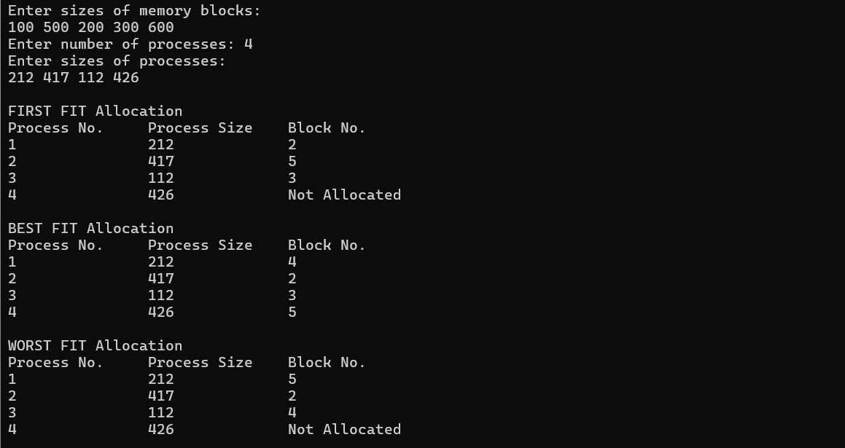

- Write a C program to simulate page replacement algorithms. a) FIFO b) LRU c) Optimal #include <stdio.h>
int search(int key, int frame[], int f) { for (int i = 0; i < f; i++) {
if (frame[i] == key) return 1;
}
return 0;
}

void fifo(int pages[], int n, int f) { int frame[f];
int index = 0, faults = 0;

for (int i = 0; i < f; i++) frame[i] = -1;

printf("\nFIFO Page Replacement Process:\n"); for (int i = 0; i < n; i++) {
if (!search(pages[i], frame, f)) {

frame[index] = pages[i]; index = (index + 1) % f; faults++;
printf("PF No. %d: ", faults); for (int j = 0; j < f; j++) {
if (frame[j] != -1)
printf("%d ", frame[j]); else
printf("- ");
}
printf("\n");
}
}

printf("FIFO Page Faults: %d\n", faults);
}

void lru(int pages[], int n, int f) { int frame[f], time[f];
int faults = 0, count = 0;

for (int i = 0; i < f; i++) { frame[i] = -1;
time[i] = 0;
}

printf("\nLRU Page Replacement Process:\n"); for (int i = 0; i < n; i++) {
int found = 0;

for (int j = 0; j < f; j++) {
if (frame[j] == pages[i]) { count++;
time[j] = count; found = 1; break;
}
}

if (!found) { int pos = 0;
for (int j = 1; j < f; j++) { if (time[j] < time[pos])
pos = j;
}

frame[pos] = pages[i]; count++;
time[pos] = count; faults++;
printf("PF No. %d: ", faults); for (int j = 0; j < f; j++) {
if (frame[j] != -1)
printf("%d ", frame[j]); else

printf("- ");
}
printf("\n");
}
}

printf("LRU Page Faults: %d\n", faults);
}

void optimal(int pages[], int n, int f) { int frame[f];
int faults = 0;

for (int i = 0; i < f; i++) frame[i] = -1;

printf("\nOptimal Page Replacement Process:\n"); for (int i = 0; i < n; i++) {
if (!search(pages[i], frame, f)) { int pos = -1, farthest = i + 1;
for (int j = 0; j < f; j++) { if (frame[j] == -1) {
pos = j; break;
}
}

if (pos == -1) { int max = -1;
for (int j = 0; j < f; j++) { int k;
for (k = i + 1; k < n; k++) { if (frame[j] == pages[k])
break;
}

if (k > max) { max = k; pos = j;
}
}
}

frame[pos] = pages[i]; faults++;
printf("PF No. %d: ", faults); for (int j = 0; j < f; j++) {
if (frame[j] != -1)
printf("%d ", frame[j]); else
printf("- ");
}
printf("\n");
}
}

printf("Optimal Page Faults: %d\n", faults);
}

int main() { int f, n;
printf("Enter the number of Frames: "); scanf("%d", &f);

printf("Enter the length of reference string: "); scanf("%d", &n);

int pages[n];
printf("Enter the reference string: "); for (int i = 0; i < n; i++)
scanf("%d", &pages[i]);

fifo(pages, n, f);
lru(pages, n, f);

optimal(pages, n, f);

return 0;
}

OUTPUT:
