Email SPAM Detection

In below screen I am uploading dataset

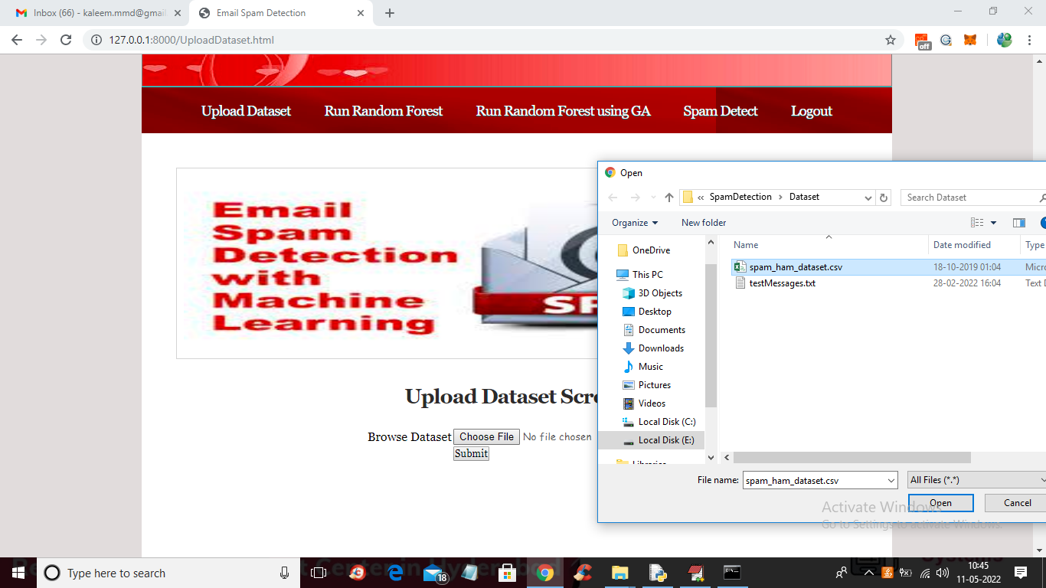

After uploading dataset click submit button to get below output

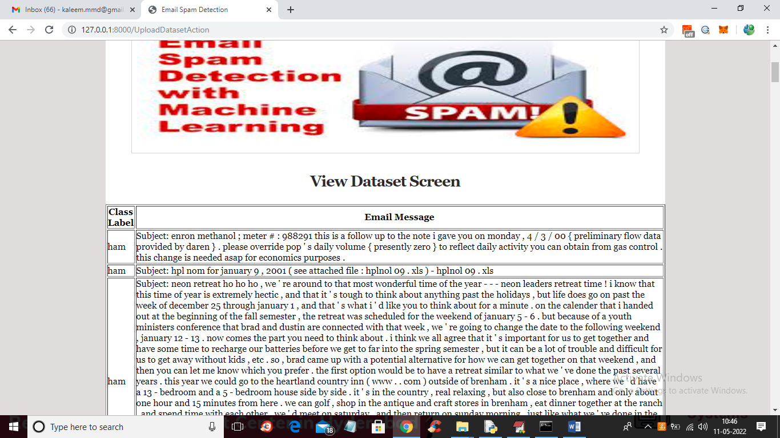

In above screen dataset loaded and now click on ‘Run Random Forest’ button to train Random Forest without GA

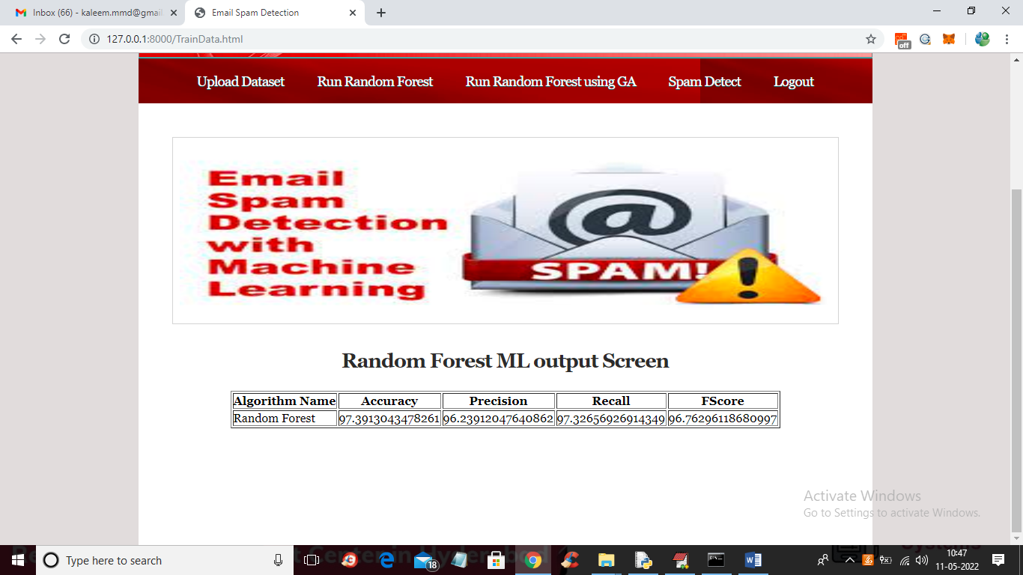

In above screen without GA we got 97% accuracy and now click on ‘Run Random Forest using GA’ button to select features using GA and then train with Random Forest

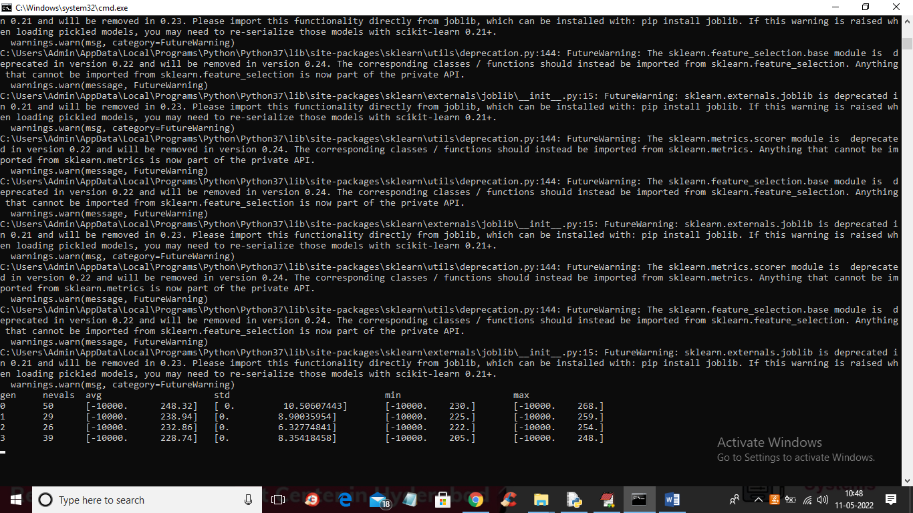

In above screen we can see genetic algorithm start iterations to select features and after executing will get below output

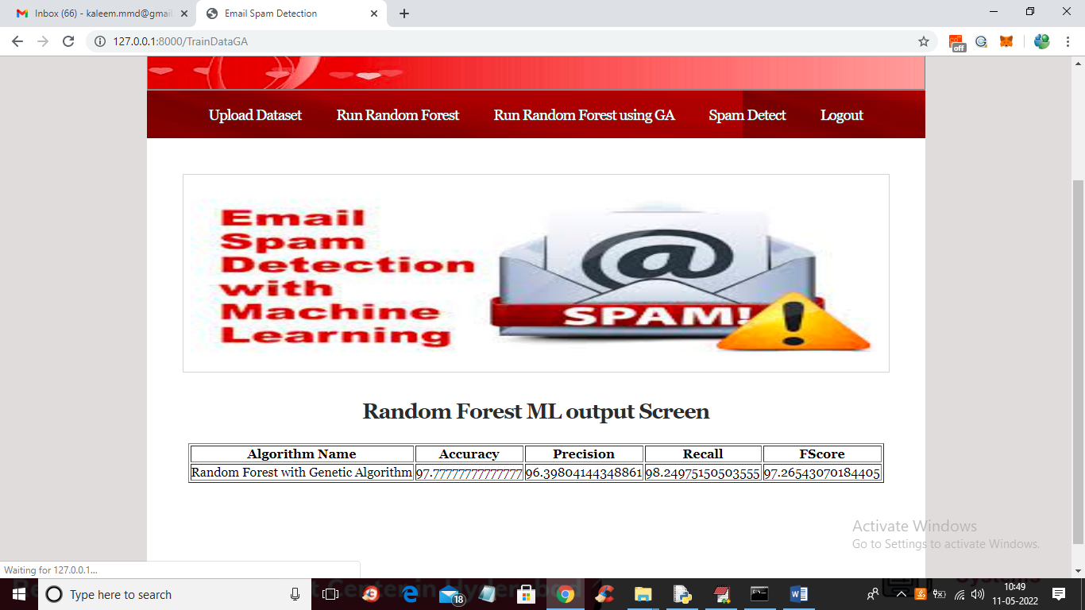

In above screen after applying GA we got 97.777% accuracy and without GA we got 97.39% and below screen showing code for GA

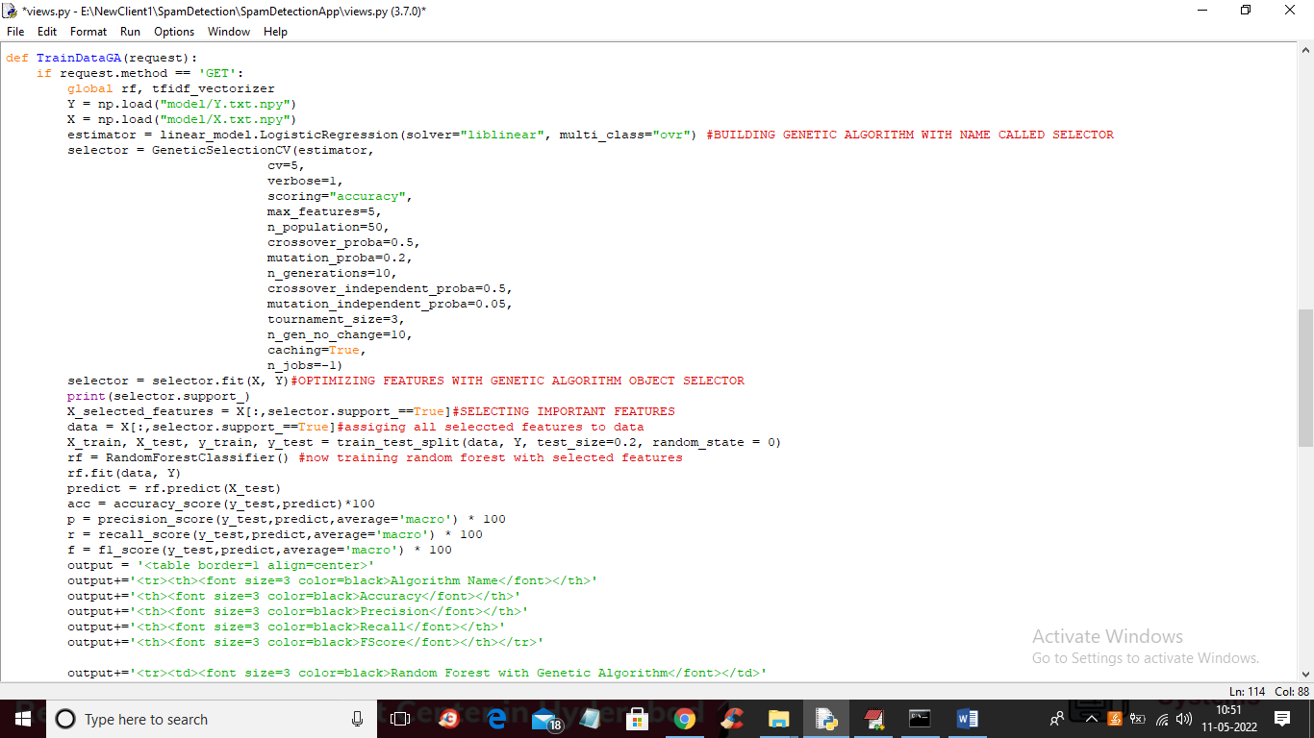

In above screen read red colour comments to know features selection with GA and then selected features get trained with Random Forest