Building a Beowulf Cluster in Virtual Environment
Raju Vemula
Department of Computer Science
Montclair State University
Montclair, NJ 07043
Vemular1@montclair.edu

ABSTRACT
This paper presents the design and development of the Beowulf cluster on the virtual environment which adds the virtualization features like, reducing the cost of more machines and increasing the functionality and improving the performance with addition to the parallel computing. In many industries and scientific applications, there is frequently a need to examine large files by utilizing the computational power of distributed and parallel systems. The High-Performance Computing (HPC) components are very expensive but with the use of virtual environment the costs can be lowered down. In High-Performance, Computing jobs are divided into several small jobs that can be distributed into all the nodes and they run concurrently on the system, this is made possible by the use of parallel computing. This paper will address the advantage that the Beowulf clusters have in the High-performance computing field as well as how it can be implemented in the virtual environment. The most important part of this paper is to investigate the performance of cluster by calculating the PI value with Simpson's rule.
Keywords
Virtualization, Beowulf Cluster, Simpson’s rule

INTRODUCTION
Various institutions today, are either involved in some kind of research, or have complex computations to do as a part of their day by day schedules. However, such complex computations require a lot of processing power. As of now the only way to obtain this power, was to buy large server or mainframe machines, which are well beyond the financial ability of essentially every organization and research/educational institution. However with the emergence of clusters, such massive computational power is currently within the scope of just about anyone.

“A cluster is a sort of parallel or distributed processing system that comprises of a collection of interconnected stand-alone, off the shelf low priced computers working together as a single, integrated computing resource, to convey scientific computational power at a relatively low cost.”

A Beowulf cluster is a multi-computer architecture which can be used for parallel computations. It is a system which usually compromises of one server node, and one or more client nodes associated together through Ethernet or some other network. It is a system built in XEN server with three virtual machines, like any other PC running Linux system. The server node controls the entire cluster and serves files to the client nodes. Nodes are configured and controlled by the server node and do only what they are told to do. One of the main differences between Beowulf and a Cluster of Workstations (COW) is the way that Beowulf acts more like a single machine instead of numerous workstations. The client nodes are totally devoted to the cluster. Most of the time client nodes do not have keyboards or monitors, and are accessed only via remote login or possibly serial terminal. In a Beowulf machine a big job is broken in to many sub-jobs & assigned to different client nodes for computing sub-job, then integrating output of each client when all client nodes have finished their job. All this is controlled by server that is right from breaking of job code to assigning of sub-jobs and then collecting results to compute final result.

PARALLEL COMPUTING
Parallel computing is a type of computation in which numerous computations and calculations are carried out simultaneously. In this computing, large problems are often partitioned into smaller tasks that can be solved simultaneously for high-performance computing. The serial computations are constructed and implemented as a serial stream of guidelines that are executed on a single Central Processing Unit (CPU) on one PC with one instruction execution at once. Parallel algorithms, on the other hand, use multiple processing elements at the same time to solve a problem, which is refined by breaking the problem into individual parts. Each part of the parallel algorithm is being executed by a processing element in parallel with the other parts. The processing elements can be diverse and include multiple computer resources such as a single computer with multiple processors, multiple networked computers, or a combination of both. Therefore however parallel algorithms are hard to code than sequential algorithms, they offer high-performance computing, high-performance scalability, multiple executions simultaneously, and less computing time for large problems.

CP
Prob
Instruct
CP
Prob
CPI
Prob
tN t2 t1
Figure 1– Parallel Computation

RELATED WORK
The first Beowulf was made in 1994 at the Center of Excellence in Space Data and Information Sciences (CESDIS), a builder to NASA at the Goddard Space Flight Center in Greenbelt, Maryland. It was first planned by Don Becker and Thomas Sterling and involved of 16 Intel DX4 processors connected by 10MBit/sec Ethernet. Beowulf was assembled by and for researchers with parallel programming experience.
SAC’10, March 22-26, 2010, Sierre, Switzerland.
Copyright 2010 ACM 978-1-60558-638-0/10/03…$10.00.

Permission to make digital or hard copies of all or part of this work for personal or classroom use is granted without fee provided that copies are not made or distributed for profit or commercial advantage and that copies bear this notice and the full citation on the first page. To copy otherwise, or republish, to post on servers or to redistribute to lists, requires prior specific permission and/or a fee.

There is much work that has been done in past decades to develop high performance clusters that at a low cost and get a high performance.

Fan et al. proposed to utilize a cluster of Graphics Processing Unit (GPU) for high-performance computing where they built up a parallel flow simulation using the Lattice Boltzmann model (LBM) [2]. The Lattice Boltzmann model (LBM) was developed on a GPU cluster and have simulated the dispersion of airborne contaminants in the Times Square area in New York City [2]. The GPU cluster was developed for two purposes: the first one was a GPU cluster for graphics and processing, and secondly one for visualization for interpretation large capacity data sets [2].

Hu and Evans developed a Power and Environment Awareness Module (PEAM) for Beowulf clusters [3]. The development of the PEAM addresses the issues that the Beowulf clusters encounter such as heat-inducted hardware failure which makes large scale commodity clusters fail frequently and the cost effectiveness of Beowulf clusters is challenged by lack of means of adapting its power state according to varying work load [3]. The PEAM module was developed on a Beowulf cluster at Purdue University, which aimed at reducing the operational cost and increase the reliability of the cluster by reducing heat generation and optimizing workload distribution in an environment aware manner [3].

Hsu and Feng conducted a feasibility analysis of power awareness in commodity based high performance clusters [4]. Hsu and Feng study revolves around a 16 processors Opteron-based Beowulf cluster. The Beowulf cluster was configured as four nodes of quad processors. The study showed that a 5 % performance slowdown can be traded off for average of 19% system energy which is saving and 24% system power reduction [4]. Hsu and Feng further stated that power efficiency is the most critical part for developing cost-effective , small-footprint clusters [4]. Hsu and Feng performed various tests such as benchmark tests of different software’s to compare power consumption between them. The HPL and NAS MPI benchmarks were compared so as to see which can save power.

DESIGN/IMPLEMENTATION
The Beowulf cluster was built in a XEN server with the following specifications:
- XEN Server 6.2
- Ubuntu 14.04 (Linux operating system)

The cluster was built with 1 master node and 2 slave nodes.
The hardware specifications are:
Master node:
- Memory: 1536MB
- Storage: 15GB
Node 1/Node 2:
- Memory: 256MB
- Storage: 10GB

There are few other software that are needed to work he cluster properly, these are MPI (MESSAGE PASSING INTERFACE) for distribution of the jobs, NFS (NETWORK FILE SYSTEM) for sharing files remotely and Secure shell (SSH) for remotely login to the nodes.
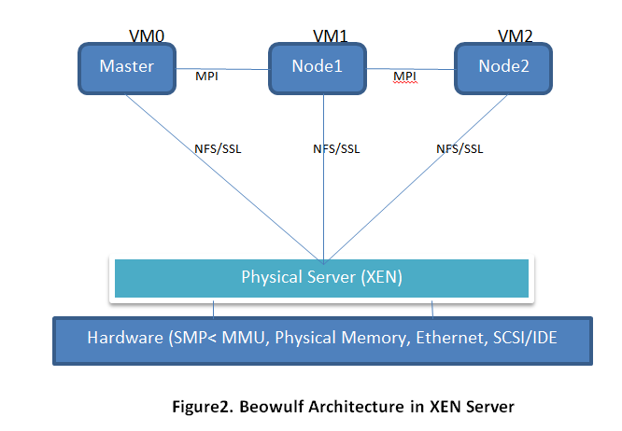
MPI is an industry standard API specification intended for high-performance computing on multi-processor machines and clusters of machines. It permits numerous PCs to communicate with each other, it is used in computer clusters and supercomputers, and it offers a distributed memory programming model for parallel applications. In spite of the fact that the entire MPI API set is relative large containing more than 300 routines, numerous MPI applications can be programmed with not as much as twelve of basic routines.

There are various MPI executions originating from different research foundations and companies. The most popular one is MPICH which is regularly used as the code base for MPI executions optimized for a specific platform or interconnect. In MPICH design, the whole API set is implemented and built on top of a small core set of low-level device interconnect routines. This design architecture offers great transportability across different platforms. One only need to re-work the small core set of device interconnects routines to port or optimize MPICH for a new platform or interconnect.
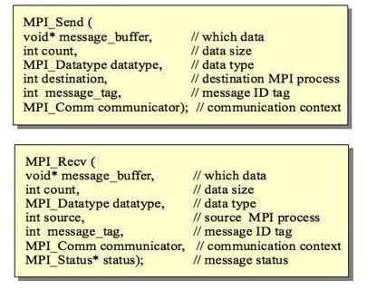
Figure3. MPI send and receive
IMPLEMENTATION:

The following screen shows the successful implementation of Beowulf cluster with 1 master node and 2 slave nodes.

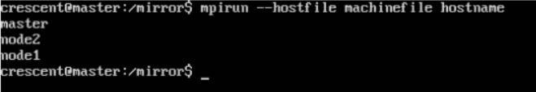
Figure4. Execution of cluster

Experiments
For the experiment I ran a series of tests on different number of nodes to see the performance of the cluster. For this I have used Simpson’s PI calculation program with 1000 million divisions. I have used standard C libraries and message passing interface.

In the first test I wanted to find the worst case scenario like, the time taken to execute the program in single node i.e. nothing but the master node. In the next series I have executed with 3 and 9 nodes to see the performance of the Beowulf cluster in virtual environment. One of the machines was a master machine which was assigning the work to the other machines and was used for synchronization. The remaining machines were doing the computation. So when two machines are used, only one machine is doing the computation. With 3 machines, two are doing the computation and so forth.
The results of the experiments are:
Calculating PI using 1000 million divisions on single node:
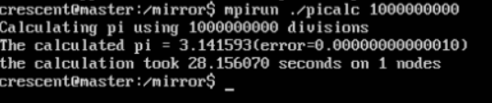
Figure5. In single node
When the test ran in single node the time taken to compute the result is approximately 28.15sec

Calculating PI using 1000 million divisions on 3 nodes:
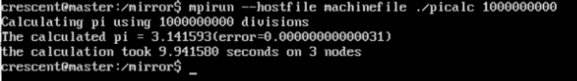
Figure6. With three nodes
When the test ran in three nodes the time taken to compute the result is approximately 9.94sec which is 1/3 of the time taken with single node.

Calculating PI using 1000 million divisions on 9 nodes:
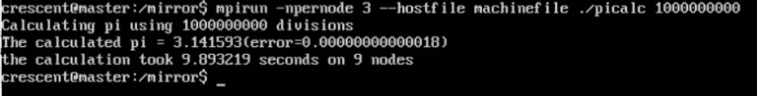
Figure7. with nine nodes
When the test ran in 9 nodes the time taken to compute the result is approximately 9.89sec which is almost same as the time taken with the 3 nodes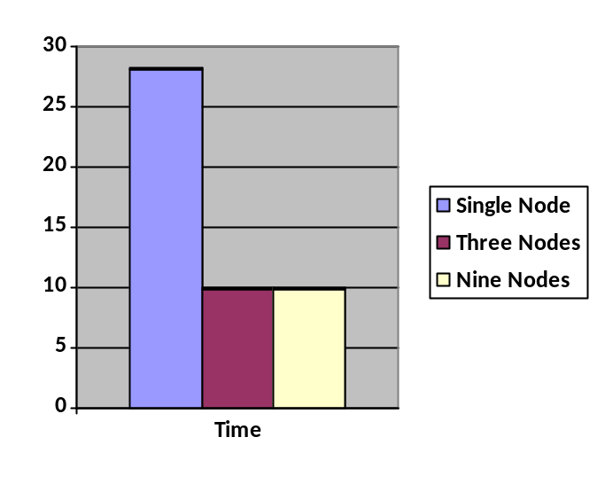

Conclusion
Our thanks to ACM SIGCHI for allowing us to modify templates they had developed.

REFERENCES
[1] J. Nakano, “Parallel computing techniques,” 2004.
[2] Z. Fan, F. Qiu, A. Kaufman, and S. Yoakum-stover, “GPU Cluster for High Performance Computing,” vol. 00, no. 1, 2004.
[3] F. Hu and J. J. Evans, “Power and environment aware control of Beowulf clusters,” no. May 2008, pp. 299– 308, 2009.
[4] C. Hsu and W. Feng, “A Feasibility Analysis of Power Awareness in Commodity-Based,” no. Cluster, pp. 1–10, 2005.
[5] A. B. R. Al-shaikh, M. Sechi, and M. Notare, “Towards Building a Highly-Available Cluster Based Model for High Performance Computing 3. The Beowulf Cluster Architecture,” pp. 1–8, 2006.
[6] S. CHAVAN, “Design and Implementation of High Performance Computing Cluster for Educational Purpose,” no. June, 2012.

Columns on Last Page Should Be Made As Close As Possible to Equal Length

