SYNCLOCK
Concurrent File Access Management System
A Project Report Submitted in partial fulfillment of the requirements for the award of the degree of
BACHELOR OF TECHNOLOGY
in
DEPARTMENT OF COMPUTER SCIENCE AND ENGINEERING

By
P.Likith Kumar - 2520090084
P.Rithwik Rao - 2520090203
V.Santhosh -2520090051

Under the Guidance of
Dr.Alekhya
K L (Deemed to be) University
Academic Year 2026–2027

DECLARATION
We hereby declare that the project report entitled “SyncLock: Concurrent File Access Management System” is a record of our bonafide work carried out as part of the academic/hackathon project requirements. The system was designed and implemented to demonstrate safe concurrent access to shared files using operating-system synchronization concepts on Ubuntu Linux.
We further declare that the work presented in this report is our own implementation and that the technical concepts, libraries, documentation, and external resources used during development have been appropriately acknowledged. The project has been developed for educational and demonstration purposes.
Team Members:
• P.Likith Kumar
• P.Rithwik Rao
• V.Santhosh
Place: ____________________
Date: _____________________

CERTIFICATE
This is to certify that the project report entitled “SyncLock: Concurrent File Access Management System” is a bonafide work carried out by P.Likith Kumar, P.Rithwik Rao, and V.Santhosh in partial fulfillment of the requirements for the award of the degree of Bachelor of Technology in the Department of Computer Science and Engineering, K L (Deemed to be) University, during the academic year 2026–2027.
The project demonstrates the practical implementation of concurrent file access control, reader-writer synchronization, Linux file locking, version-based conflict detection, atomic file updates, and a web-based monitoring interface.

Role | Signature
Project Guide | ____________________________
Course Coordinator | ____________________________
Head of Department | ____________________________

ACKNOWLEDGEMENT
We express our sincere gratitude to the faculty members and mentors of the Department of Computer Science and Engineering, K L (Deemed to be) University, for their guidance, encouragement, and support throughout the development of SyncLock.
We are grateful for the academic environment and laboratory facilities that enabled us to study operating-system concepts such as processes, synchronization, mutual exclusion, file systems, and inter-process coordination and convert those concepts into a working software prototype.
We also thank our friends and classmates for their suggestions during testing and demonstration. Finally, we thank our parents and well-wishers for their continuous support and encouragement.
P.Likith Kumar
P.Rithwik Rao
V.Santhosh

ABSTRACT
Modern computing environments frequently require multiple processes or users to access a common file. Without coordination, simultaneous access can produce race conditions, lost updates, inconsistent state, or even corrupted data. SyncLock is a Linux-based Concurrent File Access Management System developed to address this problem by combining operating-system-level file locking with application-level version control and a visual monitoring dashboard.
The core synchronization mechanism uses the Linux fcntl.flock() interface. Shared locks are used for read operations so that multiple readers can access a file concurrently, while exclusive locks are used for writes so that only one writer can modify a file at a time. SyncLock additionally maintains a monotonically increasing file version. When a client attempts to save an outdated version, the backend detects the stale update and rejects it rather than silently overwriting a newer change. Atomic temporary-file replacement is used to make updates safer.
The implementation consists of a FastAPI backend, SQLite metadata and activity storage, an HTML/CSS/JavaScript dashboard, and a multiprocessing simulator. The simulator launches real operating-system processes that compete for the same shared file, allowing the locking behavior to be observed during a live hackathon demonstration. The dashboard reports shared files, operations, blocked conflicts, successful writes, versions, and recent activity. The project therefore provides both a practical file-management utility and a clear demonstration of concurrency-control principles.

TABLE OF CONTENTS
Chapter | Title | Contents
1 | Introduction | 1.1 Background; 1.2 Problem Statement; 1.3 Scope; 1.4 Objectives; 1.5 Importance; 1.6 Target Users
2 | OS Concepts and Background Study | 2.1 Processes; 2.2 Concurrency; 2.3 Race Conditions; 2.4 Mutual Exclusion; 2.5 Reader-Writer Model; 2.6 File Locks
3 | System Requirements | 3.1 Hardware; 3.2 Software; 3.3 Ubuntu/WSL; 3.4 Development Environment
4 | Technology and Tools Used | 4.1 Python; 4.2 FastAPI; 4.3 Uvicorn; 4.4 SQLite; 4.5 fcntl; 4.6 Multiprocessing; 4.7 HTML/CSS/JS
5 | System Architecture and Design | 5.1 Architecture; 5.2 Workflow; 5.3 Data Flow; 5.4 Modules; 5.5 Input/Output Design
6 | Implementation | 6.1 Backend; 6.2 Lock Manager; 6.3 Versioning; 6.4 Atomic Writes; 6.5 Database; 6.6 Simulator; 6.7 Frontend
7 | Execution and Demonstration | 7.1 Ubuntu Setup; 7.2 Commands; 7.3 Sample Scenario; 7.4 Dashboard; 7.5 Judge Demonstration
8 | Testing and Results | 8.1 Test Cases; 8.2 Expected Results; 8.3 Observations; 8.4 Limitations
9 | Conclusion and Future Scope | 9.1 Summary; 9.2 Objectives Achieved; 9.3 Learning Outcomes; 9.4 Future Enhancements
10 | References | Books; Linux/GNU Documentation; Python/FastAPI Documentation

CHAPTER 1 — INTRODUCTION

1.1 Background of the Project
A process is an executing instance of a program. In an operating system, several processes can run at the same time and may access common resources. Files are one of the most common shared resources. When two or more processes use the same file without synchronization, the order in which operations occur becomes important.
For example, suppose two processes read a counter with value 10. If both independently calculate 11 and then write 11, the final result is 11 even though two updates were requested. This illustrates the lost-update problem. A similar issue can occur in collaborative documents, configuration files, logs, and application data stored in files.
SyncLock applies concurrency-control principles to this situation. Instead of allowing every process to modify the file freely, the system controls access through shared and exclusive locks, checks the version before saving, and records the outcome of each operation.

1.2 Problem Statement
To design and implement a system that allows multiple processes to access a shared file concurrently while preventing inconsistent or conflicting updates. The system should permit safe concurrent reads, serialize conflicting writes, detect stale versions, perform safe updates, and provide a dashboard through which the locking behavior can be observed.

1.3 Scope of the Project
• Shared text-file creation, reading, updating, and deletion within a controlled storage directory.
• Reader-writer synchronization using Linux file locks.
• Version-based optimistic conflict detection.
• Atomic update of the underlying file.
• Logging of operations and lock outcomes in SQLite.
• Real concurrent-process simulation using Python multiprocessing.
• Web-based visualization of files, statistics, and activity.
• Execution on Ubuntu Linux or Ubuntu through WSL2.

1.4 Objectives of the Project
Prevent simultaneous conflicting writes.
Allow multiple readers where the operating system permits shared locking.
Demonstrate mutual exclusion using real processes.
Reject stale updates using file versions.
Maintain an auditable operation history.
Provide a simple interface suitable for a hackathon demonstration.

1.5 Importance of the Application
The project converts abstract operating-system concepts into a visible and testable application. Judges can observe a process obtaining a lock, another process being blocked, the successful writer updating the version, and the dashboard reflecting these events. This makes synchronization behavior easier to understand than a command-line-only demonstration.

1.6 Target Users / Audience
• Students learning operating systems and synchronization.
• Developers building multi-process Linux applications.
• Hackathon judges evaluating practical OS concepts.
• Researchers or educators demonstrating file concurrency.
• Teams that need a lightweight shared-file coordination prototype.

CHAPTER 2 — OS CONCEPTS AND BACKGROUND STUDY

2.1 Processes
A process contains the execution state of a running program. Separate processes have separate address spaces, which makes process-level concurrency useful for demonstrating synchronization at the operating-system boundary. SyncLock uses Python multiprocessing so that multiple independent processes can contend for a common file.

2.2 Concurrency
Concurrency means that multiple tasks make progress during overlapping time intervals. On a multicore system, tasks may actually execute in parallel; on a single core, the operating system may rapidly switch between them. In either case, shared resources require coordination.

2.3 Race Conditions
A race condition occurs when the result depends on the timing or interleaving of concurrent operations. File read-modify-write sequences are particularly vulnerable because a process can read a value, pause, and later write an outdated result.

2.4 Mutual Exclusion
Mutual exclusion ensures that a critical section is executed by only one conflicting participant at a time. SyncLock uses an exclusive file lock for writes. This creates a critical section around the update operation.

2.5 Reader-Writer Model
The reader-writer problem distinguishes between operations that only observe shared state and operations that modify it. Multiple readers can often coexist because they do not change the resource. A writer must have exclusive access to avoid observing or producing an inconsistent state.

2.6 Linux File Locks
SyncLock uses fcntl.flock() in Ubuntu Linux. LOCK_SH requests a shared lock, while LOCK_EX requests an exclusive lock. The lock is associated with the open file description and is coordinated by the operating system among processes using the same filesystem environment.

2.7 Synchronization Strategy Used
Operation | Lock | Concurrent? | Purpose
Read | LOCK_SH | Yes with other readers | Safe observation of file content
Write | LOCK_EX | No with conflicting access | Protect modification critical section
Version check | Inside write lock | No | Prevent stale overwrite
Atomic replacement | Inside write lock | No | Reduce partial-update exposure

CHAPTER 3 — SYSTEM REQUIREMENTS

3.1 Hardware Requirements
Component | Minimum / Recommended
Processor | Dual-core CPU or better
RAM | 4 GB minimum; 8 GB recommended
Storage | At least 1 GB free for project and logs
Display | Any monitor supporting a modern browser
Network | Not required for core locking; localhost access is sufficient

3.2 Software Requirements
Software | Purpose
Ubuntu Linux / Ubuntu on WSL2 | Execution environment and native file locking
Python 3 | Backend, locking logic and simulator
FastAPI | REST backend and web server application
Uvicorn | ASGI server
SQLite | Metadata and operation logging
HTML/CSS/JavaScript | Dashboard UI
pytest (optional) | Automated testing

3.3 Operating System Environment — Ubuntu / WSL
The project is intended to be demonstrated in Ubuntu. On Windows systems, Ubuntu can be provided through WSL2. The important point is that the application and simulator execute in the Linux environment so that the fcntl file-locking API is available.

3.4 Development Tools
• VS Code or another code editor.
• Ubuntu Terminal / WSL terminal.
• Python virtual environment or system Python installation.
• Web browser such as Chrome or Firefox.
• Git for source-code version control (optional).

CHAPTER 4 — TECHNOLOGY AND TOOLS USED

4.1 Python
Python is used for the core application because it provides file I/O, operating-system interfaces, multiprocessing, database connectivity, and a strong web-development ecosystem.

4.2 FastAPI
FastAPI exposes the application functionality through HTTP endpoints. The browser communicates with the backend to create files, read content, save changes, retrieve statistics, and start the concurrency simulation.

4.3 Uvicorn
Uvicorn runs the FastAPI application as an ASGI server. During demonstration the application is accessible locally through port 8000, for example http://127.0.0.1:8000.

4.4 SQLite
SQLite stores persistent metadata without requiring a separate database service. It is used for file records, operation history, versions, lock-related events, and dashboard statistics.

4.5 fcntl and flock
The fcntl module exposes Linux file-control operations. flock() is the central synchronization primitive in SyncLock. The implementation requests shared locks for readers and exclusive locks for writers.

4.6 multiprocessing
The multiprocessing module starts independent worker processes. Each worker attempts to read or write the same shared file, creating an authentic concurrency test rather than a visual-only simulation.

4.7 Frontend Technologies
The frontend uses HTML for structure, CSS for the dark dashboard appearance, and JavaScript for asynchronous API calls and dynamic updates. The interface includes cards for shared files, operations, conflicts blocked, and successful writes, along with a shared-file editor and activity monitor.

4.8 Key Design Principles
• Separation of frontend and backend responsibilities.
• OS-level synchronization rather than only JavaScript locking.
• Fail-safe handling of conflicting updates.
• Atomic persistence of modified file content.
• Observable and auditable system behavior.

CHAPTER 5 — SYSTEM ARCHITECTURE AND DESIGN

5.1 Overall System Architecture
User / Judge
↓
Web Browser
↓ HTTP / JSON
FastAPI Backend
├── File Manager
├── Lock Manager ──→ fcntl.flock()
├── Version Manager
└── Activity / Statistics DB ──→ SQLite
↓
storage/shared_files/
↑
Multiprocessing Simulator
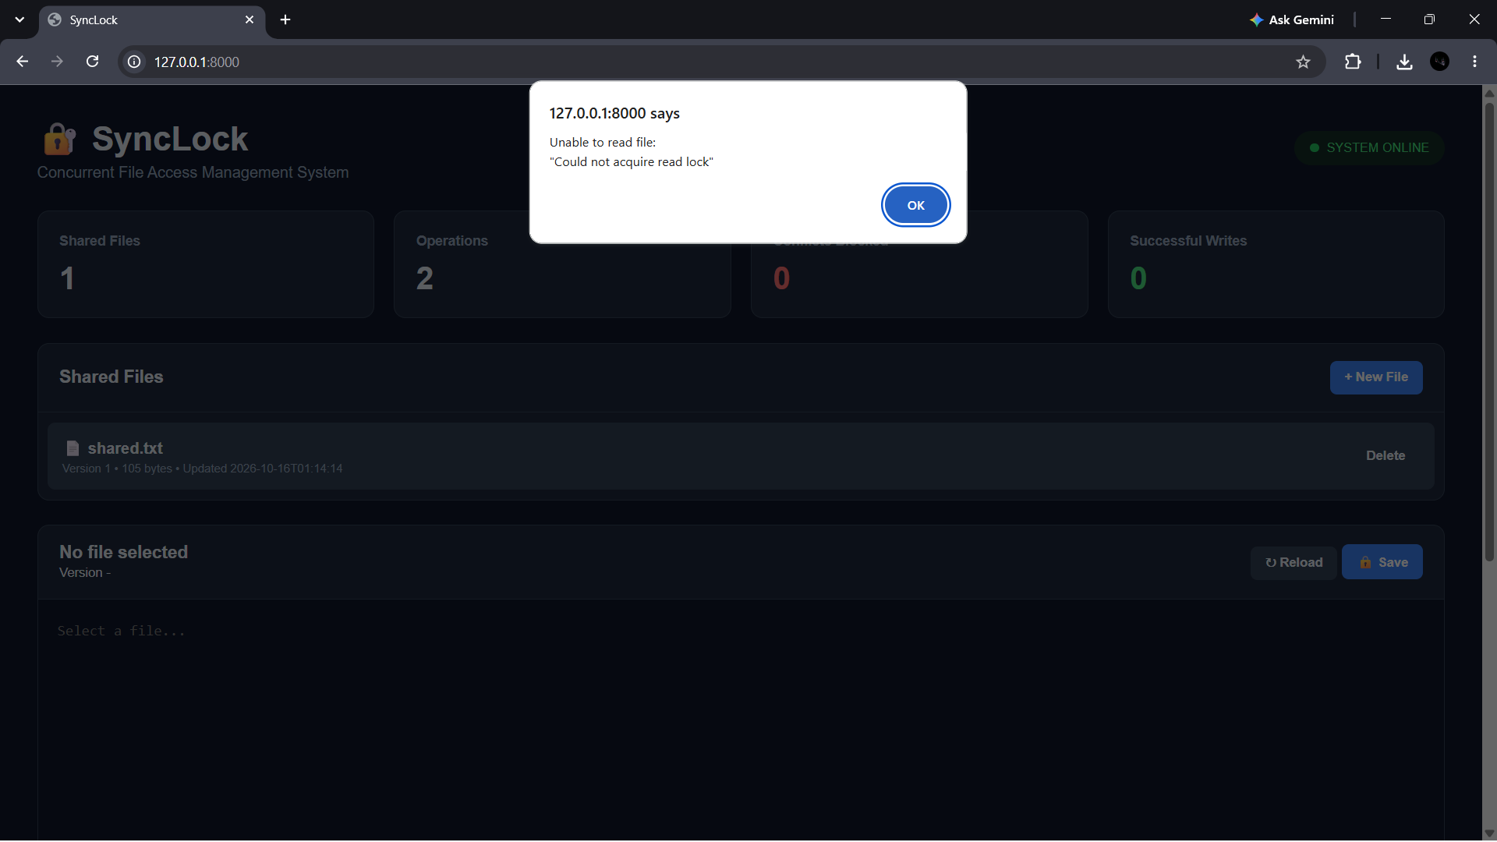
Figure 5.1 — SyncLock dashboard used for system monitoring.

5.2 System Workflow
1. User selects an existing shared file or creates a new file.
2. The browser sends an API request to the FastAPI backend.
3. The backend opens the target file and requests the appropriate lock.
4. A read operation obtains a shared lock; a write operation obtains an exclusive lock.
5. The requested operation is executed while the lock protects the critical section.
6. For a write, the expected version is compared with the current version.
7. The new content is written to a temporary file and atomically replaced into place.
8. The version and operation log are updated and the lock is released.
9. The dashboard refreshes its statistics and activity information.

5.3 Data Flow
Browser → API request → File/Lock Manager → Linux file system
↓
SQLite log
↓
API response
↓
Browser dashboard

5.4 Module Description
Module | Main Responsibility
Web UI | File selection, editing, statistics, activity visualization
FastAPI API | HTTP routing, validation, responses
File Manager | Controlled file creation, reading, saving, deletion
Lock Manager | Shared/exclusive lock acquisition and release
Version Manager | Expected/current version comparison
Atomic Writer | Temporary file + flush/fsync + os.replace
Database Layer | Metadata, operation records and statistics
Simulator | Concurrent process generation and stress demonstration

5.5 Input and Output Design
Typical inputs are a filename, initial content, edited content, expected version, operation type, and simulation parameters. Outputs include file content, current version, lock status, operation result, conflict messages, and updated dashboard statistics.

CHAPTER 6 — IMPLEMENTATION

6.1 Project Structure
SyncLock/
├── app.py
├── simulator.py
├── requirements.txt
├── README.md
├── storage/
│ └── shared_files/
└── database/
└── synclock.db

6.2 Backend Implementation
app.py contains the FastAPI application and the main application services. It defines the routes used by the dashboard and coordinates file access, synchronization, version handling, logging, and statistics.
from fastapi import FastAPI
import fcntl
app = FastAPI(title="SyncLock")
The actual implementation may contain additional validation, helper functions, database operations, and error handling around these core concepts.

6.3 Lock Acquisition
with open(file_path, "r+") as f:
fcntl.flock(f.fileno(), fcntl.LOCK_EX)
# protected write operation
fcntl.flock(f.fileno(), fcntl.LOCK_UN)
For a reader, LOCK_SH is used instead of LOCK_EX. A non-blocking variant can be used when the application needs to immediately report that a lock cannot currently be acquired.

6.4 Version Control
Every shared file has a current version. A client that reads version 4 and later tries to save version 4 after another successful writer has already produced version 5 is rejected. This combines pessimistic OS locking with optimistic version validation.
if expected_version != current_version:
reject_update("Version conflict: file changed by another process")

6.5 Atomic Write
write new content → flush → fsync → os.replace(temp, original)
Atomic replacement means the old file remains intact until the new temporary file is ready to replace it. The exclusive lock prevents competing SyncLock writers from entering the critical section during this sequence.

6.6 Database Logging
The database records each meaningful operation so that the dashboard can explain what happened. A conflict can therefore be demonstrated not merely as a message but as an auditable event.

6.7 Multiprocessing Simulator
Process A → READ shared.txt
Process B → WRITE shared.txt
Process C → WRITE shared.txt
Process D → READ shared.txt
The simulator intentionally overlaps operations using delays so that lock contention becomes visible. The expected behavior is that concurrent readers can proceed, while conflicting writes are serialized or reported as blocked according to the selected locking mode.

6.8 Frontend Dashboard
The dashboard presents the system state using four summary cards: Shared Files, Operations, Conflicts Blocked, and Successful Writes. A Shared Files section lists files and versions. The editor panel lets a user reload and save content. An Activity Monitor displays recent operations and their status.
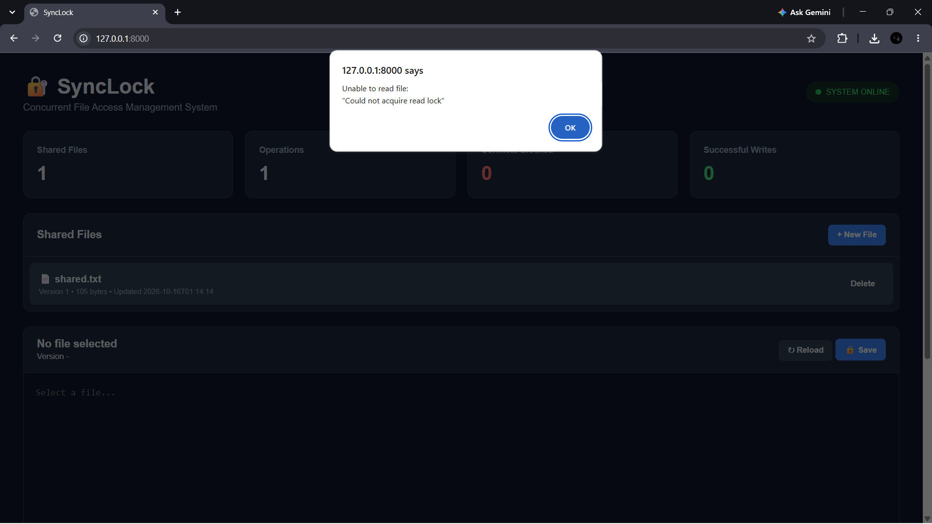
Figure 6.1 — SyncLock file-management interface and shared-file controls.

CHAPTER 7 — EXECUTION AND DEMONSTRATION

7.1 Setup in Ubuntu
sudo apt update
sudo apt install python3 python3-venv -y
python3 -m venv venv
source venv/bin/activate
pip install -r requirements.txt
If a requirements file is already supplied with the project, installing from that file is preferred. On Ubuntu, use python3 and python3 -m pip when the plain pip command is unavailable.

7.2 Start the Web Application
cd ~/SyncLock_Hackathon/SyncLock
python3 -m uvicorn app:app --host 0.0.0.0 --port 8000
Open the browser at 127.0.0.1:8000. The dashboard should show the system as online and display the current shared files and statistics.

7.3 Basic User Flow
Click “+ New File”.
Enter a name such as shared.txt and some initial content.
Create the file and select it from Shared Files.
Use Reload to read the current version.
Edit the content and click Save.
Observe the version increment and Successful Writes counter.
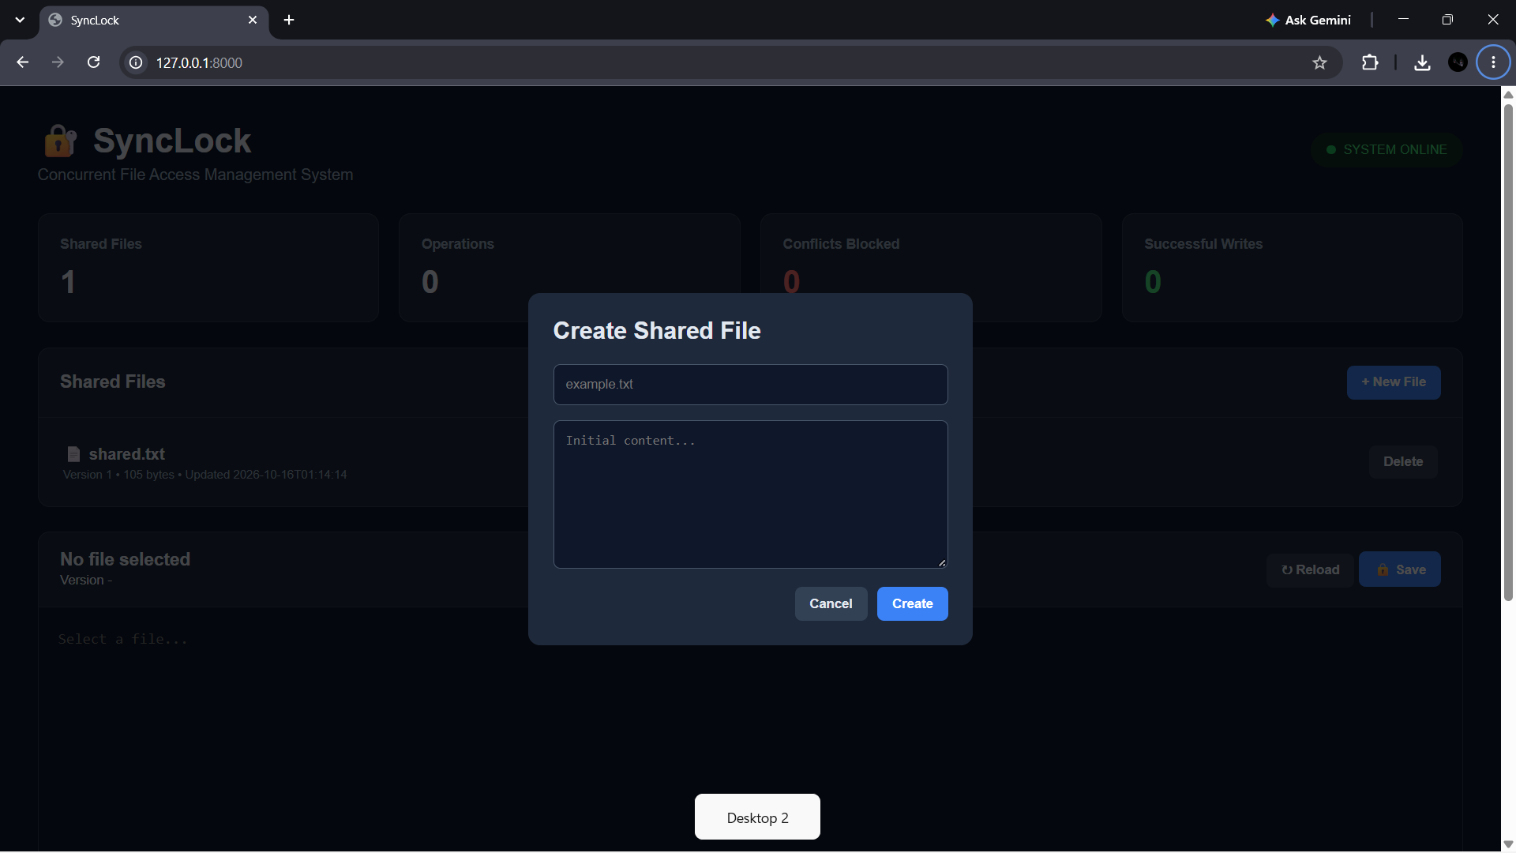
Figure 7.1 — Create Shared File dialog used to add a shared resource.

7.4 Demonstrating a Conflict
For the judge demonstration, open the same shared file in two browser sessions or use the multiprocessing simulator. Session/process A reads version 1. Session/process B successfully writes first, changing the file to version 2. Session/process A then attempts to save using version 1. The backend detects that the expected version is stale and rejects the update.
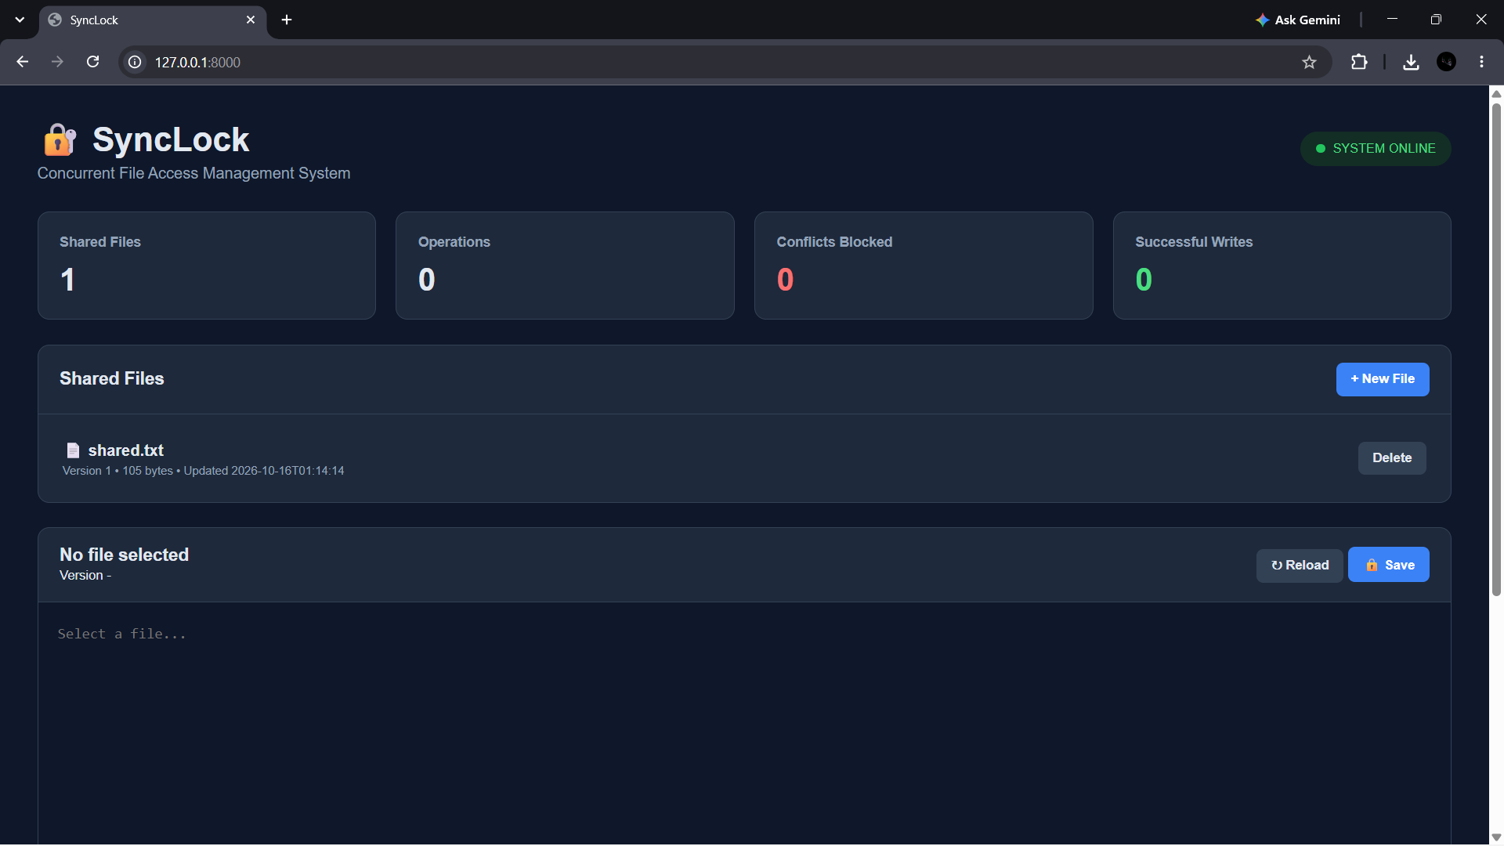
Figure 7.2 — Example of the system reporting an inability to acquire the read lock during a conflict scenario.

7.5 Recommended Hackathon Demonstration
• Start the FastAPI server in Ubuntu.
• Open the dashboard and explain the four statistics cards.
• Create shared.txt with simple content such as “Initial value = 100”.
• Show Version 1 in the file list.
• Start the concurrent simulator with several readers and writers.
• Point out that readers may coexist while writers require exclusive access.
• Show the activity monitor and the conflict counter.
• Perform a stale-version save and show that SyncLock rejects it instead of overwriting newer data.
• Perform a fresh save and show the successful write and version increment.
• Conclude by explaining that the browser is only the control/visualization layer; the actual synchronization is performed by Linux processes and file locks.

CHAPTER 8 — TESTING AND RESULTS

8.1 Test Cases
ID | Test Case | Expected Result
TC01 | Create shared file | File created and listed with initial version
TC02 | Read file | Content returned with valid read access
TC03 | Multiple concurrent readers | Readers can share the read lock
TC04 | Concurrent writers | Only one conflicting writer enters critical section at a time
TC05 | Writer vs active conflicting access | Writer waits or is reported blocked according to mode
TC06 | Fresh-version save | Write succeeds and version increments
TC07 | Stale-version save | Write rejected as version conflict
TC08 | Atomic replacement | Final file contains complete new content
TC09 | Unsafe path | Request rejected
TC10 | Operation logging | Activity record created for the operation

8.2 Observed / Expected System Results
The working prototype dashboard shows the shared-file count and operation statistics. During normal use, the operation count increases as requests are made. Successful saves increase the successful-write count. Conflict scenarios increase the conflict/blocked metric when an operation cannot safely proceed.

8.3 Demonstration Evidence
Figure 8.1 — Dashboard showing the online system, shared file list, editor, and statistics.
Figure 8.2 — Shared file interface used for selecting and managing a file.

8.4 Limitations
• The prototype is primarily intended for Ubuntu/Linux environments because it depends on fcntl.flock().
• SQLite is suitable for a hackathon prototype but is not the ideal choice for very high-volume distributed deployments.
• The current design protects files within the same Linux filesystem/locking domain; true multi-machine distributed locking requires additional coordination.
• Authentication, authorization, encryption, and enterprise audit controls can be strengthened for production use.

CHAPTER 9 — CONCLUSION AND FUTURE SCOPE

9.1 Summary of the Project
SyncLock provides a practical solution to concurrent file-access problems by combining Linux file locks, version validation, atomic writes, database logging, and a monitoring dashboard. It demonstrates the transition from an unsafe direct-access model to a controlled shared-resource model.

9.2 Objectives Achieved
• Implemented controlled shared-file access.
• Implemented shared and exclusive lock concepts.
• Integrated Linux fcntl.flock() for OS-level synchronization.
• Added version-aware conflict detection.
• Added atomic update logic.
• Added operation logging and dashboard statistics.
• Added a multiprocessing-based concurrency demonstration.
• Provided an Ubuntu-compatible execution workflow.

9.3 Skills and Learning Outcomes
• Understanding process concurrency and synchronization.
• Applying mutual exclusion to a real shared resource.
• Using Linux system interfaces from Python.
• Designing REST APIs using FastAPI.
• Using SQLite for persistent application metadata.
• Building a browser dashboard that visualizes backend state.
• Testing race-condition and conflict scenarios.
• Presenting operating-system concepts as a working hackathon prototype.

9.4 Future Enhancements
• Role-based authentication for readers, writers, and administrators.
• Real-time WebSocket lock-status updates.
• Lock timeout and recovery for crashed processes.
• Advanced conflict-resolution and merge support.
• PostgreSQL or another production database for larger deployments.
• Distributed locking using a dedicated coordination service.
• Cloud/shared storage integration.
• Exportable audit reports and analytics.
• Containerized deployment for easy installation.

CHAPTER 10 — REFERENCES
1. Abraham Silberschatz, Peter B. Galvin, Greg Gagne, Operating System Concepts, Wiley.
2. Andrew S. Tanenbaum and Herbert Bos, Modern Operating Systems, Pearson.
3. Python Software Foundation, Python 3 Documentation — file handling, os, fcntl, multiprocessing and sqlite3 modules.
4. Linux manual pages — flock(2), fcntl(2), open(2), fsync(2), rename(2).
5. FastAPI Documentation — API routing, request handling and application deployment.
6. Uvicorn Documentation — ASGI server configuration and execution.
7. SQLite Documentation — SQL language and database engine reference.
8. POSIX/Linux filesystem and synchronization concepts used for the design of SyncLock.

APPENDIX A — SAMPLE DEMONSTRATION DATA
File: shared.txt
Initial content:
Initial value = 100
Process A: READ → Version 1
Process B: WRITE → Version 2 → SUCCESS
Process A: WRITE using Version 1 → CONFLICT BLOCKED
Process C: WRITE using Version 2 → Version 3 → SUCCESS

APPENDIX B — JUDGE EXPLANATION
“SyncLock is not just a UI mock-up. The browser sends requests to a FastAPI backend, and the backend performs the protected file operations on Ubuntu. The concurrency simulator creates actual processes. The operating system controls shared and exclusive access using flock, while application-level version checking prevents a stale editor from overwriting a newer version. SQLite records what happened, and the dashboard makes the synchronization behavior visible to the judges.”

