**PHOTOELECTRIC EFFECT**

**Photoelectric effect** is the observation that many [metals](https://en.wikipedia.org/wiki/Metals) emit [electrons](https://en.wikipedia.org/wiki/Electron) when [light](https://en.wikipedia.org/wiki/Light) shines upon them. Electrons emitted in this manner can be called *photoelectrons*. The phenomenon is commonly studied in [electronic](https://en.wikipedia.org/wiki/Electronics) [physics](https://en.wikipedia.org/wiki/Physics), as well as in fields of [chemistry](https://en.wikipedia.org/wiki/Chemistry), such as [quantum chemistry](https://en.wikipedia.org/wiki/Quantum_chemistry) or [electrochemistry](https://en.wikipedia.org/wiki/Electrochemistry).

According to [classical electromagnetic](https://en.wikipedia.org/wiki/Classical_electromagnetism) theory, this effect can be attributed to the transfer of [energy](https://en.wikipedia.org/wiki/Energy) from the light to an electron in the metal. From this perspective, an alteration in either the [intensity](https://en.wikipedia.org/wiki/Intensity_(physics)) or [wavelength](https://en.wikipedia.org/wiki/Wavelength) of light would induce changes in the rate of emission of electrons from the metal. Furthermore, according to this theory, a sufficiently dim light would be expected to show a time lag between the initial shining of its light and the subsequent emission of an electron. However, the experimental results did not correlate with either of the two predictions made by classical theory.

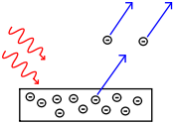

Instead, electrons are only dislodged by the impingement of photons when those photons reach or exceed a threshold [frequency](https://en.wikipedia.org/wiki/Frequency). Below that threshold, no electrons are emitted from the metal regardless of the light intensity or the length of time of exposure to the light. To make sense of the fact that light can eject electrons even if its intensity is low, [Albert Einstein](https://en.wikipedia.org/wiki/Albert_Einstein) proposed that a beam of light is not a wave propagating through space, but rather a collection of [discrete wave packets](https://en.wikipedia.org/wiki/Photon) (photons), each with energy *hf*. This shed light on [Max Planck](https://en.wikipedia.org/wiki/Max_Planck)'s previous discovery of the [Planck relation](https://en.wikipedia.org/wiki/Planck%27s_relation) (*E* = *hf*) linking energy (*E*) and frequency (*f*) as arising from quantization of energy. The factor *h* is known as the [Planck constant](https://en.wikipedia.org/wiki/Planck_constant).

In [1887](https://en.wikipedia.org/wiki/1887_in_science), [Heinrich Hertz](https://en.wikipedia.org/wiki/Heinrich_Hertz) discovered that [electrodes](https://en.wikipedia.org/wiki/Electrodes) illuminated with ultraviolet light create [electric sparks](https://en.wikipedia.org/wiki/Electric_spark) more easily. In [1905](https://en.wikipedia.org/wiki/1905_in_science)[Albert Einstein](https://en.wikipedia.org/wiki/Albert_Einstein) published a paper that explained experimental data from the photoelectric effect as the result of light energy being carried in discrete quantized packets. This discovery led to the [quantum](https://en.wikipedia.org/wiki/Quantum) revolution. In 1914, [Robert Millikan](https://en.wikipedia.org/wiki/Robert_Andrews_Millikan)'s experiment confirmed Einstein's law on photoelectric effect. Einstein was awarded the [Nobel Prize](https://en.wikipedia.org/wiki/Nobel_Prize_in_Physics) in [1921](https://en.wikipedia.org/wiki/1921_in_science) for "his discovery of the law of the photoelectric effect", and Millikan was awarded the Nobel Prize in 1923 for "his work on the elementary charge of electricity and on the photoelectric effect".

The photoelectric effect requires photons with energies from a few [electron volts](https://en.wikipedia.org/wiki/Electronvolt) to over 1 [MeV](https://en.wikipedia.org/wiki/MeV" \o "MeV) in [elements](https://en.wikipedia.org/wiki/Chemical_element) with a high [atomic number](https://en.wikipedia.org/wiki/Atomic_number). Study of the photoelectric effect led to important steps in understanding the quantum nature of light and electrons and influenced the formation of the concept of [wave–particle duality](https://en.wikipedia.org/wiki/Wave%E2%80%93particle_duality).[[1]](https://en.wikipedia.org/wiki/Photoelectric_effect#cite_note-serway_1-1) Other phenomena where light affects the movement of electric charges include the photoconductive effect also known as [photoconductivity](https://en.wikipedia.org/wiki/Photoconductivity) or [photo resistivity](https://en.wikipedia.org/wiki/Photoresistor)), the [photovoltaic effect](https://en.wikipedia.org/wiki/Photovoltaic_effect), and the [photo electrochemical effect](https://en.wikipedia.org/wiki/Photoelectrochemical_cell).

1. [Introduction](http://chemwiki.ucdavis.edu/Physical_Chemistry/Quantum_Mechanics/01._Waves_and_Particles/Case_Study%3A_Photoelectric_Effect#Introduction)
2. [Classical Explanation](http://chemwiki.ucdavis.edu/Physical_Chemistry/Quantum_Mechanics/01._Waves_and_Particles/Case_Study%3A_Photoelectric_Effect#Classical_Explanation)
3. [Lenard's Experiment](http://chemwiki.ucdavis.edu/Physical_Chemistry/Quantum_Mechanics/01._Waves_and_Particles/Case_Study%3A_Photoelectric_Effect#Lenard's_Experiment)
4. [Quantum Explanation](http://chemwiki.ucdavis.edu/Physical_Chemistry/Quantum_Mechanics/01._Waves_and_Particles/Case_Study%3A_Photoelectric_Effect#Quantum_Explanation)
5. [References](http://chemwiki.ucdavis.edu/Physical_Chemistry/Quantum_Mechanics/01._Waves_and_Particles/Case_Study%3A_Photoelectric_Effect#References)
6. [Outside Links](http://chemwiki.ucdavis.edu/Physical_Chemistry/Quantum_Mechanics/01._Waves_and_Particles/Case_Study%3A_Photoelectric_Effect#Outside_Links)
7. [Problems](http://chemwiki.ucdavis.edu/Physical_Chemistry/Quantum_Mechanics/01._Waves_and_Particles/Case_Study%3A_Photoelectric_Effect#Problems)

The photoelectric effect is observed when electromagnetic radiation strikes the surface of a metal and the resulting energy transfer causes the metal to emit electrons. This phenomenon played a major role in the rejection of classical physics and the development of quantum mechanics.

**Introduction**

The photoelectric effect was first documented in 1887 by the German physicist Heinrich Hertz and is therefore sometimes referred to as the Hertz effect. While working with a spark-gap transmitter (a primitive radio-broadcasting device), Hertz discovered that upon absorption of certain frequencies of light, substances would give off a visible spark. In 1899, this spark was identified as light-excited electrons (also called photoelectrons) leaving the metal's surface by J.J. Thomson. One of Hertz’' former assistants named Philipp Lenard went on to study this effect and was awarded the Nobel Prize in physics for his efforts. In 1905, Albert Einstein explained the photoelectric effect mathematically by proposing the concept of light quanta, or photons. This conclusion runs counter to the classic understanding of physics and is better understood in the context of [wave-particle duality](http://chemwiki.ucdavis.edu/Physical_Chemistry/Quantum_Mechanics/02._Fundamental_Concepts_of_Quantum_Mechanics/Wave-Particle_Duality).

**Classical Explanation**

According to the classical understanding of physics, when light shines on a surface, it slowly transfers energy into the substance. This increases the kinetic energy of the particles until finally, they give off excited electrons. This process is called thermal emission and it was considered the most likely explanation for the photoelectric effect. Given this justification, it was expected that increasing light intensity, regardless of frequency, would result in photoelectrons with higher kinetic energies. In addition, since the substance must first reach a critical temperature before it can begin ejecting electrons, it was expected that the photoelectric effect would not be observed immediately.

**Lenard's Experiment**

To test the theories proposed by classical mechanics, Lenard built the experimental device shown below.

**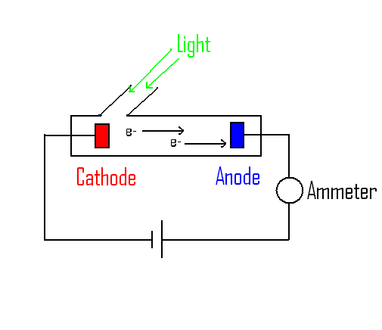**

***Figure 1:****Lenard's experimental setup*

When light reached the cathode, electrons were emitted and traveled down the vacuum tube until they reached the anode. Lenard could then determine the amount of electrons reaching the anode by measuring the current through the wire using a set potential voltage (battery). Using this device, Lenard ran a series of experiments in which he varied the frequency and intensity of the light. Surprisingly, Lenard found that below a certain threshold frequency, no matter how intense the light was, there was no emission of electrons. Above the threshold frequency, the current (i.e. the # of electrons reaching the anode) was directly proportional to the light intensity.

**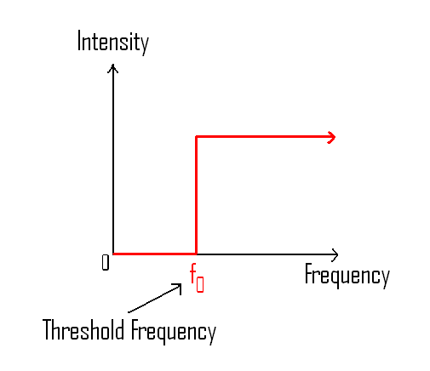**

***Figure 2:****Current Intensity and Threshold frequency*

Moreover, the current appeared almost instantaneously after the light was turned on (Lenard measured this to within 0.1 s, but today it has been observed to occur within 1 ns). Finally, by varying the potential and observing the change in current, Lenard was able to determine the kinetic energy of the ejected electrons. Interestingly, he found that higher frequency light increased the kinetic energy of the electrons, while changing the light intensity had no effect on the kinetic energy. Clearly, these findings could not be explained by classical physics and there must be some other explanation for the photoelectric effect.

**Einstein’s Light Quantum Hypothesis**

Based on Lenard's experiment, the young physicist Albert Einstein set about explaining the photoelectric effect using the concept of photons (i.e. distinct "packets" of light). This controversial theory states that light, while it may have wave-like properties, can also be described by small, massless particles of energy. This complex understanding of electromagnetic radiation is referred to as [wave-particle duality](http://chemwiki.ucdavis.edu/Physical_Chemistry/Quantum_Mechanics/02._Fundamental_Concepts_of_Quantum_Mechanics/Wave-Particle_Duality). With this theory, Einstein proposed that in the photoelectric effect, each photon was striking a single electron and causing it to break its association with the atom.

**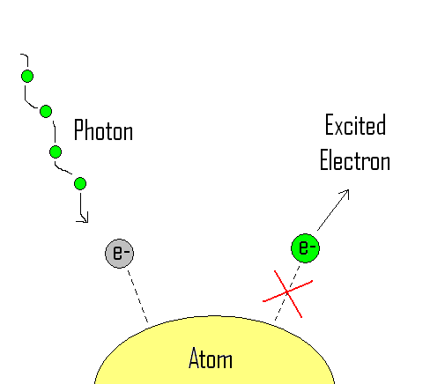**

***Figure 3:****Absorption of a photon by an electron*

However, each electron will only absorb the energy and be ejected if the frequency of the light is of sufficient energy according to the equation

E=hν(1)

Where, ν is the frequency of the incident light and h is Planck's constant = h=6.626∗10−34Js. The required energy to free an electron from an atom is called the work function and is designated by the symbol ϕ. The threshold frequency is the lowest energy light particle needed to satisfy this work function (i.e. overcome the electron's affinity for the atom). Higher frequency light increases the kinetic energy (KE) of the ejected electron according to the equation:

KE=hν−Φ(2)

The following table summarizes the work functions for several elements:

| ***Table 1:****Work Functions of Select Elements* | | |
| --- | --- | --- |
| **Element** | **Work Function**ϕ**(eV)** | **Ionization Energy (kJ/mole)** |
| Potassium | 2.30 | 418.8 |
| Sodium | 2.75 | 495.8 |
| Aluminum | 4.28 | 577.5 |
| Tungsten | 4.55 | 770 |
| Copper | 4.65 | 745.5 |
| Iron | 4.70 | 762.5 |
| Gold | 5.10 | 890.1 |

Since every photon of sufficient energy excites only one electron, increasing the light's intensity (i.e. the number of photons/sec) only increases the number of released electrons and not their kinetic energy. In addition, no time is necessary for the atom to be heated to a critical temperature and therefore the release of the electron is nearly instantaneous upon absorption of the light. Finally, because the photons must be above certain energy to satisfy the work function, a threshold frequency exists below which no photoelectrons are observed. This frequency is measured in Hertz (1/second) in honor of the discoverer of the photoelectric effect.

Thus in summary, Einstein's simple explanation completely accounted for the observed phenomenon in Lenard's experiment and began an investigation into the field we now call [quantum mechanics](http://chemwiki.ucdavis.edu/Physical_Chemistry/Quantum_Mechanics/01._Waves_and_Particles/Classical_vs._Quantum_Mechanics). This new field seeks to provide a quantum explanation for classical mechanics and create a more unified theory of physics and thermodynamics. The study of the photoelectric effect has also lead to the creation of new photoelectron spectroscopy [theory](http://chemwiki.ucdavis.edu/Physical_Chemistry/Spectroscopy/Photoelectron_Spectroscopy/Photoelectron_Spectroscopy%3A_Theory) and [applications](http://chemwiki.ucdavis.edu/Physical_Chemistry/Spectroscopy/Photoelectron_Spectroscopy/Photoelectron_Spectroscopy%3A_Application).

**COMPTON EFFECT AND RICHARDSON –relation between photo electric current and retarding potential –relationship between velocity of photoelectrons and frequency of light**

Returning to the United States, Compton was appointed Wayman Crow Professor of Physics, and Head of the Department of Physics at [Washington University in St. Louis](https://en.wikipedia.org/wiki/Washington_University_in_St._Louis) in 1920. In 1922, he found that [X-ray](https://en.wikipedia.org/wiki/X-ray) [quanta](https://en.wikipedia.org/wiki/Quantum) scattered by free electrons had longer [wavelengths](https://en.wikipedia.org/wiki/Wavelength) and, in accordance with [Planck's relation](https://en.wikipedia.org/wiki/Planck_constant), less [energy](https://en.wikipedia.org/wiki/Energy) than the incoming X-rays, the surplus energy having been transferred to the electrons. This discovery, known as the "[Compton effect](https://en.wikipedia.org/wiki/Compton_effect)" or "Compton scattering", demonstrated the [particle](https://en.wikipedia.org/wiki/Particle_physics) concept of [electromagnetic radiation](https://en.wikipedia.org/wiki/Electromagnetic_radiation).

In 1923, Compton published a paper in the [*Physical Review*](https://en.wikipedia.org/wiki/Physical_Review) that explained the X-ray shift by attributing particle-like momentum to [photons](https://en.wikipedia.org/wiki/Photon), something Einstein had invoked for his 1905 Nobel Prize–winning explanation of the [photo-electric effect](https://en.wikipedia.org/wiki/Photo-electric_effect). First postulated by [Max Planck](https://en.wikipedia.org/wiki/Max_Planck) in 1900, these were conceptualized as elements of light "quantized" by containing a specific amount of energy depending only on the frequency of the light. In his paper, Compton derived the mathematical relationship between the shift in wavelength and the scattering angle of the X-rays by assuming that each scattered X-ray photon interacted with only one electron. His paper concludes by reporting on experiments that verified his derived relation:

\lambda' - \lambda = \frac{h}{m_e c}(1-\cos{\theta}),

where

\lambda is the initial wavelength,

\lambda' is the wavelength after scattering,

h is the [Planck constant](https://en.wikipedia.org/wiki/Planck_constant),

m_e is the [electron rest mass](https://en.wikipedia.org/wiki/Electron_rest_mass),

c is the [speed of light](https://en.wikipedia.org/wiki/Speed_of_light), and

\theta is the scattering angle.[[15]](https://en.wikipedia.org/wiki/Arthur_Compton#cite_note-Compton_effect-15)

The quantity *h*⁄*mec* is known as the [Compton wavelength](https://en.wikipedia.org/wiki/Compton_wavelength) of the electron; it is equal to 2.43×10−12 m. The wavelength shift *λ′* − *λ* lies between zero (for *θ* = 0°) and twice the Compton wavelength of the electron (for *θ* = 180°).He found that some X-rays experienced no wavelength shift despite being scattered through large angles; in each of these cases the photon failed to eject an electron. Thus the magnitude of the shift is related not to the Compton wavelength of the electron, but to the Compton wavelength of the entire atom, which can be upwards of 10,000 times smaller.

"When I presented my results at a meeting of the [American Physical Society](https://en.wikipedia.org/wiki/American_Physical_Society) in 1923," Compton later recalled, "it initiated the most hotly contested scientific controversy that I have ever known." The wave nature of light had been well demonstrated, and the idea that it could have a dual nature was not easily accepted. It was particularly telling that diffraction in a crystal lattice could only be explained with reference to its wave nature. It earned Compton the [Nobel Prize in Physics](https://en.wikipedia.org/wiki/Nobel_Prize_in_Physics) in 1927. Compton and Alfred W. Simon developed the method for observing at the same instant individual scattered X-ray photons and the [recoil](https://en.wikipedia.org/wiki/Recoil) [electrons](https://en.wikipedia.org/wiki/Electron). In Germany, [Walther Bothe](https://en.wikipedia.org/wiki/Walther_Bothe) and [Hans Geiger](https://en.wikipedia.org/wiki/Hans_Geiger) independently developed a similar method.

Relation between photoelectric current and retarding potential

.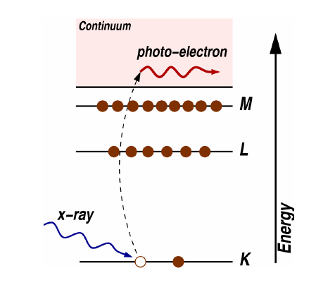

The picture is a typical diagram used to elaborate on the photoelectric effect, where the photon's energyhν has to be larger than the electron's binding energy to its atom usually denoted as work function E0, only then a photoelectron is created. As for its kinetic energy, just make use of the Energy Conservation in photoelectric effect:

hν=E0+ℏ2k22m

where the second term in the right hand side is the kinetic energy, h Planck's constant, m mass of the electron and k its wave number (momentum p=ℏk)

Now back to our photoelectric current:

When a photosensitive surface is subject to incident light (x-ray for example), photoelectrons can be ejected from the surface (metallic surface) if the photons' frequency is high enough to reach the necessary work function of the metal, then electrons can be ejected, and now you should already know how to define their kinetic energy. It is important to note again that the maximum kinetic energy depends on the frequency of the photons and not the intensity of the ray.

Next step: if the electrons now reach a collecting plate, a current can be detected. Furthermore if an external retarding potential is placed between the metallic surface and the collecting electrode, the current can be reduced, because at high enough potentials, even the fastest electrons will be prevented from reaching the collector. With the potential U=qV (charge q, the voltage V), the work-energy theorem is written simply W=ΔKE=−ΔU. The electron starting from rest, strikes the plate at zero potential relative to its first plate: ΔKE=12mv2 and −ΔU=qV, so an electron failing to reach the plate, must have had a kinetic energy of KE=eV, where eV is the work done on charge moving through the retarding potential V. The kinetic energy of the fastest electrons can then be obtained by finding the critical retarding potential necessary to reduce the current flow to zero:

eVcrit=hν−W

Finally as for the intensity of the ray and current saturation, if the intensity is high enough (very high number of incident photons) then all the electrons get the chance to be ejected (assuming ν high enough) and contribute to the current, once all possible electrons are ejected from the plate, saturation current can be reached.