# External Data editing summary.

## Simple editing of existing data

For simple editing of features, this can be done via a web based service at geojson.io, which links to your github account. This is best suited to smaller geojson files.

## Adding new data, and more complex editing

Download and install QGIS - http://www.qgis.org/en/site/forusers/download.html

Download and install TortoiseGit - <https://code.google.com/p/tortoisegit/wiki/Download>

Obtain source data

Example using Koordinates:

Search for NZ Power Transmission Lines - https://koordinates.com/layer/17-nz-power-transmission-lines/

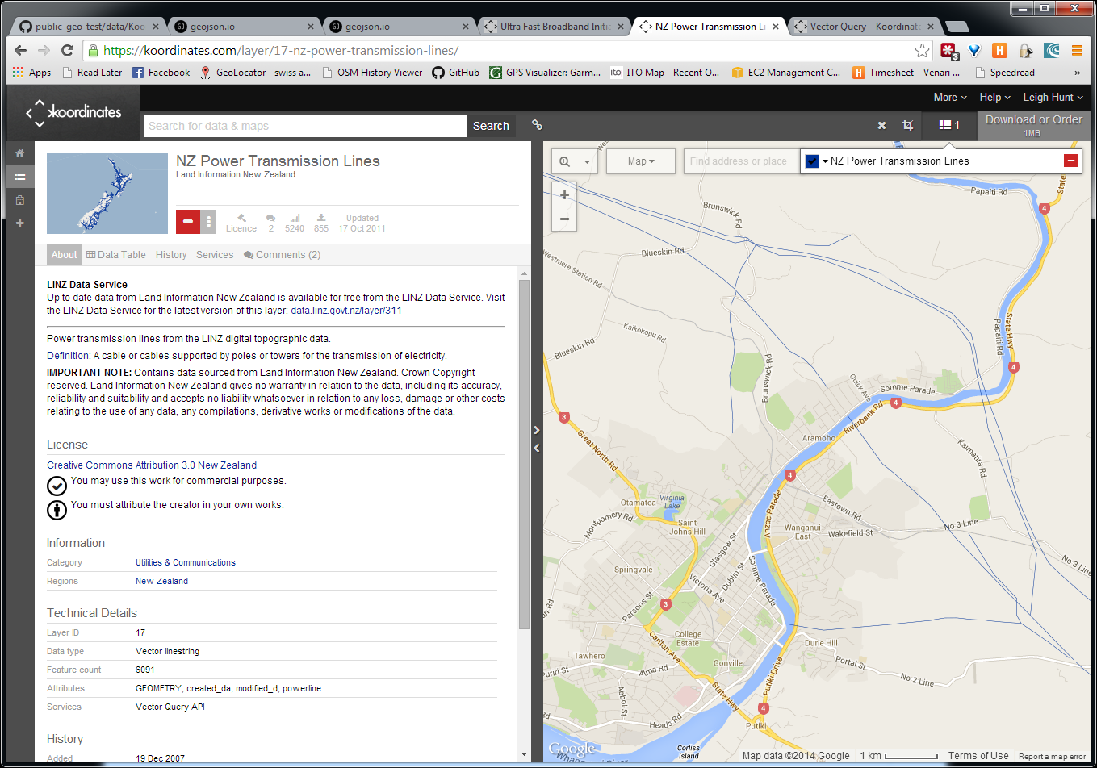

Click the add button, and click Download or Order.

Select Google Earth (KML) as the file format, and click Accept terms and create download.

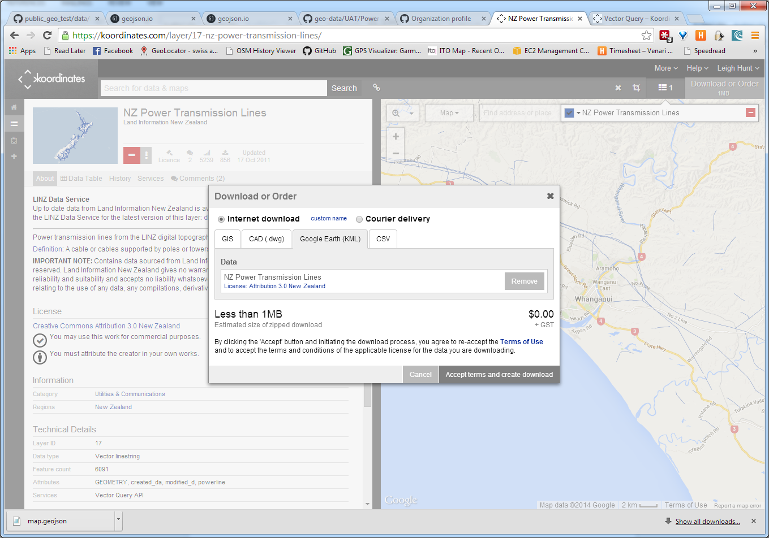

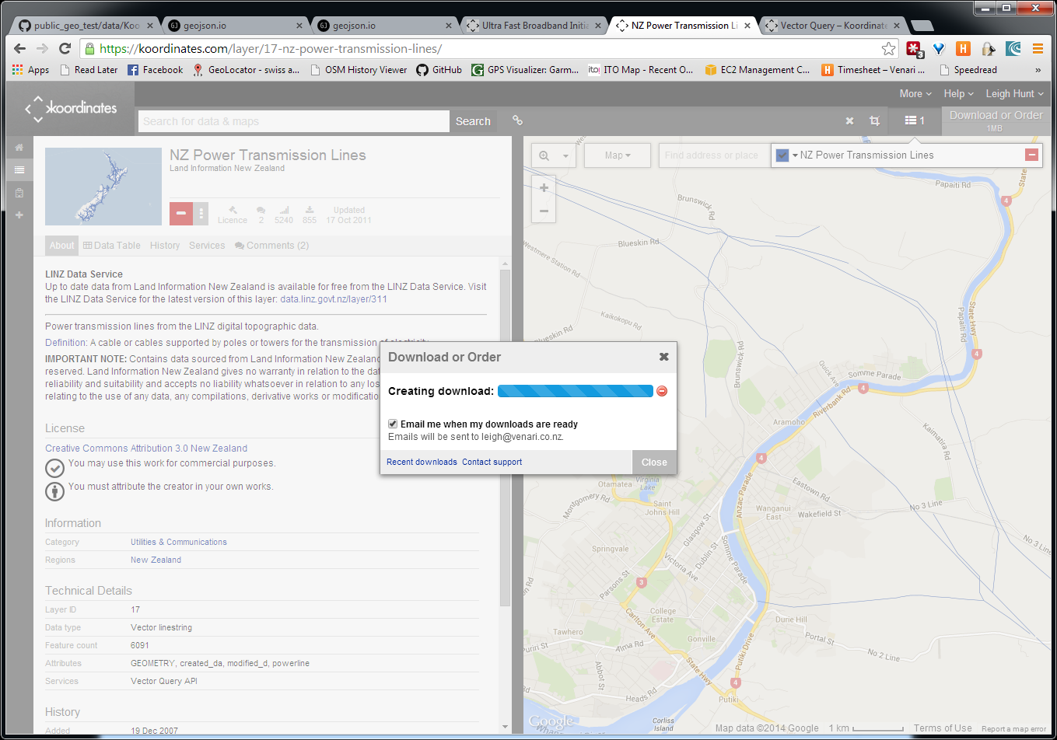

Locate downloaded kml file.

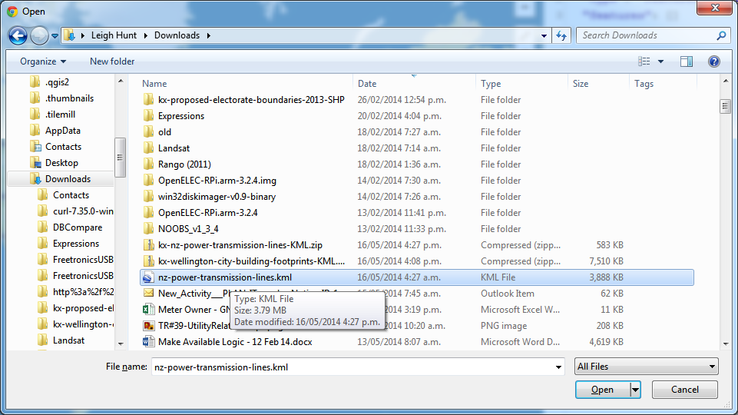

Start QGIS.

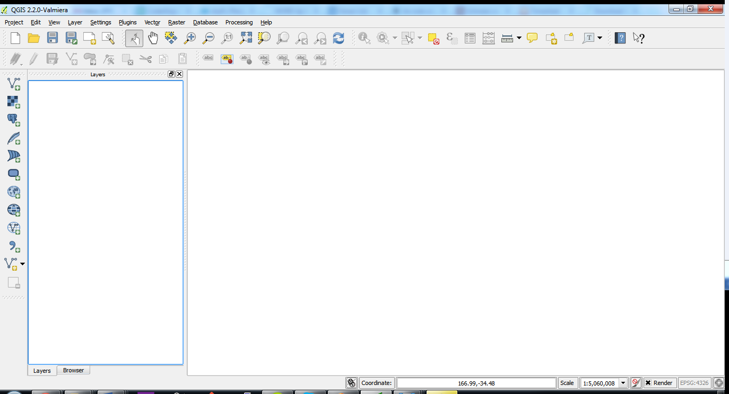

Click Layer🡪Add Vector Layer….

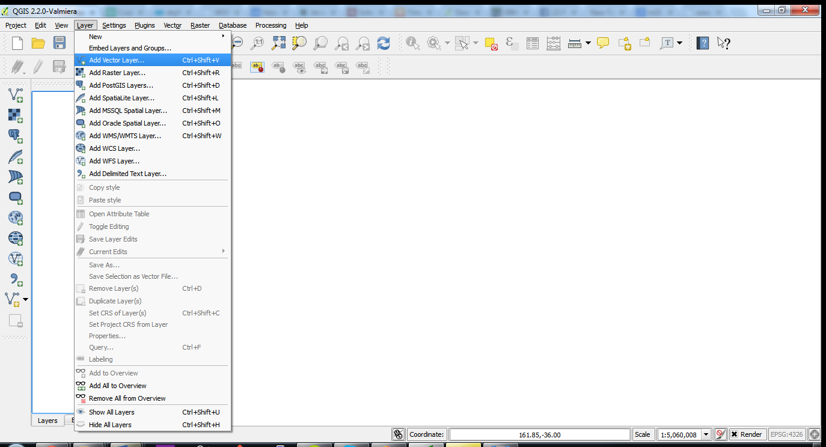

The Add vector layer dialogue appears – ensure File is selected as the source type, and click Browse. Locate the KML file you just downloaded.

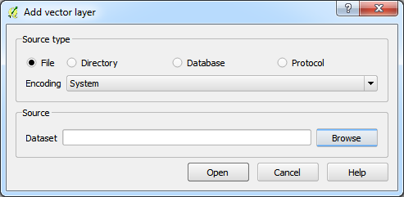

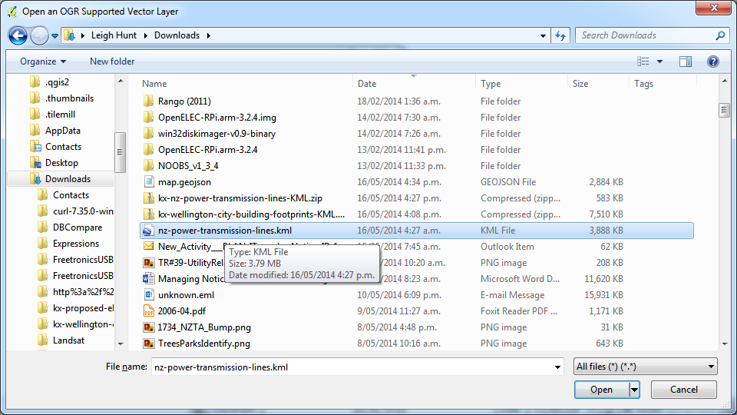

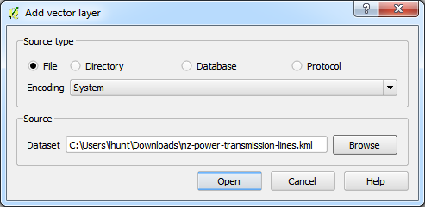

Click Open.

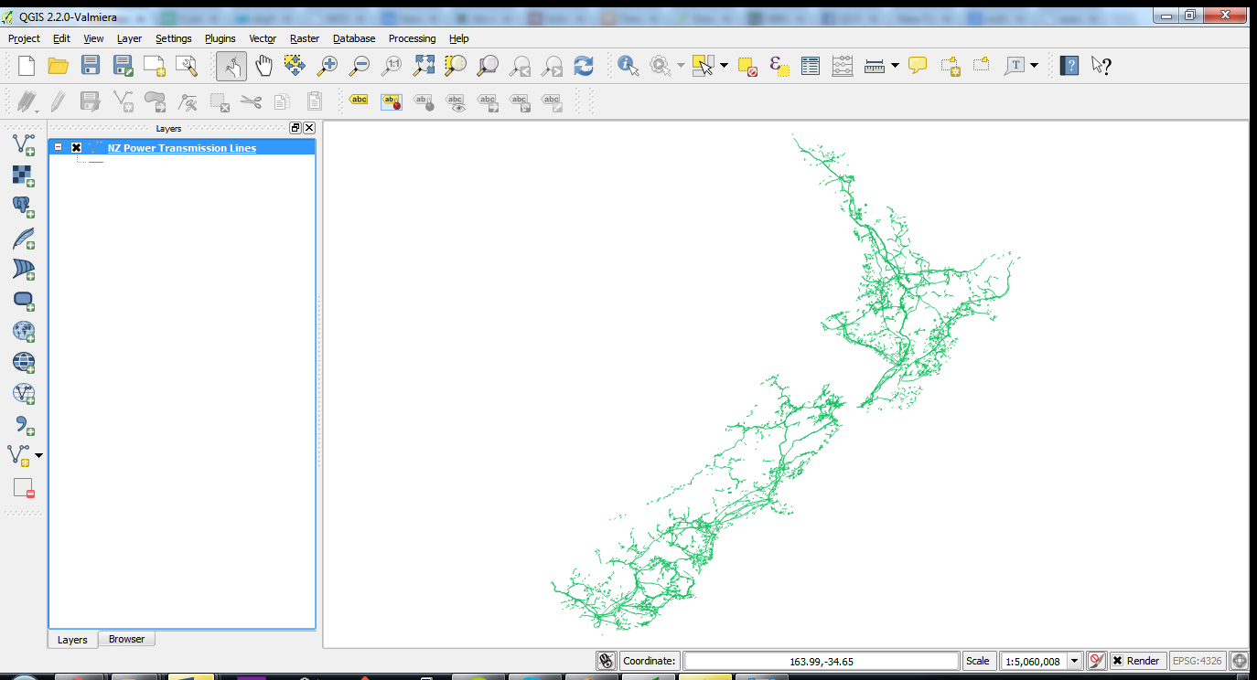

The KML file is displayed in QGIS. Now convert it to GEOJSON format. Right click the layer in the left hand Layers pane, and select Save As….

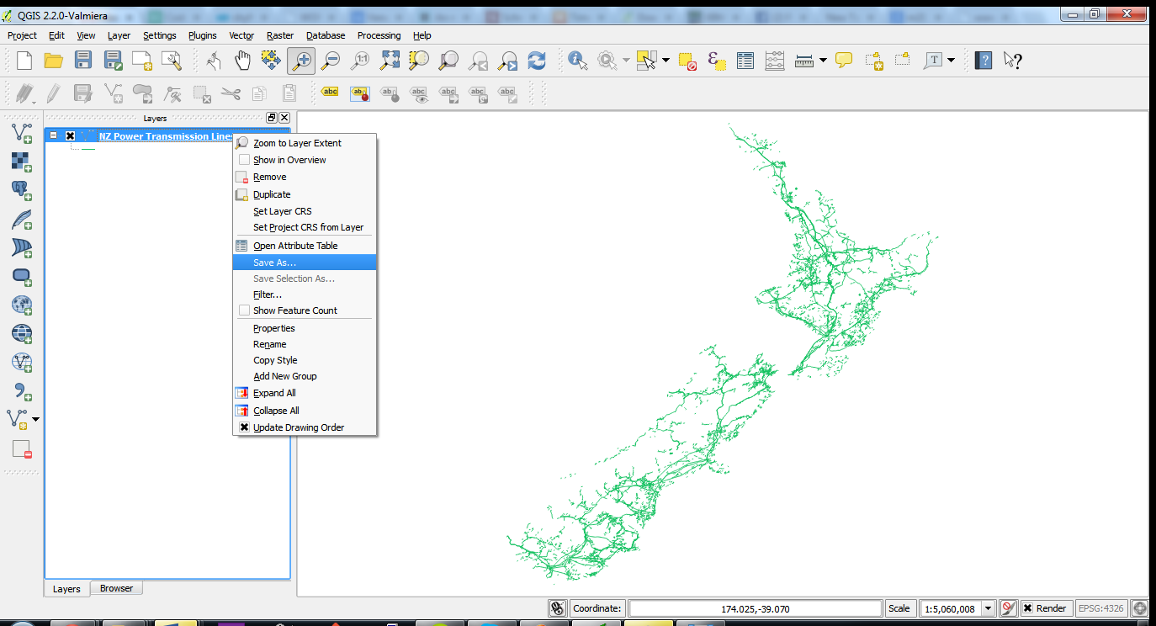

The Save vector layer as… dialogue appears.

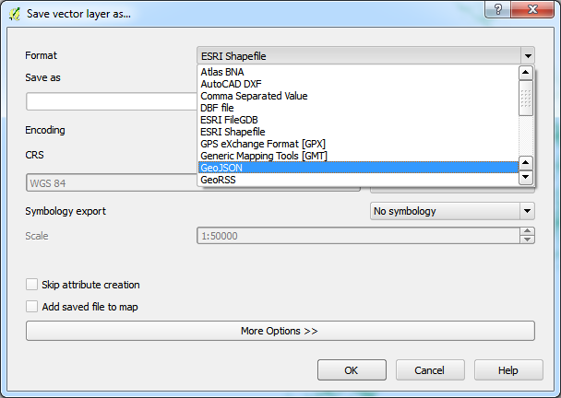

Select GeoJSON in the Format dropdown. Save the file to the relevant folder in your local geo-data repository (I’ll set this up for you rather than document it here).

GitHub for Windows/Mac

<https://windows.github.com/>

Download GitHub for Windows. Run the installer.

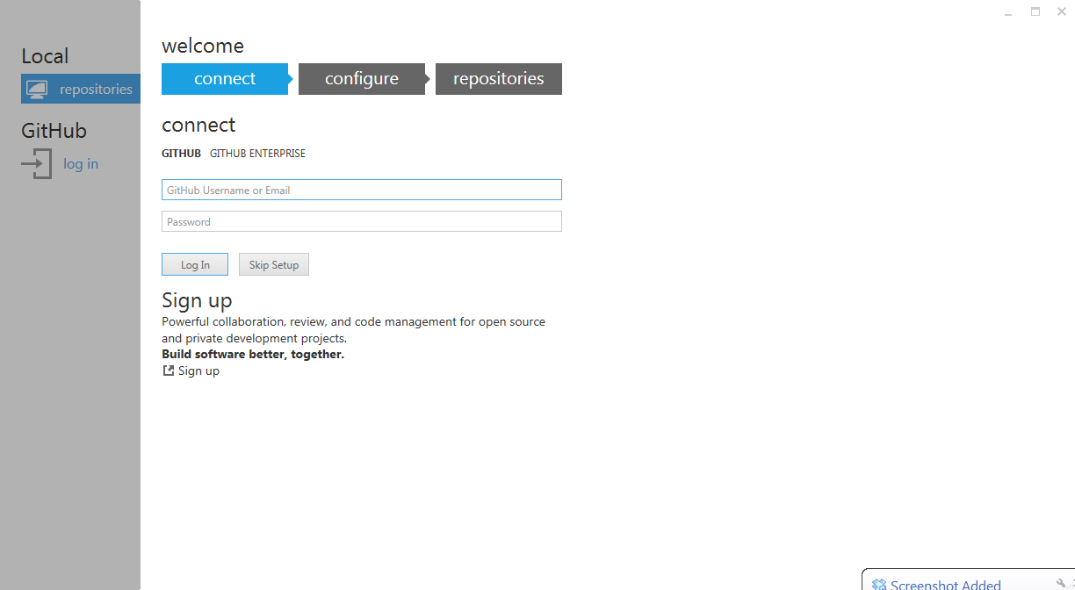

You may get the following splash screen – if so, just let it complete.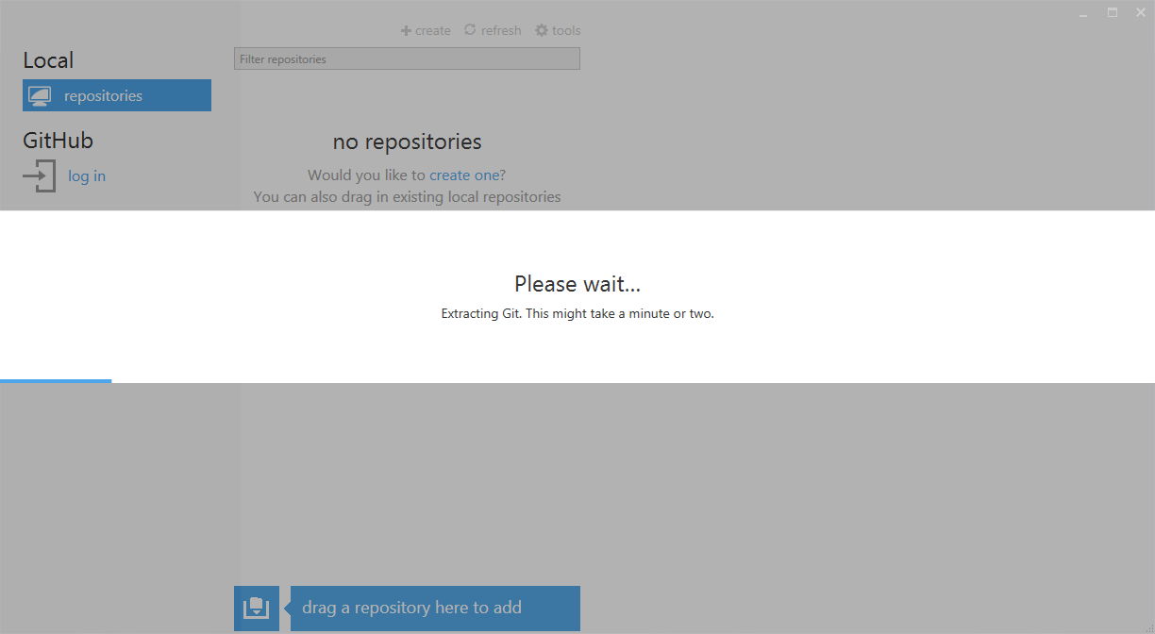

If necessary, click on the GitHub log in button. Supply your GitHub credentials. Click Log In.

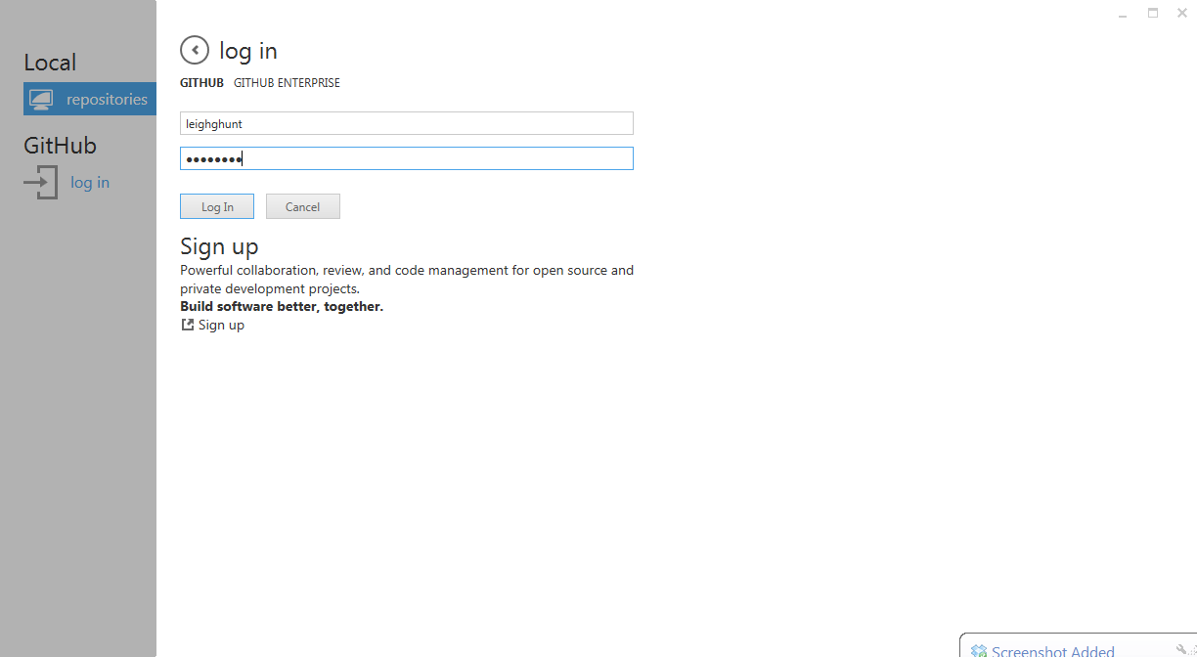

Click venari in the left hand pane, and select geo-data, and click CLONE.

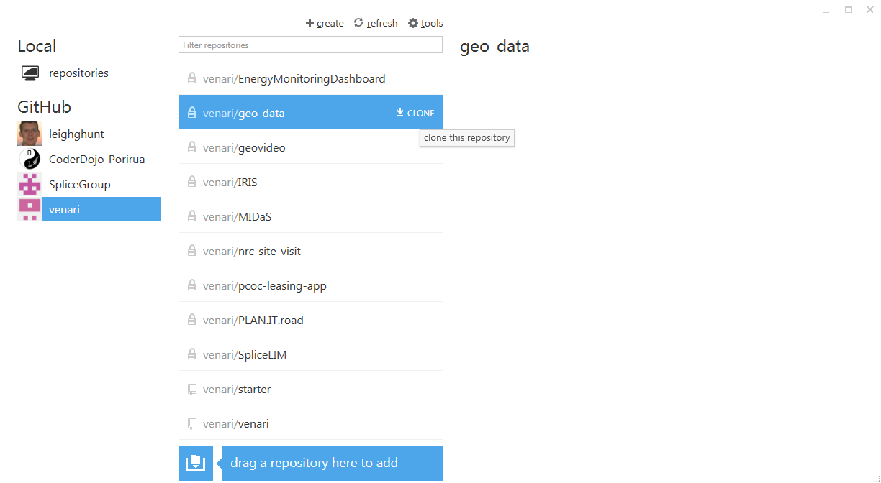

Now click Local/repositories in the left hand pane, and you will see venari/geo-data listed.

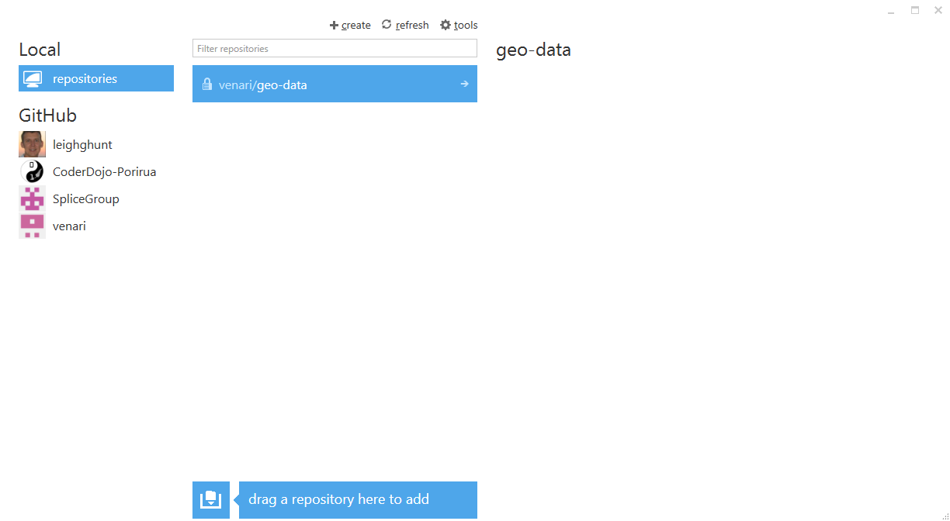

Click on the arrow to the right of venari/geo-data, and it will open the repository, and show you any changes you have to commit and synchronise.

<https://mac.github.com/>