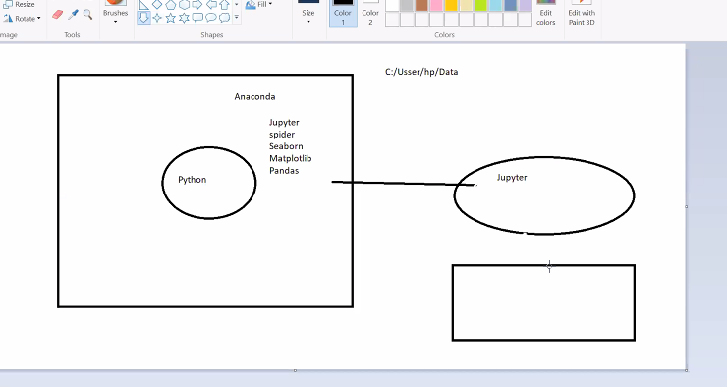

Online editor

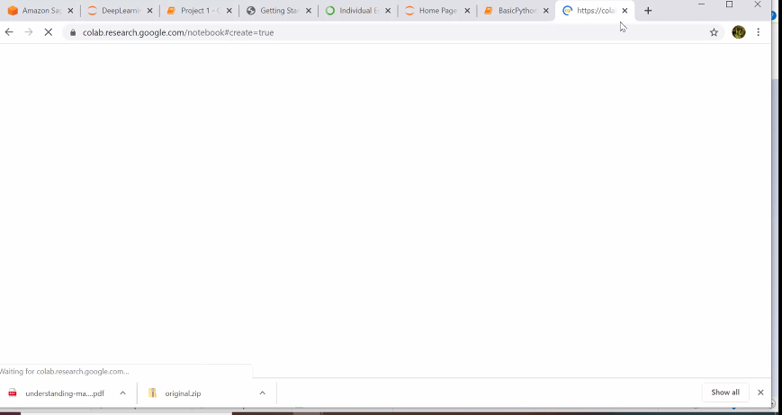

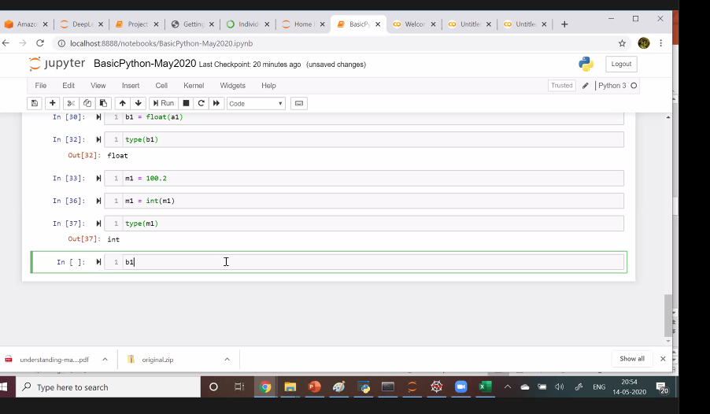

From Me to Everyone: 10:32 AM

hari300677@gmail.com

From srinivas rao vakkalanka to Everyone: 10:32 AM

srinivas.sesha@gmail.com

From Karlapudi, Venkatesh to Everyone: 10:32 AM

venkykarthik1989@gmail.com

From Nizamuddin shaik to Everyone: 10:33 AM

[shaik.nizam1047@gmail.com](mailto:shaik.nizam1047@gmail.com)

[kishoredeep@gmail.com](mailto:kishoredeep@gmail.com)