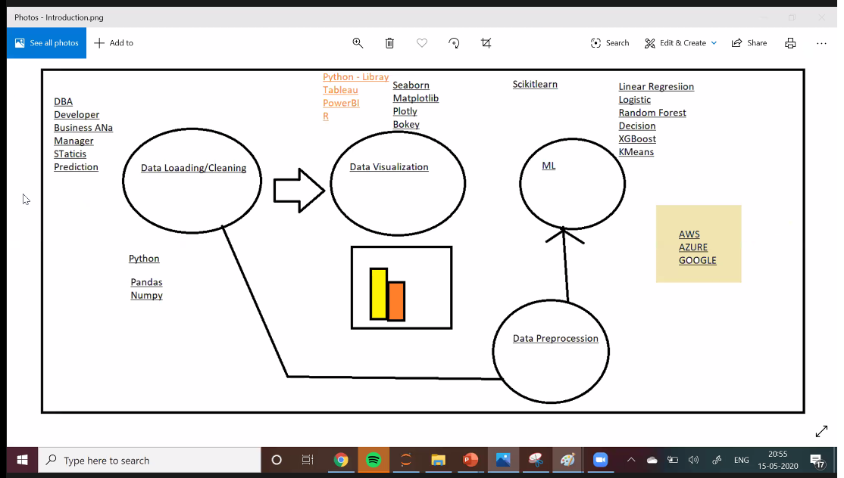

https://pandas.pydata.org/pandas-docs/stable/search.html?q=groupby#

<https://pandas.pydata.org/pandas-docs/stable/reference/api/pandas.DataFrame.groupby.html>

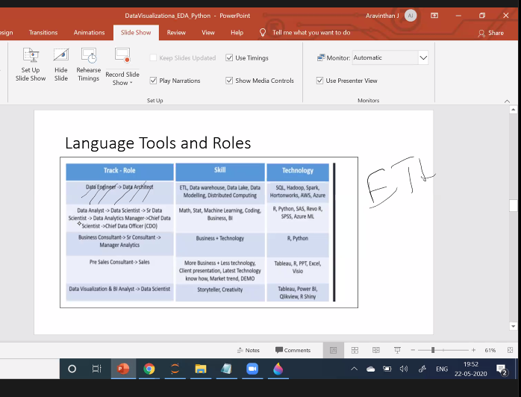

Eg.,



HR

https://seaborn.pydata.org/tutorial/categorical.html

Colors link -- <https://matplotlib.org/3.1.0/gallery/color/named_colors.html>

https://plotly.com/python/pie-charts/

All Material in the google drive

Finding the highest probability is very important.

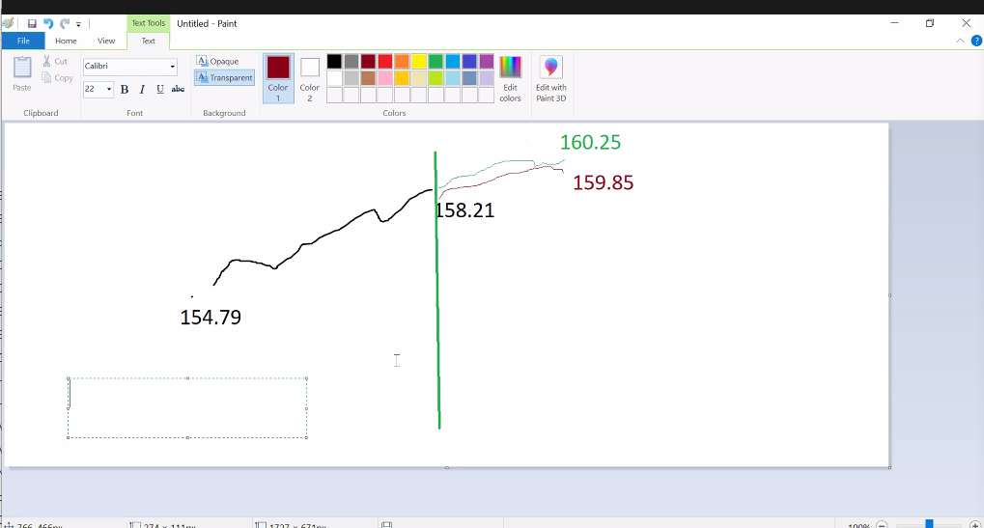

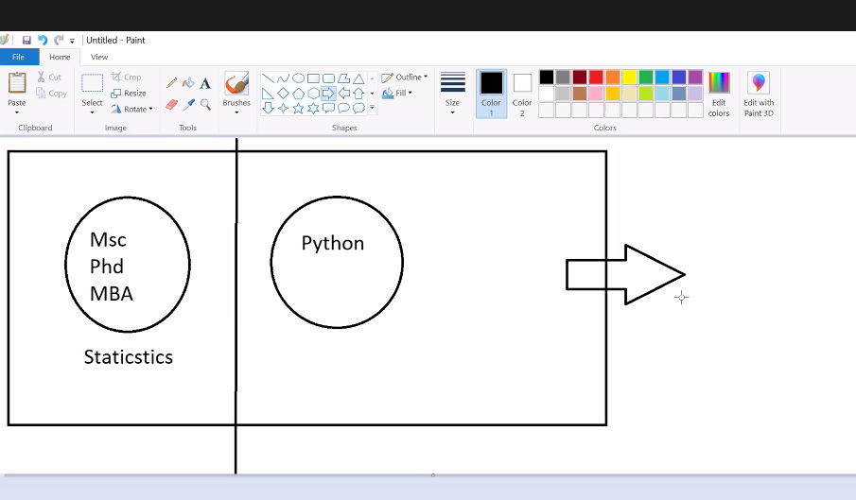

Toss a coin

Probabilty ( head )

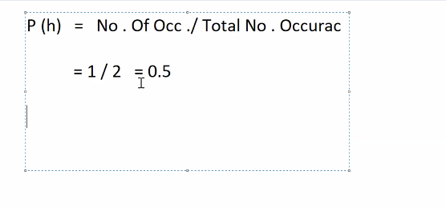

P ( 1 ) in a dice = 1/ 6

P ( king ) = 4 / 52

P ( heart ) = 13 / 52

P ( black ) = 26 /52

P ( Black+ diamond ) = 26 + 13 / 52 = .75

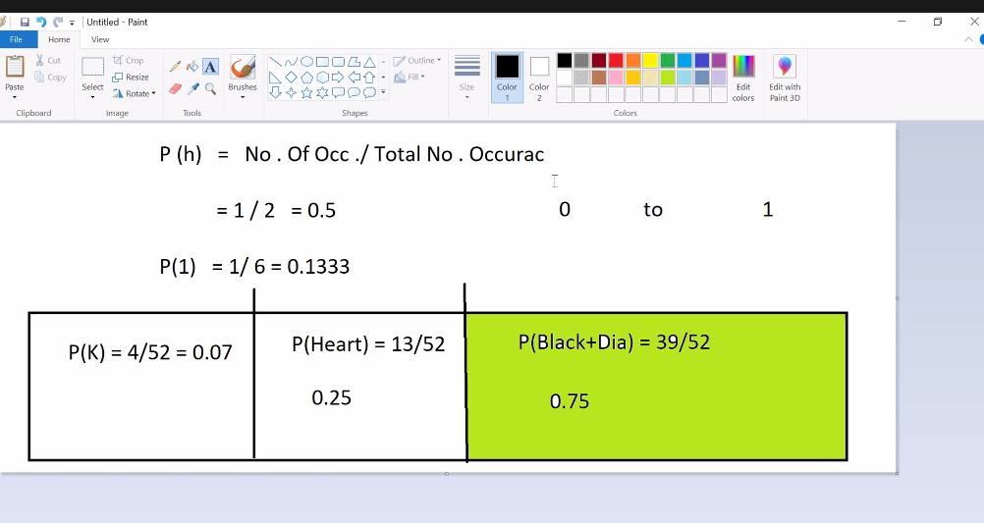

SQL connection

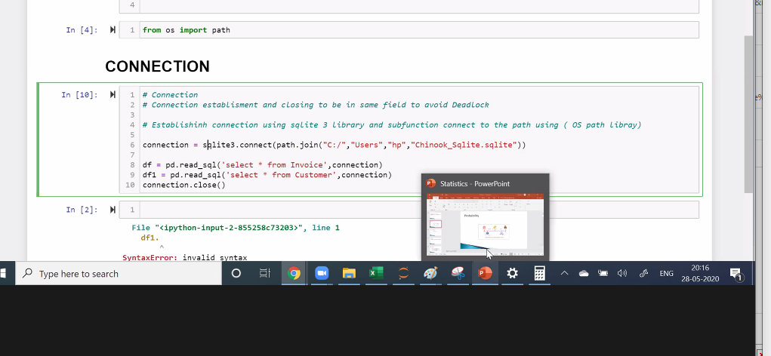

Slope

