Assignment 12

Sriya Reddy

2023-04-02

## R Markdown

For this assignment, I used my code from a previous assignment and ported it to a Word file. I followed the code I wrote for Assignment 7 where I used different functions on the mtcars dataset.

I loaded the data into the variable cars with the command

cars <- mtcars  
cars

## mpg cyl disp hp drat wt qsec vs am gear carb  
## Mazda RX4 21.0 6 160.0 110 3.90 2.620 16.46 0 1 4 4  
## Mazda RX4 Wag 21.0 6 160.0 110 3.90 2.875 17.02 0 1 4 4  
## Datsun 710 22.8 4 108.0 93 3.85 2.320 18.61 1 1 4 1  
## Hornet 4 Drive 21.4 6 258.0 110 3.08 3.215 19.44 1 0 3 1  
## Hornet Sportabout 18.7 8 360.0 175 3.15 3.440 17.02 0 0 3 2  
## Valiant 18.1 6 225.0 105 2.76 3.460 20.22 1 0 3 1  
## Duster 360 14.3 8 360.0 245 3.21 3.570 15.84 0 0 3 4  
## Merc 240D 24.4 4 146.7 62 3.69 3.190 20.00 1 0 4 2  
## Merc 230 22.8 4 140.8 95 3.92 3.150 22.90 1 0 4 2  
## Merc 280 19.2 6 167.6 123 3.92 3.440 18.30 1 0 4 4  
## Merc 280C 17.8 6 167.6 123 3.92 3.440 18.90 1 0 4 4  
## Merc 450SE 16.4 8 275.8 180 3.07 4.070 17.40 0 0 3 3  
## Merc 450SL 17.3 8 275.8 180 3.07 3.730 17.60 0 0 3 3  
## Merc 450SLC 15.2 8 275.8 180 3.07 3.780 18.00 0 0 3 3  
## Cadillac Fleetwood 10.4 8 472.0 205 2.93 5.250 17.98 0 0 3 4  
## Lincoln Continental 10.4 8 460.0 215 3.00 5.424 17.82 0 0 3 4  
## Chrysler Imperial 14.7 8 440.0 230 3.23 5.345 17.42 0 0 3 4  
## Fiat 128 32.4 4 78.7 66 4.08 2.200 19.47 1 1 4 1  
## Honda Civic 30.4 4 75.7 52 4.93 1.615 18.52 1 1 4 2  
## Toyota Corolla 33.9 4 71.1 65 4.22 1.835 19.90 1 1 4 1  
## Toyota Corona 21.5 4 120.1 97 3.70 2.465 20.01 1 0 3 1  
## Dodge Challenger 15.5 8 318.0 150 2.76 3.520 16.87 0 0 3 2  
## AMC Javelin 15.2 8 304.0 150 3.15 3.435 17.30 0 0 3 2  
## Camaro Z28 13.3 8 350.0 245 3.73 3.840 15.41 0 0 3 4  
## Pontiac Firebird 19.2 8 400.0 175 3.08 3.845 17.05 0 0 3 2  
## Fiat X1-9 27.3 4 79.0 66 4.08 1.935 18.90 1 1 4 1  
## Porsche 914-2 26.0 4 120.3 91 4.43 2.140 16.70 0 1 5 2  
## Lotus Europa 30.4 4 95.1 113 3.77 1.513 16.90 1 1 5 2  
## Ford Pantera L 15.8 8 351.0 264 4.22 3.170 14.50 0 1 5 4  
## Ferrari Dino 19.7 6 145.0 175 3.62 2.770 15.50 0 1 5 6  
## Maserati Bora 15.0 8 301.0 335 3.54 3.570 14.60 0 1 5 8  
## Volvo 142E 21.4 4 121.0 109 4.11 2.780 18.60 1 1 4 2

I used the head command to get 6 rows of the dataset

head(cars)

## mpg cyl disp hp drat wt qsec vs am gear carb  
## Mazda RX4 21.0 6 160 110 3.90 2.620 16.46 0 1 4 4  
## Mazda RX4 Wag 21.0 6 160 110 3.90 2.875 17.02 0 1 4 4  
## Datsun 710 22.8 4 108 93 3.85 2.320 18.61 1 1 4 1  
## Hornet 4 Drive 21.4 6 258 110 3.08 3.215 19.44 1 0 3 1  
## Hornet Sportabout 18.7 8 360 175 3.15 3.440 17.02 0 0 3 2  
## Valiant 18.1 6 225 105 2.76 3.460 20.22 1 0 3 1

The function plot generates the follwoing plot.

plot(cars)

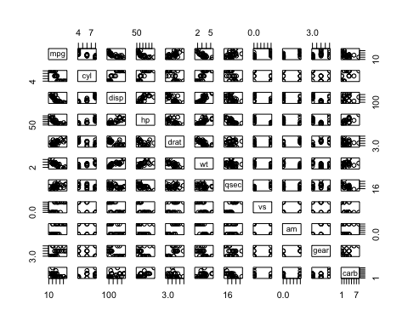

The summary function provides the mean, median, quartiles and min/max values for each parameter.

summary(cars)

## mpg cyl disp hp   
## Min. :10.40 Min. :4.000 Min. : 71.1 Min. : 52.0   
## 1st Qu.:15.43 1st Qu.:4.000 1st Qu.:120.8 1st Qu.: 96.5   
## Median :19.20 Median :6.000 Median :196.3 Median :123.0   
## Mean :20.09 Mean :6.188 Mean :230.7 Mean :146.7   
## 3rd Qu.:22.80 3rd Qu.:8.000 3rd Qu.:326.0 3rd Qu.:180.0   
## Max. :33.90 Max. :8.000 Max. :472.0 Max. :335.0   
## drat wt qsec vs   
## Min. :2.760 Min. :1.513 Min. :14.50 Min. :0.0000   
## 1st Qu.:3.080 1st Qu.:2.581 1st Qu.:16.89 1st Qu.:0.0000   
## Median :3.695 Median :3.325 Median :17.71 Median :0.0000   
## Mean :3.597 Mean :3.217 Mean :17.85 Mean :0.4375   
## 3rd Qu.:3.920 3rd Qu.:3.610 3rd Qu.:18.90 3rd Qu.:1.0000   
## Max. :4.930 Max. :5.424 Max. :22.90 Max. :1.0000   
## am gear carb   
## Min. :0.0000 Min. :3.000 Min. :1.000   
## 1st Qu.:0.0000 1st Qu.:3.000 1st Qu.:2.000   
## Median :0.0000 Median :4.000 Median :2.000   
## Mean :0.4062 Mean :3.688 Mean :2.812   
## 3rd Qu.:1.0000 3rd Qu.:4.000 3rd Qu.:4.000   
## Max. :1.0000 Max. :5.000 Max. :8.000

Earlier, I had created a function to generate the histogram for the histogram of the carb. I obtain the following plot.

car_func <- function(x, ...)  
 UseMethod("car_func")  
car_func.carb_hist <- function(x) hist(x$carb)  
car_func.carb_hist(cars)

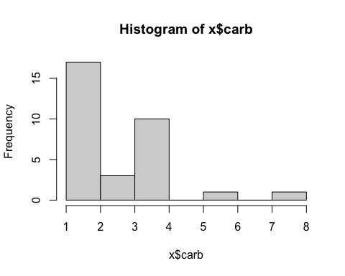 This is the markdown file for my code. The process of creating the Word/PDF/HTML file from the code directly is super interesting and easy to use!