22/01/2026 Learning Go to make another side project using prabogo an the whole merah putih framework because good god it would be so fucking funny!!!!!! Uwu
Advantages of Go : 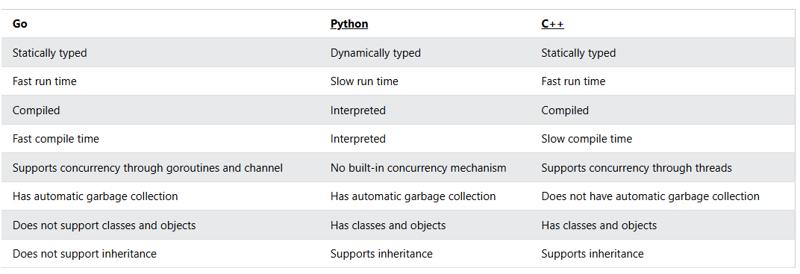
It also have concurrency unlike JS so you don’t have to use longass callback functions for the backend.
//hello_world.go
package main
import ("fmt")
func main() {
fmt.Println("Hello World!")
}

Line 1: In Go, every program is part of a package. We define this using the package keyword. In this example, the program belongs to the main package.
Line 2: import ("fmt") lets us import files included in the fmt package.
Line 3: func main() {} is a function. Any code inside its curly brackets {} will be executed.
Line 5: fmt.Println() is a function made available from the fmt package. It is used to output/print text. In our example it will output "Hello World!".
Variables :
2 ways to declare :
Var :
var variablename type = value

:= sign -> inferred values from the values
variablename := value

Eg:
// Variable declaration and initialization
var (
a int = 6
b string = "Hello"
)
c, d := 7,"World!"

Constants :
Similar to js const but it allows static typing
package main
import ("fmt")
const (
A int = 1
B = 3.14
C = "Hi!"
)
func main() {
fmt.Println(A)
fmt.Println(B)
fmt.Println(C)
}

Print functions :
Go has three functions to output text:
- Print() -> print without line
- Println() -> print with line
- Printf() -> print with format
REGEX formats
General format
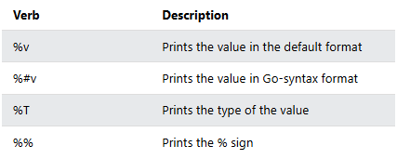
Integer formats : | Str formats :
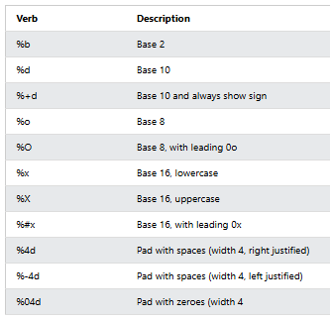 | 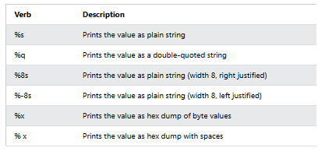
Bool formats | Float formats
The default value of a boolean data type is false. | 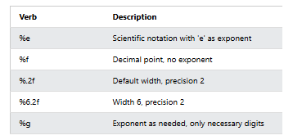

ARRAYS
Unlike python, Go Arrays cannot be of different types
2 ways to declare : using var or :=
Using var keyword
var array_name = [length]datatype{values} // here length is defined
or
var array_name = [...]datatype{values} // here length is inferred

Using the := sign:
array_name := [length]datatype{values} // here length is defined
or
array_name := [...]datatype{values} // here length is inferred

Eg :
var arr1 = [4]int{1,2,3}
arr2 := [...]int{4,5,6,7,8}
arr3 := [5]int{1:10,2:40}

fmt.Println(arr1)
fmt.Println(arr2)
fmt.Println(arr3)
fmt.Println(len(arr3))
}

Slices
Slices are similar to arrays, but are more powerful and flexible.
Like arrays, slices are also used to store multiple values of the same type in a single variable.
However, unlike arrays, the length of a slice can grow and shrink as you see fit.
In Go, there are several ways to create a slice:
- Using the []datatype{values} format
- Create a slice from an array
- Using the make() function
myslice1 := []int{}
fmt.Println(len(myslice1))
fmt.Println(cap(myslice1))
fmt.Println(myslice1)
myslice2 := []string{"Go", "Slices", "Are", "Powerful"}
fmt.Println(len(myslice2))
fmt.Println(cap(myslice2))
fmt.Println(myslice2)

- len() function - returns the length of the slice (the number of elements in the slice)
- cap() function - returns the capacity of the slice (the number of elements the slice can grow or shrink to)
Slicing from an array (see where did it get it’s name):
arr4 := [6]int{10, 11, 12, 13, 14, 15}
myslice := arr4[2:4]

Using make function :
slice_name := make([]type, length, capacity)

Operators
Arithmatic | Logical | Bitwise Logical
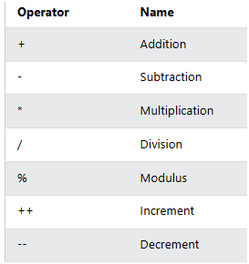 | 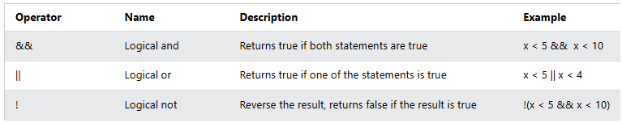 | 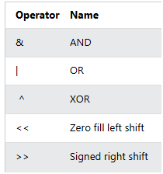

Conditional
if condition1 {
// code to be executed if condition1 is true
} else if condition2 {
// code to be executed if condition1 is false and condition2 is true
} else {
// code to be executed if condition1 and condition2 are both false
}

Loops
There’s only for loops in Go
// for loop
for i := 0; i < 9; i++ {
if i == 3 {
continue
}
fmt.Println(i)
if i == 6 {
break
}
}
fmt.Println("")
// enumerate over slice
fruits := []string{"apple", "orange", "banana"}
for idx, val := range fruits {
fmt.Printf("%v\t%v\n", idx, val)
}

Functions
HASHMAP !!!!
2 implementations also using make and direct
Direct implementations :
package main
import ("fmt")
func main() {
var a = map[string]string{"brand": "Ford", "model": "Mustang", "year": "1964"}
b := map[string]int{"Oslo": 1, "Bergen": 2, "Trondheim": 3, "Stavanger": 4}
fmt.Printf("a\t%v\n", a)
fmt.Printf("b\t%v\n", b)
}
Make Implementations :
// using maps
var x = map[string]string{"brand": "Ford", "model": "Mustang", "year": "1964"}
// using make to create map
y := make(map[string]int)
y["Oslo"] = 1
y["Bergen"] = 2
y["Trondheim"] = 3
y["Stavanger"] = 4

delete(x, "year")
// add elements to map
x["color"] = "Red" // Adding an element

// access elements from map
_, ok4 := x["model"] // Only checking for existing key and not its value
fmt.Println(ok4)
// delete element from map

fmt.Printf("x\t%v\n", x)
fmt.Printf("y\t%v\n", y)

// took as reference
z := x
z["color"] = "Blue"
fmt.Printf("x\t%v\n", x)
fmt.Printf("z\t%v\n", z)

// iterate over map
for k, v := range x {
fmt.Printf("%v : %v, ", k, v)
}
}

