Navida, Vincenzo Roberto July 4, 2019

Banglagan, Kevin

* **Proposed Application**

Our proposed application is the “Rock-Paper-Scissors” app. We’ve taken one of the most common games known to humanity and turned it into an app. Users can play online against people all around the world; friends or strangers. Users can play offline with an AI opponent or use Bluetooth to play with anyone nearby. The app is very simple and is operated with a simple tap and scroll function.

* **Purpose of the Application**

We created this application to help people fight boredom. People, especially kids or teenagers, nowadays are easily succumbed to boredom, especially when they’re waiting. Whether it’s waiting for their dad to pick them up somewhere, or waiting for mom to finish shopping, they always want to keep themselves occupied by using their phones. Through our app, they can kill time and play with others.

* **Objective of the Application**

Our objective is to give people an alternative way to fight against boredom and stay connected with others through a simple game. Ever since we were kids, we’ve loved playing Rock-Paper-Scissors with our friends, whether it’s for a bet, or to settle some kind of dispute, the game was always fun to play. We want people to be able to have fun wherever they are and we chose Rock-Paper-Scissors because it’s a game that has never gotten too old to play.

Wireframe for Rock-Paper-Scissors Game

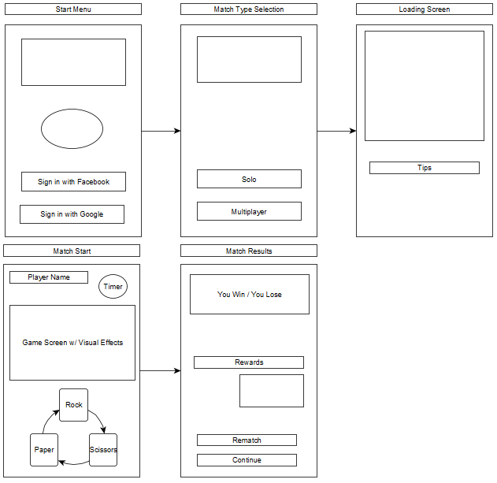

Mockup for Rock, Paper, Scissor Game

