IT2607 – NET TECH 2
05 Laboratory Exercise 1: Design a VPC
Name: Ryven Revina | Section: BSIT 411
Course: Net Tech 2 (IT2607) | Date: October 19, 2026

VPC Architecture Diagram
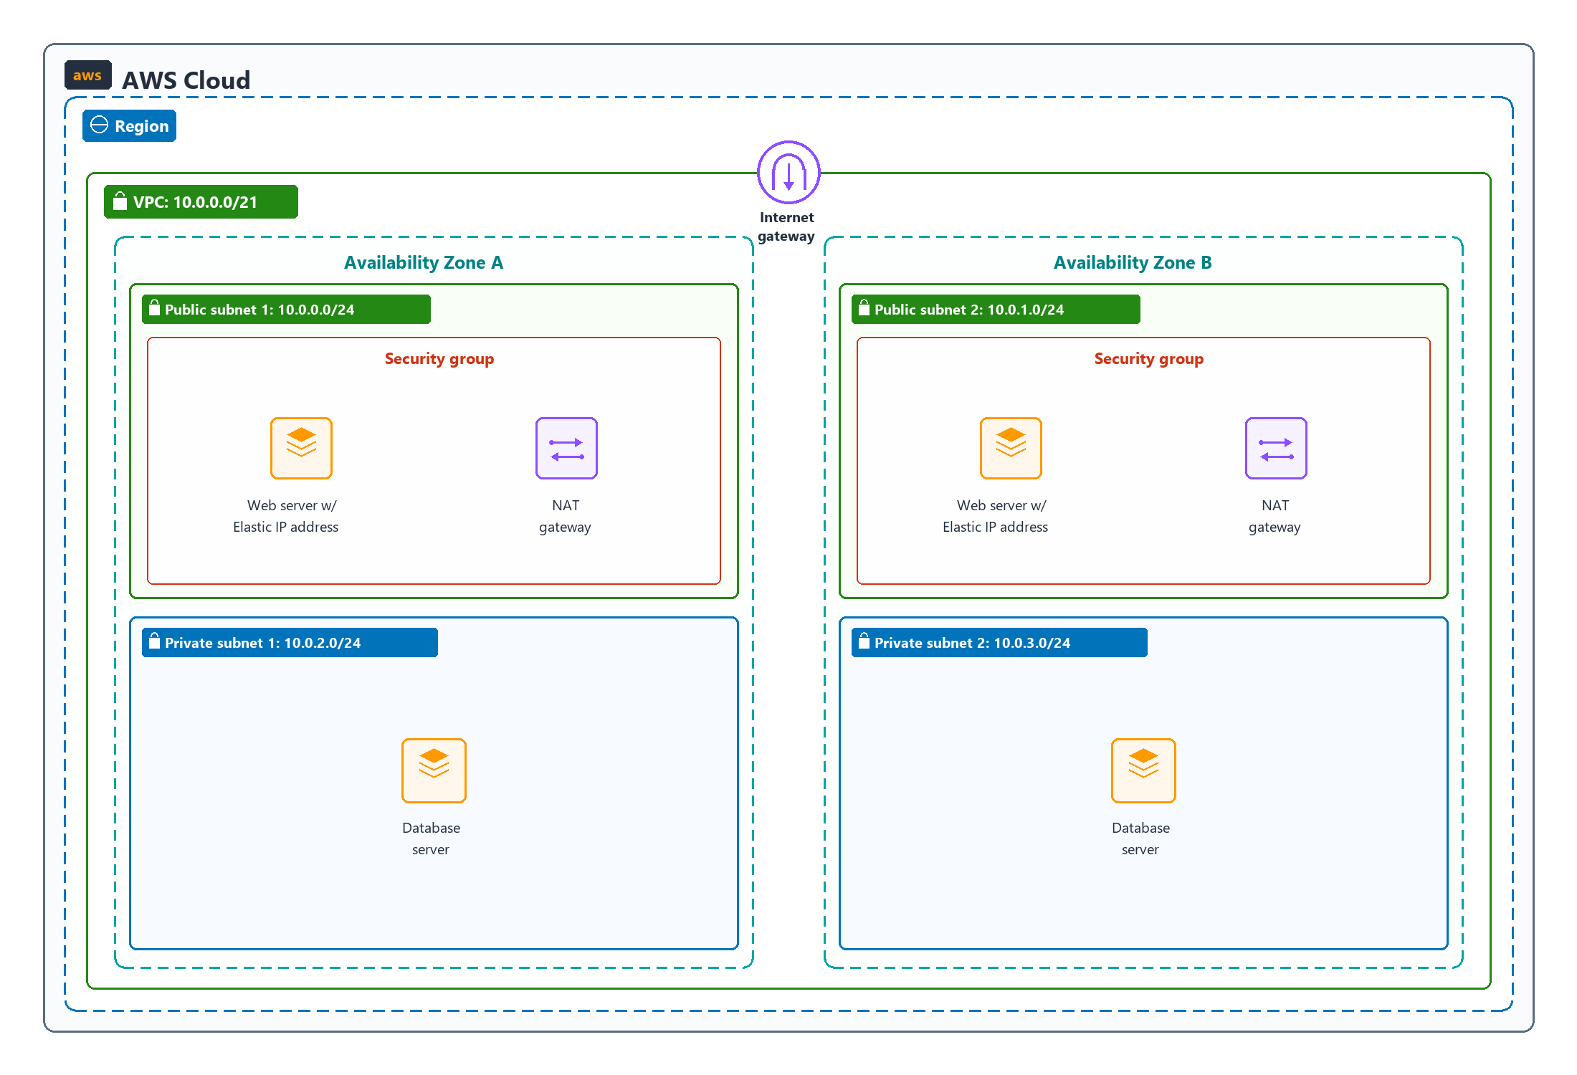
Brief Architecture Explanation
• Separation of the web server and database server: The web servers are placed in public subnets so people on the internet can visit the website. The database servers are placed in private subnets with no direct internet access to keep customer data safe. Only the web servers are allowed to talk to the database.
• 256 total IPv4 addresses per subnet: Each subnet uses a /24 size, which gives exactly 256 total IP addresses per subnet. Starting from 10.0.0.0, the subnets are: Public Subnet 1 (10.0.0.0/24), Public Subnet 2 (10.0.1.0/24), Private Subnet 1 (10.0.2.0/24), and Private Subnet 2 (10.0.3.0/24).
• Customer access to the web server: Customers can open the website through the Internet Gateway. Each web server has an Elastic IP (a permanent public IP address) and a security group that allows normal web traffic (HTTP and HTTPS) from anywhere.
• Internet access for database patch updates: A NAT Gateway is placed in the public subnet. When the database server needs to download software updates or patches, it sends the request out through the NAT Gateway. The NAT Gateway allows the database to go out to the internet, but blocks outsiders from coming in.
• High availability and custom firewall protection: High availability means the servers are copied across two Availability Zones (AZ A and AZ B). If one zone goes down, the other zone keeps working so the website never stops. For firewall protection, security groups act like virtual guards that let public visitors reach only the web servers while keeping the database hidden.

