

Vendasta Services
2025 Website & SEO Services Process Guide

Section 1: Website Import & Support
Website Imports
Website Support
Google Workspace Set Up
Inbox Pro Enablement

Section 2: Search Engine Optimization
SEO Standard
SEO Monthly (PRBS only)

Section 1: Website Import & Support

Website Import & Support
The project steps and assignees are as follows
- Send Confirmation Email
  - Client Engagement Admin
- Domain & Back-End Access Received
  - Client Engagement Assignee
- Vet Websites
  - Website Support Specialist
- Send Import Approval/Rejection Email
  - Drafted by Website Support Specialist
  - Sent by Client Engagement Assignee.
- Add-Ons Activated
  - Website Support Leadership
- Complete Website Import
  - Website Support Specialist
- Adjust DNS Records
  - Website Support Specialist
- Publication Email Sent
  - Client Engagement

Admin/Client Engagement Steps
- Send Confirmation Email - The Admin team will send the Order Confirmation email to the contacts listed on the order form to confirm we have received the request to vet the website to be imported and/or supported.
- Domain & Backend Access Received - Communications will check to see that we have received Domain and WordPress backend login credentials and that they are valid.
  - If not, please follow up with the client/Partner to ensure the correct credentials are received.
    - Once we have the credentials send the Websites - Import Vetting Receipt macro to the client with the due date of 2 business days.
    - The ticket should be assigned to Website Support as On-Hold with a due date of two business (M-F) days from the time we receive the credentials.
Note: If we have the WordPress Admin credentials, we can begin the process without the domain credentials. These can be obtained later in the process
  - The website support team will respond to the email with a confirmation if we can support the website or not. Send the information to the partner/client with the update.
    - IF THE WEBSITE IS REJECTED - please ensure all tasks in the project are closed.
    - IF THE WEBSITE IS APPROVED - assign the ticket back to MS Website Support with following info:
      - Internal Notes - with the following info PID/SMB/AGID/VTM
      - Due date - 3 Business Days
      - Website Support Tier - Import
      - Status - ON HOLD
    - The ticket will be reassigned to you when the import has been completed.

Website Support Steps
Note: the development of the site should be done in the Production environment unless there is a branded domain connected.

- Vet Website - Within 2 days of receiving the domain and WordPress credentials from the partner or client, Website Support will log into the site to be Imported and/or supported by the team and check to see (vet) if it is indeed a site we can support or not.
Vetting a Website for Import and Support.
  - The following points would be what you should check to verify if a site would be eligible for import.
    - Themes - check the theme to ensure that it is not a custom coded theme because they use sections that have to be custom created. Adding to those pages becomes problematic due to HTML, CSS issues as well as taxonomy issues.
    - Ensure that the theme is up to date - typically within 6 months to a year.
    - Plugins - ensure that plugins are up to date usually within the last 6 months to a year. Older versions could cause issues within the site if they have not been updated and the functionality may not be intact once it is updated.
    - ACF (Advanced Custom Fields) - we actively try to avoid sites with these. Updating the plugins, especially on older versions, can cause issues with functionality.
    - Multiple website builders - this will cause issues with the pages as many of these will leave code in the backend of each page that should have been deleted and again will cause issues with functionality.
  - If Yes - Proceed with the rest of the steps.
    - In Zendesk, Support Specialists reply to the Vetting Process email thread with an internal macro which includes the website URL and license keys.
  - If No - Send Approval/Rejection Email, rejecting the Import. Please provide the reason to the client/Partner for the rejection of the import and/or support.
    - Close out the rest of the tasks
- Send Import Approval/Rejection Email - Using the Macro in Zendesk "Websites - Website Vetting Reject/Accept". Keep the red portion of the macro for rejected imports and the green portion of the macro for accepted Imports. Make sure the approval or rejection is updated in VTM.

Hey [Name],

We have reviewed the website <URL> for import and we <are/are not> able to import & support this site.

<Choose for rejected import>
Reason for Rejection:

Please note that we do offer website rebuilds and that is our recommendation at this time.

<Choose for accept import>
We are excited to begin importing your website. Your site will be imported within 3 business days, <due date>. We have activated the Website Support add-on product and Website Pro on your behalf to begin the import process.

If you have any questions, please do not hesitate to reach out!

Please note: in order to keep communications organized, please use this email thread only. It will help prevent the loss of content from you and your team and also ensure we don't miss anything on our end as well.

Thank you!

- Add-Ons Activated - The following add-ons/products need to be activated upon approval of website Import.
  - Website Import (Add-on)
    - This is the $200 set up fee, a one time charge.
  - Website Support+
    - This is $30/month Support SKU. There is a 3 month commitment
  - WordPress Hosting | Pro
- Complete Website Import
  - Log into the website on the external Hosting Platform. DO NOT UPDATE PLUGINS OR THEMES!
  - Open the PlugIns and install and activate WP All-in-One Migration Plugin. (You may also need to install the WP All-in-One Unlimited Extension depending on the size of the website)
  - Open up WP All in One Migration and select the option to export.
  - When you select Export - Select Advanced Options. Select the option "Do not replace email domain"
  - Export To >> Select File
  - Open the account in WordPress Hosting Pro from Partner Center.
  - Keep the domain and title information as default (unless domain is unavailable)
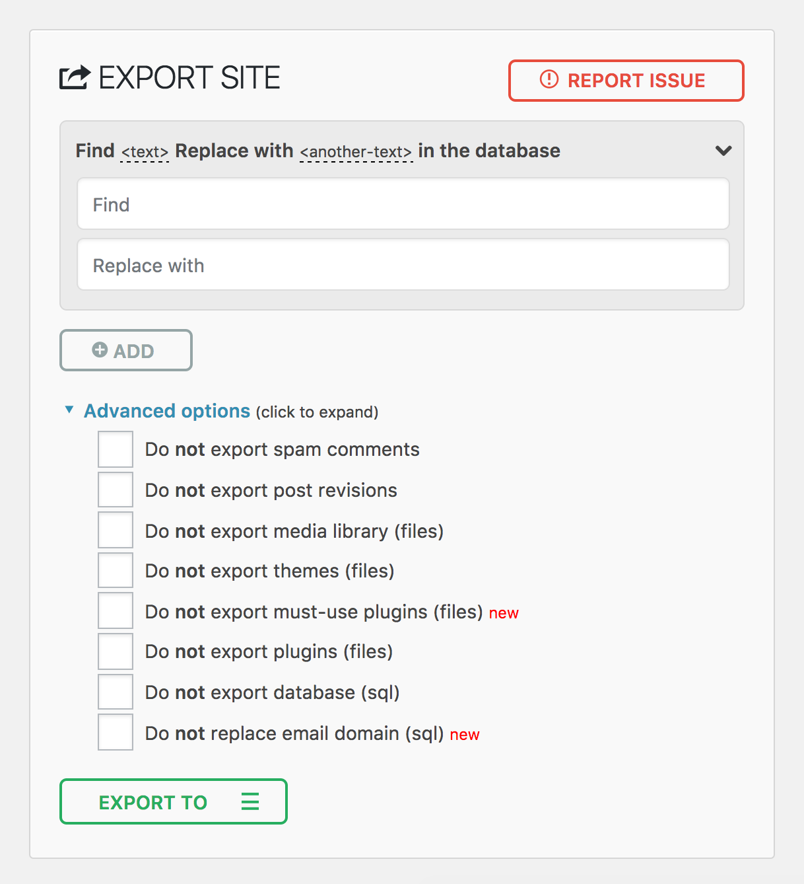
  - Select blank template - Wait for WordPress to install.
  - Open up WordPress Dashboard
  - Under PlugIns, Install WP All in One Migration. (Ignore if it is already installed).
  - If the plugin is asking for the Unlimited version of All-In-One, then Click Here
  - Select Import and choose the file you exported from the old hosting.
  - Update themes, plugins, and WordPress Core.
  - Review the website and ensure all links and functionality are working.
  - In the footer, ensure that the name of the Agency has been changed to the new Agency that has had the site imported along with the link to the new Agency.
- Adjust DNS Records - Once we have received approval from the Partner, adjust the DNS settings to the values in the chart below to push the site live.
  - A Record
    - @ - 34.149.86.124
  - CNAME
    - Www - https://host.websiteprohosting.com
  - In the Website Pro dashboard, select Domains
  - Connect a Domain
    - Add Domain - Check the box to include www and add domain
  - Once the domains populate, set the primary domain to the custom domain without the www
- Publication Email sent - Select the Website Import Completed (a white label version is available for Partners with White/Grey Label emails), update, edit, and send.
  - Send the ticket to the QA Specialist and close out all tasks in the VTM project after the notes have been made.

Note: If the WebsitePro is deactivated for more than 3 months the site can't be retrieved if the instance is activated once again. We can restore the website after deactivation of WebsitePro in 365 days but it will require 1x hour for reimport on a new instance of WebsitePro.

FindLaw Imports *Must be approved by Management
In the case of an import that has been previously hosted on the website FindLaw (the only PID approved to import these sites is HV68 - Capstone Marketing, all other PIDs must receive approval from Website Support leaders to proceed)

- The files for these websites will be provided to us and must be imported uniquely.
  - Install a local instance of WordPress on your computer.
  - Add WP Prime Mover to the WP instance.
  - Import the website into the local instance of WordPress on your device.
  - Remove WP Prime Mover as this plugin is not compatible with Website Pro
  - Install the All-In-One Migration and Unlimited Plugins.
  - Export the website from the local instance using All-in-One
- Once exported using All-in-One, we can proceed with standard import steps to bring the website into Website Pro.
  - While the website is being imported, we will receive a list of plugins that are no longer present on the website, please make note of these in the Capstone Marketing Import Checklists document under the Audit Plug-Ins after Import.
- Once this initial import is completed, Client Engagement will communicate the turnaround time to the Partner as determined by the website support team and approved by the Website Support Manager. The typical turnaround time on these websites is about 10 business days.
- Once turnaround time is communicated to the Partner, the work can begin. Please refer to the Capstone Marketing Import Checklist for tasks to be completed and checked over.
  - Contact Forms need to be rebuilt in Gravity Forms
    - Recaptcha needs to be added to the form
    - The form needs to be tested to confirm they are sending to the correct email address.
  - Header & Navigation
    - Check that all links in the Navigation are correctly pointing to the appropriate pages.
    - Rebuild the side menu bar on the services pages
    - Confirm Logo & Favicon are displaying correctly
    - Ensure the correct phone number is showing at the top of the page.
  - Footer
    - Add the provided disclaimer to the footer (see Checklist)
    - Change the copyright information
  - Plugins
    - Complete a plugin Audit and let the Partner know any plugins that need to be repurchased.
    - Install Divi Blurb Extended Plugin (For Capstone sites, all other PIDs need to purchase this plugin). The file is linked in the checklist.
  - Website Edits
    - Audit each page on the website and ensure that links are working.
    - Ensure all Social Media is linking to the correct page
    - Replace missing images
  - Add Privacy Policy Page
  - Delete user access from Thomson Reuters emails
  - Update Blog author to admin
    - Update blog pages (check links and images)
  - Check the content and replace the Phone and firm name with the correct information
  - Ensure the appropriate Meta Titles and Descriptions are showing. Please pay attention to the phone number listed.
- Once this work is completed, assign the website to Support QA to check over before sending it back to Client Engagement.
- When we receive the green light, push the website live.

Imports with Website Files
For websites where we are not able to gain backend admin access to vet the site for import and support, we can vet the site via a file. Depending on the file type we typically charge 1x Hourly Charge for the work needed to vet a site this way.

- There are typically two types of files that we can use to vet a site for import and support.
  - All-in-One files (.wpress) - These files can be imported into Website Pro.
    - If we can support the site, proceed as per normal. There is no need to charge the additional hour.
    - If we cannot, let the partner know that we will not be able to support the site. We need to charge 1x hourly charge as the site was imported and that work was completed.
  - BackUp Files (.zip, .tar.gz)
    - These imports are more complicated and all websites vetted this way regardless of whether we can import them need to have 1 hour charged.

Website Support
Website Support Requests are divided into three tiers, based on the type and complexity of the task. The Tier that a task is assigned to determines the time it takes to complete the request. A Website Support leader must approve any task/request that is urgent and requires a same-day turnaround.

Tier | VTM Task Name | Turnaround Time | Types of Requests | Examples
Tier 0 | Website Support Request T0 | Immediate/Same Day | Quick & basic website support requests | Photo changes  Colour changes  Button updates
Tier 1 | Website Support Request T1 | 1 Business Day | Basic Website Support Requests | Basic Requests, changes & updates  Information updates  Website Down  Uploading Blogs  Pushing websites live**
Tier 2 | Website Support Request T2 | 3-5 Business Days | Lengthy requests that include multiple edits | A large number of edits  Requests that will take longer than 30 minutes  Adobe XD or Markup files  Documents with edits
Tier 3 | Website Support Request T3 | 3 Business Days | Technical Requests | Integrations  Changes to website functionality  Plugins  Hourly Charges  Email Issues  Analytics & Indexing Concerns
**Note about pushing websites live: DNS records should not be adjusted any later than 2:00 pm CST Monday to Thursday or noon on Fridays. This is due to possible delays in the generation of SSL certificates which causes the website to go down until the SSL is generated in Website Pro.

We strongly recommend against pushing sites live after noon on Fridays as if an issue does arise with setting the site live, there will not be anyone available to troubleshoot the problem until Monday morning.

Process Guide for Client Engagement
- When a website support request is received, please compose a response to the Partner or SMB using the Website Support Request macro in Zendesk.
  - This email needs to summarize the support request to the client to confirm the desired website edits to be completed.
  - This ticket is to remain in the Client Engagement assignee’s queue as pending with a due date of 1 - 5 days, depending on the type of request.
- Open the Website Build project in VMKA and add a task labeled:
  - Website Support Request T1
  - Website Support Request T2
  - Website Support Request T3
*This wording must be EXACT, including capitalization and spacing for tracking purposes.
- Create a new task in VTM (Vendasta Task Manager
  - Fill in the following information:
    - List of edits or work requested
    - Main Zendesk ticket number (this is the Zendesk ticket from step 1)
  - Assign the ticket to the Website Support in VTM using the following settings:
    - Service Category: Website Support
    - Service Level: (Verticals/Agency/High Velocity)
    - Classification: Support Request
    - Type: Task
    - Due Date:
      - For Tier 1 requests it should be the next business day.
      - For Tier 2 & 3 requests the due date should be 3 business days from today’s date.
    - Website Support Tier: This should match the VTM task
  - Submit the Internal ticket as:
    - Tier 1 - On Hold
    - Tier 2 or 3 - Open
      - These requests need to be reviewed by website support to determine if any additional time or hourly charges are needed to complete the request.
- Add an internal note to the main ticket thread referencing the submitted internal Website Support ticket number. The main ticket and internal ticket should both have the same due date as the VTM task.

Process Guide for Website Support Specialists
- Review all tickets assigned to you to ensure you have everything necessary to complete the request changes.
- Tickets should be completed in the following order:
  - Imports
  - Tier 2 & 3 tickets (these have been sitting for up to 3 days and need to be addressed and sent out as soon as possible)
  - Tier 1 tickets (These are the easiest to get help with from other teams if we are back logged and should be left for last.)
- Tier 1 Requests
  - Due 1 business day after the request was received
  - Once the request is completed, send the ticket to the QA team member for review.
  - Make sure the information from the request has been logged in the website support QA tracking sheet.
- Tier 2 Requests
  - Due 3 business days after the request is received
  - Once the request is completed, send the ticket to the QA team member for review.
  - Make sure the information from the request has been logged in the website support QA tracking sheet.
  - Follow-up questions do not need to be QA’d if there are no edits associated with them.
- Tier 3 Requests
  - Due 3 business days after the request is received. Review these requests to ensure we are not missing any assets or information. If we cannot deliver by the due date, please let client engagement know immediately with the updated completion date.
  - Once the request is completed, send the ticket to the QA team member for review.
  - Make sure the information from the request has been logged in the website support QA tracking sheet.
  - Follow-up questions do not need to be QA’d if there are no edits associated with them.

Process Guide for Website Support Quality Assurance Team
- Tickets are assigned to Quality Assurance Specialists after they are completed by the Website Support team members. Please ensure that ticket information was entered into the Website Support Quality Assurance Error Log.
- Review the requested edits and check them against the live site to ensure they have been completed as requested.
  - If there is any discrepancies please log them in the QA Error Log to ensure they are tracked and reassign the ticket to the Specialists who completed the work.
  - If there is not errors, assign the ticket back to the Client Engagement Assignee as open.
  - If there are any issues found unrelated to the requested edits, please update client engagement with a request to reassign the ticket back as a T1 or T3 request with the appropriate due date and a VTM task created.

Posting Blogs
Blog Written by: | Website Hosting: | Website Support | Do We Post?
Vendasta Services | WordPress Hosting | Active | Yes
Vendasta Services | WordPress Hosting | Not active | Yes
Vendasta Services | Vendasta Services Duda | Active - All Duda sites have Support | Yes
Vendasta Services | External Hosting | Channel Partner - No Support | No*
Vendasta Services | External Hosting | Direct / Broadly - External Support Active | Yes
Partner / Client | WordPress Hosting | Active | Yes
Partner / Client | WordPress Hosting | Not Active | No
Partner / Client | External Hosting | Channel Partner - No Support | No
Partner / Client | External Hosting | Direct / Broadly - External Support Active | Yes
- For any situation where we do not post, but Vendasta Services is the author of the blog, Custom Request can be activated as an add-on to the Blog Product for posting. This can be monthly recurring or one-time.
- For Blogs written by partners or clients, we will post up to 3 for sites with active Website Support at no additional cost. After 3 blogs, additional costs may be incurred.

Google Workspace Set Up

Setting up the Google Workspace
- Ensure to check in products if the Google Workspace is ordered under that AGID.
- Click on kebab inline with Google Workspace, then click on “Launch”.
- A new window will open with the Users tab.
- If no users are added, check the request received for following emails to setup.

Setting up the Users in Google Workspace
- Select the Business Center User, if a specified user is selected.
- Enter the first and last name as per the partner/client shared.
- Enter the email address without a domain.
- Enter a recovery email address. (This is used for password recovery. Provide an email address that is not on the Google Workspace domain)
- Send reset password email to Business Center user.

Setup Google Workspace
- Verify Domain - Verify domain using TXT record, by adding the record to the domain.
- MX & TXT Record: Enter MX record for Google Workspace to send/receive emails.
DNS Record Type: MX
Host: @
Value: SMTP.GOOGLE.COM

DNS Record Type: TXT
Host: @
Value: v=spf1 include:_spf.google.com

- If you would like to migrate the data from One Google Workspace to another then, you will have to activate “Google Workspace Transfer” and then follow the steps as per the product.

Configuring Settings
- Single Sign-On (SSO): When active, allows Google Workspace users to access the product via Business App.

Inbox Pro Enablement
*This product is fulfilled by the Automations team, however, Websites may need to provide support with this process from time to time.

Setting up the web chat
- Ensure you have access to the backend of the site, either with credentials sent from the SMB, or through Website Pro.
  - Please note that Website Pro is NOT required to add the Web Chat.
  - If you do not have access, reach out to client engagement to gain access and do not move forward with the following steps until access is received.
  - Continue to reach out and add notes in the VTM project each time you reach out.
- Navigate to Partner Center and select the desired account.
- Ensure Inbox Pro and Inbox Pro Enablement are active under the Products section.
  - Products that do not require the activation of Inbox Pro and Inbox Pro Enablement:
    - Agency Website SKU - see full instructions here
    - Amazon Sponsored Display Ads
- In the top bar, click the Open In button and choose Business App.
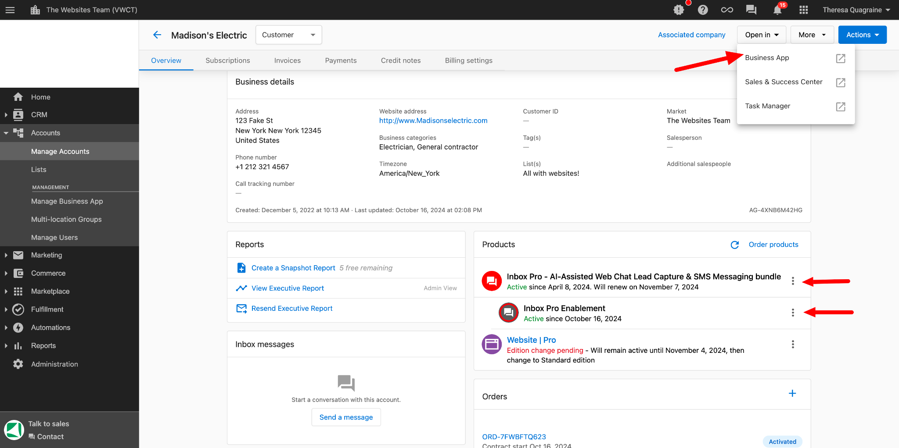
- In the Business App, click Settings and select Inbox Settings.
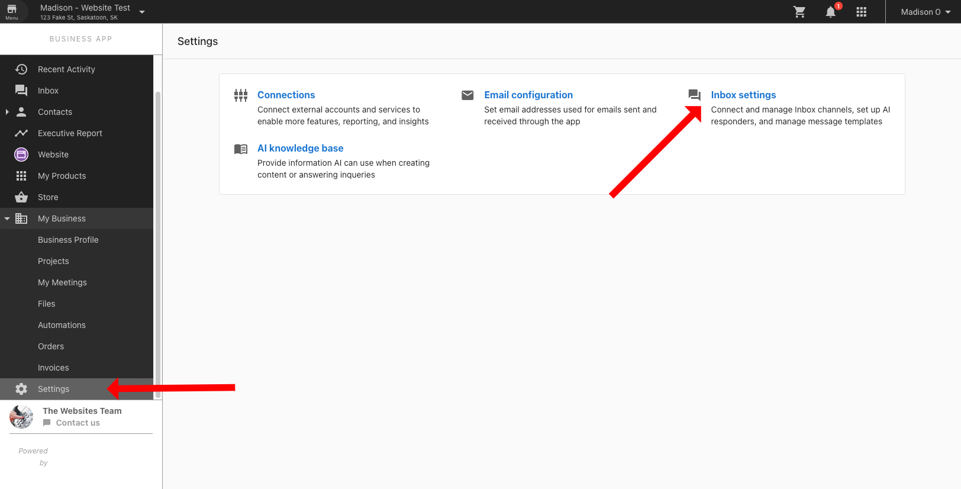
- Scroll down to the Web Chat section and click Setup Web Chat.
- Enter in the Widget Name. Note that this is used internally only and the default is “Web Chat”.
- In the AI Assistant section, ensure that the Business Profile is selected. This is where majority of the information will be pulled from. See the Business Profile section below for further instruction on what should be set up there.
  - Click in the Add Knowledge text box and click the Add New Knowledge button.
    - Select the Website option to pull the information from the SMB’s website.
    - Enter the URL and business name, then select Follow Links in the Mode dropdown. It is important to select this option so that all pages on the site are crawled.
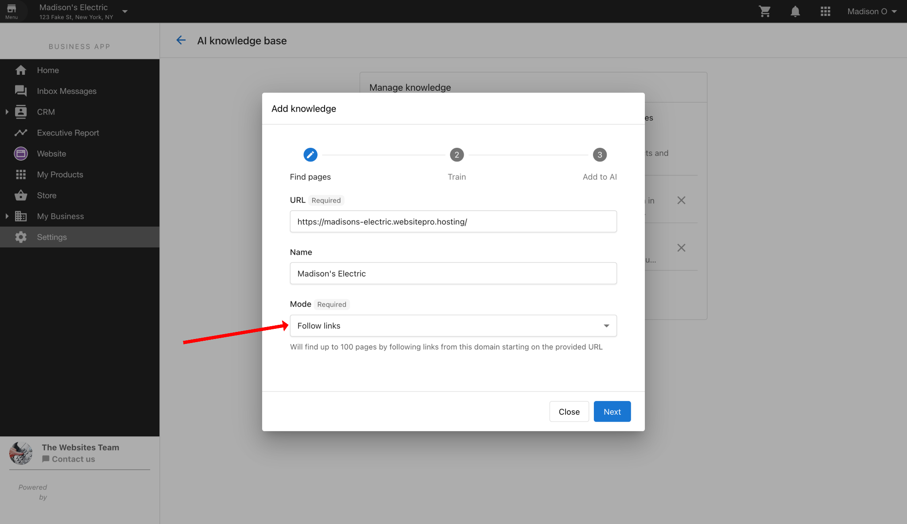
    - Click Next.
    - After it finishes finding all of the pages, you will click in the Choose Applications text box and select the web chat that you have set up in the previous steps.
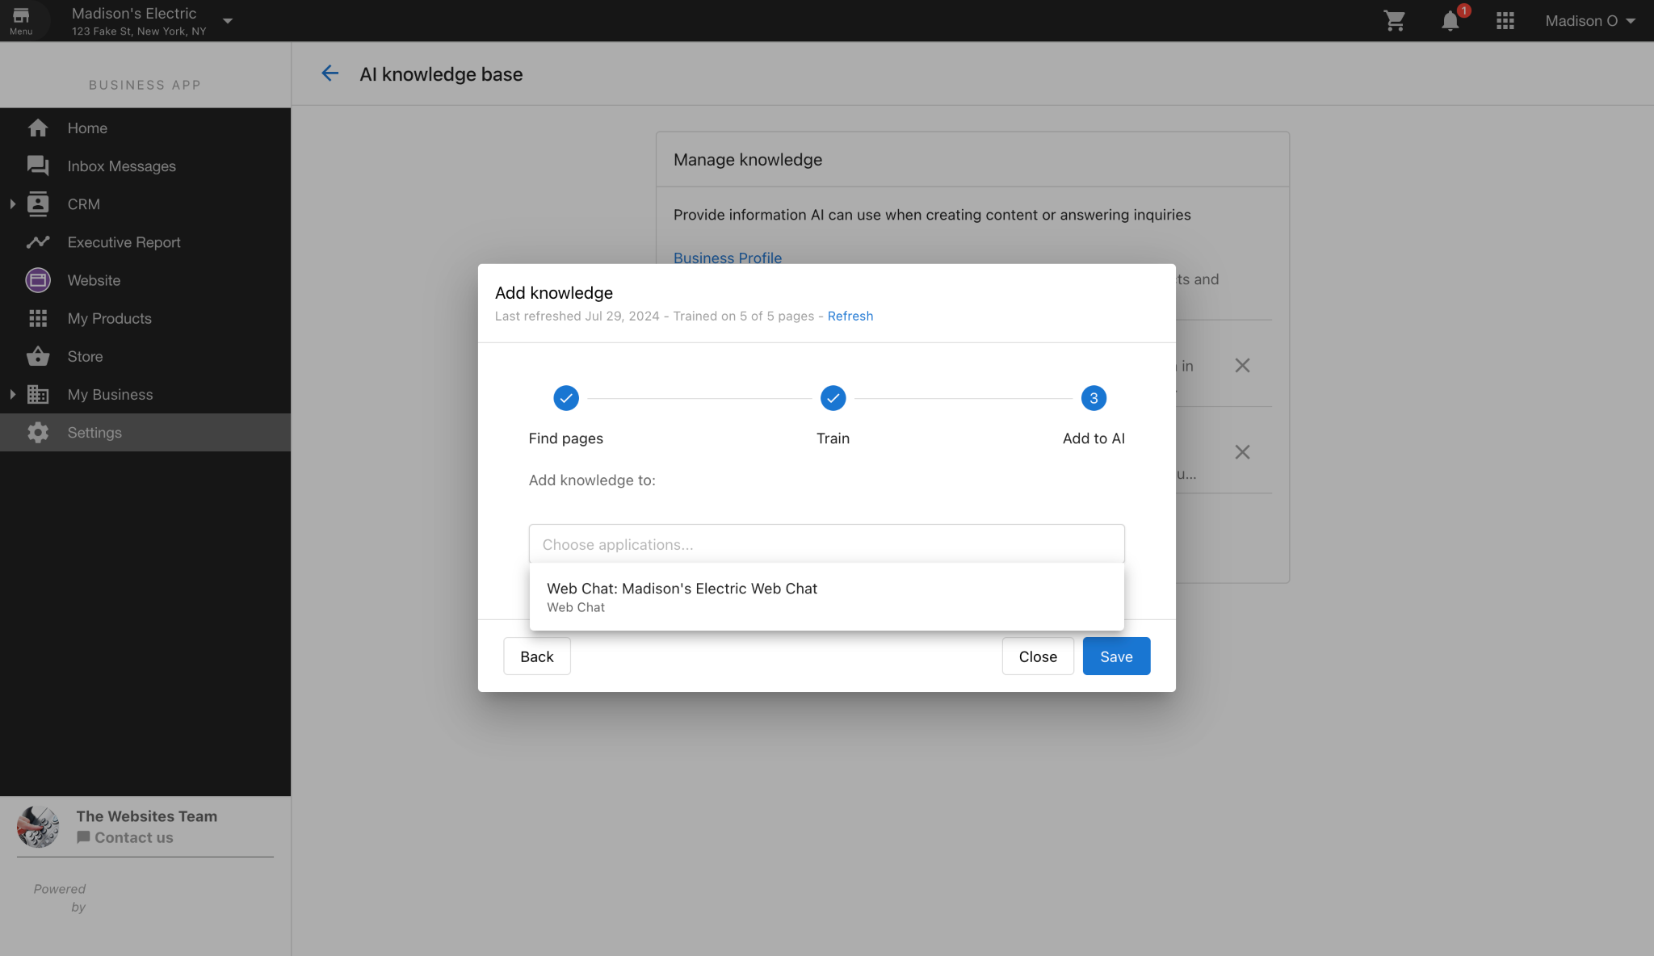
    - Hit Save.
- Enter in the Web Chat Greeting, or leave this blank for the default greeting. This message will appear when a customer first opens the web chat window.
  - Ex. “Welcome to Madison’s Electric. How can I help you today?”
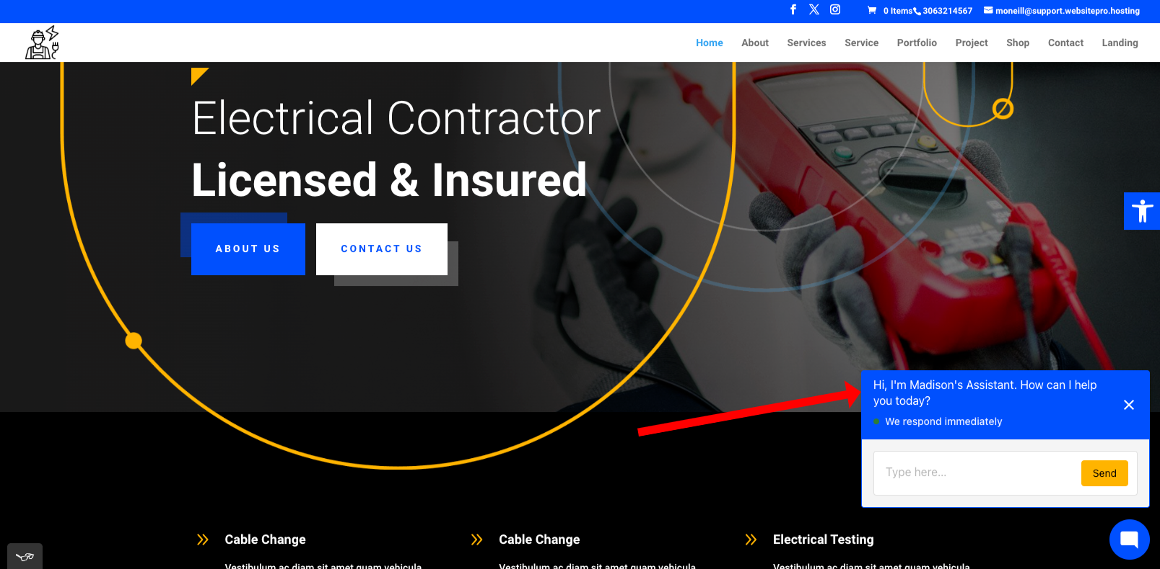
- In the Appearance section, change the color and text colors to reflect the branding on the website. Ensure that you choose the most readable color for the text (light text on dark backgrounds or dark text on light backgrounds).
- Click Next.

Installation Settings:

For Amazon Ads only:
  - Click Google Tag Manager and copy the Javascript code provided.
  - Click Save.
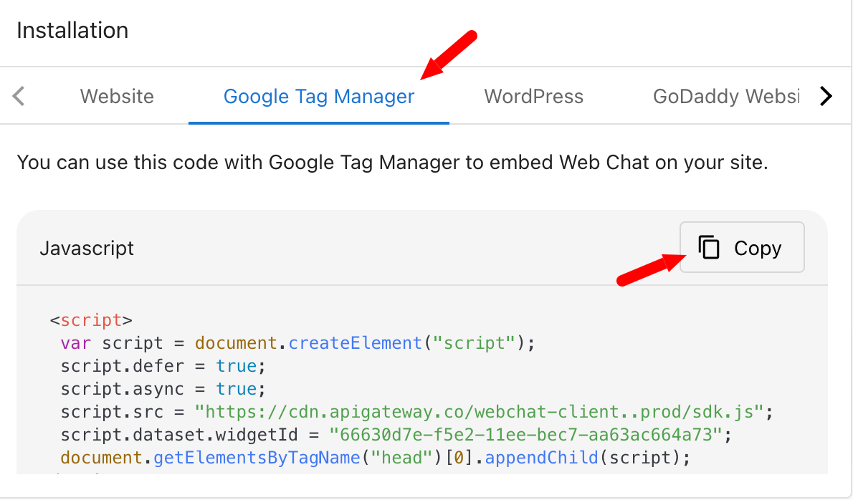
  - In the VTM project, open the document linked in the Project Description section and paste the Web Chat code inside.
  - The GTM code to be added to the website will be added in this same document.
    - If it is not already in here, please let the Client Engagement team know to reach out to the Ads team.
  - Log into the backend of the SMB’s site, either through login credentials provided or through Website Pro.
  - Paste the GTM code provided by the client/partner or Ads team in the head and body of the site as specified.
  - Save the pages.

For Inbox Pro Enablement or a Website SKU:
  - Click Website and copy the Javascript code provided.
  - Click Save.
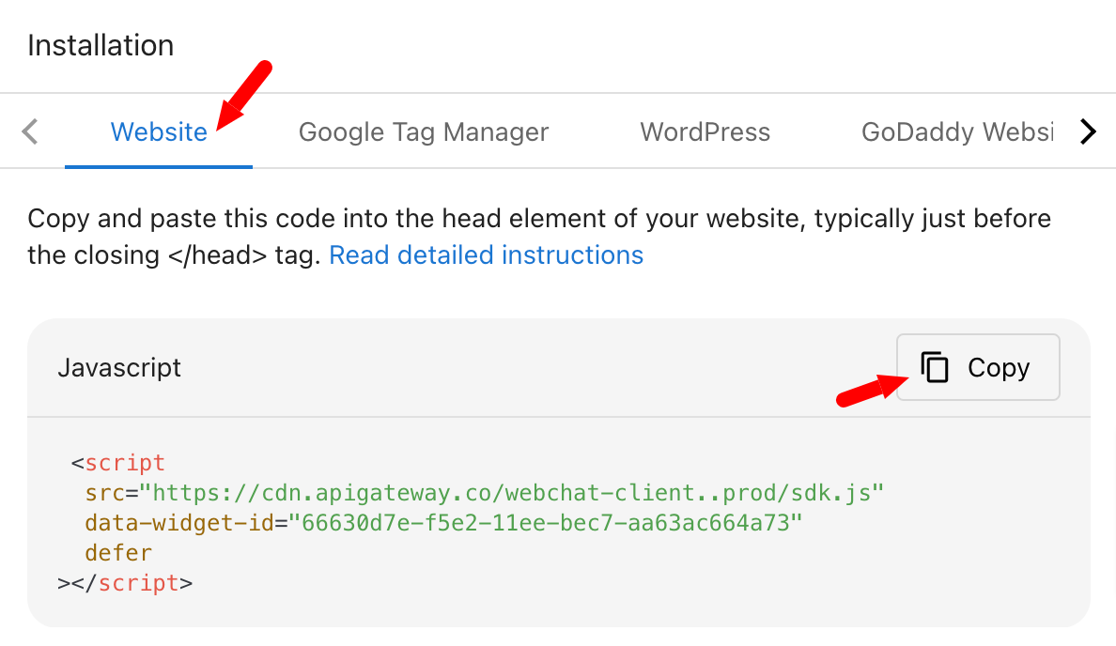
  - Log into the backend of the SMB’s site, either through login credentials provided or through Website Pro.
  - Install the copied code and paste it to the head of all pages. Instructions for this will vary depending on how the site is built.
  - Save the pages.

Business Profile Information:
- In the Business App, click My Business > Business Profile. (This can be edited in account in Partner Center as well)
  - Ensure at least the following is filled out:
    - Primary Info
      - Business Name
      - Primary Category
      - Phone Number
      - Address and/or Service Area
      - Services Offered
    - Hours
      - Hours of Operation
    - Descriptions
      - Short Description
      - Long Description
      - ** If these are not filled out, generate them with AI using the Suggest Description button or by pulling some information from their website.
    - Social
      - Any business pages as necessary
  - Save any changes that you have made.
  - If any information in Step 1 is not filled out, flag this with the client engagement team to request the partner to fill it out.

Setting up Inbox Pro in Partner Center
- Ensure you have access to the backend of the site, either with credentials sent from the partner, or through Website Pro.
  - Please note that Website Pro is NOT required to add the Web Chat.
  - If you do not have access, reach out to client engagement to gain access and do not move forward with the following steps until access is received.
  - Continue to reach out and add notes in the VTM project each time you reach out.
- Navigate to Partner Center and select the desired account.
- In the top bar, click the Inbox icon.
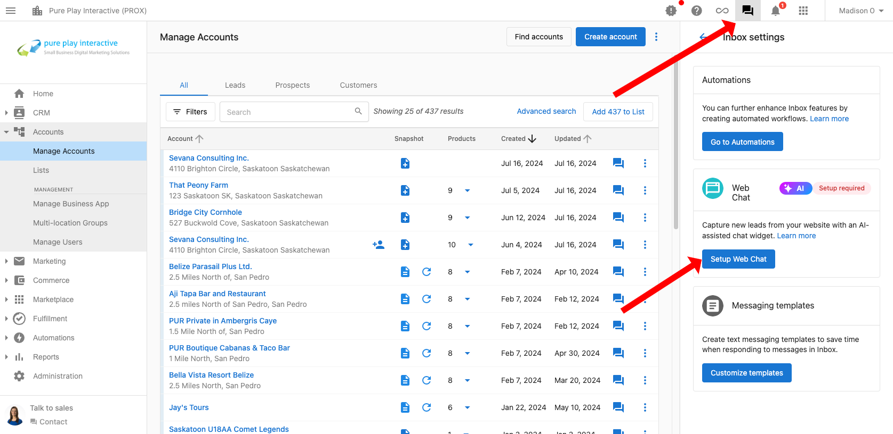
- Click the Settings icon.
- Scroll down to the Web Chat section and click Setup Web Chat.
- Enter in the Widget Name. Note that this is used internally only and the default is “Web Chat”.
- In the AI Assistant section, ensure that the Business Profile is selected. This is where majority of the information will be pulled from. See the Business Profile section below for further instructions on what should be set up there.
  - Click in the Add Knowledge text box and click the Add New Knowledge button.
    - Select the Website option to pull the information from the SMB’s website.
    - Enter the URL and business name, then select Follow Links in the Mode dropdown. It is important to select this option so that all pages on the site are crawled.

    - Click Next.
    - After it finishes finding all of the pages, you will click in the Choose Applications text box and select the web chat that you have set up in the previous steps.

    - Hit Save.
    - Note: if the website is already added as a knowledge area, please ensure that the Mode is set to Follow Links and then refresh the data.
- Enter in the Web Chat Greeting, or leave this blank for the default greeting. This is the message that will appear when a customer first opens the web chat window.
  - Ex. “Welcome to Madison’s Electric. How can I help you today?”

- In the Appearance section, change the color and text colors to reflect the branding on the website. Ensure that you choose the most readable color for the text (light text on dark backgrounds or dark text on light backgrounds).
- Click Next.

Installation Settings:

For Amazon Ads only:
    - Click Google Tag Manager and copy the Javascript code provided.
    - Click Save.

    - In the VTM project, open the document linked in the Project Description section and paste the Web Chat code inside.
    - The GTM code to be added to the website will be added in this same document.
      - If it is not already in here, please let the Client Engagement team know to reach out to the Ads team.
    - Log into the backend of the SMB’s site, either through login credentials provided or through Website Pro. Refer to this document on how to implement the GTM code to different platforms.
    - Paste the GTM code sections in the head and body of the site as specified.
    - Save the pages.

For Inbox Pro Enablement or a website SKU:
    - Click Website and copy the Javascript code provided.
    - Click Save.

    - Log into the backend of the SMB’s site, either through login credentials provided or through Website Pro.
    - Install the copied code and paste it to the head of all pages. Instructions for this will vary depending on how the site is built.
    - Save the pages.

Business Profile Information:
- In the Business App, click My Business > Business Profile. (This can be edited in account in Partner Center as well)
  - Ensure at least the following is filled out:
    - Primary Info
      - Business Name
      - Primary Category
      - Phone Number
      - Address and/or Service Area
      - Services Offered
    - Hours
      - Hours of Operation
    - Descriptions
      - Short Description
      - Long Description
      - ** If these are not filled out, generate them with AI using the Suggest Description button or by pulling some information from their website.
    - Social
      - Any business pages as necessary
  - Save any changes that you have made.
  - If any information in Step 1 is not filled out, flag this with the client engagement team to request the partner to fill it out.

Next Steps
Check out the Ways to upload the GTM/chat widget codes for different platforms

Section 2: Search Engine Optimization

SEO Standard
Month One
Complete Admin Work
Completed by Client Engagement
- Review and organize all client-provided materials.
- Set up initial project files and folders.
  - This should be created as a subfolder within the SMBs Website file folder.
- Confirm receipt of necessary access credentials.
  - Based on responses to the Fulfillment form answers.
Audit Fulfillment Form
Completed by Client Engagement
- Review the fulfillment form for completeness.
- Validate the provided information against project requirements.
- Note any discrepancies or missing information for follow-up.
Schedule Consultation Call
Completed by Client Engagement
- Coordinate with the client to find a suitable time for the call.
  - Offering two times for the partner to choose.
- Send a calendar invitation with the meeting details.
- Prepare an agenda for the consultation call.
Send Confirmation Email
Completed by Client Engagement
- Draft a confirmation email to the client.
  - Use macros as a starting point.
- Outline the next steps in the process.
- Include the Consultation Call link.
  - Once a call time has been selected
- Send the email and log the communication in the VTM project.
Perform a Competitive Analysis
Completed by SEO Specialist
- Identify key competitors in the client’s industry.
  - Using keywords from Google and SEMRush, identify the competitors based on results. Look at the industry and specific services offered based on location when selecting these competitors.
  - Making sure that we are targeting the correct geo location.
  - Making sure we are using Google and Bing to confirm the competition suggested by SEMRush
- Analyze competitors' SEO strategies, including keyword usage and backlink profiles.
  - Information can be pulled using SEMRush.
- Compile findings into a competitive analysis report.
  - Include in the Onboard slide deck.
Audit Client's Website
Completed by SEO Specialist
- Conduct a thorough audit of the client’s website.
  - Load website in pagespeed.web.dev (USE INCOGNITO WINDOW!)
  - GTMetrix or Chrome Development Tools can be used as an alternative, however, the slide deck should feature the Google Pagespeed data. Make sure there is no contradicting information.
- Review technical SEO elements such as site speed, mobile-friendliness, and security.
  - Check mobile on a smart phone if possible or use browser stack.
  - Check website user interface & user experience
  - Review on page content
    - Chrome Extension SEO Meta in 1 Click.
- Document findings and prepare an audit report.
  - Include website audit results in the Onboard slide deck.
  - Make notes for yourself in the Audit Client’s Website task in VTM to be addressed when the work begins post Consultation call.
Research & Finalize Keyword Set
Completed by SEO Specialist
- Conduct keyword research to identify relevant search terms.
  - Review website’s current content and look for keywords and conduct research on the keywords.
  - Using Google, Bing, and SEMRush to identify search volume, look at competitors, analyze competitors current keywords and use this data to establish initial set of keywords.
  - If Google Search Console or Bing Webmaster Tools are connected, you can review the search results there.
- Analyze search volume, competition, and relevance.
- Finalize the keyword set and document it for reference and consultation call deck.

Establish Baseline Rank of Keyword Set
Completed by SEO Specialist
- Use SEMRush to determine the current ranking of identified keywords.
- Record baseline rankings for future comparison.
  - Search volume and rank on both Google and Bing search engines.
- Create a baseline rank report.
Complete Consultation Call
Include both Client Engagement and SEO Specialist
- Conduct the scheduled consultation call with the client.
- Discuss findings from the initial audit and competitive analysis.
- Outline the next steps and gather client input.
Send Post-Consult Email
Drafted by SEO Specialist, Sent by Client Engagement
- Draft a follow-up email summarizing the consultation call in an internal ticket.
  - Include agreed-upon action items and timelines.
  - Send the ticket to Client Engagement.
- Send the email and log the communication in the project file.
Review Technical SEO Elements
Completed by SEO Specialist
- Conduct a detailed review of the website’s technical SEO elements.
  - Checking the site map, robots.txt, core web vitals, & canonical tags
  - Check for duplicate pages
  - Adding GSC, Bing Webmaster, GTM, etc
- Identify areas for improvement and document recommendations.
  - Making note of indexing issues, crawlability, internal linking and communicating to Client Engagement any info needed from the client.
- Create Google Analytics and add it to the website.
- Prepare a technical SEO review report.
Complete Website Performance Optimization
Completed by SEO Specialist
- Implement improvements based on the technical SEO review.
- Optimize site speed, mobile usability, and other performance factors.
  - Correct any responsiveness issues
  - Check lazy loading and rendering, improve where needed
  - Adding optimization plugins if necessary. (Smush Pro)
- Test the website to ensure optimizations are effective.
Review & Optimize Website Content
Completed by SEO Specialist
- Review existing website content for SEO best practices.
- Optimize on-page elements such as titles, meta descriptions, and headers.
  - Add keywords into Metadata and onpage content.
  - Focus on the 5 key pages.
- Enhance content with targeted keywords and relevant updates.
- Generate and edit first month’s blog.
  - Tag the Content Leaders in the VTM task to let them know the Edit Blog task needs to be assigned.
Create & Claim GMB Listing
Completed by SEO Specialist (If Support is needed reach out to Listings)
- Create or claim the client's Google My Business listing.
  - listings@yourdigitalagents.com (Michelle to get access to team)
- Complete the profile with accurate business information.
- Verify the listing and optimize it for local search.

Create & Claim Bing Listing
Completed by SEO Specialist (If Support is needed reach out to Listings)
- Create or claim the client's Bing Places for Business listing.
  - websiteanalytics@localmarketpage.com
- Complete the profile with accurate business information.
- Verify the listing and optimize it for local search.

Month Two
SEO Review Call
- Client Engagement to schedule and conduct a review call with the client and SEO Specialist.
- Discuss progress, performance metrics, and next steps.
- Document the meeting and update the project plan accordingly.
Generate and Review Monthly Performance Report
- Compile performance data from SEO tools and analytics.
- Generate a comprehensive performance report.
- Review the report with the client and discuss findings.
Review Off-Page SEO Assets and Provide Recommendations
- Analyze the client’s off-page SEO assets, including backlinks and social signals.
- Identify opportunities for improvement and provide recommendations.
- Document findings in an off-page SEO report.
Optimize On-Page Content
- Implement on-page content optimizations based on research and audit findings.
  - Ensure that the 5 key pages have appropriate keyword density and proximity.
- Ensure content aligns with targeted keywords and SEO best practices.
  - Make sure Metadata reflects the keyword set.
- Review changes for quality and effectiveness.

Month Three
Generate and Review Monthly Performance Report
1. Compile performance data from SEO tools and analytics.
2. Generate a comprehensive performance report.
3. Review the report with the client and discuss findings.

Optimize Technical SEO Elements
- Implement technical SEO improvements identified in previous reviews.
- Ensure all technical elements are optimized for search engine visibility.
- Optimize site speed, mobile usability, and other performance factors.
  - Correct any responsiveness issues
  - Check lazy loading and rendering, improve where needed
  - Adding optimization plugins if necessary. (Smush Pro)
- Test the website to confirm effective implementation of optimizations.

Months Four, Seven, & Ten
- Generate and Review Monthly Performance Report
  - Update competitors if any changes have occurred.
- Re-Evaluate keywords
  - Ensure they are still relevant to the business
- Research & Finalize Keyword Set
  - Conduct keyword research to identify relevant search terms.
  - Analyze search volume, competition, and relevance.
  - Finalize the keyword set and document it for reference.
- Ensure proper keyword density on page
- Post monthly blog

Months Five, Eight, & Eleven
- Generate and Review Monthly Performance Report
  - Review Analytics and ensure the accuracy of visuals.
- Quarterly SEO Review Call
- On-Page Content Audit
  - Identify areas to expand on relevant content
  - Audit the website for duplicate content, and rephrase or rewrite if found.
  - Ensure that the HTML Headers are reflecting
- Post monthly blog (if applicable)

Months Six, Nine, & Twelve
- Generate and Review Monthly Performance Report
- Review Off-Page SEO Assets
  - Review analytics and performance reports
  - Submit Sitemaps
- Optimize Technical SEO Elements
  - Check for Indexing Issues
  - 4xx, 5xx, 3xx errors and redirects
    - Look into any 404 errors
  - Ensure proper Canonicalization
  - Confirm robots.txt is present and working correctly
  - Confirm sitemap is updated
  - Review Meta Title and description tags, and update where necessary with relevant keywords.
  - Update up to 25 alt text on images.
- Website performance check
  - Optimize wherever possible
  - Scan for broken links and fix any present on site.
  - Repair any broken images
- Review the website for UX improvements that could help user flow.
- Post monthly blog (if applicable)that

SEO Monthly (PRBS Only)
Month 1 Set Up Tasks
*Methods of fulfillment will vary from site to site as there are several platforms supported by this product.
- Send Confirmation Email
  - Client Engagement to send confirmation of order via Zendesk
- Confirm Backend Access
  - Client Engagement to confirm we have backend edit access to the website.
- Add Sitemap to Website Backend
  - SEO Specialist to add a site map to the website
- Add robots.txt to Website Backend
  - SEO Specialist to confirm and/or add robots.txt file
- Add Headings to Content on Website
  - SEO Specialist to audit up to 5 pages and ensure there is proper headings in place
- Add Metadata to Website Backend
  - SEO Specialist to add Meta Titles and Descriptions for up to 5 pages
- Fix any Broken Links on Website Backend
  - SEO Specialist to audit and repair all broken links
- Add Website URL Keywords on Website Backend
  - SEO Specialist to add keywords in the appropriate spots
- Optimize Site Speed on Website Backend
  - SEO Specialist to complete an audit and optimize site wherever possible.
- Send Sitemap to Google via Google Search Console
  - SEO Specialist
- Send SEO Optimization Complete email to PRBS
  - Client Engagement

Monthly Tasks
- Confirm Login credentials are valid
- Complete keyword research and add to website
- Add alt text to images on the Website’s backend
- Ensure each page has a Meta Title and Description
- Add H1/H2/H3 Text
- Check for and Fix broken links

