**Project Brief :**

Team member names:

Vendel Gomes  
Agnes Juliana Javier   
Dinh Minh Tri Huynh  
Zandro Uriel Silverio Getuya

The problem context for this web page is that there are users who are looking for niche/obscure books. Books are always bought out locally to the point where it is near impossible for customers to go into a bookshop and find the book they are looking for. This website aims to allow customers to buy books directly from online and to allow customers in areas with little to no internet to be able to purchase books online too.

**Your Goals:**

I think that the user will be looking for niche books that the website will be able to provide for them through ecommerce. This will allow them to order books that may not be found locally or are too obscure for local bookshops to order in.

**Design Inspirations:**

HTML, CSS and Javascript are all being used across the domain to give the users a better experience. The technology that can be used that I would also be able to design card systems for the customer that allows them to navigate the website more efficiently. Technology can be used to allow people who are not used to using computers or have certain disabilities/impairments to navigate the website easier than before. Disability access such as a text to speech button can also help integrate people into the domain while also supporting them.

**Assumptions ideas:**

I believe that the users will need to be able to purchase niche/obscure books online. Our ecommerce website that specialises in niche books will be able to solve that need. The initial users of the website will be people who enjoy reading and people who are looking for a specific book that local bookshops may not have in stock due to its obscurity. The main value that the end user of the website is being able to browse the website and search it for any books that they may be looking for. Some additional benefits that they may get from the website include being able to browse obscure/niche books of the same genre and being able to browse the website for any other books they may be interested in based on their past purchases/browsing history. Most users will be acquired through the fact that many mainstream book retailers/suppliers do not carry any of the niche and obscure books that people may be after. The primary competition of the market is other websites that allow users to purchase/order books from online, our website will be better however because we will stock niche/obscure books that many other retailers and suppliers will not have in stock. We will know that we are successful when we have users that come to our wesbsite to purchase a specific book that they have been looking for but end up browsing/purchasing other books in our website that they were also interested in. Another assumption that we have that would cause the website to fail is that people have no need or aren’t interested in niche and obscure books so will have no need to use our website.

# **User Assumptions to create personas:**

The user is someone who enjoys reading obscure books. The website is often used by the user to find books that they can read in his spare time that isn’t aren’t well known so they aren’t supplied to local retailers. Because he cant get them at his local bookshop, he is able to order them online. Our website is used when the user runs out of books to read, in which case he browses the website for any other obscure books that have the same theme/genre that they may be interested in reading. The search bar and genre features are important. The website should look simple and be responsive to the user while they are using it.

# Then explain **IN DETAIL** how these led to your persona (one per individual). Provide persona with description:

The user assumptions above are used to see what the kind of users of the website will be in terms of how they will interact with it. The persona I created is a middle aged student who enjoys reading books that are obscure that is unheard of to most people. He has basic knowledge on technology so he would be able to easily browse the website with little to no issues. The fact that he is able to operate the website with little to no help means he would be one of the main end users of the website, especially considering the fact that he would be interested in purchasing the books from the website.

**Hypothesis statement:**

We believe that the website will be able to assist users in finding unpopular/niche books that are unavailable elsewhere. The fact that customers may or may not end up browsing the website afterwards should also be considered when it comes to looking at the success of the website. We believe that eh website will be successful when we see that customers are using the tools within the website to help locate books that they are wanting to purchase. Qualitative feedback could be whether the customer likes the website/the user interface of the website and chooses to keep using the website because of their fondness for the website. Quantitative feedback would be the number of users that visit/use the website to see its success. The main key performance indicator for the website would be the number of purchases made by the users of the website.

**Your Component design**

**MVP**

The minimal viable product (MVP) must contain a small number of components that can be used to satisfy user needs from the website. Some of the main ones would be the search bar and genre tab which would allow users to look for/browse the website for a specific book. Another important element that would be needed for the website would be the purchase/cart page where the customer is able to make purchases on the books that they are looking for. The website would need to include a home page, search bar, genre page, database of available books and checkout page. These would all be needed to satisfy the user needs for the website. The component that was created was the genre page, which is one of the MVP’s needed for the functionality of the website with the end user.

**Information Architecture**

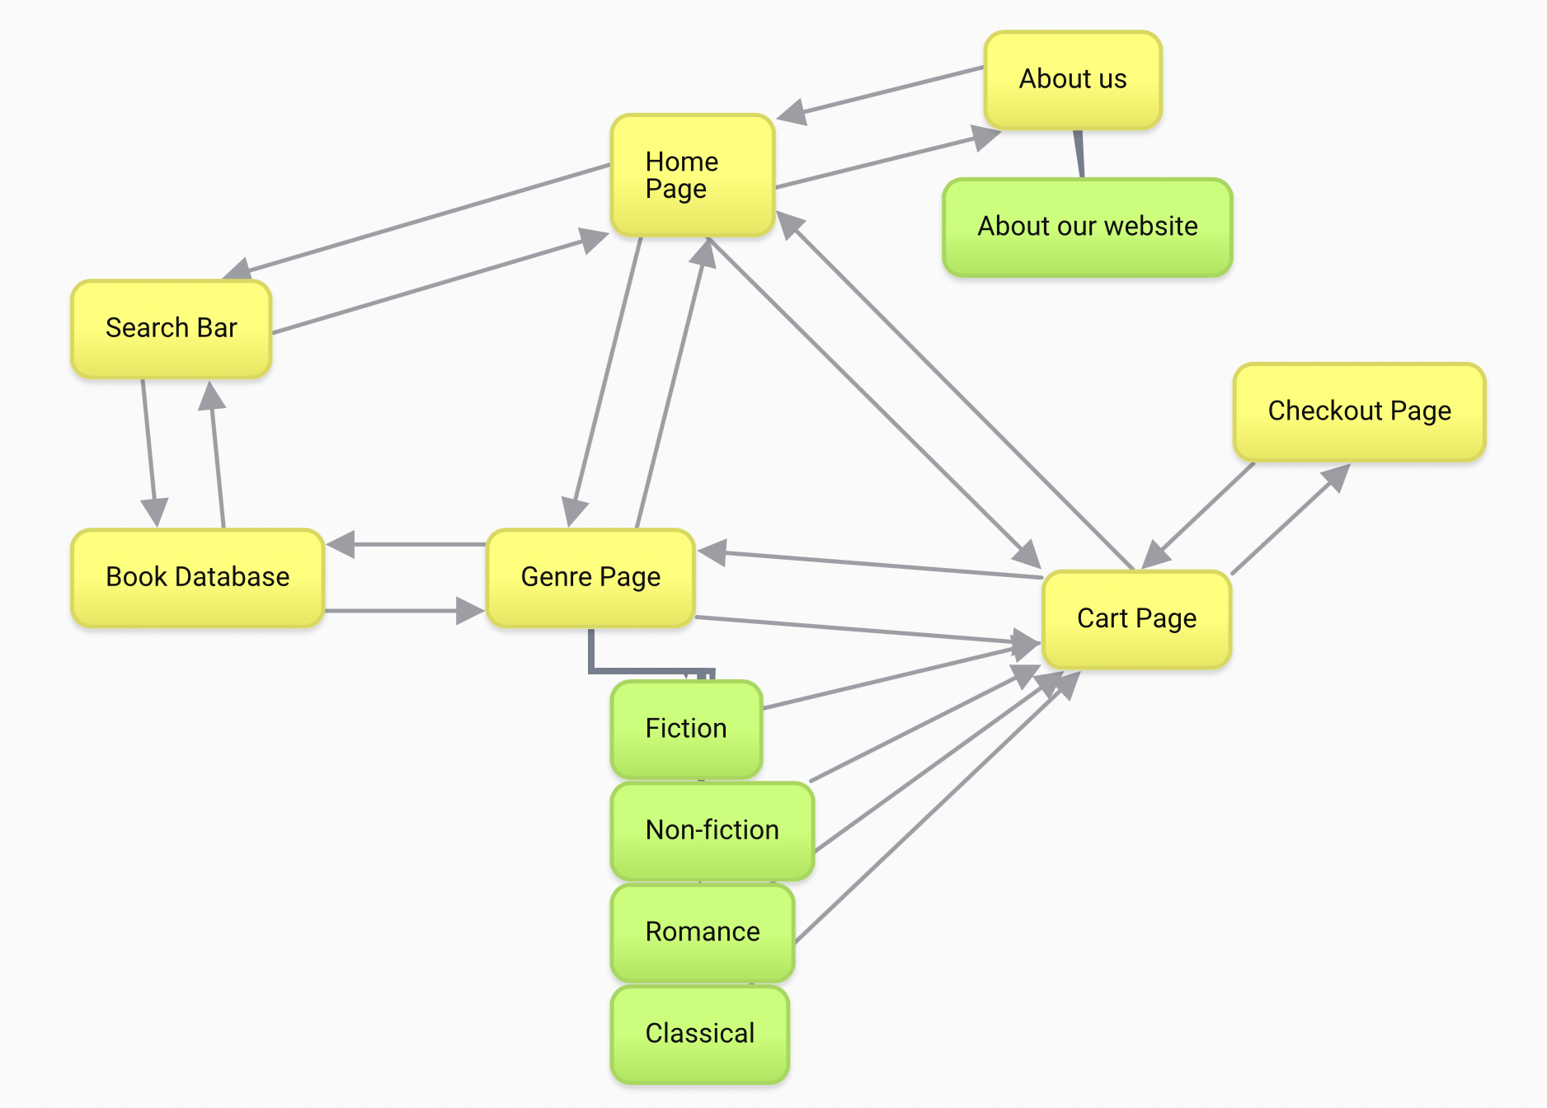

**Add your Bitbucket.io or github.io link to your component design**

<https://vendelg.github.io/s321266_hit266_sprint3/>

Proto Persona outline

|  |  |
| --- | --- |
| Q1 – Demographics Data:   * Who are they? * What are their ages? * What are their skills? | Q2 – Objectives and Needs   * What do they want to accomplish? * What do they need to reach objectives? |
| Q3 – Behaviour and preferences   * What do they like? * What are they better at doing? * How do they like to do it? | Q4- Difficulties   * What are the difficulties they may face * What frustrates them? * What known issues affect their interactions |

**MVP**



Persona template

Name: Jim Bobby  
Description: Middle aged student that enjoys reading in his spare time

**Personal Profile**

Jim Bobby is a 25 year old business student from Melbourne. He has been interested in reading from a young age and usually reads as part of his leisure time. He often finds the mainstream books not to his liking so he ends up reading more obscure books to sate his appetite for reading. He is interested in getting more books for his collection.

*Key message*

* Data 1
* Data2
* Data3

**Personal Information**

**Profession**

**Location**

**Age**

**Hobbies**

**Favorite TV Show**

**Personality**

**Internet usage**

**Internet experience**

**Primary Uses**

**Favourite Sites**

**Hours online per week**

**Computer**

**Study information**

**Current qualifications**

**Literacy**

**IT Skills/knowledge**

*Key message*

* Data 1
* Data2
* Data3

**Personal Information**

**Profession - student**

**Location - melbourne**

**Age - 25**

**Hobbies - reading**

**Favourite TV Show – law and order**

**Personality – quiet, stoic**

**Internet usage**

**Internet experience - moderate**

**Primary Uses – youtube videos, online shopping**

**Favourite Sites – youtube, ebay, amazon**

**Hours online per week – 50 hours**

**Computer – macbook**

**Study information**

**Current qualifications – highschool diploma**

**Literacy – very good**

**IT Skills/knowledge - moderate**

|  |  |
| --- | --- |
| User Goals  Purchasing and finding books that he is interested in to read in his spare time. | User Stories  Jim bobby was born and raised in Melbourne by his middle-class parents. He often read books to pass the time as his parents were strict and did not allow him to play with toys or video games growing up. His favourite genre of books is classic literature and he has read all of the mainstream titles within that genre. |

**Personal Information**

**Profession**

**Location**

**Age**

**Hobbies**

**Favorite TV Show**

**Personality**

**Internet usage**

**Internet experience**

**Primary Uses**

**Favourite Sites**

**Hours online per week**

**Computer**

**Study information**

**Current qualifications**

**Literacy**

**IT Skills/knowledge**

*Key message*

* Data 1
* Data2
* Data3