**Name : Vaidehi Bhamare**

**Roll No : 19101B0002**

**Branch/Div : CMPN/B**

**Subject : Audit Course Level 1 Task.**

**Project: Order online**

|  |  |
| --- | --- |
| Front End Tools | HTML 5, CSS3 |
| Project Leader | Vaidehi Bhamare |
| Project Language | English |
| Country | India |
| Reference sites | www.w3schools.com |
| Github Repository Link | https://github.com/vendubhamare/auditCourse1 |

**Project Description :**

Its a website for small cafe , where they can order online and get order placed.

**Screenshots:**

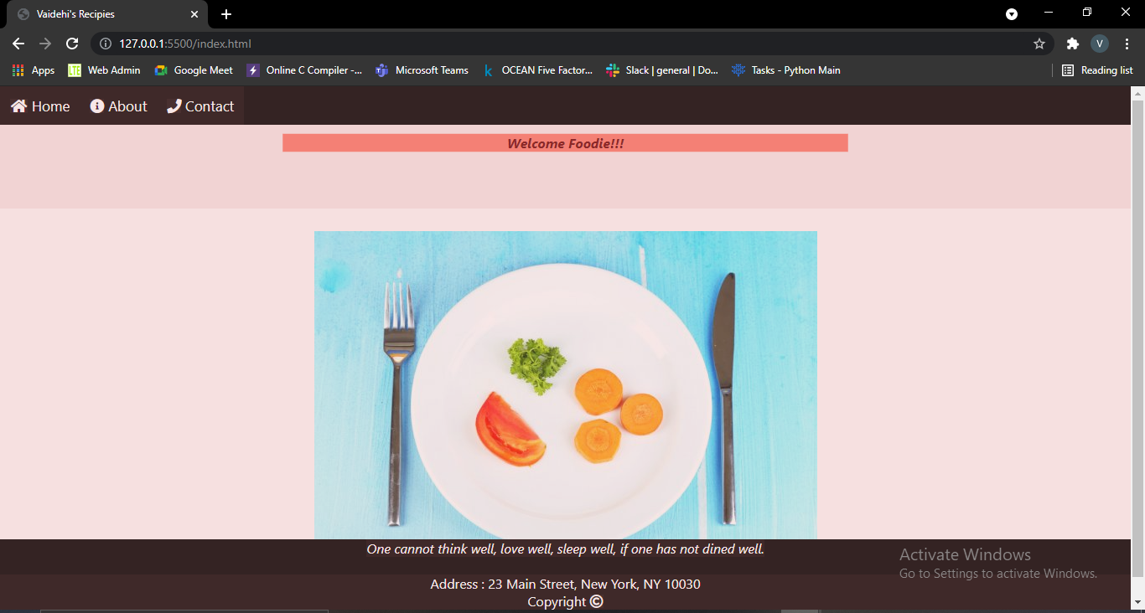

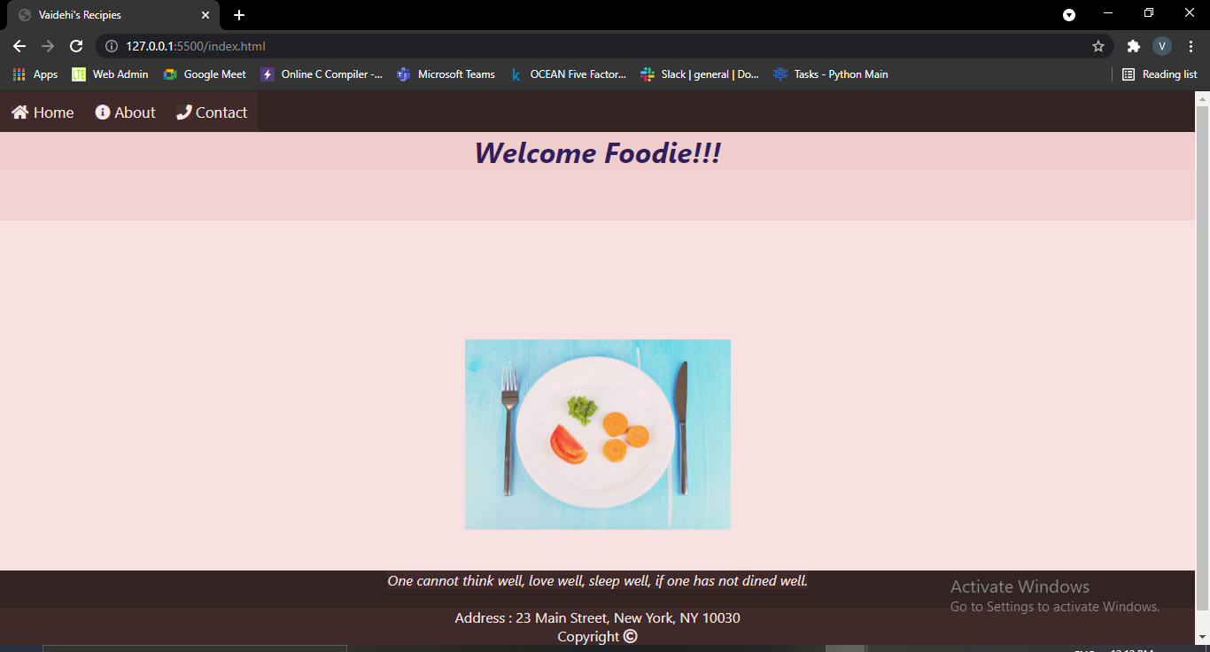

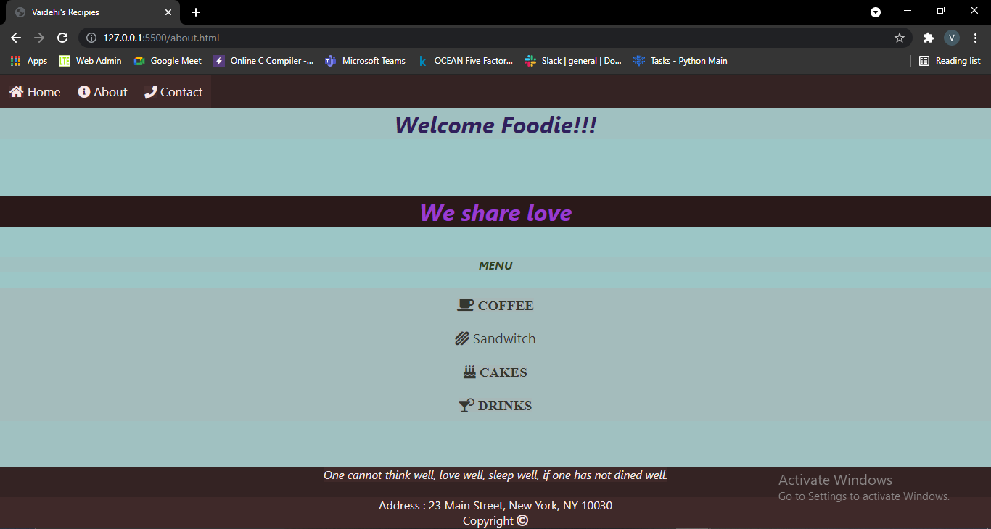

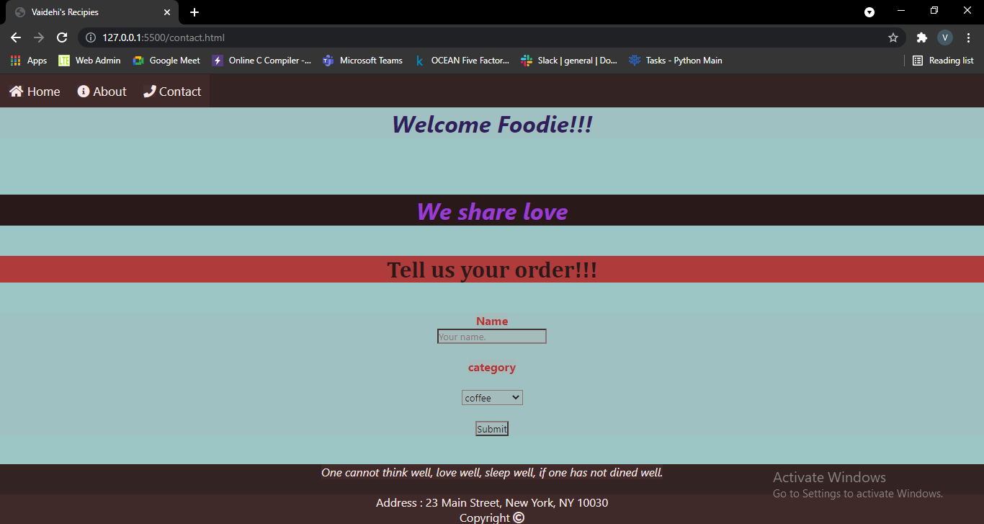

**Repository Link Here : https://github.com/vendubhamare/auditCourse1**